12. Libraries

The BSR package includes the four libraries BSPLINE, ZCONF, ZCOM and LAPACK, which contain routines common to all programs. The ZCONF library contains specific routines, which deal with the configuration and close-coupling expansions while ZCOM contains common routines used for a variety of auxiliary computations. The LAPACK library (http://www.netlib.org/lapack/index.html ) was chosen to provide the necessary linear algebra calculations, such as diagonalizing matrices or solving a system of linear equations.
The BSPLINE library is the central part of the present complex. It contains routines for using B-spline bases in atomic structure calculations. The most extensive survey of recent applications of B-splines in atomic and molecular physics is presented in the review by Bachau et al [26]. The present library represents the accumulated developments made by different people over the last twenty years. BSPLINE includes based on original FORTRAN IV routines from the monograph by de Boor [60], who first presented algorithms for the construction and manipulation of B-splines. These were modified by Froese Fischer and her collaborators who started the design and implementation of the present library, and numerous investigations of different numerical algorithms for using B-splines in atomic structure calculations were published [39,49,50,61,62,63,64]. This spline library has been modified and extended by the present author. Features were added to accommodate the more complex requirements of the R-matrix method, and the programming was upgraded to F95 standards.
Most of the routines in BSPLINE can be used in many other atomic structure calculations. For this reason we decided to present a rather detailed description of the BSPLINE library, including calling sequences for the main routines and the internal structure of the modules. The FORTRAN module is a program unit, which contains specifications and definitions that can be made accessible to other program units. It was found convenient to cluster the principal parameters, variables and arrays in different modules according to the subject they describe. For the given module name to be accessible, the other program units must reference the module in a use name statement. All arrays in the modules in the present implementation are dynamically allocated for the case under consideration. The module structure used in BSPLINE simplifies the use of separate subroutines in other applications.
The modules and routines in the description below have been grouped together for convenience. This includes the general routines and the atomic-orbital-related routines. The latter concern first of all the evaluation of a two-electron integral in the B-spline basis, and the generation of the B-spline representation for the Hamiltonian matrix. Along with the description of the routines, each section provides a brief description of the basic theory.
12.1. Description of B-splines

B-splines are functions designed to generalize polynomials used for approximating arbitrary functions in some finite interval. Consider the interval [a,b] divided into subintervals. The endpoints of these subintervals are given by the knot sequence [t_{i}], i = 1,2,...,n + k. The B-splines of order k, B_{i,k}(r), on this knot sequence are defined recursively by the relations
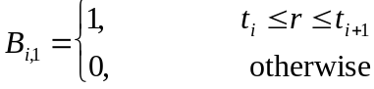 (12.1)
and
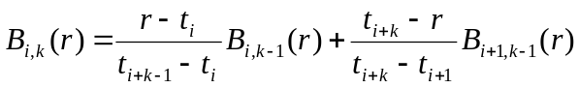 (12.2)
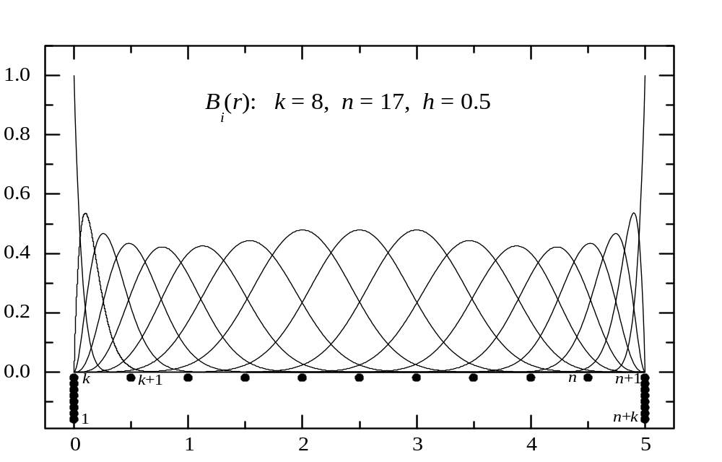Since k and t are usually fixed, we will indicate only one index, B_{i}. Each B_{i} is defined over the interval [t_{i},t_{i+k}], which contains k + 1 consecutive knots, and is indexed by the knot where it starts. An example of a full set of B-splines is shown in Fig. 12.1. In this example, the interval [0,5] is divided into equidistant
Fig. 12.1. The full set of B-splines of order k = 8 relative to the equidistant knot sequence (represented by full circles, with an indication of their numeration).
subintervals, with h = 0.5. Each B_{i} starts at the knot t_{i}, i=1,…,n, and ends k knots later. In order to provide the same number of B-splines in each interval, the multiplicity of knots in the endpoints is usually chosen to the maximum possible value, which is equal to the B-spline order k. The most common choice for the multiplicity at inner knots is unity, corresponding to the maximum continuity of B-spline functions inside the interval. With this choice, employed in the BSPLINE library, the number of subintervals is related to the number of B-splines as
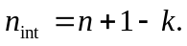
Some general properties of B-splines are the following.

- Over each subinterval [t_{i},t_{i}+1], exactly k B-splines are nonzero
the first being B_{i-k+1}, which ends at t_{i} +1, and the last being B_{i}, which starts at t_{i}. This means that
- In the expansion of an arbitrary function
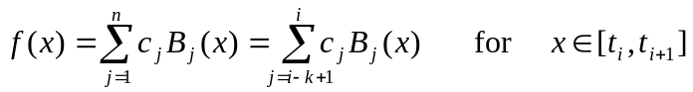
only k term contribute. Consequently, the B-spline representation for different operators will exhibit a band structure, simplifying to a great extent the solution of the relevant matrix equations.

- B-splines are normalized as 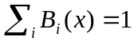. Since the B-splines are non-negative with minimal support, the expansion coefficients of an arbitrary function are close to the function values at the knots. This means that wild oscillations in the coefficients are avoided, cancellation errors are minimal, and the numerical stability is maximized.

- B-splines satisfy the recursion relations (12.2). Together with the definition of B-splines of order k =1 (12.1), this provides a simple algorithm for their practical evaluation: given a point x, one generates by recursion the values of all k B-splines that are nonzero at x. The derivative of a B-spline of order k can be also expressed as a linear combination of B-splines of the order (k-1):
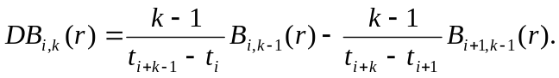 (12.3)
The first B₁-spline is the only spline with nonzero value at the left end of interval [a,b] while all other B_{i}-splines have the (r-a)^{i-1} dependence. A similar behavior applies at the point b. This makes it very easy to implement boundary conditions at the endpoints. For instance, f(a) = 0 is satisfied by deleting B₁ from the set, or Df(b) = 0 may be satisfied by combining B_{n-1} and B_{n} as 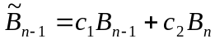 so that 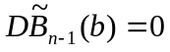, and so on.
- With a minimum multiplicity of knots, the B_{i,k}-spline functions belong to the functions of class C^{k-2}, i.e., they are all continuous functions together with their derivatives up to order k-2. In each subinterval [t_{i},t_{i+k}], B-spline functions can be represented by a polynomial of order k (maximum degree k – 1). That allows, in principle, for analytical manipulations with B-spline functions in symbolic packages.

In quantum mechanical applications we deal mostly with matrix elements, i.e., definite integrals involving B-splines and their derivatives. These are best computed to machine accuracy by employing Gauss-Legendre integration of appropriate order over each subinterval [t_{i},t_{i+1}]. Recall that the Gauss-Legendre method of order n (n points) is exact for a polynomial integrand of order 2n. This means that a k-points Gauss-Legendre method integrates exactly the product B_{i}B_{j}, and also provides accurate results even for non-polynomial integrands, provided no singularity is present in the given interval. At the same time, in the first subinterval, (1/r)B_{i}B_{j} is also evaluated exactly if i or j > 1. For most applications, therefore, we only need the B-spline values at the k Gauss points. This also spares us from directly dealing with the vicinity of r = 0, where the potentials may have singularities.
Another important problem in quantum mechanical applications is the solution of the radial Schrödinger equation. In order to demonstrate the use of B-spline for this problem, consider the one-electron radial equation
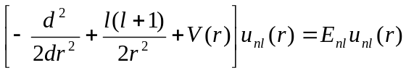. (12.4)
An approximation solution is expressed as a linear combination of B-splines over an interval [0,r_{max}], say {B_{i}(r), i=1,...,n_{s}}. Then
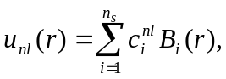 (12.5)
Usually the approximate (or trial) functions satisfy the boundary conditions. When the B-spline basis is generated using a grid with multiple knots at the ends of the interval, the zero boundary conditions, for example, are fulfilled by removing the first and the last B-splines from the basis set. We shall refer to the column vector c = {c_{i}} as a spline expansion vector of u(r). The solutions of (12.4) are calculated by solving the system of n_{s} linear equations obtained when substituting (12.5) into (12.4) and projecting onto B_{j}(r). Written in matrix form, this procedure is equivalent to solving the generalized eigensystem
 (12.6)
where
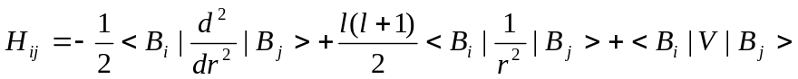, (12.7)
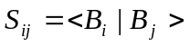. (12.8)
The overlap matrix S originates from the fact that the B-splines do not form an orthogonal set of basis functions. We will refer to the H_{ij} matrix as the B-spline representation of the Hamiltonian. Note that all matrix elements in (12.6) may be easily computed, as discussed above, to machine accuracy using Gauss-Legendre integration, applied to each subinterval. Another key property related to the use of a B-spline basis follows from the fact that a B-spline of order k differs from zero only on k successive subintervals. Therefore, any local operator expressed in the B-spline basis appears as a banded matrix with nonvanishing values only on a diagonal band of width 2k-1. This simplifies considerably the solution of the generalized eigenproblem (12.6).
Provided the wavefunctions fit into the cavity (often called the box), in which we solve the problem (12.6), the first few eigenvalues and eigenvectors agree precisely with the corresponding bound-state eigenvalues and eigenvectors obtained by numerically integrating the radial Schrödinger equation, but as the principal quantum number increases, the cavity spectrum departs from the real spectrum and forms the so-called pseudospectrum, which can be used instead of the real spectrum in different physical problems. Each of these eigenvectors defines an atomic orbital. By using a B-spline set, it is possible to account for the influence of an entire Rydberg series without introducing a cut-off. For example, the second-order energy correction in the framework of the Rayleigh-Schrödinger perturbation theory
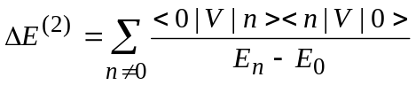 (12.9)
requires the direct evaluation of the sum in terms of an infinite sum over the bound states and an integration over the continuum. In the B-spline pseudospectrum, only a few states are bound while the remaining states are unbound, and the infinite sum (12.9) is reduced to a finite sum. As shown in many numerical examples [65], this sum very accurately reproduces the infinite sum (12.9) with a small number of B-splines, i.e., the B-spline basis is effectively complete in this sense. This effective completeness of the basis set means that the summation is independent, or almost independent, of the box size and the number of splines if these two quantities are chosen sufficiently large. We can check numerically if the summation is independent of the box size and the number of splines. Completeness of the B-spline basis is a very valuable property, simply because it is possible to replace an infinite summation over bound states and an integration over continuum states with a summation over a small number of L²-integrable functions. This property also found wide application in the investigation of the strong interaction between a perturber and a Rydberg series [66], or in the investigation of the influence of the continuum spectrum in two-electron atoms [67].

12.2. General routines

B-splines can be considered as elementary functions like sin x or j_{l}(x). One becomes familiar with them by understanding their qualitative behavior and how to use them, i.e., how to obtain values of the functions, their derivatives, or integrals. This is the purpose of the routines described in the next section.

List of general routines

bav | computes y = B x or y = xB, where B is symmetric or non-symmetric band matrix, y and x are vectors.
bvalue | calculates at given radius the value and derivatives of a function given in a B-spline representation.
bvmv | returns the matrix element <x|A|y>, where x,y are vectors, A is a band array in symmetric, non-symmetric, or almost symmetric form.
bxv | computes y = B x, where B is a symmetric band matrix while y and x are vectors.
define_grid | gets input data for the grid and sets up the knots for spline.
define_spline | initializes the values of the spline and its derivatives, and evaluates the basic elementary operators in the spline basis.
dinty | computes the matrix elements <B_{i}| y(r)|B’_{j}> between individual B-splines for an input function y(r) given at the Gaussian points of each interval.
facsb | factorizes the overlap matrix <B_{i}| B_{j}>.
gauss | provides the Gaussian coordinates and weights over the interval [0, 1].
minty | computes the matrix elements <B_{i}| y(r)|B_{j}> between individual B-splines for an input function y(r) given at the Gaussian points of each interval.
mkgrid | sets up the knot sequence.
mrm | generates the B-spline representation of the operator r^{m}.
spline_param | module, contains the main spline parameters.
spline_grid | module, defines the values of the splines and their most general functions at the Gaussian points needed for integrations on the grid.
spline_galerkin | module, contains common arrays used in the application of splines in the Galerkin method.
splin3 | provides coefficients for a cubic interpolating spline.
vbsplvd | calculates the values of the B-splines and their derivatives for one point per each interval.
vinty | computes the vector elements <B_{i}|y(r)>, where the function y(r) is given at the Gaussian points of each interval.
yval | computes the values of r^{m} f(r), r^{m} f'(r) or r^{m} f''(r) at the Gaussian points of each interval, where f(r) is defined by the spline expansion vector.

Internal representation of band matrices

The BSPLINE library uses different storage modes for banded matrices depending on the symmetry of the matrix and on the operator represented by this matrix. Let A(n,n) be a matrix with a diagonal band of width 2k-1. Then the possible storage modes, matrices B, can be described schematically as:

- Symmetric lower-column storage mode.

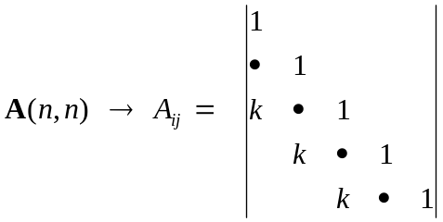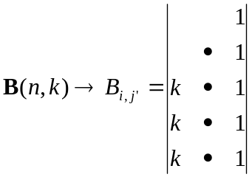
A(i,j) = B(i,j') with j =j'+i-k.
The summation over elements: Do j'= 1,k
Do i = k+1-j',n

- Symmetric upper-column storage mode.

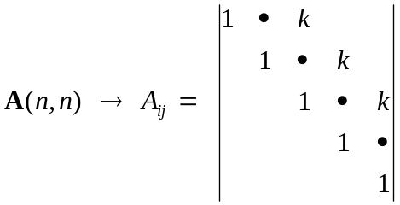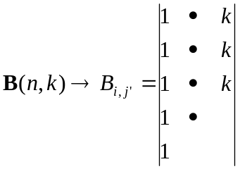
A(i,j) = B(i,j') with j =j'+i-1
The summation over elements: Do j'= 1,k
Do i = 1,n-j'+1

- Non-symmetric column storage mode.

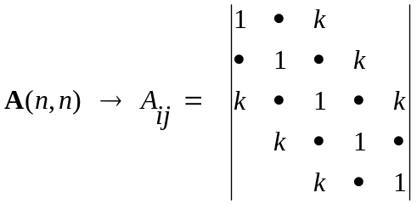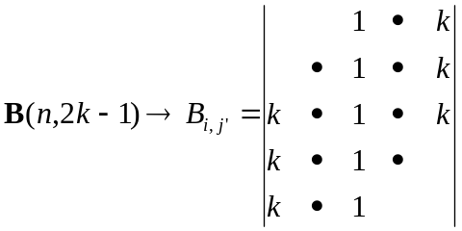
A(i,j) = B(i,j') with j =j'+i-k
The summation over elements: Do j'= 1,k+k-1
Do i = max(1,1+k-j'),min(n,n+k-j')

- Almost symmetric lower-column storage mode.
There is only one non-symmetric element: A(n,n-1) ≠ A(n-1,n), the latter is saved in B(1,1) for low-column storage mode, or in B(n,n) for upper-column storage mode.

MODULE spline_param

ks | order of B-splines.
ns | number of B-splines.
nv | number of intervals.
ml | number of distinct points from 0 to 1.
me | number of points in the "exponential" region.
h | initial step in knot sequence.
hmax | maximum step.
rmax | border radius.

MODULE spline_grid

t(1:ns+ks) | knot sequence.
bsp(1:nv+1,1:ks,1:ks) | bsp(i,m,ith)contains value of the i+ith-1 B-spline in interval i at Gaussian point m.
bspd(1:nv+1,1:ks,1:ks,1|2) | values of first and second derivatives of B-splines at the same points. bsp(nv+1,1,.) and bspd(nv+1,1,.,.) contain corresponding values at the last knot point, i.e. at r_{max}.
bsq(1:nv+1,1:ks,1:ks) | values of the expression B(r)-1/rB’(r) in Gaussian points.
gr(1:nv,1:ks) | gr(i,m) contains Gaussian point m in interval i.
grm(1:nv,1:ks) | reciprocals of the values of gr(i,m).
grw(1:nv,1:ks) | Gaussian weights at corresponding points.
Internal routines:
Allocate_grid | allocates space for arrays bsp, bspd, gr, grm, and grw according to parameters from module spline_param.

MODULE spline_galerkin

sb(1:ns,1:ks) | sb(i,j) --> <B_{i}|B_{i+j-k}>
r1(1:ns,1:ks) | r1(i,j) --> <B_{i}|r|B_{i+j-k}>
rm1(1:ns,1:ks) | rm1(i,j) --> <B_{i}|(1/r)|B_{i+j-k}>
rm2(1:ns,1:ks) | rm2(i,j) --> <B_{i}|(1/r²)|B_{i+j-k}>
rm3(1:ns,1:ks) | rm2(i,j) --> <B_{i}|(1/r³)|B_{i+j-k}>
db1(1:ns,1:ks) | db1(i,j) --> <B_{i}|B'_{i+j-k}>
db2(1:ns,1:ks) | db2(i,j) --> <B_{i}|B''_{i+j-k}>
bs(1:ks,1:ns) | factorization of array sb
Internal routines:
Allocate_galerkin | allocates space for all arrays according to the parameters from module spline_param. The arrays are stored in the symmetric lower-column storage mode, except for db2 - almost symmetric mode, and db1 - antisymmetric array.

Remarks

All arrays and parameters in the above modules should be initialized before the B-spline applications. This can be done with the routines define_grid and define_spline, which should be called at the beginning of each BSR program.
The define_grid subroutine generates the knot sequence. This is a very important first step in the BSR calculations, because the B-splines are fully defined by the given knot sequence. Hence the grid, together with the spline order, k, determines the accuracy of the approximation. Though there is a complete freedom in choosing the mesh of knots, the optimal choice will depend on the type of result we are particularly interested in. With splines, we can create any composite grid if needed but too dense a grid can lead to a rapid saturation of the computational resources. Experience shows that the most appropriate choice is a logarithmic grid that reflects the exponential behavior of atomic orbitals. On the other hand, in the continuum calculations, the wavelength of the scattering particle cannot be smaller than the grid step; otherwise the B-spline basis hardly describes the oscillating behavior of the wavefunction. In the present implementation, we use a mixed sequence which can easily be adjusted to the task under consideration. We introduce four main parameters: the step size at the origin, h = 2^{-m}, where m is the integer, the maximum step size h_{max}, the maximum range r_{max}, and the order of splines k. Let Z be the nuclear charge of the atom. The grid points are now defined through the array t_{i}=Zr_{i} such that
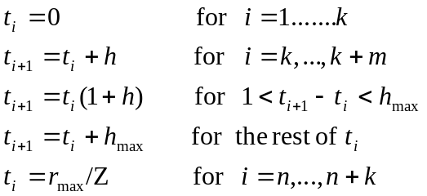 (12.10)

This grid is linear near the origin, at Zr < 1, which guarantees an accurate representation of the radial orbitals at small radii. Experience shows that values Zh = 0.25 or 0.125 are good enough for most applications. In the middle-radii region, the grid is exponential. This gives some advantage in computational time, because for B-splines entirely in the outer region, relations such as
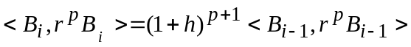 (12.11)
hold (see, for example, Froese Fischer and Idrees 1989). Similar rules can also be derived for two-electron integrals commonly occurring in atomic structure calculations (see Section 12.5). Thus, only a few integrals need to be evaluated while a scaling law applies for others.
Another grid parameter defines the maximum range of the solution. Since the range of a 1s orbital is much less than that of a 10s, the software may automatically adjust the range for each orbital, but in a general purpose software, a sufficient range is needed to allow orbitals to reach their full extent for the desired accuracy. In BSR calculations, the r_{max} is usually chosen from the condition that |P(r_{max})| < 10⁻⁵ for all bound radial functions, and this value coincides with the R-matrix boundary, a.
For bound-state calculations we can use the exponential grid in the outer region, whereas in scattering calculations the maximum size of the subintervals should be restricted according to the maximum energy of the scattering electron. Experience shows that the oscillating behavior of the scattering radial functions is reproduced accurately with at least three knot points for a half wavelength. Hence, the user should choose the parameter h_{max} ≤ 1/k_{max} , where k_{max} is the maximum linear momentum of the scattering electron expected in the subsequent calculations. This restriction is primarily important in direct scattering calculations [42], whereas in the R-matrix calculations this restriction was found can be reduced at least three times without noticeable influence on the numerical accuracy.
The grid parameters are provided in the BSR calculations in the file knot.dat, and these parameters should hold the same values during the entire set of calculations. An example of a knot.dat file is given in Fig. 12.2. The routine define_grid first reads the main parameters from knot.dat, and then generates the knot sequence in the routine mkgrid. The number of B-splines is an output parameter in this procedure and defined at this stage. The resulting knot sequence and the relevant parameters are then rewritten to the knot.dat file. If the program cannot find the knot.dat file, the execution will be stopped. The user is strongly advised to first try different sets of parameters to produce the desired knot sequence with a minimum number of B-splines, because this parameter strongly affects the computation time for all subsequent calculations.

8 ==> order of splines (ks)
101 ==> number of splines (ns)
6.00000 ==> nuclear charge (z)
0.25000 ==> step size from 0 to 1 (h for z*r, = 1/2^m)
0.70000 ==> maximum step size (hmax for r)
50.00000 ==> maximum r (rmax)
***
0.00000 0.00000 0.00000 0.00000 0.00000
0.00000 0.00000 0.00000 0.04167 0.08333
0.12500 0.16667 0.20833 0.26042 0.32552
0.40690 0.50863 0.63578 0.79473 0.99341
1.24176 1.55220 1.94026 2.42532 3.03165
3.63798 4.24431 4.85064 5.45697 6.06330
6.66963 7.27596 7.88229 8.48862 9.09495
9.70128 10.30761 10.91394 11.52027 12.12660
12.73293 13.33926 13.94559 14.55192 15.15825
15.76457 16.37090 16.97723 17.58356 18.18989
18.79622 19.40255 20.00888 20.61521 21.22154
21.82787 22.43420 23.04053 23.64686 24.25319
24.85952 25.46585 26.07218 26.67851 27.28484
27.89117 28.49750 29.10383 29.71016 30.31649
30.92282 31.52915 32.13548 32.74181 33.34814
33.95447 34.56080 35.16713 35.77346 36.37979
36.98612 37.59245 38.19878 38.80511 39.41144
40.01777 40.62410 41.23043 41.83676 42.44309
43.04942 43.65575 44.26208 44.86841 45.47474
46.08106 46.68739 47.29372 47.90005 48.50638
49.11271 50.00000 50.00000 50.00000 50.00000
50.00000 50.00000 50.00000 50.00000
***

Fig.12.2. Example of a knot.dat file in the case of the e – C scattering.
12.3. Atomic orbital routines

This block of routines deals with the set of atomic radial functions and their B-spline representations, denoted below as vectors p_{i}. The operator L is defined as
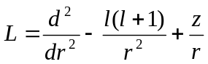.

List of routines

azl | provides B_{l+2}/r^{l+1} at r = 0, which defines the leading term for orbital nl.
bcore | computes the energy of the common closed shells (core).
bhl | evaluates the matrix element <p_{i} |L |p_{j}> for atomic orbitals i,j.
bhwf | computes the spline expansion coefficients for hydrogen radial functions.
coulomb | builds the interaction matrix for the Coulomb problem.
grad | gives the matrix element <p_{i} | d/dr + l/r |p_{j}> for atomic orbitals i,j.
hlc | computes the matrix element <p_{i} |L |p_{j}> modified by the interaction with closed shells.
hlm | sets up the matrix of the L operator in the B-spline basis.
quadr | evaluates the matrix element <p_{i} |r^{k}|p_{j}> for atomic orbitals i,j.
mvcv | computes the matrix elements for the mass-velocity correction in the B-spline basis.
r_bwfn | reads the atomic orbitals from the bsw-files.
spline_atomic | module - contains the main atomic parameters.
spline_hl | module - contains the L matrix and routines for evaluation of relativistic shifts.
spline_orbital | module - contains the description of the atomic orbitals.
zeta | evaluates the spin-orbit integrals (including the interaction with closed shells).

MODULE spline_orbitals

nbf | number of atomic orbitals.
nbs(1:nbf) | principal quantum numbers.
lbs(1:nbf) | orbital angular momenta of the orbitals.
kbs(1:nbf) | set indexes of orbitals.
ebs(1:nbf) | spectroscopic labels for orbitals.
mbs(1:nbf) | length of the B-spline expansion.
iech(1:nbf) | Additional pointer, used to distinguish the continuum orbitals.
pbs(1:ns,1:nbf) | B-spline expansion coefficients for atomic orbitals.
qbs(1:ns,1:nbf) | vectors B·p, where B is the B-spline overlap matrix.
obs(1:nbf,1:nbf) | one-electron overlaps.
iort(1:nbf,1:nbf) | orthogonal constraints, imposed on the one-electron orbitals.
Internal routines:
allocate_bsorb | allocates space for all arrays for a given value of nbf.
Ifind_bsorb | defines the position of the orbital n,l,k in the common list.
Iadd_bsorb | adds the orbital n,l,k to the common list.

MODULE spline_atomic

z | charge of nucleus.
kclosd | number of closed shells.
rel | indicates the relativistic calculations.
fine | fine-structure constant.
EC | energy of core.
ioo | if ioo > 0, the core energy also includes the orbit-orbit interaction.

MODULE spline_hl

hl(1:ns,1:ks) | matrix of the L operator in the B-spline basis (in almost symmetric lower-column mode)
lh | the corresponding value of the orbital angular momentum
vc(1:ns,1:ks) | matrix of mass-velocity correction in the B-spline basis
Internal routines:
Allocate_hl | allocates space of for the hl and vc arrays according to parameters from module spline_param.

Format of the bsw-files.

The atomic orbitals in the B-spline representation are supposed to be recorded in the unformatted bsw-files, which are similar to the w-files in the MCHF package [68]. In the bsw-files each orbital is recorded sequentially with the following information:
1. ebs, z, h, hmax, rmax, ksb, nsb, mbs
2. pbs(1:mbs)

where the notation corresponds to the definitions in the module spline_orbitals. Along with the usual information about the quantum numbers and the B-spline expansions, the bsw-file also contains the B-spline parameters, which enables us to reconstruct the corresponding knot sequence.
12.4. Evaluation of two-electron integrals

The BSPLINE library contains three sets of routines for the evaluation of two-electron integrals, which are based on the different numerical methods. They include the usual direct differential method, the B-spline differential method, and the direct summation over the B-spline cells. The different methods are suitable for different kind of calculations, have different accuracy and speed, and different representations of the final results. The direct differential method provides only the total values for the integrals, has the lowest accuracy but the highest speed. This method can be used in large-scale CI calculations. The B-spline differential method provides the B-spline representation for different two-electron integrals, that can be used in generating the Hamiltonian matrix, including the Breit-Pauli terms. The evaluation of the total values of integrals, however, is slower, approximately by one order of magnitude, than in the direct differential method. In the direct summation over B-spline cells, we first evaluate the two-electron integrals in the different (r₁,r₂) cells, defined by the B-splines subintervals [t_{i},t_{i+1}]. The integration is performed by using the Gauss-Legendre quadratures. This provides the highest accuracy, which is comparable to machine accuracy. This method can be used efficiently for both the B-spline representation and the evaluation of total integral values, although the speed is still slower that in the direct differential method.
Below we outline the relevant theory and the different numerical methods used in BSPLINE to deal with the two-electron integrals. Then we give a short description of the relevant routines and modules. These routines have been developed on the basis of algorithms and recommendations, previously presented by Brage and Froese Fischer [49] and of Qui and Froese Fischer [64]. We follow closely their notation.

12.4.1. Evaluation of two-electron integrals by direct differential equation method

The two-electron radial integrals in atomic structure calculations are of the form
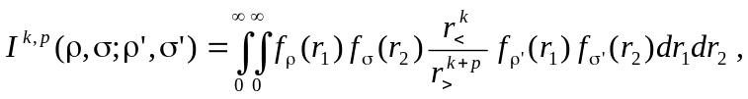 (12.12)
where r< and r> are the smaller and larger of the two coordinates r₁ and r₂, respectively. The f(r) functions are linked to the radial orbitals, p is a positive integer, and k can assume a range of different integer values. If we define a function Y^{k,p}(σ,σ';r) so that
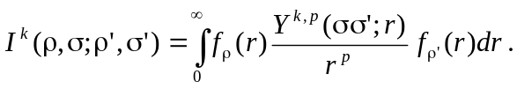
it follows that
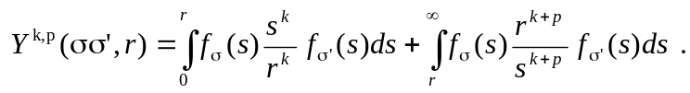 (12.13)
It can be shown that this function satisfies a differential equation of the form
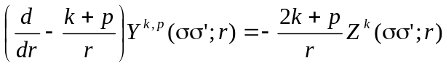 (12.14)
Here we have introduced a second function
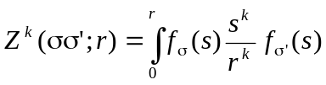, (12.15)
which satisfies the differential equation
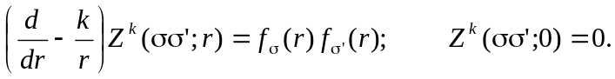 (12.16)
The form of the Z^{k} function is quite general when defined in this way, since it is independent of p.
In Breit-Pauli calculations, all two-electron integrals can be reduced to four main types: R^{k}, N^{k}, V^{k}, and T^{k} integrals.

R^{k} Integrals
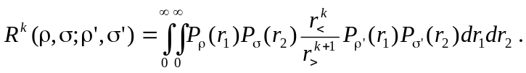 (12.17)
This is the special case of equation (12.12) with p = 1, and the f functions being the radial orbitals. The R^{k} integrals are highly symmetric
i.e., they are unchanged as long as the ρ and ρ' orbitals, and thereby the σ and σ', are linked together with one coordinate.
The two-step procedure described above can be avoided, since the differential equation for the Y^{k} functions is
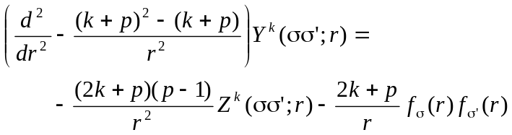 (12.18)
In the special case of p = 1, the coefficient of the Z^{k} function disappears, and we are left with a single, though second-order, differential equation for Y^{k}
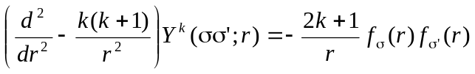 (12.19)
with the boundary conditions
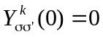
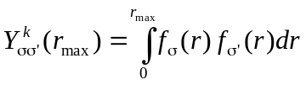, if k=0, (12.20)
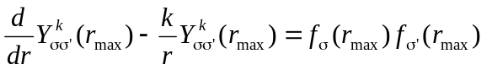, if k >0
The boundary condition at r_{max} can be obtained from (12.13), assuming that the orbitals disappear at r > r_{max}.

N^{k} integrals
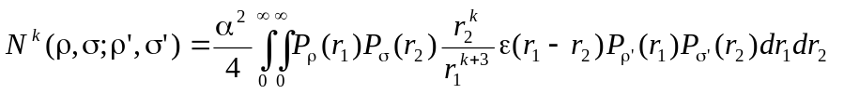 (12.21)
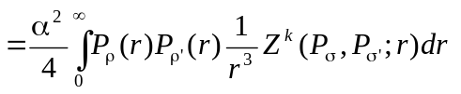
where k ≥ -1 and ε(x) = 0 for x≤ 0, ε(x) = 1 for x > 0. The ε(x) step function reduces the Y^{k} function to Z^{k}, and the N^{k} integral is the special case of equation (12.12) with p=3, Y^{k}=Z^{k} and the f functions as the radial orbitals. Hence, in this case we need to solve only one first-order differential equation (12.16). But an additional complication occurs when dealing with the case N⁻¹, i.e., k < 0. In this case the homogeneous solution to equation (12.16) is
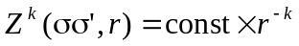
which leads to an ambiguous result when r → 0, since k > 0. This is solved by imposing a stronger boundary condition
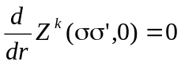, if k < 0. (12.22)
The N^{k} integrals have fewer symmetries than the R^{k} integrals:
In applications, we also use the integrals
(12.23)
which are as symmetric as the R^{k} integral and differ from the latter only by p = 3.

V^{k} integrals
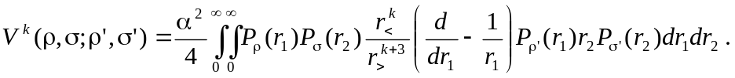 (12.24)
This is the special case of equation (12.12) with p=3 and
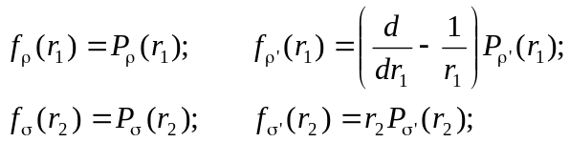
The V^{k} integral allows only the two-step procedure (12.14)–(12.16), and it has the most restricted symmetry relations:
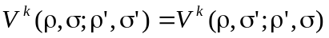
In applications, we also use more the symmetric integrals [25]:
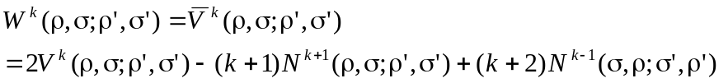 (12.25)
(12.26)

T^{k} integrals
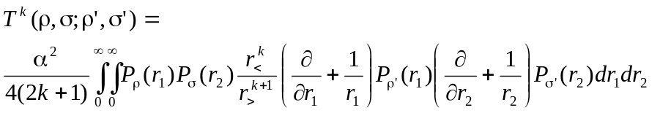 (12.27)
with p = 1 and
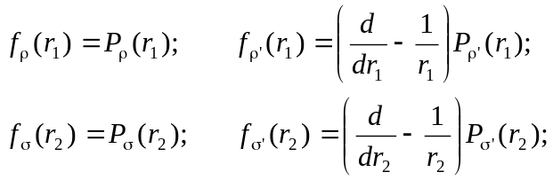
Here we can use the same procedure as for the R^{k} integrals, but the symmetry relations are stricter:
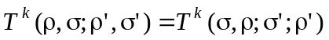
In the Breit-Pauli approximation, one also frequently uses the U^{k} integrals [25]. In the present implementation we do not use any special procedure for U^{k}, but instead the relationship

(12.28)

List of routines

spline_slater | module, contains common arrays used in the evaluation of two-electron integrals by direct differential equation method.
bzk | computes the spline solution for the Z^{k} function.
facdyk | sets up and factorizes the matrix of the Y^{k} operator d²/dr² -k(k+1)/r² in the B-spline basis.
facdzk | sets up and factorizes the matrix of the Z^{k} operator d/dr + k/r.
rky | evaluates the R^{k} integral by the direct differential method.
nky | evaluates the N^{k} integral by the direct differential method.
mky | evaluates the M^{k} integral by the direct differential method.
tky | evaluates the T^{k} integral by the direct differential method.
vky | evaluates the V^{k} integral by the direct differential method.
ykf | computes the spline solution for the Y^{k} function.

MODULE spline_slater
kz | multipole index for the Z^{k} function.
dzk(1:ktx,ns)  ipvtz(1:ns)  ktx = 3*ks-2 | factorization of the matrix for the Z^{k} operator d/dr + k/r in the B-spline basis.
ky | multipole index for the Y^{k} function.
dyk(1:ktx,1:ns)  ipvtd(1:ns) | factorization of the matrix for the Y^{k} operator d²/dr² -k(k+1)/r² in the B-spline basis.
yk(1:ns) | B-spline representation of the Y^{k} (or Z^{k}) function.
fyk(1:nv,1:ks) | values of Y^{k} (or Z^{k}) function at the Gaussian points.
fc1(1:nv,1:ks), ic1  fc2(1:nv,1:ks), ic2  fy1(1:nv,1:ks), iy1  fy2(1:nv,1:ks), iy2 | values at the Gaussian points and pointers for four one-electron radial functions in the two-electron integral under consideration.
fc(1:nv,1:ks) | work array.
Internal routines
Allocate_slater | allocates space for all arrays according to parameters from the module spline_param
Dealloc_slater | deallocates space in the module spline_slater

Calling sequences
rky nky
--------------- ----------
/ \ / \
ykf yval bzk yval
| |
------------------------- -------------
| | | | \ / | \
facdyk yval vinty quadr dgbsl facdzk yval dgbsl
| |
dgbfa dgbfa

tky vky
---------- ------------
// \ // \
ytk yval yvk yval
| |
-------------------------- -------------------------
| | | | \ | | | | \
facdyk yval vinty quadr dgbsl bzk yval vinty facdzk dgbsl
| | |
dgbfa -------------- dgbfa
facdzk yval dgbsl
|
dgbfa

Remarks

- The routines ykf, bzk, ytk, and yvk differ only by their way of calculating the Y^{k} functions. The specific routines ytk and yvk are incorporated in the calling routines.
- The Y^{k} and T^{k} integrals are defined through the solution of second-order differential equations. The N^{k} integral needs only the Z^{k} solution of the first-order equation while the V^{k} integral is evaluated by the sequential solution of two first-order differential equations.
- The ykf routine includes the relativistic shift modification of the Y^{k} function if the parameter rel = 'TRUE' .
- The quadr routine is used to determine the appropriate boundary conditions (12.20) when k=0. It is important in the case of non-orthogonal orbitals.
- These routines are very fast but not as accurate as the cell integration. They can be used for evaluating two-electron integrals, but not for generating the interaction matrix in the B-spline basis.

12.4.2. Evaluation of two-electron integrals in the B-spline basis

In the B-spline representation of radial atomic orbitals (12.5), the two-electron integrals (12.12) become
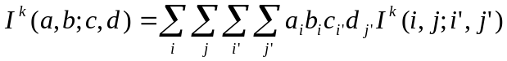 (12.29)
where the matrix elements I^{k}(i,j;i',j') are
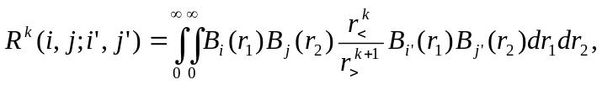 (12.30)
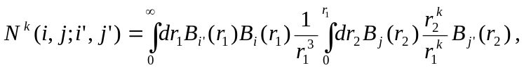
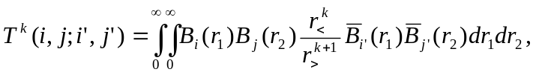
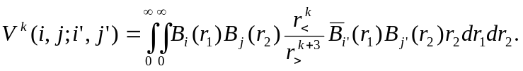
where we introduced 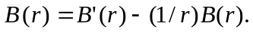 The matrix elements (12.30) can be obtained by using the same procedures described above in section 12.4.1 after replacing the f(x) functions by the corresponding B-splines.
Therefore, the two-electron integral is given as a four-fold summation, but considerable simplification is possible. Note that
(12.31)
Furthermore, the integrals may be symmetric relative to the (i,i') or (j,j') indexes. As a result, the B-spline integrals can be stored as a matrix with band character relative to the (i,i') or (j,j') indexes, namely:
R^{k}(n_{s}, n_{s}, k_{s}, k_{s}), (12.32)
N^{k}(n_{s}, n_{s}, k_{s}, k_{s}),
V^{k}(n_{s}, n_{s}, 2k_{s}-1, k_{s}),
T^{k}(n_{s}, n_{s}, 2k_{s}-1, 2k_{s}-1).
In particular, the array element R^{k}(i,j;i_{p},j_{p}) refers to the matrix element in which i' = i + i_{p} -1 and j' = j + j_{p} -1, where i_{p},j_{p} = 1,...,k_{s} (the symmetric upper-column mode). However, the array element T^{k}(i,j; i_{p},j_{p}) refers to the matrix element in which i' = i + i_{p} - k_{s} and j' = j + j_{p} - k_{s}, where i_{p},j_{p} = 1,...,2k_{s}-1 (the non-symmetric column mode).
Thus, it is convenient to regroup the summation as follows:
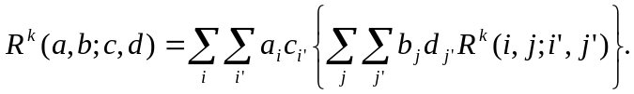 (12.33)
Let us consider the innermost double summation. Only the matrix elements with j' ≥ j are stored, but the summation in Eq. (12.33) runs over all values. However, the summation may be written as
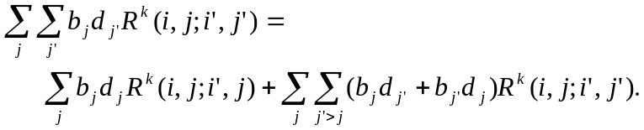 (12.34)
Let us define a direct "density matrix"
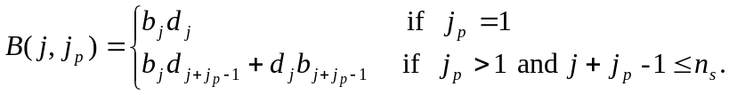 (12.35)
With a similar definition for the another pair of indexes,
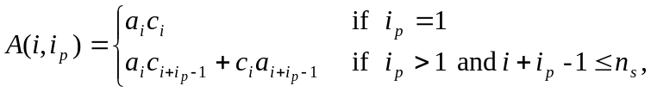 (12.36)
the Slater integral is then defined as
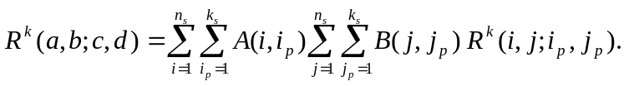 (12.37)
Similarly, we can obtain
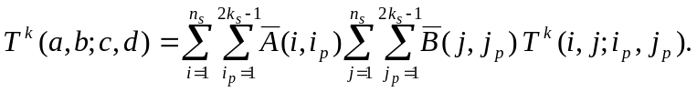 (12.38)
where
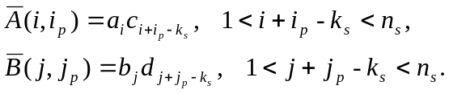 (12.39)
The N^{k} integrals are also defined through the 'symmetric' summation (12.37), whereas the V^{k} integrals are the mixed case
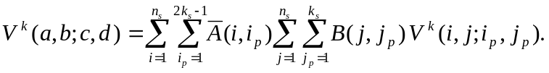 (12.40)

List of routines

spline_integrals | module, contains the B-spline representation of the given two-electron integral.
convol | convolutes the four-dimensional array of B-spline two-electron spline integrals with a two-dimensional density matrix.
density | provides the density matrices (12.35) or (12.39).
mrk_diff | sets up the matrix for the B-spline representation of the R^{k}-integral using the differential equation method.
mnk_diff | sets up the matrix for the B-spline representation of the N^{k}-integral using the differential equation method.
mmk_diff | sets up the matrix for the B-spline representation of the M^{k}-integral using the differential equation method.
mtk_diff | sets up the matrix for the B-spline representation of the T^{k}-integral using the differential equation method.
mvk_diff | sets up the matrix for the B-spline representation of the V^{k}-integral using the differential equation method.
rk | evaluates the R^{k} integral by assembling the B-spline integrals.
nk | evaluates the N^{k} integral by assembling the B-spline integrals.
mk | evaluates the M^{k} integral by assembling the B-spline integrals.
tk | evaluates the T^{k} integral by assembling the B-spline integrals.
vk | evaluates the V^{k} integral by assembling the B-spline integrals.

MODULE spline_integrals

krk | multipole index for the integral under consideration.
itype | character (rk, nk, mk, tk, or vk) which indicates the type of integral.
rkb | the B-spline representation of the given two-electron integral, stored in column mode with dimensions (1:n_{s},1:n_{s},1:2k_{s}-1,1:2k_{s}-1).
Internal routines
Allocate_integrals | allocates space for the rkb array according to parameters from module spline_param.
Dealloc_integrals | deallocates space in module spline_integral.

Calling sequences

rk nk
| |
mrk_diff mnk_diff
| |
----------------- -----------------
/ || | \ / || | \
facdyk bspyk yval minty facdzk bspzk yval minty
| | | |
dgbfa dgbsl dgbfa dgbsl

tk vk
| |
mtk_diff mvk_diff
| |
----------------- -----------------
/ || | \ / || | \
facdyk bsptyk yval dinty facdzk bspvyk yval dinty
| | | |
dgbfa dgbsl dgbfa ----------
/ | \
yval vinty dgbsl

Remarks

- The module spline_integrals contains only one array for all types of integrals. If requirements on memory are not very strict, it is possible to introduce specific arrays (with different shape) for each type of integrals.
- The rk, nk, mk, vk, and tk routines evaluate the two-electron integrals by assembling the matrix elements in the B-spline basis with the corresponding orbital expansion coefficients (see Eqs. 12.33-12.40). The calculations of matrix elements in the B-spline basis are performed by the routines mrk_diff, mnk_diff, mmk_diff, mvk_diff, and mtk_diff by the differential equation method, or with the routines mrk_cell, mnk_cell, mmk_cell, mvk_cell, and mtk_cell by the cell integration method (see next section). All these routines first check the parameters krk and itype in the module spline_integrals. Only if these parameters differ from that is required, the calculation of the corresponding B-spline representation for the given integrals is initialized.
- The above routines differ mainly by their way of calculating the corresponding Z^{k} and Y^{k} functions between the individual B-spline functions in the bspyk, bspzk, bsptyk, and bspvyk routines, respectively. These specific routines are incorporated in the calling routines, and the algorithms are similar to the algorithms in routines ykf, bzk, ytk, and yvk, based upon the direct integration of two-electron integrals (see section 12.3.2).
- When the parameter rel = 'TRUE'', the bspyk routine includes the relativistic shift modification for the Y^{k} function due to the two-electron Darvin and spin-spin contact terms (see Section 2.6). The fine-structure multiplicative factor α²/4 is applied directly to the rkb array, if it contains a B-spline representation for the relativistic integral.

12.4.3. Cell algorithm for the evaluation of two-electron integrals

In this algorithm, the two dimensional region (r₁,r₂) is divided into a number of rectangular cells according to the chosen grid. The direct two-dimensional integration using Gaussian quadrature is performed for the evaluation of integrals within each cell. Over the off-diagonal cells, the integration is separable, so the two-dimensional cell integral is reduced to a product of two one-dimensional integrals. Furthermore, the scaling invariance of the B-splines in the logarithmic region of the chosen grid is fully exploited, and only a restricted amount of cell integrations need to be performed. The values of the required integrals can then be obtained by assembling the cell integrals. This algorithm significantly improves the efficiency and accuracy of the traditional methods that rely on the solution of the differential equations.

Integration over the off-diagonal cells

In this case the integrand in the matrix elements is separable and the two-dimensional integrals are reduced to a product of two one-dimensional integrals. Consider, for example, the Slater integral and assume i_{v} < j_{v}, where i_{v} and j_{v} enumerate the knot subintervals 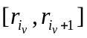 and 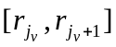. Then
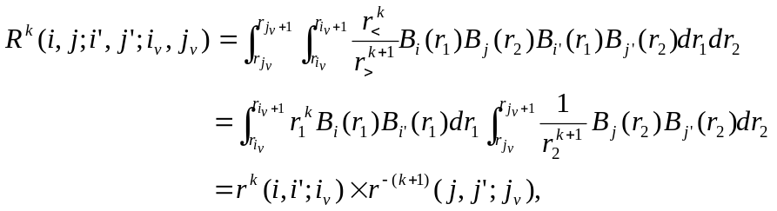 (12.41)
where
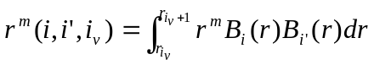. (12.42)
The r^{m}(i,i';i_{v}) quantities are called the integral moments. Although there are n_{v}(n_{v}-1) off-diagonal cells, we only need to calculate and store the n_{v} two-dimensional moment arrays r^{m}(i,i';i_{v}). Recall that each B-spline is a positive polynomial over a finite range. Hence, the moment integrals can be effectively evaluated using Gaussian quadrature with k_{s} Gaussian points. For a given order k_{s}, the spline B_{i} is nonzero only in the range from knot i to knot i+k_{s}, i.e., for a given cell i_{v}, the i and j indexes only run over the k_{s} values i_{v}, ..., i_{v}+k_{s}-1. Hence, the moment arrays r^{m}(i,i';i_{v}) have dimension (1:k_{s};1:k_{s},1:n_{v}). Furthermore, since r^{m}(i,i';i_{v}) is symmetric with respect to interchanging the indexes i,i', only r^{m}(i,i';i_{v}) with i ≤ i' needs to be evaluated. The evaluation can be further reduced by using their scaling properties in the logarithmic grid region. Suppose that the splines lie entirely within the exponential region. Let the left-most knot defining B_{i}(r) be t_{i} and let r = t_{i}+s. Then
B_{i}(t_{i}+s) = B_{i+1}((1+h)( t_{i}+s)) = B_{i+1}(( t_{i+1} + s(1+h)). (12.43)
Based on this displacement invariance, the following scaling law holds for the moment integrals:
r^{m}(i+1,i'+1;i_{v}+1) = (1+h)^{1+m} r^{m}(i,i';i_{v}). (12.44)
Expressions similar to (12.41) can also be written for the N^{k}, V^{k}, and T^{k} integrals:
(12.45)
where we introduced the moment integrals d^{m}(i,i',i_{v}) containing derivatives:
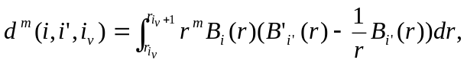 (12.46)

Integration over the diagonal cells

In the diagonal cells, the two coordinates in the integrand of the two-electron integrals are coupled. Moreover, the integrand is not continuous across the cell diagonal where r₁ = r₂. We therefore separate the rectangular cell into two triangles, so that the integrand inside each triangle is continuous. The integration over the rectangular cell is then a summation of integrations over the two triangles, which are symmetric with respect to index exchange
, (12.47)
where
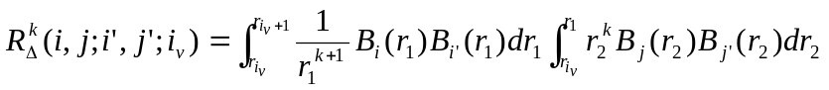. (12.48)
We use again Gaussian quadrature for the integration over the triangular cells. Here, however, we should generate new B-splines at the Gaussian points for the interval 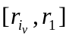. To minimize the number of new B-spline values needed to perform the two-dimensional integration, we apply the original Gaussian points used in the evaluation of the one-dimensional integrals to the integration with respect to the coordinate r₁ (i.e., the first integral in (12.48)). In the integration over the coordinate r₂, we also use the k_{s} Gaussian points for each interval , dynamically calculating the required B-spline values. With this two-dimensional grid, the difficulty of the cell integrals near the origin due to the singularity of the integrand is minimized and uniformly accurate results for all Slater integrals can be obtained. The full storage of the 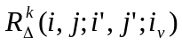integrals takes n_{v}×k_{s}⁴ locations ignoring the symmetry over the indexes. The computational time for these integrals can also be reduced by using the scaling law in the logarithmic grid region [64]:
(12.49)

For the N^{k} integrals we have
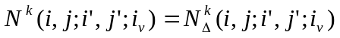,
where
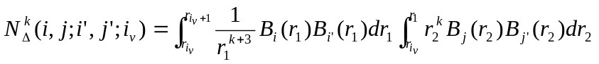.
Then for the T^{k} integrals:
,
where
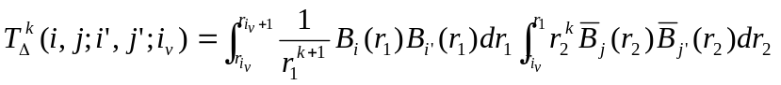,
and, finally, the V^{k} integrals:
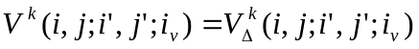,
where
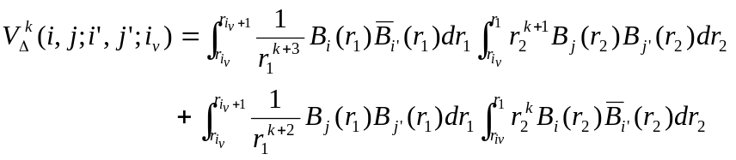.
For all relativistic integrals, the scaling law in the exponential region is the same, but it differs from that for the R^{k} case:
(12.50)
Now one can obtain the B-spline representation for any integral by summing the corresponding cell integrals over the relevant cells.

Direct summation of cell integrals

Consider the cell (i_{v},j_{v}). Its contribution to the total R^{k} (a,b;c,d) integral is
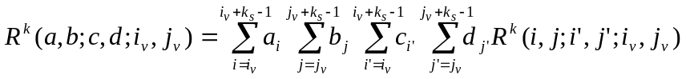 (2.51)
Using the formula for the cell integrals, we obtain
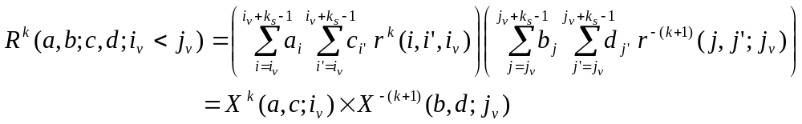
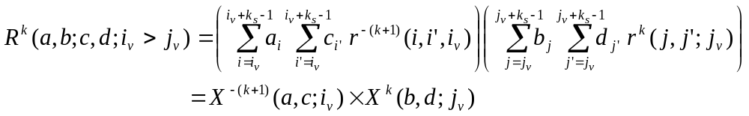
where
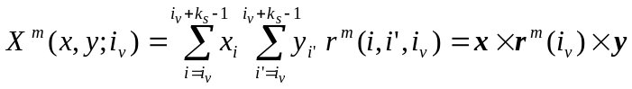 (12.52)
Hence, the off-diagonal cell integrals for the atomic orbitals can also be represented as a product of two quantities, which depend only on the cell index. Introducing the four vectors
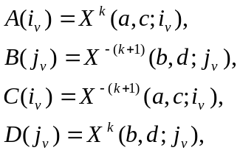 (12.53)
the cell representation of the total R^{k} integral has the form

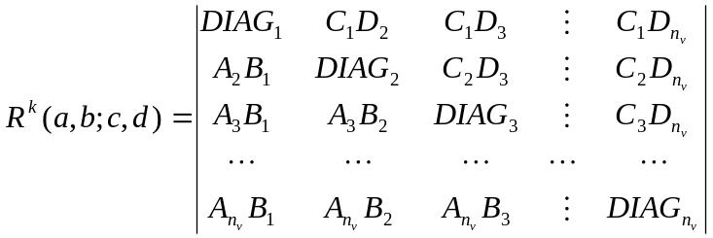 . (12.54)

Therefore, the R^{k} integral can be obtained by directly summing the above quantities, without the generation of the corresponding B-spline representation for the given integral, described in the previous sections. Such procedure is much more efficient.

List of routines

spline_moments | module, contains the off-diagonals moments and diagonal-cell integrals for a given type of integral
moments | evaluates the moments <B_{i}|r^{λ}|B_{j}> or <B_{i}|r^{λ}|B'_{j}> for a given power index
rk_moments | generates all off-diagonals moments and diagonal-cell integrals for the R^{k}-integral
nk_moments | generates all off-diagonals moments and diagonal-cell integrals for the N^{k}-integral
mk_moments | generates all off-diagonals moments and diagonal-cell integrals for the M^{k}-integral
tk_moments | generates all off-diagonals moments and diagonal-cell integrals for the T^{k}-integral
vk_moments | generates all off-diagonals moments and diagonal-cell integrals for the V^{k}-integral
mrk_cell | generates the B-spline representation of the R^{k}-integral using the cell-integration method
mnk_cell | generates the B-spline representation of the N^{k}-integral using the cell-integration method
mmk_cell | generates the B-spline representation of the M^{k}-integral using the cell-integration method
mtk_cell | generates the B-spline representation of the T^{k}-integral using the cell-integration method
mvk_cell | generates the B-spline representation of the V^{k}-integral using the cell-integration method
rkc | evaluates the R^{k} integral by direct assembling the moments
nkc | evaluates the N^{k} integral by direct assembling the moments
mkc | evaluates the M^{k} integral by direct assembling the moments
tkc | evaluates the T^{k} integral by direct assembling the moments
vkc | evaluates the V^{k} integral by direct assembling the moments

MODULE spline_moments

This module contains moments, and the two-electron integral over the diagonal cell, Eqn. (12.49). These moments are used for calculating the two-electron integrals according to the cell algorithm.
kmk | multipole index for the integral under consideration.
mtype | character (rk, nk, mk, tk, or vk), which indicates the type of integral.
rkd (1:k_{s}× k_{s},1: k_{s} × k_{s},1:n_{v}) | stores the two-electron integrals between individual B-splines over the diagonal cells.
rkd1 (1: k_{s},1: k_{s},1: n_{v})  rkd2 (1: k_{s},1: k_{s},1: n_{v})  rkd3 (1: k_{s},1: k_{s},1: n_{v})  rkd4 (1: k_{s},1: k_{s},1: n_{v}) | one-electron moments r^{m}(i,i';i_{v}) and d^{m}(i,i';i_{v}) as defined in Eqs. (12.44) and (12.46), which define the integration over the off-diagonal cells for a given type of integrals.
Internal routines
Allocate_monents | allocates space for arrays according to parameters from module spline_param.
Dealloc_moments | deallocates space in module spline_moments.

Calling sequences

rk_moments nk_moments
| |
---- ----
/ \\ / \\
moments rk_pdiag moments nk_pdiag
|| ||
rk_triang nk_triang
/ \ / \
gauss vbsplvb gauss vbsplvb

tk_moments vk_moments
| |
---- ----
/ \\ / \\
moments tk_pdiag moments vk_pdiag
|| ||
tk_triang vk_triang
/ \ / \
gauss vbsplvb gauss vbsplvb

Remarks

- All the above routines for the calculations of the moments have the same structure and only differ by their way of calculating the diagonal cell contributions with the triang-routines. The pdiag-routines control the scaling properties.
- The mrk_cell, mnk_cell, mmk_cell, mtk_cell and mvk_cell routines generate the B-spline representation for the given two-electron integral and place the corresponding information in the array rbk in the module spline_integral.
- The direct cell-integration routines rkc, nkc, mkc, tkc, and vkc use the direct summation of elements in (12.54). They are the most effective and accurate way to calculate individual atomic integrals. However, mrk_cell and similar routines should be used to generate the interaction matrices.

12.5. The library ZCONF

This library contains subroutines and functions that deal with the configuration and close-coupling expansions. They were designed to unify the representation of different expansions and are used in almost all programs of the BSR package. The main modules in ZCONF are configs, channels and target, with handle data related to the configuration expansion, the scattering channels, or the description of the target states, respectively. The description of the atomic states in the present package is based upon the configuration model, and the corresponding expansions for each state should be represented in the so-called c-files, which are used in the MCHF atomic structure package [52]. For completeness of the description, we recall below the main features of the c-files.
A general configuration consists of groups of equivalent electrons
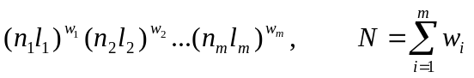 (12.55)
Each subshell is additionally characterized by its term α_{i}L_{i}S_{i}. The total orbital angular momentum and the total spin are obtained by coupling the momenta of all occupied subshells according to the given scheme, completely specified by the intermediate angular quantum numbers L’_{i}, S’_{i}. In this package, the coupling is from left to right, for which the notation
(12.56)
can be used. Here |L₁-L₂|≤L’₂≤|L₁+L₂|, |L₃-L’₂|≤L’₃≤|L₃+L’₂|, etc. Other coupling schemes may prove to be more advantageous in special circumstances. Therefore, each configuration state function, CSF, is defined by its configuration (12.55) and the coupling scheme (12.56). The c-file for a given atomic state contains the list of the CSFs involved, with the corresponding expansion coefficients as an option when the given c-file describes the specific atomic state. An example of a c-file is given in fig. 12.3. All orbital angular momenta in the c-file are given in spectroscopic notation. The configuration states are specified by first listing the subshells and their occupation in a linear form where, for example, 2p³ becomes 2p( 3), followed by a separate line with multiplicity (2S+1), the coupled orbital angular momentum (L), and the seniority, first for each subshell, and then for the resultant when coupling these subshells from left to right. For the latter, the seniority is no longer relevant. Notice that for the same configuration there are several possible CSFs, which differ by the intermediate angular quantum numbers. For fine-structure LSJ atomic states, the c-file may also contain CSFs with different total terms. The expansion coefficients are given at the end of the configuration line. The first line of the c-file is reserved for the title (optional) and the energy of the given state. In the present implementation, the user can also define the J-value (if relevant) by including the statement 2J = value at any position in the first line. The second line in the c-file contains the list of fully occupied, or closed, subshells common to all CSFs. This saves space and is also justified by the fact that the treatment of closed shells at the computation of matrix elements can be simplified by redefining the radial integrals for the outer electrons [68].

C 3P -37.7603504
1s
2s( 2) 2p( 2) 0.97657139
1S0 3P2 3P
2p( 4) -.13532612
3P2
2s( 1) 2p( 2) 3d( 1) 0.10709232
2S1 1D2 2D1 2D 3P
2s( 1) 2p( 2) 3d( 1) 0.06814467
2S1 3P2 2D1 4P 3P
2s( 1) 2p( 2) 3d( 1) -.06450278
2S1 3P2 2D1 2P 3P
2s( 1) 2p( 1) 3s( 1) 3p( 1) 0.05052374
2S1 2P1 2S1 2P1 3P 2P 3P
2s( 2) 3p( 2) -.03579417
1S0 3P2 3P
2s( 2) 3d( 2) 0.03468992
1S0 3P2 3P
2p( 2) 3d( 2) -.03455937
3P2 1S0 3P
2s( 1) 2p( 1) 3s( 1) 3p( 1) -.02901590
2S1 2P1 2S1 2P1 3P 2P 3P
2p( 2) 3s( 2) -.02546691
3P2 1S0 3P
*
Fig. 12.3. Structure of a c-file (representing the ground state of C as an example).

The spectroscopic notation adopted in the c-files is very convenient for the user, but it imposes several restrictions to the possible CSFs. First, the spectroscopic symbols for the angular momenta are restricted by the character map used in the computer. For values up to l=21 we adopt the usual alphabetical characters s, p, d, f, …, z, whereas for higher values (which can be important in scattering calculations), we use the symbols from the computer character map with indexes from 101 and higher. Note that the one-electron spectroscopic notation, in addition to the nl-values, may also contain the so-called ‘set index’, which indicates the non-orthogonal orbitals. For example, we can use the notation 3p1, 3p2, … for the term-dependent radial functions for the 3p orbital in the various 2p⁵3p LS states, or we can use different set indexes for orbitals obtained in independent calculations. The c-file provides only a four-character space for each orbital, and this imposes additional restrictions on the maximum value of possible principal quantum numbers and set indexes (for details, see the routines al, elf, new_index). However, in practical calculations these restrictions are usually not critical.
Note also that the c-file format was changed from its original presentation in the MCHF program [52,68]. Previously, it was assumed that there will be at most five subshells (filled or unfilled) outside the closed subshells common to all CSFs. This turned out to be a serious restriction, especially in scattering calculations, where we have an additional continuum orbital, i.e., an additional shell in the CSF. The format of the c-file was changed, so that we can now use CSFs with up to eight subshells outside the closed subshells.
In addition to the c-files, the present BSR package can also use the l- and j-files provided by the MCHF complex. The name.l file represents the list of solutions obtained in the frame of the configuration-interaction method on the basis of configurations in the file name.c. The name.j file corresponds to the list of solutions obtained in the frame of LSJ Breit-Pauli calculations.
Below we provide only the alphabetical list of modules and routines, with a brief description of the main points. The detailed description of the input/output parameters can be found at the beginning of the corresponding source codes.

Modules

configs | contains different information used for the description of the configuration expansions under consideration.
channel | defines the scattering channels for one partial wave.
channels | defines the scattering channels for all partial waves.
target | contains the description of the target states.

Routines

allocations | provides different array allocations in the modules.
decode_c | decodes the spectroscopic representation of the CFSs in the c-file to the ‘integer’ representation used by the programs.
det_exp | provides the determinant expansion for the given subshell.
gen_conf | generates all CFSs that can be built from a given configuration by adding the additional electron nl.
idef_jot | defines the total electronic angular momentum J for the configuration expansion in the given c-file.
idef_label | generate the list of labels for the CSFs in the given c-file.
idef_ncfg | defines the number of configuration in the given c-file.
idef_ne | defines the number of electrons for the CSFs in the given c-file.
idef_prt | defines the parity for the CSFs in the given c-file.
idef_st | defines the number of states in given l- or j-file.
idef_term | defines the total term LS for the configuration expansion in the given c-file.
incode_c | incodes the ‘integer’ configuration representation used by the programs into spectroscopic c-file format.
new_index | assigns a new set index for the orbital on the base of the given orthogonal conditions.
pre_iort | prepares the orthogonality conditions for the one-electron radial functions according to their set indexes and additionally imposed conditions.
pri_conf | prints the given configuration in spectroscopic format.
r_closd | reads the list of common closed shells from the given c-file.
r_confc | reads the configuration list from the given c-file.
r_expn | reads the expansion coefficients from the given c-file.
r_orbit | defines the list of one-electron orbitals in the given c-file.
r_target | reads the information about the target states and the close-coupling expansion from the file target.
r_term | defines the list of different terms in the given c-file.
sym_conf | defines the configuration and angular symmetries for the given CSF.
test_a | checks the "AFTER" relations between the orbitals in the given configuration.
test_c | checks the configurations (number of electrons, parity, couplings).

12.6. The library ZCOM

This library contains subroutines and functions that are part of the BSR package, but they also provide a variety of auxiliary computations common to different atomic-structure calculations. This includes, for example, the calculation of 3j-symbols or various sorting procedures. The routines in ZCOM do not use any COMMON or USE Fortran statements, and all input and output parameters are transferred through the formal arguments only. No call is made from the library to any routine outside the library, with the exception of interface subroutines used for calling the LAPACK routines.
Below we provide the alphabetical list of routines, with only a brief description of the main points. The input/output parameters and the method used by each routine are fully commented at the beginning of the corresponding source code. If a user needs to use some routine in other applications than a BSR calculation, or wants to replace it with a more effective procedure, we advise to first read the relevant source code for a detailed description of formal arguments.

al | provides the spectroscopic symbol (s, p, d, …) for an orbital angular momentum l.
clebsh | determines a Clebsch-Gordan coefficients via the corresponding 3j-symbol.
conv_au | provides the transformation factor from a.u. to cm⁻¹ or eV.
det | calculates the determinant value in the Gauss method.
dj_fact | defines the J-dependent factor for the reduced matrix elements of an electric multipole transition operator.
djm_fact | defines the J-dependent factor for the reduced matrix elements of a magnetic multipole transition operator.
el_nlk | decodes the spectroscopic notation for the electron orbital (n,l,k).
elf | provides the spectroscopic notation for the electron orbital (n,l,k).
f_gauss | gives the value of a given Gaussian at the point x.
gauss | looks up the values of the Gaussian coordinates and weights  for a k-point Gaussian quadrature over the interval [0, 1].
gen | provides the fractional parentage coefficients for p^{q}- and d^{q}-shells.
hwf | routines in this module provide hydrogenic bound radial functions and average values of r¹, r², r³, r⁻¹, r⁻², r⁻³ for a given nuclear charge Z.
iglq | total statistical weight of l^{q}-subshell.
interv | a reformatted version of the de Boor routine (de Boor 1978) with the same name.
inv | calculates the inverse matrix for the square input matrix A(n,n).
ipointer | determines the position of an element i in the input integer array, with output value 0 if that element is not a member of the set.
iterm | provides information about possible atomic shell terms.
itri | checks the triangular relations for three coupled angular momenta.
la | gives the value of the orbital momentum l for a given spectroscopic symbol.
lap_call | contains interface routines for calling the most ‘popular’ LAPACK procedures,  with the possibility of automatic allocation of work arrays if needed.
num | finds the integer representation for an arbitrary real number r, i.e., it finds such i₁ and i₂ that abs(r) = sqrt ( i₁ / i₂ ) and sign(r) = sign(i₁). It is used for the output of angular coefficients.
read_par | a set of routines for reading the parameter values, presented in the input file  as name = value.
read_arg | a set of routines for reading the input arguments presented in the command line  as name=value.
rttc | an interface program for timing routines. The user may choose the proper Fortran time routine that is most appropriate for a given computational platform.
t_ls_jk | provides the recoupling coefficients from LS- to jj-coupling.
t_ls_jk | provides the recoupling coefficients from LS- to jK-coupling.
xlagr | contains k points of a Lagrange interpolation procedure.
z_3j | calculates a 3j-symbol without directly using factorials.
z_6j | calculates a 6j-symbol without directly using factorials.
z_9j | calculates a 9j-symbol as a sum of 6j-symbols.
zcb | provides the square of a 3j-symbol with zero magnetic numbers, using a simplified algorithm.
zclkl | calculates the reduced matrix elements of spherical harmonics, <l||C^{k}||l’>, without directly using factorials.

