2. General theory

2.1. The close-coupling expansion

The problem of low-energy electron scattering on an N-electronic atomic target is reduced to solving the time-independent Schrödinger equation
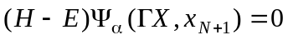 (2.1)
with appropriate boundary conditions. The collision wave function Ψ_{α}(ΓΧ,x_{N+1}) represents a fully antisymmetrized wave function of the system “target atom + projectile electron”, where Χ ≡ (x₁,x₂,...,x_{N}), x_{i} ≡ (r_{i},σ_{i}) with spatial (r_{i}) and spin (σ_{i}) coordinates of the ith electron, Γ is a complete set of quantum numbers of the (N+1)-electron system, and E is the total energy. The subscript α characterizes the initial conditions and usually denotes the incoming scattering channel.
The Hamiltonian Η_{Ν+1} which describes the scattering of an electron on an N-electron atomic target with the nuclear charge Ζ has the form
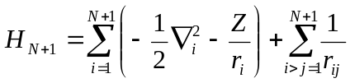, (2.2)
where r_{i,j} = |r_{i} - r_{j}|, r_{i} and r_{j} being the vector coordinates of electrons i and j. The origin of the coordinate frame is set at the target nucleus, which is assumed to have an infinite mass. For the time being we have neglected all relativistic effects. We introduce a set of target eigenstates, and possibly pseudostates Φ_{i}, and their corresponding eigenenergies E_{i} by the equation
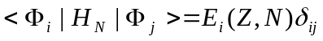 , (2.3)
where the integration is carried out over all the space and spin coordinates of the target electrons. Then the total energy is Ε = Ε_{i} + k_{i}²/2 , with Ε_{i} being the energy of the target in the state i while k_{i}²/2, represents the kinetic energy of the projectile electron. The target states Φ_{i} are expanded in terms of single-configuration basis states ϕ_{j} by
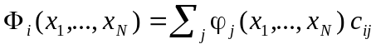, (2.4)
where the coefficients c_{ij} are determined by diagonalizing the target Hamiltonian. The basis configurations ϕ_{j} are constructed from a one-electron bound orbital basis, usually consisting of physical self-consistent field orbitals plus possibly additional pseudo-orbitals. The latter are included to represent correlation effects. Note that we do not assume the one-electron basis to be orthogonal, as usually imposed in the scattering calculations. This allows one to optimize the bound orbitals in independent calculations for each target state and use term-dependent one-electron radial functions.
The solution of (2.1) has to satisfy the boundary conditions of an incoming wave in some scattering channel α and outgoing waves in this and all other channels. In the close-coupling approximation, this solution is expanded in terms of a complete set of Ν-electron target wave functions Φ_{i}. The corresponding expansion coefficients play effectively the role of wave functions for the incident electron. In practice, one uses the
, (2.5)
where Â is the antisymmetrization operator with respect to the exchange of any pair of electrons while F_{iα}(r) is the radial component of the scattered electron wave function when the target is in the ith state. 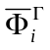is called a channel function, which is obtained by coupling the target state Φ_{i} with the spin-angle function of the scattered electron. Let us denote the quantum numbers of the scattered electron in channel i as 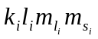. The Hamiltonian (2.2) is diagonal with respect to the total orbital momentum L, total spin S, their projections on to the chosen axis M_{L} and M_{S}, and the parity π of the total (N+1)-electron system. Therefore, in the expansion (2.5) it is convenient to use the total momentum representation in which
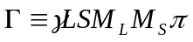 (2.6)
and channel functions 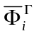 are defined according to the following coupling
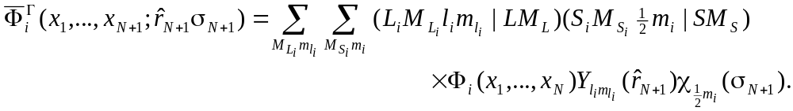 (2.7)
Here Y_{lm} is a spherical harmonic, χ(σ) is a spin function, and we use the standard notation for the Clebsch-Gordan coefficients. The function F_{iα}(x_{N+1}) of the incident electron describes both open and closed channels. Very often the F_{iα}(x_{N+1}) in (2.5) are called channel orbitals. If (E - E_{i}) is positive, the channel is said to be “open”; otherwise the channel is “closed”. Note, however, that the function F_{iα}(x_{N+1}) is not quadratically integrable for open channels. Closed-channel radial functions must satisfy the same boundary conditions at r = 0 and the same orthogonality conditions as the open channel functions, but the closed-channel functions are quadratically integrable.
The first term in expansion (2.5) should also include the integration over the continuous spectrum of the target, which corresponds to the virtual (or real) target excitation into the ionization continuum. A direct inclusion of this term in (2.5) would tremendously complicate the computational problem since the channel index becomes a continuous variable and the number of channels is not denumerable. Very often, therefore, this term is omitted. However, the continuum part of the close-coupling expansion was found to be very important at intermediate scattering energy. It can be simulated, to some extent, by the inclusion of bound pseudo-states.
The so-called correlation functions χ_{i} are quadratically integrable functions, usually constructed of the same one-electron orbitals as the target states Φ_{i}. The correlation functions ensure that the expansion (2.5) is complete in the bound orbital basis space even though the continuum radial functions are chosen to be orthogonal to the bound orbitals as discussed below. In the central field approximation, the atomic orbitals are represented in the form
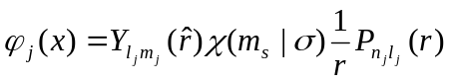 . (2.8)
Then it is usually demanded that for l_{j} = l_{i} the orthogonality condition
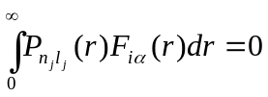 (2.9)
is satisfied. This condition does not follow from general principles and is introduced only for simplification of numerical calculations. The introduction of the correlation functions χ_{j}(x₁ ,...,x_{N+1}) means that in spite of implying conditions (2.9) the second sum in the expansion (2.5) permits us to take into account the possibility of the virtual capture of electrons in the unfilled subshell. The minimally necessary set of correlation functions χ_{j} in this case can be estimated as follows. The terms in the first sum in (2.5) can be schematically represented as Ck_{j}l_{j}, where C denotes some target state configuration. Then after imposing the orthogonality conditions (P_{nl}⏐F_{iα}) = 0 it is necessary to include the correlation function with the configuration Cnl, that could require recoupling of angular momenta in the case of equivalent electrons.
In the present implementation, the conditions (2.9) are optional. The use of non-orthogonal continuum orbitals allows us to avoid the introduction of the correlation functions χ_{j}(x₁,...,x_{N+1}), or to use them directly for additional inclusion of short range correlation. In this case they also can be generated independently from the target states.
Coupled equations for the radial components of the functions F_{i}(r) representing scattered electrons and the coefficients c_{j} can be obtained by substituting expansion (2.5) into the Schrödinger equation and projecting onto the target functions Φ_{i} and the L² functions χ_{i}. After separating out the spin and angular variables and eliminating the coefficients c_{j}, we obtain the following set of coupled integro-differential ("close-coupling") equations
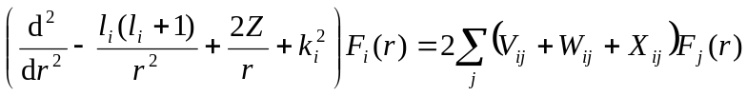 (2.10)
satisfied by the radial components F_{i}(r). In this equation, l_{i} is the orbital angular momentum of the scattered electron and V_{ij}, W_{ij} and X_{ij} are the partial wave decompositions of the local direct, non-local exchange and non-local correlation potentials. These potentials are too complicated to write down explicitly except for the simplest atoms. Instead they are constructed by general computer programs. The equations (2.10) also can contain terms which arise from the orthogonality constraints on the scattering radial functions F_{i}(r).
A set of different computational methods for solving equations (2.10) to yield the scattering matrices and amplitudes, which can be compared with experiment, has been developed over the past decades. These methods now form the basis for a number of computer program packages, some of which are widely used. As examples, we mention the linear algebraic equation method [36], the non-iterative integral equation method [37], and the convergent close-coupling method [38]. All these methods can be referred as straightforward methods where the solution of equation (2.10) is obtained in either configuration or momentum space for each collision energy. A promising new approach for the direct solution of the close-coupling equations (2.10), based on the B-spline basis and notable for its simplicity which is a key to a successful computational implementation, has been put forward by Froese Fischer and Idrees [39]. The method determines the required solution within a finite boundary, with no assumed boundary conditions. This is not a limitation, provided that the asymptotic region is reached, so that the solutions can be matched to a linear combination of true asymptotic solutions. The core of the algorithm involves evaluation of the Hamiltonian and overlap matrix elements in the B-spline basis,
(2.11)
and the extraction of the eigenvectors relative to the minimum modulus eigenvalues of the non-Hermitian, energy dependent matrix
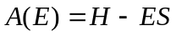 (2.12)
at each prefixed energy E. Here the very effective inverse iteration procedure is used. The B-spline approach has been further generalized to the single- and multichannel continuum case, mainly with application to photoionization of few-body system such as H, He, H⁻ and He⁻ [40,41,42].

2.2. The R-matrix method

The R-matrix method is one of many methods for solving the close-coupling equations (2.10). The important difference from the straightforward close-coupling formalism is a separate treatment of the two regions: an inner region, in which all the electrons are fully interacting with each other and possible external fields, and an outer region, in which the continuum electron only feels a local potential. Here the coupled equations (with simple long-range potentials) are solved for each collision energy and matched, at the boundary r = a, to the solution in the inner region. However, instead of solving a set of coupled integro-differential equations in the internal region for each collision energy, the (N+1)-electron wavefunction is expanded in terms of an energy-independent basis set and treated similarly to the N electrons in atomic bound states. Consequently, general computer codes written for bound-state atomic structure problems can be used, with only slight modifications, to generate the scattering algebra.
In the internal region, the (N+1)-electron wavefunction at energy E is expanded in terms of an energy-independent basis set, Ψ_{k} , as
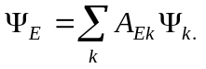 (2.13)

The basis states for given total angular momenta are constructed as
. (2.14)
The u_{i} in equation (2.14) are radial continuum basis functions describing the motion of the scattering electron. They are non-zero on the boundary of the internal region and thus provide the link between the solution in the internal and external regions. The quadratically integrable functions χ_{i} have the same meaning as in equation (2.5) and are assumed to be fully confined in the internal region.
Consider now the solution of the Schrödinger equation in the internal region [0,a]. We note that the Hamiltonian H_{N+1} is not Hermitian in this region due to the surface terms at r = a that arise from the kinetic energy operator. These surface terms can be cancelled by introducing the Bloch operator
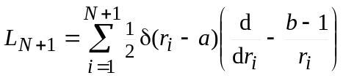 , (2.15)
where b is an arbitrary constant (in the present implementation we use b = 0). Note that H_{N+1} + L_{N+1} is Hermitian for functions satisfying arbitrary boundary conditions at r = a. We then rewrite the Schrödinger equation in the inner region as
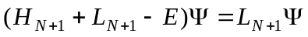 . (2.16)
This equation can be formally solved in terms of the R-matrix basis functions Ψ_{k}, which are obtained as eigenfunctions of the equation
, (2.17)
where the integration over the radial variables is restricted to the internal region. The formal solution of equation (2.17) can then be expanded as
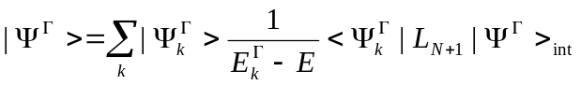 (2.18)
Projecting this equation onto the channel functions 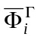and evaluating on the boundary of the internal region r_{N+1} = a yields
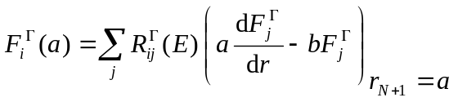 (2.19)
where we have introduced the R-matrix with elements
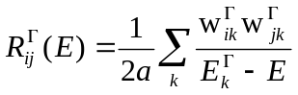 , (2.20)
the reduced radial wavefunctions
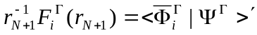, (2.21)
and the surface amplitudes
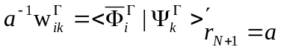. (2.22)
The primes on the brackets in equations (2.21) and (2.22) mean that the integration is carried out over all the electronic space- and spin-coordinates except for the radial coordinate r_{N+1} of the scattered electron. Equations (2.19) and (2.20) are the basic equations describing the scattering of electrons by atoms or ions in the internal region. Together with the following relations for coefficients A_{Ek} in equation (2.13)
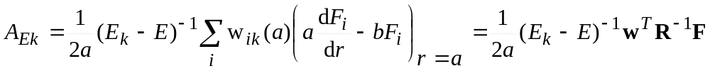 (2.23)
they allow us to establish the total wavefunction Ψ_{E} in the inner region for any value of the total energy E given the values of the scattering orbitals on the boundary. The R-matrix given by equation (2.20) is obtained at all energies by diagonalizing H_{N+1} + L_{N+1} once for each set of conserved quantum numbers Γ to determine the basis functions Ψ_{k} and the corresponding eigenenergies E_{k}. The logarithmic derivatives of the continuum radial wavefunctions F_{i}(r) on the boundary of the internal region are then given by equation (2.19).
An important point in the R-matrix method is the choice of the radial continuum basis functions u_{j} in equation (2.14). Although members of any complete set of functions satisfying arbitrary boundary conditions can be used, a careful choice will speed up the convergence of the expansion (2.13). In the standard R-matrix approach developed by the Belfast group [4] numerical basis functions satisfying homogeneous boundary conditions at r = a were adopted. This approach gives accurate results provided that corrections proposed by Buttle [16], to allow for the omitted high-lying poles in the R-matrix expansion, are included. The shortcoming of this approach is that all basis functions have the same (usually, zero) logarithmic derivative at the boundary of the internal region. This yields a discontinuity in the slope of the resulting continuum orbitals. In the standard approach, the basis functions u_{i} are constructed to be orthogonal to the bound orbitals P_{nl} used for construction of the target wavefunctions. To compensate for the resulting restrictions on the total wavefunctions, the basis states Ψ_{k} must contain the correlation functions χ_{i} as in equation (2.14). In the case of complex atoms, when extensive many-configuration expansions are used for accurate representations of the target state wave functions, this may lead to a very large number of the correlation functions χ_{i} which must be included in the close-coupling expansion to compensate for the orthogonality constraints. The present program has the option to imply a fully non-orthogonal set of basis functions u_{j} in equation (2.14). It allows us to use the close-coupling expansions (2.14) without any correlation functions at all. Nevertheless, in practical calculations some restricted orthogonality constraints are usually imposed on the basis functions u_{j}, depending on the physical model under consideration.
The other key point of the present approach is the use of the B-splines instead of the one-electron basis functions u_{i}(r) in the R-matrix representation (2.14) of the inner region. The full description of B-splines is given in section 12. The B-splines possess properties as though they were especially created for the R-matrix theory. They form a complete basis on the finite interval [0,R], have a universal nature, and are very convenient in numerical calculations because they allow us to avoid finite-difference formulae. Here we have to distinguish between using B-splines as another basis for representation of the one-electron orbitals and using B-splines for generating the complete pseudo-spectrum for some one-electron Hamiltonian as is done in many atomic structure calculations [26]. The present program provides both options. In the first case, the coefficients a_{ijk} are found from the diagonalization (2.17) of the full Hamiltonian in the B-spline representation. Such an approach is more suited for bound-state calculations. In the second case, we first perform a preliminary diagonalization of the Hamiltonian blocks corresponding to one channel. This generates a complete set of one-electron orbitals for each channel. We can transform the Hamiltonian matrix to the new representation based on these one-electron orbitals, and now we are able to reduce the dimension of the full interaction matrix by dropping some of the basis orbitals, depending on the problem under consideration.
The boundary conditions in the B-spline basis define only the first and the last basis functions, which are the only non-zero terms, respectively, for r = 0 and r = r_{max}. The boundary conditions for the scattering function at the origin are satisfied in the form F(0) = 0 by simply removing the first B-spline from the basis set. For the definition of the R-matrix at the boundary (2.20), the amplitudes of the wavefunctions at r = r_{max} , w_{ki}, are required. These values are defined by the coefficients of the last spline, which is equal to one at the boundary. The summation over the entire expansion (2.13) now gives the surface amplitudes in a straightforward manner. The details for using B-splines in the construction and diagonalization of the interaction matrix (2.17) are given in sections 7 and 8, respectively, along with a description of the corresponding programs.

2.3. The external region

The next step in the calculation is to solve the scattering problem in the external region and to match the solutions on the boundary r = a in order to obtain the K-matrices, S-matrices, or phase shifts. Since the radius a is chosen such that electron exchange is negligible in this region, we can expand the total wavefunction in the form
(2.24)
where the are the same set of channel functions as those retained in expansion (2.5) and the F_{i}(r) are the analytic continuations for r > a of the reduced radial wavefunctions defined by equations (2.21). The radial functions F_{i}(r) satisfy the set of coupled differential equations
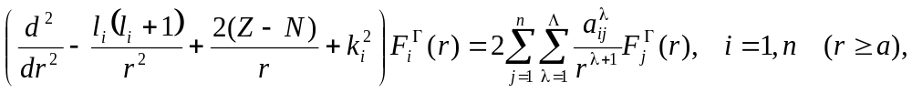 (2.25)
where n is the number of channel functions retained in expansions (2.5) and (2.24) while l_{i} and k_{i}² are the channel angular momenta and energies. The interaction between channels is defined by the long-range potential with coefficients
, (2.26)
where 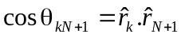, P_{λ}(x) is a Legendre polynomial. The integral in equation (2.26) is carried out over all electronic space and spin coordinates except for the radial coordinate of the scattered electron. In practical calculations, the long-range potential coefficients are the by-product of generating the interacting matrix (2.17) and defined by the coefficients of the relevant Slater integrals R^{k}, describing the direct interaction between channels in the internal region. Note that 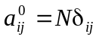 because of the orthogonality of the target wavefunctions Φ_{i}. This relation is used to check the target representation in the present program.
Equations (2.25) can be integrated outwards from r=a and fitted to an asymptotic expansion at large r as described by [28]. If all n scattering channels are open, the asymptotic form of the radial wavefunctions F_{i}(r) may be written in the form
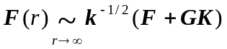, (2.27)
where we have written the channel momenta, k, as a diagonal matrix. The diagonal matrices F and G correspond to regular and irregular Coulomb (or Riccatti-Bessel) functions in each scattering channel. The asymptotic expression (2.27) defines the scattering K-matrix, K, appropriate for standing-wave boundary conditions. The K-matrix is related to the scattering S-matrix by the equation
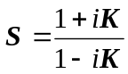 . (2.28)
It may be used directly to calculate cross sections and other scattering observables.
The long-range coefficients α_{ij} together with the target energies and the definition of the structure of the close-coupling equations constitute the information needed to solve the scattering problem in the external region. This problem is well developed, and there is a set of general computer codes for its solution. An efficient code is the outer region program FARM [28], which uses the R-matrix propogator technique. In the present implementation, we use the program ASYPCK [43] for treating the external region. Note that, in addition to the K-matrix, we also need the outer region solutions at the boundary r = a for the calculation of photoionization cross sections.

2.4. Radiative processes

In R-matrix theory, the photoionization cross-sections can be defined through the dipole matrix between the initial state Φ₀ and the R-matrix basis states Ψ_{k}, provided that all radial orbitals of the initial state are well confined to the inner region. The total photoionization cross section for a given photon energy ω is
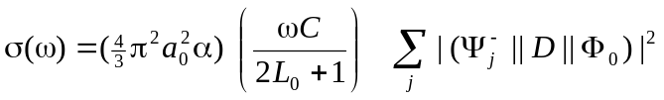 (2.29)
where D is a dipole operator. It could be either in the length or the velocity form, with C = 1 in the length form, and C = 4/ω² in the velocity form, and the photon energy being in Ry. The index j runs over different possible solutions, and the other quantities have their usual meaning. The solutions Ψ_{j}⁻ in (2.29) correspond to asymptotic conditions with a plane wave in the direction of the ejected electron momentum k and ingoing waves in all open channels. The corresponding radial functions F ⁻ are related to the F(r) with the K-matrix asymptotic form (2.27) via
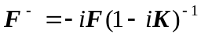. (2.30)
Expanding Ψ_{j}⁻ in terms of the R-matrix states as in equation (2.13) and using the expressions (2.23), we find that
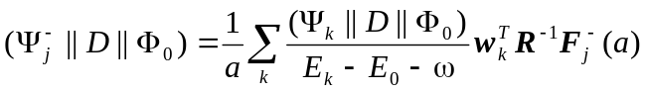 (2.31)
where (Ψ_{k}||D||Φ₀) are reduced matrix elements between the initial state and the R-matrix basis functions.
In addition to the total cross section, another important quantity is an anisotropy parameter β, which defines the angular distribution of photoelectrons. For example, for linearly polarized incident radiation the angular distribution of photoelectrons is given by
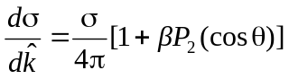 ,
where θ is the angle of the ejected electron relative to the axis of polarization, while for unpolarized radiation it takes the form
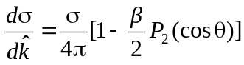 ,
where θ is the angle of the ejected electron relative to the incident radiation beam. β is determined from [2]:
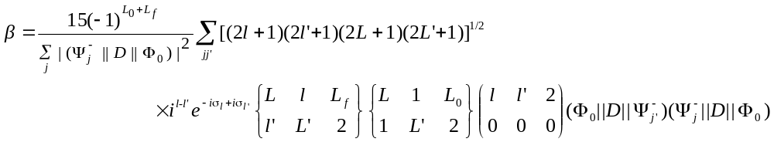
where L_{o} and L_{f} are the angular momenta of the initial atomic state and final target states, respectively, and indexes j and j' stand for continuum channels, associated with the given target state. σ_{l} stands for Coulomb phase, see (2.34). Here and below the standard notation for the n-j symbols are used.
In order to use the expression (2.31), we need the values of the solutions F_{i}(a) at the R-matrix boundary. They can be obtained by matching the general asymptotic solutions of equation (2.25) to the solutions in the internal region at r = a. This can be done with relation (2.19), which in matrix form reads
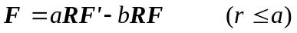 (2.32)
Note that in the outer region we have n_{o} independent physical solutions, where n_{o} is the number of open channels, which is defined by all the target states accessible at a given excitation energy. To relate the n × n dimensional R-matrix to the n_{o} × n_{o} K-matrix defined in Eq. (2.27), we introduce n + n_{o} linearly independent solutions s_{ij}(r) and c_{ij}(r) of Eq. (2.25) satisfying the boundary conditions
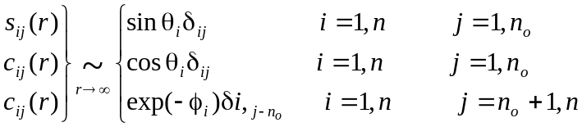 (2.33)
where θ_{i} and φ_{i} define the asymptotic phases in the open and closed channels, respectively:
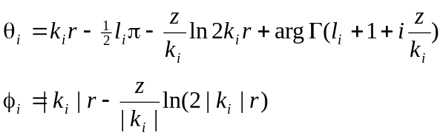 (2.34)
Now we can rewrite the asymptotic form of scattering wavefunction in a general form
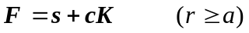. (2.35)
Substituting this into Eq. (2.22) and solving for K, we get
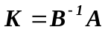 (2.36)
where
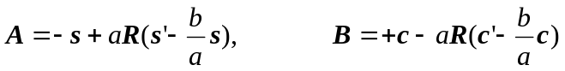. (2.37)
This completes the evaluation of the reactance matrix K and the value F(a), provided that the asymptotic solutions s_{ij}(r) and c_{ij}(r) are known. As mentioned above, a number of computer packages are available for obtaining these solutions, such as the program ASYPCK [43], which we use in the present package.
The initial state Φ₀ in the present program can be obtained either in an independent MCHF calculation, or in the framework of B-spline bound-states calculations discussed in the next section. In general, it requires the evaluation of dipole matrix elements between states with non-orthogonal orbitals. Details of the calculation of dipole matrix elements in this case are presented in sections 9 and 10.

2.5. Bound-state calculations

Electron-atom collision theory is concerned with states of an (N+1)-electron system for which N electrons are bound in an atom or atomic ion and one electron can escape to infinity. Such states may be represented accurately using the close-coupling expansion (2.5). This expansion is obviously also suitable for representing states with one electron highly excited and the other N electrons more tightly bound. When the close-coupling approximation is used to calculate bound states of atomic systems, it is referred to as the frozen-core (FCS) approximation, and the Φ_{i} are usually labelled 'core' rather than 'target' functions.
The FCS method has several advantages. It can readily be extended to highly excited states. The multichannel form of Eq. (2.5) allows us to include explicitly the interaction between different Rydberg series, as well as the interaction of the Rydberg series with perturbers that can be represented in the second part of the expansion. The energies and wavefunctions can be computed efficiently with an accuracy comparable to that obtainable using the best alternative methods, from which large amount of radiative data can be generated. The same expansions can be used for close-coupling collision calculations as for FCS bound-state calculations. Often a comparison of the calculated bound-state energies with experimental energies provides a check on the accuracy of the collision calculations. At the same time, one can take advantage of the extensive experience accumulated from close-coupling collision calculations and the codes developed for such calculations, and one can apply them to the study of Rydberg series. The first extensive FSC calculations for many-electron systems were made using the computer program IMPACT [36] that solved the resulting integro-differential equations (see, for example, [44,45,46]). Further developments of the FCS method for the study of Rydberg series were obtained in connection with the R-matrix method [47]. A good example of such a calculation is given by Berrington and Seaton [48] .
The accuracy of both the above-mentioned methods is restricted through the use of finite-difference methods for computing the radial functions. More accurate numerical results can be obtained by using a spline FCS method for Rydberg series, in which the wavefunctions of the outer electrons are expanded directly in B-splines in some finite region r ≤ a, with a sufficiently large value of a. Such a method is implemented in the present package. The zero boundary conditions are imposed by deleting from the expansion the first and the last splines, i.e., the only splines with a nonzero value at the boundary. We also delete the next to last spline, in order to guarantee a zero derivative at the boarder for all bound solutions.
The choice of B-splines as basis functions has some advantages. The completeness of the B-spline basis ensures that, in principle, we can study the entire Rydberg series. The number of physical states we can obtain in one diagonalization is defined by the box radius a, which can easily be varied in the B-spline representation. The exponential grid was found to be quite suitable for bound states, and it allows us to use a rather large radius with a relatively small number of B-splines. For example, in order to obtain Rydberg states up to n=10 in neutral atoms, it is often sufficient to choose the box radius equal to 300 au and the number of splines as 45. If we aim to study Rydberg series up to n=20, we should increase the border radius to 1200 au. With an exponential grid, this increases the number of splines only to 51. Hence, the size of the interaction matrix, which is proportional to the number of splines, does not increase considerably. Of course, these numbers somewhat depend on the nuclear charge Z. For very high Z, it is advisable to add a few splines at very small radii to achieve an accurate representation of the orbitals near the nucleus.
The wavefunctions in this method are obtained for all radii and for all Rydberg states under consideration. There is no need to obtain an asymptotic solution and to match it to the inner-region solution as in the R-matrix method discussed above. This considerably simplifies the calculations and the codes, but the use of a finite B-spline basis limits the upper n-value for the Rydberg states. Consequently, this method can be efficient for the study of moderately excited states with values of n not too large, typically in the range 10-30.
Our implementation of the spline method differs from a previous one [6] through the use of non-orthogonal orbitals, both for the construction of target wavefunctions and for the representation of the outer electron. It provides us with a great deal of flexibility in the choice of the ‘target’ wavefunctions, which can be optimized for each atomic state separately, and in the introduction of different correlation corrections. In the present program, the core-core correlation may be taken into account by using extensive multi-configuration target states. The core-valence correlation can be introduced, in principle, in two ways, either by using a large set of excited target states in the close-coupling expansion or by introducing additional (N+1)-electron states, specially designed for this purpose. The convergence of the close-coupling expansion can be very slow, and hence the first approach is much more time consuming. Nevertheless, our experience shows that this method gives a more accurate description of the core-polarization potential, and the (N+1)-electron terms in Eq. (2.5) are better used only for the inclusion of the short-range correlation.
Another difference compared to earlier implementations of B-splines concerns the relativistic corrections. Usually (see, e.g., [49,50]) relativistic corrections are introduced via the Breit-Pauli CI approach after having calculated nonrelativistic wavefunctions using the B-spline expansions for the relevant states. We include the Breit-Pauli operators directly into the secular equations (2.17). Hence, our B-spline expansions for Rydberg electrons include both the relativistic and correlation corrections.

2.6. Relativistic corrections

With increasing nuclear charge Z, relativistic effects become important both in the target description and the scattering wavefunctions, even for low energy electron scattering. In the current code, relativistic corrections can be included through the Breit-Pauli Hamiltonian.
The Breit-Pauli Hamiltonian [51] can be considered as a first-order correction to the non-relativistic atomic Hamiltonian. It includes all relativistic terms up to order (αZ)², where α is the fine-structure constant. According to their different angular symmetry and different influence on the atomic structure, we recognize three parts of the Breit-Pauli Hamiltonian, namely
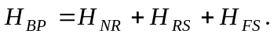 (2.38)
Here H_{NR} is the ordinary non-relativistic many-electron Hamiltonian
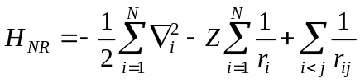 . (2.39)
The relativistic shift operator H_{RS} commutes with L and S and can be written as
(2.40)
where H_{MC} is the mass correction term
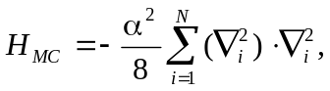 (2.41)
while H_{D1} and H_{D2} are the one-body and two-body Darwin terms, i.e., the relativistic correction to the potential energy,
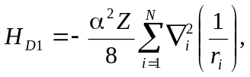 (2.42)
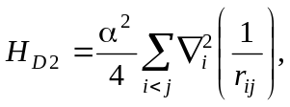 (2.43)
Next, H_{SSC} is the spin-spin contact term
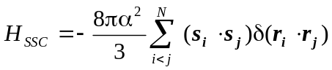 (2.44)
and, finally, H_{OO} is the orbit-orbit term
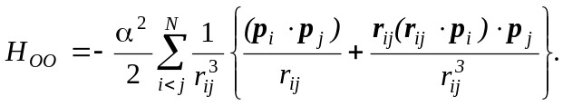 (2.45)
The fine-structure operator H_{FS} describes interactions between the spin and the orbital angular momenta of the electrons. It does not commute with L and S but only with the total electronic angular momentum J = L + S. The fine-structure operator consists of three terms,
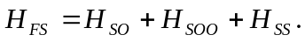 (2.46)
Here H_{SO} is the nuclear spin-orbit term
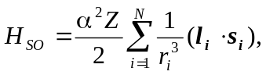 (2.47)
H_{SOO} is the spin-other-orbit term
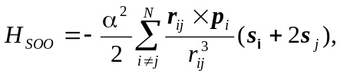 (2.48)
and H_{SS} is the spin-spin term
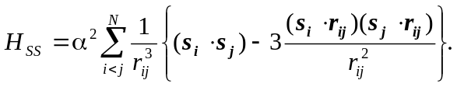 (2.49)
The present code has the option of directly including all the Breit-Pauli terms in the interaction matrix. For most applications, however, it is sufficient to only include the one-electron terms and the two-electron spin-other-orbit interaction. In contrast to the Belfast R-matrix code, the present code does not use recoupling to include the relativistic terms. Hence, storage and time problems associated with a possibly very large number of non-relativistic Hamiltonian matrices to be calculated first can be avoided. An exception is made for the mass correction term (2.42). Direct inclusion of this term in the interaction matrix often leads to non-physical R-matrix poles with very low energies. For this reason, the program has the option to include this term as a first-order perturbation, as described further in section 8.
The non-fine structure interactions commute with S², S_{z}, L² and L_{z} and can therefore be considered in the |βLS M_{L} M_{S}⟩ representation. The fine structure interaction only commutes with S², L², J² and J_{z}, where J and J_{z} are the total electronic angular momentum and its projection on the quantization axis, respectively. Here we must use the |γLS J M_{J}⟩ representation for the total configuration state functions
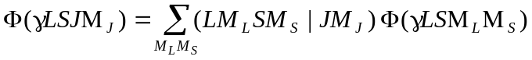. (2.50)
When we include the fine-structure interactions, we must define the pair-coupling scheme in the close-coupling expansion (2.5). The present program has three options for the definition of the pair-coupling scheme. The first option is LSJ coupling. It is applied only in the bound-state calculations as
. (2.51)
Here L_{i} and S_{i} define the target term while l and ½ are the orbital angular momentum and the spin of the valence electron. This scheme allows us to use simpler LS expansions for the target states and also reduces the number of channels (Rydberg series) in the FCS expansion.
The most popular scheme for scattering calculations is the jK pair coupling
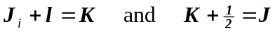, (2.52)
where J_{i} is the total electronic angular momentum of the target state. The target expansions should now be specified for each fine-structure level. The corresponding Hamiltonian matrix (2.17) then becomes much larger. This results in more coupled channels in the close-coupling expansion (2.5), therefore requiring a considerable increase in the computational effort.
The last coupling option is the jj pair coupling scheme
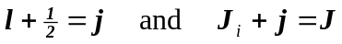, (2.53)
which can be useful in case of a strong spin-orbit interaction.

