10. Program BSR_DMAT

The BSR_DMAT program prepares the dipole matrix, d.nnn, for subsequent use in the BSR_PHOT program for photoionization calculations, or performs the calculations of oscillator strengths between B-spline bound-state solutions. For completeness, BSR_DMAT also has the option to calculate oscillator strengths between MCHF solutions, and between B-spline bound states and MCHF solutions.

10.1.Dipole transition matrix

For photoionization calculations we need the D-files, which contain the dipole matrix elements between the initial state and the R-matrix solutions for a given partial wave. It is convenient to represent the dipole matrix elements by using the dipole transition matrix, which consists from the dipole matrix elements between the basis states. Suppose we have two sets of solutions of the Hamiltonian matrix in different bases. In our case, it can be either the configuration basis from the MCHF calculations, or a close-coupling B-spline expansion (7.2) from a BSR calculation. Then the matrix element for the given solutions a and b is
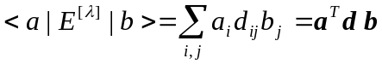, (10.1)
where {a_{i}} and {b_{i}} are the corresponding expansion coefficients in the respective bases. Once we generate the dipole transition matrix d , the matrix elements for any other solutions is simply defined by convoluting d with the corresponding expansion vectors. The logical structure of BSR_DMAT is such that it first generates the relevant dipole transition matrix, and then, if indicated, calculates the corresponding set of oscillator strengths. This enables us to use the same code for photoionization and bound-state calculations.
Consider the structure of the transition matrix in the B-spline representation. This structure is very similar to the structure of the Hamiltonian matrix considered in the write-up of the BSR_MAT program in Section 7. In the present close-coupling approach, the B-spline bound-state solution vector, c, can be written as
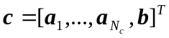 (10.2)
where each a_{i} is a column vector of B-spline coefficients for the given channel functions 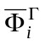
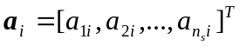 (10.3)
and b is the column vector of correlation functions coefficients
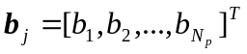, (10.4)
where N_{c} is the number of channels while N_{p} is the number of correlation functions. Then the transition matrix d has the form
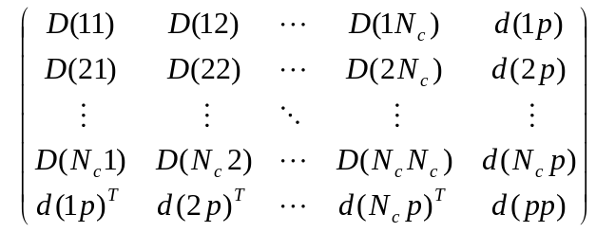 (10.5)
where d(pp) is an N_{p}×N_{p} matrix that comes from the bound-bound interaction, the d(ip) are the n_{s}×N_{p} matrices, representing the interaction between the i-th channel and the bound states, and the D(ij) are the n_{s}×n_{s} matrices for the channel-channel interaction. When we work with MCHF solutions, the transition matrix is reduced to the single last row, if the initial state is given in the MCHF representation, or simply to the d(pp) matrix, if both solutions are MCHF configuration expansions.
Each individual matrix element in (10.5) is expressed by the program MULT in the form
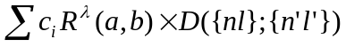 (10.6)
where the c_{i} are numeric coefficients that only depend on the angular symmetry of the CSFs involved, R^{λ} stands for the corresponding one-electron dipole integrals (9.17), and D({nl},{n'l'}) is the overlap factor which depends only on the orthogonality of the radial orbitals used in the construction of the basis CSFs. In general, the overlap factor is the multiplier of determinants of matrices consisting of one-electron overlaps between radial functions in the initial and final states (see eq. 7.8).
The B-spline orbitals can appear in the radial integrals R^{λ}, as well as in the determinant factors. To derive the final expression for the matrix elements in the B-spline basis, let us first simplify the overlap factors (7.8) by expanding them over those rows which contain one-electron overlaps with the B-spline orbitals. At most, there can be two such rows. The residual overlap determinants depend only on the known bound orbitals and they can be calculated in a standard manner. It is convenient to redefine the angular coefficients c_{i} by multiplying them by these residual overlap factors. As a result, the initial overlap factor D({nl},{n'l'}) in expression (10.6) is reduced to one-electron or two-electron overlaps of the form
, (10.7)
where |kl> stands for the radial function of the B-spline orbital
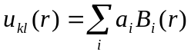 . (10.8)
Each term in (10.6) gives rise to some matrix in the spline basis. To elucidate the structure of these matrices, we introduce the following n_{s}×n_{s} matrices with elements
(10.9)
To describe the channel-bound interaction, we introduce the following vectors with elements
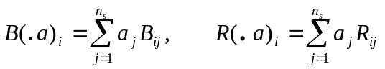, (10.10)
Finally, for bound-bound interaction we have
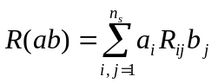. (10.11)
With this notation, table 10.1 represents the contributions of the different terms from the matrix element expression (10.6), which usually produces the angular integration codes, to the transition matrix (10.5), along with an indication of its structure.

Table 10.1. Contribution of different terms (without indication of angular coefficients) in the transition matrix. The symbols a,b stand for the bound orbitals, while the symbol k_{i} indicates the B-spline orbital in channel i.

Term | Contribution | Remarks
Channel-channel interaction
R(k_{i}, k_{j}) | R( • •) | banded matrix
⟨ k_{i}| a⟩ ⟨b | k_{j}⟩ R^{λ} | B( • a) •B( • b) * R^{λ} (or L) | Full matrix,  contribution due to non-orthogonality
⟨ k_{i}| k_{j}⟩ R^{λ} | B( • •) * R^{λ} | Banded matrix,
R^{λ}(k_{i},a) ⟨b | k_{j}⟩ | L( • a ) •B( • b) | full matrix,  contribution due to non-orthogonality
Channel-bound interaction
R^{λ} (k_{i},a) | R^{λ}( • a ) | vector
⟨ k_{i} | a⟩ R^{λ} | B( • a ) * R^{λ} | vector,  contribution due to non-orthogonality
Bound-bound interaction
R^{λ}( a, b) |  | scalar

10.2. Oscillator strengths and decay probabilities

For completeness of the description, we provide below the main formulae used in the present code for the calculation of radiative properties. The line strength for a given transition is defined as
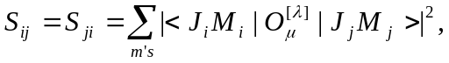 (10.12)
It is given in atomic units, which are 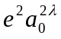 and 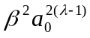 for electric and magnetic transitions, respectively. Here β=eħ/2mc is the Bohr magneton. The transition probability can be written as:
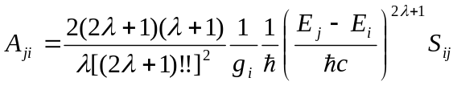. (10.13)
The oscillator strength (unitless) is related to the transition probability by
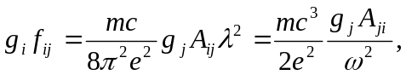 (10.14)
independent of the nature of the radiative transition.

10.3. Structure and data flow

The block diagram of the program BSR_DMAT, along with the data flow, is given in Fig. 10.1. Since BSR_DMAT requires only a small number of input parameters, all of them must be defined in the command line as arguments. The input parameters for the BSR_DMAT program are the names of the c-files with a list of configuration state functions for the initial and final states involved, and the mode of calculation ctype (see Section 10.4.) The input c-files may be the ordinary c-files from MCHF calculations, or cfg.nnn files generated in BSR calculations. The mode of calculation defines whether this is the generation of the transition matrix for subsequent photoionization calculations or the calculation of oscillator strengths between bound states. The ctype parameter also defines the representation format for the initial and final states, which can be in the LS or LSJ coupling schemes. BSR_DMAT reads a set of other input data files. All of them have default names, or names which are directly connected to the names of the input c-files.
First, the program defines the set of LS terms and one-electron orbitals under consideration (routines read_term and read_orbit). The orbitals in the initial and final sets are supposed to be non-orthogonal. Then the program reads the one-electron radial functions in the B-spline representation (routine read_bsw). They can be either the user-prepared name1.bsw files, or the bound.nnn files generated by the BSR_HD program. In the latter case, the program also reads the target file with a description of the relevant close-coupling expansions. Finally, the program generates all the B-spline arrays needed in the routine define-spline. Note that all arrays involved are automatically allocated in accordance with the input data.
In the next step, routine check_bnk, the program analyses the information contained in the databank mult_bnk, and determines whether the data bank contains all angular coefficients needed for the given case. If not, the program stops, suggesting to rerun MULT program. Note that the multipole index and the type of transition under consideration are defined in mult_bnk.
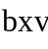
BSR_DMAT
check_bnk
read arguments from command line
d_out
mult_bnk
read_term

read_bsw
dmatrix
gen_matrix
D_matr - calculation of the transition matrix
read_coef
quadr
read_dets
cmdata
LS_case or J_case
read_orbit
name1.c, name2.c; or cfg.nnn
name1.c, name2.c; or cfg.nnn
name1.bsw, name2.bsw; or bound.nnn
read_target
target
define_spline
knot.dat
d.nnn
zf_res
check_det
add_coef
mult_bnk
add_coef
merge_cdata
d_data
mult_bnk
rdol.nnn
Fig. 10.1. Block diagram for the program BSR_DMAT and data flow (see text).

The routine D_matr controls the calculation of the transition matrix. First, the routine reads all overlap factors D({nl},{n'l'}) from data bank in routine read_dets before calculating all necessary R^{λ} integrals in routine quadr. All relevant B-spline matrices presented in table 10.1 are then generated by the routine bxv from B-spline library. The list of specific integrals (10.6) for the configurations under consideration is generated dynamically from the information in mult_bnk. The overlap factor D({nl},{n'l'}) in expression (10.6) is reduced to one-electron or two-electron overlaps of the form (10.8) by the routine check_det. The integrals are then sorted according to their structure (see table 10.1) and stored in the module cmdata in different ordered blocks (routines add_coef and add_cdata). When all coefficients from mult_bnk are exhausted, or when all blocks are full, they are merged if necessary with the routine merge_cdata before being processed by gen_matrix to get the B-spline representation for specific integrals (routine d_data). The corresponding contributions are then added to the interaction matrix, located in module dmatrix.
The next step of the calculation depends on the input mode. In photoionization calculations, the dipole matrix (10.1) is calculated on the base of the R-matrix solutions placed in the file rsol.nnn, and then is recorded in the file d.nnn. For calculations of oscillator strengths, however, the program calls the routine LS_case, or J_case for processing transitions between LSJ states. The resulting line strengths, oscillator strengths, transition energies, and transition probabilities are recorded in the file zf_res (see section 10.6 below).

10.4. Data files

name1.c or cfg.nnn | File type: formatted sequential input.  Created by MCHF or BSR_CONF programs.  Read by routine check_bnk.  Description: contains the configuration expansion for the initial state.
name2.c or cfg.nnn | File type: formatted sequential input.  Created by MCHF or BSR_CONF programs.  Read by routine check_bnk.  Description: contains the configuration expansion for the final state.
mult_bnk | File type: unformatted sequential input.  Written by program MULT.  Read by routine check_bnk.  Description: databank for the angular coefficients of the dipole operator.
bound.nnn | File type: formatted sequential input.  Created by program BSR_HD.  Read by BSR_DMAT program.  Description: bound-state solutions for a given partial wave in the B-spline representation (10.2).
target | File type: formatted sequential input.  Written by user and modified by BSR_PREP and BSR_CONF programs.  Read by routine read_target.  Description: contains description of the target states and scattering channels.
knot.dat | File type: formatted sequential input.  Written by user.  Read by routine define_grid from BSPLINE library.  Description: input parameters that define the B-spline grid.
target.bsw | File type: unformatted sequential input.  Created by program bsr_prep.  Read by routine read_bsw.  Description: target one-electron orbitals in the B-spline basis.
pert_nnn.bsw | File type: unformatted sequential input.  Created by program bsr_prep.  Read by routine read_bsw.  Description: perturber one-electron orbitals in the B-spline basis, optional.
name1.bsw | File type: unformatted sequential input.  Created by user.  Read by routine read_bsw.  Description: one-electron orbitals in the B-spline basis for the initial state, optional.
name2.bsw | File type: unformatted sequential input.  Created by user.  Read by routine read_bsw.  Description: one-electron orbitals in the B-spline basis for the final state, optional.
d.nnn | File type: formatted sequential output.  Written by program BSR_DMAT.  Read by BSR_PHOT.  Description: dipole matrix.
zf_res | File type: formatted sequential output.  Written by program BSR_DMAT.  Read by user.  Description: oscillator strengths for the dipole operator given in mult_bnk.
bsr_dmat.log | File type: formatted sequential output.  Written by program BSR_DMAT.  Read by user.  Description: running information.

  - Input parameters

Input parameters must be provided in the command line.

name1.c or cfg.nnn | name of c-file for the initial state
name2.c or cfg.nnn | name of c-file for the final state
ctype1 | character*1, denotes the representation mode for the initial state:  c – initial state is defined by c-file from MCHF calculations  l - initial state is defined by l-file from MCHF calculations  j - initial state is defined by j-file from MCHF calculations  b - initial state is defined by bound.nnn file from BSR calculations
ctype2 | character*1, the same as ctype1, but for the final state. An additional mode is p,  which indicates that only the dipole transition matrix should be generated in the output file d.nnn for subsequent photoionization calculations. All other modes assume the calculation of oscillator strengths, with the output put in the file zf_res.

10.6. Output of dipole matrix.

Summary of the output records in the d.nnn file.

- LT1,ST1,IP1,E1 – term and energy of the initial state.

- LT2,ST2,IP2,nstate2 - term and number of final states.

- (cl(i),cv(i),i=1,nstate2) – dipole matrix in length and velocity form.

10.7. Output of radiative data in zf_res.

The output format in zf_res is the same as in the MCHF Atomic Structure Package [52]. An example of output is given in Fig.10.2. Each transition is represented by a block, which consists of two empty lines as a delimiter, two lines with a description of the initial and final atomic states, one line with the transition energy in cm⁻¹ and Angstroms, and finally a line with the line strength, the oscillator strength, and the transition probability in the length form. For E1 transitions, there is an additional line with the results in the velocity form.
Each atomic state is represented by its spectroscopic label, its absolute energy in a.u., and the value of 2J, in case of a transition between LSJ states. The f- values are always for transitions from the lower to the higher state, whereas the transition probabilities are always reported from the higher to the lower state.
The file zf_res is opened in the BSR_DMAT program with access mode append. Hence, the results from different calculations can be accumulated.

-1 -37.77853956 1s(2).2s(2).2p(2)3P2_3P
-1 -37.48150929 1s(2).2s_2S.2p(3)2D3_3D
65187.63 CM-1 1534.03 ANGS(VAC) 1534.03 ANGS(AIR)
E1 S = 4.85375D+00 GF = 9.61141D-01 AKI = 1.81637D+08
6.44181D+00 1.27561D+00 2.41066D+08

-1 -37.48150929 1s(2).2s_2S.2p(3)2D3_3D
-1 -37.45433756 1s(2).2s(2).2p_2P.3p_3P
5963.23 CM-1 16769.43 ANGS(VAC) 16764.85 ANGS(AIR)
E1 S = 6.26544D+00 GF = 1.13495D-01 AKI = 2.99142D+05
1.17451D+00 2.12756D-02 5.60767D+04

2 -940.13842975 2p(2)3P2
2 -932.54958058 2p(4)3P2
1665544.77 CM-1 60.04 ANGS(VAC) 60.04 ANGS(AIR)
E2 S = 3.55924D-05 GF = 2.76118D-08 AKI = 1.70307D+04

0 -940.46450303 2p(2)3P2
2 -940.13842975 2p(2)3P2
71564.16 CM-1 1397.35 ANGS(VAC) 1397.35 ANGS(AIR)
M1 S = 1.80864D+00 GF = 5.23415D-06 AKI = 5.96024D+03

Fig. 10.2. Example of the output zf_res file.

