12. Libraries

The BSR package includes four libraries, BSPLINE, ZCONF, ZCOM and LAPACK, which contain routines common for all programs. ZCONF library contains specific routines, which deal with the configuration and close-coupling expansions, and ZCOM contains common routines used for variety of auxiliary computations. The LAPACK library (http-5??) was chosen to provide the necessary linear algebra calculations, such as diagonalization of matrices or solving a system of linear equations.
BSPLINE library is the central part of the present complex, and contains routines for using B-spline bases in the atomic structure calculations. The most complete report of recent applications of B-splines in atomic and molecular physics is presented in the review by Bachau et al (2001). The present library accumulated developments made by different people during the last fifteen years. BSPLINE includes some original routines from the monograph by de Boor (1985), who first presented FORTRAN algorithms for the construction and manipulation of B-splines. A prototype of the present library was first created by C.Froese Fischer, who also published, together with collaborators, numerous investigations of different numerical algorithms for using B-splines in atomic structure calculations (Froese Fischer and Idrees 1989, Froese Fischer 1992, Brage and Froese Fischer 1994, Qui and Froese Fischer 1999).
Most of the routines in BSPLINE can be used in many other atomic structure calculations. For this reason we decided to present a rather detailed description of the BSPLINE library, including calling sequences for main routines and internal structures of modules. A FORTRAN module is a program unit, which contains specifications and definitions that can be made accessible to other program units. It was found convenient to cluster main parameters, variables and arrays in different modules according to the subject they describe. For the given module name to be accessible, the other program units must reference the module in a use name statement. All arrays in the modules in the present implementation are dynamically allocated for the case under consideration. The module structure used in BSPLINE simplifies the use of separate subroutines in other applications.
The modules and routines in the description below have been grouped together for convenience. It includes the general routines and the atomic-orbital-related routines. The latter concerns first the evaluation of the two-electron integral in the B-spline basis, and the generation of the B-spline representation for Hamiltonian matrix. Along with the description of routines, each section provides a brief description and outline of the theory.

12.1. Description of B-splines

B-splines are functions designed to generalize polynomials used for approximating an arbitrary function in some finite interval. Consider the interval [a,b] divided into subintervals. The endpoints of these subintervals are given by the knot sequence [t_{i}], i = 1,2,...,n + k. The B-splines of order k, B_{i,k}(r), on this knot sequence are defined recursively by the relations
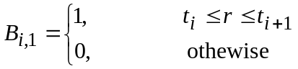 (12.1)
and
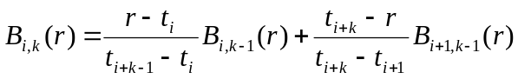 (12.2)
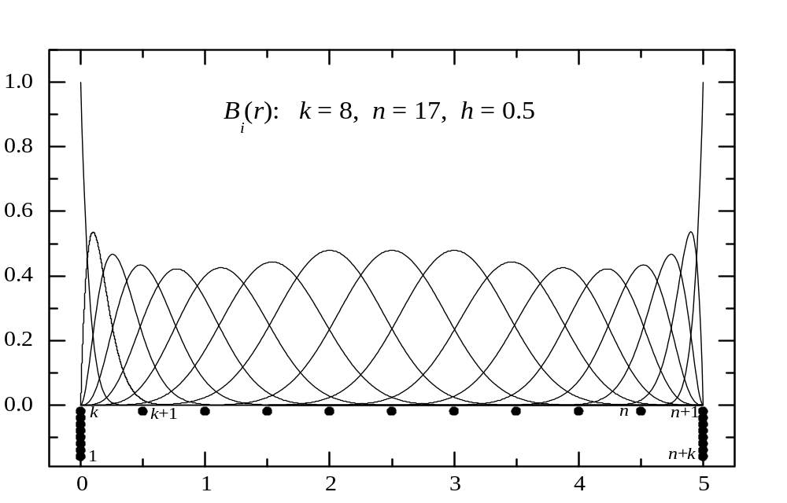Since k and t are usually fixed, we will indicate only one index, B_{i}. Each B_{i} is defined over the interval [t_{i},t_{i+k}], which contains k + 1 consecutive knots, and is indexed by the knot where it starts. An example of full set of B-splines is shown in Fig.12.1. In this example, the interval [0,5] is divided into equidistant
Fig. 12.1. The full set of B-splines of order k = 8 relative to the equidistant knot sequence (represented by full circles, with an indication of their numeration).
subintervals, with h = 0.5. Each B_{i} starts at knot t_{i}, i=1,…,n, and ends k knots later. In order to provide the same number of B-spline in each interval, the multiplicity of knots in the endpoints is usually chosen to the maximum possible value, which is equal to the B-spline order k. The most common choice for multiplicity at inner knots is unity, corresponding to maximum continuity of B-spline functions inside the interval. With this choice, employed in the BSPLINE library, the number of subintervals is related to the number of B-splines as
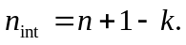
Some general properties of B-splines are the following.

- Over each subinterval [t_{i},t_{i}+1], exactly k B-splines are nonzero
the first being B_{i-k+1}, which ends at t_{i} +1, and the last is B_{i}, which starts at t_{i}. It means that
- In the expansion of an arbitrary function
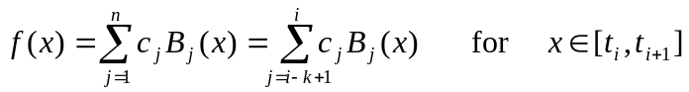
there are only k terms contributing to the value, so the B-spline representation for different operators will have the band structure, simplifying in great extent the solution of relevant matrix equations.

- B-splines are normalized so that 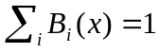. Because the B-splines are non-negative with minimal support, the expansion coefficients of an arbitrary function are close to the function values at the knots. This means that wild oscillations in the coefficients are avoided, cancellation errors are minima, and numerical stability maximal.

- B-splines satisfy the recursion relation (12.2). Together with the definition of B-splines of order k =1 (12.1), this gives a simple algorithm for their practical evaluation: given a point x, one generates by recursion the values of all the k B-splines which are nonzero at x. The derivation of a B-spline of order k can be also expressed as a linear combination of B-splines of the order (k-1):
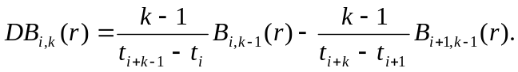 (12.3)
The first B₁-spline is the only spline with nonzero value in the left end of interval [a,b], and other B_{i}-splines have the (r-a)^{i-1} dependence. A similar behavior applies at the porint b. This makes it very easy to implement boundary conditions at the endpoints. For instant, f(a) = 0 is satisfied be deleting B₁ from the set, Df(b) = 0 by combining B_{n-1} and B_{n} as 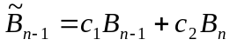 so that 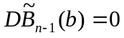, and so on.
- With minimum multiplicity of knots, the B_{i,k}-spline functions belong to the functions of class C^{k-2}, i.e. all they are continuous functions together with their derivatives up to order k-2. In each subinterval [t_{i},t_{i+k}], B-spline functions can be represented by polynomial of order k (maximum degree k – 1). That allows the analytical manipulation of B-spline functions, by using MAPLE, for example. (CFF: in fact, this is how I tested many integrals!)

In quantum mechanical applications we deal mostly with matrix elements, i.e. definite integrals involving B-splines and their derivatives. These are best computed to machine accuracy employing Gauss-Legendre integration of appropriate order over each subinterval [t_{i},t_{i+k}]. Recall that Gauss-Legendre method of order n (n points) is exact for a polynomial integrand of order 2n. So a k-points Gauss-Legendre method integrates exactly the product B_{i}B_{j}, and provides also rather accurate results even for nonpolynomial integrands, provided no singularity is present in the given interval. At the same time, in the first subinterval, (1/r)B_i B_j is also evaluated exactly if i or j > 1. So, for most applications we need only the B-spline values at the k Gaussian points. These avoid the evaluation of integrands at r=0, where potentials may have singularities.
Another important problem in quantum mechanical applications is solving the radial Schrödinger equation. In order to demonstrate the use of B-splines in this problem, consider the simple one-electron radial equation
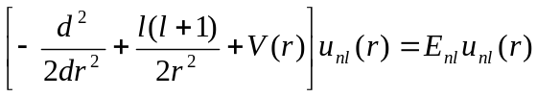. (12.4)
An approximation solution is expressed as a linear combination of B-splines over an interval [0,r_{max}], say {B_{i}(r), i=1...N}. Then
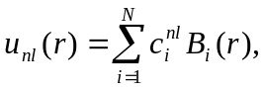 (12.5)
Usually the approximate (or trial) functions satisfy the boundary conditions. When the B-spline basis is generated using a grid with multiple knots at the ends of the interval, the zero boundary conditions, for example, are fulfilled by removing (or setting to zero) the first and the last B-splines from the basis set. We shall refer to the column vector c = {c_{i}} as a spline expansion vector of u(r). The solutions of (12.4) by the Galerkin method are calculated by solving the system of N linear equations obtained when substituting (12.5) in (12.4) and projecting on B_{j}(r). Written in matrix form, this procedure is equivalent to solving the following generalized eigensystem:
, (12.6)
where
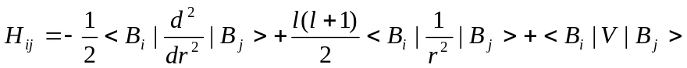, (12.7)
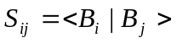. (12.8)
The overlap matrix S originates from the fact that B-splines do not form an orthogonal set of basis functions. The H_{ij} matrix we will refer as a B-spline representation of the Hamiltonian. Note that all matrix elements in (12.6) may be easily computed, as discussed above, to machine accuracy using Gauss-Legendre integration, applying on each subinterval. Another key property related to the use of a B-spline basis follows from the fact that a B-spline of order k differs from zero only on k successive subintervals. Therefore, any local operator expressed in the B-spline basis appears as a banded matrix having nonvanishing values on a diagonal band of width 2k-1. This simplifies considerably the solution of the generalized eigenproblem (12.4).
The first few eigenvalues and eigenvectors in the cavity (often called the box), in which we solve the problem (12.6), agree precisely with the first few bound-state eigenvalues and eigenvectors obtained by numerically integrating the radial Schrödinger equations, but as the principal quantum number increases, the cavity spectrum departs more from the real spectrum, and forms the so-called pseudospectrum which can be used instead of the real spectrum in different physical problems. Each of these eigenvectors define an atomic orbital. It has been found that by using this B-spline orbital set it is possible to take into account the influence of a whole Rydberg series, without introducing a cut-off. For example, the second-order energy correction in the framework of the Rayleigh-Schrödinger perturbation theory
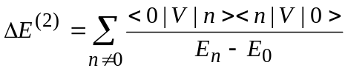 (12.9)
requires the direct evaluation of the sum in terms of an infinite sum over the bound states and an integration over the continuum. In the B-spline pseudospectrum, only some first states are bound, and the remaining states are unbound, and the infinite sum (12.9) is reduced to the finite sum. As shown in many numerical examples (Sapirstein and Johnson 1996), this sum very accurately reproduces the infinite sum (12.9) with only a small number of B-spline orbitals, i.e. the B-spline orbital basis is effectively complete in this sense. The effective completeness of the basis set means that the summation is independent, or almost independent, of box size and number of splines if these two quantities are chosen large enough. We can check numerically if the summation is independent of the box size and number of splines. Completeness of the B-spline orbital basis is a very valuable property, simply because it is possible to replace an infinite summation over bound states and an integration over continuum states with a summation over a small number of L²-integrable functions. This property has found wide application in the investigation of strong interactions between perturbers and Rydberg series (Hansen et al 1993), or in the investigation of influence of continuum spectrum in the two-electron atoms [..].

12.2. General routines

B-splines can be considered as new elementary functions like sin x or j_{l}(x). One becomes familiar with them by understanding their qualitative behavior and how to use them, that is how to obtain values of the functions, their derivatives or integrals. This is the purpose of routines described below in the next section.

List of general routines

bav | computes y = B x or y = xB, where B is symmetric or non-symmetric band matrix, y and x are vectors.
bvalue | calculates at a given radius the value and derivatives of a function given in the B-spline representation.
bvmv | Returns the matrix elements <x|A|y>, where x,y are vectors, A is band array in symmetric, non-symmetric or almost symmetric form.
bxv | computes y = B x, where B isa symmetric band matrix, and y and x are vectors.
define_grid | gets input data for the grid and sets up the knots for the spline grid.
define_spline | initializes the values of the spline and its derivatives, and evaluates the basic elementary operators in a spline basis.
dinty | computes matrix elements <B_{i}| y(r)|B’_{j}> between individual B-splines for input function y(r) given at the Gaussian points of each interval.
facsb | factorizes the overlap matrix <B_{i}| B_{j}>.
gauss | produces the values of Gaussian coordinates and Gaussian weights over the interval [0, 1].
minty | computes matrix elements <B_{i}| y(r)|B_{j}> between individual B-splines given the function y(r) the Gaussian points of each subinterval.
mkgrid | sets up the knot sequence
mrm | generates the B-spline representation of the operator r^{m}.
spline_param | module, contains the main spline parameters.
spline_grid | module, defines the values of splines and their most general functions at the Gaussian points needed for integrations on the grid.
spline_galerkin | module, contains common arrays used in the application of splines in the Galerkin method.
splin3 | provide coefficients for a cubic interpolating spline.
vbsplvd | calculates the values of the b-splines and their derivatives for one point per each subinterval.
vinty | computes the vector elements <B_{i}|y(r)>, where function y(r) is given at the Gaussian points of each subinterval.
yval | computes the values of r^{m} f(r), r^{m} f'(r) or r^{m} f''(r) at the Gaussian points of each interval, where f(r) is defined by the spline expansion vector.

Internal representation of band matrices

BSPLINE library uses different storage modes for banded matrices depending on the symmetry of the matrix and on the operator represented by this matrix. Let A(n,n) be a matrix of bandwidth 2k-1. Let B =(Bij) be a two-dimensional storage array. Several possible storage modes can be described schematically.
- Symmetric lower-column storage mode.
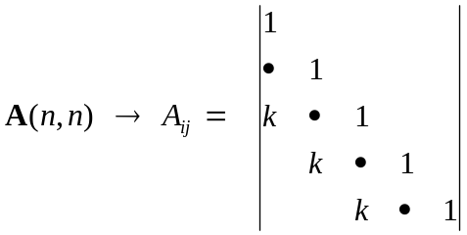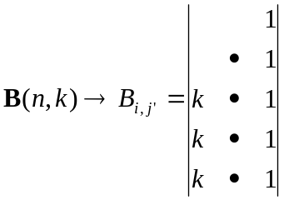
A(i,j) = B(i,j') with j =j'+i-k.

In this representation the summation over elements is:
Do j' = 1, k
Do i = k+1-j', n
- Symmetric upper-column storage mode.
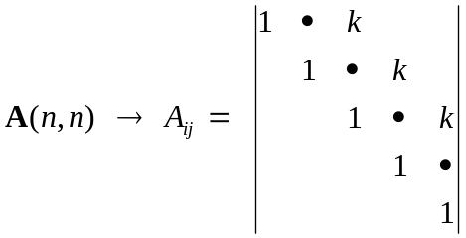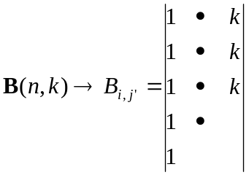
A(i,j) = B(i,j') with j =j'+i-1
The summation over elements is: Do j' = 1, k
Do i = 1, n-j'+1
- Non-symmetric column storage mode.
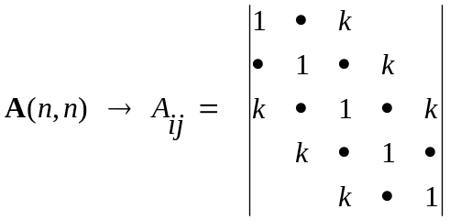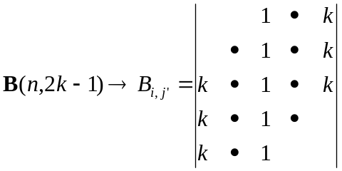
A(i,j) = B(i,j') with j =j'+i-k
The summation over elements: Do j' = 1, k+k-1
Do i = max(1,1+k-j'),min(n,n+k-j')
- Almost symmetric lower-column storage mode.
There is only one non-symmetric element: A(n,n-1) ≠ A(n-1,n), the latter is saved in B(1,1) for low-column storage mode, or in B(n,n) for upper-column storage mode.

MODULE spline_param

ks | order of B-splines.
ns | number of B-splines.
nv | number of intervals.
ml | number of distinct points from 0 to 1.
me | number of points in the "exponential" region.
h | initial step in knot sequence.
hmax | maximum step.
rmax | border radius.

MODULE spline_grid

t(1:ns+ks) | knot sequence.
bsp(1:nv+1,1:ks,1:ks) | bsp(i,m,ith)contains value of the i+ith-1 B-spline in interval i at Gaussian point m.
bspd(1:nv+1,1:ks,1:ks,1|2) | values of first and second derivatives of B-splines at the same points. bsp(nv+1,1,.) and bspd(nv+1,1,.,.) contain corresponding values at the last knot point, i.e. at r_{max}.
bsq(1:nv+1,1:ks,1:ks) | values of the expression B(r)-1/rB’(r) at Gaussian points.
gr(1:nv,1:ks) | gr(i,m) contains Gaussian point m in interval i.
grm(1:nv,1:ks) | reciprocals of the values of gr(i,m).
grw(1:nv,1:ks) | Gaussian weights at corresponding points.
Internal routines:
Allocate_grid | allocates space for arrays bsp, bspd, gr, grm, and grw according to parameters from module spline_param.

Module spline_galerkin

sb(1:ns,1:ks) | sb(i,j) --> <B_{i}|B_{i+j-k}>
r1(1:ns,1:ks) | r1(i,j) --> <B_{i}|r|B_{i+j-k}>
rm1(1:ns,1:ks) | rm1(i,j) --> <B_{i}|(1/r)|B_{i+j-k}>
rm2(1:ns,1:ks) | rm2(i,j) --> <B_{i}|(1/r²)|B_{i+j-k}>
rm3(1:ns,1:ks) | rm2(i,j) --> <B_{i}|(1/r³)|B_{i+j-k}>
db1(1:ns,1:ks) | db1(i,j) --> <B_{i}|B'_{i+j-k}>
db2(1:ns,1:ks) | db2(i,j) --> <B_{i}|B''_{i+j-k}>
bs(1:ks,1:ns) | factorization of array sb
Internal routines:
Allocate_galerkin | allocates space for all arrays according to parameters from module spline_param. Arrays are stored in the symmetric lower-column storage mode, except db2 - almost symmetric mode, and db1 - antisymmetric array. (CFF: Needs an explanation)

Remarks

All arrays and parameters in the above modules should be initialized before the B-spline applications. It can be done by calling the routines define_grid and define_spline at the beginning of each BSR program.
The define_grid subroutine generates the knot sequence. This is a very important first step in the BSR calculations, because the B-splines are fully defined by the given knot sequence, so the grid together with the order of spline, k, determines the accuracy of approximation. Though there is a total freedom in choosing the mesh of knots, an optimal choice will depend on the type of result we are particularly interested in. With splines, we can create any composite grid if needed but since too rich a grid can lead to a rapid saturation of computational resources. The existing experience shows that the most appropriate choice is a logarithmic grid that reflects the exponential behavior of atomic orbitals. On the other hand, in the continuum calculations, the wavelength of the scattering particle cannot be smaller than the grid step otherwise the B-spline basis hardly describes the oscillating behavior of the wavefunction. In the present implementation, we use a mixed sequence which can easily be adjusted to the task under consideration. We introduce four main parameters: the step size in the origin, h = 2^{-m}, where m is an integer, the maximum step size h_{max}, the maximum range r_{max} and the order of splines k. Let Z be the nuclear charge of atom. The grid points are now defined through the array t_{i}=Zr_{i} such that
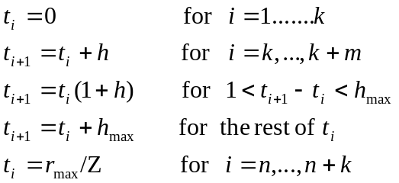 (12.10)

This grid is linear in the origin, at Zr < 1, and this guarantees the accurate representation the radial orbitals at small radii. The existing experience shows that values Zh = 0.25 or 0.125 are good enough for most applications. In the middle-radii region, the grid is exponential. It gives some advantage in computational time, because when B-splines are entirely in the outer region, relations such as the following,
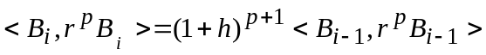 (12.11)
can be shown to hold. Similar rules can also be derived for two-electron integrals commonly occurring in atomic structure calculations (see section 12.5). Thus, only a few integrals need to be evaluated, and for others, a scaling law applies. (CFF: Reference to this grid goes back to Idrees and CFF. Can’t remember when we first published scaling laws. The certainly were part of a thesis.)
Another grid parameter defines the maximum range or extent of the solution. Since the extent of a 1s orbitals is much less than, say a 10s, the software may automatically adjust the range for each orbital, but in general purpose software, sufficient range is needed to allow orbitals to attain their full extent for the desired accuracy. In the BSR calculations, the r_{max} was usually chosen from the condition that for all bound radial functions |P(r_{max})| < 10⁻⁵ , and this value coincides with the R-matrix boundary, a.
For bound state calculations we can use the totally exponential grid in the outer region, whereas in the case of scattering calculations the maximum size of the subintervals should be restricted according to maximum energy of the scattering electron. The existing experience shows that the oscillating behavior of scattering radial functions is reproduced accurately with at least three knot points for the half wavelength. So, a user should choose the parameter h_{max} ≤ 1/k_{max} , where k_{max} is the maximum linear momentum of scattering electron expected in the given calculations. This restriction is primarily important in the case of direct scattering calculations (Xi and Froese Fischer 1999), whereas in the case of R-matrix calculations this restriction can be reduced at least three times without noticeable influence on the numerical accuracy.
The grid parameters are provided in BSR calculations by the file knot.dat, and these parameters should remain unchanged for the duration of the whole calculation. An example of a knot.dat file is given in Fig. 12.2. Routine define_grid first reads the main parameters from knot.dat, and then generates the knot sequence in the routine mkgrid. The number of B-spline is an outer parameter in this procedure and defined in this stage. The resulting knot sequence and relevant parameters are then rewritten to the knot.dat file. If program can not find the knot.dat file, the execution will be stopped. Users are strongly advised to first try different sets of parameters to produce the desired knot sequence with a minimum number of B-splines, because this parameter strongly affects the computation time for all subsequent calculations.

8 ==> order of splines (ks)
101 ==> number of splines (ns)
6.00000 ==> nuclear charge (z)
0.25000 ==> step size from 0 to 1 (h for z*r, = 1/2^m)
0.70000 ==> maximum step size (hmax for r)
50.00000 ==> maximum r (rmax)
***
0.00000 0.00000 0.00000 0.00000 0.00000
0.00000 0.00000 0.00000 0.04167 0.08333
0.12500 0.16667 0.20833 0.26042 0.32552
0.40690 0.50863 0.63578 0.79473 0.99341
1.24176 1.55220 1.94026 2.42532 3.03165
3.63798 4.24431 4.85064 5.45697 6.06330
6.66963 7.27596 7.88229 8.48862 9.09495
9.70128 10.30761 10.91394 11.52027 12.12660
12.73293 13.33926 13.94559 14.55192 15.15825
15.76457 16.37090 16.97723 17.58356 18.18989
18.79622 19.40255 20.00888 20.61521 21.22154
21.82787 22.43420 23.04053 23.64686 24.25319
24.85952 25.46585 26.07218 26.67851 27.28484
27.89117 28.49750 29.10383 29.71016 30.31649
30.92282 31.52915 32.13548 32.74181 33.34814
33.95447 34.56080 35.16713 35.77346 36.37979
36.98612 37.59245 38.19878 38.80511 39.41144
40.01777 40.62410 41.23043 41.83676 42.44309
43.04942 43.65575 44.26208 44.86841 45.47474
46.08106 46.68739 47.29372 47.90005 48.50638
49.11271 50.00000 50.00000 50.00000 50.00000
50.00000 50.00000 50.00000 50.00000
***

Fig.12.2. Example of knot.dat file in the case of the e + C scattering.

12.3. Atomic orbital routines

This block of routines deals with the set of atomic radial functions and their B-spline representations.

azl | provides the value of B_{l+2}/r^{l+1} at r = 0, that defines the leading term for orbital nl..
bcore | computes the energy of the common closed shells (core).
bhl | evaluates matrix element <P_{i} |L |P_{j}> for atomic orbitals i,j.
bhwf | computes the spline expansion coefficients for hydrogenic radial functions.
coulomb | builds the interaction matrix for Coulomb problem.
grad | gives the matrix element <P_{i} | d/dr + l/r |P_{j}> for atomic orbitals i,j.
hlc | computes matrix element <P_{i} |L |P_{j}> modified by theinteraction with closed shells.
hlm | sets up the matrix of L operator in the B-splines basis.
quadr | evaluates matrix element <P_{i} |r^{k}|P_{j}> for atomic orbitals i,j.
mvcv | computes the matrix elements for the mass-velocity correction in the B-spline basis.
r_bwfn | reads the atomic orbitals from the bsw-files.
spline_atomic | module - contains the main atomic parameters.
spline_hl | module - contains the L matrix and routines for evaluation of rel. shift.
spline_integrals | module - contains arrays for the B-spline representation of two-electron integrals.
spline_orbital | module - contains the description of atomic orbitals.
zeta | evaluates the Z(P_{i},P_{j}) integrals (including interaction with closed shells).

MODULE spline_orbitals

nbf | number of atomic orbital.
nbs(1:nbf) | principal quantum numbes.
lbs(1:nbf) | orbital momentums of orbitals.
kbs(1:nbf) | set indexes of orbitals.
ebs(1:nbf) | spectroscopic labels for orbitals.
mbs(1:nbf) | length of the B-spline expansion.
iech(1:nbf) | Additional pointer, used to distinguish of the continuum orbitals.
pbs(1:ns,1:nbf) | B-splines expansion coefficients for atomic orbitals.
qbs(1:ns,1:nbf) | vectors B·p, where B is the B-spline overlap matrix.
obs(1:nbf,1:nbf) | one-electron overlaps.
iort(1:nbf,1:nbf) | orthogonal constraints, imposed on the one-electron orbitals.
Internal routines:
allocate_bsorb | allocates space for all arrays for given value nbf.
Ifind_bsorb | defines the position orbital n,l,k in the common list.
Iadd_bsorb | adds the orbital n,l,k to the common list.

MODULE spline_hl

hl(1:ns,1:ks) | matrix of L operator in the B-spline basis (in almost symmetric lower-column mode)
lh | the corresponding value of the orbital momentum
vc(1:ns,1:ks) | matrix of mass-velocity correction in the B-spline basis
Internal routines:
Allocate_hl | allocates space of for the hl and vc arrays according to parameters from module spline_param.

MODULE spline_atomic

z | charge of nucleus.
kclosd | number of closed shell.
rel | indicates on the relativistic calculations.
fine | fine-structure constant.
EC | energy of core.
ioo | if ioo > 0, the core energy also includes the orbit-orbit interaction.

Format of the bsw-files.

The atomic orbitals in the B-spline representation are supposed to be recorded in the unformatted bsw-files, which are similar to the w-files in the MCHF package (Froese Fisher 1999). In bsw-files each orbital is recorded sequentially with following information:
1. ebs, z, h, hmax, rmax, ksb, nsb, mbs
2. pbs(1:mbs)
where the notation corresponds to the definitions in module spline_orbitals. Along with the usual information about the quantum numbers and B-spline expansions, the bsw-file also contains the B-spline parameters, which allow us to reconstruct the corresponding knot sequence.
12.4. Evaluation of two-electron integrals

BSPLINE library contains three sets of routines for the evaluation of two-electron integrals, which are based on the different numerical methods. They include the orbital direct differential method, the B-spline differential method, and direct summation over the B-spline cells. The different methods are suitable for different kinds of calculations, have different accuracy and speed, and different representations for the final results. The orbital direct differential method provides only the total values of integrals, has lower accuracy but the highest speed. This method can be used in the large-scale CI calculations. The B-spline differential method provides the B-spline representation for different two-electron integrals, that can be used in generating the Hamiltonian matrix, including the Breit-Pauli terms. The evaluation of the total values of integrals, however, is slower, approximately by one order, than the orbital direct differentilal method. In the summation over B-spline cells, we first evaluate the two-electron integrals in the different (r₁,r₂) cells, defined by the B-splines subintervals [t_{i},t_{i+1}]. The integration is done by using Gauss-Legendre quadratures. This provides the highest accuracy, which is comparable to the machine accuracy. This method can be efficiently used for both the B-spline representation and evaluation of total integral values, though the speed is still lower than in the direct differential method, though the same cell data can be reused for different orbital integrals.
Below we outline the relevant theory and different numerical methods used in BSPLINE to deal with the two-electron integrals. Then we give the short description of relevant routines and modules. These routines have been developed on the basis of algorithms and recommendations, first presented in the works (Brage and Froese Fischer 1994, Qui and Froese Fisher 1999). We follow closely their notation.

12.4.1. Evaluation of two-electron integrals by direct differential equation method

The two-electron radial integrals in atomic structure calculations are of the form
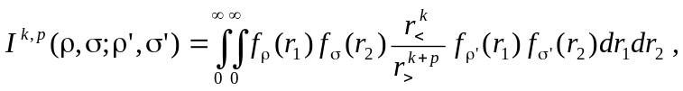 (12.12)
where r< and r> are the smaller and larger of the two coordinates r₁ and r₂ . The f(r) functions are linked to the radial orbitals, p is the positive integer and k can assume a range of different integer values. If we define a function Y^{k,p}(σ,σ';r) so that
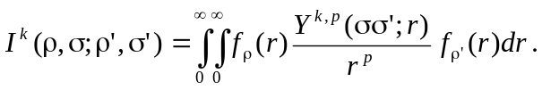
from which it follows that
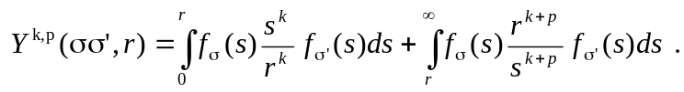 (12.13)
It is easy to show that this function satisfies a differential equation of the form
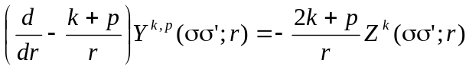 (12.14)
In the above, we have introduced a second function
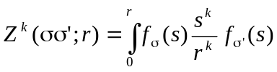, (12.15)
which satisfies the differential equation
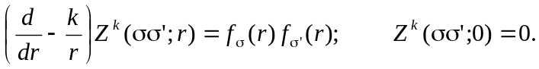 (12.16)
The form of the Z^{k} function is quit general, when defined in this way, since it is independent of p.
In the Breit-Pauli calculations all two-electron integrals can be reduced to the four main types: R^{k}, N^{k}, V^{k} , and T^{k} integrals.

R^{k} Integrals
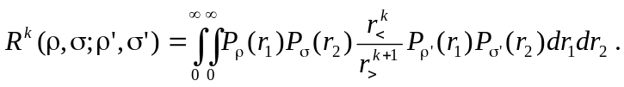 (12.17)
It is the special case of equation (12.12) with p = 1, and f functions are simply the radial orbitals. The R^{k} integrals are highly symmetric
that is, they are unchanged as long as the ρ and ρ' orbitals, and thereby the σ and σ', are linked together with one coordinate.
The two-step procedure described above can be avoided, since the differential equation for the Y^{k} functions is
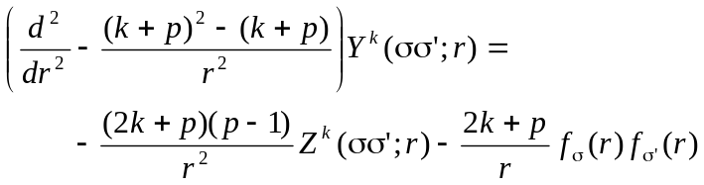 (12.18)
In the special case of p = 1, the coefficient of the Z^{k} function disappears, and we are left with one single, but second-order, differential equation for Y^{k}
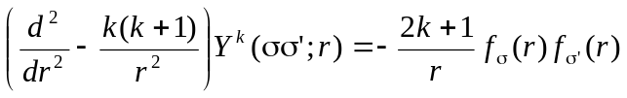 (12.19)
with boundary conditions
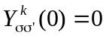
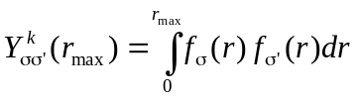, if k=0, (12.20)
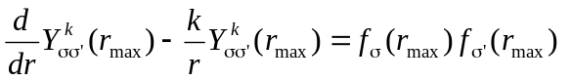, if k >0
The boundary condition at r_{max} can be obtained from (12.13), assuming that orbitals disappear at r > r_{max}.

N^{k} integrals
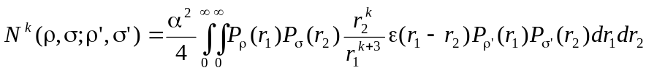 (12.21)
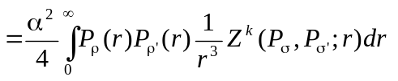
where k ≥ -1 and ε(x) = 0 for x≤ 0, ε(x) = 1 for x > 0. The ε(x) step function reduce the Y^{k} function to the Z^{k}, and N^{k} integral is the special case of equation (12.12) with p=3, Y^{k}=Z^{k} and f functions are simply the radial orbitals. So, in this case we need to solve only one first-order differential equation (12.16). But additional complication occurs when dealing with the case N⁻¹, i.e. k < 0. In this case the homogeneous solution to equation (12.16) is
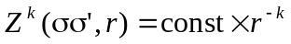
which leads to an ambiguous result when r → 0, since k > 0. This is solved by imposing a stronger boundary condition
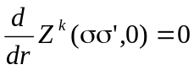, if k < 0. (12.22)
The N^{k} integrals are not as symmetric (CFF: have fewer symmetries than ?) as R^{k} integrals:
In applications, we also use the integrals
(12.23)
which has all the symmetries of the R^{k} integral and differs from the latter only in that p = 3.

V^{k} integrals
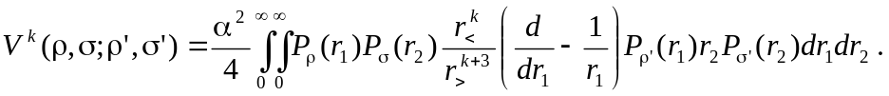 (12.24)
This is the special case of equation (12.12) with p=3 and
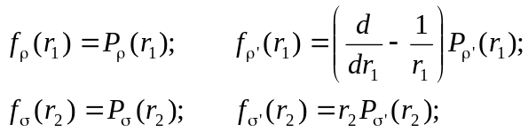
The V^{k} integral allows only to use the two-step procedure (12.14)-(12.16), and has the most restricted symmetrical relations:
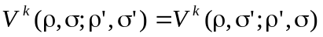
In applications, we also use the more symmetric integrals (Zatsarinny and Froese Fisher 1999):
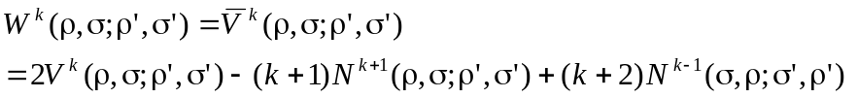 (12.25)
(12.26)

T^{k} integrals
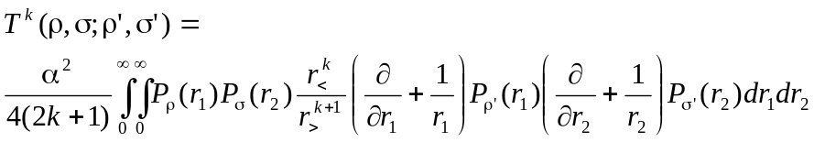 (12.27)
with p=1 and
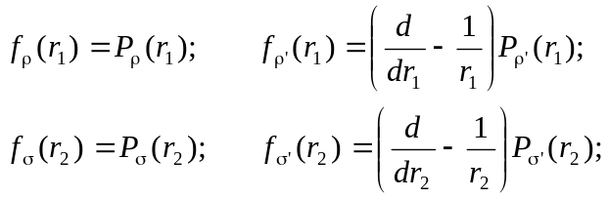
Here we can use the same procedure as for R^{k} integrals but the symmetry relations are more strict:
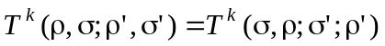
Note that in Breit-Pauli approximations, U^{k} integrals are frequently used (see, for example Zatsarinny and Froese Fischer 1999). In the present implementation we do not have any special procedure for U^{k}, but instead use the following relationship:

(12.28)

List of routines

spline_slater | module, contains common arrays used in the evaluation of two-electron integrals by direct differential equation method
bzk | computes the spline solution for the the Z^{k} function
facdyk | sets up and factorizes the matrix of Y^{k} operator d²/dr² -k(k+1)/r² in B-spline basis
facdzk | sets up and factorizes the matrix of Z^{k} operator d/dr + k/r
rky | evaluates R^{k} integral by the orbital direct differential method
nky | evaluates N^{k} integral by the orbital direct differential method
mky | evaluates M^{k} integral by the orbital direct differential method
tky | evaluates T^{k} integral by the orbital direct differential method
vky | evaluates V^{k} integral by the orbital direct differential method
ykf | computes the spline solution for the Y^{k} function

MODULE spline_slater
kz | multipole index for Z^{k} function.
dzk(1:ktx,ns)  ipvtz(1:ns)  ktx = 3*ks-2 | factorization of matrix for the Z^{k} operator d/dr + k/r in the B-spline basis.
ky | multipole index for Y^{k} function.
dyk(1:ktx,1:ns)  ipvtd(1:ns) | factorization of matrix for the Y^{k} operator d²/dr² -k(k+1)/r² in the B-spline basis.
yk(1:ns) | B-spline representation of Y^{k} (or Z^{k}) function.
fyk(1:nv,1:ks) | values of Y^{k} (or Z^{k}) function in Gaussian points.
fc1(1:nv,1:ks), ic1  fc2(1:nv,1:ks), ic2  fy1(1:nv,1:ks), iy1  fy2(1:nv,1:ks), iy2 | values in Gaussian points and pointers for four one-electron radial functions in the two-electron integral under consideration.
fc(1:nv,1:ks) | work array.
Internal routines
Allocate_slater | allocates space for all arrays according to parameters from module spline_param
Dealloc_slater | deallocates space in the module spline_sleter

Calling sequences
rky nky
--------------- ----------
/ \ / \
ykf yval bzk yval
| |
------------------------- -------------
| | | | \ / | \
facdyk yval vinty quadr dgbsl facdzk yval dgbsl
| |
dgbfa dgbfa

tky vky
---------- ------------
// \ // \
ytk yval yvk yval
| |
-------------------------- -------------------------
| | | | \ | | | | \
facdyk yval vinty quadr dgbsl bzk yval vinty facdzk dgbsl
| | |
dgbfa -------------- dgbfa
facdzk yval dgbsl
|
dgbfa

Remarks

- All the above routines differ only by the way the corresponding Y^{k} functions are calculated: routines ykf, bzk, ytk and yvk. The specific routines ytk and yvk are incorporated in the calling routines.
- The Y^{k} and T^{k} integrals are defined through solution of the second-order differential equations. The N^{k} integral needs only the Z^{k} solution of the first order equation. V^{k} integral is evaluated by sequential solution of two first-order differential equations.
- ykf routine include the relativistic shift modification of the Y^{k} function if parameter rel = 'TRUE' .
- The quadr routine is used for determination of the right boundary conditions (12.20) when k=0. It is important in the case of non-orthogonal orbitals.
- These routines are very quick but not as accurate as the cell integration. They can be used for the evaluation two-electron integrals, but not for generating interaction matrix in a B-spline basis.

12.4.2. Evaluation of two-electron integrals in B-spline basis

Under the B-spline representation of radial functions of atomic orbitals (12.5), the two-electron integrals (12.12) becomes
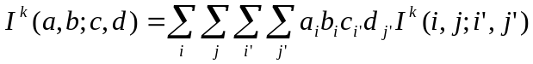 (12.29)
where the matrix elements I^{k}(i,j;i',j') are
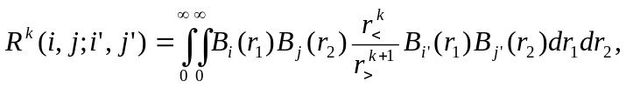)
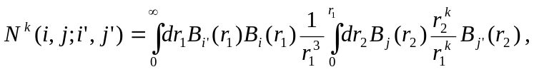
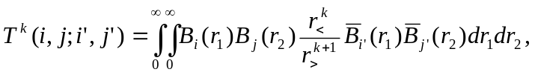
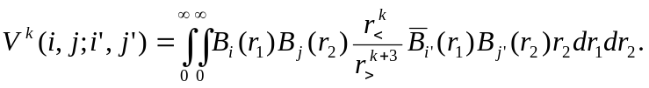
where we introduced 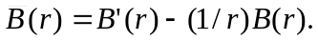 Matrix elements (2.29) can be obtained by using the same procedures described above in section 12.4.1 but by replacing f(x) functions with the corresponding B-splines.
So, the two-electron integral is given as a fourfold summation, but considerable simplification is possible. Note that,
(12.30)
Besides, the integrals may be symmetric relative to (i,i') or (j,j') indexes. In result, the B-spline integrals can be stored as matrix with band character relative to (i,i') or (j,j') indexes, namely:
R^{k}(n_{s}, n_{s}, k_{s}, k_{s}),
N^{k}(n_{s}, n_{s}, k_{s}, k_{s}),
V^{k}(n_{s}, n_{s},2k_{s}-1, k_{s}),
T^{k}(n_{s}, n_{s}, 2k_{s}-1, 2k_{s}-1).
In particular, array element R^{k}(i,j;i_{p},j_{p}) referred to the matrix element in which i' = i + i_{p} -1 and j' = j + j_{p} -1, where i_{p},j_{p} = 1,..,k_{s} (the symmetric upper-column mode). However, array element T^{k}(i,j;i_{p},j_{p}) referred to the matrix element in which i' = i + i_{p} - ks and j' = j + j_{p} - k_{s}, where i_{p},j_{p} = 1,..,2k_{s}-1 (the non-symmetric column mode).
Thus, it is convenient to regroup the summation as follows:
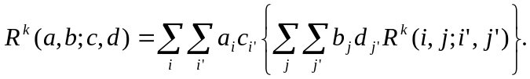 (12.33)
Let us consider the innermost double summation. Only the matrix elements with j' ≥ j are stored but the summation in Eq.(2.33) is over all values. However, the summation may be written as
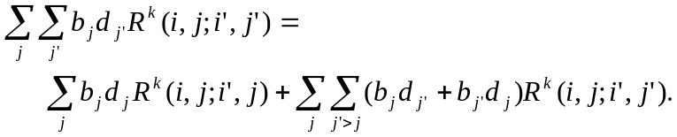 (12.34)
Let us define a direct "density matrix":
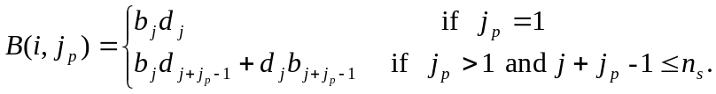 (12.35)
With a similar definition for the direct density matrix:
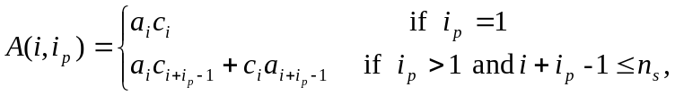 (12.36)
the Slater integral is then defined as
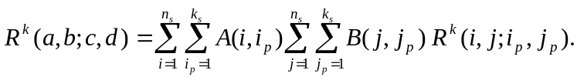 (12.37)
Similarly, we can obtain
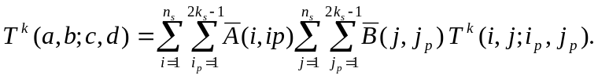 (12.38)
where
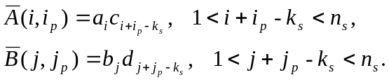 (12.39)
The N^{k} integrals are also defined through the 'symmetric' summation (2.37), whereas the V^{k} integrals are a mixed case:
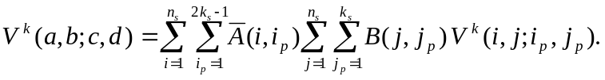 (12.40)

List of routines

spline_integrals | module, contains the B-spline representation of the given two-electron integral
convol | convolutes the four-dimentional array of B-spline two-electron spline integrals with two-dimentional density matrix.
density | provides the density matrices (12.35) or (12.39).
mrk_diff | sets up the matrix for B-spline representation of R^{k}-integral  using the differential equation method
mnk_diff | sets up the matrix for B-spline representation of N^{k}-integral  using the differential equation method
mmk_diff | sets up the matrix for B-spline representation of M^{k}-integral  using the differential equation method
mtk_diff | sets up the matrix for B-spline representation of T^{k}-integral  using the differential equation method
mvk_diff | sets up the matrix for B-spline representation of V^{k}-integral  using the differential equation method
rk | evaluates R^{k} integral by assembling the B-spline integrals
nk | evaluates N^{k} integral by assembling the B-spline integrals
mk | evaluates M^{k} integral by assembling the B-spline integrals
tk | evaluates T^{k} integral by assembling the B-spline integrals
vk | evaluates V^{k} integral by assembling the B-spline integrals

MODULE spline_integrals

krk | multipole index for integral under consideration.
itype | character (rk, nk, mk, tk, or vk) which indicates the type of integral.
rkb | the B-spline representation of the given two-electron integral, stored in the column mode with dimensions (1:n_{s},1:n_{s},1:2k_{s}-1,1:2k_{s}-1)
Internal routines
Allocate_integrals | allocates space of for the rkb array according to parameters from module spline_param
Dealloc_integrals | deallocates space in module spline_integral.

Calling sequences

rk nk
| |
mrk_diff mnk_diff
| |
----------------- -----------------
/ || | \ / || | \
facdyk bspyk yval minty facdzk bspzk yval minty
| | | |
dgbfa dgbsl dgbfa dgbsl

tk vk
| |
mtk_diff mvk_diff
| |
----------------- -----------------
/ || | \ / || | \
facdyk bsptyk yval dinty facdzk bspvyk yval dinty
| | | |
dgbfa dgbsl dgbfa ----------
/ | \
yval vinty dgbsl
Remarks

- Module spline_integrals contains only one array for all type of integrals. If limitations on memory not very strict, it is possible to introduce specific arrays (with different shape) for each integral.
- rk, nk, mk, vk, and tk routines evaluate the two-electron integrals by assembling the matrix elements in the B-spline basis with corresponding orbital expansion coefficients (see Eq.12.33-12.40). The calculations of matrix elements in the B-spline basis are performed by routines mrk_diff, mnk_diff, mmk_diff, mvk_diff, and mtk_diff within differential equation method (or with routines mrk_cell, mnk_cell, mmk_cell, mvk_cell, and mtk_cell within cell integration method, see next section). All these routines check first the parameters krk and itype in the module spline_integrals, and only if these parameters are not appropriate, the calculation of corresponding B-spline representation for given integrals is initialized.
- The above routines differ mainly by way of calculations of the corresponding Z^{k} and Y^{k} functions between the individual B-spline functions in bspyk, bspzk, bsptyk and bspvyk routines, respectively. These specific routines are incorporated into the calling routines, and the algorithms are similar to algorithms in routines ykf, bzk, ytk, and yvk, based on the direct integration of two-electron integrals, section 12.3.2.
- When parameter rel = 'TRUE'', the bspyk routine includes the relativistic shift modification for the Y^{k} function due to two-electron Darwin and spin-spin contact terms, see Section 2.6. The fine-structure multiplier α²/4 is applied directly to the rkb array, if it contains B-spline representation for relativistic integral.

12.4.3. Cell algorithm for evaluation of two-electron integrals

In this algorithm, the two dimensional region (r₁,r₂) is divided into a number of rectangular cells according to the chosen grid. The two-dimensional integration of a diagonal cell uses Gaussian quadrature within the limits of each cell. Over the off-diagonal cells, the integration is separable, so that two-dimensional cell integral is reduced to a product of two one-dimensional integrals. Furthermore, the scaling invariance of the B-splines in the logarithmic region of the chosen grid is fully exploited, and only a restricted amount of cell integrations need to be performed. The values of given integrals can then be obtained by assembling the cell integrals. This algorithm significantly improves the efficiency and accuracy of traditional methods that rely on the solution of the differential equations.

Integration over the off-diagonal cells

In this case the integrand in the matrix elements is separable and the two-dimensional integrals are reduced to a product of two one-dimensional integrals. Consider, for example, Slater integral, and assume i_{v} < j_{v}, where i_{v} and j_{v} numerate the knot subintervals 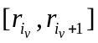 and 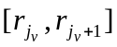. Then
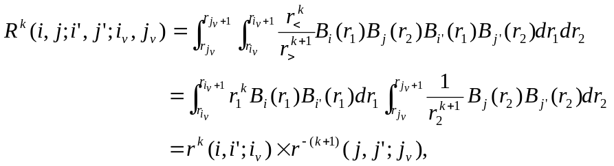 (12.43)
where
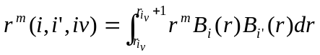. (12.44)
The r^{m}(i,i';i_{v}) quantities are called as the integral moments. We see, although there are n_{v}(n_{v}-1) off-diagonal cells, we only need to be calculated and store the n_{v} one-dimensional moment arrays r^{m}(i,i';i_{v}). Recall, that each B-spline is a positive polynomial over a finite range. Hence, the moment integrals can be effectively evaluated using Gaussian quadrature with k_{s} Gaussian points. For given order k_{s}, the spline B_{i} is non trivial only in the range from knot i to knot i+k_{s}, i.e. for given cell i_{v}, i and j indexes run only k_{s} values: i_{v}, ..., i_{v}+k_{s}-1. So, the moment arrays r^{m}(i,i';i_{v}) has dimension (1:k_{s};1:k_{s},1:n_{v}). Besides, because the r^{m}(i,i';i_{v}) is symmetrical relative to indexes i,i', only r^{m}(i,i';i_{v}) with i ≤ i' need to be evaluated. Moreover, the evaluation can be further reduced by using their scaling properties in the logarithmic grid region. Suppose, the splines lie entirely within the exponential region. Let the left-most knot defining B_{i}(r) be t_{i} and let r = t_{i}+s, then,
B_{i}(t_{i}+s) = B_{i+1}((1+h)( t_{i}+s)) = B_{i+1}(( t_{i+1} + s(1+h)). (12.45)
Based on this displacement invariance, it can be shown the following scaling low for moment integrals
r^{m}(i+1,i'+1;i_{v}+1) = (1+h)^{1+m} r^{m}(i,i';i_{v}). (12.46)
Similar to (12.43) expressions can be easy written also for N^{k}, V^{k}, and T^{k} integrals:
where we introduce moment integrals d^{m}(i,i',i_{v}) which contains derivatives:
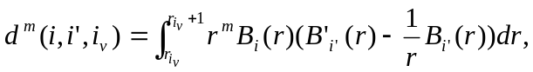 (12.47)

Integration over the diagonal cells

In the diagonal cells, the two coordinates in the integrand of the two-electron integrals are coupled. Moreover, the integrand as not continuous across the cell diagonal where r₁ = r₂. We separate the rectangular cell into two triangles so that the integrand inside each triangle is continuous. The integration over the rectangular cell is then a summation of integrations over the two triangles, which are symmetric with respect to index exchange
, (12.48)
where
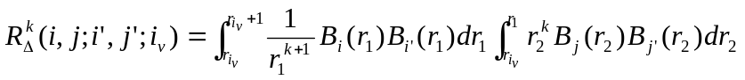. (12.49)
We use Gaussian quadrature again for integration over the triangular cell. Here, however, we should generate new B-splines in the Gaussian points for interval 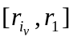. To minimize new B-spline values needed to perform two-dimensional integration, we apply the original Gaussian points used in the evaluation of one-dimensional integrals to the integration with respect to coordinate r₁ (i.e. in first integral in (12.49)). In the integration regarding to coordinate r₂, we also use the k_{s} Gaussian points for each interval , with dynamically calculating the required B-spline values. With this two-dimensional grid, the difficulty of the cell integrals near the origin because of the singularity of the integrand is minimized and uniformly accurate results for all Slater integrals can be obtained. The full storage of the 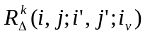integrals takes n_{v}×k_{s}⁴ locations ignoring symmetry over indexes. The computational time for these integrals can be also reduced by using the scaling law in the logarithmic grid region (Qiu and Froese Fischer 1999):
(12.50)

For N^{k} integrals we have
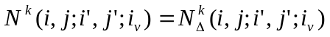,
where
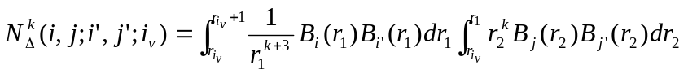.
T^{k} integrals:
,
where
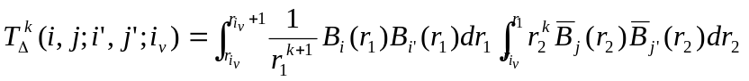.
V^{k} integrals:
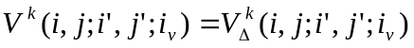,
where
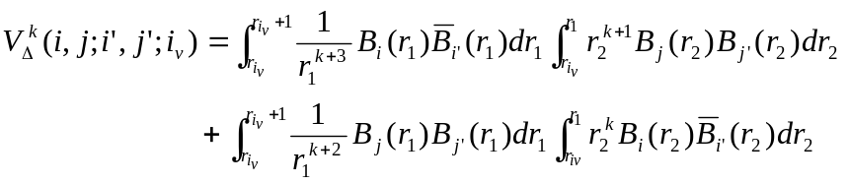.
For all relativistic integrals the scaling law in the exponential region is the same but differs from the R^{k} case:
(12.51)
Now one can easily obtain the B-spline representation for any integral simply by summing the corresponding cell integrals over relevant cells.

Direct summation of cell integrals

Consider the cell (i_{v},j_{v}). Its contribution to the total R^{k} (a,b;c,d) integral is
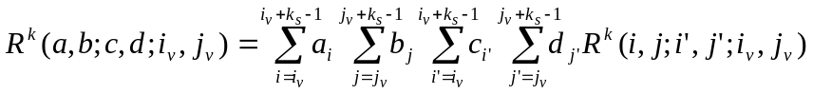 (2.52)
Using the formula for the cell integrals, we obtain
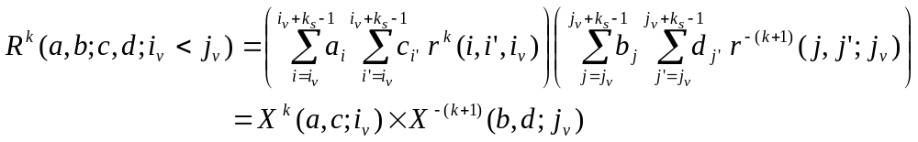
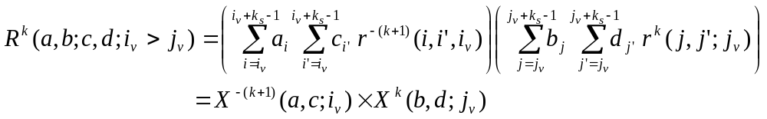
where
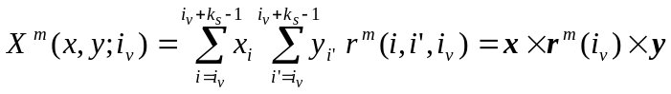 (12.53)
So, the off-diagonal cell integrals for atomic orbitals also can be represented as product of two quantities which depend only on the cell index. Introduce four vectors:
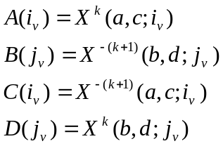
Then, the cell representation of total R^{k} integral has the form

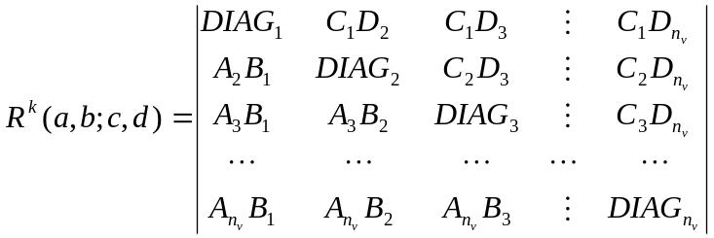 (12.54)

So, R^{k} integrals can be obtained by direct summation the above quantities, without preliminary generation of the corresponding B-spline representation for the given integral. Such a procedure requires much less time.

List of routines

spline_moments | module, contains the off-diagonals moments and diagonal-cell integrals for given type of integral
moments | evaluates the moments <B_{i}|r^{λ}|B_{j}> or <B_{i}|r^{λ}|B'_{j}> for given power index
rk_moments | generates all off-diagonals moments and diagonal-cell integrals for R^{k}-integral
nk_moments | generates all off-diagonals moments and diagonal-cell integrals for N^{k}-integral
mk_moments | generates all off-diagonals moments and diagonal-cell integrals for M^{k}-integral
tk_moments | generates all off-diagonals moments and diagonal-cell integrals for T^{k}-integral
vk_moments | generates all off-diagonals moments and diagonal-cell integrals for V^{k}-integral
mrk_cell | generates the B-spline representation of R^{k}-integral using the cell-integration method
mnk_cell | generates the B-spline representation of N^{k}-integral using the cell-integration method
mmk_cell | generates the B-spline representation of M^{k}-integral using the cell-integration method
mtk_cell | generates the B-spline representation of T^{k}-integral using the cell-integration method
mvk_cell | generates the B-spline representation of V^{k}-integral using the cell-integration method
rkc | evaluates R^{k} integral by direct assembly of the moments
nkc | evaluates N^{k} integral by direct assembly of the moments
mkc | evaluates M^{k} integral by direct assembly of the moments
tkc | evaluates T^{k} integral by direct assembly of the moments
vkc | evaluates V^{k} integral by direct assembly of the moments

MODULE spline_moments

This module contains moments, and the two-electron integral over diagonal cell, eq.(12.49). These moments are used for calculating of two-electron integrals according to the cell algorithm.
kmk | multipole index for integral under consideration.
mtype | character (rk, nk, mk, tk, or vk) which indicates the type of integral.
rkd (1:k_{s}× k_{s},1: k_{s} × k_{s},1:n_{v}) | stores the two-electron integrals between individual B-splines over the diagonal cells.
rkd1 (1: k_{s},1: k_{s},1: n_{v})  rkd2 (1: k_{s},1: k_{s},1: n_{v})  rkd3 (1: k_{s},1: k_{s},1: n_{v})  rkd4 (1: k_{s},1: k_{s},1: n_{v}) | one-electron moments r^{m}(i,i';i_{v}) and d^{m}(i,i';i_{v}) as defined in eq.(12.46) and (12.47) which define the integration over the off-diagonal cells for given type of integrals.
Internal routines
Allocate_monents | allocates space for arrays according to parameters from module spline_param.
Dealloc_moments | deallocates space in module spline_integral.

Calling sequences
rk_moments nk_moments
| |
---- ----
/ \\ / \\
moments rk_pdiag moments nk_pdiag
|| ||
rk_triang nk_triang
/ \ / \
gauss vbsplvb gauss vbsplvb

tk_moments vk_moments
| |
---- ----
/ \\ / \\
moments tk_pdiag moments vk_pdiag
|| ||
tk_triang vk_triang
/ \ / \
gauss vbsplvb gauss vbsplvb

Remarks

- All the above routines for the calculation of moments have the same structure and differ only in the calculation of the diagonal cell contributions, the triang-routines. The pdiag-routines control the scaling properties.
- The mrk_cell, mnk_cell, mmk_cell, mtk_cell and mvk_cell routines generate the B-spline representation for the given two-electron integral, and place the corresponding information in the array rbk in the module spline_integral.
- The direct cell-integration routines rkc, nkc, mkc, tkc, and vkc use the direct summation of elements in (12.52). They are the most effective and accurate way of calculating individual atomic integrals, whereas routines mrk_cell and similar should be used for generating the interaction matrices.

12.5. Library ZCONF

This library contains subroutines and functions, which deal with the configuration and close-coupling expansions. They were designed to unify the representation of different expansions, and are used almost in all programs of the BSR package. The main modules in ZCONF90 are the modules configs, channels and target, with contain data related with configuration expansion, scattering channels or description of target states, respectively. The description of atomic states in the present package is based on the configuration model, and the corresponding expansions for each state should be represented in the so-called c-files, which are used in the MCHF atomic structure package (Froese Fischer et al 1997). For completeness of description, we recall below the main features of the c-files.
A general configuration consists of groups of equivalent electrons
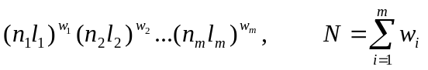 (12.55)
Each subshell is characterized additionally by its term α_{i}L_{i}S_{i}. The total orbital momentum and total spin are obtained by coupling the momenta of all occupied subshells according to the given scheme, completely specified by the intermediate angular quantum numbers L’_{i}, S’_{i}. In this package, the coupling is from left to right, for which the notation
(12.56)
can be used. Here |L₁-L₂|≤L’₂≤|L₁+L₂|, |L₃-L’₂|≤L’₃≤|L₃+L’₂|, etc. Other coupling schemes may prove to be more advantageous in special circumstances. So, each configuration state functions, CSF, is defined by its configuration (12.55) and coupling scheme (12.56). The c-file for given atomic state contains the list of the involved CSFs, optionally, with corresponding expansion coefficients. The example of c-file is given in fig.12.3. All the orbital momenta in c-file are given in the spectroscopic notation. The configuration states are specified by first listing the subshells and their occupation in a linear form where, for example, 2p³ become 2p( 3), followed on a separate line by multiplicity (2S+1), the orbital symmetry (L) and the seniority, first for each subshell, and then for the resultant when coupling these subshells from left to right. For the latter, seniority is no longer relevant. Notice that for the same configuration there are several possible CSFs, which differ by the intermediate angular quantum numbers. In the case of the fine-structure LSJ atomic states, the c-file also can contain the CSFs with different total terms. The expansion coefficients are given in the end of configuration line. The first line of c-file is reserved for title, optional, and energy of the given state. In the present implementation, the user also can define the J-value, if relevant, by including statement 2J = value at any position of the first line. The second line in c-file contains the list of fully occupied, or closed, subshells common for all CSFs. It saves space and it is also justified by the fact, that treatment of closed shells at the computation of matrix elements can be done through the simplified procedure, just by redefinition of radial integrals for the outer electrons (Froese Fischer …).

-242.33822775
1s 2s 2p
3s( 2) 3p( 1) 0.96066732
1S0 2P1 2P
3s( 1) 3p( 1) 3d( 1) 0.15404693
2S1 2P1 2D1 1P 2P
3s( 1) 3p( 1) 3d( 1) -0.11458819
2S1 2P1 2D1 3P 2P
3p( 3) 0.18957603
2P1
3p( 1) 3d( 2) -0.05447378
2P1 1S0 2P
3p( 1) 3d( 2) -0.02898859
2P1 3P2 2P
3p( 1) 3d( 2) -0.02259622
2P1 1D2 2P
*
Fig. 12.3. Structure of c-file (represented the ground state in Al, as example).

The spectroscopic notation adopted in c-files is very convenient for user, but it applies several restrictions to the possible CSFs. First, spectroscopic symbols for angular momentums are restricted by the character map used in the computer. For values up to l=21 we adopted usual alphabet characters s, p, d, f, …,z, whereas for higher values (that can be important in the scattering calculations), we used the symbols from the computer character map with indexes beginning from 101 and higher. Note the one-electron spectroscopic notation, in addition to the nl-values, can also contain the so-called ‘set index’, which indicates the non-orthogonal orbitals. For example, we can use the 3p1, 3p2, … notation for the term-dependent radial functions for the 3p orbital in the different 2p⁵3p LS state, or we can use the different set indexes for orbitals obtained in independent calculations. The c-file provides only four-character space for one orbital, that applies additional restrictions on the maximum value of possible principal quantum numbers and set indexes (see, for details the routines al, elf, new_index). However, in practical calculations these restrictions usually is not important.
Note also that the c-file format was changed from its original presentation in the MCHF program (Froese Fischer 1999). Originally, it was assumed that there will be at most five subshells (filled or unfilled) outside the closed subshells common to all CSFs. It turned out to be a serious restriction, especially in the scattering calculations, where we have additional continuum orbital, i.e. additional shell in the CSF. Format c-file was changed, so now we can used CSFs with up to eight subshells outside the closed subshells. For users, who have old version of MCHF program, we provide the utility program c_cc (see section 13.??) for transformation from one c-format to another.
In addition to c-files, the present BSR package can also use the l- and j-files provided by the MCHF complex. The name.l file is the list of the solutions obtained in the frame of the configuration-interaction method on the base of configurations in the file name.c. The name.j file is the list of the solutions obtained in the frame of the LSJ Breit-Pauli calculations.
Below we provide only the alphabetical list of modules and routines, with brief description of main points. The detailed description of formal input/output parameters can be found in the beginning of the corresponding source codes.

Modules:

configs | contains different information used for description of configuration expansions under consideration
channel | defines scattering channels for one partial wave
channels | defines scattering channels for all partial waves
target | contains description of target states

Routines:

allocations | provides different allocations in the modules
decode_c | decodes the spectroscopic representation of CFSs in c-file in the ‘interger’ representation used by programs
det_exp | provides the determinant expansion for the given subshell.
gen_conf | generates all CFSs which can be built from given configuration by adding additional electron nl.
idef_jot | defines total momentum J for configuration expansion in the given c-file.
idef_label | generate the list of labels for CSFs in the given c-file.
idef_ncfg | defines the number of configuration in the given c-file.
idef_ne | defines the number of electrons for CSFs in the given c-file.
idef_prt | defines parity for CSFs in the given c-file.
idef_st | defines number of states in given l- or j-file.
idef_term | defines total term LS for configuration expansion in the given c-file.
incode_c | incodes the ‘interger’ configuration representation used by programs into spectroscopic c-file format.
new_index | assign new set index for the orbital on the base of the given orthogonal conditions.
pre_iort | prepares the orthogonality conditions for one-electron radial functions according to their set indexes and additional imposed conditions.
pri_conf | prints the given configuration in the spectroscopic format.
r_closd | reads the common closed shells list from the given c-file
r_confc | reads the configuration list from the given c-file.
r_expn | reads the expansion coefficients from the given c-file.
r_orbit | defines the list of one-electron orbitals in the given c-file.
r_target | read the information about target states and close-coupling expansion from file target.
r_term | defines the list of different terms in the given c-file.
sym_conf | defines the configuration and angular symmetries for given CSF.
test_a | checks the "AFTER" relations between orbitals in given configuration.
test_c | checks the configurations (number of electron, partity, couplings).

12.6. Library ZCOM

This library contains subroutines and functions, which though part of the BSR package, provide variety of auxiliary computations common for different atomic-structure calculations. Examples are the calculation of the 3j-symbols or sorting procedures. Routines in ZCOM90 do not use any COMMON or USE Fortran statements, and all input and output parameters are transferred through formal arguments only. No call is made from the library to any routine outside the library, with the exception for interface subroutines used for calling the LAPACK routines.
Below we provide only the alphabetical listing of routines, with a brief description of the main points. The input/output parameters and the method used are fully commented for each routine in the beginning of the corresponding source code. A user wfo needs to use some routine in other than BSR calculations, wants to replace it with more effective procedure, is advised to read fist the relevant source code for detailed description of formal arguments.

al | provides spectroscopic symbols (s, p, d, …) for orbital momentum l.
clebsh | determines the Clebsch-Gordan coefficients through the 3j-symbol.
conv_au | gives transformation factor from a.u. to cm⁻¹ or eV.
det | calculates the determinant value by Gauss method.
dj_fact | defines the J-dependent factor for reduced matrix elements for multipole electric transition operator.
djm_fact | defines the J-dependent factor for reduced matrix elements for multipole magnetic transition operator.
el_nlk | decodes the spectroscopic notation for electron orbital (n,l,k)
elf | provides the spectroscopic notation for electron orbital (n,l,k)
f_gauss | gives value of given Gaussian in the point x.
gauss | looks up the values of Gaussian coordinates and Gaussian weights  for k-point Gaussian quadrature over the interval [0, 1].
gen | provides the fractional parentage coefficients for p^{q}- and d^{q}-shells
hwf | routines in this module provide hydrogenic bound radial functions and average meaning of the r¹, r², r³, r⁻¹, r⁻², r⁻³ for given Z.
iglq | total statistical weight of l^{q}-subshell.
interv | a reformatted version of the de Boor routine [..] with the same name.
inv | calculates the inverse matrix for square input matrix a(n,n).
ipointer | determines position of an element i in the input integer array, with output zero value being indicated that element is not a member of the set.
iterm | provides information about possible atomic shell terms.
itri | checks triangle relations for three coupled momentums.
la | gives the value of orbital momentum l for given spetroscopic symbol.
lap_call | contains interface routines for calling the most ‘popular’ LAPACK procedures,  with possibility of automatic allocation of work arrays if needed.
num | finds integer representation for arbitrary real number r, i.e. finds such i₁ and i₂ that abs(r) = sqrt ( i₁ / i₂ ) and sign(r) = sign(i₁). Used for output of angular coefficients.
read_par | a set of routines for reading the parameter values, presented in the input file  as name = value.
read_arg | a set of routines for reading the input arguments presented in command line  as name=value.
rttc | it is an interface program for time routines. The user may choose to proper Fortran time routine that is most appropriate for given computation platform.
t_ls_jk | provides recoupling coefficients from LS- to jj-coupling.
t_ls_jk | provides recoupling coefficients from LS- to jK-coupling.
xlagr | contains k points Lagrang interpolation procedures.
z_3j | calculates the value of the 3j-symbols without direct using of factorials.
z_6j | calculates the value of the 6j-symbols without direct using of factorials.
z_9j | calculates the value of the 9j-symbols through the expansion over 6j-symbols.
zcb | provides value of square of 3j-symbol with zero magnetic numbers, with using simplified algorithm.
zclkl | calculates reduced matrix elements of spherical garmonics, <l||C^{k}||l’>, without direct using of factorials.

