# CREATE TABLE

create table gate (

gate_id int,

address varchar,

primary key (gate_id)

);

create table entry (

entry_id int,

e_time int,

e_date date,

primary key (entry_id)

);

create table parking (

park_id int,

lot_number int,

primary key (park_id)

);

create table driver (

driver_id int,

lname varchar,

fname varchar,

car_number varchar,

entry_id int,

park_id int,

primary key (driver_id),

foreign key (entry_id) references entry(entry_id),

foreign key (park_id) references parking(park_id)

);

create table employee (

emp_id int,

lname varchar,

fname varchar,

salary decimal,

working_hours int,

gate_id int,

primary key (emp_id),

foreign key (gate_id) references gate(gate_id)

);

create table problem (

problem_id int,

description varchar,

primary key (problem_id)

);

create table helping_center(

h_c_id int,

address varchar,

emp_id int,

problem_id int,

driver_id int,

primary key (problem_id),

foreign key (emp_id) references employee(emp_id),

foreign key (problem_id) references problem(problem_id),

foreign key (driver_id) references driver(driver_id)

);

alter table entry

add column enter_time time(0);

alter table entry

drop column e_time;

alter table entry

add column exit_time time(0);

create table paying_system(

pay_id int,

charge int,

min_from int,

min_to int,

primary key (pay_id)

);

alter table employee

add column department varchar;

# INSERT INTO

insert into gate (gate_id, address) values

(1, 'Block A'),

(2, 'Block B'),

(3, 'Block C'),

(4, 'Block D'),

(5, 'Block E');

insert into parking (park_id, lot_number) values

(1, 101),

(2, 102),

(3, 103),

(4, 104),

(5, 105),

(6, 106),

(7, 107),

(8, 108),

(9, 109),

(10, 110),

(11, 111),

(12, 112),

(13, 113),

(14, 114),

(15, 115);

insert into employee (emp_id, salary, working_hours, fname, lname, department) values

(101, 100000, 45, 'Cherrie', 'Stops', 'manager'),

(102, 120000, 50, 'Jerrold', 'Appleberry', 'manager'),

(103, 57000, 25, 'Eloy', 'Simoes', 'security'),

(104, 64000, 30, 'Rocco', 'Friar', 'assistant'),

(105, 98000, 41, 'Denis', 'Toye', 'manager'),

(106, 73000, 34, 'Chung', 'Bagnall', 'assistant'),

(107, 70000, 33, 'Cristin', 'Monsivais', 'security'),

(108, 95500, 40, 'Crista', 'Holdeman', 'manager'),

(109, 42000, 19, 'Brittney', 'Ferguson', 'assistant'),

(110, 53000, 23, 'Blanch', 'Baillargeon', 'security');

insert into helping_center (h_c_id, address, emp_id, problem_id, driver_id) values

(1, 'Block A', 101, 2, 5),

(2, 'Block B', 108, 3, 3),

(3, 'Block C', 105, 1, 2),

(4, 'BLock D', 108, 4, 1);

insert into problem (problem_id, description) values

(1, 'Accident'),

(2, 'Technical issue'),

(3, 'Wrong receipt'),

(4, 'Suggestions');

insert into employee (gate_id) values (1), (2), (1), (5), (3), (4), (2), (5), (3), (4);

insert into paying_system (pay_id, charge, min_from, min_to) values

(1, 0, 0, 15),

(2, 100, 16, 60),

(3, 200, 61, 120),

(4, 300, 121, 180),

(5, 400, 181, 240),

(6, 500, 241, 300);

insert into entry (entry_id, e_date, enter_time, exit_time) values

(1, '2019-12-1', '09:10:00', '10:00:00'),

(2, '2019-11-23', '15:03:00', '15:10:00'),

(3, '2019-9-19', '17:25:00', '19:30:00'),

(4, '2019-10-27', '13:59:00', '14:10:00'),

(5, '2019-10-28', '18:10:00', '19:00:00');

insert into driver (driver_id, fname, lname, car_number, entry_id, park_id) values

(1, 'Jami', 'Ray', 'Z180OPI', 2, 15),

(2, 'Earl', 'Dawe', 'A548ITR', 1, 10),

(3, 'Paris', 'Lombardi', 'Q745ASR', 5, 7),

(4, 'Joselyn', 'Beery', 'V648PSX', 4, 1),

(5, 'Devora', 'Gully', 'W700UYT', 3, 5);

ALTER TABLE driver

add column pay_id int;

ALTER TABLE driver

ADD CONSTRAINT driver_fk

FOREIGN KEY (pay_id)

REFERENCES paying_system (pay_id);

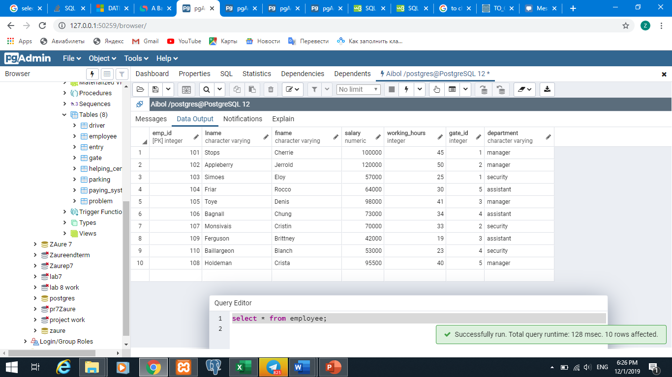

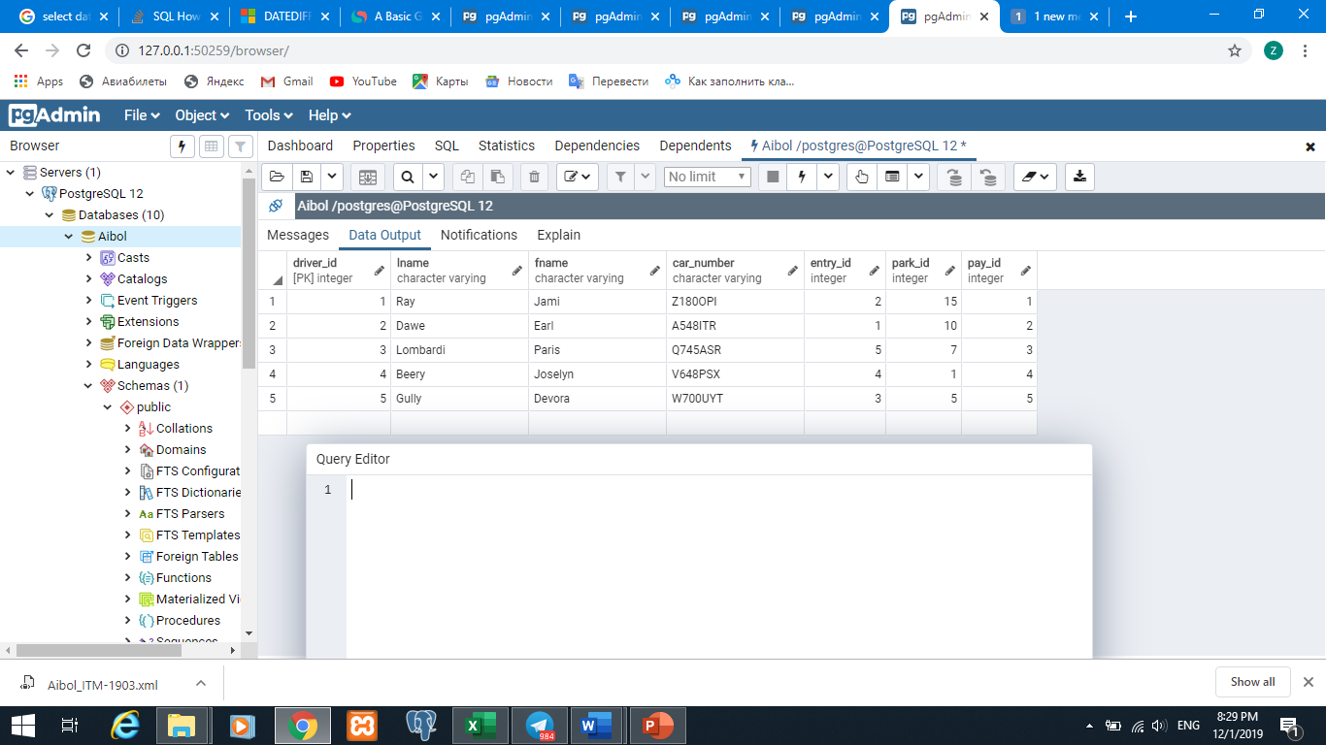

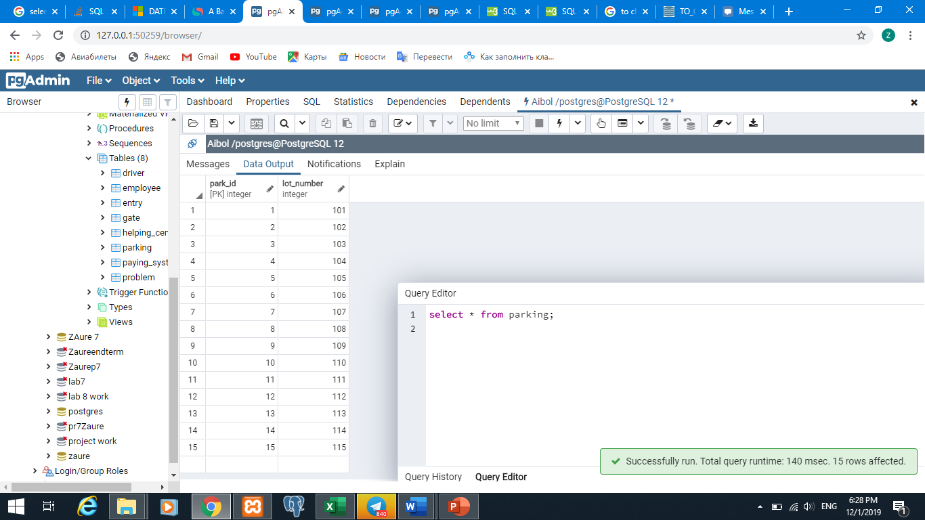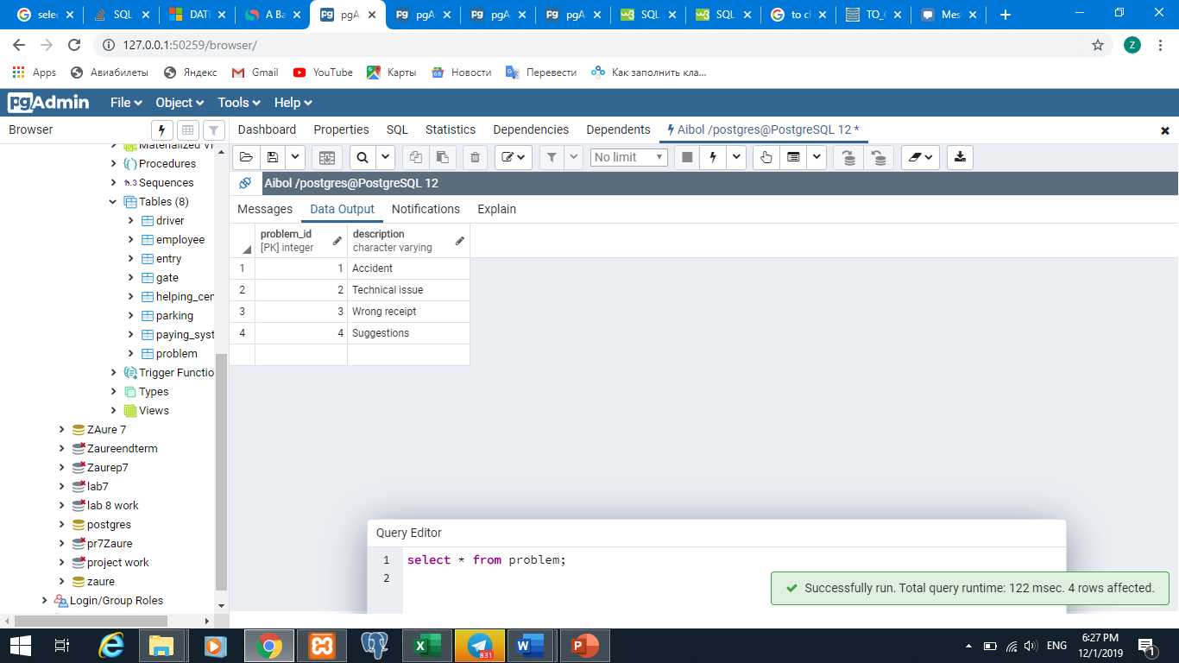

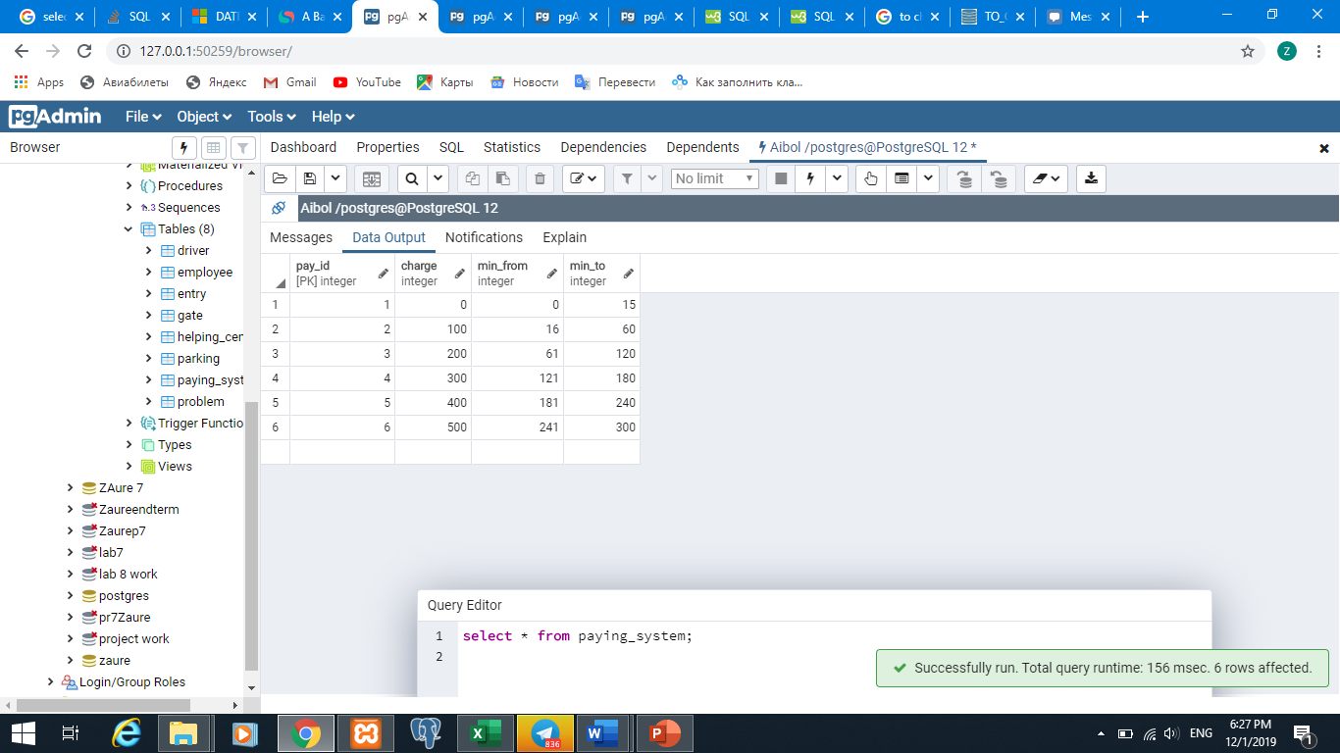

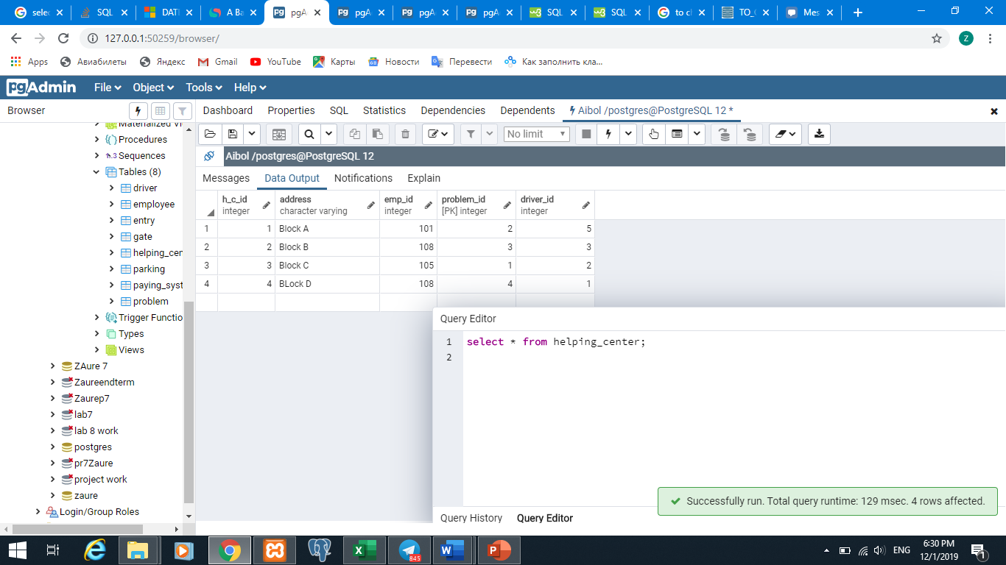

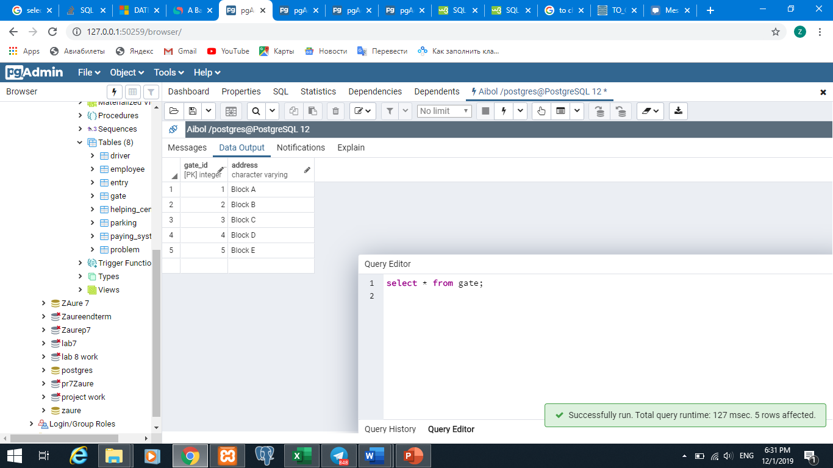

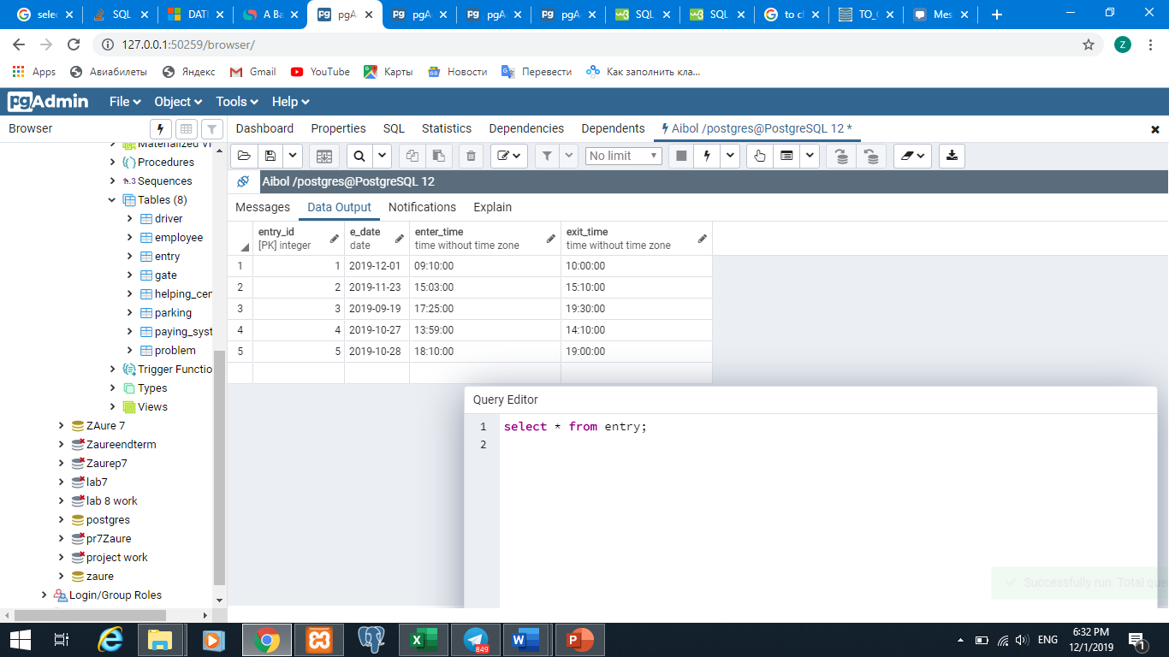

select distinct department from employee;

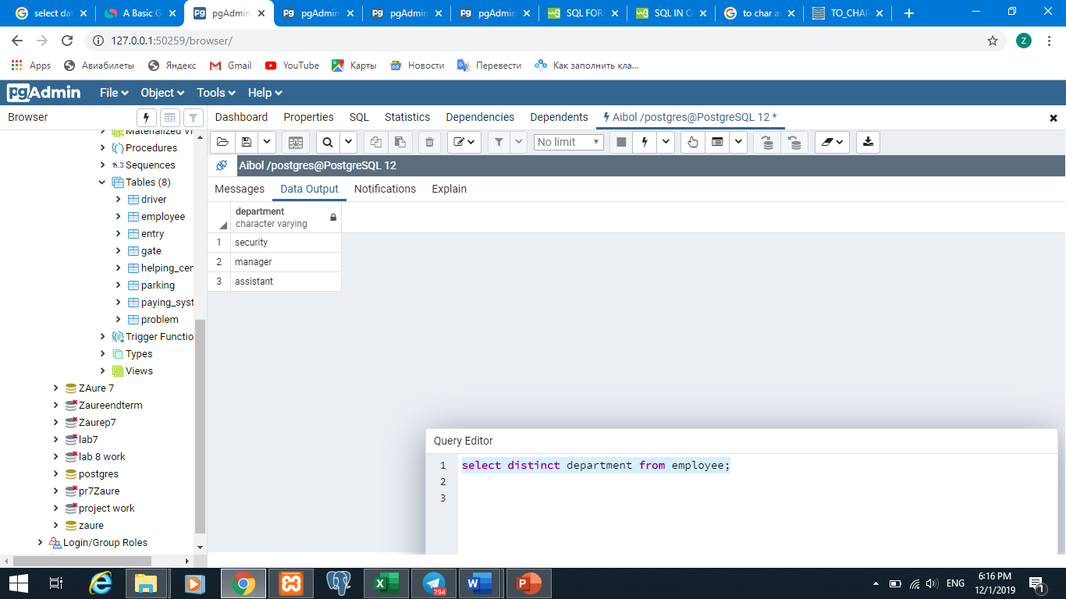

select lname, fname, department from employee

where salary >=70000;

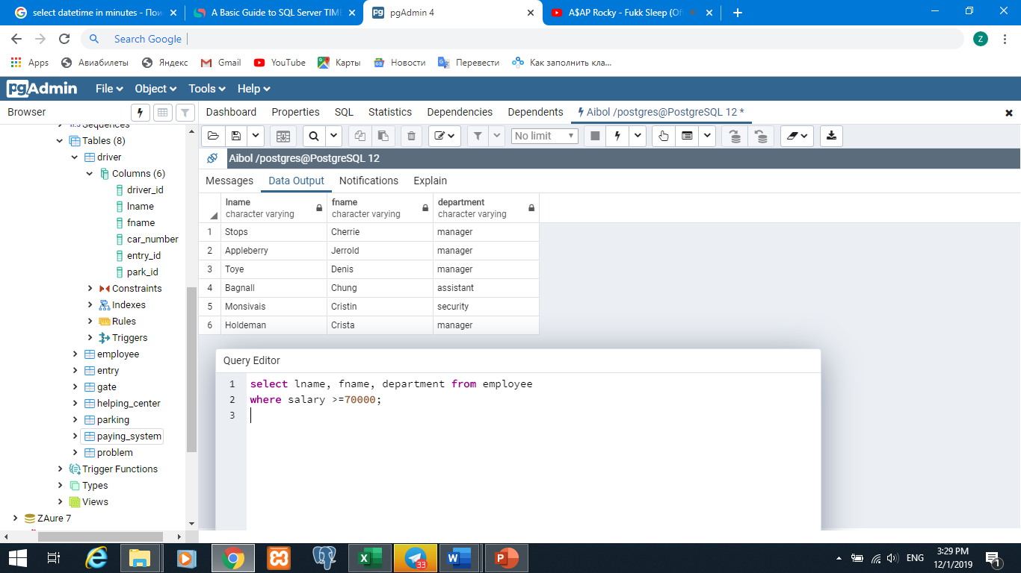

select fname, lname, gate_id from employee

where department = 'manager' or department = 'assistant';

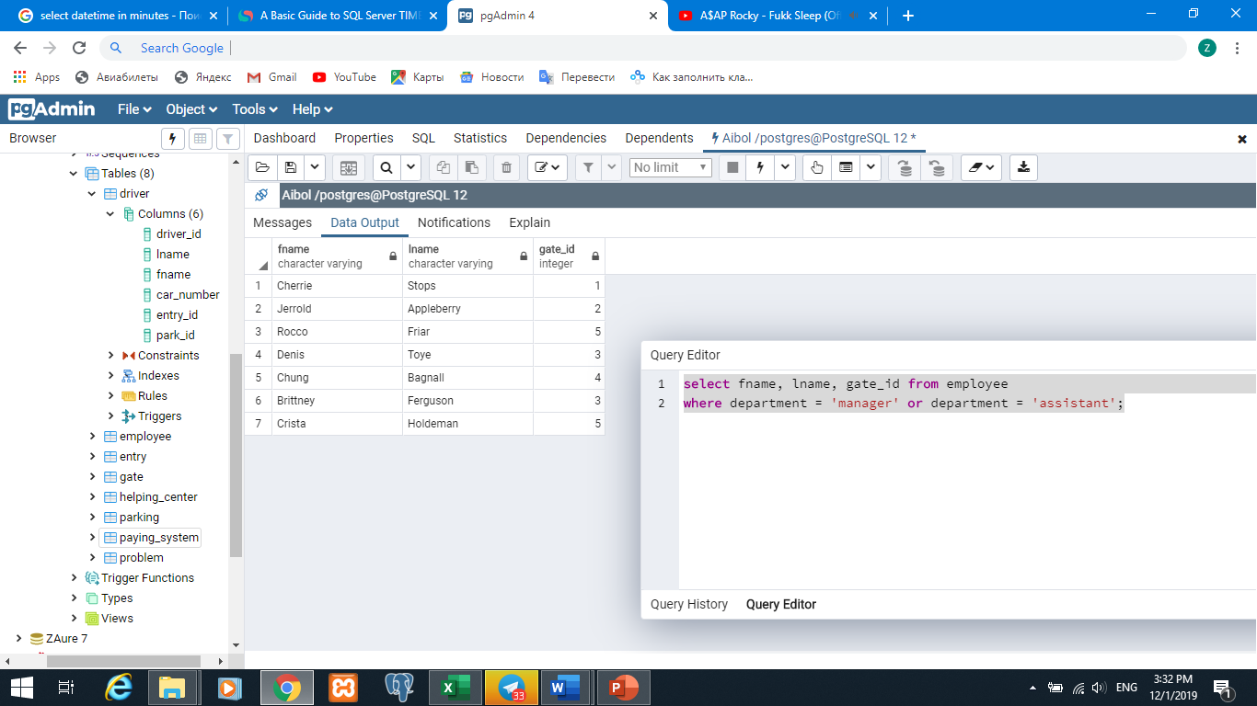

select fname, lname, gate_id from employee

where salary > (select min(salary) from employee)

and salary < (select max(salary) from employee);

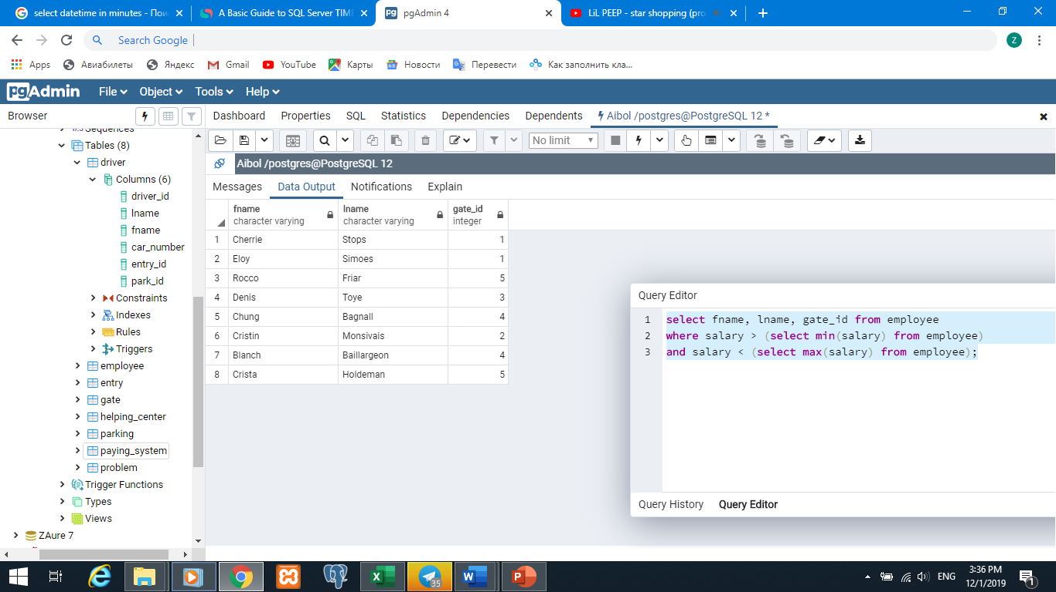

select driver_id, lname, fname, p.park_id from driver d

right join parking p on d.park_id=p.park_id

where p.lot_number between 101 and 110;

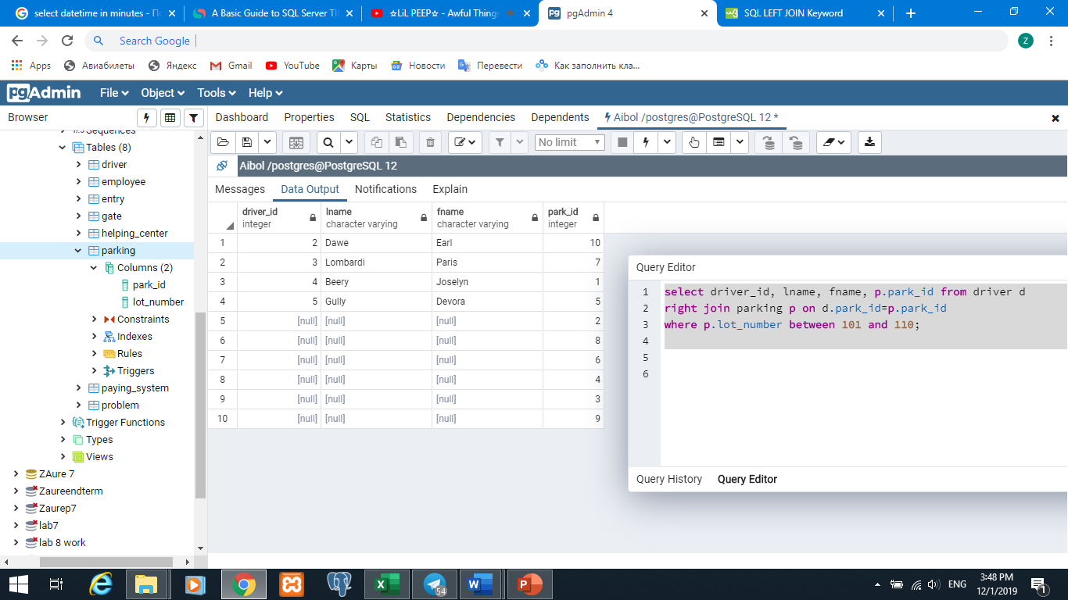

select emp_id, driver_id from helping_center hc

full join problem p on hc.problem_id=p.problem_id

where p.description in ('Accident', 'Suggestions');

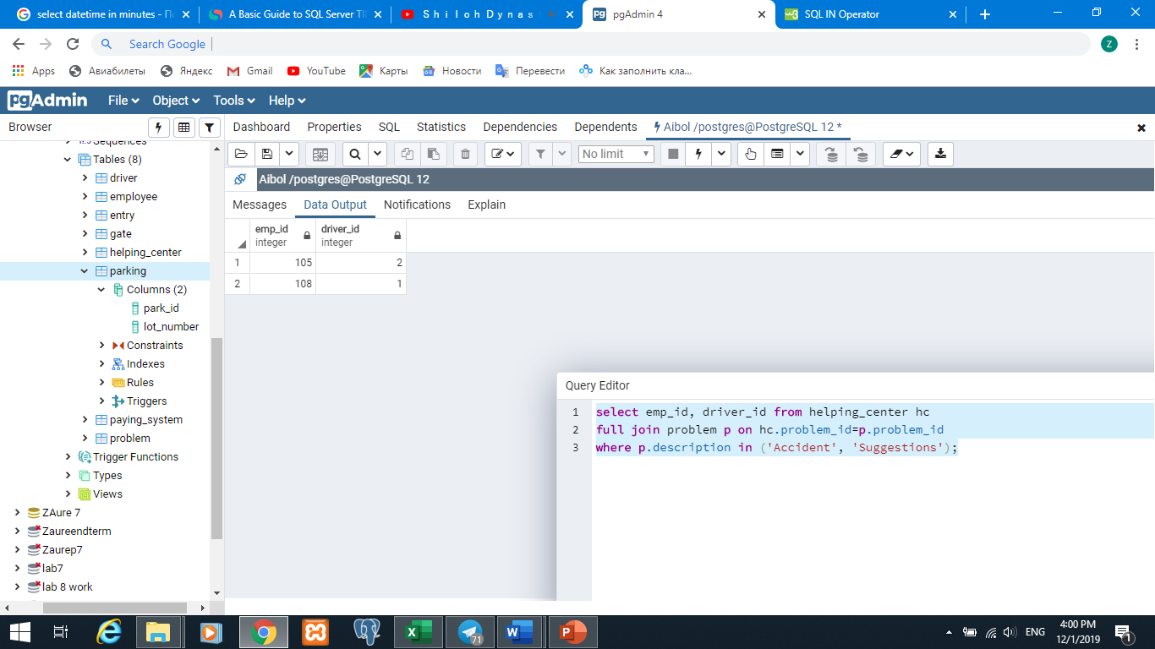

select fname,lname,salary

from employee

where fname like 'C%';

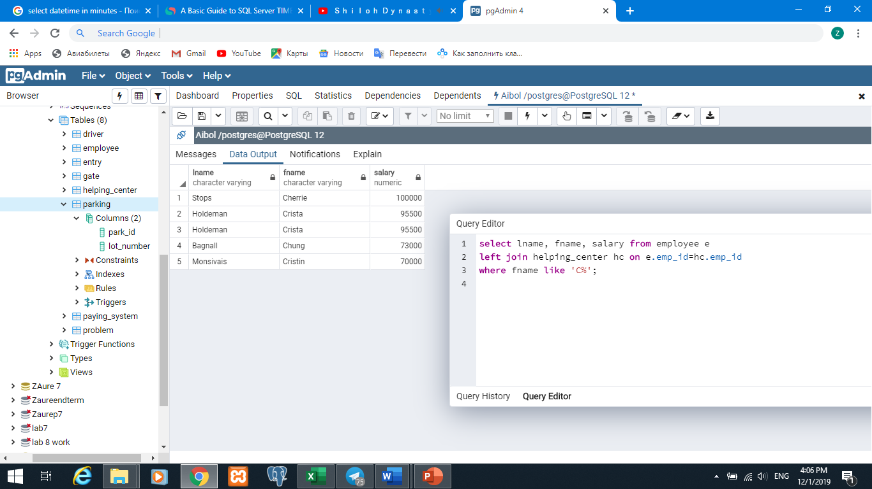

select fname, length(fname) as LengthOfName

from driver;

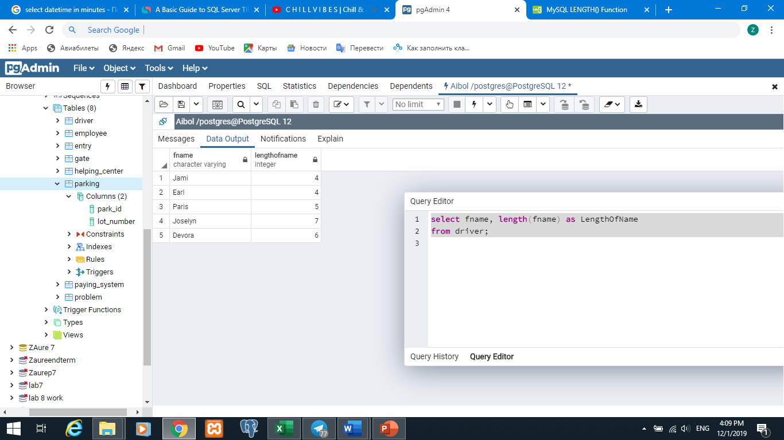

select count(emp_id), department from employee

group by department;

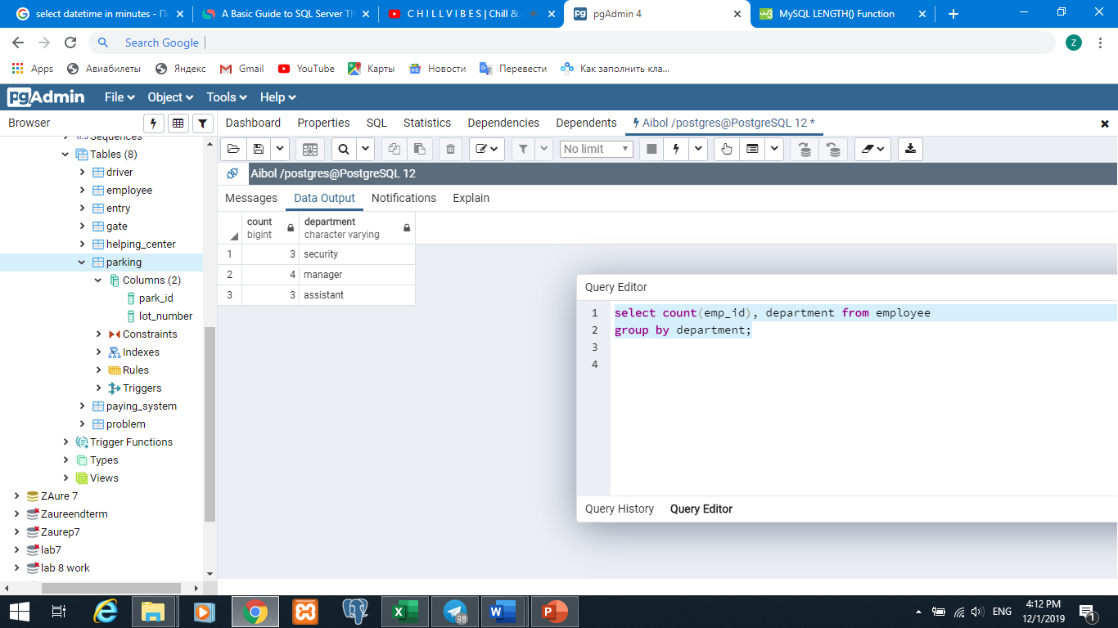

select sum(salary) as overall, avg(salary) as average_salary

from employee;

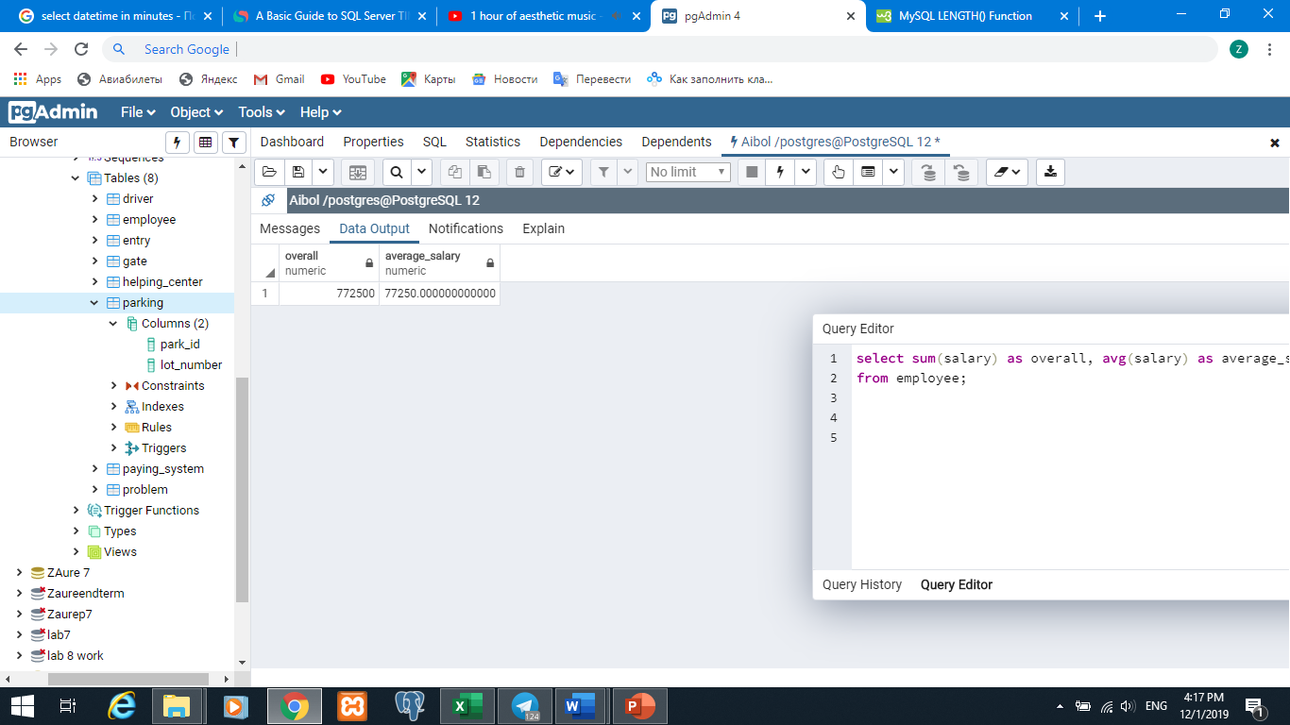

select date_part('minutes', (exit_time-enter_time)::interval) as time_on_park, p.charge, d.driver_id

from entry e

inner join driver d

on e.entry_id=d.entry_id

left join paying_system p

on d.pay_id=p.pay_id

where d.driver_id= 3;

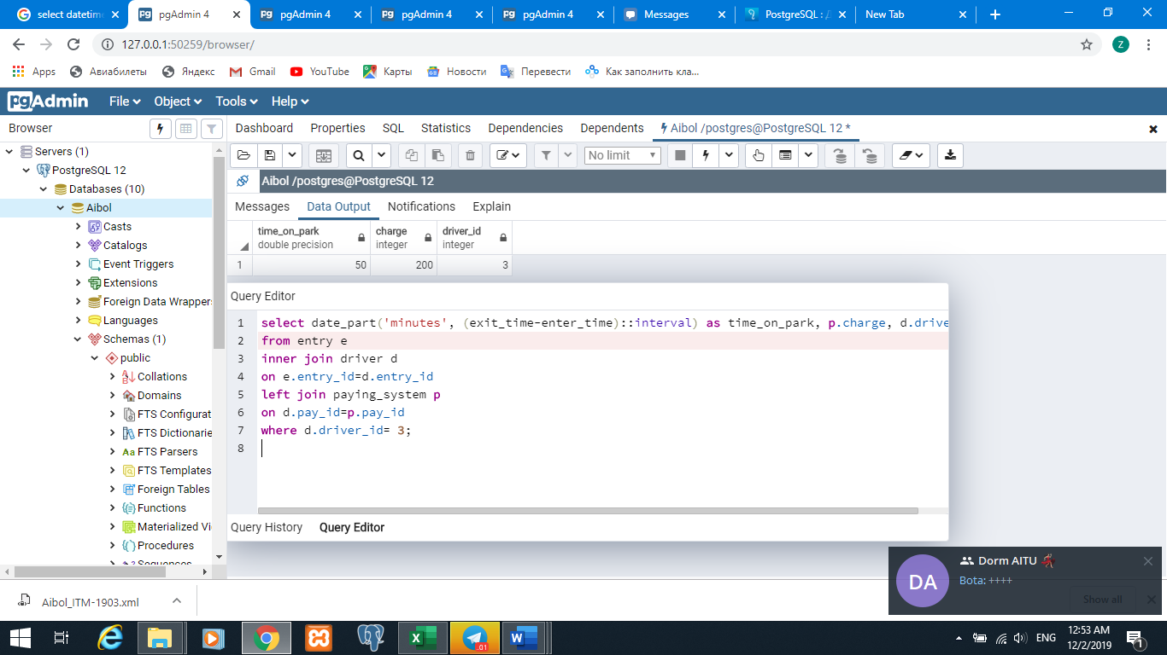

select gate_id, address from gate g

where exists (select fname, lname from employee e

where g.gate_id=e.gate_id and salary> 50000);

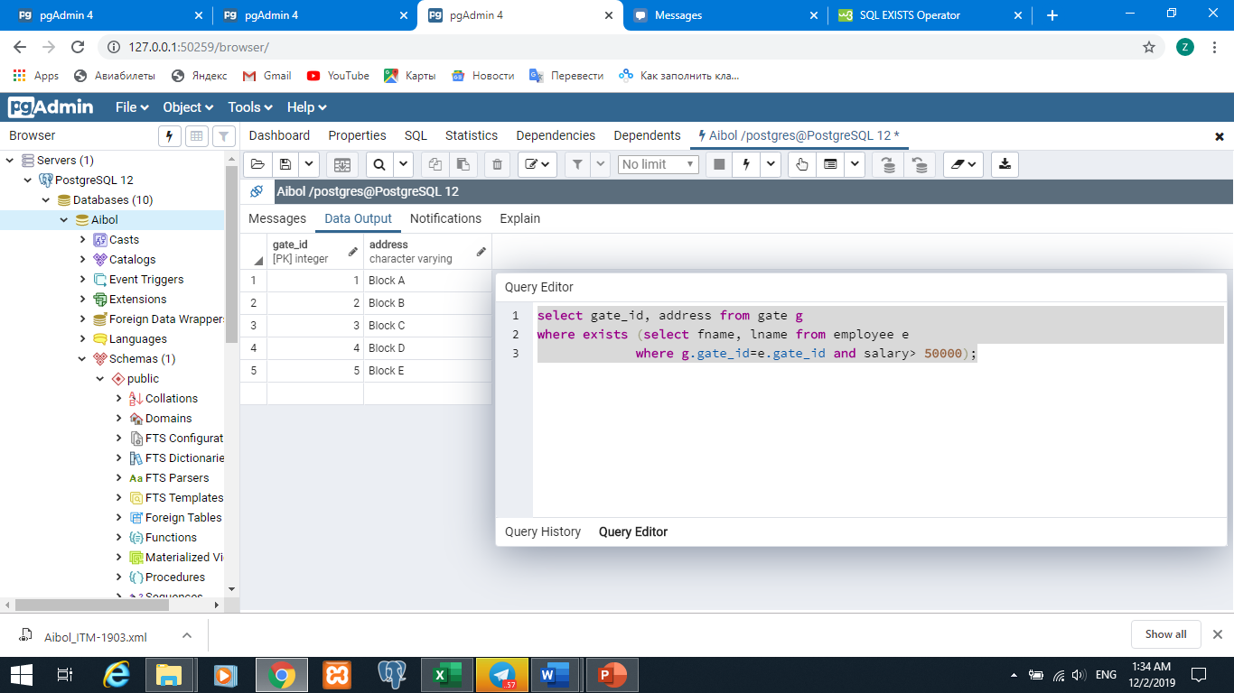

select fname, lname from employee

where salary >= all(select salary from employee);

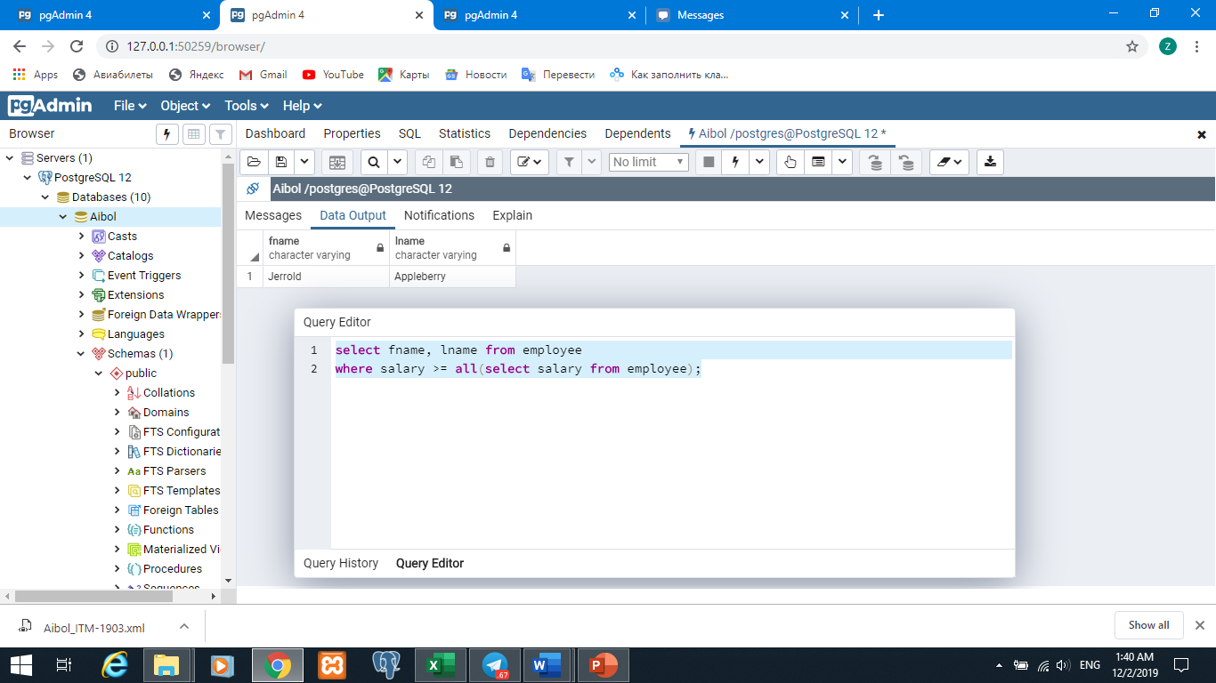

select fname, lname from employee

where salary > any(select salary from employee);

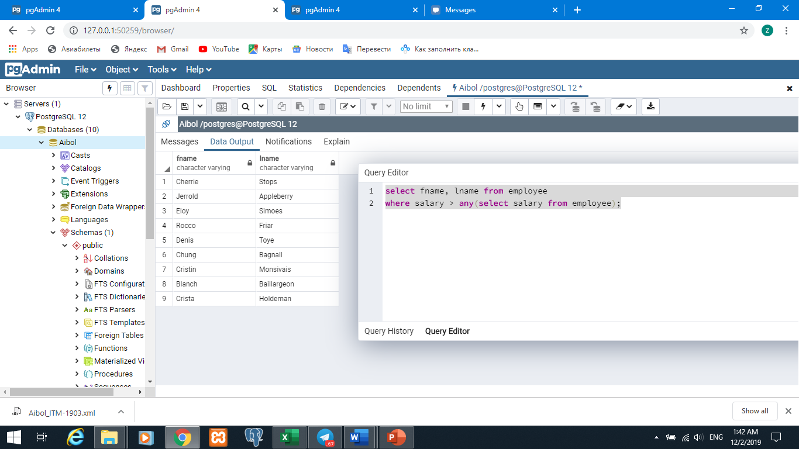

select gate_id, address from gate g

where not exists (select fname, lname from employee e

where g.gate_id=e.gate_id and salary > 50000);



