Original annotation for vertical hand position:
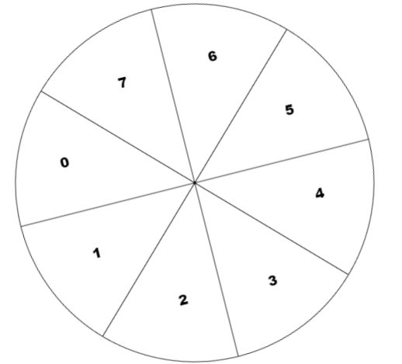

Transformed annotation for z:

Original | new
0 | 2
1 | 1
2 | 0
3 | 1
4 | 2
5 | 3
6 | 4
7 | 3

