Project Analysis

What we did and how to use it

**CODING PART:**

We developed a music lesson app using the asp.net core MVC framework.

We have created six models:

1. Student: In the student model you can CREATE, EDIT, DELETE and find details of

And you will find:

* + First name:
  + Last Name
  + Date of Birth
  + Guardian Name
  + VALID Email address (if you don’t put “@” it will display an error)
  + Phone
  + Age (Automatically calculated using Date of Birth)

Student model is connected to **lesson list** where you will see more specific details of student, e.g.

* The instrument student is learning
* The tutor teaching the instrument
* The term semester and year student is enrolled followed by the lesson date ,time and duration.
* There is also a payment status which shows “PAID OR UNPAID” status.

1. **Letter Model:**

* Once we click on “submit” button on lesson list it takes us to “**LETTER MODEL”** where we can create a invoice letter to the student. The letter will consist of the following information:
* Beginning Comment
* Signature
* Bank Account
* BSB
* ACCOUNT NUMBER
* TERM
* SEMESTER
* YEAR

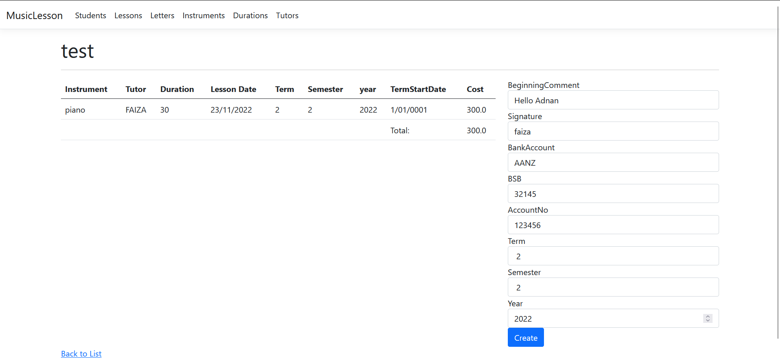

* Once we click on “create” button on **letter** model list it adds the student’s name on the top of invoice and provides a unique reference number in the invoice.

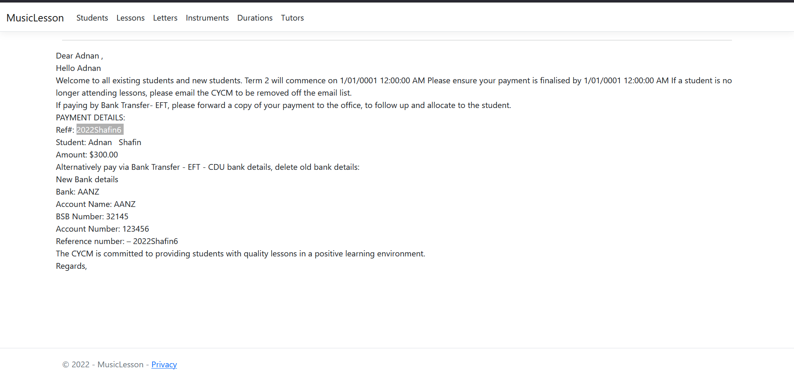

1. Lesson In the student model you can CREATE, EDIT, DELETE

And you will find:

* Student ID : obtain from student model
* Instrument ID : obtain from instrument model
* Tutor ID : obtain from tutor model
* Duration ID: obtain from duration model
* Letter ID : obtain from letter model
* Lesson Date time
* Term
* Semester
* Year
* Term start date

1. Instrument: In the instrument model you can CREATE, EDIT, DELETE and you can create number of instruments by clicking on Create New button. These instruments can be selected from lesson list
2. Duration: In the Duration model you can CREATE, EDIT, DELETE and you can create different slots of duration and set the price accordingly by clicking on Create New button. This durations can be selected from lesson list
3. Tutor: In the Tutor model you can CREATE, EDIT, DELETE and you can add a number of tutors by clicking on Create New button. These tutors can be selected from lesson list

**Documentation PART:**

Documents for HIT 339:

i. Requirements : ‘what we need to do’…………….SARIKA

ii. Architecture/Design ‘how we intend to do it………. SARIKA

iii. Technical ‘what we did’…………..FAIZA

iv. End User ’how to use it………….FAIZA ZAVERIA

v. Marketing ’look what we did!’………. ZAVERIA

1. **Installation and Running Instructions** : This section should include instructions on how someone new can install your application on their computer for running and further development. Please make sure that you test these instructions by sending the code to a computer that does not already have the project. If these instructions don’t work at my end, you will lose marks. You can assume that they have .net 6 core and the latest copy of visual study community. If there is something “different” about your project (MAC OS, .net 5, SQLite, etc) please make sure you indicate that here and change your instructions to suit……. FAIZA

**vii. User Guide:** This is where you write a brief guide on how to use your application. Like the installation instructions, you should have this guide peer reviewed………….. SARIKA

**viii. Project Plan:** This plan should be made up of several parts:…… ZAVERIA

1. The team contract(s)

2. The requirements document, and your notes

3. Your team’s approach to completing the project

4. Links to any websites used to manage the project, with at-least “read” credentials

5. Tasks, broken down into manageable chunks with hours and allocations

6. Meeting minutes

7. Your team’s strengths and weaknesses