**Store Management**

**Introduction**

Store Management project have two modules

1. Category
2. Product

User can add, modify and delete Category and Product.

If category is used by any product then user can not delete category.

**Technical Specification**

**Technologies Used :** MVC & Web API (C#.NET), JQuery

**Error Handling :** ELMAH

**Requred Tool to Execute Project**

Visual Studio 2019 (Preferred)

SQL Server 2016 (Prefered)

**Setup Development Environment**

Solution contains 3 projects

1. Store Schema
2. Store Management API
3. Store Management

**Store Management API - Web API - Setup**

To configure Web API –

1. Open *web.config*
2. Search for *StoreDBEntities*
3. Use following guidelines to update connection string

Configuration with Integrated Security

<add name="StoreDBEntities" connectionString="metadata=res://*/Models.DataLayer.StoreDBModel.csdl|res://*/Models.DataLayer.StoreDBModel.ssdl|res://*/Models.DataLayer.StoreDBModel.msl;provider=System.Data.SqlClient;provider connection string=&quot;data source=(localDB)\MSSQLLocalDB;initial catalog=StoreDB;integrated security=True;MultipleActiveResultSets=True;App=EntityFramework&quot;" providerName="System.Data.EntityClient" />

Database Name – Change to your Database Name

Database Server – Change to your Database Server Name/IP

Configuration with SQL Server Authentication

<add name="StoreDBEntities" connectionString="metadata=res://*/Models.DataLayer.StoreDBModel.csdl|res://*/Models.DataLayer.StoreDBModel.ssdl|res://*/Models.DataLayer.StoreDBModel.msl;provider=System.Data.SqlClient;provider connection string=&quot;data source=(localDB)\MSSQLLocalDB;initial catalog=StoreDB;User ID=username;Password=passwd;MultipleActiveResultSets=True;App=EntityFramework&quot;" providerName="System.Data.EntityClient" />

Database Name – Change to your Database Name

Database Server – Change to your Database Server Name/IP

User ID – Change to your SQL User ID

Password – Change to your SQL Password

**Store Management – UI – Setup**

To configure UI –

1. Open *web.config*
2. Search for *WebAPIUrl*
3. Use following guidelines to update connection string

Configuration

<add key="WebAPIUrl" value="http://localhost:58743" />

API Link – Web API Link

**Database Setup**

1. Open SQL Server Management Studio
2. Open New Query
3. Point to the database where project should be setup
4. Execute *dbscript.sql*

**Application Execution Process**

1. Right click on solution and go to properties

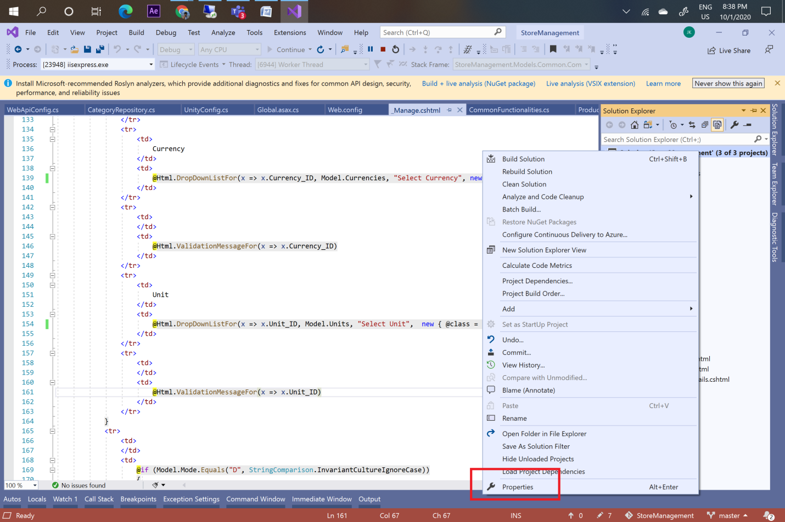

1. Select Multiple setup option and do following changes. You can change sequence of execution using arrow button.

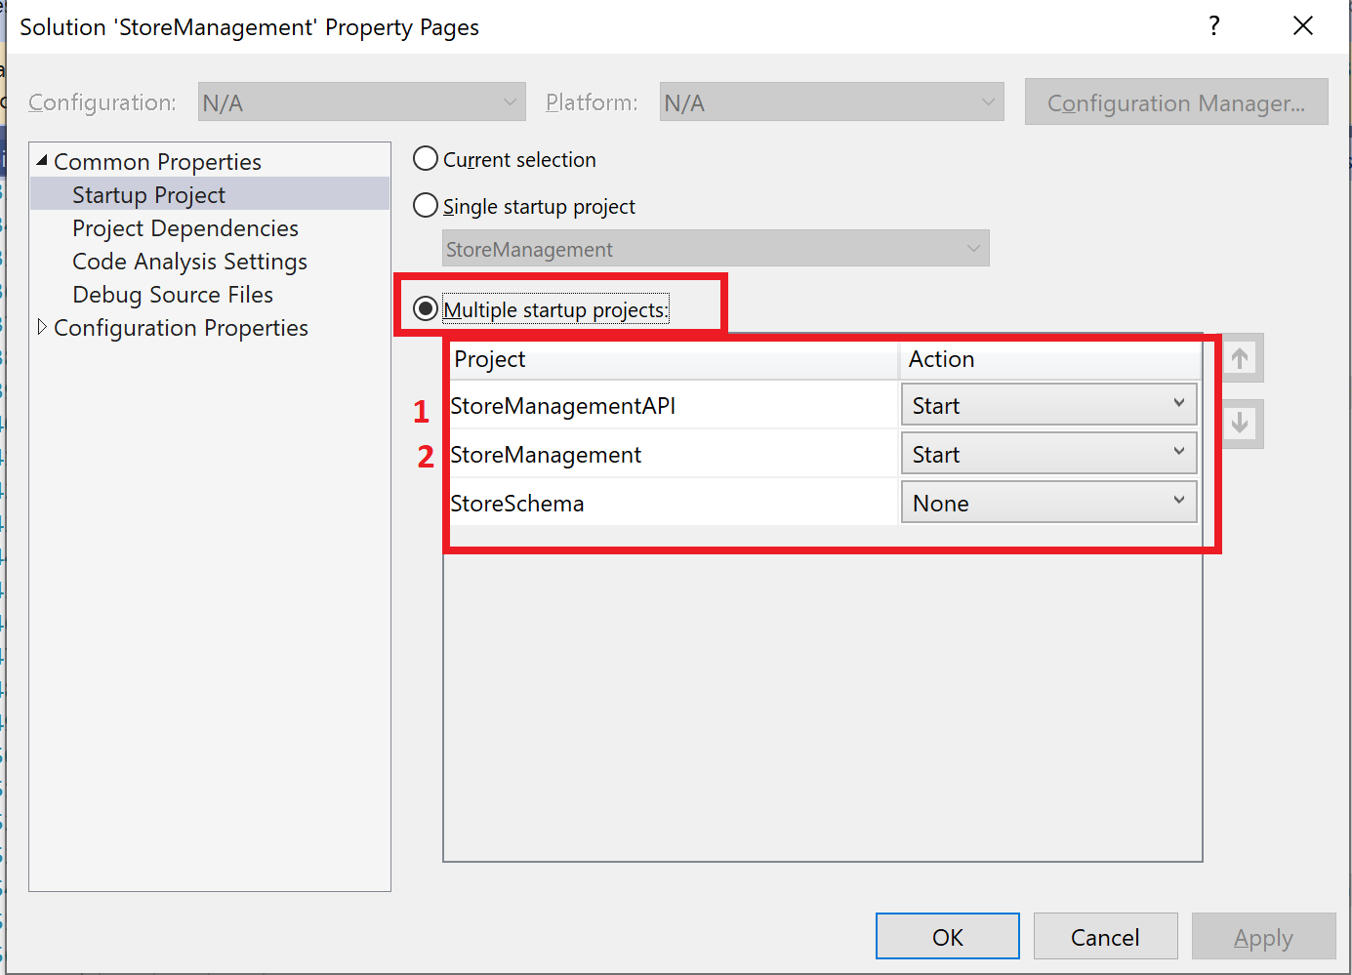

1. Please note that URL of your Store Management API project (from browser) must be configured as *WebAPIUrl* value for Store Management project

**Application Overview**

**Product Screen**

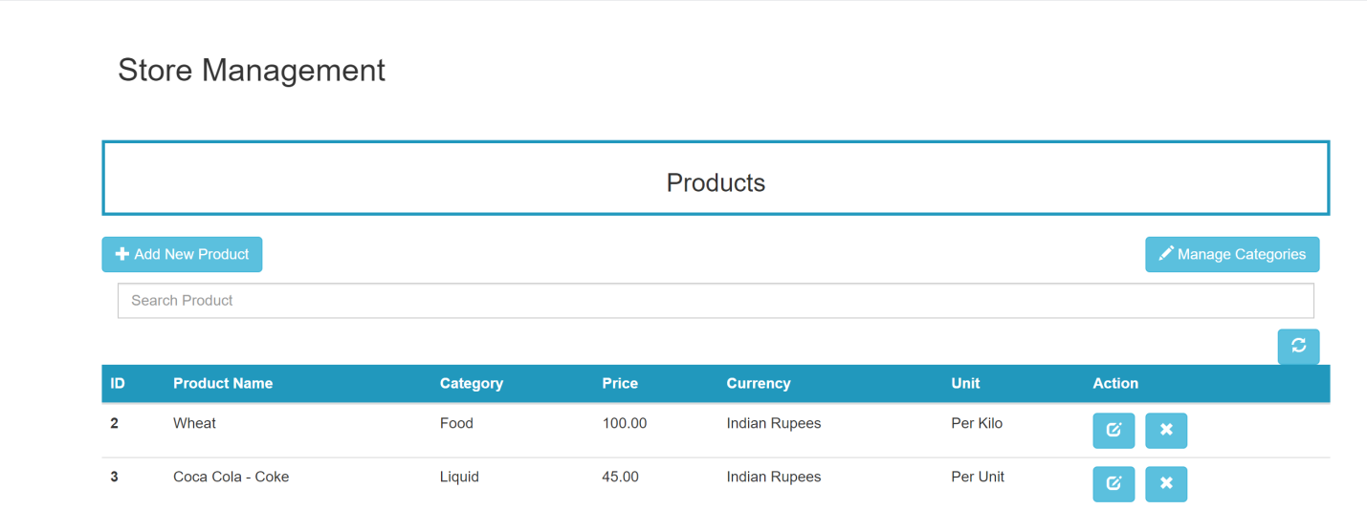

**Category Screen**

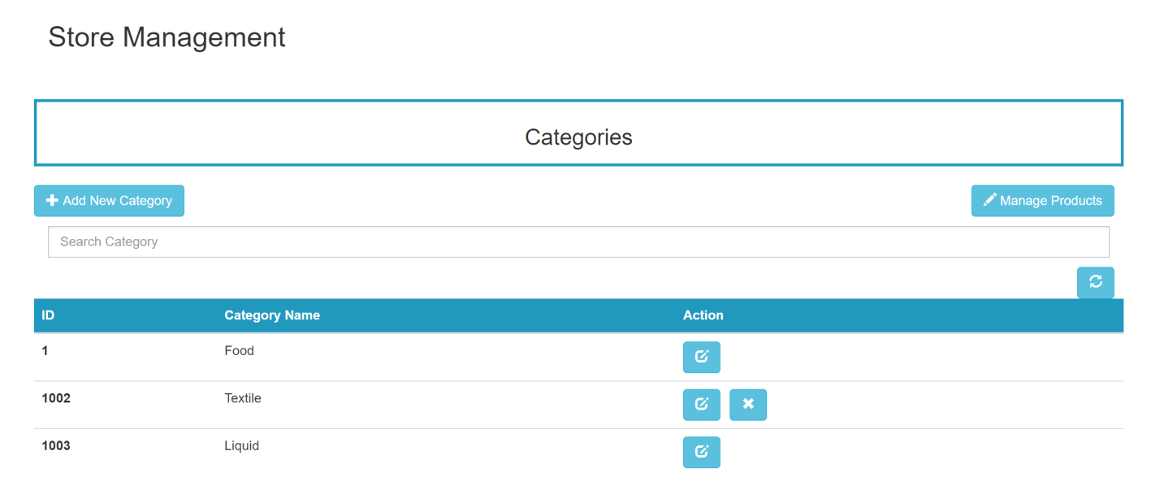

**Button Annotations**



Click to Add New Product



Click to to go to Category Screen



Click to to Add New Category



Click to go to Product Screen



Click to edit current item



Click to delete current item



Click to delete refresh item list

**Important Notes**

* Kindly execute dbscript.sql file in database
* Do the highlighted changes (if required or port changed)
* Execute API and UI application (Better to execute in same sequence)
* Kindly reach out on [zaviiee@gmail.com](mailto:zaviiee@gmail.com) for any queries