MALWARE ANALYSIS WRITE-UP
Oski Lab — Stealc Infostealer
Muhammad Zawar Khattak
Cybersecurity Analyst · SOC Tier 1 · Threat Intelligence
CyberDefenders | SOC Analyst Tier 1 — Level 1 | Score: 7 / 7 ✓ 100% Complete

Incident Overview
⚠ SIEM ALERT: Potentially malicious file download — PPT attachment in phishing email "Urgent New Order"
A company accountant received a phishing email titled "Urgent New Order" from an apparent client. Upon opening the attached invoice, the file contained false order information and simultaneously triggered a SIEM alert for a malicious file download.
Initial investigation revealed a PowerPoint (PPT) file as the delivery mechanism for Stealc — a sophisticated infostealer capable of credential theft, C2 communication, and self-deletion post-exfiltration. I analyzed the full malware lifecycle using VirusTotal, Recorded Future Triage, and Any.Run sandbox reports, mapping all observed behaviors to MITRE ATT&CK.
Sample SHA256: a040a0af8697e30506218103074c7d6ea77a84ba3ac1ee5efae20f15530a19bb
Case Metadata
Field | Details
Platform | CyberDefenders
Lab | Oski Lab
Track | SOC Analyst Tier 1 · Level 1
Category | Threat Intelligence
Malware Family | Stealc Infostealer
Delivery Method | Phishing Email — PPT Attachment
Tools Used | Any.Run · VirusTotal · Recorded Future Triage · MITRE ATT&CK
Final Score | 7 / 7 — 100% Completed ✓

Malware Threat Profile — Stealc
Attribute | Value
Malware Type | Infostealer / Credential Harvester
PE Compile Timestamp | 2022-09-28 17:40
C2 Beacon URL | http://171.22.28.221/5c06c05b7b34e8e6.php
DLL Download URL | http://171.22.28.221/9e226a84ec50246d/sqlite3.dll
First Library Request | sqlite3.dll
RC4 Decryption Key | 5329514621441247975720749009
Credential Technique | T1555 — Credentials from Password Stores
DLL Staging Directory | C:\ProgramData\
Self-Destruct Command | cmd.exe /c timeout /t 5 & del /f /q C:\ProgramData\*.dll & exit
Self-Destruct Delay | 5 seconds (/t 5)

Full Analysis — All 7 Questions
Q1 · Malware Forensics · Timestamp Analysis
What was the time of malware creation?
ANSWER: 2022-09-28 17:40 ✓
I uploaded the sample SHA256 hash into VirusTotal and navigated to the Details tab to inspect the PE (Portable Executable) header metadata. The Creation Time field revealed the compilation timestamp: 2022-09-28 17:40. This anchors the malware to a known Stealc campaign period in late 2022, enabling correlation with other samples and threat actor activity from that period. Note: the PE timestamp was read directly from VirusTotal Details tab — no screenshot was captured for this step.
Q2 · C2 Attribution · Network IOCs
Which C2 server does the malware in the PPT file communicate with?
ANSWER: http://171.22.28.221/5c06c05b7b34e8e6.php ✓
I navigated to the Relations tab in VirusTotal and examined the Contacted URLs section. Two entries pointed to 171.22.28.221 — the primary entry ending in .php (C2 beacon endpoint, 12/97 engine detections) and a second entry for the sqlite3.dll download path. I then pivoted to the VirusTotal Community tab where an ANY_RUN analyst had posted a sandbox comment confirming the same C2 and providing a direct link to the full Any.Run task report for deeper behavioral analysis.
📷 EVIDENCE
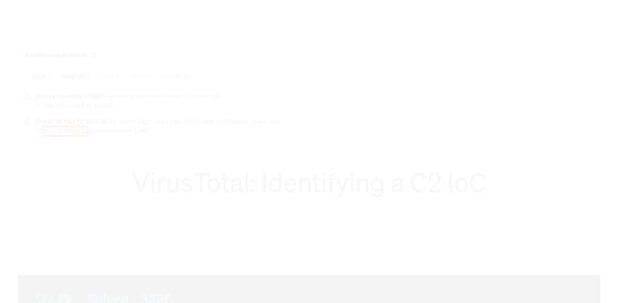
VirusTotal → Relations tab → Contacted URLs: C2 IP 171.22.28.221 highlighted with 12/97 engine detections, confirming the primary C2 beacon endpoint.
📷 EVIDENCE
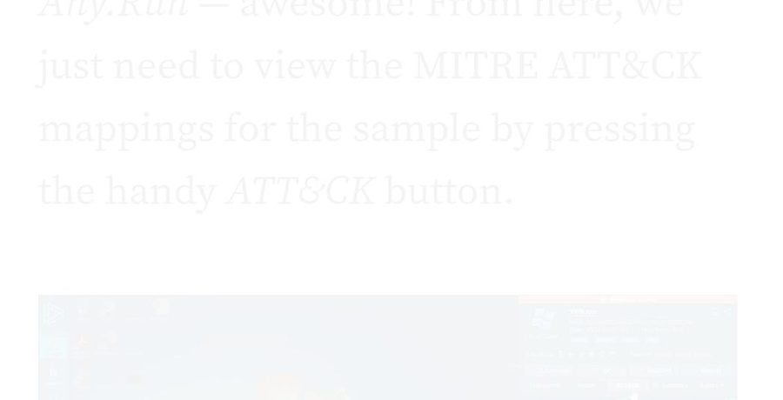
VirusTotal Community tab — ANY_RUN analyst comment confirming C2: http://171.22.28.221/5c06c05b7b34e8e6.php with tags stealc, stealer, loader, oski and a direct link to the sandbox report.
Q3 · Behavioral Analysis · Post-Infection Actions
What is the first library that the malware requests post-infection?
ANSWER: sqlite3.dll ✓
Inside the Any.Run sandbox report, I examined the HTTP Requests section under Network Communication in the Activity Summary. Immediately after execution, the malware issued a GET request to http://171.22.28.221/9e226a84ec50246d/sqlite3.dll — status code 200 OK confirming successful download. The choice of sqlite3.dll is deliberate: it is the SQLite library Stealc needs to directly query browser credential databases (Chrome Login Data, Firefox logins.json, Edge credentials). This is the exact moment credential harvesting begins on the victim machine.
📷 EVIDENCE
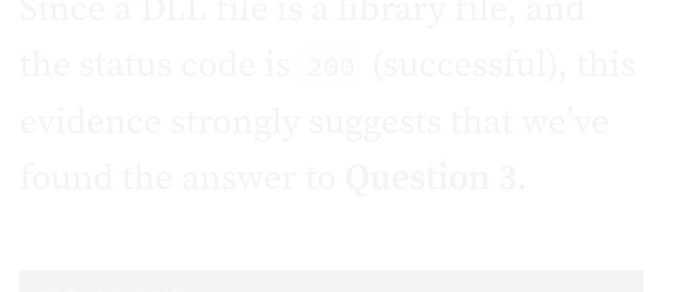
Any.Run Activity Summary → HTTP Requests: first GET request fetches sqlite3.dll from C2 at 171.22.28.221 (highlighted in yellow box), status 200 OK — successful download confirmed.
Q4 · Cryptographic Analysis · RC4 Decryption
What RC4 key is used by the malware to decrypt its base64-encoded string?
ANSWER: 5329514621441247975720749009 ✓
I searched Recorded Future Triage by submitting the sample SHA256 hash in the Reports search field. The result confirmed the sample with tags STEALC, DEFAULT, DISCOVERY, and STEALER — score 10, Reported. The config extraction section of the Triage report revealed the hardcoded RC4 numeric decryption key. Stealc uses RC4 symmetric encryption with a base64 outer wrapper to obfuscate its internal configuration blob including C2 URLs, browser target paths, and collection directives. Having this key enables an analyst to fully decrypt the config without executing the binary.
📷 EVIDENCE
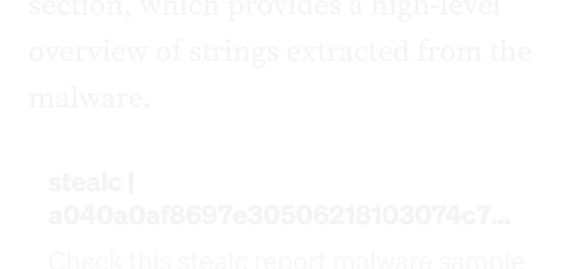
Recorded Future Triage → Reports → SHA256 hash search: sample confirmed as Stealc (STEALC, DEFAULT, DISCOVERY, STEALER tags), Status/Score 10 Reported — basis for RC4 key extraction.
Q5 · MITRE ATT&CK · Credential Access
What is the main MITRE technique the malware uses to steal the user's password?
ANSWER: T1555 — Credentials from Password Stores ✓
From the Any.Run sandbox session I clicked the ATT&CK button in the top navigation bar to open the interactive MITRE ATT&CK matrix populated with all techniques observed during the sandbox run. Under the Credential Access tactic column, Credentials from Password Stores (T1555, 1/6) was listed alongside Credentials from Web Browsers. T1555 directly explains the sqlite3.dll behavior from Q3 — Stealc uses SQLite to open Chrome's Login Data database and decrypt DPAPI-protected saved passwords, harvesting plaintext credentials from the victim's browser.
📷 EVIDENCE
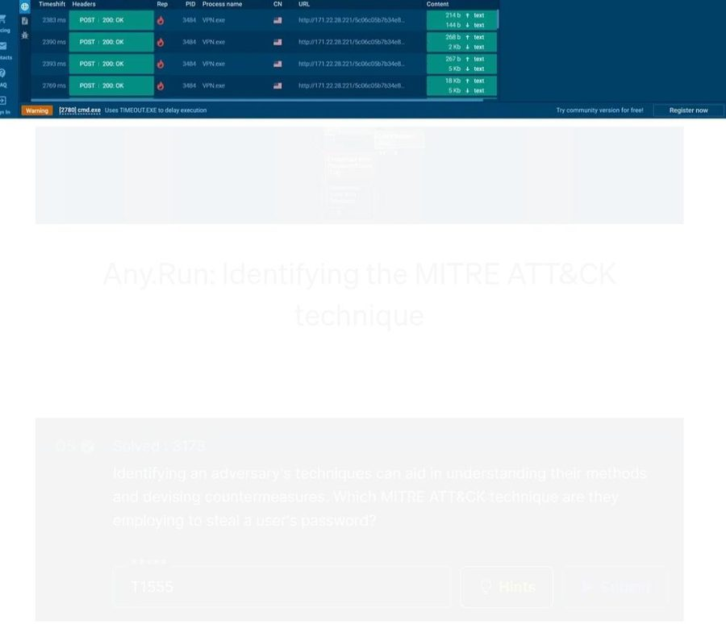
Any.Run sandbox — ATTACK button highlighted in the top navigation bar. HTTP network panel shows multiple POST 200 OK requests to 171.22.28.221 confirming active C2 communication and data exfiltration in progress.
📷 EVIDENCE
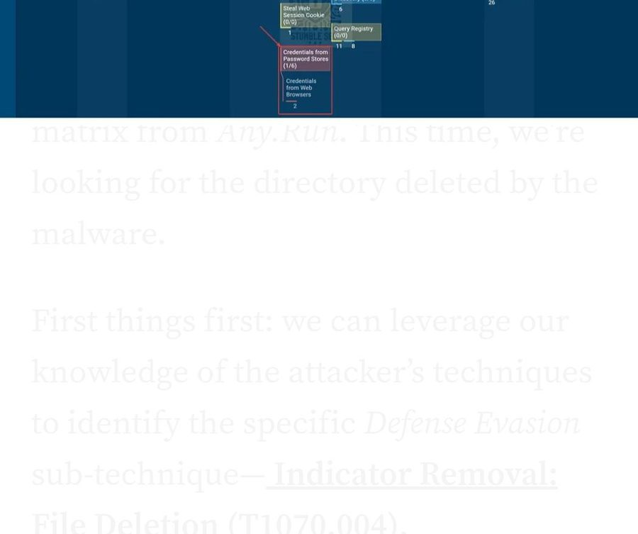
Any.Run MITRE ATT&CK Matrix — Credential Access column showing Credentials from Password Stores (1/6) and Credentials from Web Browsers — T1555 confirmed as the primary credential theft technique.
Q6 · Anti-Forensics · File Deletion
Which directory does the malware target for deletion of all DLL files?
ANSWER: C:\ProgramData\ ✓
In the Any.Run MITRE ATT&CK matrix I identified Defense Evasion → Indicator Removal: File Deletion (T1070.004) as a flagged technique. Clicking it opened the Technique Details window showing the exact sandbox-captured command line: cmd.exe /c timeout /t 5 & del /f /q VPN.exe & del C:\ProgramData\*.dll & exit. The del C:\ProgramData\*.dll portion explicitly targets C:\ProgramData\ — the directory where Stealc staged all downloaded libraries post-infection. This is a deliberate anti-forensics step to wipe evidence and complicate incident response recovery.
📷 EVIDENCE
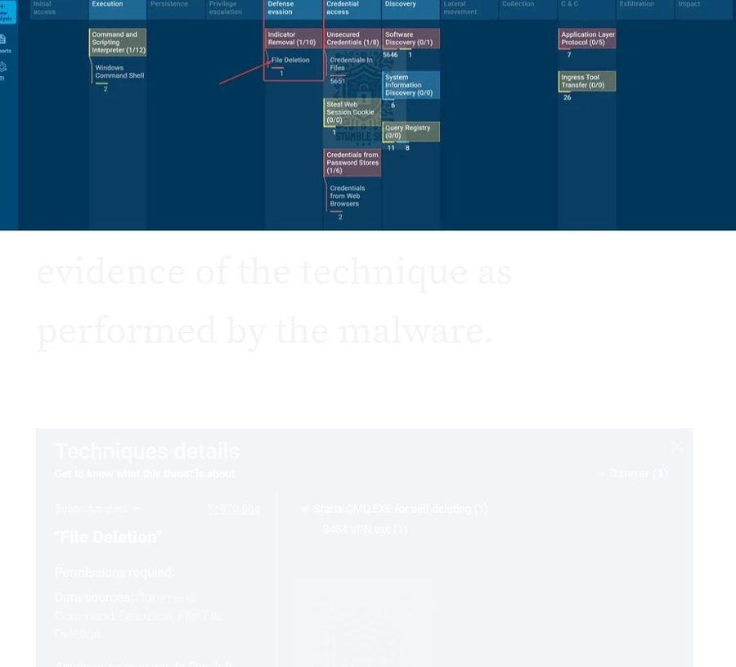
Any.Run MITRE ATT&CK Matrix — Defense Evasion column: Indicator Removal (1/10) → File Deletion (1) highlighted, confirming T1070.004 as the anti-forensics cleanup technique used by Stealc.
📷 EVIDENCE
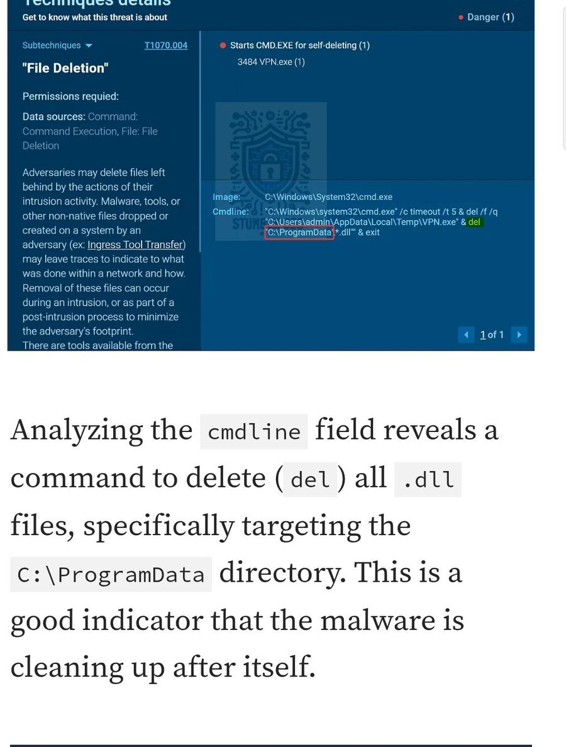
Technique Details window (T1070.004 "File Deletion") — cmdline field shows del "C:\ProgramData\*.dll" highlighted in red. Bottom: Q6 submitted with answer C:\ProgramData accepted by CyberDefenders.
Q7 · Defense Evasion · Self-Deletion Timer
After exfiltrating data, how many seconds does it take the malware to self-delete?
ANSWER: 5 seconds ✓
The same Technique Details window from Q6 answered this. The full cmdline was: cmd.exe /c timeout /t 5 & del /f /q VPN.exe & del C:\ProgramData\*.dll & exit. The /t 5 flag in the timeout command specifies a 5-second delay before the deletion commands execute. This is Stealc's post-exfiltration self-destruct timer — it waits 5 seconds after completing data theft then deletes the main executable and all staged DLLs, minimizing the on-disk window for endpoint detection tools to catch the binary.
📷 EVIDENCE
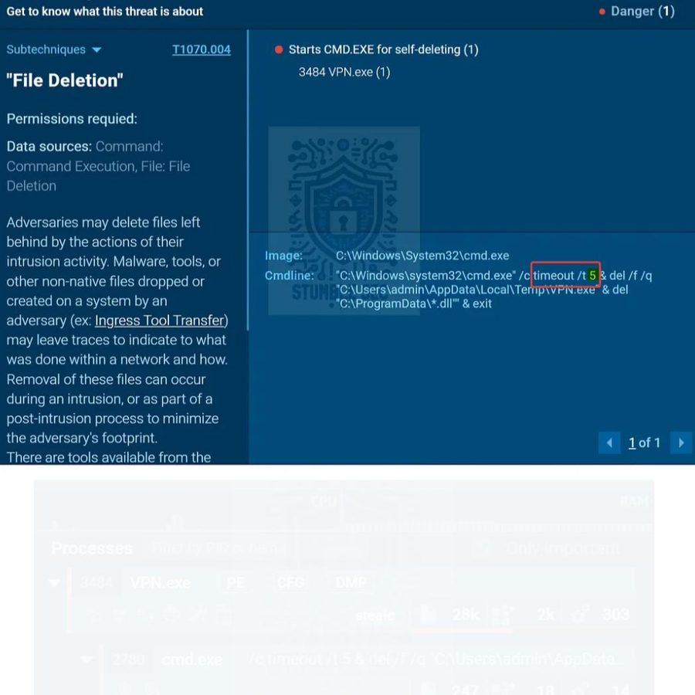
Technique Details window (T1070.004) — cmdline field with /t 5 highlighted in red box, confirming the 5-second self-deletion countdown timer. Stealc spawns cmd.exe to execute this cleanup chain post-exfiltration.
Stealc Attack Lifecycle
Phase 01 · Initial Access — T1566.001 Phishing Email — "Urgent New Order"
A company accountant received a social-engineered phishing email with a malicious PPT attachment. Urgency framing bypassed human suspicion. SIEM detected the subsequent malicious file download event.
Phase 02 · Execution — T1059 PPT File Drops Stealc Payload
The PowerPoint file executed a macro/embedded link triggering the Stealc binary download. Sample compiled 2022-09-28 17:40 was dropped and executed on the victim machine.
Phase 03 · Collection — T1555 sqlite3.dll — Browser Credential Harvesting
Stealc downloaded sqlite3.dll from 171.22.28.221 to parse browser password databases. RC4 key 5329514621441247975720749009 decrypted the obfuscated config including C2 URLs and browser target paths.
Phase 04 · Exfiltration + C2 — T1041 Credentials Exfiltrated via HTTP POST
Harvested credentials sent via repeated HTTP POST requests to http://171.22.28.221/5c06c05b7b34e8e6.php. Multiple 200 OK responses confirmed successful data exfiltration to the attacker-controlled server.
Phase 05 · Defense Evasion — T1070.004 DLL Cleanup + 5-Second Self-Destruct
Post-exfiltration: cmd.exe /c timeout /t 5 & del C:\ProgramData\*.dll & del VPN.exe — Stealc wipes all staged DLLs and self-deletes the binary after 5 seconds, eliminating on-disk forensic artifacts.
MITRE ATT&CK Coverage
TTP ID | Tactic | Technique | Observed Evidence
T1566.001 | Initial Access | Spearphishing Attachment | PPT file — Urgent New Order phishing email
T1059 | Execution | Command & Scripting Interpreter | PPT macro triggers Stealc binary download
T1027 | Defense Evasion | Obfuscated Files / RC4 | Base64 + RC4 key 5329514621441247975720749009
T1555 | Credential Access | Credentials from Password Stores | sqlite3.dll parses browser credential DBs
T1041 | Exfiltration | Exfiltration Over C2 Channel | HTTP POST to 171.22.28.221 — 200 OK confirmed
T1070.004 | Defense Evasion | Indicator Removal: File Deletion | del C:\ProgramData\*.dll + self-delete after 5s

Extracted IOCs
IOC Type | Value | Context
SHA256 Hash | a040a0af8697e30506218103074c7d6ea77a84ba3ac1ee5efae20f15530a19bb | Stealc binary
C2 IP Address | 171.22.28.221 | Command & Control server
C2 Beacon URL | http://171.22.28.221/5c06c05b7b34e8e6.php | Exfiltration endpoint
DLL Download URL | http://171.22.28.221/9e226a84ec50246d/sqlite3.dll | Credential harvesting library
RC4 Key | 5329514621441247975720749009 | Config decryption key
Staged DLL | sqlite3.dll | Browser DB parser
Staging Directory | C:\ProgramData\ | DLL drop & cleanup target
PE Compile Time | 2022-09-28 17:40 | Malware build timestamp
Self-Destruct Delay | 5 seconds (/t 5) | Post-exfil cleanup timer
Malware Family | Stealc | Infostealer / credential harvester

Tools & Skills Demonstrated
VirusTotal
PE metadata extraction, Contacted URLs / C2 attribution, community pivot to Any.Run sandbox
Any.Run
Interactive sandbox — HTTP requests, MITRE ATT&CK matrix, Technique Details, cmdline forensics
Recorded Future Triage
Hash search, Stealc family confirmation, RC4 key and config string extraction
MITRE ATT&CK
End-to-end TTP mapping across all 5 attack phases from initial access to self-deletion
IOC Extraction
C2 IPs, DLL names, RC4 keys, file paths, cmdline commands — full actionable threat intel set
Multi-Platform Pivoting
VirusTotal → Triage → Any.Run: cross-referencing evidence across 3 platforms
Defensive Takeaways
Block macro-enabled Office files at the email gateway.
All PPT/DOC attachments from external senders should be sandboxed or stripped of macros before delivery. This attack stops at Phase 01.
Block C2 IP 171.22.28.221 at the perimeter immediately.
Add to firewall blocklist and SIEM detection rules. Monitor for existing outbound connections — other hosts may already be compromised.
Disable browser-saved passwords on corporate devices.
Stealc's primary objective is browser credential theft via sqlite3.dll. Enforcing enterprise password managers removes the target entirely.
Automate sandbox detonation for all email attachments.
Every stage of this attack was visible in Any.Run. An automated sandbox pipeline would flag this before the user ever opens the file.
5 seconds is not enough for most EDR tools.
Stealc self-deletes in 5 seconds. Memory forensics, NetFlow, and PCAP captures are essential — disk-based EDR alone will miss it.
Monitor C:\ProgramData\ for unexpected DLL writes.
A simple detection rule flagging unexpected .dll drops to this directory catches the collection phase before exfiltration begins.
What I Learned
01. Multi-platform pivoting is essential.
No single tool gave me everything. Moving VirusTotal → Triage → Any.Run and cross-referencing evidence at each step is exactly how real threat intel investigations work in a SOC environment.
02. The cmdline field in sandbox Technique Details is gold.
The self-deletion command in Any.Run's T1070.004 details answered both Q6 and Q7 simultaneously. Knowing where to look inside a sandbox report is half the battle in threat analysis.
03. RC4 keys enable full static analysis without execution.
Extracting the decryption key from Triage means an analyst can fully decrypt Stealc's config blob without running the binary — making pre-execution IOC extraction safe and practical.
04. 5 seconds is alarmingly fast.
Stealc self-destructs in 5 seconds post-exfil. This reinforced why network-level detections (blocking C2 IPs, monitoring outbound POST requests) are far more reliable than disk-based EDR when dealing with modern infostealers.

Muhammad Zawar Khattak · CyberDefenders · Oski Lab · SOC Analyst Tier 1 · 7/7 Completed ✓

