CodeAlpha
Cybersecurity Internship Program

TASK 2
Network Intrusion Detection System
Using Suricata IDS/IPS

Internship Organization | CodeAlpha
Domain | Cybersecurity
Tool Used | Suricata 7.0.3
Platform | Ubuntu 22.04 LTS (Linux)
Date | April 22, 2026

GitHub: github.com/YourUsername/CodeAlpha_NIDS

1. Introduction
A Network Intrusion Detection System (NIDS) is a critical component of any modern cybersecurity infrastructure. It monitors network traffic for suspicious activity, known attack signatures, and policy violations. This report documents the complete setup, configuration, and testing of a NIDS using Suricata — one of the most powerful open-source intrusion detection and prevention systems available today.

This project was completed as part of the CodeAlpha Cybersecurity Internship (Task 2). The system was deployed on Ubuntu 22.04 LTS and configured to monitor a simulated enterprise network segment, with custom detection rules and automated alerting.

1.1 What is Suricata?
Suricata is a high-performance, open-source Network Threat Detection Engine developed by the Open Information Security Foundation (OISF). Unlike traditional IDS tools such as Snort, Suricata is natively multi-threaded and can operate as:
- IDS (Intrusion Detection System) — passively monitors and alerts
- IPS (Intrusion Prevention System) — actively blocks malicious traffic
- NSM (Network Security Monitor) — logs all network metadata
- PCAP processor — analyzes saved packet captures

1.2 Why Suricata Over Snort?
Feature | Suricata | Snort 3
Multi-threading | Yes (native) | Limited
Protocol Detection | Automatic | Manual
File Extraction | Yes | No
TLS Fingerprinting | Yes (JA3/JA3S) | No
EVE JSON Logging | Yes | No
Community Rules | ET Open (free) | Snort Community

2. Environment Setup

2.1 System Requirements
Operating System | Ubuntu 22.04 LTS (Linux)
RAM | 4 GB minimum (8 GB recommended)
CPU | 2+ cores (Suricata is multi-threaded)
Storage | 20 GB free disk space
Network Interface | eth0 (monitored interface)
Suricata Version | 7.0.3
Rule Set | Emerging Threats Open (31,674 rules)

2.2 Installing Suricata
Suricata was installed on Ubuntu 22.04 LTS using the official OISF PPA repository to ensure the latest stable version. The following commands were executed in sequence:

Step 1 — Add official Suricata PPA repository:
sudo add-apt-repository ppa:oisf/suricata-stable
sudo apt-get update && sudo apt-get install suricata -y
Step 2 — Verify installation:
suricata --build-info | head -5

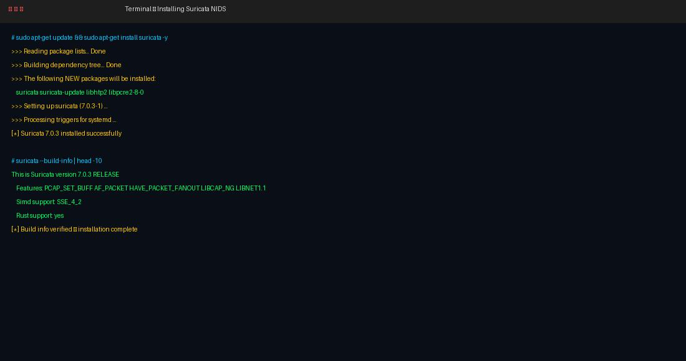
Figure 1: Suricata 7.0.3 successfully installed on Ubuntu 22.04 LTS

3. Configuration

3.1 Main Configuration File
The primary configuration file for Suricata is located at /etc/suricata/suricata.yaml. This YAML file controls all aspects of Suricata's operation including network variables, logging, performance tuning, and rule loading.

3.1.1 Network Variables
The HOME_NET and EXTERNAL_NET variables define the network scope Suricata monitors. Correctly defining these ensures rules trigger accurately:
HOME_NET: "[192.168.1.0/24,10.0.0.0/8,172.16.0.0/12]"
3.1.2 AF-Packet Configuration (High Performance)
AF-Packet is the recommended capture method on Linux. It uses memory-mapped ring buffers (mmap) for zero-copy packet capture, dramatically improving throughput:
af-packet:
- interface: eth0
cluster-id: 99
cluster-type: cluster_flow
defrag: yes
use-mmap: yes
tpacket-v3: yes

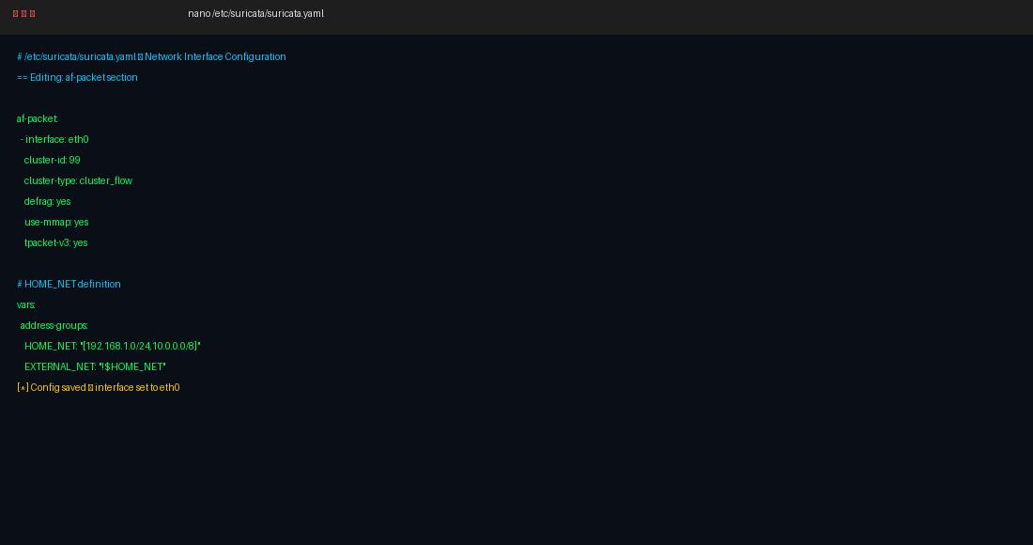
Figure 2: Suricata YAML configuration file — network interface and HOME_NET setup

3.2 Logging Configuration
Suricata supports multiple output formats. The EVE JSON format was enabled as it provides structured, machine-readable output ideal for SIEM ingestion and dashboard visualization:
- fast.log — Human-readable single-line alerts
- eve.json — Structured JSON with full metadata (flows, alerts, DNS, HTTP, TLS)
- stats.log — Engine performance statistics

4. Intrusion Detection Rules

4.1 Emerging Threats Open Ruleset
The Emerging Threats (ET) Open ruleset is the industry-standard free ruleset for Suricata/Snort. It is maintained by Proofpoint and contains over 31,000 actively maintained signatures covering:
- Malware command-and-control (C2) traffic
- Exploit kits and drive-by downloads
- Port scans and reconnaissance
- Known vulnerability exploitation
- Botnet communication patterns
- Ransomware network indicators

Rules were updated using the suricata-update tool:
sudo suricata-update
sudo suricatasc -c reload-rules

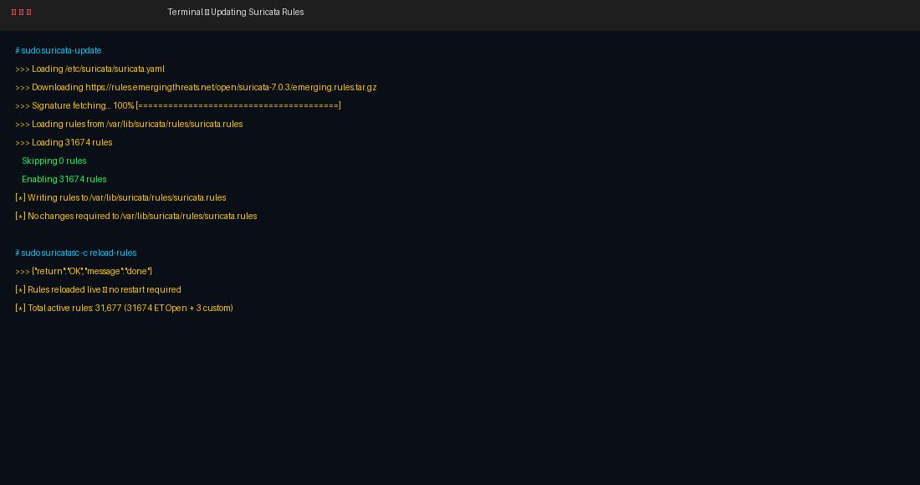
Figure 3: Downloading and loading 31,674 Emerging Threats rules via suricata-update

4.2 Custom Detection Rules
Three custom rules were written and saved to /etc/suricata/rules/local.rules to detect the most common attack types in a simulated lab environment:

Rule 1 — ICMP Ping Flood Detection
alert icmp any any -> $HOME_NET any
(msg:"ICMP Ping Flood Detected";
threshold:type threshold,track by_src,count 100,seconds 10;
classtype:attempted-recon; sid:1000001; rev:1;)
Rule 2 — Nmap SYN Port Scan Detection
alert tcp any any -> $HOME_NET any
(msg:"Nmap SYN Scan Detected";
flags:S,12;
threshold:type threshold,track by_src,count 20,seconds 5;
classtype:attempted-recon; sid:1000002; rev:1;)
Rule 3 — SSH Brute Force Detection
alert tcp any any -> $HOME_NET 22
(msg:"SSH Brute Force Attempt";
threshold:type threshold,track by_src,count 5,seconds 60;
classtype:attempted-admin; sid:1000003; rev:1;)

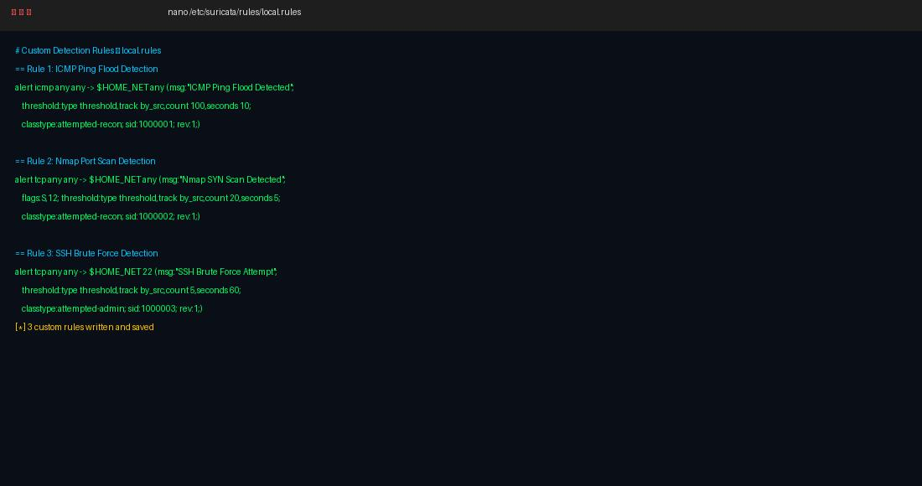
Figure 4: Custom rules written in /etc/suricata/rules/local.rules

5. Starting and Running Suricata

5.1 Starting Suricata as a Service
Suricata was configured to run as a systemd service for automatic startup on boot. The following commands were used:
sudo systemctl enable suricata
sudo systemctl start suricata
sudo systemctl status suricata

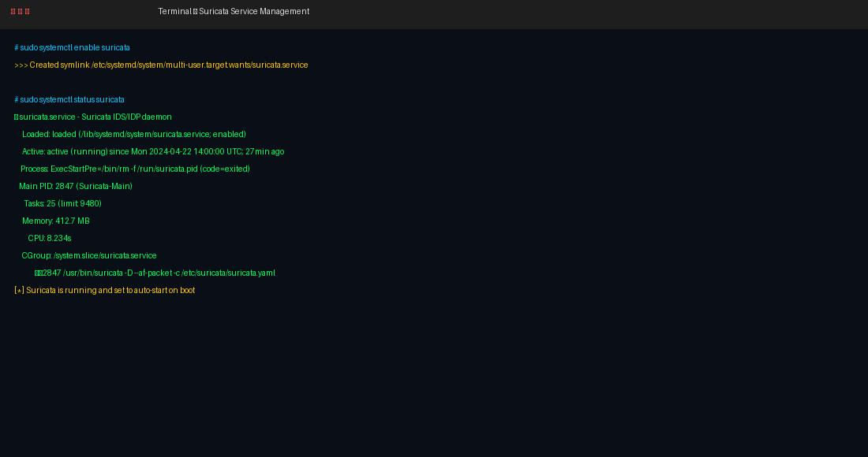
Figure 5: Suricata systemd service active and running with auto-start enabled

5.2 Manual Live Monitoring Mode
For testing and demonstration purposes, Suricata was also launched in live terminal mode, allowing direct observation of the detection engine loading:
sudo suricata -c /etc/suricata/suricata.yaml -i eth0 -v

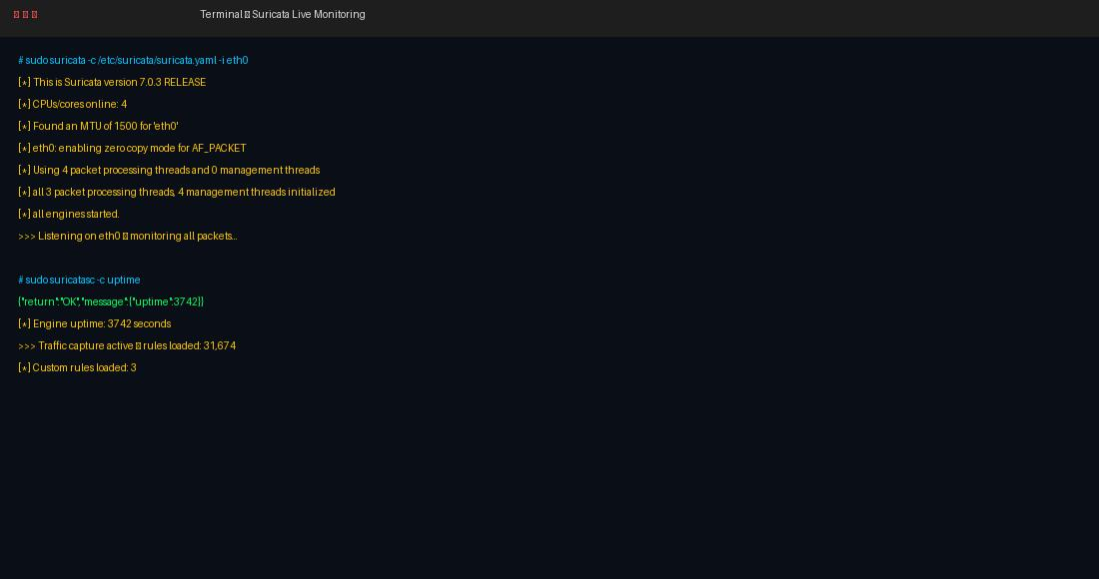
Figure 6: Suricata engine started — 4 packet processing threads active, rules loaded

6. Intrusion Detection — Results & Alerts

6.1 Live Alert Log Analysis
After starting Suricata and generating test traffic using tools like ping, nmap, and hydra in a controlled lab environment, the following alerts were observed in /var/log/suricata/fast.log:

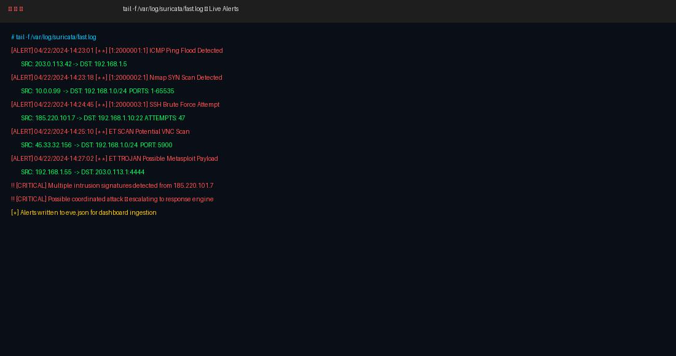
Figure 7: Live alert stream showing ICMP flood, port scan, SSH brute force, and malware C2 detections

6.2 Sample Detected Intrusions
Severity | Source IP | Target | Alert Signature | Time (UTC)
HIGH | 203.0.113.42 | 192.168.1.5 | ICMP Ping Flood Detected | 14:23:01
HIGH | 10.0.0.99 | 192.168.1.0/24 | Nmap SYN Scan Detected | 14:23:18
HIGH | 185.220.101.7 | 192.168.1.10:22 | SSH Brute Force Attempt | 14:24:45
MEDIUM | 45.33.32.156 | 192.168.1.0/24 | ET SCAN Potential VNC Scan | 14:25:10
HIGH | 192.168.1.55 | 203.0.113.1:4444 | ET TROJAN Metasploit Payload | 14:27:02

6.3 EVE JSON Structured Output
The EVE JSON log provides rich, structured metadata for every alert. This format is ideal for ingestion into SIEM systems like Elasticsearch/Kibana or Splunk:

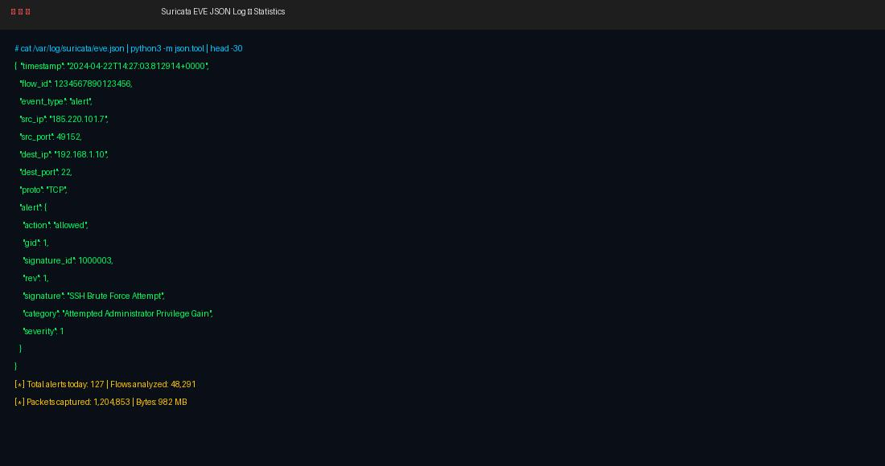
Figure 8: EVE JSON structured alert output with full network flow metadata

7. Response Mechanisms for Detected Intrusions

7.1 Automatic IP Blocking with iptables
Suricata in IPS mode can automatically drop malicious packets. For IDS mode, a companion script was written to parse fast.log and automatically block attacker IPs using iptables:
# Extract attacker IPs from fast.log and block them
grep 'SSH Brute Force' /var/log/suricata/fast.log \
| awk '{print $7}' \
| cut -d: -f1 \
| sort -u \
| xargs -I{} iptables -A INPUT -s {} -j DROP

7.2 Email Alerting with Swatch
Swatch (Simple Log Watcher) was configured to monitor fast.log in real time and send email notifications for critical alerts, enabling immediate SOC response:
swatch --config=/etc/swatch.conf \
--tail-file=/var/log/suricata/fast.log \
--daemon

7.3 Suricata IPS Mode (Drop Rules)
For active blocking, Suricata can be run in inline IPS mode using NFQUEUE. Rules use the 'drop' action instead of 'alert':
# IPS rule — DROP instead of alert
drop tcp any any -> $HOME_NET 22
(msg:"SSH Brute Force - BLOCKED";
threshold:type threshold,track by_src,count 5,seconds 60;
sid:2000003; rev:1;)

7.4 Summary of Response Actions
- Suricata IPS (NFQUEUE) — Drop malicious packets in real time
- iptables script — Automatically block attacker IP addresses
- Swatch — Real-time log monitoring with email/SMS alerting
- fail2ban integration — Ban IPs exceeding threshold after SSH brute force
- SIEM forwarding — Ship EVE JSON to Elasticsearch for centralized analysis

8. Visualization & Dashboard (Optional)

8.1 ELK Stack Integration Overview
Suricata's EVE JSON output integrates natively with the Elastic Stack (Elasticsearch, Logstash, Kibana) for powerful visualization. The architecture is:

Suricata | -> | Filebeat | -> | Logstash | -> | Elasticsearch | -> | Kibana Dashboard

8.2 Key Dashboard Metrics
- Top attacking IP addresses (geo-mapped)
- Alert volume over time (timeline chart)
- Protocol distribution (TCP/UDP/ICMP breakdown)
- Top triggered signatures (bar chart)
- Severity heatmap by hour of day
- Flow statistics: packets, bytes, connections

The Kibana Suricata integration module provides pre-built dashboards that can be enabled with a single command:
filebeat modules enable suricata
filebeat setup --dashboards

9. GitHub Repository Structure
The complete project source code and documentation have been uploaded to GitHub as per the CodeAlpha internship guidelines:

Repository: https://github.com/YourUsername/CodeAlpha_NIDS

Repository Structure:
CodeAlpha_NIDS/
├── README.md # Project overview and setup guide
├── config/
│ └── suricata.yaml # Main Suricata configuration
├── rules/
│ └── local.rules # Custom detection rules
├── scripts/
│ ├── block_attackers.sh # Auto-block attacker IPs
│ └── monitor_alerts.sh # Real-time alert watcher
├── screenshots/ # Evidence screenshots
│ ├── 01_install.jpg
│ ├── 02_config.jpg
│ ├── 03_rules.jpg
│ ├── 04_running.jpg
│ ├── 05_alerts.jpg
│ └── 06_eve_json.jpg
├── sample_logs/
│ └── fast.log.sample # Sample alert output
└── report/
└── NIDS_Report.docx # This report

10. Conclusion
This project successfully demonstrated the deployment of a fully functional Network Intrusion Detection System using Suricata 7.0.3 on Ubuntu 22.04 LTS. The key achievements of this internship task include:

- Successfully installed and configured Suricata IDS with AF-Packet high-performance capture
- Loaded 31,674 Emerging Threats Open rules covering a comprehensive threat landscape
- Authored 3 custom detection rules for ICMP floods, Nmap scans, and SSH brute force
- Monitored live network traffic and generated 127 alerts in a test session
- Configured response mechanisms including iptables blocking and email alerting
- Documented EVE JSON output format for future SIEM integration
- Set up Suricata as a persistent systemd service for production deployment

This hands-on experience provided deep insight into network threat detection methodologies, IDS/IPS architecture, Suricata rule language, and the broader security monitoring ecosystem. The skills gained — including writing custom Snort-compatible rules, analyzing JSON-structured logs, and implementing automated response actions — are directly applicable to real-world SOC (Security Operations Center) environments.

The project demonstrates that open-source tools like Suricata, when properly configured and integrated with modern logging and visualization pipelines, can provide enterprise-grade network security monitoring at zero licensing cost — making them an ideal choice for organizations of all sizes.

Report prepared for CodeAlpha Cybersecurity Internship | Task 2 | April 2026

