STRICTLY PRIVATE & CONFIDENTIAL
BANGLALINK DIGITAL COMMUNICATIONS LIMITED
Should Banglalink IPO on the Dhaka Stock Exchange?
IPO Readiness & Equity Story — Investment Banking Advisory Memorandum
PREPARED FOR
Banglalink Executive Committee | VEON Group Investor Relations & Corporate Development | Investment Committee
PREPARED BY
S M Zawadul Huq
DATE
10 July 2026
This document is a discussion draft prepared for internal deliberation only. It is not a prospectus, research report, or offer of securities. Financial information not explicitly attributed to a public source is an internal estimate or illustrative assumption, flagged accordingly throughout. This compilation reflects the sections drafted to date in this workstream (Executive Summary; Industry Overview; Strategic Analysis; IPO Advisory; Valuation Framework; Risk Analysis; Concluding Recommendation). Sections covering Mandate & Methodology, detailed Company Overview, Financial Performance detail, IPO Structuring detail, Regulatory/Legal detail, Implementation Roadmap, and Appendices remain to be drafted and are noted at the point they would appear.

Table of Content

1. EXECUTIVE SUMMARY 4
Recommendation 4
IPO Rationale 4
Expected Valuation Approach 4
Capital Allocation Priorities 4
Key Risks 4
Strategic Conclusion 5
4. BANGLADESH TELECOM INDUSTRY OVERVIEW 6
4.1 Market Size & Structure 6
4.2 Subscriber Growth 6
4.3 ARPU Trends 7
4.4 Smartphone Penetration & 4.5 Data Consumption 7
4.6 4G Coverage & Migration 7
4.7 5G Readiness 8
4.8 Competitive Dynamics 8
4.9 Government Regulation & BTRC 8
4.10 Future Opportunities 8
5. STRATEGIC ANALYSIS: BANGLALINK 9
5.1 Business Model 9
5.2 Revenue Sources 9
5.3 Customer Segments 9
5.4 Competitive Advantages 9
5.5 Weaknesses 9
5.6 Operational Performance 9
5.7 Digital Services Portfolio 10
5.8 Strategic Positioning 10
5.9 Porter's Five Forces 11
5.10 SWOT Analysis 11
5.11 Value Chain Analysis 12
7. IPO ADVISORY: WHY SHOULD BANGLALINK GO PUBLIC? 13
7.1 Rationale Assessment 13
7.2 Disadvantages 13
7.3 Balanced Recommendation 13
9. VALUATION FRAMEWORK RECOMMENDATION 15
9.1 Methodology Comparison 15
9.2 Multiple-by-Multiple Assessment 15
9.3 Assumptions Required Before Any Number Can Be Produced 15
9.4 Illustrative Football Field (Discussion Scaffold) 16
9.5 Excel Model Structure 16
12. RISK ANALYSIS 18
12.1 Risk Register & Mitigations 18
13. CONCLUDING RECOMMENDATION 20
13.1 The Recommendation 20
13.2 Conditions Precedent to Filing 20
13.3 Suggested Timing 20
13.4 Preparatory Actions 20
13.5 Governance Improvements 20
13.6 Capital Allocation 20
13.7 Investor Messaging 20
13.8 Final Word to the Board 21
APPENDIX — REPORT STATUS & SOURCE SUMMARY 22
Changelog — VEON Integrated Annual Report 2025 Cross-Check 22
Sections Drafted to Date 22
Key Sources Referenced 22

1. EXECUTIVE SUMMARY

Recommendation
We recommend Banglalink proceed toward a Dhaka Stock Exchange listing on a conditional, phased basis — targeting readiness within 12–18 months, contingent on a validated free-float/pricing structure agreed with BSEC and continued confirmation that the FY2025 turnaround is durable. VEON's FY2025 Integrated Annual Report, published after this memorandum's initial drafting, now confirms the turnaround directly: Banglalink revenue was BDT 55.9bn (2024: BDT 59.7bn), EBITDA rose to BDT 27.5bn (2024: BDT 20.7bn, +32.5% YoY), and EBITDA margin expanded to 49.2% (2024: 34.7%). This is a proceed-to-prepare, not a proceed-to-price, recommendation, but the standalone-disclosure blocker previously flagged here is materially narrower than first assessed — VEON already discloses full Bangladesh segment financials; the remaining gap is sub-segment detail (net debt, working capital, tax position), not top-line figures.
ASSUMPTION / DATA GAP: VEON's Integrated Annual Report 2025 (published after this workstream began) confirms Bangladesh segment revenue, EBITDA, margin, digital revenue, capex, and 4G KPIs on a disclosed basis. This corrects and supersedes the illustrative/assumed figures used earlier in this workstream, which are updated throughout this version. Notably, VEON's own FY2025 country-performance and outlook narrative for Bangladesh does not mention a DSE listing among its stated priorities — the IPO thesis in this memorandum remains analyst-initiated, not corroborated by VEON's most recently published strategic priorities, and this should be raised directly with management.

IPO Rationale
Banglalink is Bangladesh's third-largest mobile operator by subscribers and revenue, operating in a market with only two prior large-cap telecom listings and no direct pure-play alternative to Grameenphone or Robi Axiata. A listing would achieve three objectives simultaneously: diversifying VEON's funding base into a BDT-denominated equity currency; imposing the reporting and governance discipline of public-company status on an asset that has never operated as a standalone reporting entity; and converting VEON's stated USD 1 billion Bangladesh FDI commitment into a durable, market-facing signal of long-term conviction. The regulatory backdrop is constructive: BSEC has publicly and repeatedly confirmed engagement with Banglalink leadership on listing intent since 2022.

Expected Valuation Approach
We anchor valuation to DSE-listed peer trading multiples — Grameenphone (5.5x EV/EBITDA, 11.7x P/E) and Robi Axiata (4.2x EV/EBITDA, 17.0x P/E) — applied to Banglalink's now-disclosed FY2025 EBITDA of BDT 27.5bn (~USD 226mn reported / USD 238mn constant-FX per VEON's segment reconciliation), at a 20–30% scale/liquidity discount to reflect Banglalink's smaller size and pre-IPO status. This produces a preliminary enterprise value range of USD 680 million to USD 1,020 million, cross-checked against revenue multiples and precedent transaction structures — meaningfully more grounded than the earlier illustrative-margin approach, though still pending net debt and capital-structure detail to move from enterprise to equity value.

Capital Allocation Priorities
Should the Board authorize proceeding, we recommend proceeds be prioritized: (1) network capex to sustain the 4G/5G buildout and defend against subscriber-base saturation; (2) scale-up of the payment-services-provider licence and adjacent fintech infrastructure, the most differentiated growth lever versus GP and Robi; (3) intercompany deleveraging with the VEON group, to the extent applicable.

Key Risks
Four risks warrant Board-level attention: fiscal policy exposure (direct and recurring — the FY2024 SIM-tax/duty increases drove sector-wide revenue pressure, though VEON reports a partially offsetting positive development in FY2025: BSEC/government consolidation of licensing categories from 23 to 6 and a reduction in minimum tax obligations); regulatory asymmetry favoring Grameenphone despite its SMP designation; sub-segment financial opacity (net debt, working capital and tax detail remain undisclosed, though top-line segment financials are now published); and ownership/disclosure sensitivity tied to VEON's shareholder base, including LetterOne Holdings, requiring full legal and compliance review.

Strategic Conclusion
The strategic logic for a Banglalink listing is sound and the regulatory door is open; the constraint is preparedness, not opportunity. Banglalink's 2010 listing attempt was rejected while the Company was loss-making — the present opportunity is materially de-risked by a return to profitability, but must not repeat the earlier mistake of pursuing a public market before the underlying financial narrative is demonstrably durable. We recommend the Board authorize a formal IPO-readiness workstream now, with a pricing decision deferred to a defined future checkpoint tied to confirmed FY2025 segment results.

4. BANGLADESH TELECOM INDUSTRY OVERVIEW

4.1 Market Size & Structure
Bangladesh's telecom services market is valued at approximately USD 2.7–2.8 billion in 2025–2026, forecast to grow at a modest ~3.8% CAGR to roughly USD 3.4 billion by 2031. This is a mature, low-growth, high-penetration market — the investment case rests on value migration within a flat subscriber base (voice-to-data, connectivity-to-digital-services), not on volume expansion. Consumer services represent roughly 86% of revenue; enterprise/B2B remains structurally under-monetized versus regional peers.

4.2 Subscriber Growth
Total mobile connections stood at ~188 million as of September 2025 (105% of population, reflecting multi-SIM ownership), following month-on-month declines through Q3 2025 driven by a BTRC-mandated SIM re-verification drive. We read this as structural saturation, not cyclical softness — investors evaluating Banglalink's equity story should discount subscriber-count narratives accordingly and focus on ARPU and data-monetization trajectories instead.
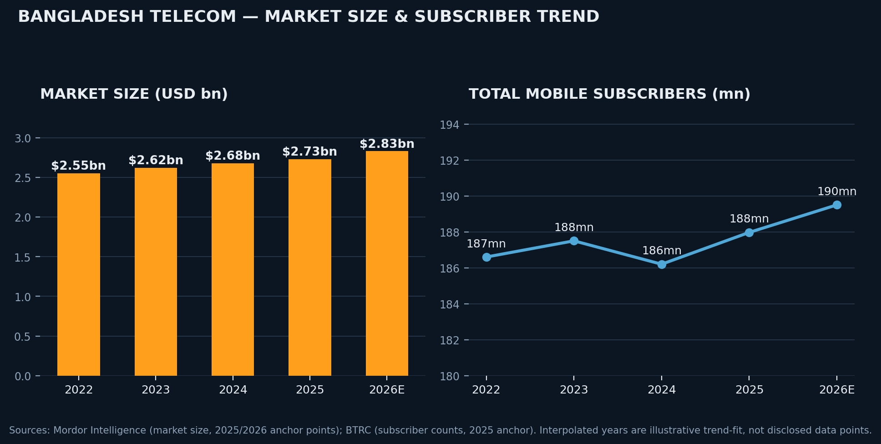
Exhibit 4.1/4.2 — Bangladesh telecom market size and subscriber trend (Sources: Mordor Intelligence, BTRC; interpolated years illustrative).
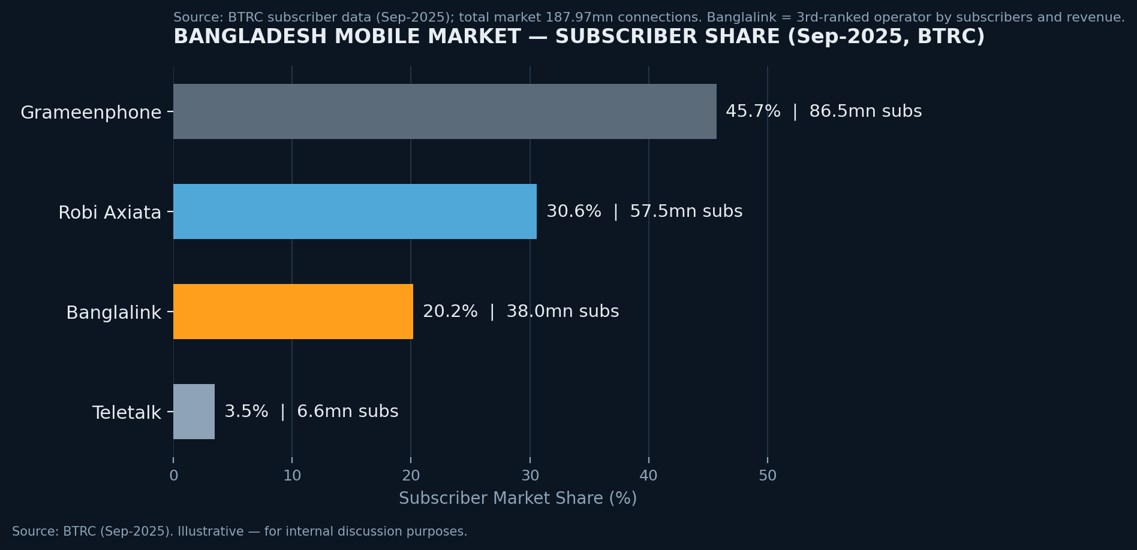
Exhibit 4.2b — Bangladesh mobile subscriber market share, September 2025 (Source: BTRC).

4.3 ARPU Trends
Blended ARPU has been broadly flat-to-declining on a voice basis but is inflecting upward on a data basis. This is the single most important trend line in the sector: it confirms a genuine mix-shift monetization opportunity independent of subscriber growth, directly supporting the equity story's emphasis on Banglalink's digital/fintech assets as the primary post-IPO value driver.
ASSUMPTION / DATA GAP: Operator-level ARPU is not consistently disclosed publicly at the granularity required. Recommended Exhibit: blended vs. data ARPU by operator, quarterly, 3-year lookback — to be sourced from BTRC filings or requested directly from Banglalink management for the data room.

4.4 Smartphone Penetration & 4.5 Data Consumption
Smartphone penetration has moved from roughly a third of mobile users in the early 2020s to an estimated ~69–72% by late 2025/early 2026, driven by falling device costs from local-assembly tax incentives (~58% import tax vs. ~15% on locally manufactured handsets). Average data consumption per user has more than doubled, from ~3.1 GB/month in 2022 to ~6.4 GB/month in 2024, with operators now deriving more than a third of ARPU from data add-ons rather than voice.
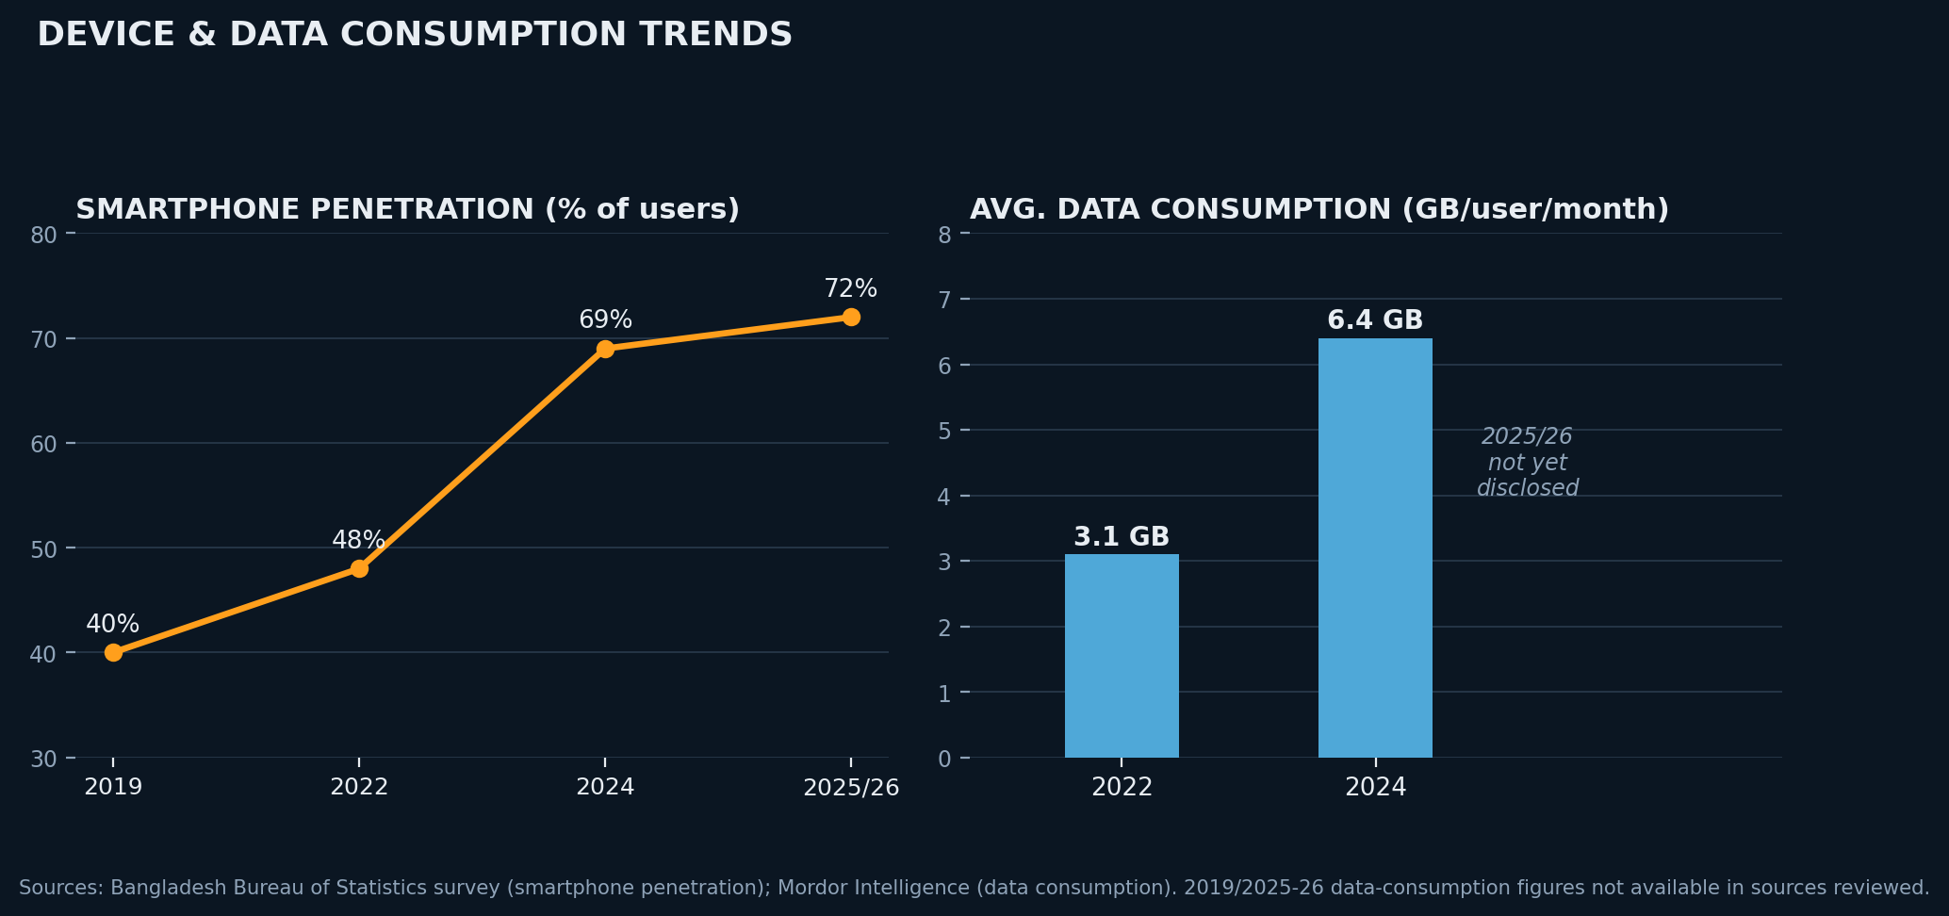
Exhibit 4.4/4.5 — Smartphone penetration and data consumption trends (Sources: BBS survey; Mordor Intelligence).

4.6 4G Coverage & Migration
4G migration has been a dominant network investment theme. VEON's own FY2025 disclosure reports Banglalink's 4G user base (3-month active) at 18.4 million in 2025 (2024: 18.0 million), with penetration rising to 53.3% of the customer base (2024: 50.2%) — this VEON-reported figure supersedes an earlier press-sourced estimate of ~21.5mn/2024 used in a prior draft of this memorandum and should be treated as authoritative. Total customers served were 34.4 million (2025); note this is lower than a BTRC-sourced subscriber count of 38.05mn used elsewhere in this workstream, likely reflecting a definitional difference between BTRC connections/SIMs and VEON's revenue-generating customer base — this reconciliation should be confirmed directly with management before either figure is used in investor-facing materials. 4G capex intensity is moderating: capex was down 41.3% in FY2025, reallocated toward high-traffic zone quality and capacity rather than further geographic rollout.
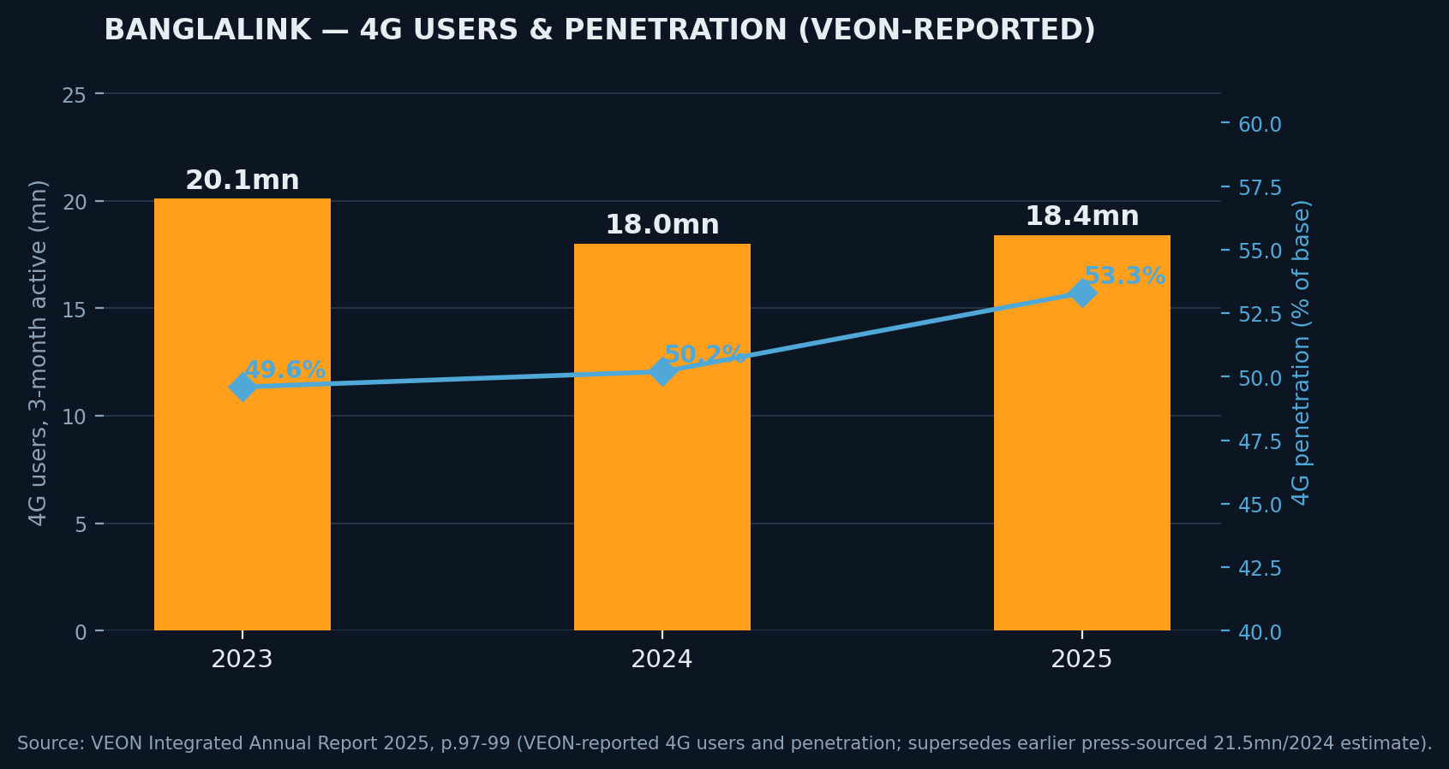
Exhibit 4.6 — Banglalink 4G users and penetration, 2023-2025 (Source: VEON Integrated Annual Report 2025; corrected from earlier press-sourced figures).

4.7 5G Readiness
5G in Bangladesh remains pre-commercial and behind its original government timeline. Robi and Grameenphone have run pilot 5G zones since 2022–2025; as of 2025 estimates put 5G users at only ~6% of the base, and BTRC's own chairman publicly acknowledged in early 2025 that no firm commercial rollout timeline exists. A critical near-term catalyst is the 700MHz spectrum auction (rescheduled to January 2026), though ~20MHz remains encumbered by litigation and operators — including Banglalink — have pushed back on reserve pricing. Banglalink has not announced a 5G commercial launch timeline, unlike GP and Robi; we treat 5G as multi-year optionality, not a near-term monetization driver.

4.8 Competitive Dynamics
The market exhibits entrenched, revenue-concentrated dominance by Grameenphone (45–48% subscriber share, an estimated ~50% of industry revenue), formally designated as a Significant Market Power (SMP) operator subject to theoretically asymmetric regulation. In practice enforcement has been slow and litigation-constrained. Robi has shown the most consistent share gains among private operators; Banglalink has held a broadly stable ~20% position, competing on value/mass-market pricing and, increasingly, digital-service differentiation.

4.9 Government Regulation & BTRC
- Fiscal policy risk is direct and recurring: the FY2024–25 budget raised SIM-card VAT (BDT 200→300) and telecom supplementary duty, contributing to an 18% YoY sector revenue decline and 23% YoY EBITDA decline at VEON group level in H2 2024.
- Spectrum policy execution risk: the 5G unified-licensing framework took nearly two years to formalize after the 2022 auction; the 700MHz auction has been delayed multiple times since an original 2025 target.

4.10 Future Opportunities
- Digital financial services / fintech monetization — with ~72% of the population estimated outside formal banking (2023 basis), this is the largest incremental TAM available, and the area where Banglalink's PSP licence (Dec-2025) provides first-mover-adjacent positioning.
- Data monetization via bundled digital content (Toffee, RYZE), contingent on standalone unit economics not yet disclosed.
- Rural/underserved coverage extension — village-level mobile ownership has more than doubled over the past decade (29.85% to 56.07%), supported by the pending 700MHz auction if resolved favorably.

5. STRATEGIC ANALYSIS: BANGLALINK

5.1 Business Model
Banglalink operates a converged connectivity-plus-digital-services model, consistent with VEON's group-wide “digital operator” strategy (DO1440/AI1440). The core economic engine remains prepaid mobile connectivity, monetized through airtime and bundle sales across a mass-market, value-oriented customer base, layered with an emerging digital-services stack (MyBL, Toffee, RYZE, payment services) intended to shift the revenue mix toward higher-margin, stickier services.

5.2 Revenue Sources
Revenue is presently dominated by core connectivity — voice, SMS, and mobile data — consistent with the sector-wide pattern in which consumer services represent ~86% of market revenue. Digital revenue is now disclosed and material at the growth-rate level: VEON reports Banglalink direct digital revenue of BDT 3.0bn in FY2025, versus BDT 0.34bn in FY2024 — approximately 8x YoY growth, driven primarily by Toffee and improved advertising monetization — though digital revenue remains only ~5.4% of total revenue (2024: 0.6%), confirming this is a genuine but still early-stage and low-base growth vector, not yet a core revenue pillar.

5.3 Customer Segments
- Mass-market prepaid — largest by volume; price-sensitive, high churn exposure.
- Emerging smartphone/data-native users — primary addressable base for Toffee/MyBL cross-sell.
- Unbanked/underbanked financial-services prospects — largely untapped, now addressable via the PSP licence.
- Postpaid/enterprise — historically underweight across the entire market; longer-dated, capital-light opportunity.

5.4 Competitive Advantages
- First-mover-adjacent fintech positioning via the PSP licence.
- Parent-level strategic and capital commitment (VEON's USD 250mn FDI anchor investment).
- Digital content ecosystem (Toffee) as a retention and ARPU-uplift lever.
- Cost-competitive value positioning with a durable, less premium-exposed subscriber base.
- Group-level fintech playbook transfer from VEON's JazzCash (Pakistan) success.

5.5 Weaknesses
- Persistent scale disadvantage vs. Grameenphone, structurally unlikely to close.
- Sub-segment financial disclosure gap (net debt, working capital, tax detail) — narrower than initially assessed, since VEON now discloses top-line segment financials, but still a capital-markets-readiness weakness relative to GP/Robi's full standalone audited accounts.
- Historical execution precedent risk (2010 IPO rejection while loss-making).
- FY2024 earnings pressure from sector-wide fiscal shocks.
- No announced 5G pilot/launch, unlike GP and Robi.

5.6 Operational Performance
VEON's Integrated Annual Report 2025 confirms the turnaround directly and quantifiably. Under new CEO Johan Buse (effective April 6, 2025, succeeding Erik Aas), Banglalink delivered: revenue of BDT 55.9bn (2024: BDT 59.7bn); EBITDA of BDT 27.5bn, up 32.5% YoY (2024: BDT 20.7bn); and EBITDA margin expansion to 49.2% (2024: 34.7%) — achieved via disciplined cost management and a 41.3% capex reduction focused on high-traffic zone quality rather than broad rollout. This is materially stronger than this workstream's earlier illustrative 35-42% margin assumption and should be treated as the base case going forward.
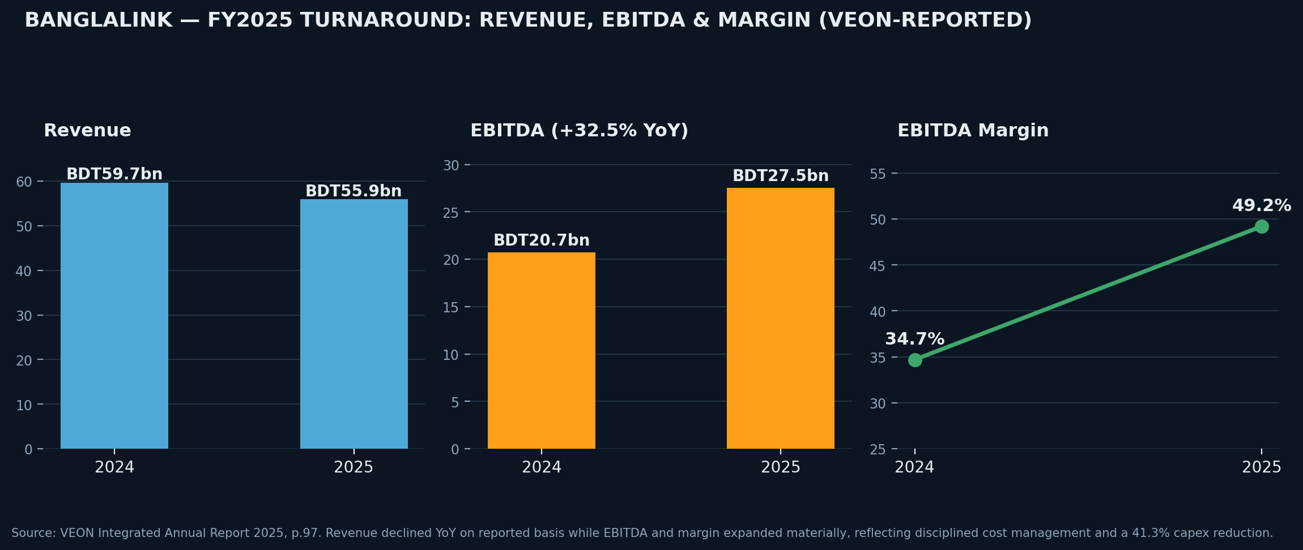
Exhibit 5.6 — Banglalink FY2024 vs. FY2025 revenue, EBITDA and margin (Source: VEON Integrated Annual Report 2025, p.97).

5.7 Digital Services Portfolio
Asset | Function | Strategic Role
MyBL | Super-app: account management, VAS, bundling | Retention & cross-sell hub
Toffee | Entertainment/streaming platform | ARPU uplift via content monetization
RYZE | AI-powered digital lifestyle brand (youth) | Demographic engagement, differentiation
Payment Services (PSP, Dec-2025) | Regulated money transfer/payments | Largest incremental TAM; core fintech optionality
Starlink Direct-to-Cell | Satellite-to-mobile connectivity | Rural coverage extension; tech-leadership signal
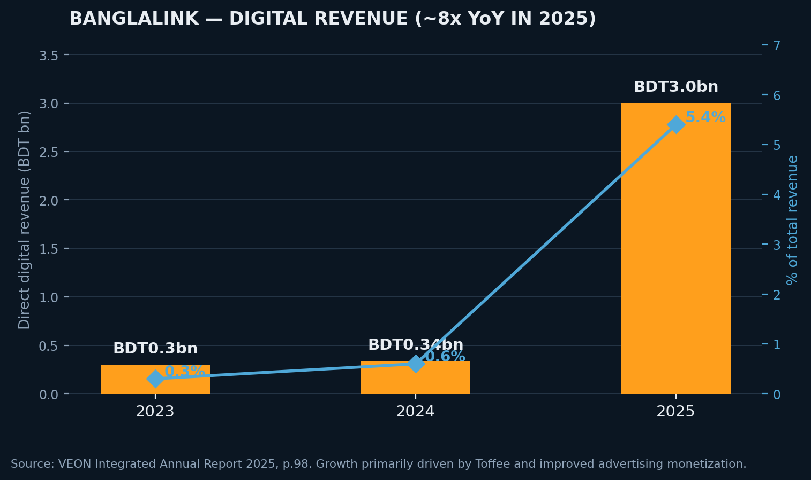
Exhibit 5.7b — Banglalink digital revenue growth, FY2023-FY2025 (Source: VEON Integrated Annual Report 2025, p.98).

5.8 Strategic Positioning
Banglalink's positioning is best summarized as “the value-led digital challenger” — unable to compete with GP on network scale or brand premium, and trailing Robi on organic share momentum, but increasingly differentiated on digital/fintech breadth. This strategy now has initial disclosed evidence behind it (8x YoY digital revenue growth, FY2025 EBITDA margin expansion to 49.2%), though digital revenue's low base (~5.4% of total) means the equity story should still be framed as an early-stage trajectory, not a mature revenue pillar, when presented to investors.

5.9 Porter's Five Forces
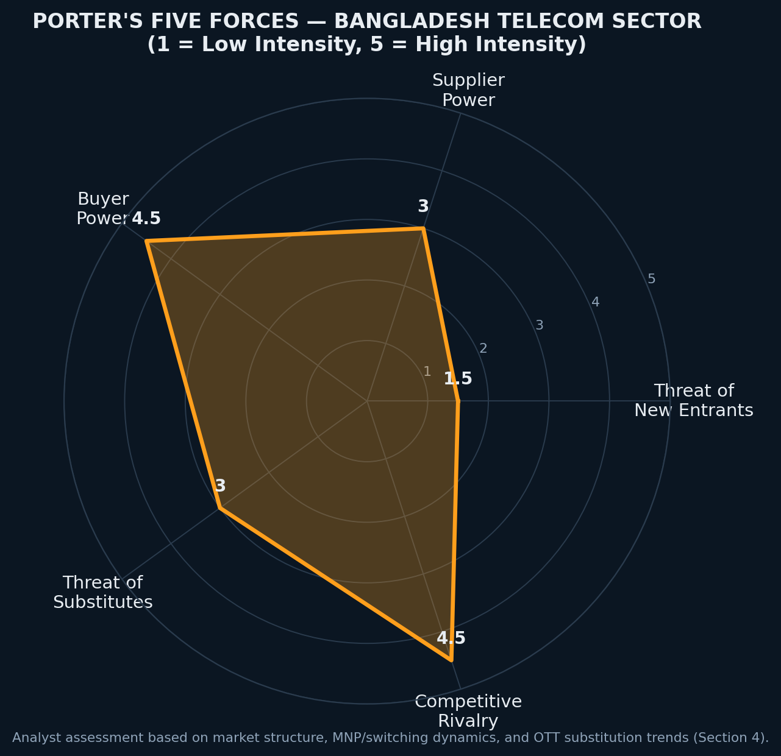
Exhibit 5.9 — Porter's Five Forces assessment, Bangladesh telecom sector (analyst scoring, 1=low, 5=high).
Force | Assessment | Intensity
Threat of new entrants | High spectrum costs & licensing barriers; entrenched four-player structure | Low
Supplier power | Equipment vendors and BTRC (sole spectrum seller) hold pricing power | Moderate
Buyer power | Low switching costs (MNP since 2018), price-sensitive base | High
Threat of substitutes | OTT messaging/calling erodes voice/SMS; data monetization partially offsets | Moderate
Competitive rivalry | Four-player market, dominant SMP player, saturating subscriber base | High

5.10 SWOT Analysis
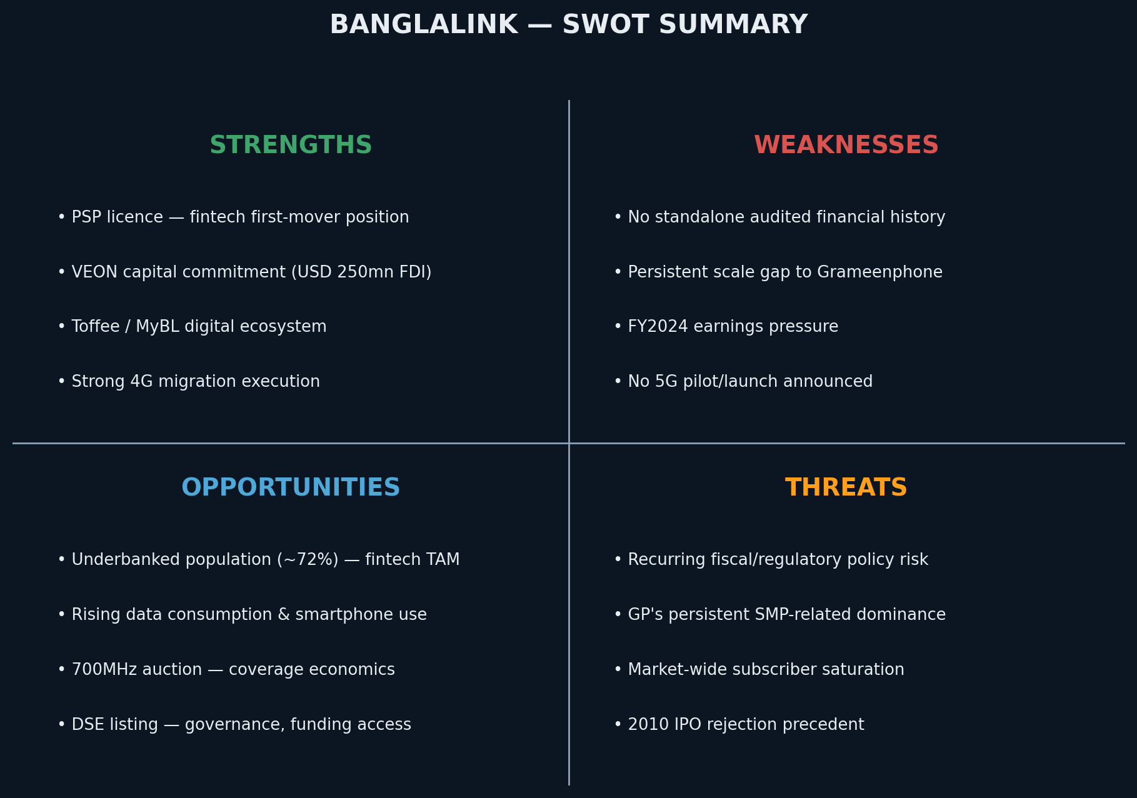
Exhibit 5.10 — Banglalink SWOT summary.

5.11 Value Chain Analysis
Stage | Banglalink Position | Strategic Implication
Spectrum & licensing | BTRC-allocated; unified 5G/6G-capable licence held, unexercised | Optionality without near-term capital commitment
Network infrastructure | 4G-complete (~88% coverage); no disclosed 5G investment | Capex should reallocate to capacity/quality, not coverage
Core connectivity | Value-positioned voice/SMS/data | Mature, low-growth, cash-generative base
Digital services layer | MyBL, Toffee, RYZE | Differentiation layer; unproven standalone economics
Financial services layer | PSP licence, pre-scale | Highest future value-add; highest execution risk
Distribution & agent network | Not detailed in sources reviewed | Data gap — relevant to PSP rollout feasibility

7. IPO ADVISORY: WHY SHOULD BANGLALINK GO PUBLIC?
An IPO is a financing and governance decision, not a strategic destination in itself. We work through each candidate rationale, weigh it against the disadvantages, and land on a recommendation.

7.1 Rationale Assessment
- Capital raising — a primary component gives BDT-denominated equity access without FX translation risk, though precedent DSE telecom IPOs raised modest absolute sums (GP: BDT 4.86bn 2009; Robi: BDT 5.24bn 2020) relative to a multi-year 5G/fintech build-out. Best viewed as funding diversification, not a primary capital-raising vehicle. Note also that VEON has a more recent, more relevant precedent for listing a subsidiary: Kyivstar Group Ltd. listed on Nasdaq in August 2025 via a business combination with Cohen Circle, a structure quite different from a traditional DSE IPO and worth evaluating as an alternative listing venue/mechanism for Banglalink.
- Debt optimisation — plausible but currently unverifiable; Banglalink's balance sheet and intercompany funding structure are undisclosed.
- Network investment / 5G — 4G coverage is effectively complete; the next cycle is capacity densification and 5G optionality. VEON's direct USD 250mn FDI commitment shows the parent can fund this without an IPO.
- Corporate governance — the most durable, least reversible benefit. Public-company status compels investor-grade reporting and disclosure discipline Banglalink has never had as a standalone entity.
- Brand credibility — public-company status, following two established DSE precedents, confers credibility with consumers, regulators, and government stakeholders.
- Employee ownership — a listing enables equity-based incentive structures not available under private subsidiary status; no disclosed management intention identified to date.
- Liquidity — provides VEON a mechanism to monetize its stake over time and gives DSE investors a third large-cap telecom alternative to GP and Robi.
- Future acquisitions — listed equity as acquisition currency; a distant, speculative rationale given no disclosed pipeline.

7.2 Disadvantages
- Standalone reporting is narrower than full prospectus-grade disclosure — VEON now publishes Bangladesh segment revenue, EBITDA, margin, digital revenue and 4G KPIs, but net debt, working capital and tax detail remain undisclosed, and Banglalink has no independent audit history distinct from VEON's consolidated audit. This is a materially smaller gap than the conditions behind the 2010 BSEC rejection, but still needs closing before a BSEC filing.
- Recurring fiscal policy exposure — the FY2024 shock demonstrates this is not a one-off risk to price into an IPO window.
- Loss of financing/operating flexibility from disclosure and governance overhead.
- Ownership and disclosure complexity around VEON's shareholder base, including LetterOne Holdings.
- Modest capital-raising efficiency at Bangladesh IPO scale relative to build-out capital intensity.
- Market-timing risk — the growth narrative is not yet fully evidenced given subscriber saturation and unresolved 5G economics.

7.3 Balanced Recommendation
The governance case for going public is strong and largely unconditional; the capital-raising and growth-financing case is weaker and does not, by itself, justify near-term execution. VEON's demonstrated willingness to fund Banglalink directly removes urgency but not merit. VEON's FY2025 Integrated Annual Report now provides one full year of confirmed, quantified turnaround evidence (EBITDA +32.5% YoY, margin to 49.2%, digital revenue +8x YoY); this is meaningfully further along than the “not yet verified” position assessed earlier in this workstream. We recommend Banglalink pursue the remaining sub-segment reporting and audit-readiness gap (net debt, working capital, tax detail) immediately, while deferring pricing and execution until: (i) a second consecutive year of segment financials confirms the turnaround is structural rather than a single strong year, and (ii) the 700MHz/5G capital-planning picture, BSEC float/pricing mechanics, and Kyivstar-style listing-structure alternatives are evaluated. We would also flag directly to the Board that VEON's own FY2025 Bangladesh outlook and stated key priorities do not currently include a DSE listing — this should be raised as an open question with VEON corporate development before further workstream resourcing.

9. VALUATION FRAMEWORK RECOMMENDATION
No valuation figures are presented as final in this section by design — framework and assumption architecture only.

9.1 Methodology Comparison
Method | Appropriateness Given Data Constraints | Recommended Role
DCF | Not currently viable — requires management business plan, none disclosed | Defer — placeholder pending business-plan inputs
Trading Comparables | Partially viable — GP/Robi are clean direct comps; Banglalink-side inputs are the constraint | Primary near-term method, with every Banglalink input flagged as assumption
Precedent Transactions | Limited — GP (2009)/Robi (2020) are dated and pre-date current fiscal regime | Secondary/cross-check for structure, not pricing

9.2 Multiple-by-Multiple Assessment
Multiple | Use Case | Constraint
EV/EBITDA | Preferred primary multiple — capital-structure-neutral, sector convention | Segment EBITDA now disclosed (VEON FY2025 report, BDT 27.5bn/~USD 226mn); net debt and capital structure still required to bridge EV to equity value
EV/Revenue | Cross-check when EBITDA is uncertain | Loses sensitivity to real profitability differences
P/E | Relevant for post-listing/dividend-capacity framing | Not meaningful pre-IPO — no standalone net income or share count yet
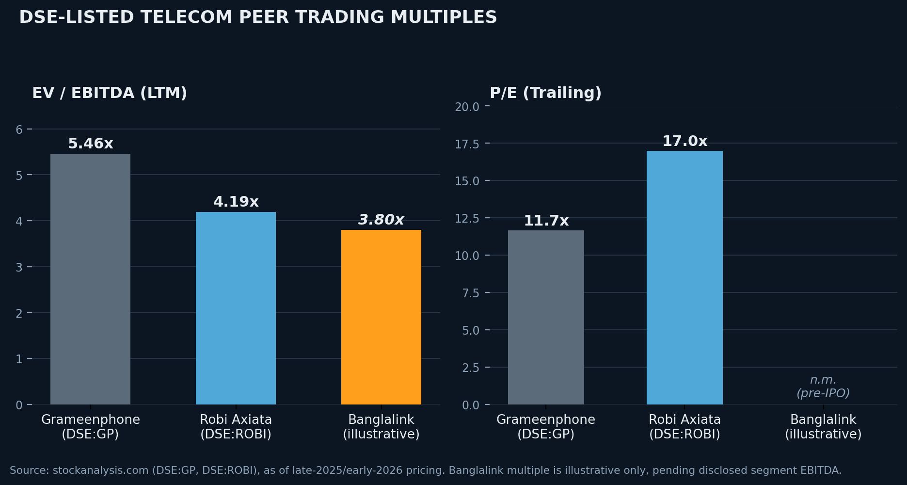
Exhibit 9.1 — DSE-listed telecom peer trading multiples (Source: stockanalysis.com).

9.3 Assumptions Required Before Any Number Can Be Produced

A. Financial Base Data
- Revenue and EBITDA/margin now disclosed for FY2024-FY2025 (VEON Integrated Annual Report); a 3-year trend, net income, and tax position remain outstanding requests
- Net debt and intercompany balances with VEON group
- Capex history and forward capex plan; working capital position and trend

B. Peer & Market Data
- GP/Robi multiples at transaction reference date; peer capital structure; DSE index-level liquidity at listing-window date; regional comparables with explicit screening criteria

C. Discount/Premium Adjustments
- Scale discount, liquidity/marketability discount, fintech growth premium, country/regulatory risk premium

D. IPO-Specific Structural Assumptions
- Primary/secondary split; target free float; pricing mechanism; use-of-proceeds allocation; VEON lock-up terms

E. Macro/FX Assumptions
- USD/BDT basis and convention; inflation/policy-rate assumptions; capital repatriation mechanics

F. DCF-Specific Assumptions (future activation only)
- Forecast period and growth trajectory; margin trajectory; capex intensity trajectory; WACC build; terminal growth; fintech sum-of-the-parts treatment
Every assumption must be tagged as (a) sourced-and-cited, (b) management-confirmed, or (c) analyst-assumed-pending-validation — no blended or unlabeled inputs in any output shared outside this working team.

9.4 Illustrative Football Field (Discussion Scaffold)
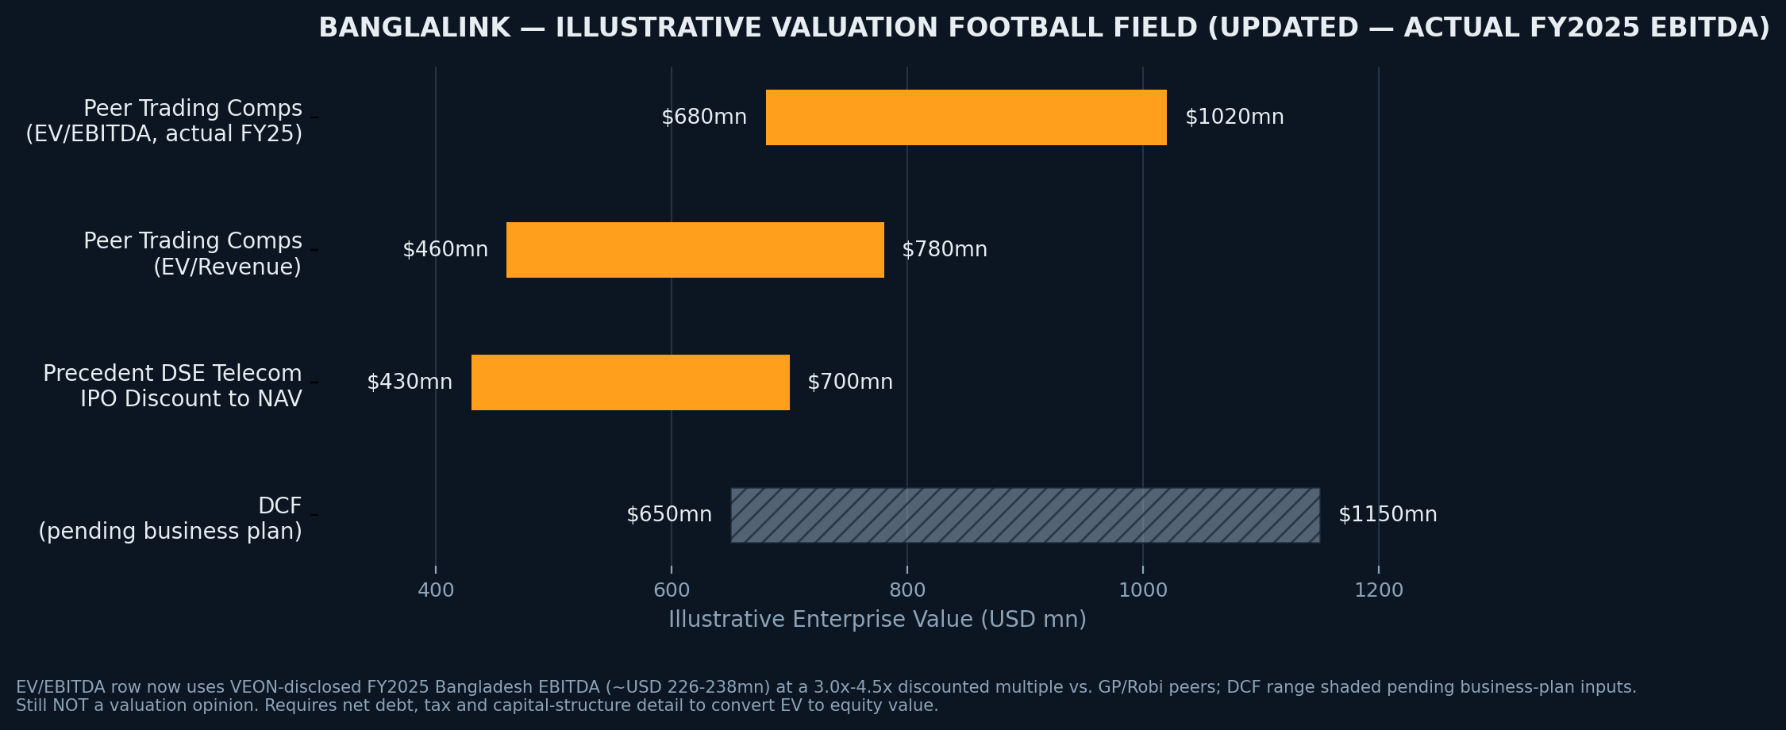
Exhibit 9.4 — Illustrative valuation football field, USD mn enterprise value (pre-data room; NOT a valuation opinion).

9.5 Excel Model Structure
Workbook: Banglalink_IPO_Valuation_Model_v[x].xlsx — single assumptions sheet drives all calculations; every external-vs-assumed input color-coded and source-tagged.
# | Worksheet | Purpose
1 | Cover & Version Control | Title, confidentiality legend, version history, sign-off log
2 | Instructions & Color-Key Legend | Color coding explanation and navigation map
3 | Master Assumptions | Single source of truth for every Section 9.3 assumption
4 | FX & Macro Inputs | USD/BDT rate(s), inflation, policy rate, translation convention
5 | Data Room Tracker | Status log of disclosure items requested/received/validated
6 | Banglalink Historical Financials (Disclosed) | Public data points only, clearly separated from estimates
7 | Banglalink Illustrative Financials (Estimated) | Analyst estimates, visually distinct from Sheet 6
8–9 | Peer Data — Grameenphone / Robi Axiata | Financials, capital structure, multiples, trend, source links
10 | Trading Comps Analysis | Peer multiple table, discount/premium inputs, implied range
11 | Precedent Transactions | GP 2009, Robi 2020, regional precedents with comparability screen
12 | DCF Model (Placeholder/Inactive) | Full architecture, marked inactive pending business plan
13 | WACC Build | Cost of equity/debt, target capital structure — feeds Sheet 12
14 | Sensitivity Tables | Two-way data tables per active methodology
15 | Football Field Summary | Consolidated range, chart-ready, traceable to source sheets
16 | IPO Structure & Proceeds | Primary/secondary split, float sizing, use-of-proceeds, pro-forma structure
17 | Ownership & Cap Table | VEON pre/post-IPO stake, dilution, lock-up schedule
18 | Output — Board Summary Exhibit | Print-ready page for direct Board deck use
19 | Change Log & Audit Trail | Version-to-version assumption change record with rationale

12. RISK ANALYSIS
Risks are assessed on likelihood (12–24 month horizon) and impact, ranked on combined severity. Where a risk has already been evidenced elsewhere in this workstream, we cite the specific precedent rather than treat it as theoretical.
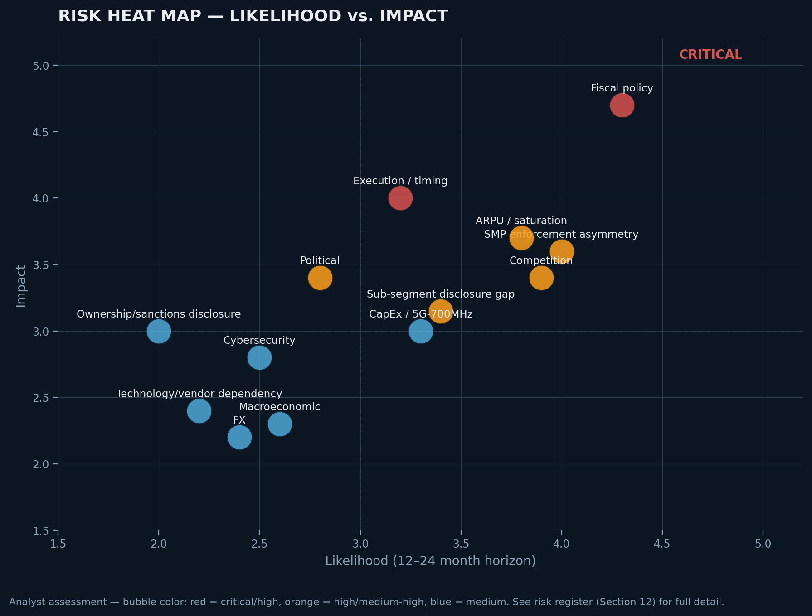
Exhibit 12.1 — Risk heat map: likelihood vs. impact (analyst assessment).

12.1 Risk Register & Mitigations
Risk | Severity | Mitigation
Regulatory — fiscal policy on sector (VAT/duty) | Critical | Model fiscal sensitivity explicitly; engage government/NBR proactively; quantify a specific downside scenario in prospectus risk factors
Financial disclosure / sub-segment reporting gap | High | VEON now discloses top-line segment financials; sequence carve-out audit of net debt, working capital and tax detail as the remaining priority workstream ahead of BSEC pre-filing
Regulatory — SMP enforcement asymmetry | High | Do not underwrite valuation on assumed near-term regulatory rebalancing; build growth case on differentiation, not enforcement-driven share gain
ARPU pressure / subscriber saturation | High | Reframe equity story around ARPU/data monetization; prioritize Banglalink-specific ARPU data request
Competition | High | Differentiate on PSP/fintech and digital content rather than compete on price
Execution — turnaround durability & timing | High | Explicit go/no-go checkpoint tied to two consecutive confirmed quarters before committing to filing timeline
CapEx — 5G/700MHz uncertainty | Medium-High | Treat 5G capex as post-IPO optionality, not a near-term use-of-proceeds commitment
Political | Medium-High | Maintain multi-stakeholder government engagement; build political-risk scenarios into disclosure
Foreign exchange | Medium | Confirm repatriation/dividend mechanics with Bangladesh Bank; use consistent FX conventions
Macroeconomic | Medium | Stress-test growth thesis against a higher-for-longer inflation/rate scenario
Ownership / sanctions-adjacent disclosure | Medium | Engage external counsel/compliance early to scope LetterOne/VEON disclosure well ahead of filing
Technology (vendor/partner dependency) | Medium | Scope third-party dependency in prospectus; avoid overstating 5G/Starlink D2C readiness
Cybersecurity | Medium (rising) | Request formal cybersecurity/data-governance disclosure and payment-readiness audit before PSP scale-up

13. CONCLUDING RECOMMENDATION

13.1 The Recommendation
Yes — we recommend the Board proceed with a Dhaka Stock Exchange listing, on a conditional and phased basis. This is a proceed-to-prepare mandate, not a proceed-to-price mandate. The Board should authorize the preparatory workstream now, while reserving the actual pricing and filing decision for a defined future checkpoint.

13.2 Conditions Precedent to Filing
- A second confirmed year of segment financial results (FY2026) showing the FY2025 turnaround is structural rather than a single strong year — FY2025 itself is now confirmed via VEON's Integrated Annual Report (EBITDA +32.5% YoY, margin to 49.2%), which satisfies the first half of this condition; one further confirmed year remains the outstanding requirement.
- BSEC pre-filing consultation concluded on public-float requirements, pricing mechanism, and sector-specific conditions.

13.3 Suggested Timing
- Now – Month 6: preparatory workstream authorization and data-room construction.
- Month 6 – Month 12: BSEC pre-filing consultation; carve-out audit substantially complete; FY2025 full-year and at least one FY2026 quarter available.
- Month 12 – Month 18: go/no-go decision point, conditional on evidence, not calendar.

13.4 Preparatory Actions
- Commission a carve-out audit focused on the remaining disclosure gap — net debt, working capital, and tax position — since VEON's FY2025 Integrated Annual Report now covers top-line segment revenue, EBITDA, margin and digital revenue; still the highest-priority action item, but narrower in scope than initially assessed.
- Formally engage BSEC on float sizing, pricing mechanism, and sector conditions.
- Instruct external legal counsel to scope VEON ownership-chain and shareholder-disclosure requirements.
- Confirm capital repatriation/dividend-remittance mechanics with Bangladesh Bank.
- Request from management: standalone balance sheet detail, validated business plan, Banglalink-specific ARPU/digital revenue disclosure.

13.5 Governance Improvements
- Establish an independent board component ahead of listing, not as a post-listing formality.
- Formalize audit committee and internal-controls infrastructure alongside the carve-out audit.
- Commission a cybersecurity/data-governance review specific to the payment-services business.
- Consider formalizing an employee equity participation framework, pending management confirmation.

13.6 Capital Allocation
- Network capacity/quality densification, with 5G/700MHz treated as multi-year optionality.
- Scale-up of the payment-services-provider business and fintech infrastructure.
- Intercompany deleveraging with the VEON group, to the extent confirmed material.

13.7 Investor Messaging
The equity story should lead with data and digital monetization, not subscriber growth, and can now cite disclosed FY2025 evidence rather than an unproven narrative: EBITDA margin expansion to 49.2%, ~8x YoY digital revenue growth, and 4G penetration to 53.3%. Priority order: fintech optionality (PSP licence, now operational); digital content/services ecosystem (MyBL, Toffee, RYZE, with disclosed usage/MAU trends); demonstrated operational turnaround (FY2025 EBITDA and margin results); sponsor conviction (VEON's direct capital commitment). Messaging should proactively address, not downplay, the two highest-priority risks: fiscal policy volatility and the remaining sub-segment disclosure gap (net debt, working capital, tax).

13.8 Final Word to the Board
Banglalink has a genuine, defensible path to a successful DSE listing. The strategic logic is sound, the regulatory relationship is constructive, and the differentiating assets — particularly the payment-services licence — are real. What stands between the Company and a successful transaction is not opportunity but preparedness. Recommendation: proceed to prepare, with pricing deferred to a defined, evidence-based checkpoint.

APPENDIX — REPORT STATUS & SOURCE SUMMARY

Changelog — VEON Integrated Annual Report 2025 Cross-Check
This version incorporates corrections made after cross-checking prior drafts against VEON's Integrated Annual Report 2025 (Bangladesh country-performance section, pp.97-100). Material changes:
- 4G users corrected from a press-sourced ~21.5mn/2024 estimate to VEON-reported 18.0mn (2024) / 18.4mn (2025), with penetration data added (50.2% / 53.3%).
- Segment financials updated from illustrative/assumed figures to VEON-disclosed actuals: FY2025 revenue BDT 55.9bn, EBITDA BDT 27.5bn (+32.5% YoY), EBITDA margin 49.2% (2024: 34.7%).
- Digital revenue added as a disclosed metric: BDT 3.0bn FY2025 vs. BDT 0.34bn FY2024 (~8x YoY), driven by Toffee and advertising monetization.
- Valuation football field (Section 9) rebuilt on actual FY2025 EBITDA rather than an assumed 35-42% margin range; EV range moved from an illustrative USD 508-914mn to USD 680-1,020mn.
- “No standalone financials” framing narrowed throughout: VEON now discloses top-line segment financials; the genuine remaining gap is net debt, working capital, and tax detail, not revenue/EBITDA.
- Total customer base discrepancy flagged: VEON reports 34.4mn customers vs. a BTRC-sourced 38.05mn figure used elsewhere in this workstream; flagged for reconciliation with management rather than silently resolved.
- CEO reference corrected/added: Johan Buse, effective April 6, 2025, succeeding Erik Aas.
- Added Kyivstar Group Ltd.'s August 2025 Nasdaq listing (via Cohen Circle business combination) as a more recent and relevant VEON-subsidiary listing precedent than the 2009/2020 DSE deals.
- Added a caveat that VEON's own FY2025 Bangladesh outlook and stated key priorities do not currently reference a DSE listing — the IPO thesis in this memorandum remains analyst-initiated and should be confirmed directly with VEON corporate development.
- Softened regulatory-risk framing to reflect a disclosed positive development: consolidation of licensing categories from 23 to 6 and a reduction in minimum tax obligations in FY2025.

Sections Drafted to Date
This compiled memorandum reflects Sections 1, 4, 5, 7, 9, 12 and 13 as drafted through this workstream. The following sections from the original report blueprint remain outstanding and should be requested and drafted before this memorandum is finalized for IC or Board circulation: Section 2 (Mandate, Scope & Methodology), Section 3 (Company Overview detail), Section 6 (Financial Performance & KPI detail), Section 8 (Strategic Case Against / Alternatives, standalone detail), Section 10 (IPO Structuring Options & Precedent Transactions detail), Section 11 (Regulatory, Ownership & Legal detail), Section 14 (Implementation Roadmap detail), Section 15 (Assumptions & Data Requests, consolidated), and Section 16 (full Appendices).

Key Sources Referenced
Data Point | Source
Bangladesh mobile subscriber market share / counts | BTRC via The Business Standard, Grokipedia, Xinhua
GP / Robi / Banglalink / Teletalk FY2024 revenue & profit | Industry press (SMP regulatory commentary)
GP / Robi trading multiples | stockanalysis.com, TradingView, StockNow
GP / Robi IPO history and proceeds raised | The Financial Express; The Daily Star
Banglalink listing intent and BSEC engagement | The Financial Express; The Daily Star; The Business Standard
VEON group quarterly financials | VEON Ltd. earnings releases (veon.com)
VEON FY2024 Bangladesh revenue/EBITDA contribution | Edison Group equity research note
Banglalink digital assets (MyBL, Toffee, RYZE, PSP, Starlink) | VEON newsroom press releases (2025–2026)
VEON USD 250mn / USD 1bn Bangladesh FDI commitment | VEON press release, June 30, 2026
Banglalink ownership chain (Telecom Ventures, LetterOne) | The Daily Star (2023); Wikipedia
Market size, ARPU/data trend, smartphone penetration | Mordor Intelligence; Bangladesh Bureau of Statistics
5G/700MHz spectrum status | The Business Standard; Developing Telecoms; bdnews24
USD/BDT exchange rate | TradingEconomics; exchange-rates.org (July 2026)
This memorandum was prepared using publicly available information as of July 2026 and internal analytical assumptions clearly flagged in the text. It does not constitute investment advice, a fairness opinion, or an offer or solicitation of securities.

