EXECUTIVE BRIEFING
Roar Regiment
Strategic Rationale, Alignment, and Boundaries — For Board & Business Leadership Review
This briefing exists to give Banglalink board members and business leaders a single, self-contained view of Roar Regiment: what it is, what it deliberately is not, where the concept came from, what in it is genuinely aligned to Banglalink's own strategy versus what is still an open assumption, and what decision is actually being asked for. It is written to be read on its own — no other document is required to follow the argument.
Author's note: this is an independent strategy portfolio exercise prepared for the Banglalink Strategic Assistantship Programme application. It is not an official Banglalink or VEON document and does not represent any actual agreement, partnership, or endorsement.

1. Purpose of This Briefing
Three documents already exist for this venture: a Strategic Repositioning Brief (the strategic thesis), a Financial Model (the numbers), and a Pitch Deck (the narrative for a room). This briefing sits above all three. Its job is not to sell the venture — it's to give a board member enough grounding to ask the right hard questions and to tell, quickly, what parts of this concept are solid and what parts are still assumptions dressed up as facts.
It answers four questions directly:
- What is Roar Regiment, precisely — and what is it explicitly not?
- Where did the concept come from, and what should and shouldn't be borrowed from that inspiration?
- What in this plan is genuinely grounded in Banglalink's own disclosed strategy, versus what is still an internal estimate?
- What decision is actually being asked of leadership today?

2. Executive Summary
- Roar Regiment is a lean, Banglalink-seeded digital entertainment and competitive-gaming vertical, distributed through Banglalink's own Toffee, MyBL, and Ryze platforms — not a standalone esports organization.
- It is modeled loosely on SK Telecom's ownership of T1, one of the most successful esports organizations in the world — but the comparison is instructive, not literal. Section 3 sets out exactly what does and doesn't transfer from a market twenty years more mature than Bangladesh's.
- Financially, it is not an ROI-positive venture under realistic assumptions. NPV, IRR, and 5-year ROI all read negative. This is disclosed plainly, not smoothed over — see Section 6.
- Strategically, it is closer to a bounded, declining-cost brand and human-capital investment — the same category as Banglalink's existing CSR programmes, but reaching an audience (young, digitally-native, gaming-engaged) that pure CSR spend rarely reaches.
- Bangladesh currently has no meaningful presence on international esports stages — two tournament appearances, ever, and zero prize money won internationally — despite a young population and an official federation that has existed since 2021. That gap is the strategic opportunity.
- The ask is bounded: a BDT 28.1M (~USD 231K) seed investment, an 18-month pilot horizon, and one formal review gate — not an open-ended commitment.

3. Where the Concept Came From: SK Telecom × T1
The inspiration for this venture is SK Telecom's ownership of T1, one of the most decorated esports organizations in the world. It's worth being precise about what T1 actually is, because the honest scale gap between SK Telecom's market and Banglalink's is the most important context for evaluating this proposal.
3.1 What T1 actually is
- Originally founded in 2002 as Team Orion; acquired and rebranded by SK Telecom in 2004 as SK Telecom T1.
- The League of Legends division became the most successful team in the game's history — six World Championship titles (2013, 2015, 2016, 2023, 2024, 2025) — anchored by global superstar player Lee “Faker” Sang-hyeok.
- In 2019, SK Telecom formed a joint venture with Comcast Spectacor (Comcast's sports and entertainment arm) to create T1 Entertainment & Sports — a global esports and lifestyle brand, not just a competitive team. The joint venture was valued at roughly USD 92 million; SK Telecom (via its successor SK Square) holds roughly 55%, Comcast Spectacor roughly 34%, and Highland Capital Management roughly 10–12%.
- As of late 2025, Comcast Spectacor is reportedly in discussions to acquire SK Square's stake in the venture — a reminder that even a mature, globally dominant esports brand's ownership structure isn't necessarily permanent. That is directly relevant to how Roar Regiment's governance should be framed (Section 9).
3.2 Why it's genuinely instructive
- It proves a telecom operator can build serious, durable global brand equity through esports ownership over a multi-year horizon — not just sponsorship, but ownership and content/lifestyle branding.
- It shows the winning model isn't “fund a competitive team” in isolation — it's building a content and lifestyle brand (“gaming culture and lifestyle, content creation, entertainment and merchandise,” per T1's own description of itself) that a competitive roster anchors.
- It's a real precedent for treating competitive gaming as a legitimate, long-horizon strategic asset for a telecom — useful for making this case internally, since it isn't a hypothetical.
3.3 The honest scale gap — read this before citing T1 in any pitch
 | SK Telecom × T1 | Banglalink × Roar Regiment
Market position | ~50% market share, Korea's largest mobile operator | Challenger operator, materially smaller subscriber base than market leader
Esports market maturity | 20+ years of state-supported, mainstream esports culture | Nascent — 2 international tournament appearances ever, federation founded 2021
Investment scale | ~USD 92M joint-venture valuation (2019), after 15 years of prior SKT-funded development | BDT 28.1M (~USD 231K) seed, Year 1 — roughly 0.25% of T1's JV valuation
Competitive scope | Multi-title, globally competitive rosters including a genuine world-champion-caliber LoL team | 2–3 titles, domestic-first, academy-led talent pipeline
Ownership structure | Joint venture with a major global media conglomerate (Comcast Spectacor) | Banglalink-seeded and governed directly; no equivalent partner exists or is assumed

3.4 What transfers to Roar Regiment, and what doesn't
- Transfers: the idea that esports ownership is a brand/lifestyle play, not just a sponsorship line; the logic of anchoring it in owned platforms and content distribution; treating it as a multi-year build, not a one-season bet.
- Does NOT transfer: T1's investment scale, its multi-title world-championship-caliber roster, Korea's decades of cultural and government support for esports, or any assumption that Banglalink can replicate T1's brand outcomes on a fraction of the time and capital. Roar Regiment must be evaluated as a Year-1 pilot in a nascent market — not a mini-T1.

4. What Roar Regiment Is — and Is Not
IT IS | IT IS NOT
A lean content & community vertical distributed through Toffee, MyBL, and Ryze | A standalone esports organization Banglalink builds and operates from scratch
A bounded, declining-cost strategic investment, reviewed on a fixed schedule | An open-ended financial commitment with no exit point
Measured on youth engagement, national representation, employer brand, and talent pipeline KPIs | A venture expected to be standalone NPV-positive or deliver a conventional ROI
Loosely inspired by SK Telecom × T1's brand-building logic | A claim that Banglalink can replicate T1's scale, roster, or results
Governed and funded directly by Banglalink, with illustrative ambassador partnerships | Co-owned with any named individual as a settled, existing agreement

5. Strategic Alignment Map
Roar Regiment does not require new infrastructure. It plugs a content and community core into three platforms Banglalink already owns and is actively scaling — and the value it creates back to Banglalink is measured on engagement, reach, and brand KPIs, not standalone financial return.
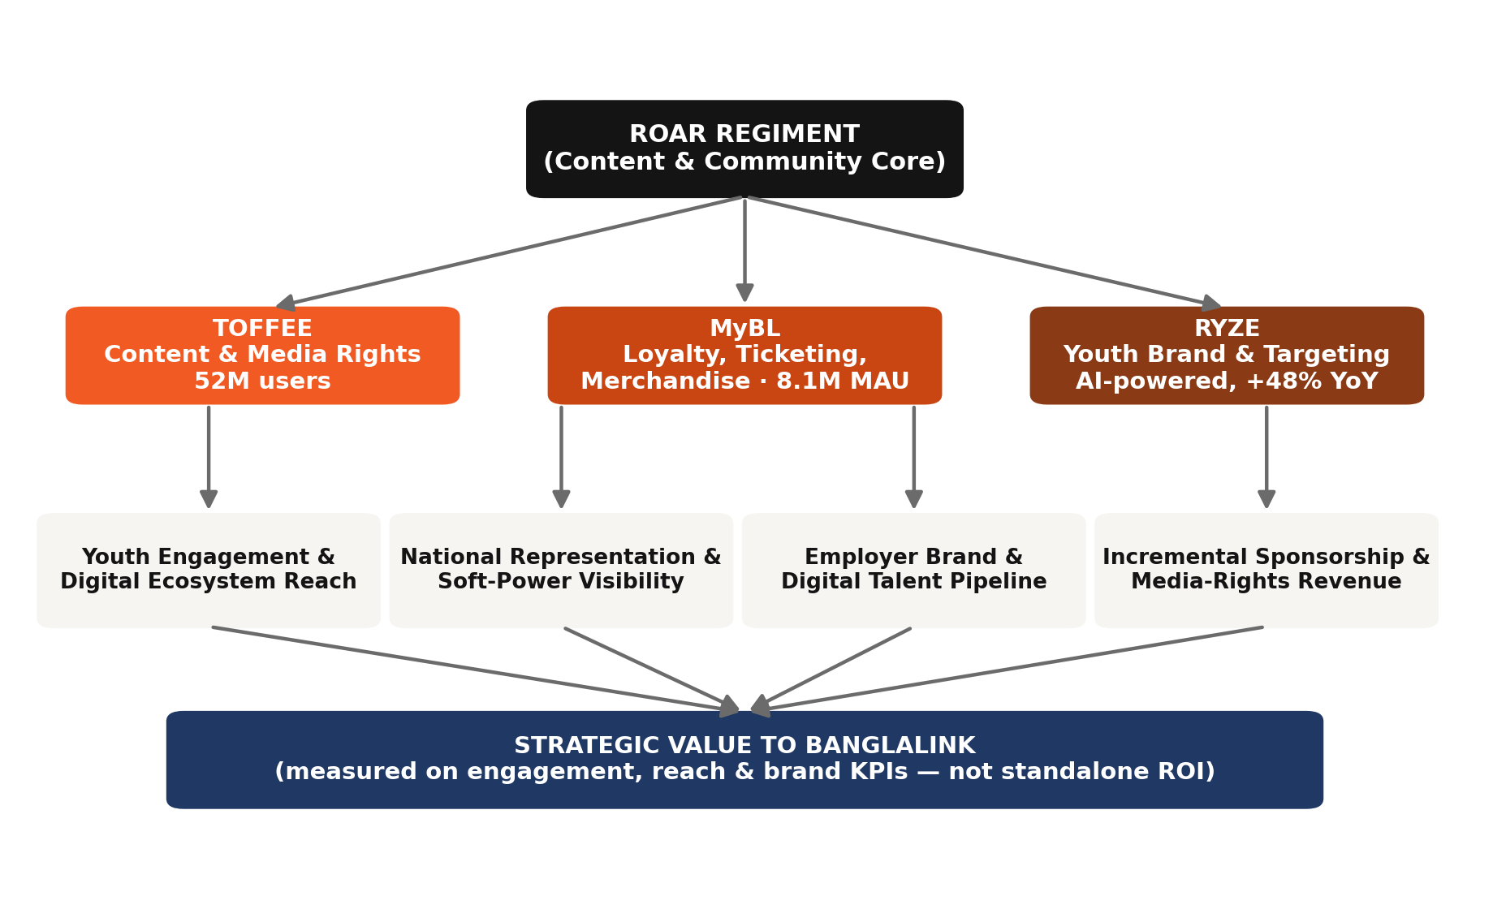
Figure 1 — Roar Regiment's integration into Banglalink's existing Toffee / MyBL / Ryze ecosystem.

6. Financial Reality, At a Glance
This is the section a board member should read most skeptically. The figures below come directly from the reconciled Financial Model — every number traces to a single set of assumptions, not two disconnected datasets.
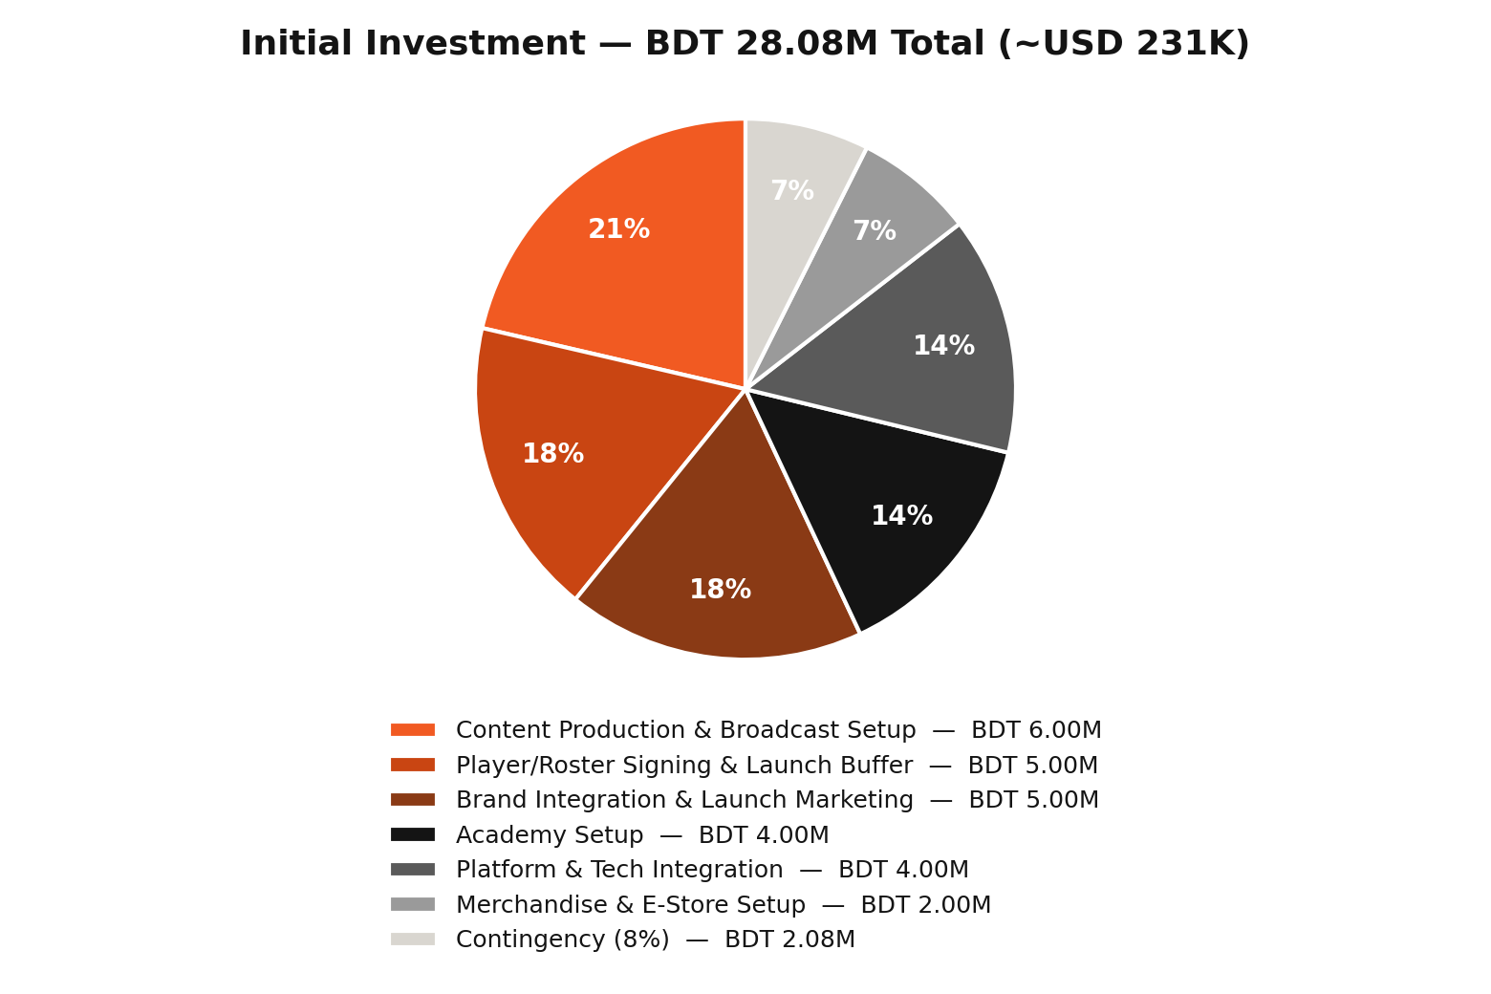
Figure 2 — Initial investment build-up (Banglalink seed capital, Year 1).
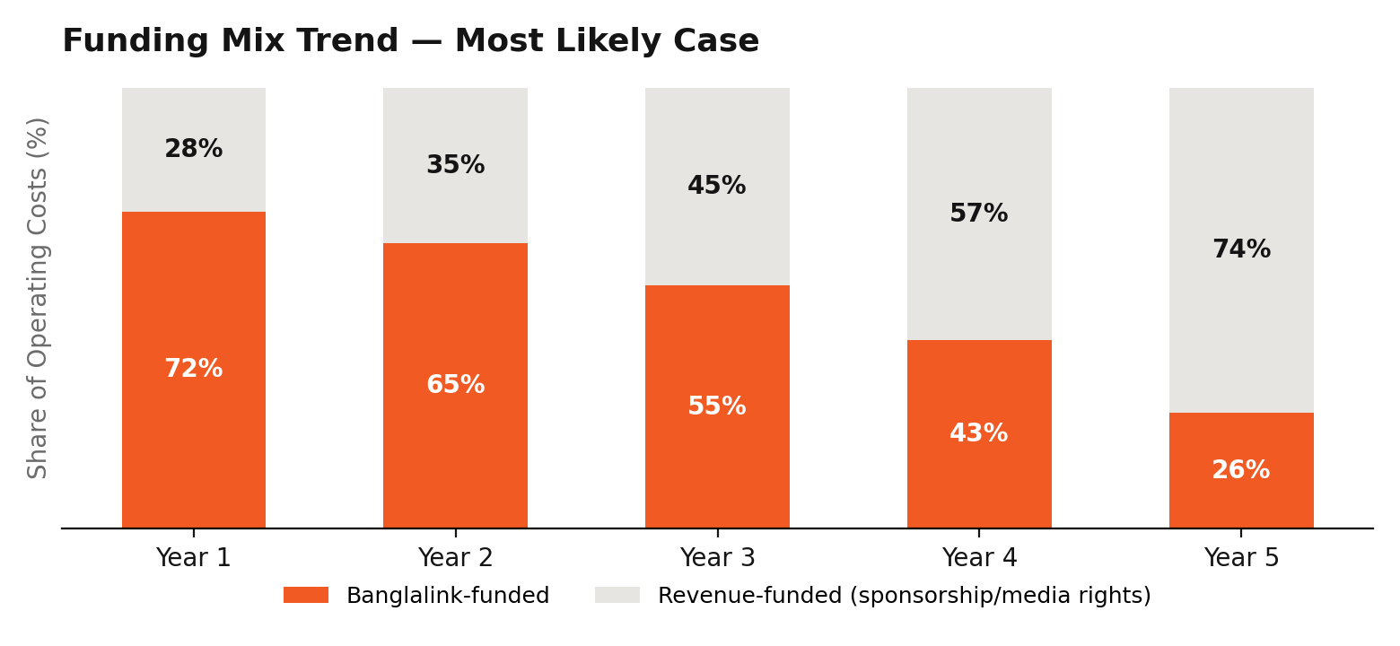
Figure 3 — Banglalink's funding share of operating costs, declining but not reaching zero within 5 years (Most Likely case).
Stated plainly
- Total Year-1 seed investment: BDT 28.1M (~USD 231K).
- 5-year cumulative funding requirement, Most Likely case: approximately BDT 108.5M (~USD 892K).
- NPV, IRR, and 5-year ROI: all negative under the Most Likely case. Under an Optimistic case, the venture approaches but does not reach full break-even within 5 years.
- This is the honest output of a reconciled model, not a modeling failure — and it's the reason this briefing frames Roar Regiment as a strategic/brand investment rather than a commercial one.

7. What Genuinely Aligns With Banglalink's Own Strategy
Everything in this section is sourced to Banglalink's own FY2025 disclosures (VEON Integrated Annual Report 2025) or its 2024 “Bangladesh: Growth Ambition 2027” strategy deck — not to assumptions about the company.
- Banglalink's own 2026 priorities explicitly name “Entertainment” as a non-telco vertical to expand into, alongside B2B, fintech, health, education, and AI.
- Toffee's FY2025 digital revenue grew ~8x YoY, and Toffee is explicitly being positioned as a standalone growth entity with a 2027 ambition of BDT 5bn service revenue — proof that owned digital-entertainment platforms are a live, funded priority.
- Ryze — Banglalink's AI-powered youth lifestyle brand — grew MAUs 48% YoY and is explicitly the channel built to reach the under-25 segment that makes up 48% of Bangladesh's population.
- Banglalink already runs cost-bearing, non-ROI strategic and CSR initiatives (Proyash Digital Classroom, GSMA disability-inclusion signatory status, free connectivity during the Milestone plane-crash emergency response) — this venture sits in the same category, not a new one.
- Banglalink received Bangladesh Bank approval to operate as a payment service provider in 2025 — a plausible, if early-stage, path to in-ecosystem monetization (merchandise, ticketing) worth tracking, not over-claiming.

8. What Was Deliberately Removed or Does Not Align
Transparency matters more here than anywhere else in this briefing. The original version of this concept contained several elements that did not hold up and were removed:
- Grameenphone branding and strategic references (GP Star, GP 5G) — the original materials were never actually built for Banglalink, despite the brief calling for it.
- A four-title, fully salaried “gaming house” roster model — inconsistent with Banglalink's asset-light, margin-disciplined operating philosophy.
- Co-ownership with a named individual (a professional footballer) presented as settled fact, with no actual agreement in place — replaced with an illustrative ambassador-partnership model.
- A flat, unexplained BDT 24,000,000/year sponsorship assumption held constant for five years, with no ramp or justification.
- Two unreconciled sets of financial figures — the original Key Metrics tab computed IRR/NPV off a dataset (BDT 200M investment, BDT 120–240M revenue) entirely disconnected from the rest of the file (BDT 32.5M investment, BDT 35–64M revenue). This was the single biggest credibility risk in the original package and was the first thing fixed in the rebuild.

9. Governance and the Decision Being Asked
Given Section 3.3's Comcast Spectacor/SK Square precedent — even a globally dominant esports brand's ownership structure can change — Roar Regiment's governance is deliberately built around a fixed review point rather than an assumption of indefinite commitment.
- Approve: a BDT 28.1M seed investment for an 18-month pilot.
- Review at 18 months against: the Funding Mix trajectory (is Banglalink's cost share actually declining on schedule?), and the non-financial KPI set (youth reach, national representation progress, employer brand signal, talent-pipeline output).
- Decide at that gate: continue as planned, scale back scope, or wind down — with the financial exposure capped at the pilot budget unless leadership explicitly re-approves continued funding.
- What is NOT being asked: a multi-year financial commitment, an ROI guarantee, or approval of any specific individual as a co-owner or ambassador.

10. Appendix: Key Sources
- VEON Integrated Annual Report 2025 — Bangladesh/Banglalink section (financials, Toffee/MyBL/Ryze metrics, strategic priorities, CSR initiatives).
- Banglalink “Bangladesh: Growth Ambition 2027” strategy presentation (2024).
- Esports Charts / Liquipedia tournament records — Bangladesh international esports participation data (2025).
- Public reporting on SK Telecom × T1 / Comcast Spectacor joint venture — Korea Times, Korea Herald, Comcast Spectacor corporate site, Wikipedia, and Grokipedia (cross-referenced), 2019 and 2025.
- Companion documents: Strategic Repositioning Brief, Financial Model v2, Pitch Deck v2 (this venture's other portfolio materials).

