NEO PSP
A Strategic Roadmap for Accelerating Digital Financial Services in Bangladesh
Independent Strategic Advisory Report
Prepared for: Banglalink CEO · Chief Strategy Officer · DFS Leadership · VEON Regional Executives
August 2026
Prepared using publicly available information, industry benchmarks, and explicitly stated assumptions. Not an official Banglalink or VEON publication.

Table of Contents
Report Architecture & Design Rationale 3
Frameworks used 3
1. Executive Summary 4
1.1 Strategic opportunity 4
1.2 Market potential 4
1.3 Investment priorities 4
1.4 Expected outcomes 5
1.5 Major risks 5
1.6 Board recommendation 5
2. Strategic Market Assessment 6
2.1 Mobile Financial Services market 6
2.2 Digital payment adoption 6
2.3 Merchant digitization 7
2.4 Consumer behaviour 7
2.5 Smartphone & internet penetration 7
2.6 Regulatory environment 7
2.7 Future industry trends 8
3. Competitive Benchmarking 9
3.1 Benchmark comparison 9
3.2 Strategic gaps NEO PSP could address 10
4. Three-Year Strategic Growth Framework 11
4.1 Growth levers by horizon 11
Customer acquisition 11
Merchant acquisition 11
Digital ecosystem partnerships 11
Telecom integration opportunities 11
Loyalty strategy 11
SME opportunities 11
Data-driven personalization 12
Cross-selling concepts 12
4.2 Prioritization: Impact vs. Implementation Complexity 12
5. Conceptual Business Model 13
5.1 Revenue streams 13
5.2 Cost structure 13
5.3 Key partners, resources, and activities 13
5.4 Key metrics 14
Phased Implementation Roadmap 14
Phase 1 (0–6 months): Prove the Rail 14
Phase 2 (6–18 months): Scale the Network 15
Phase 3 (18–36 months): Compound the Ecosystem 16
Cross-Phase Governance 17
Closing Note 18

0. Report Architecture & Design Rationale
Governing thought: Every section earns its page count by driving a decision. No descriptive filler — each page answers 'so what does leadership do differently because of this.'
This report is built to a ~20-page core-body discipline, with detailed appendices held separately so the board-facing narrative stays readable. The structure below reflects the sequence used throughout this document: market context and competitive reality first, strategic thesis and growth framework second, business model and financial case third, and implementation last.
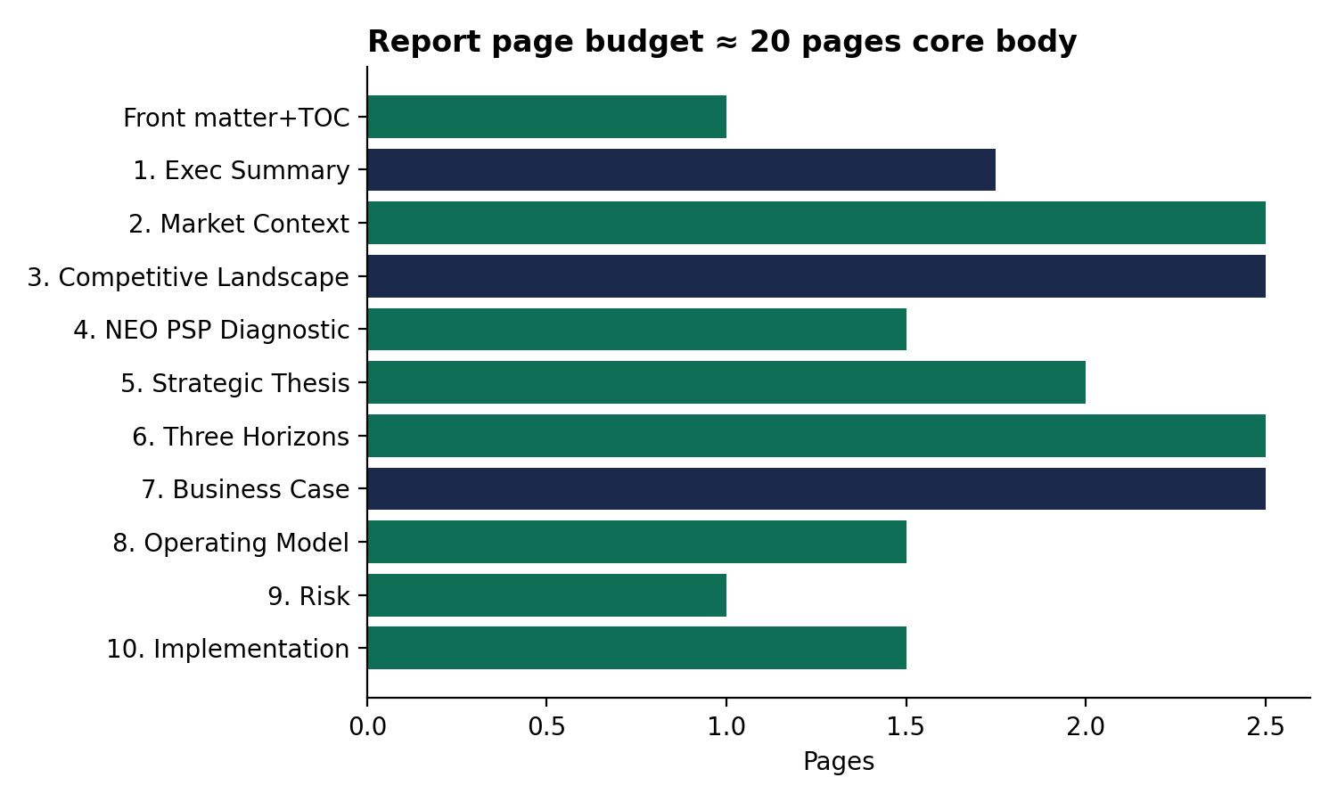
Exhibit 0.1 — Core report page budget by section

Frameworks used
McKinsey Three Horizons · Ansoff Matrix · Porter's Five Forces · TAM/SAM/SOM · asset-specific SWOT · capability heat-mapping · RACI governance · Business Model Canvas (adapted, two-sided) · Impact vs. Complexity prioritization · scenario-based sensitivity analysis.

1. Executive Summary
Governing thought: NEO PSP should not be positioned as Banglalink's answer to bKash and Nagad. It should be positioned as the consolidator of Bangladesh's fragmented merchant-payments category — entered with distribution, capital, and technology advantages none of the nine existing PSP licensees have simultaneously.

1.1 Strategic opportunity
Bangladesh's mobile financial services (MFS) market — bKash, Nagad, Rocket — is a settled duopoly-plus-one, moving roughly Tk 6,000 crore daily, with over 60% concentration in the top two players. It is not a market worth entering as a challenger. The Payment Service Provider (PSP) category — merchant acquiring, gateway processing, B2B and disbursement rails — is structurally different: nine licensed operators, none commanding decisive share. This is a fragmented, still-forming category, not a mature one.
NEO PSP enters with three assets no PSP incumbent holds simultaneously: a 41-million-plus Banglalink subscriber base for near-zero-cost acquisition, VEON's balance sheet for sustained investment, and a purpose-built platform (Mukto Pay, built with Huawei) rather than a legacy stack. Bangladesh Bank has already issued the NOC — the question is no longer whether to enter, but how fast and in what sequence to convert license into share.

1.2 Market potential
[ASSUMPTION — flagged, not fabricated] Public disclosures do not size the PSP-specific transaction pool separately from total MFS volume. Using Bangladesh Bank aggregate data and a conservative allocation of merchant/gateway-specific flows, we estimate the addressable PSP/merchant-payments pool as a meaningful and growing multi-billion-taka annual opportunity. Direction and order of magnitude — not the specific figures — should anchor the board's initial read; the full build is in Section 2.
The more important signal is compositional: merchant relationships in the PSP category are still being formed, unlike the MFS wallet layer where switching costs have already hardened. Share is winnable now in a way it will not be in three years.

1.3 Investment priorities
- Merchant acquisition infrastructure — the highest-leverage investment; PSP economics are won or lost here, not in platform technology.
- Core rail completion and reliability — instant transfers, bill payments, remittance, merchant settlement, built to institutional-grade uptime before wide commercial push.
- Compliance and settlement-bank partnerships — the Bangladesh Bank relationship is an asset to protect, not a box to check.
Product breadth beyond this core (micro-savings, insurance, credit-adjacent services) should sequence into Horizon 3, not fund in parallel with launch — capital discipline in the first 18 months matters more than product completeness.

1.4 Expected outcomes
The business case supports a 3-to-5-year path to profitability contingent on merchant and agent acquisition pace, with breakeven driven far more by transaction volume scale than by take-rate assumptions — distribution execution, not pricing, is the primary lever leadership should govern against. Non-financial outcomes matter equally: NEO PSP becomes tangible evidence of Banglalink's transition from connectivity provider to digital operator, consistent with the DO1440 strategic direction, and a potential template VEON could replicate across other operating markets.

1.5 Major risks
- Regulatory pacing risk — any delay between NOC and full commercial launch compounds against faster-moving competitors (Robi, e-commerce-native applicants).
- Execution risk, not technology risk — Huawei de-risks the platform; the real exposure is merchant acquisition velocity, a muscle Banglalink hasn't previously operated at this intensity.
- Incumbent response risk — bKash and Nagad have capital and motive to extend into merchant/gateway services defensively; a slow launch cedes the fragmentation window.

1.6 Board recommendation
Approve NEO PSP as a funded strategic priority, not an incubated side project. Specifically: (i) commit Horizon 1 funding to merchant acquisition and core-rail reliability ahead of product breadth, (ii) establish a dedicated steering committee cadence to compress decision latency during the competitive window, and (iii) mandate a 100-day post-approval execution plan so the NOC-to-launch gap does not become the constraint competitors exploit.

2. Strategic Market Assessment
Governing thought: Bangladesh Bank's Bangla QR interoperability mandate (enforced from July 2026) collapses the closed-loop network advantage that let bKash's scale become a moat. A new PSP entrant no longer needs to win the wallet war to reach a merchant's customers — it needs to win the merchant relationship, and the interoperable rail does the rest.

2.1 Mobile Financial Services market
bKash (~40%), Nagad (~18–25%), and Rocket (~12%) have converted first-mover advantage into a durable duopoly-plus-one at the consumer wallet layer. Switching costs, agent-network depth, and brand-as-category-name effects are now essentially locked in.
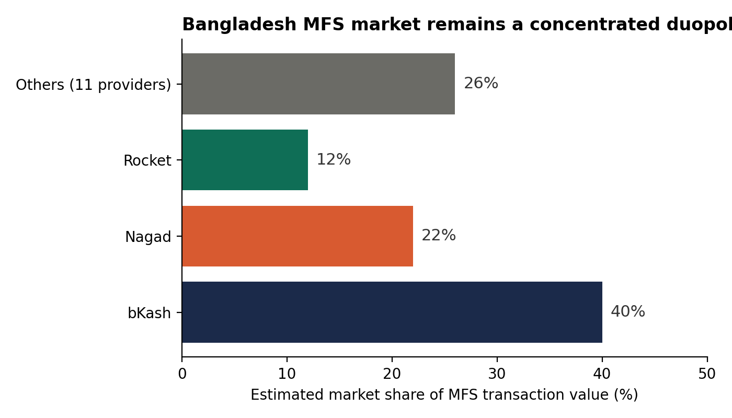
Exhibit 2.1 — Estimated MFS market share by transaction value
Strategic implication: Treat the MFS leaderboard as a boundary condition, not a target. NEO PSP's opportunity sits one layer up the stack, in merchant acceptance and processing, where interoperability neutralizes the wallet incumbents' scale advantage.

2.2 Digital payment adoption
Bangla QR is now compulsory for all banks, MFS providers, PSPs, and PSOs, live nationally from July 1, 2026, with a centrally set minimum merchant discount rate (MDR) of 1%. Every participating institution's QR now works with every other's app — a rare case of regulation directly subsidizing a new entrant's reach.
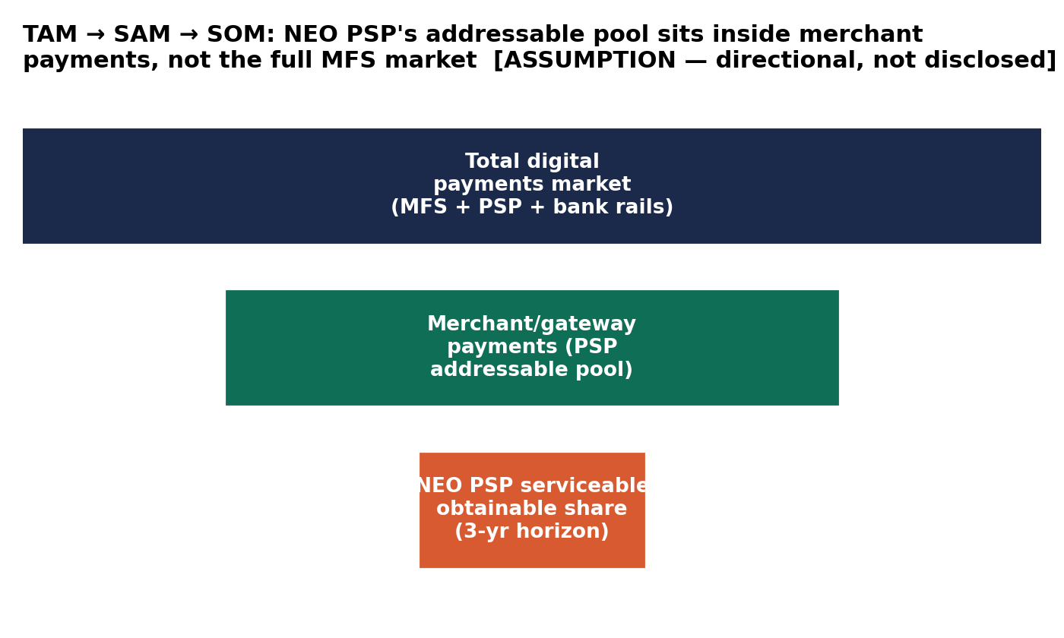
Exhibit 2.2 — TAM / SAM / SOM funnel for the PSP-addressable pool
Strategic implication: Compete on merchant onboarding speed and settlement reliability, not proprietary QR footprint — that question has been solved by the regulator.

2.3 Merchant digitization
Despite the mandate, adoption lags: Bangla QR ecosystem participation grew slowly (49 stakeholders by FY25 vs. 41 the year prior, against a far larger eligible base). Small merchants resist due to MDR fee sensitivity, incomplete practical interoperability, and low digital literacy.
Strategic implication: Merchant acquisition — not consumer marketing — is where Horizon 1 capital should concentrate. A merchant-first go-to-market bundled with Banglalink's existing SME/enterprise relationships is a genuine structural advantage.

2.4 Consumer behaviour
Cash still dominates day-to-day transactions despite 186M+ mobile connections. Adoption barriers are consistent: affordability, low digital/financial literacy, and a stark gender gap (19% of women vs. 36% of men access mobile data nationally). Rural users are markedly less likely to access mobile internet than urban counterparts.
Strategic implication: Product design should assume low-trust, low-literacy, intermittent-connectivity users as the base case. This should feed directly into the Customer Journey Maps deliverable (offline-tolerant confirmation, vernacular UX, agent-assisted onboarding).

2.5 Smartphone & internet penetration
Bangladesh sits at near-universal mobile phone household access (98.9%) and roughly 71% mobile-device share of internet traffic — among the highest mobile-leapfrogging rates globally. Internet penetration itself (47–53% depending on methodology) still trails regional peers like Bhutan and the Maldives.
Strategic implication: The device layer is not the constraint — behavior, trust, and literacy are. Rising smartphone penetration alone will not drive adoption; active trust-building is required.

2.6 Regulatory environment
Three developments matter most: the Payment and Settlement Systems Act 2024 (a modernized statutory basis for PSP/PSO licensing), the Bangla QR interoperability mandate, and Bangladesh Bank's open banking / Payment Initiation Services (PIS) target for mid-2026, which would allow account-to-account payment initiation without custody of funds.
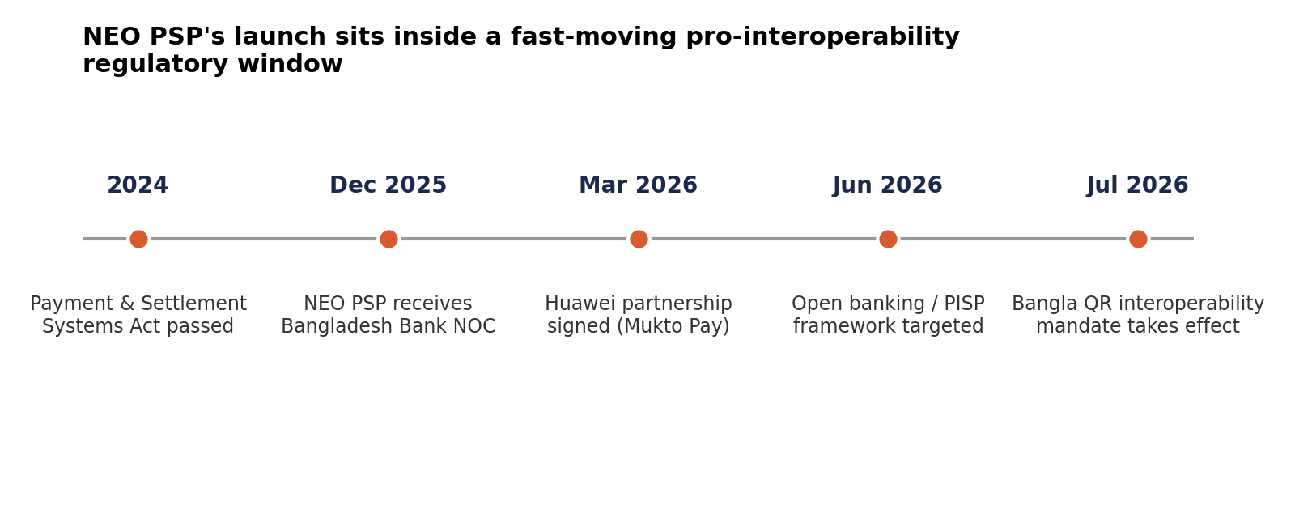
Exhibit 2.3 — Regulatory timeline positioning NEO PSP's entry
Strategic implication: Regulatory direction is unambiguously pro-interoperability and pro-new-entrant. This is a time-bound window — the next 12–18 months are the more favorable entry period, not a 'someday' opportunity.

2.7 Future industry trends
- Consolidation among the long tail of PSPs is likely as the centrally floored 1% MDR compresses margins for undifferentiated players — favoring well-capitalized entrants like NEO PSP.
- Open banking/PISP maturation will likely blur the MFS/PSP boundary over the medium term — revisit the strategic thesis at the Horizon 2/3 transition.
- E-commerce-native entrants (Daraz, Chaldal) applying for PSP licenses directly signal a future disintermediation risk to monitor, not act on immediately.

3. Competitive Benchmarking
Governing thought: NEO PSP's closest true comparable is not bKash or Nagad — it's Samadhan Services (Grameen Telecom's PSP subsidiary), the only other telco-backed PSP entrant in the market. Whoever converts telco distribution into merchant coverage faster wins the 'telco-fintech' sub-category before bank-backed or standalone fintech players close the gap.
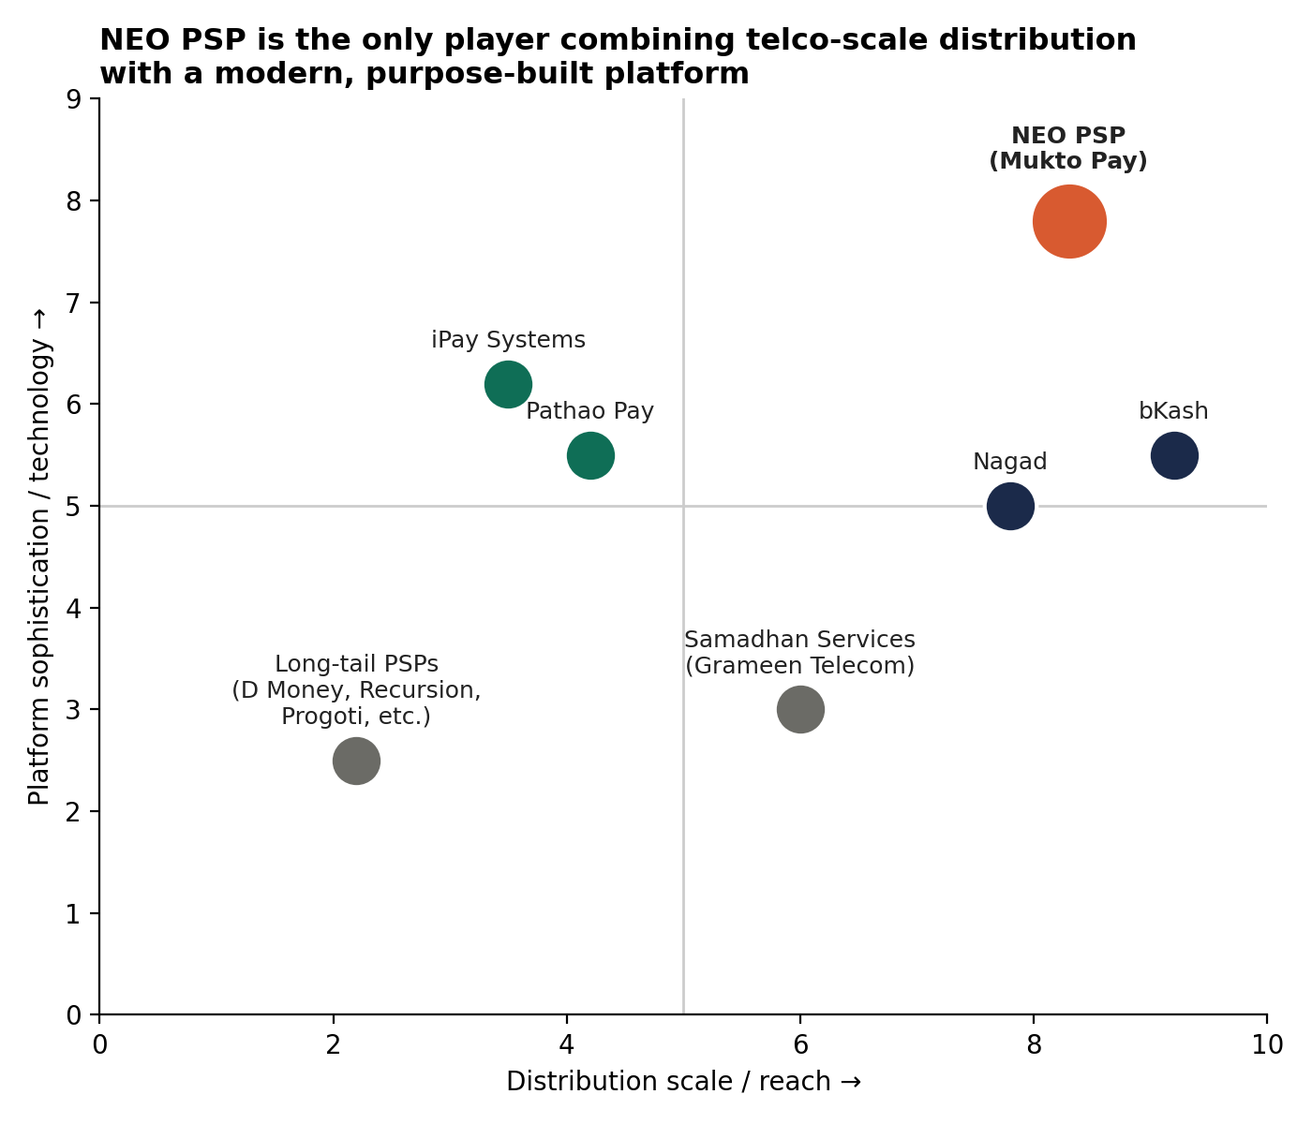
Exhibit 3.1 — Competitive positioning: distribution scale vs. platform sophistication

3.1 Benchmark comparison
Dimension | bKash / Nagad | iPay Systems | Pathao Pay | NEO PSP (Mukto Pay)
Value proposition | Ubiquitous consumer wallet | Bank-agnostic merchant gateway | Payments layered on a super-app | Telco distribution + fintech-grade platform, inclusion-framed
Customer segments | Mass consumer, broadest reach | SME merchants + their customers | Existing Pathao urban user base | Banglalink's 41M+ base incl. underserved/rural
Merchant ecosystem | Largest, most mature agent network | Merchant-first from inception | Narrow, inherited from logistics partners | Greenfield — largest risk and opportunity
Distribution | Dense decade-old agent network | Digital-first, bank partnerships | Cross-sell into app base, zero CAC | Cross-sell into Banglalink subscriber + SME base
Key weakness | High cost to maintain agent network | Sub-scale vs. MFS incumbents | Narrow addressable base | No operating history; first-mover disadvantage vs. 8+ PSPs

3.2 Strategic gaps NEO PSP could address
- The 'telco-scale distribution + fintech-grade platform' gap — no competitor combines both simultaneously; this is NEO PSP's headline right-to-win claim.
- The SME/enterprise disbursement gap — no benchmarked PSP has built a strong payroll/vendor-disbursement franchise; Banglalink's existing enterprise relationships are a direct, underexploited channel.
- The underserved/rural-inclusion credibility gap — bKash/Nagad growth concentrates in urban, higher-literacy segments; NEO PSP's 'Mukto' branding and Banglalink's rural base give it a credible differentiated claim, if backed by real product design.
Bottom line: NEO PSP should not try to out-iPay iPay on merchant tooling, out-Pathao Pathao on app cross-sell, or out-bKash bKash on consumer trust. It should compete on the one combination none of them have — deployed first into SME/enterprise disbursement and merchant acquisition, not consumer wallet share.

4. Three-Year Strategic Growth Framework
Governing thought: The eight growth levers are a sequence, not eight parallel workstreams. Customer and merchant acquisition fund the base; telecom integration and SME disbursement convert Banglalink's existing relationships into NEO PSP's cheapest growth channel; loyalty, personalization, and cross-sell only compound once there's a transacting base to compound against.
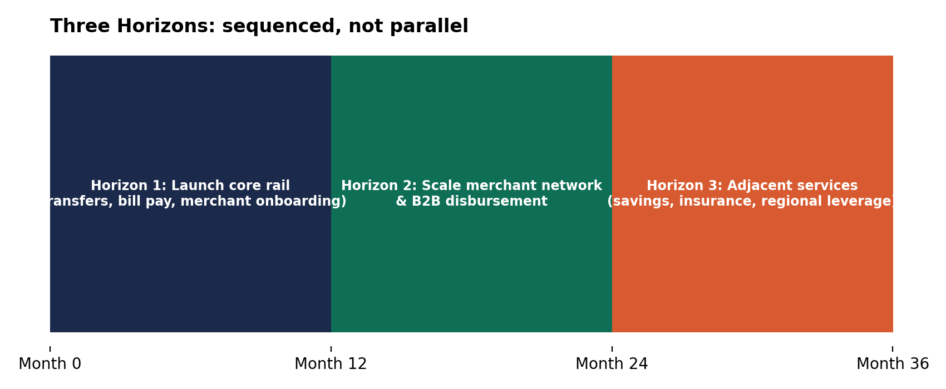
Exhibit 4.1 — Three Horizons roadmap, 36-month view

4.1 Growth levers by horizon

Customer acquisition
Y1: Banglalink-base onboarding (SIM-linked, in-store activation). Y2: Bangla QR-enabled acquisition beyond Banglalink base. Y3: Selective open-market acquisition where NEO PSP's differentiated proposition is provable.

Merchant acquisition
Y1: SME merchants already in Banglalink's enterprise relationships — highest priority, highest capital intensity lever. Y2: Agent-assisted onboarding in underserved regions. Y3: Mid-size enterprise merchant relationships.

Digital ecosystem partnerships
Y1: Settlement banks and Huawei integration (foundational). Y2: E-commerce gateway partnerships. Y3: Open banking/PISP ecosystem participation as the framework matures.

Telecom integration opportunities
NEO PSP's most defensible lever. Y1: SIM-linked activation, bill payment convergence. Y2: Bundled data/payments propositions as a Banglalink retention tool. Y3: VEON cross-market template replication.

Loyalty strategy
Y1: Deliberately deferred beyond basic onboarding incentives. Y2: Unified Banglalink–NEO PSP loyalty construct. Y3: Tiered loyalty linked to SME merchant volume.

SME opportunities
Y1: SME acceptance plus early payroll pilots. Y2: Full SME disbursement product line — the white-space gap from Section 3. Y3: Transaction-data-based credit referrals to partner banks/NBFIs.

Data-driven personalization
Y1: Foundational data infrastructure only. Y2: Merchant-side personalization (faster payback than consumer). Y3: Consumer-side personalization combining transaction and telecom usage data.

Cross-selling concepts
Y1: Telecom-to-payments only. Y2: Payments-to-telecom begins. Y3: Third-party product distribution (insurance, micro-savings) without NEO PSP carrying product risk.

4.2 Prioritization: Impact vs. Implementation Complexity
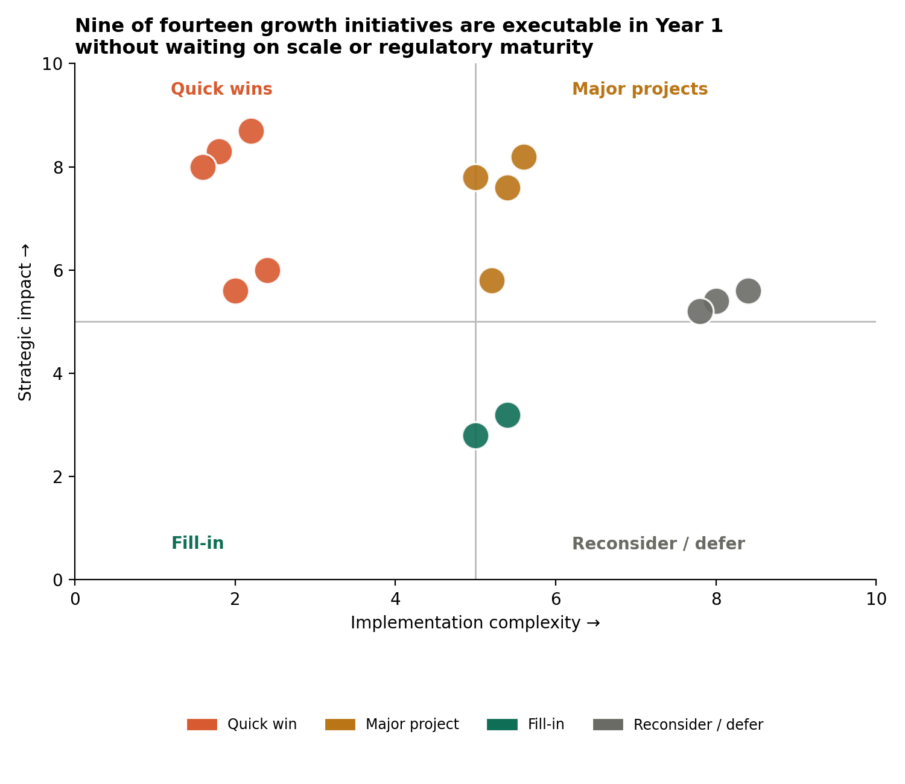
Exhibit 4.2 — Impact vs. Complexity matrix across growth initiatives
Nine of the initiatives mapped are executable in Year 1 without waiting on scale, data, or regulatory maturity — these should absorb the bulk of Horizon 1 management bandwidth. The 'Reconsider / Defer' cluster is not lower-value, it's sequence-dependent: each requires a precondition (data volume, regulatory framework, partner integration) that doesn't exist yet.

5. Conceptual Business Model
Governing thought: A PSP business model is inherently two-sided (payer and merchant), with a third dependency layer — the regulator/settlement-bank relationship — the business literally cannot operate without. This adapted canvas keeps the classic nine blocks and adds a tenth: Key Metrics.
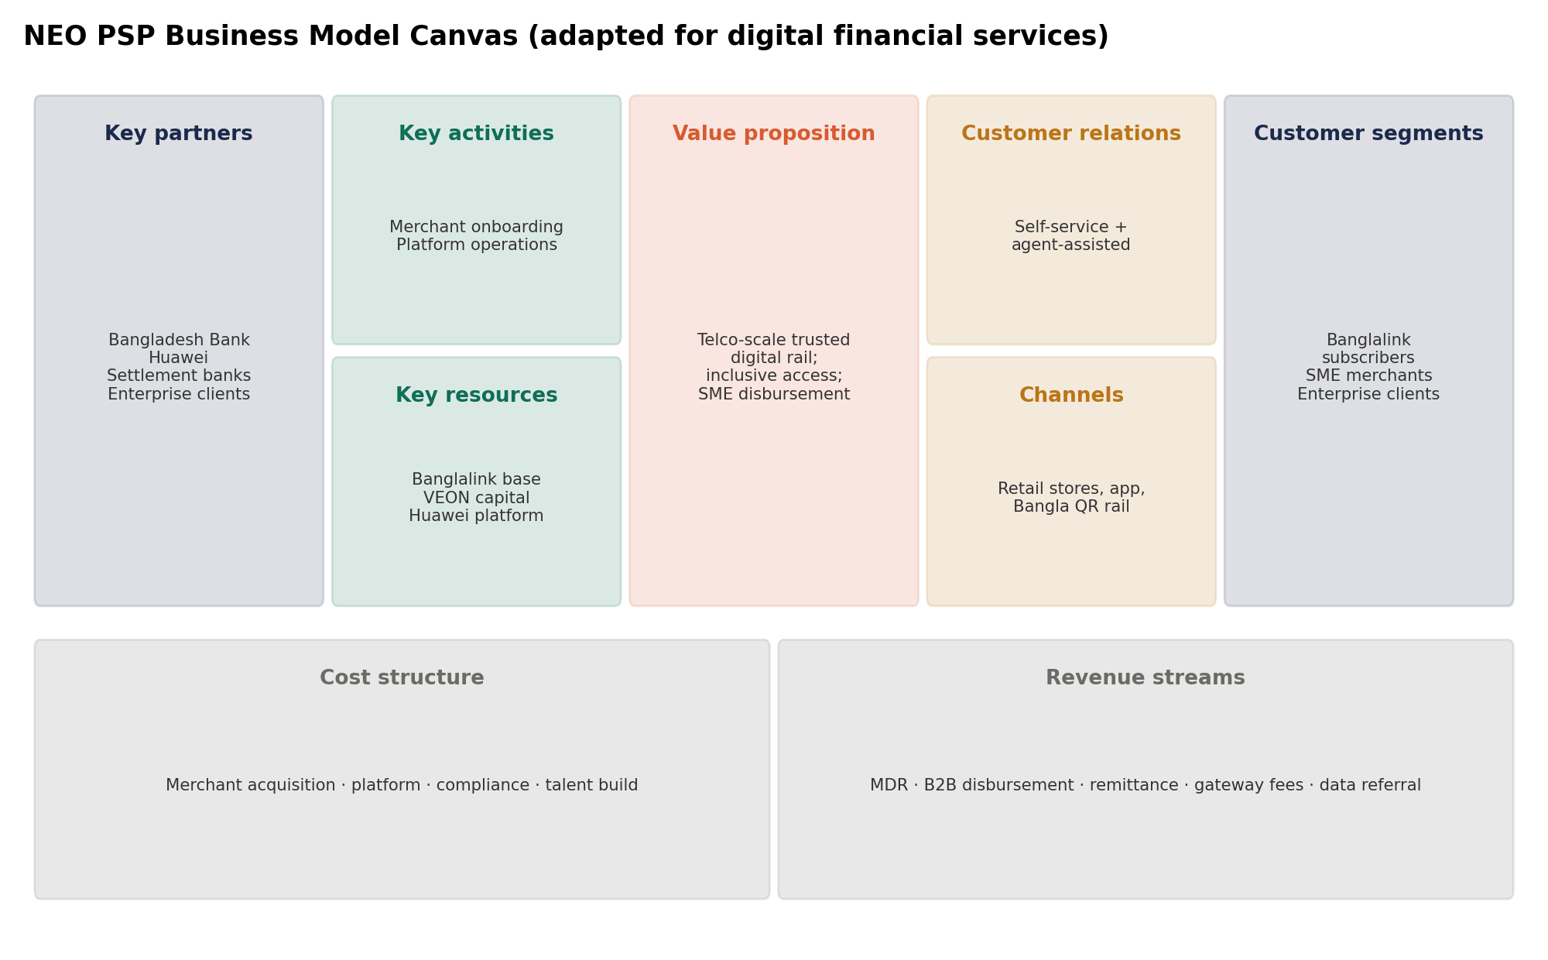
Exhibit 5.1 — NEO PSP Business Model Canvas (adapted for digital financial services)

5.1 Revenue streams
- Merchant discount rate (MDR) on transaction acceptance — centrally floored at 1% under Bangla QR, a predictable, regulator-anchored line.
- B2B/enterprise disbursement fees (payroll, vendor payments) — the differentiated, higher-margin line versus commoditized consumer MDR.
- Remittance fees (PSPs now permitted to bring inward wage remittance).
- Gateway/API fees from e-commerce and platform integrations (Horizon 2).
- Data/referral monetization with partner banks/NBFIs (Horizon 3).

5.2 Cost structure
Acquisition-driven in Horizon 1–2 (merchant acquisition cost is the largest controllable line), shifting toward volume-driven/marginal cost in Horizon 3 as the interoperable rail and existing merchant base generate recurring revenue at low incremental cost. Major lines: merchant acquisition, platform/technology (Huawei), compliance and licensing, settlement/processing, and talent build for capabilities Banglalink hasn't previously operated at this intensity.

5.3 Key partners, resources, and activities
Key partners: Bangladesh Bank, Huawei, settlement/scheduled commercial banks, Banglalink enterprise/SME clients, prospective e-commerce and open-banking ecosystem partners. Key resources: Banglalink's distribution footprint, VEON's balance sheet, the Huawei-built platform, the Bangladesh Bank PSP license, combined telecom + transaction data, and the Mukto Pay brand. Key activities: merchant acquisition and onboarding, platform operation and reliability, regulatory relationship management, settlement operations, and data governance/fraud monitoring.

5.4 Key metrics
Metric | Why it matters early
Active merchant count & retention | Merchant density drives the interoperable network's usefulness — a leading, not lagging, indicator
Transaction volume per active merchant | Distinguishes genuine usage from onboarded-but-dormant merchants
Customer-to-transacting-user conversion | Given near-zero-CAC acquisition, the real cost is in conversion, not sign-up
B2B disbursement volume | Tracks the differentiated white-space opportunity separately from commodity MDR
Cost per active merchant acquired | Governs Horizon 1–2 capital discipline directly
Settlement reliability / uptime | A trust metric with outsized strategic weight

This metric set should be operationalized directly in the standalone KPI Dashboard deliverable.

Phased Implementation Roadmap
Governing thought: Each phase has a single governing question it must answer before the next begins: Phase 1 asks 'does the rail work and can we onboard merchants at all,' Phase 2 asks 'does it scale profitably,' Phase 3 asks 'does it compound into an ecosystem.' Moving to the next phase without a clean answer to the current one is the most common way roadmaps like this fail in execution, not in planning.
This roadmap operationalizes the Three Horizons framework (Section 4) into a phase structure aligned to board governance cadence — 6-month, 18-month, and 36-month review gates rather than continuous quarterly re-litigation of strategy.

Phase 1 (0–6 months): Prove the Rail
Objective: establish that NEO PSP can onboard merchants, process transactions reliably, and operate within Bangladesh Bank's compliance framework — before committing capital to scale. This is a controlled launch, not a market-wide push.
 | Details
Objectives | - Achieve commercial launch approval from Bangladesh Bank following NOC  - Stand up core rail: transfers, bill pay, merchant QR acceptance via Mukto Pay/Huawei platform  - Onboard first wave of merchants through Banglalink's existing enterprise relationships
Key initiatives | - Complete Huawei platform integration and institutional-grade reliability testing  - Settlement bank partnership agreements finalized  - Bangla QR interoperability compliance certification  - First-wave SME merchant onboarding (warm-lead channel only)  - SIM-linked customer onboarding flow live in Banglalink app/USSD
Dependencies | - Bangladesh Bank final commercial launch approval (beyond NOC)  - Huawei platform delivery on committed timeline  - Settlement bank agreements executed  - Internal Banglalink enterprise sales team alignment on cross-sell mandate
Success metrics | - Commercial launch achieved within phase window  - First 150–300 active merchants onboarded (illustrative target, see Financial Model)  - Settlement reliability ≥99% from day one  - Zero critical compliance findings from Bangladesh Bank
Major risks | - Regulatory approval delay beyond NOC — highest-probability, highest-impact risk this phase  - Platform delivery slippage from Huawei integration complexity  - Merchant onboarding slower than warm-lead assumption if Banglalink's B2B sales team isn't incentivized to prioritize it
Expected outcomes | - A working, compliant, reliable core rail with a small but real transacting merchant and customer base  - Proof points to justify Phase 2 capital commitment — not yet a scale business

Phase 2 (6–18 months): Scale the Network
Objective: convert the proven rail into a genuine merchant network and open the SME/enterprise disbursement line — the differentiated white-space opportunity identified in the Competitive Benchmarking. This phase absorbs the bulk of Horizon 1–2 capital intensity.
 | Details
Objectives | - Scale merchant acquisition beyond the warm-lead channel into underserved regions  - Launch B2B disbursement product line (payroll, vendor payments)  - Establish telecom–payments bundled propositions and unified loyalty construct
Key initiatives | - Agent-assisted merchant onboarding in underserved regions (Feni, Cumilla, Chattogram first; Panchagarh, Kurigram inclusion-focused expansion)  - SME payroll/vendor disbursement product build and enterprise sales motion  - Unified Banglalink–NEO PSP loyalty program launch  - E-commerce/platform gateway partnership integrations  - Merchant-side data personalization (settlement timing, fee-tier optimization)
Dependencies | - Phase 1 reliability and compliance track record clean enough to support scale-up  - Dedicated headcount build in merchant acquisition, risk/compliance, and product (per Operating Model, Section 8)  - Banglalink core telecom product team coordination on bundled propositions — flagged as a cross-functional risk earlier in this engagement
Success metrics | - Active merchant base scaling toward Year 2 target trajectory (see KPI Dashboard, Financial Model)  - B2B disbursement revenue share reaching a meaningful proportion of total revenue (target: material double-digit share by end of phase)  - Merchant retention rate sustained ≥95%  - Cost per active merchant acquired trending down as warm-lead channel saturates and agent-assisted channel matures
Major risks | - Incumbent response — bKash/Nagad extending defensively into merchant/gateway services during this window  - Execution risk in agent-network build-out, a capability Banglalink has not previously operated at this intensity  - Telecom–payments bundling stalls if core telecom product team isn't formally resourced into the roadmap
Expected outcomes | - NEO PSP becomes a visible, scaling second growth engine rather than a pilot  - B2B disbursement establishes NEO PSP's differentiated position ahead of any competitor closing the gap

Phase 3 (18–36 months): Compound the Ecosystem
Objective: move from a scaling payments business to a defensible financial-services ecosystem — layering adjacent services, consumer-side personalization, and open banking participation onto a now-established merchant and customer base.
 | Details
Objectives | - Launch adjacent financial services (micro-savings placement, insurance premium collection) without carrying product risk directly  - Participate in open banking/PISP ecosystem as the Bangladesh Bank framework matures  - Establish NEO PSP as a replicable playbook for VEON's other operating markets
Key initiatives | - Consumer-side data personalization combining transaction and telecom usage data  - Credit-referral data monetization partnerships with banks/NBFIs  - Open banking/PISP participation (account-to-account payment initiation)  - Third-party insurance/micro-savings distribution partnerships  - VEON cross-market playbook documentation and knowledge transfer
Dependencies | - Bangladesh Bank open banking/PISP framework reaching sufficient maturity (targeted mid-2026, subject to regulatory pacing)  - Sufficient transaction data volume and consent architecture from Phase 1–2 to support personalization reliably  - Partner bank/NBFI agreements for credit-referral and product-distribution lines
Success metrics | - Revenue diversification: adjacent/ecosystem revenue lines contributing a growing non-MDR share of total revenue  - EBITDA breakeven achieved or clearly in sight (see Financial Model breakeven flag)  - At least one VEON cross-market replication conversation formally initiated
Major risks | - Open banking timeline slips, delaying the PISP-dependent revenue line — mitigated by treating this as upside, not core-case, per the Growth Framework's prioritization matrix  - Over-expansion into adjacent services ahead of core profitability, repeating the capital-discipline risk flagged in the Executive Summary  - E-commerce-native PSP entrants (Daraz, Chaldal) maturing into direct competitors for the same ecosystem plays
Expected outcomes | - NEO PSP operates as a diversified, increasingly self-funding digital financial services platform  - A credible, documented case for VEON to evaluate replication in other operating markets

Cross-Phase Governance
- Each phase concludes with a formal steering committee gate review against the success metrics above — not an automatic progression.
- Phase transitions should be capital-gated: Phase 2 funding is not released until Phase 1's compliance and reliability metrics are clean; Phase 3 ecosystem investment is not released until Phase 2's B2B disbursement and merchant retention targets are met.
- This roadmap should be read alongside Section 9 (Risk Assessment) and the KPI Dashboard, which operationalizes the success metrics listed above into an ongoing tracking tool rather than a one-time checklist.

Closing Note
This document compiles the strategic work products developed to date: the report architecture, executive summary, strategic market assessment, competitive benchmarking, three-year growth framework, and conceptual business model. Remaining deliverables — the full financial business case, KPI dashboard, customer journey maps, board presentation, and 2-page executive brief — build directly on the analysis and assumptions established here.
All figures not directly sourced from public disclosures are explicitly flagged as assumptions with stated rationale. This report should be read alongside those source citations before any figure is used in external or investor-facing communication.

