# HRMS User Guide (Demo Project)

This guide provides a quick overview of the HRMS demo project, covering Dashboard, Departments, Occupations, and Employees.

# Dashboard

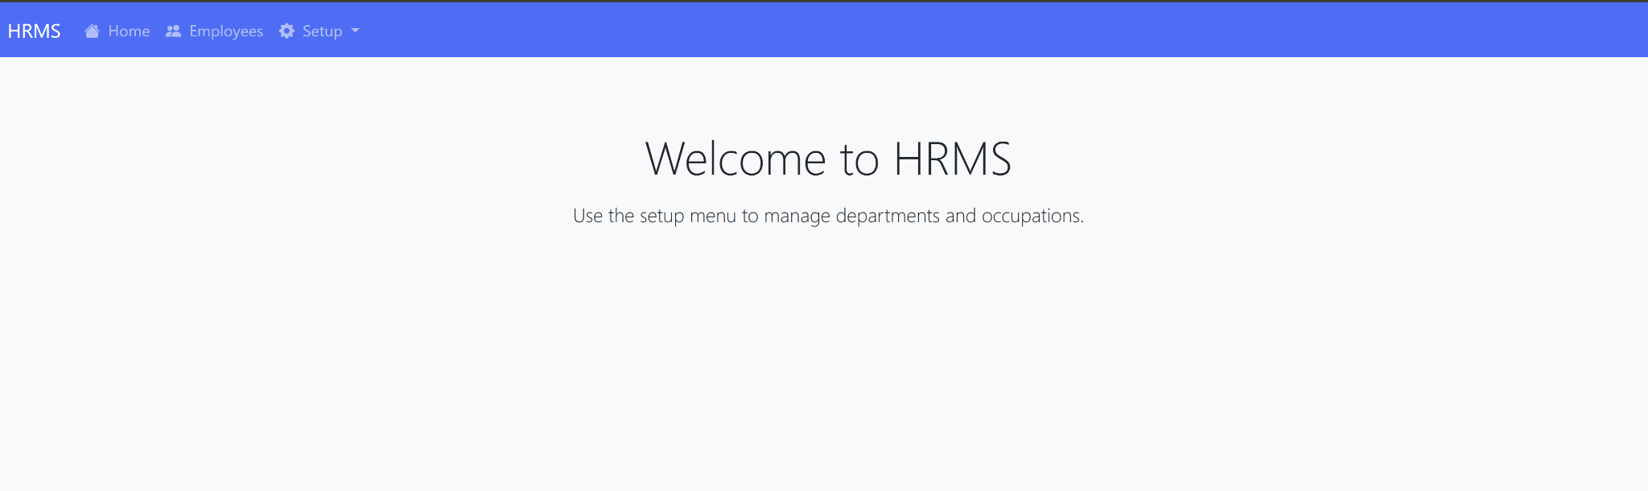

Dashboard - Welcome screen

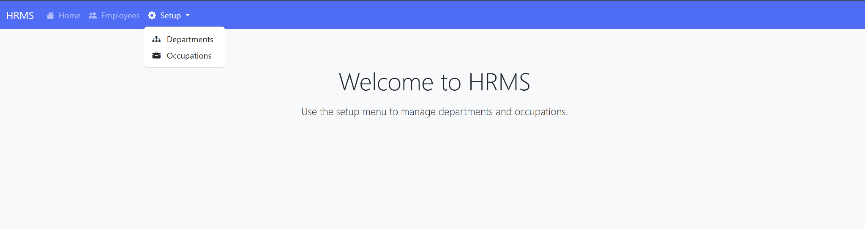

Setup menu with Departments and Occupations

# Departments

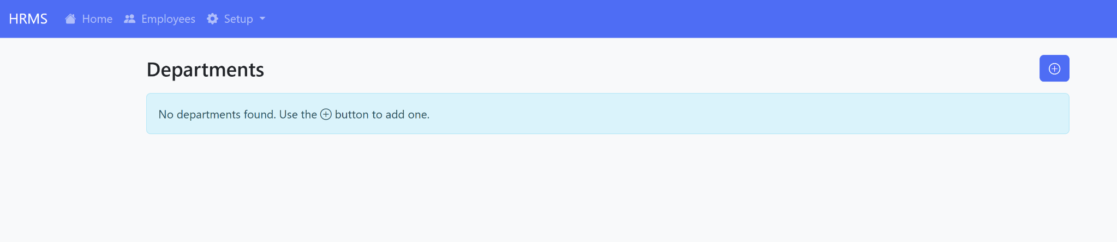

Departments - No records, add new

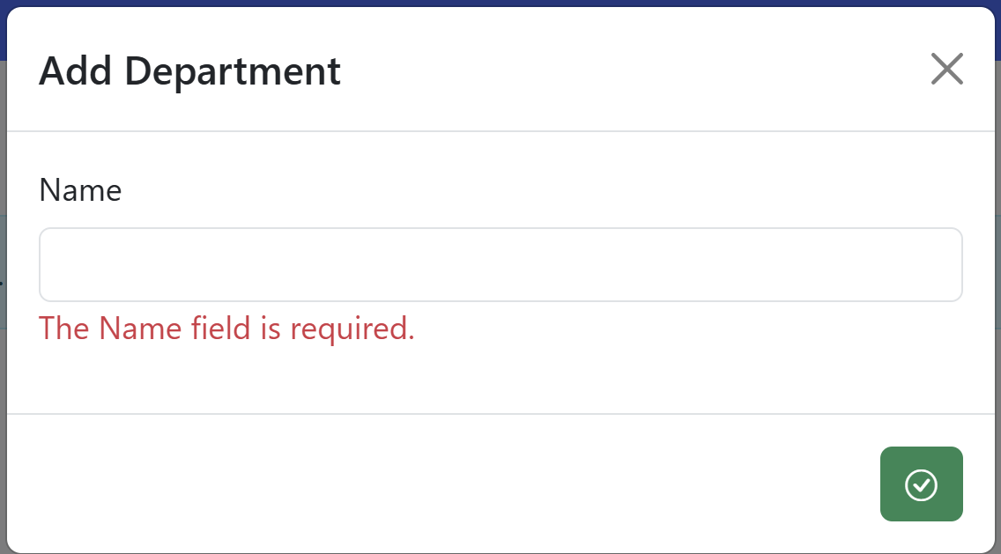

Add Department form

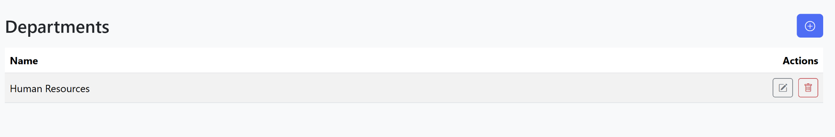

Departments - Record added

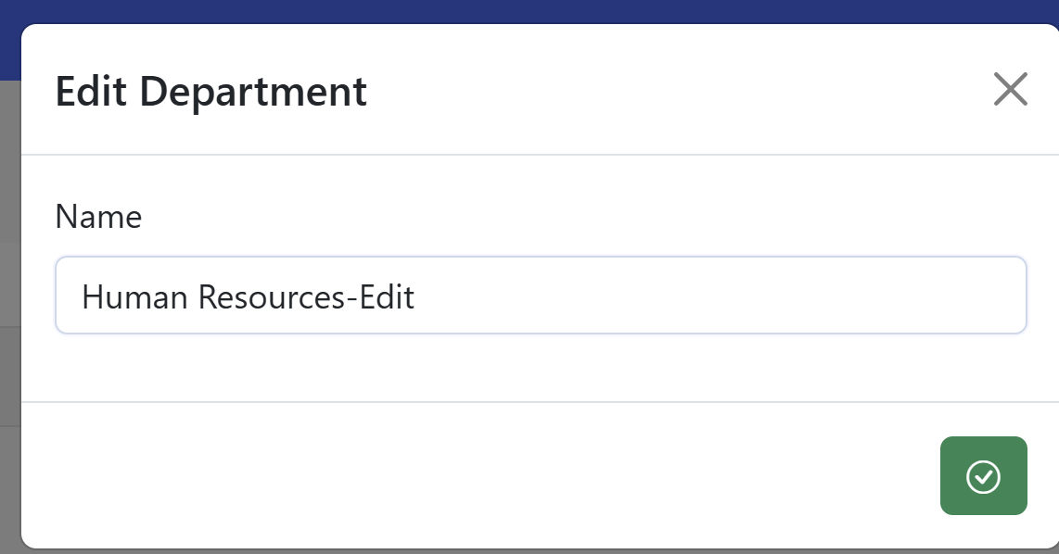

Edit Department form

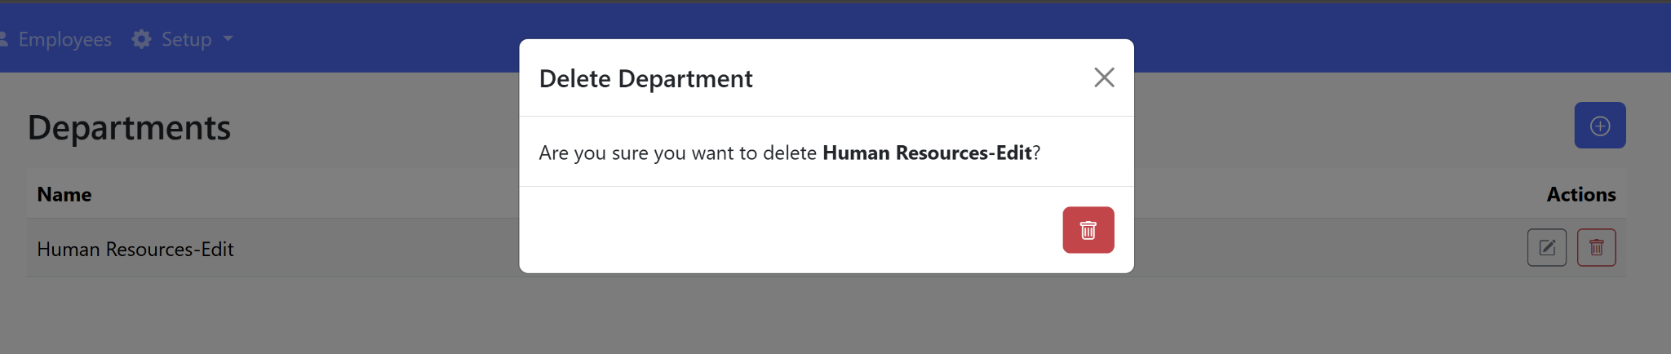

Delete Department confirmation

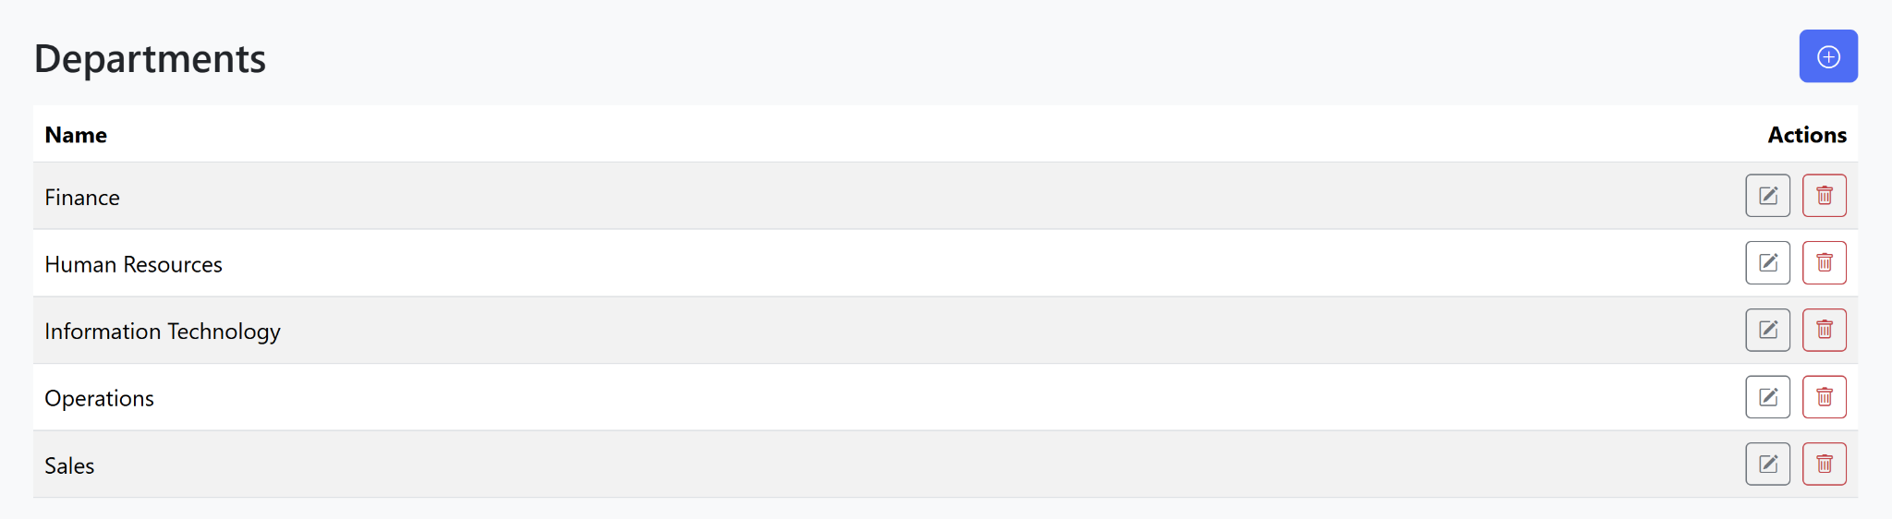

Departments list with multiple records

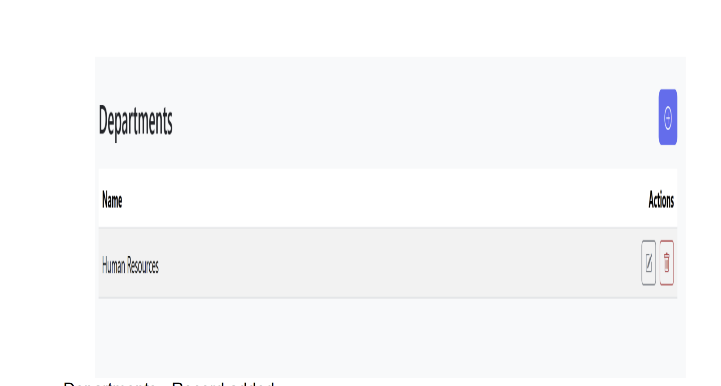

Departments - Single record (Human Resources)

# Occupations

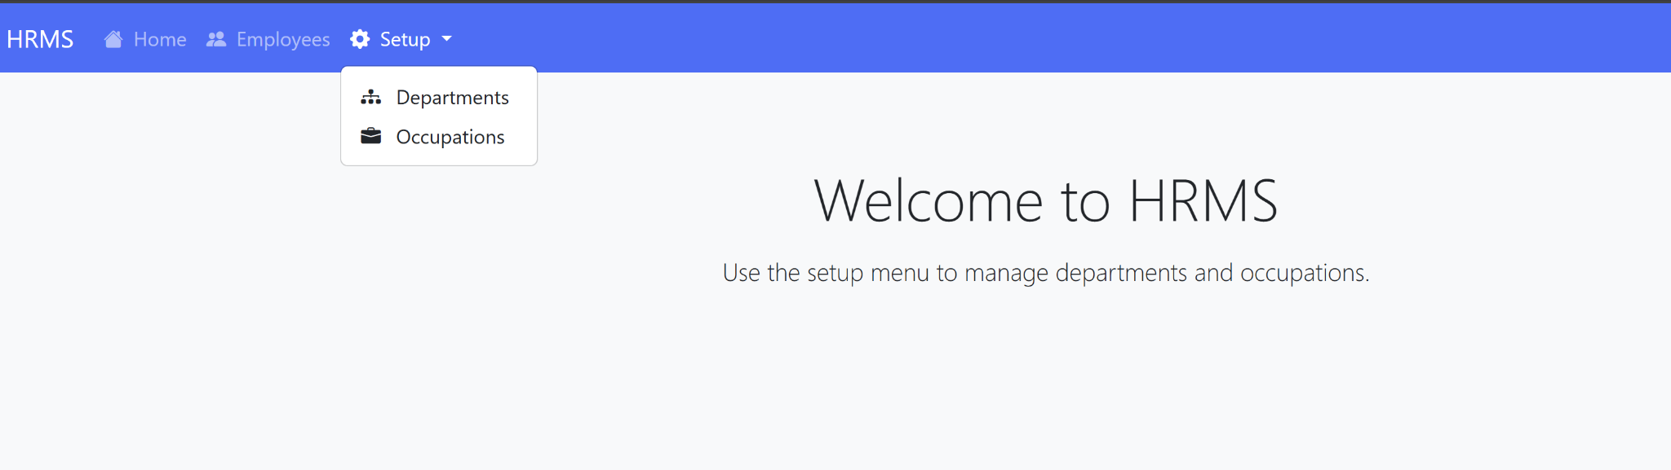

Setup - Occupations option

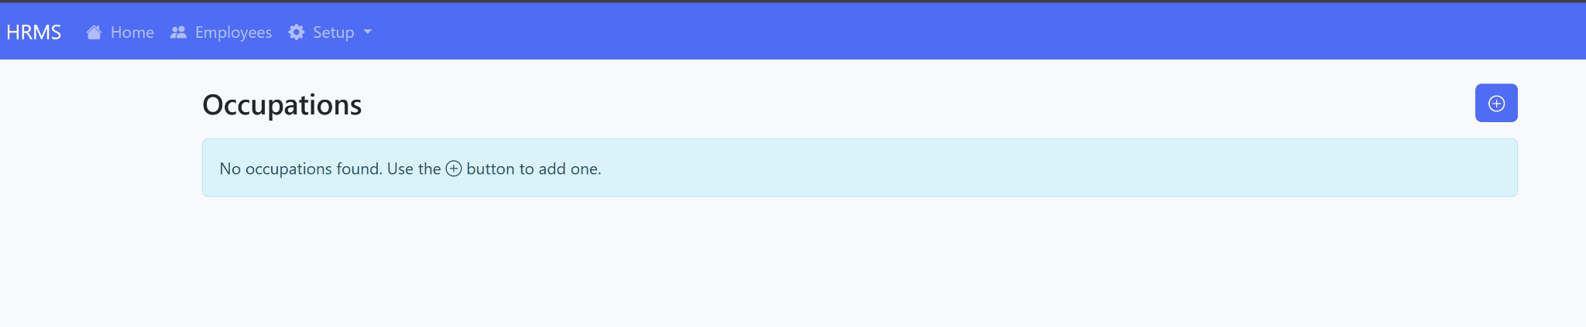

Occupations - No records, add new

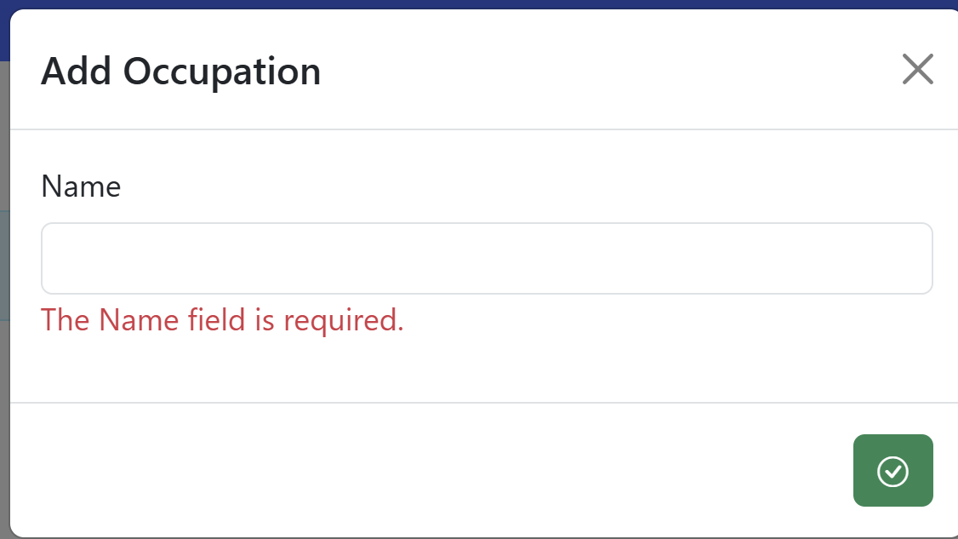

Add Occupation form

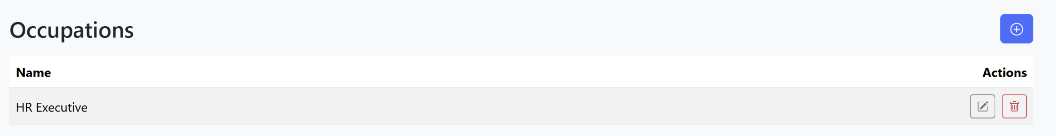

Occupations - Record added

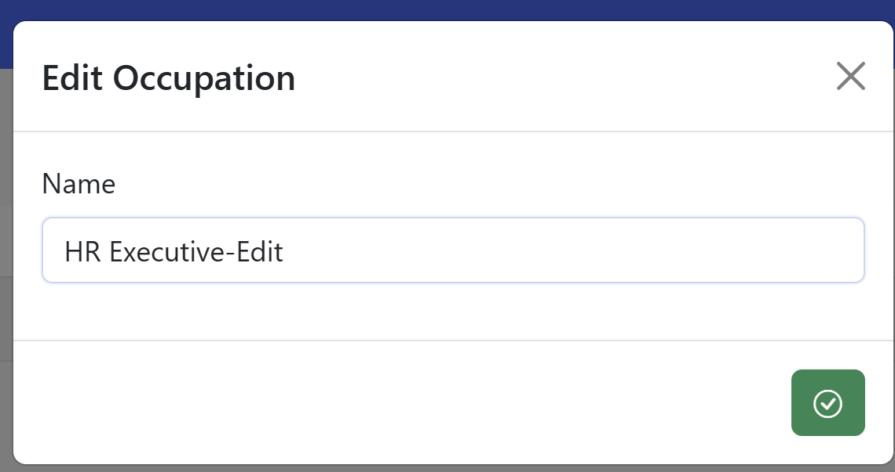

Edit Occupation form

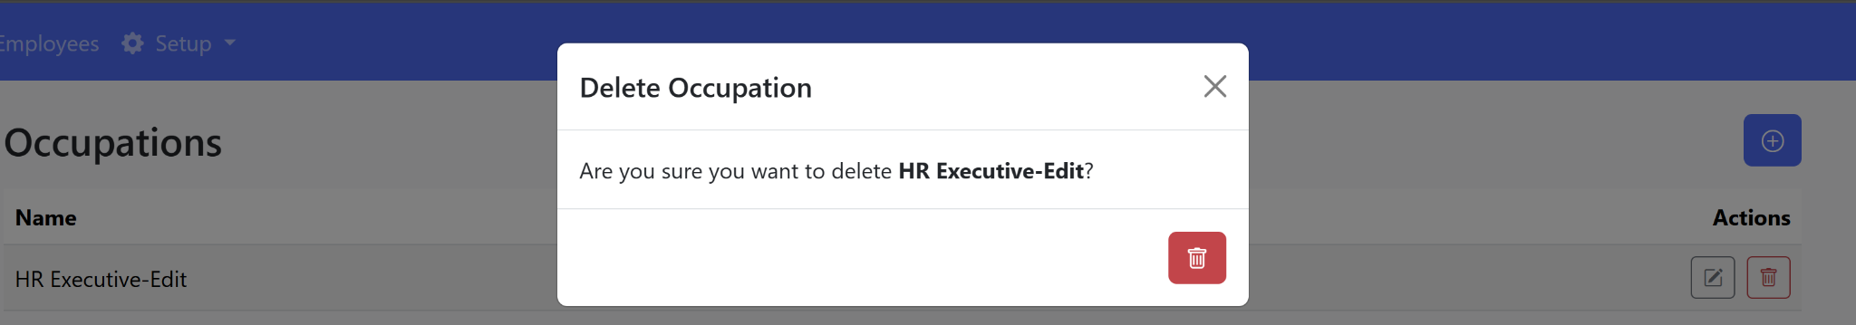

Delete Occupation confirmation

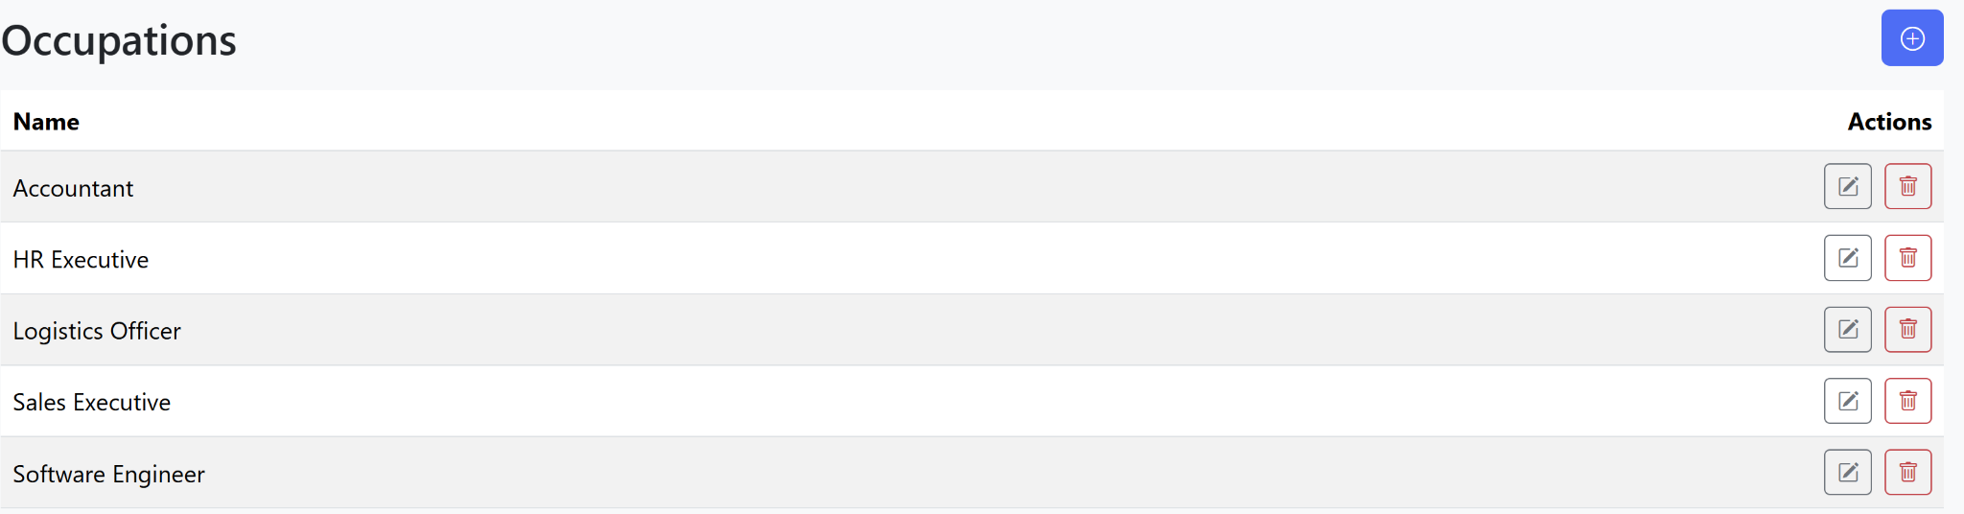

Occupations list with multiple records

# Employees

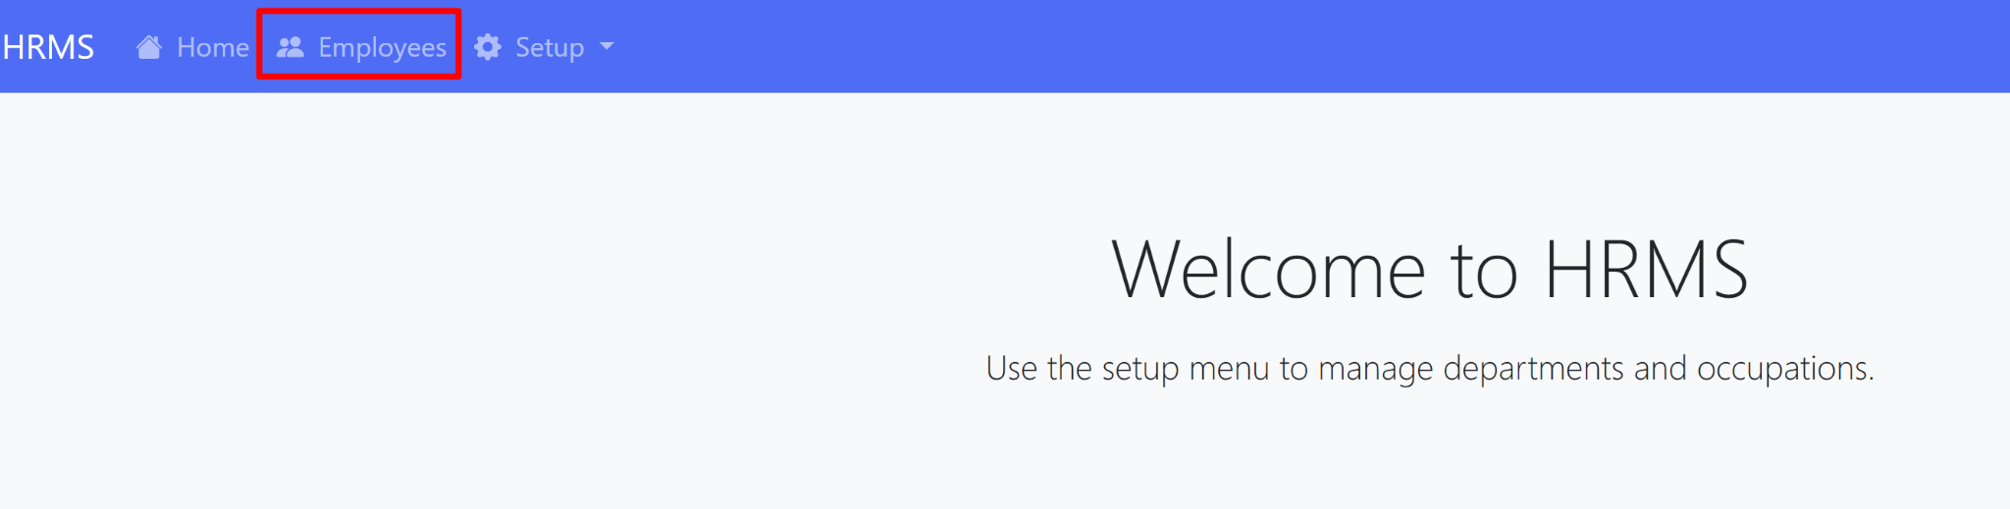

Employees menu navigation

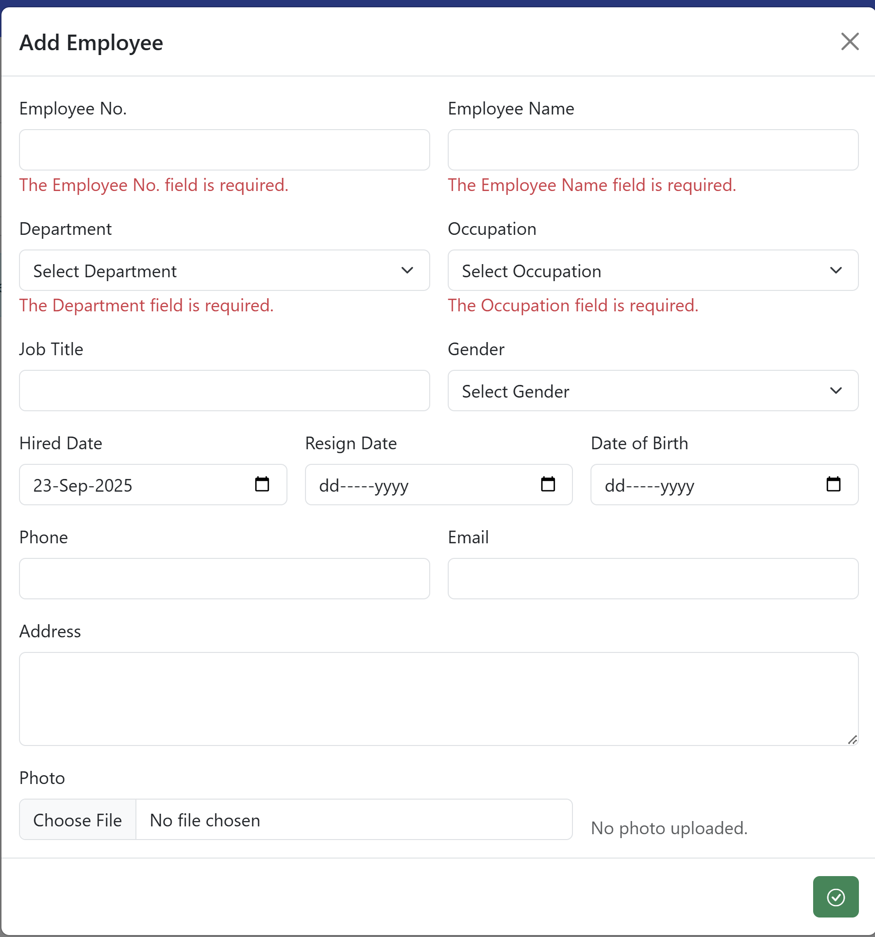

Add Employee form (empty with validation errors)

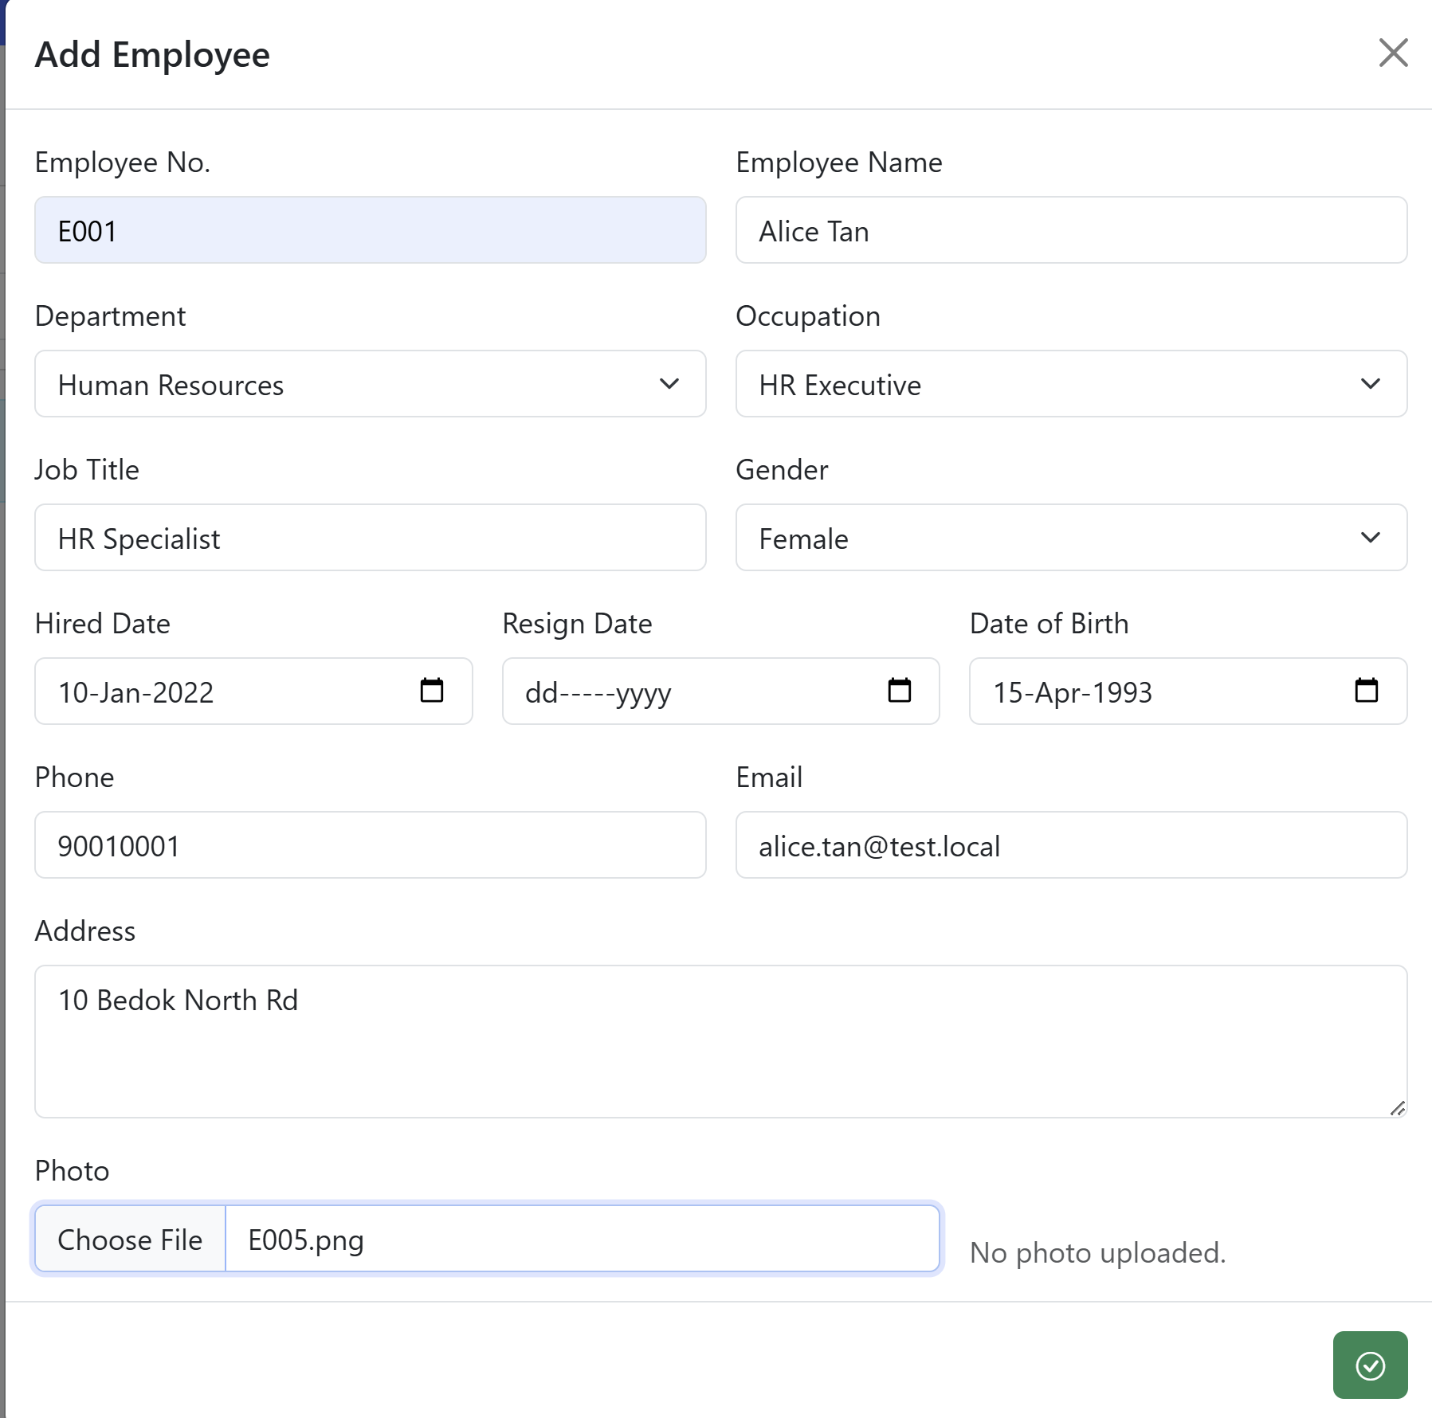

Add Employee form (with details filled)

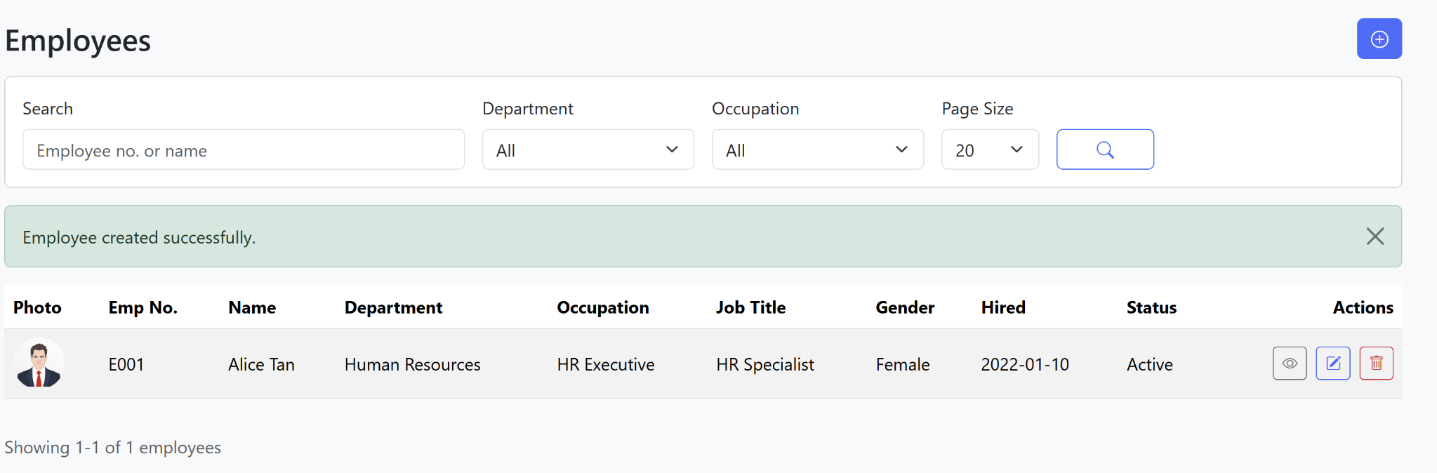

Employees list - record created

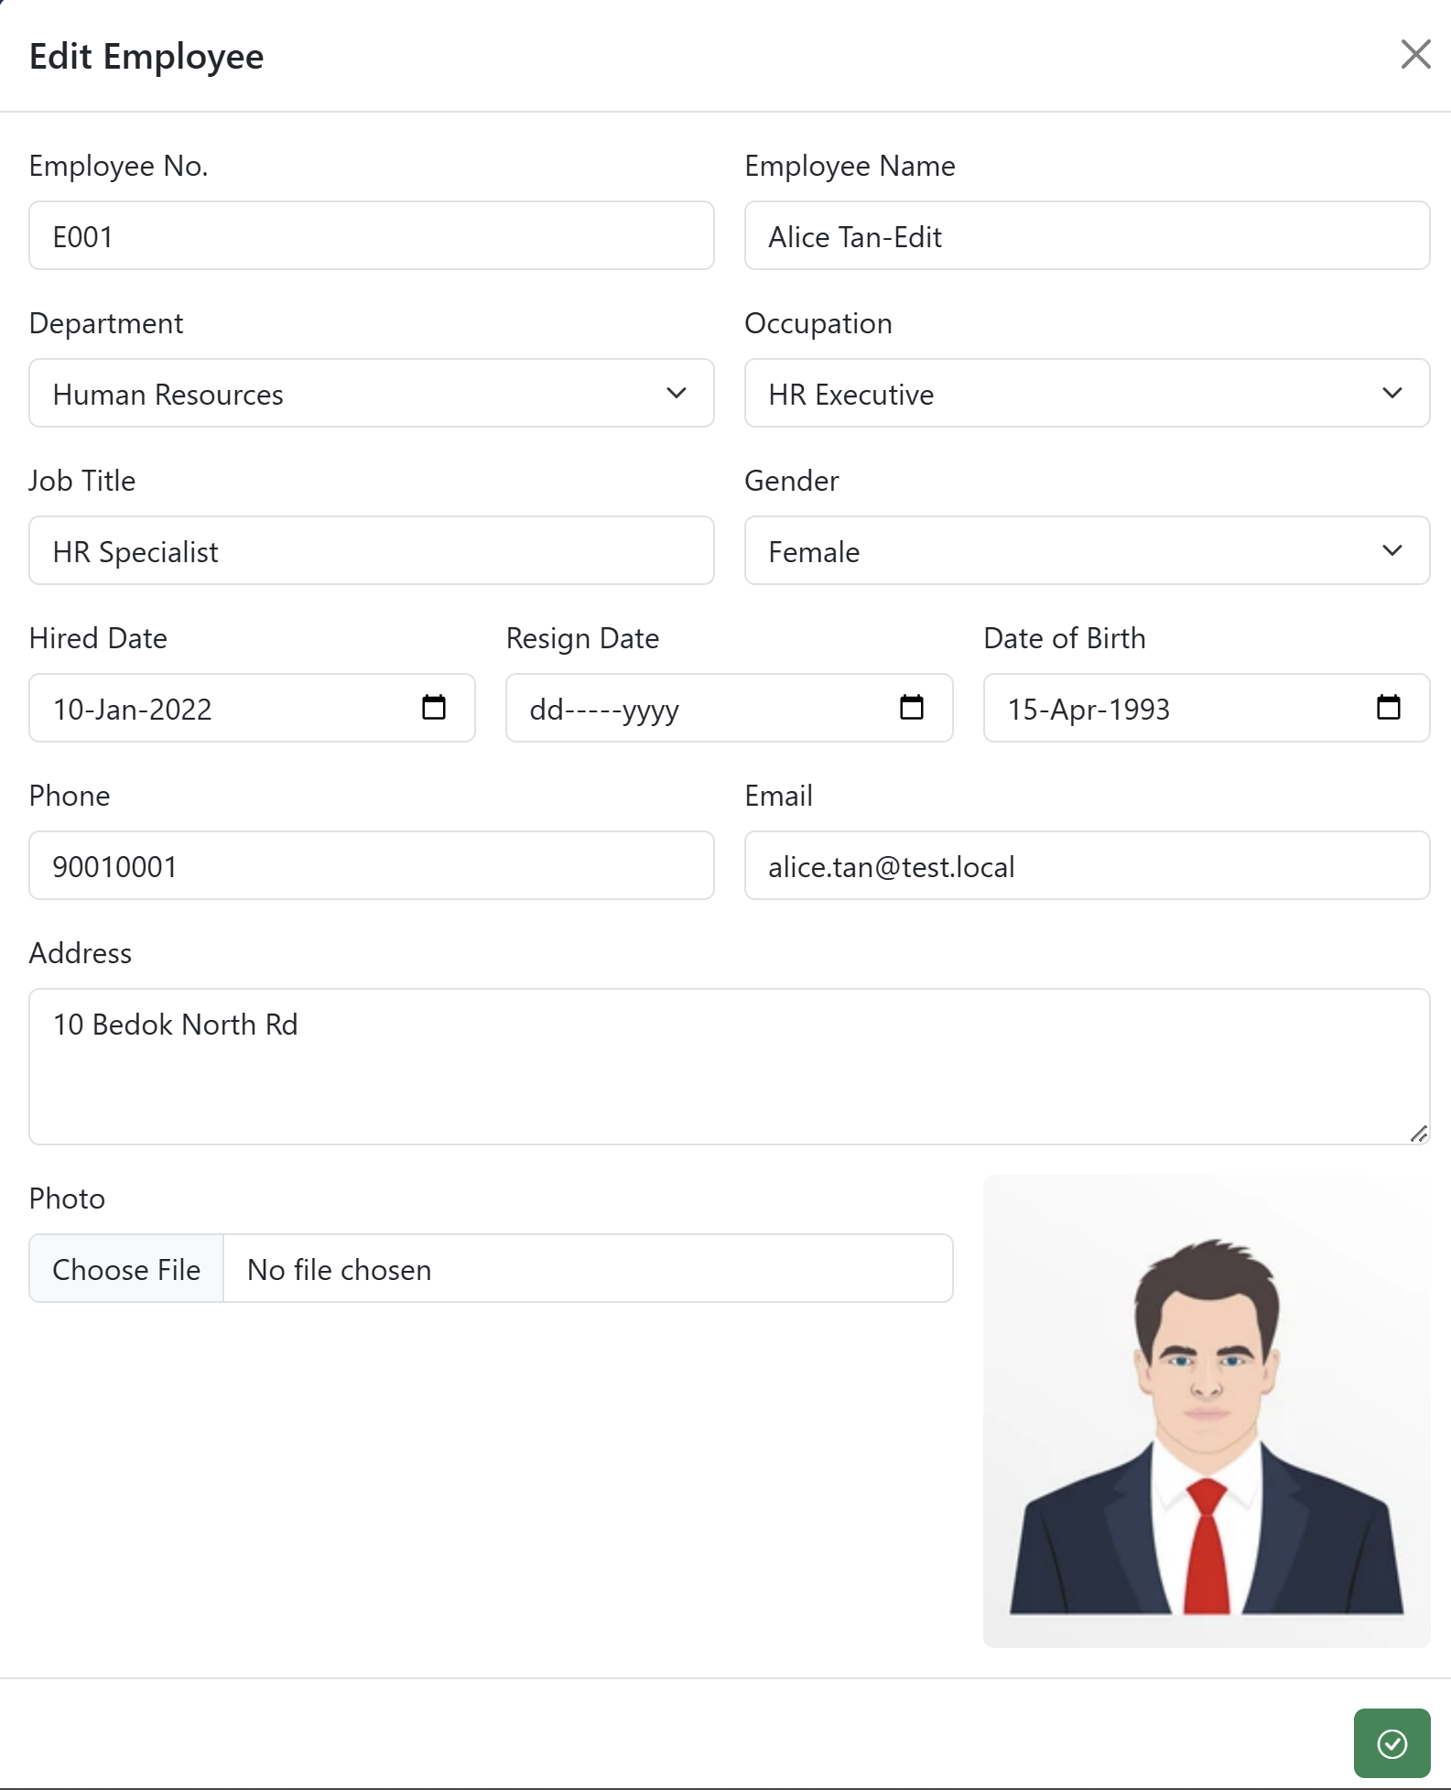

Edit Employee form

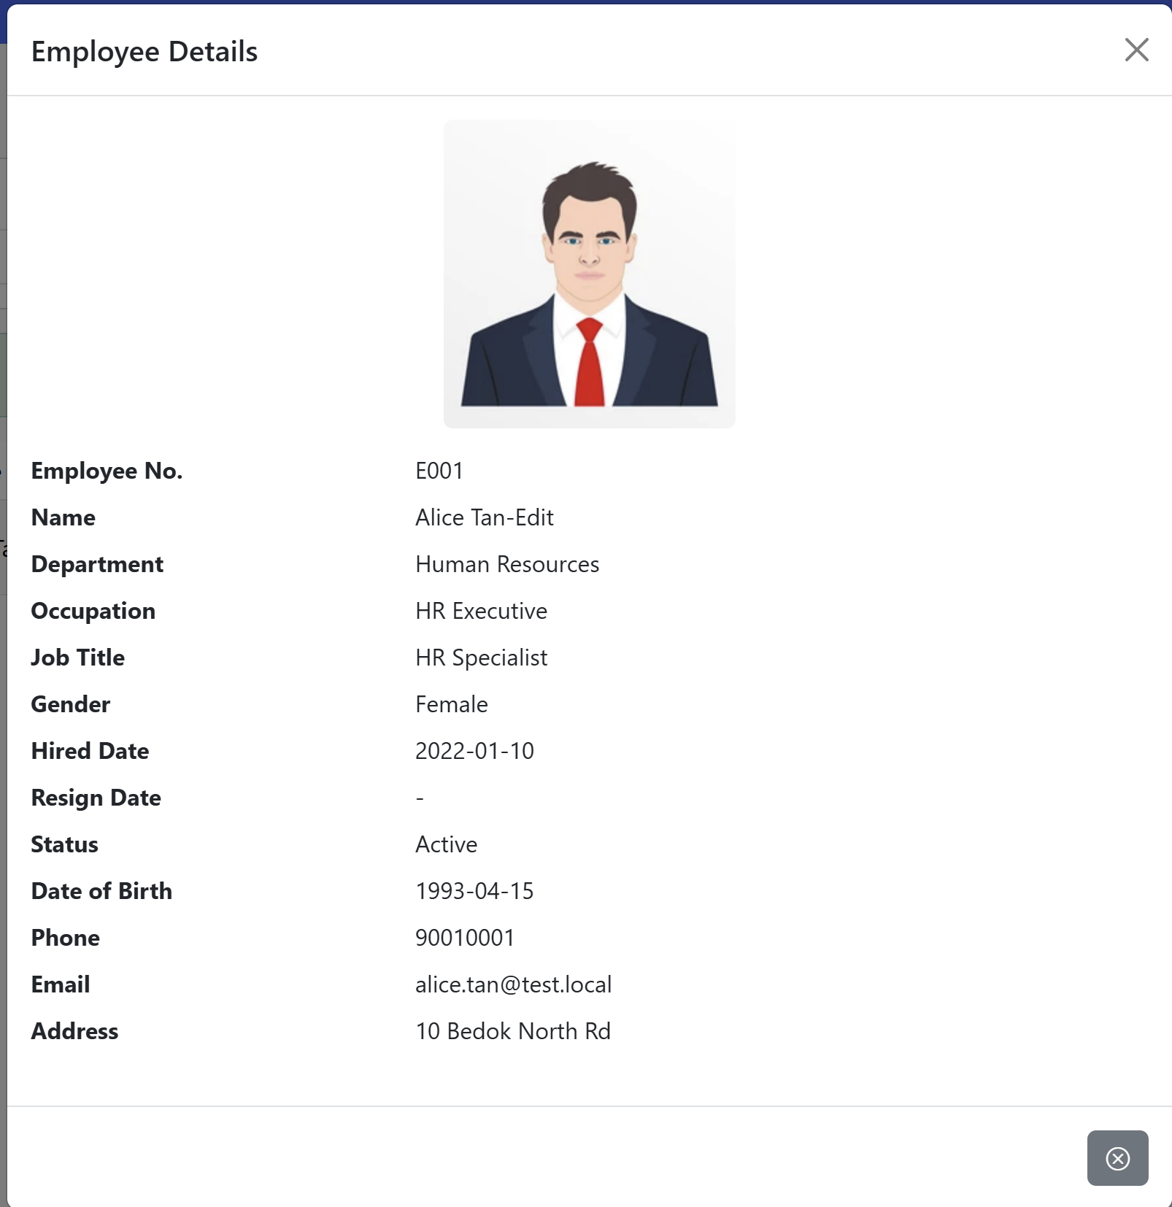

Employee details view

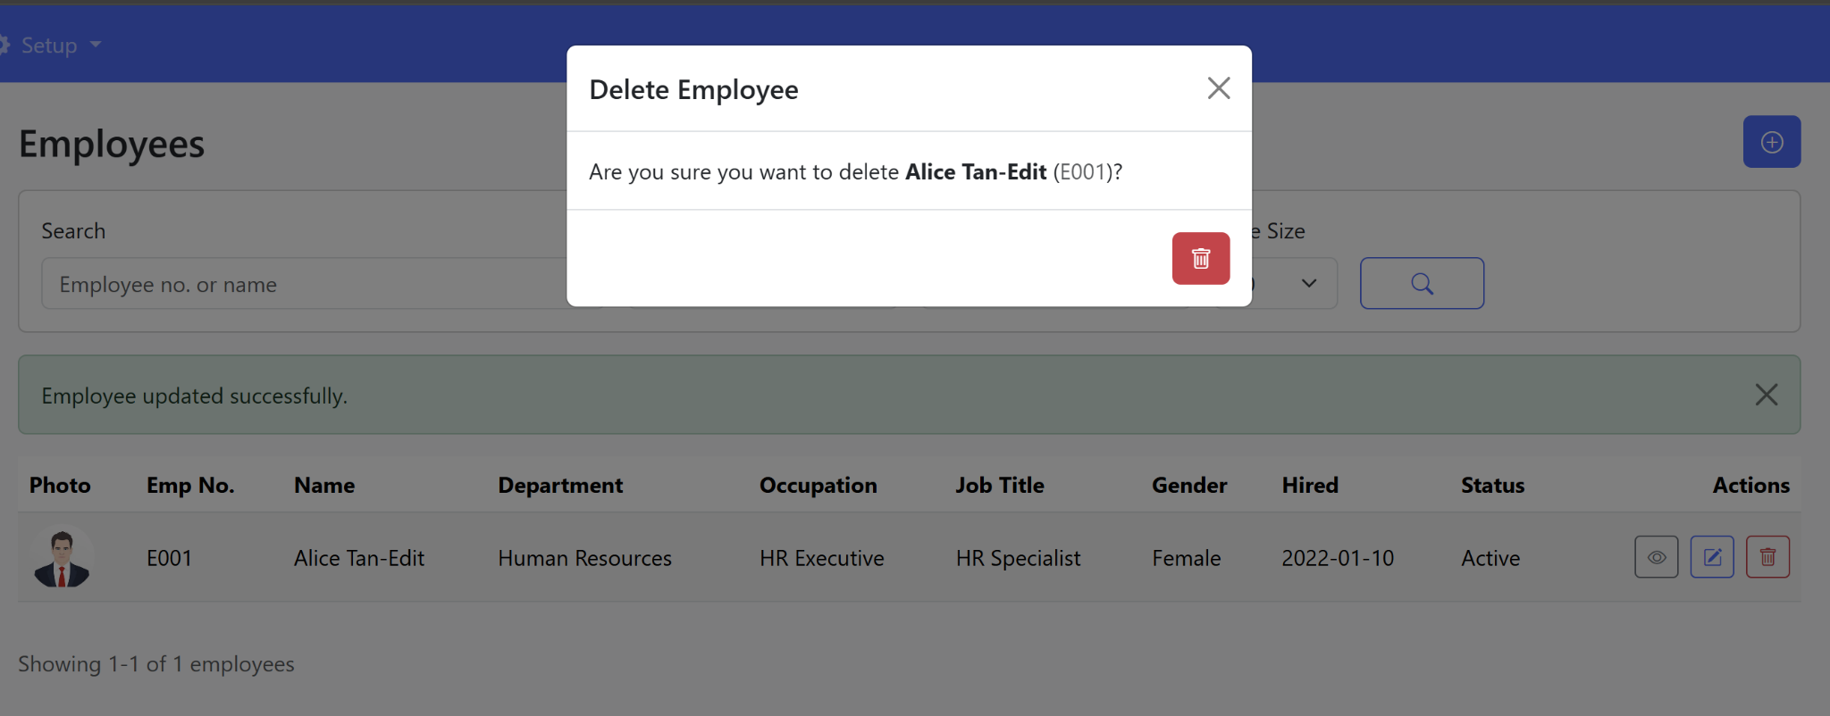

Delete Employee confirmation

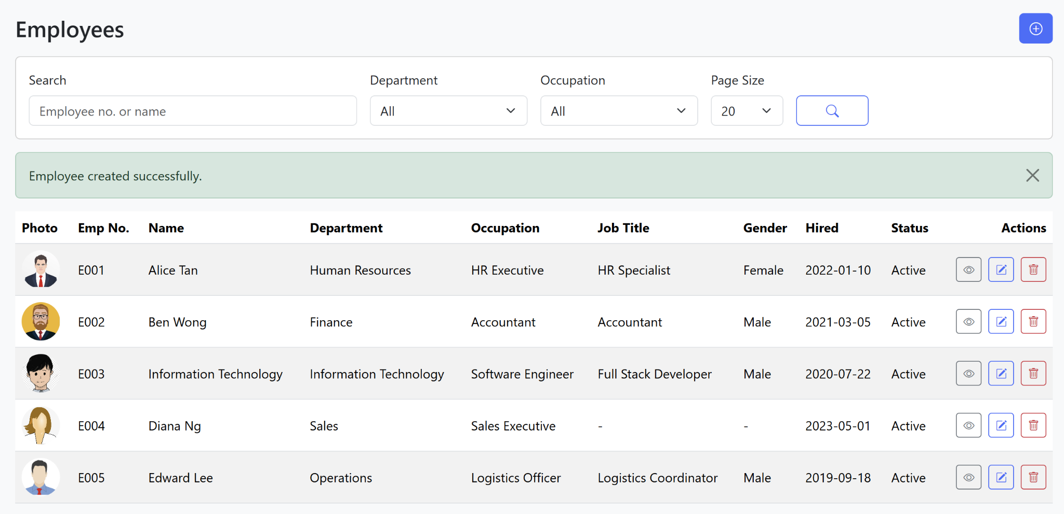

Employees list - multiple records

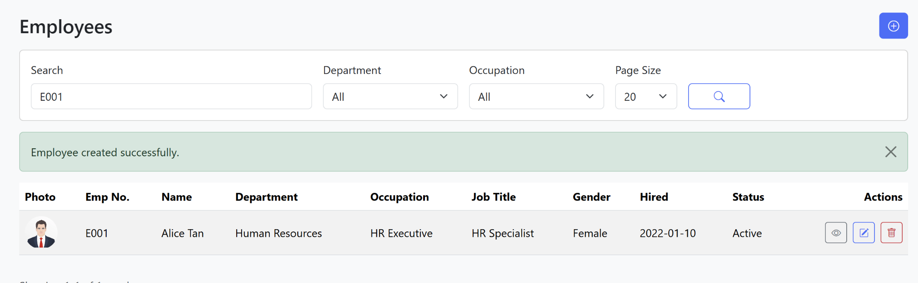

Employees search by Emp No.

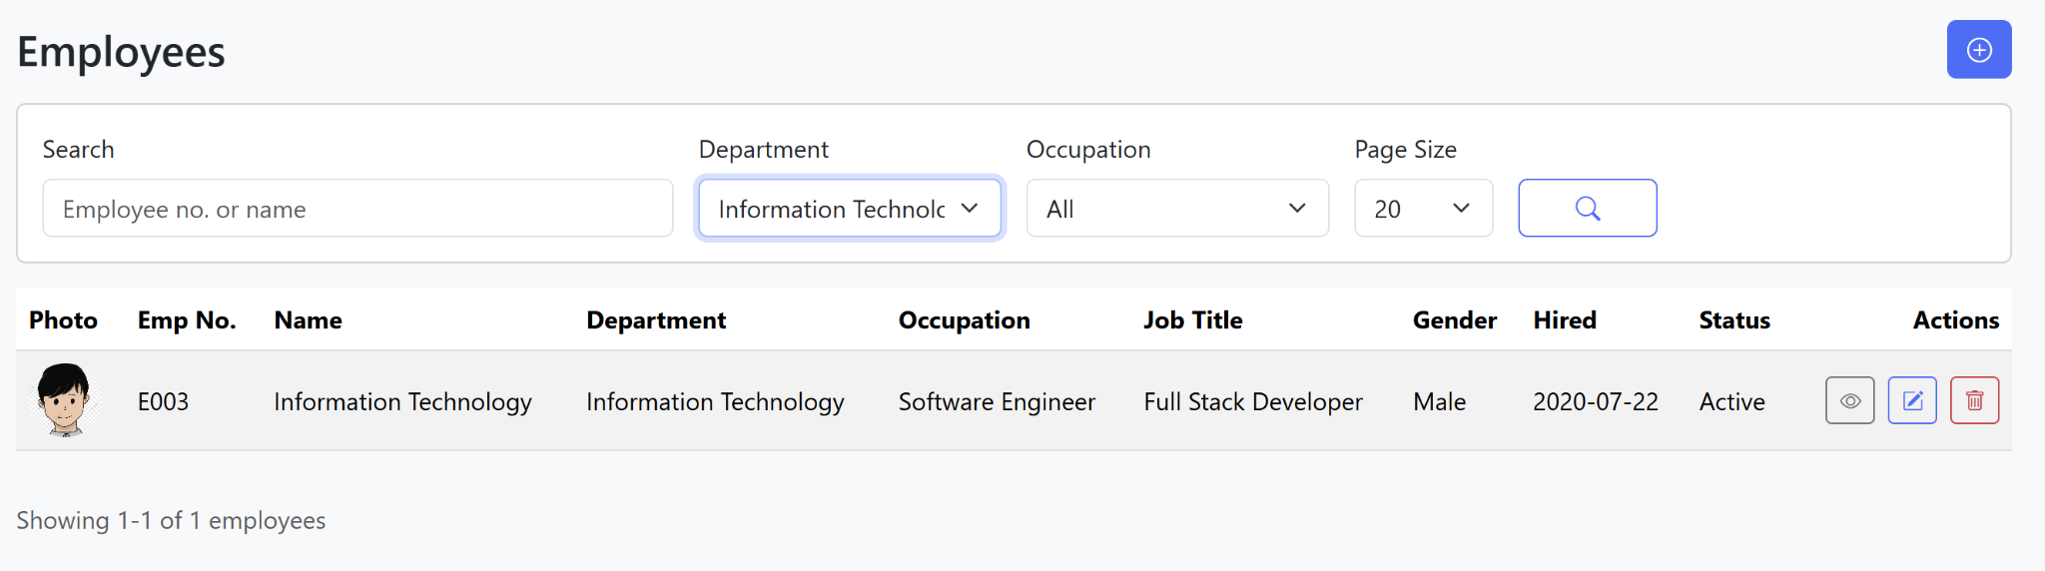

Employees filtered by Department

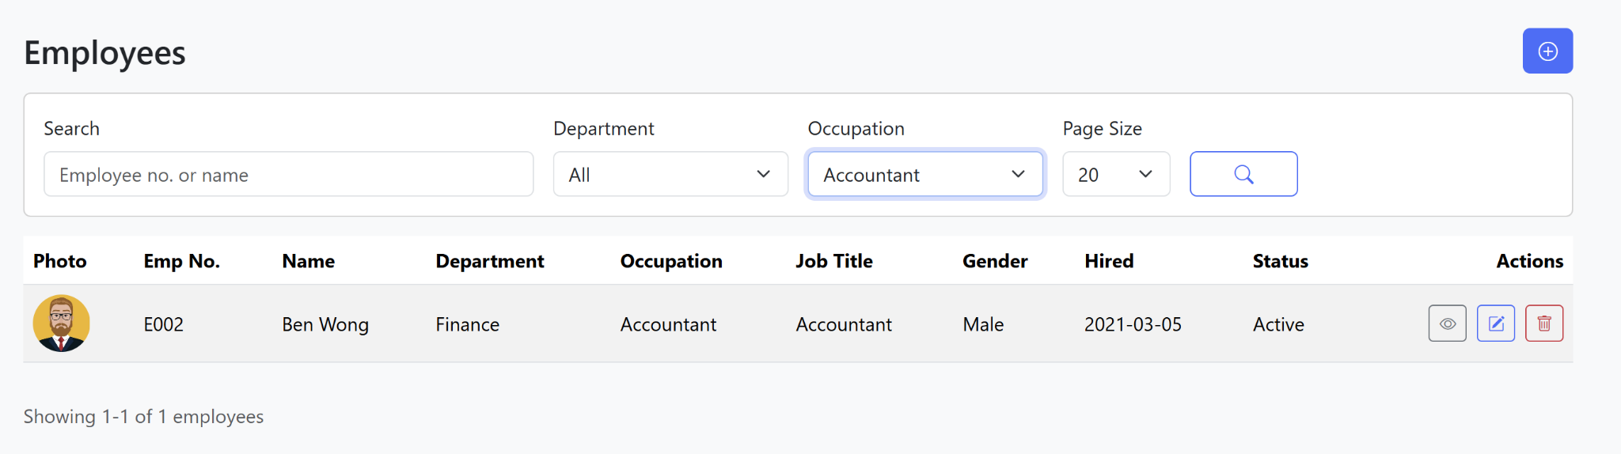

Employees filtered by Occupation