**Discrete Assignment**

**Iqra Fakhar**

**NU-ID = P17-6148**

**Section-C**

CODE

def test():

x = "p->q.~p^q.s->t.tvq"

pr = x.split('.')

clause = []

for i in pr:

temp=i.split('->')

if(len(temp)!=1):

if temp[0][0] == '~':

temp[0] = temp[0][1]

elif temp[0][0] != '~':

temp[0] = '~'+temp[0]

clause.append(temp[0]+'v'+temp[1])

else:

temp=i.split('^')

if(len(temp)!=1):

clause.append(temp[0])

clause.append(temp[1])

else:

clause.append(temp[0])

if(pr[len(pr)-1]==i):

temp = pr[len(pr)-1]

temp = i.split('v')

if(len(temp)==1):

temp=temp[0].split('^')

if(len(temp)==1):

if temp[0][0] == '~':

temp[0] = temp[0][1]

else: #temp[0] != '~':

temp[0] = '~'+temp[0]

clause[-1]=temp[0]

else:

if temp[0][0] == '~':

temp[0] = temp[0][1]

else: #temp[0] != '~':

temp[0] = '~'+temp[0]

if temp[1][0] == '~':

temp[1] = temp[1][1]

else: #temp[0] != '~':

temp[1] = '~'+temp[1]

clause[-1] = temp[0] + 'V' + temp[1]

else:

if temp[0][0] == '~':

temp[0] = temp[0][1]

else: #temp[0] != '~':

temp[0] = '~'+temp[0]

if temp[1][0] == '~':

temp[1] = temp[1][1]

else: #temp[0] != '~':

temp[1] = '~'+temp[1]

clause[-1] = temp[0] + '^' + temp[1]

print(clause)

return clause

def Main():

clause=test()

temp=clause

while clause != ['']:

for i in range(0,len(clause)-2):

cls1=clause[i]

cls1=cls1.split('v')

if(len(cls1)!=1):

for j in range(1,len(clause)-1):

cls2=clause[j]

cls2=cls2.split('v')

if(len(cls2)!=1):

if(cls1[0]=='~'+cls2[0] or '~'+cls1[0]==cls2[0]):

clause.remove(clause[i])

clause[i]=cls1[1]+'v'+cls2[1]

elif(cls1[0]=='~'+cls2[1] or '~'+cls1[0]==cls2[1]):

clause.remove(clause[i])

clause[i]=cls1[1]+'v'+cls2[0]

elif(cls1[1]=='~'+cls2[0] or '~'+cls1[1]==cls2[0]):

clause.remove(clause[i])

clause[i]=cls1[0]+'v'+cls2[1]

elif(cls1[1]=='~'+cls2[1] or '~'+cls1[1]==cls2[1]):

clause.remove(clause[i])

clause[i]=cls1[0]+'v'+cls2[0]

else:

clause[i]=''

else:

clause

print(clause)

RuleofResolution()

example – 6

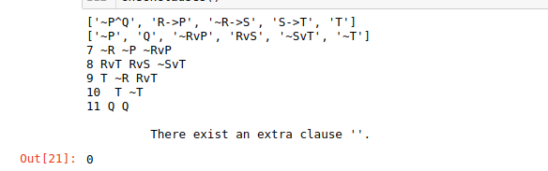

example – 7

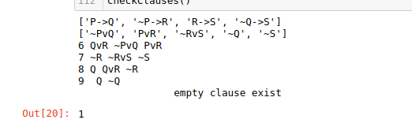

**example – 8**

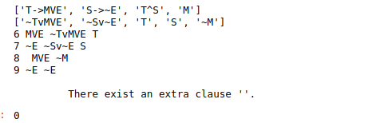

**example – 9**

