**LAB TASK # 03**

**Submitted by:**

**NAME: SABAHAT IJAZ**

**ROLL # P16-6055**

**SECTION: CS 16A**

**Submitted To:**

**Sir WAQAS ALI**

**QUESTION # 01:**

**INSERT DATA QUERIES:**

1. **Query for inserting data into employee**

insert into employees (emp_no,birth_date,first_name,last_name,gender,hire_date) values (113,str_to_date('01,jul,13','%d,%b,%y'),'Noormah','Omar','F',str_to_date('10,nov,18','%d,%b,%y'));

insert into employees (emp_no,birth_date,first_name,last_name,gender,hire_date) values (113,str_to_date('01,jul,13','%d,%b,%y'),'Noormah','Omar','F',str_to_date('10,nov,18','%d,%b,%y'));

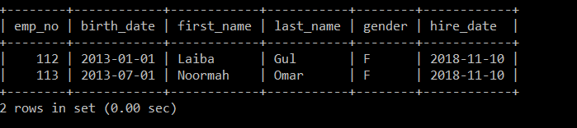

1. **Query for inserting data into DEPARTMENTS**

mysql> insert into departments(dept_no,dept_name) values (1,'Marketing');

Query OK, 1 row affected (0.00 sec)

mysql> insert into departments(dept_no,dept_name) values (2,'Finance');

Query OK, 1 row affected (0.00 sec)

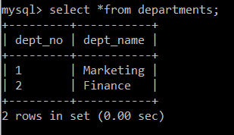

1. **Query for inserting data inTO emp_dpt**

insert into dept_emp(emp_no,dept_no,from_date,to_date) values (112,1,str_to_date('10,nov,18','%d,%b,%y'),str_to_date('10,nov,19','%d,%b,%y'));

insert into dept_emp(emp_no,dept_no,from_date,to_date) values (113,2,str_to_date('10,nov,18','%d,%b,%y'),str_to_date('10,nov,19','%d,%b,%y'));

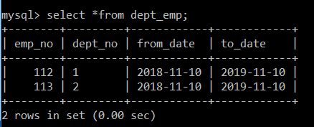

1. **QUERY FOR INSERTING DATA INTO SALARIES**

mysql> insert into salaries(emp_no,salary,from_date,to_date) values (112,100000,str_to_date('10,jan,19','%d,%b,%y'),str_to_date('10,nov,19','%d,%b,%y'));

insert into salaries(emp_no,salary,from_date,to_date) values (113,100000,str_to_date('10,jan,19','%d,%b,%y'),str_to_date('10,nov,19','%d,%b,%y'));

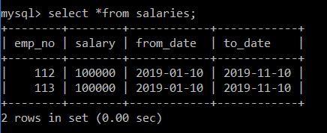

1. **QUERY FOR INSERTING DATA INTO TITLES**

mysql> insert into titles(emp_no,title,from_date,to_date) values(112,'Manager',str_to_date('10,jan,19','%d,%b,%y'),str_to_date('10,nov,19','%d,%b,%y'));

Query OK, 1 row affected (0.08 sec)

mysql> insert into titles(emp_no,title,from_date,to_date) values(113,'Employee',str_to_date('10,jan,19','%d,%b,%y'),str_to_date('10,nov,19','%d,%b,%y'));

Query OK, 1 row affected (0.08 sec)

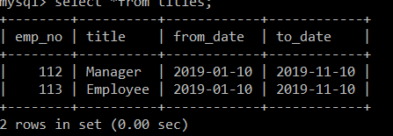

1. **QUERY FOR INSERTING DATA INTO DEPT_MANAGER**

mysql> insert into dept_manager(dept_no,emp_no,from_date,to_date) values ('1',112,str_to_date('10,jan,19','%d,%b,%y'),str_to_date('10,nov,19','%d,%b,%y'));

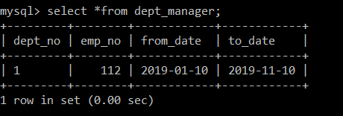

**UPDATE DATA QUERIES:**

1. **Change department of an employee**

mysql> update dept_emp

-> set dept_no=2

-> where emp_no=112;

Query OK, 1 row affected (0.00 sec)

Rows matched: 1 Changed: 1 Warnings: 0

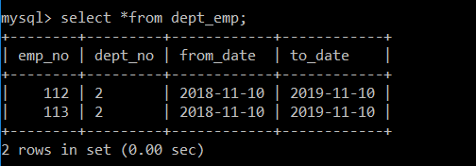

B) Update an employees’ salary

mysql> update salaries

-> set salary=200000

-> where emp_no=113;

Query OK, 1 row affected (0.00 sec)

Rows matched: 1 Changed: 1 Warnings: 0

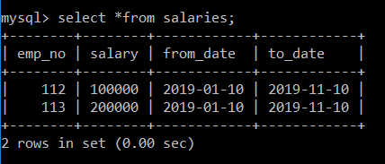

C) Change the name of a department

mysql> update departments

-> set dept_name='Accounts'

-> where dept_no=1;

Query OK, 1 row affected (0.00 sec)

Rows matched: 1 Changed: 1 Warnings: 0

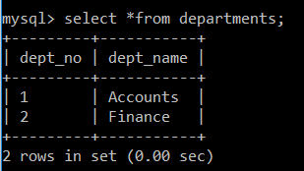

D) Change an employees’ job title.

mysql> update titles

-> set title='Clerk'

-> where emp_no=112;

Query OK, 1 row affected (0.00 sec)

Rows matched: 1 Changed: 1 Warnings: 0

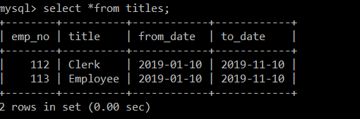

E) Change an employees’ hire date.

mysql> update employees

-> set hire_date='2018-10-10'

-> where emp_no=112;

Query OK, 1 row affected (0.00 sec)

Rows matched: 1 Changed: 1 Warnings: 0

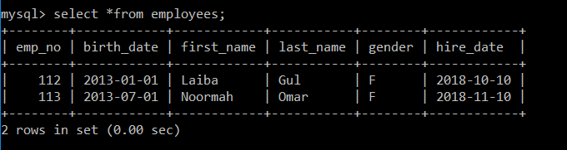

**UPDATE DATA QUERIES:**

1. DELETE every employee who was hired before February 2016.

mysql> delete from employees

-> where hire_date<'2016-02-01';

Query OK, 0 rows affected (0.00 sec)

1. DELETE all departments.

mysql> DELETE from departments;

Query OK, 2 rows affected (0.00 sec)



**QUESTION # 02:**

**1. Create a database named “pharma”.**

Creating database pharma:

mysql> create database pharma;

Query OK, 1 row affected (0.02 sec)

**2. Create tables with the primary and foreign key constrains as shown (with on cascade update and delete).**

1. Creating table products:

mysql> create table products(

-> p_id int(10) primary key,

-> p_name varchar(20) not null,

-> units int(10) not null,

-> unit_price int(10) not null,

-> type varchar(10) not null,

-> s_id int(10),

-> constraint fk_supplier_products FOREIGN KEY(s_id)

-> REFERENCES supplier(s_id)

-> ON UPDATE CASCADE ON DELETE CASCADE);

Query OK, 0 rows affected (0.09 sec)

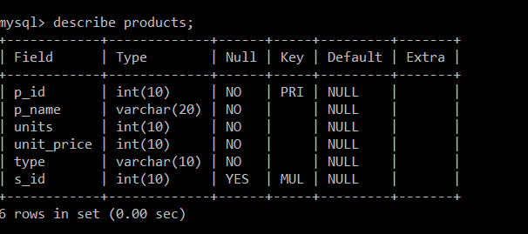

1. Creating table suppliers:

mysql> create table supplier(

s_id int(10) PRIMARY KEY,

s_name varchar(20) not null,

contact varchar(20) not null,

city varchar(10) not null);

Query OK, 0 rows affected (0.08 sec)

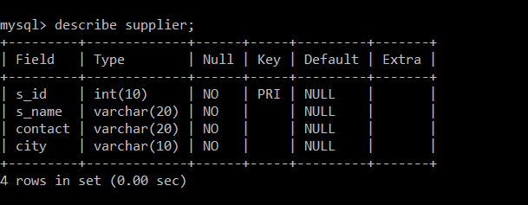

1. Creating orders table:

mysql> create table orders(

-> order_id int(10) PRIMARY KEY,

-> customer_name varchar(20) not null,

-> order_date date not null);

Query OK, 0 rows affected (0.11 sec)

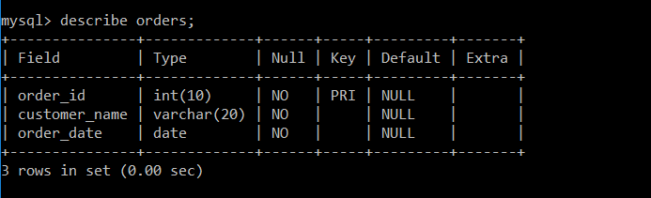

1. Creating order_detail table:

mysql> create table order_detail(

-> p_id int(10),

-> order_id int(10),

-> unit_purchased int(10) not null,

-> constraint fk_orderdetail_orders FOREIGN KEY(order_id)

-> REFERENCES orders(order_id)

-> ON UPDATE CASCADE ON DELETE CASCADE,

-> constraint fk_orderdetail_products FOREIGN KEY(p_id)

-> REFERENCES products(p_id)

-> ON UPDATE CASCADE ON DELETE CASCADE);

Query OK, 0 rows affected (0.13 sec)

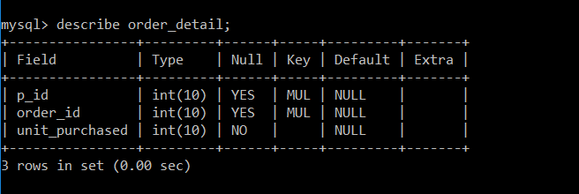

**3. Insert the data as shown.**

**INSERTING DATA INTO PRODUCTS**

mysql> insert into products (p_id,p_name,units,unit_price,type,s_id) values (1005,'ponstan',100,15,'tablets',312);

insert into products (p_id,p_name,units,unit_price,type,s_id) values (1421,'Brufen',25,35,'syrup',657);

insert into products (p_id,p_name,units,unit_price,type,s_id) values (3215,'Avil',122,26,'syrup',478);

insert into products (p_id,p_name,units,unit_price,type,s_id) values (1215,'Flagyl',42,30,'tablets',987);

insert into products (p_id,p_name,units,unit_price,type,s_id) values (7513,'Avil',140,20,'injection',478);

insert into products (p_id,p_name,units,unit_price,type,s_id) values (1216,'flagyl',10,35,'syrup',987);

insert into products (p_id,p_name,units,unit_price,type,s_id) values (1007,'Desprin',98,15,'tablets',320);

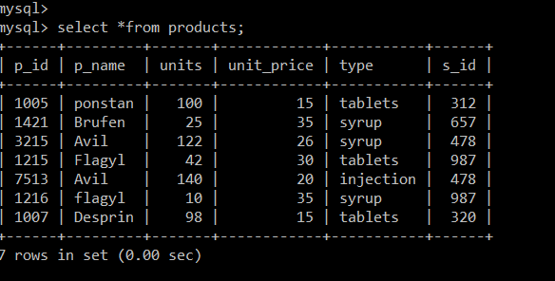

**INSERTING DATA INTO SUPPLIERS TABLE:**

insert into supplier (s_id,s_name,contact,city) values (320,'Munir Brothers','0321-1234567','Karachi');

insert into supplier (s_id,s_name,contact,city) values (312, ' Alliance Pharmaceuticals' ,'0313-7654321 ','Peshawar');

insert into supplier (s_id,s_name,contact,city) values (478, 'Abbot Pharmaceuticals ','0300-9876543 ','Lahore');

insert into supplier (s_id,s_name,contact,city) values (657,'Sanofi Aventis ','0333-5632476','Islamabad');

insert into supplier (s_id,s_name,contact,city) values (987,'Ferozsons laboratories ','0301-1934257','Peshawar');

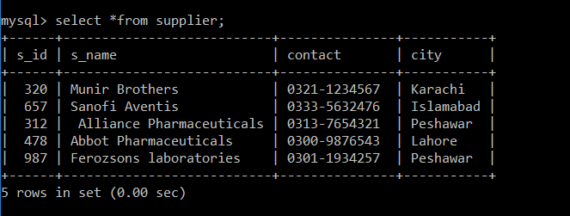

**INSERTING DATA INTO ORDERS TABLE:**

insert into orders(order_id,customer_name,order_date) values (22,'Waleed Ali',str_to_date('25,nov,14','%d,%b,%y'));

insert into orders(order_id,customer_name,order_date) values (23,'Azhar Akbar',str_to_date('02,dec,14','%d,%b,%y'));

insert into orders(order_id,customer_name,order_date) values (24,'Shahzeb Khan',str_to_date('05,dec,14','%d,%b,%y'));

insert into orders(order_id,customer_name,order_date) values (25,'Javed Iqbal',str_to_date('15,jan,15','%d,%b,%y'));

insert into orders(order_id,customer_name,order_date) values (26,'Tariq Khan',str_to_date('23,jun,15','%d,%b,%y'));

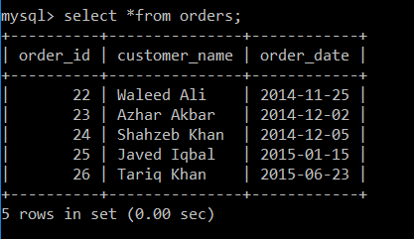

**INSERTING DATA INTO ORDER_DETAIL TABLE:**

insert into order_detail (p_id,order_id,unit_purchased) values (1007,22,5);

insert into order_detail (p_id,order_id,unit_purchased) values (1216,22,1);

insert into order_detail (p_id,order_id,unit_purchased) values (1005,22,4);

insert into order_detail (p_id,order_id,unit_purchased) values (1421,23,1);

insert into order_detail (p_id,order_id,unit_purchased) values (1005,23,1);

insert into order_detail (p_id,order_id,unit_purchased) values (3215,23,2);

insert into order_detail (p_id,order_id,unit_purchased) values (7513,23,3);

insert into order_detail (p_id,order_id,unit_purchased) values (1421,24,2);

insert into order_detail (p_id,order_id,unit_purchased) values (1215,24,1);

insert into order_detail (p_id,order_id,unit_purchased) values (1005,25,5);

insert into order_detail (p_id,order_id,unit_purchased) values (1215,26,1);

insert into order_detail (p_id,order_id,unit_purchased) values (1421,26,3);

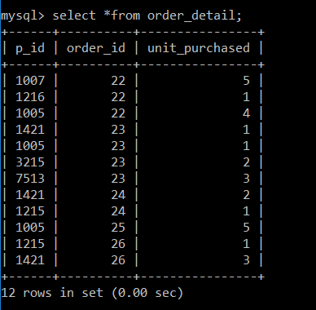

**4. Change the name of supplier named Munir Brothers to Muneer Brother.**

mysql> update supplier set s_name='Muneer Brother'

-> where s_name='Munir Brothers';

Query OK, 1 row affected (0.00 sec)

Rows matched: 1 Changed: 1 Warnings: 0

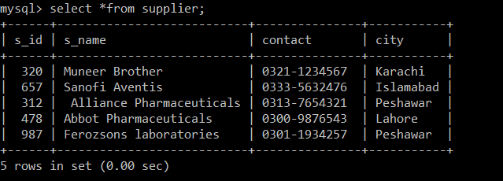

**5. Delete the Avil syrup product from the product table, does it affect order_detail table? If yes then how? If no then why?**

mysql> delete from products where p_name='Avil' AND type='syrup';

Query OK, 1 row affected (0.00 sec)

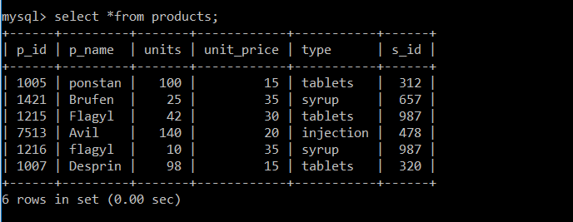

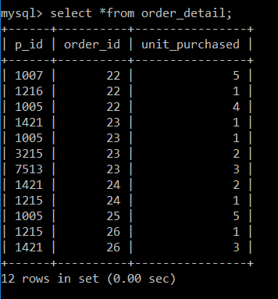

It did not affected the order_detail table because we have created primary key in order_detail table using p_id and order_id.

**6. Set unit_price to 40 for all the products whose type is “Tablets”.**

mysql> update products set unit_price=40 where type='Tablets';

Query OK, 3 rows affected (0.00 sec)

Rows matched: 3 Changed: 3 Warnings: 0

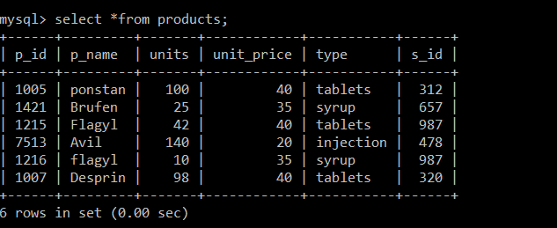

**7. Delete the order with the order _id 22 from the orders table, does it affect order_detail table? If yes then how? If no then why?**

mysql> delete from orders where order_id=22;

Query OK, 1 row affected (0.00 sec)

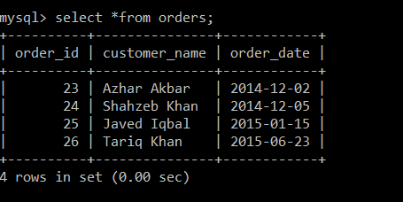

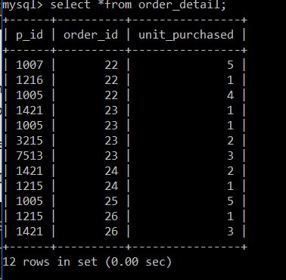

NO, it did not affected the the order_detail table because we have created primary key in order_detail table using p_id and order_id.

**8. Delete all records from all 4 tables.**

mysql> delete from products;

Query OK, 6 rows affected (0.00 sec)

mysql> delete from supplier;

Query OK, 5 rows affected (0.00 sec)

mysql> delete from orders;

Query OK, 4 rows affected (0.00 sec)

mysql> delete from order_detail;

Query OK, 12 rows affected (0.00 sec)

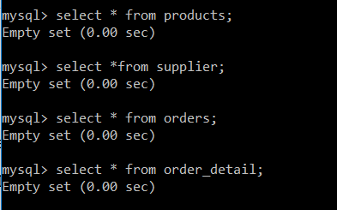

**9. Delete all 4 tables.**

mysql> drop table products;

Query OK, 0 rows affected (0.00 sec)

mysql> drop table supplier;

Query OK, 0 rows affected (0.00 sec)

mysql> drop table orders;

Query OK, 0 rows affected (0.01 sec)

mysql> drop table order_detail;

Query OK, 0 rows affected (0.01 sec)

