**LAB TASK # 04**

**Submitted By:**

NAME: SABAHAT IJAZ

ROLL # P16-6055

SECTION: CS16-A

**Submitted To:**

Sir Waqas Ali

**TASK # 01:**

**CREATING TABLES:**

**TABLE 1:**

CUSTOMER TABLE:

mysql> create table customer(

customerid int(10) PRIMARY KEY,

first_name varchar(20) not null,

last_name varchar(20) not null,

city varchar(20) not null,

country varchar(20) not null,

phone varchar(25) not null);

Query OK, 0 rows affected (0.11 sec)

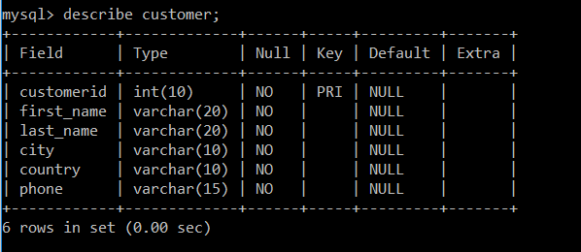

**TABLE 2:**

ORDERS TABLE:

create table orders(

id int(10) PRIMARY KEY,

orderdate date not null,

orderno int(10) not null,

customerid int(10),

totalamount int(30) not null,

constraint fk_order_customer FOREIGN KEY(customerid)

REFERENCES customer(customerid));

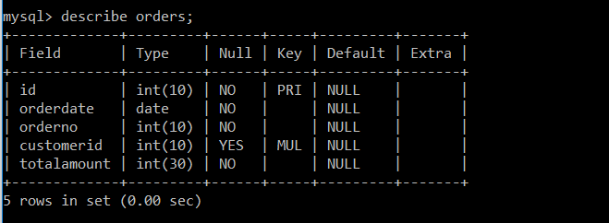

**INSERTING DATA INTO TABLE 1:**

insert into customer(customerid,first_name,last_name,city,country,phone) values (111,'zain','ali','lahore','Pakistan','0312-1234567');

insert into customer(customerid,first_name,last_name,city,country,phone) values (112,'Mahnoor','majid','Karachi','Pakistan','0312-1211567');

insert into customer(customerid,first_name,last_name,city,country,phone) values

(113,'Saim','saleem','firstcity ','Singapore','0312-1234467');

insert into customer(customerid,first_name,last_name,city,country,phone) values (114,'Abrar','ali','anterland','Austrailia','0312-1235567');

insert into customer(customerid,first_name,last_name,city,country,phone) values (115,'waqas','ali','paracity','China','0312-1236667');

insert into customer(customerid,first_name,last_name,city,country,phone) values (116,'Saleem','akhtar','quanty','Africa','0312-1237767');

insert into customer(customerid,first_name,last_name,city,country,phone) values (117,'Zainab','Ijaz','reltin','England','0312-1238867');

insert into customer(customerid,first_name,last_name,city,country,phone) values (118,'Usman','Saleem','forke','Iran','0312-1239967');

insert into customer(customerid,first_name,last_name,city,country,phone) values (119,'Umer','Saleem','ilam','Dubai','0312-1234107');

insert into customer(customerid,first_name,last_name,city,country,phone) values (120,'Arbaz','Fakhar','Rahim-yar-khan','Pakistan','0312-1234117');

insert into customer(customerid,first_name,last_name,city,country,phone) values (121,'Shahzoona','Fakhar','firstcity','Singapore','0312-12321167');

insert into customer(customerid,first_name,last_name,city,country,phone) values (123,'Nayab','Fakhar','ilam','Dubai','0312-1234137');

insert into customer(customerid,first_name,last_name,city,country,phone) values (124,'Fatima','Fakhar','sampilan','Sri-lanka','0312-1144567');

insert into customer(customerid,first_name,last_name,city,country,phone) values (125,'Iqra','Fakhar','aduka','Afghanistan','0312-1534567');

insert into customer(customerid,first_name,last_name,city,country,phone) values (126,'Tehreem','Nadeem','waston','UK','0312-1216567');

insert into customer(customerid,first_name,last_name,city,country,phone) values (127,'Ijaz','Saleem','RYK','Pakistan','0312-1217567');

insert into customer(customerid,first_name,last_name,city,country,phone) values (128,'Fakhar','Saleem','RYK','Pakistan','0312-1184567');

insert into customer(customerid,first_name,last_name,city,country,phone) values (129,'Nadeem','Akhtar','RYK','Pakistan','0312-1934567');

insert into customer(customerid,first_name,last_name,city,country,phone) values (130,'Fozia','Saleem','RYK','Pakistan','0312-2034567');

insert into customer(customerid,first_name,last_name,city,country,phone) values (131,'Shazia','Saleem','RYK','Pakistan','0312-2134567');

insert into customer(customerid,first_name,last_name,city,country,phone) values (132,'Bilal','Nadeem','Bahawalpur','Pakistan','0312-2234567');

insert into customer(customerid,first_name,last_name,city,country,phone) values (133,'Rabail','Munawar','Islamabad','Pakistan','0312-2334567');

insert into customer(customerid,first_name,last_name,city,country,phone) values (134,'Mohsin','Iqbal','Multan','Pakistan','0312-2434567');

insert into customer(customerid,first_name,last_name,city,country,phone) values (135,'Silahuddin','Khan','lahore','Pakistan','0312-2534567');

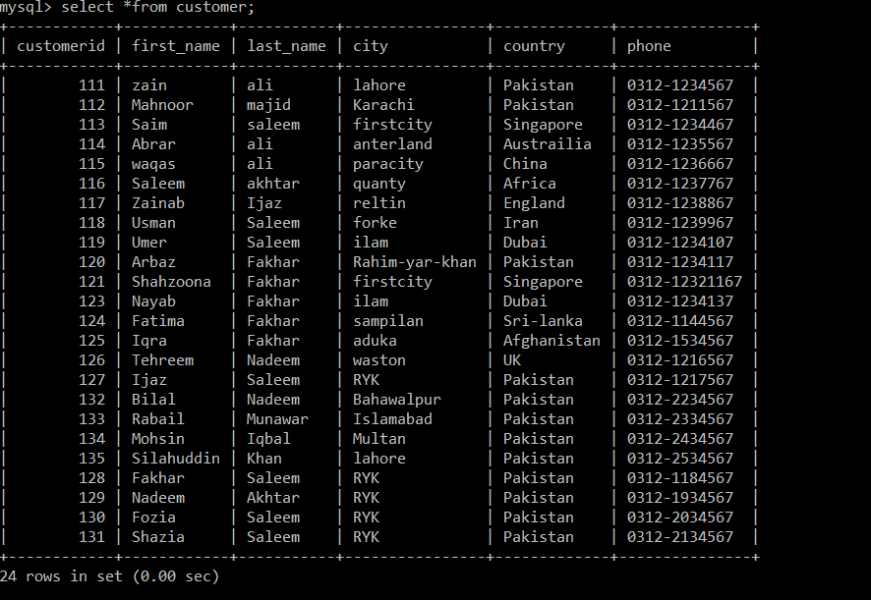

**INSERTING DATA INTO TABLE 2:**

insert into orders(id,orderdate,orderno,customerid,totalamount) values (11,str_to_date('02,dec,14','%d,%b,%y'),1,116,1000);

insert into orders(id,orderdate,orderno,customerid,totalamount) values (12,str_to_date('03,dec,14','%d,%b,%y'),2,118,9000);

insert into orders(id,orderdate,orderno,customerid,totalamount) values (13,str_to_date('04,dec,14','%d,%b,%y'),3,118,1000);

insert into orders(id,orderdate,orderno,customerid,totalamount) values (14,str_to_date('05,dec,14','%d,%b,%y'),4,118,4000);

insert into orders(id,orderdate,orderno,customerid,totalamount) values (15,str_to_date('06,dec,14','%d,%b,%y'),5,121,2000);

insert into orders(id,orderdate,orderno,customerid,totalamount) values (16,str_to_date('07,dec,14','%d,%b,%y'),6,132,3000);

insert into orders(id,orderdate,orderno,customerid,totalamount) values (17,str_to_date('08,dec,14','%d,%b,%y'),7,119,9000);

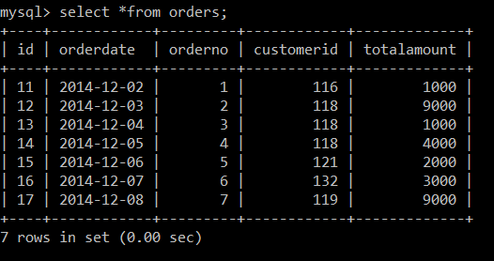

**QUERIES:**

**1. List the number of customers in each country. Only include countries with more than 10**

**customers**

mysql> select country, count(*)

-> from customer

-> group by country

-> having count(*)>10;

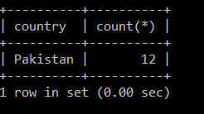

**2. List the number of customers in each country, except the USA, sorted high to low. Only include**

**countries with 9 or more customers**

mysql> select country,count(*)

-> from customer

-> where country<>'USA'

-> group by country

-> having count(*)>=9

-> order by count(*) desc;

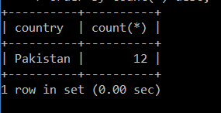

**3. List all CustomerId’s with average orders between $1000 and $1200.**

mysql> select customerid, avg(totalamount)

from orders,customer

group by customerid

having avg(totalamount) between 1000 and 1200;

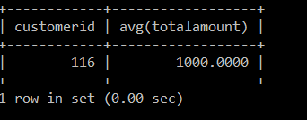

**4. List the total number of customers from each city in each country (Consider the fact that two**

**cities in different countries might have the same name).**

**mysql> select country,city,count(customerid)**

**-> from customer**

**-> group by country, city;**

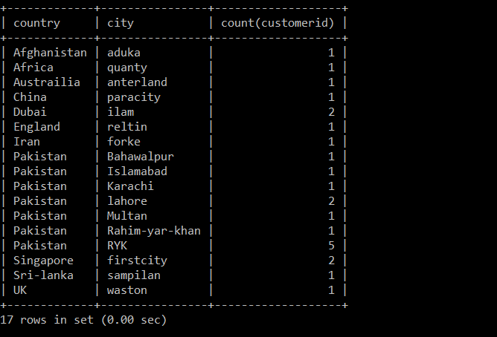

**5. List the sum of orders for each day in a particular week (e.g. sum of orders for each day (Monday**

**to Friday) for the first week of December).**

mysql> select max(orderno) as total_order

-> from orders;

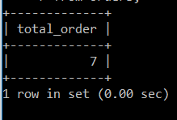

6. List the number of orders placed by each customer.

mysql> select count(*) as total_order,customerid

-> from orders

-> group by customerid;

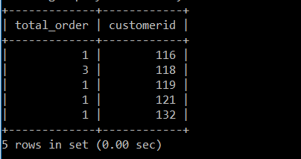

7.

**List the CustomerId of the most valued customer**

SELECT customer.customerid FROM CUSTOMER,ORDERS WHERE CUSTOMER.customerid=ORDERS.customerid GROUP BY customer.customerid HAVING SUM(totalamount)>=ALL(SELECT SUM(totalamount) FROM ORDERS GROUP BY orders.customerid);

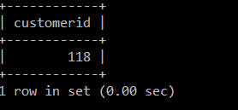

8.

**List the CustomerId of the least valued customer.**

SELECT customer.customerid FROM CUSTOMER,ORDERS WHERE

CUSTOMER.customerid=ORDERS.CUSTOMERID GROUP BY customer.customerid HAVING

SUM(totalamount)<=ALL(SELECT SUM(totalamount) FROM ORDERS GROUP BY

orders.customerid);

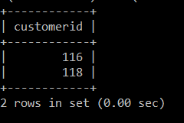

9.

List the date on which the company had the best sale.

SELECT ORDERDATE FROM ORDERS GROUP BY ORDERDATE HAVING

SUM(TOTALAMOUNT)>=ALL(SELECT SUM(TOTALAMOUNT) FROM ORDERS GROUP BY

ORDERDATE);

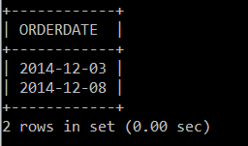

**TASK # 02:**

**QUERY FOR CREATING TABLE:**

mysql> create table data(

-> emp_id int(10) primary key,

-> f_name varchar(20) not null,

-> l_name varchar(20) not null,

-> email varchar(30) not null,

-> hire_date date not null,

-> job_id varchar(20) not null,

-> salary int(40) not null,

-> manager_id int(10) not null,

-> dept_id int(10) not null);

Query OK, 0 rows affected (0.19 sec)

**QUERIES FOR INSERTING DATA:**

insert into data(emp_id,f_name,l_name,email,hire_date,job_id,salary,manager_id,dept_id) values (100,'steven','king','sking',str_to_date('17,jun,87','%d,%b,%y'),'AD_PRES',24000,0,90);

insert into data(emp_id,f_name,l_name,email,hire_date,job_id,salary,manager_id,dept_id) values (101,'Neena','kochhar','Nkochhar',str_to_date('18,jun,87','%d,%b,%y'),'AD_VP',17000,100,90);

insert into data(emp_id,f_name,l_name,email,hire_date,job_id,salary,manager_id,dept_id) values (102,'Lex','De Haan','LDEHAAN',str_to_date('19,jun,87','%d,%b,%y'),'AD_VP',17000,100,90);

insert into data(emp_id,f_name,l_name,email,hire_date,job_id,salary,manager_id,dept_id) values (103,'Alexander','Hunold','AHUNOLD',str_to_date('20,jun,87','%d,%b,%y'),'IT_PROG',9000,102,60);

insert into data(emp_id,f_name,l_name,email,hire_date,job_id,salary,manager_id,dept_id) values (104,'Bruce','Ernst','BERNST',str_to_date('21,jun,87','%d,%b,%y'), 'IT_PROG',6000,103,60);

insert into data(emp_id,f_name,l_name,email,hire_date,job_id,salary,manager_id,dept_id) values (105,'David','Austin','DAUSTIN',str_to_date('22,jun,87','%d,%b,%y'), 'IT_PROG',4800,103,60);

insert into data(emp_id,f_name,l_name,email,hire_date,job_id,salary,manager_id,dept_id) values (106,'Valli','Pataballa','VPATABAL',str_to_date('23,jun,87','%d,%b,%y'), 'IT_PROG',4800,103,60);

insert into data(emp_id,f_name,l_name,email,hire_date,job_id,salary,manager_id,dept_id) values (107,'Diana','Lorentz','DLORENTZ',str_to_date('24,jun,87','%d,%b,%y'), 'IT_PROG',4200,103,60);

insert into data(emp_id,f_name,l_name,email,hire_date,job_id,salary,manager_id,dept_id) values (108,'Nancy','Greenberg','NGREENBE',str_to_date('25,jun,87','%d,%b,%y'),'FI_MGR',12000,101,100);

insert into data(emp_id,f_name,l_name,email,hire_date,job_id,salary,manager_id,dept_id) values (109,'Daniel','Faviet','DFAVIET',str_to_date('26,jun,87','%d,%b,%y'),'FI_ACCOUNT ',9000,108,100);

insert into data(emp_id,f_name,l_name,email,hire_date,job_id,salary,manager_id,dept_id) values (110,'John','Chen','JCHEN',str_to_date('27,jun,87','%d,%b,%y'),'FI_ACCOUNT ',8200,108,100);

insert into data(emp_id,f_name,l_name,email,hire_date,job_id,salary,manager_id,dept_id) values (111,'Ismael','Sciarra','ISCIARRA',str_to_date('28,jun,87','%d,%b,%y'),'FI_ACCOUNT ',7700,108,100);

insert into data(emp_id,f_name,l_name,email,hire_date,job_id,salary,manager_id,dept_id) values (112,'Jose Manue','Urman','JMURMAN',str_to_date('29,jun,87','%d,%b,%y'),'FI_ACCOUNT ',7800,108,100);

insert into data(emp_id,f_name,l_name,email,hire_date,job_id,salary,manager_id,dept_id) values (113,'Luis','Popp','LPOPP',str_to_date('30,jun,87','%d,%b,%y'),'FI_ACCOUNT ',6900,108,100);

insert into data(emp_id,f_name,l_name,email,hire_date,job_id,salary,manager_id,dept_id) values (114,'Den','Raphaely','DRAPHEAL',str_to_date('01,jul,87','%d,%b,%y'),'PU_MAN',11000,100,30);

insert into data(emp_id,f_name,l_name,email,hire_date,job_id,salary,manager_id,dept_id) values (115,'Alexander','Khoo','AKHOO',str_to_date('02,jul,87','%d,%b,%y'),'PU_CLERK',3100,114,30);

insert into data(emp_id,f_name,l_name,email,hire_date,job_id,salary,manager_id,dept_id) values (116,'Shelli','Baida','SBAIDA',str_to_date('03,jul,87','%d,%b,%y'),'PU_CLERK ',2900,114,30);

insert into data(emp_id,f_name,l_name,email,hire_date,job_id,salary,manager_id,dept_id) values (117,'Sigal','Tobias','STOBIAS',str_to_date('04,jul,87','%d,%b,%y'),'PU_CLERK ',2800,114,30);

insert into data(emp_id,f_name,l_name,email,hire_date,job_id,salary,manager_id,dept_id) values (118,'Guy','Himuro','GHIMURO',str_to_date('05,jul,87','%d,%b,%y'),'PU_CLERK ',2600,114,30);

insert into data(emp_id,f_name,l_name,email,hire_date,job_id,salary,manager_id,dept_id) values (119,'Karen','Colmenras','KCOLMENA',str_to_date('06,jul,87','%d,%b,%y'),'PU_CLERK ',2500,114,30);

insert into data(emp_id,f_name,l_name,email,hire_date,job_id,salary,manager_id,dept_id) values (120,'Matthew','Weis','MWEIS',str_to_date('08,jul,87','%d,%b,%y'),'ST_MAN ',8000,100,50);

insert into data(emp_id,f_name,l_name,email,hire_date,job_id,salary,manager_id,dept_id) values (121,'Adam','Fripp','AFRIPP',str_to_date('09,jul,87','%d,%b,%y'),'ST_MAN ',8200,100,50);

insert into data(emp_id,f_name,l_name,email,hire_date,job_id,salary,manager_id,dept_id) values (122,'Payam','Kaufling','PKAUFLIN',str_to_date('10,jul,87','%d,%b,%y'),'ST_MAN ',7900,100,50);

insert into data(emp_id,f_name,l_name,email,hire_date,job_id,salary,manager_id,dept_id) values (123,'Shanta','Vollman','SVOLLMAN',str_to_date('11,jul,87','%d,%b,%y'),'ST_MAN ',6500,100,50);

**TABLE AFTER INSERTING DATA:**

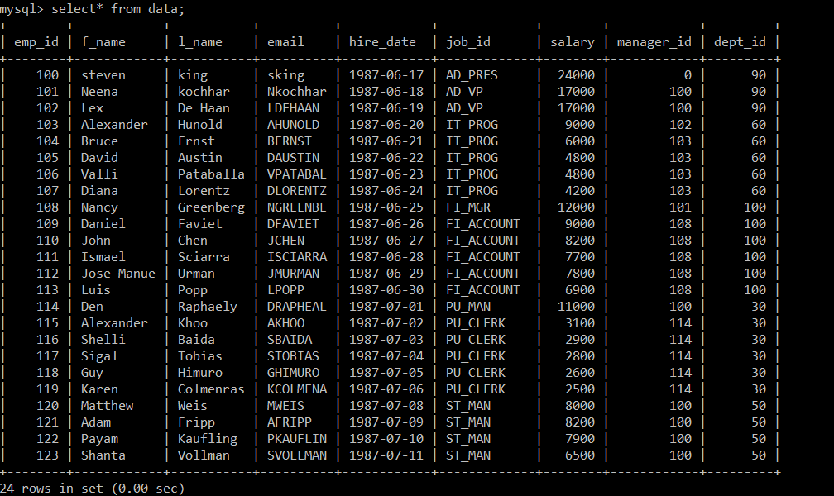

1. **List the number of employees, total salary paid to employees that work in each department.**

mysql> select count(*) as number_of_emp , sum(salary) as total_salary

from data

group by dept_id;

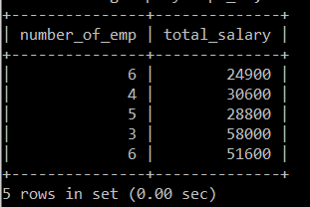

1. **List the number of employees working in each department under each manager.**

mysql> select count(*) as number_of_employees

-> from data

-> group by dept_id,manager_id;

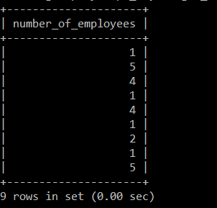

1. **List the average salaries paid to each designation (job_id).**

mysql> select avg(salary) as avg_salary

-> from data

-> group by job_id;

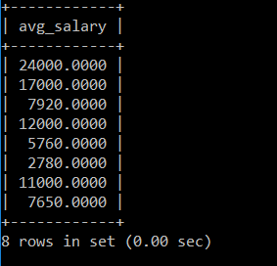

1. **List the manager under whom the most number of employees are working.**

mysql> select count(emp_id) as no_of_emp,manager_id

-> from data

-> group by manager_id

-> order by no_of_emp desc

-> limit 1;

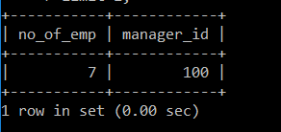

**5. List the average salaries paid to each designation in each department.**

mysql> select avg(salary) as avg_salaries

-> from data

-> group by job_id;

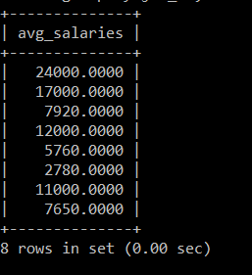

**6. List the number of employees working under each manager in ascending order.**

mysql> select count(*), manager_id

-> from data

-> group by manager_id

-> order by count(*) asc;

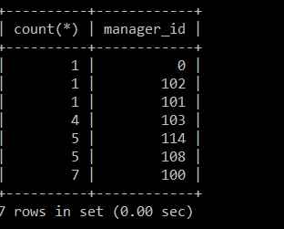

**7. List the number of managers in each department**.

mysql> select count(*) as number_of_managers, dept_id

-> from data

-> group by dept_id;

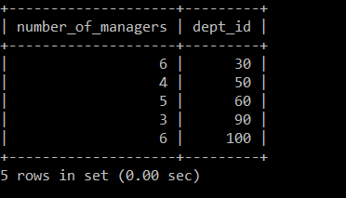

**8. List the departments that has more than 3 employees.**

mysql> select dept_id, count(*) as employees

-> from data

-> group by dept_id

-> having count(*)>3;

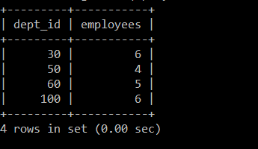

**9. List the department that has the most number of employees.**

mysql> select count(emp_id) as no_of_emp, dept_id

-> from data

-> group by dept_id

-> order by no_of_emp desc

-> limit 1;

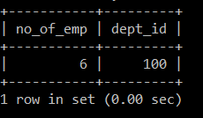

**10. List the department that the least number of employees.**

mysql> select count(emp_id) as no_of_emp, dept_id

-> from data

-> group by dept_id

-> order by no_of_emp asc

-> limit 1;

