**QUERIES FOR INSERTING DATA:**

insert into data(emp_id,f_name,l_name,email,hire_date,job_id,salary,manager_id,dept_id) values (100,'steven','king','sking',str_to_date('17,jun,87','%d,%b,%y'),'AD_PRES',24000,0,90);

insert into data(emp_id,f_name,l_name,email,hire_date,job_id,salary,manager_id,dept_id) values (101,'Neena','kochhar','Nkochhar',str_to_date('18,jun,87','%d,%b,%y'),'AD_VP',17000,100,90);

insert into data(emp_id,f_name,l_name,email,hire_date,job_id,salary,manager_id,dept_id) values (102,'Lex','De Haan','LDEHAAN',str_to_date('19,jun,87','%d,%b,%y'),'AD_VP',17000,100,90);

insert into data(emp_id,f_name,l_name,email,hire_date,job_id,salary,manager_id,dept_id) values (103,'Alexander','Hunold','AHUNOLD',str_to_date('20,jun,87','%d,%b,%y'),'IT_PROG',9000,102,60);

insert into data(emp_id,f_name,l_name,email,hire_date,job_id,salary,manager_id,dept_id) values (104,'Bruce','Ernst','BERNST',str_to_date('21,jun,87','%d,%b,%y'), 'IT_PROG',6000,103,60);

insert into data(emp_id,f_name,l_name,email,hire_date,job_id,salary,manager_id,dept_id) values (105,'David','Austin','DAUSTIN',str_to_date('22,jun,87','%d,%b,%y'), 'IT_PROG',4800,103,60);

insert into data(emp_id,f_name,l_name,email,hire_date,job_id,salary,manager_id,dept_id) values (106,'Valli','Pataballa','VPATABAL',str_to_date('23,jun,87','%d,%b,%y'), 'IT_PROG',4800,103,60);

insert into data(emp_id,f_name,l_name,email,hire_date,job_id,salary,manager_id,dept_id) values (107,'Diana','Lorentz','DLORENTZ',str_to_date('24,jun,87','%d,%b,%y'), 'IT_PROG',4200,103,60);

insert into data(emp_id,f_name,l_name,email,hire_date,job_id,salary,manager_id,dept_id) values (108,'Nancy','Greenberg','NGREENBE',str_to_date('25,jun,87','%d,%b,%y'),'FI_MGR',12000,101,100);

insert into data(emp_id,f_name,l_name,email,hire_date,job_id,salary,manager_id,dept_id) values (109,'Daniel','Faviet','DFAVIET',str_to_date('26,jun,87','%d,%b,%y'),'FI_ACCOUNT ',9000,108,100);

insert into data(emp_id,f_name,l_name,email,hire_date,job_id,salary,manager_id,dept_id) values (110,'John','Chen','JCHEN',str_to_date('27,jun,87','%d,%b,%y'),'FI_ACCOUNT ',8200,108,100);

insert into data(emp_id,f_name,l_name,email,hire_date,job_id,salary,manager_id,dept_id) values (111,'Ismael','Sciarra','ISCIARRA',str_to_date('28,jun,87','%d,%b,%y'),'FI_ACCOUNT ',7700,108,100);

insert into data(emp_id,f_name,l_name,email,hire_date,job_id,salary,manager_id,dept_id) values (112,'Jose Manue','Urman','JMURMAN',str_to_date('29,jun,87','%d,%b,%y'),'FI_ACCOUNT ',7800,108,100);

insert into data(emp_id,f_name,l_name,email,hire_date,job_id,salary,manager_id,dept_id) values (113,'Luis','Popp','LPOPP',str_to_date('30,jun,87','%d,%b,%y'),'FI_ACCOUNT ',6900,108,100);

insert into data(emp_id,f_name,l_name,email,hire_date,job_id,salary,manager_id,dept_id) values (114,'Den','Raphaely','DRAPHEAL',str_to_date('01,jul,87','%d,%b,%y'),'PU_MAN',11000,100,30);

insert into data(emp_id,f_name,l_name,email,hire_date,job_id,salary,manager_id,dept_id) values (115,'Alexander','Khoo','AKHOO',str_to_date('02,jul,87','%d,%b,%y'),'PU_CLERK',3100,114,30);

insert into data(emp_id,f_name,l_name,email,hire_date,job_id,salary,manager_id,dept_id) values (116,'Shelli','Baida','SBAIDA',str_to_date('03,jul,87','%d,%b,%y'),'PU_CLERK ',2900,114,30);

insert into data(emp_id,f_name,l_name,email,hire_date,job_id,salary,manager_id,dept_id) values (117,'Sigal','Tobias','STOBIAS',str_to_date('04,jul,87','%d,%b,%y'),'PU_CLERK ',2800,114,30);

insert into data(emp_id,f_name,l_name,email,hire_date,job_id,salary,manager_id,dept_id) values (118,'Guy','Himuro','GHIMURO',str_to_date('05,jul,87','%d,%b,%y'),'PU_CLERK ',2600,114,30);

insert into data(emp_id,f_name,l_name,email,hire_date,job_id,salary,manager_id,dept_id) values (119,'Karen','Colmenras','KCOLMENA',str_to_date('06,jul,87','%d,%b,%y'),'PU_CLERK ',2500,114,30);

insert into data(emp_id,f_name,l_name,email,hire_date,job_id,salary,manager_id,dept_id) values (120,'Matthew','Weis','MWEIS',str_to_date('08,jul,87','%d,%b,%y'),'ST_MAN ',8000,100,50);

insert into data(emp_id,f_name,l_name,email,hire_date,job_id,salary,manager_id,dept_id) values (121,'Adam','Fripp','AFRIPP',str_to_date('09,jul,87','%d,%b,%y'),'ST_MAN ',8200,100,50);

insert into data(emp_id,f_name,l_name,email,hire_date,job_id,salary,manager_id,dept_id) values (122,'Payam','Kaufling','PKAUFLIN',str_to_date('10,jul,87','%d,%b,%y'),'ST_MAN ',7900,100,50);

insert into data(emp_id,f_name,l_name,email,hire_date,job_id,salary,manager_id,dept_id) values (123,'Shanta','Vollman','SVOLLMAN',str_to_date('11,jul,87','%d,%b,%y'),'ST_MAN ',6500,100,50);

**TABLE AFTER INSERTING DATA:**

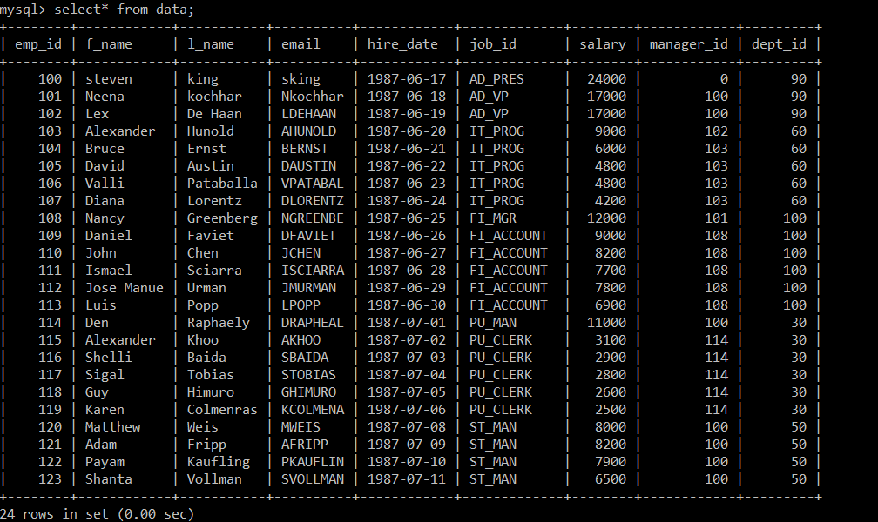

1. **List the number of employees, total salary paid to employees that work in each department.**

mysql> select count(*) as number_of_emp , sum(salary) as total_salary

from data

group by dept_id;

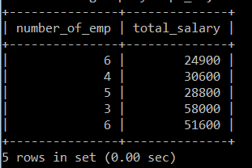

1. **List the number of employees working in each department under each manager.**

mysql> select count(*) as number_of_employees

-> from data

-> group by dept_id,manager_id;

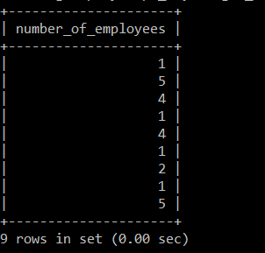

1. **List the average salaries paid to each designation (job_id).**

mysql> select avg(salary) as avg_salary

-> from data

-> group by job_id;

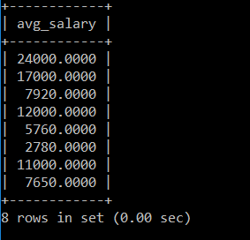

1. **List the manager under whom the most number of employees are working.**

mysql> select count(emp_id) as no_of_emp,manager_id

-> from data

-> group by manager_id

-> order by no_of_emp desc

-> limit 1;

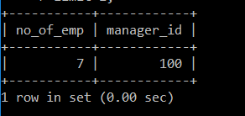

**5. List the average salaries paid to each designation in each department.**

mysql> select avg(salary) as avg_salaries

-> from data

-> group by job_id;

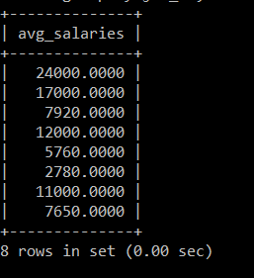

**6. List the number of employees working under each manager in ascending order.**

mysql> select count(*), manager_id

-> from data

-> group by manager_id

-> order by count(*) asc;

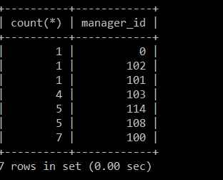

**7. List the number of managers in each department**.

mysql> select count(*) as number_of_managers, dept_id

-> from data

-> group by dept_id;

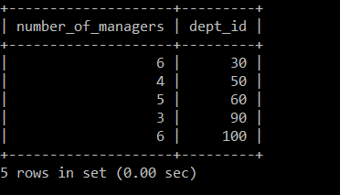

**8. List the departments that has more than 3 employees.**

mysql> select dept_id, count(*) as employees

-> from data

-> group by dept_id

-> having count(*)>3;

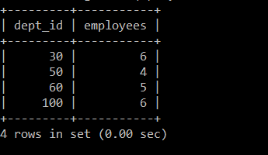

**9. List the department that has the most number of employees.**

mysql> select count(emp_id) as no_of_emp, dept_id

-> from data

-> group by dept_id

-> order by no_of_emp desc

-> limit 1;

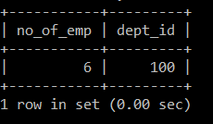

**10. List the department that the least number of employees.**

mysql> select count(emp_id) as no_of_emp, dept_id

-> from data

-> group by dept_id

-> order by no_of_emp asc

-> limit 1;

