

**From:-** Muhammad Ahsan

**To:-** Dr. Tariq Yousafzai

**Section:-** A

**Rollno :-** P17-6142

**Submission:-** 04/02/2019

**Graph:-**

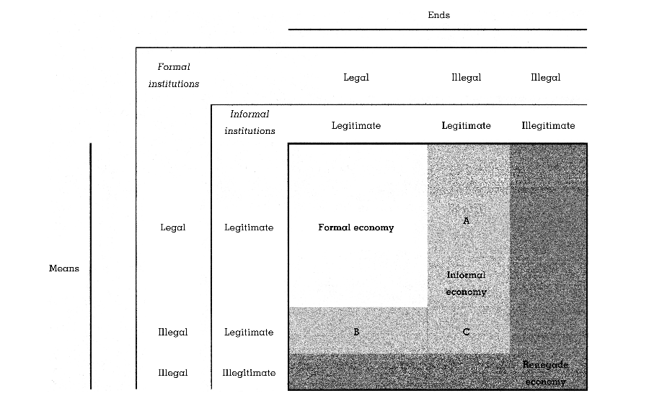

**Formal Economy:**

The economy that is accepted by government rules and regulations and also society called Formal Economy. Formal economy always has legal and legitimate means and ends.

**Examples:**

1. Airbus Company is legal according to rules and regulations of government.
2. Air Indus is also example of formal economy.

**Informal Economy:**

The economy that is not accept by government rules and regulations but not society called informal economy. Informal economy has three cases. In case A it has legal and legitimate means and ends. In case B illegal and legitimate means and legal and legitimate ends. In case C illegal and legitimate means and ends.

**Example:**

1. Karkhano market is illegal by rules and regulation but accepted by society.
2. Carpet weaving at small level is also example of informal economy.

**Renegade Economy:**

The economy that is not accepted both government and society called Renegade economy. It has always illegal and illegitimate ends.

**Examples:**

1. Show weapons without license in public.