

Assignment # 2
Discrete Structure

by: Muhammad Ahsan
P17-6142
Section-C
to: Dr. Nauman Azam

Code in Python 3

# EXAMPLE=8
def makeClause(st):
#print('Use -> for implies \nUse ^ for and \nUse v for OR \nUse ~ for negation\n')
#str=input("enter a string of premices :")
clause=[]
#st="P->Q.~P->R.R->S.~Q->S"
st=st.split('.')
size=len(st)-1
print(st)
for p in st:
temp=p.split('->')

if(len(temp)!=1):
if(temp[0][0]!='~'):
temp[0]='~'+temp[0]
clause.append(temp[0]+'v'+temp[1])
elif(temp[0][0]=='~'):
temp[0]=temp[0][1]
clause.append(temp[0]+'v'+temp[1])
else:
temp=p.split('^')
if(len(temp)==1):
if(temp[0][0]=='~'):
temp[0]=temp[0][1]
else:
temp[0]='~'+temp[0]
clause.append(temp[0])
else:
clause.append(temp[0])
clause.append(temp[1])

if(st[size]==p):
size=len(clause)-1
temp=clause[size].split('v')
if(len(temp)!=1):
if(temp[0][0]=='~'):
temp[0]=temp[0][1]
else:
temp[0]='~'+temp[0]
if(temp[1][0]=='~'):
temp[1]=temp[1][1]
else:
temp[1]='~'+temp[1]
clause[size]=temp[0]
clause.append(temp[1])
else:
if(temp[0][0]!='~'):
temp[0]='~'+temp[0][0]
else:
temp[0]=temp[0][1]

print(clause)
return clause
def resolution(a, b):
a = a.split('v')
b = b.split('v')
x = ""
y = ""
for i in range(len(a)):
for j in range(len(b)): # checking principle of resolution
if (a[i][0] == '~' and b[j][0] == a[i][1]) or (b[j][0] == '~' and b[j][1] == a[i][0]):
a.pop(i)
b.pop(j)
if a == []:
x = 'v'.join(b)
return x
if b == []:
x = 'v'.join(a)
return x
x = 'v'.join(a)
y = 'v'.join(b)
return x + 'v' +y
return None #if not found any premis to apply resolution

def checkClauses():
# enter premices here
d="~P^Q.R->P.~R->S.S->T.T" # premices
clause=makeClause(d)
i = 1
n = len(clause) + 1
count = 0
while clause != ['']: # checking for empty clause
for i in range(count+1, len(clause)):
x = resolution(clause[count],clause[i])
if x != None:
print( '{:5}C{:2}: {:15} By solving ({}) and ({})'.format("",str(n),x,clause[count],clause[i]))
clause[count] = x
clause.pop(i)
n+=1
break;
if len(clause) == 2 and clause[0] == "":
print( '{:5}C{:2}: {:15} By solving ({}).'.format("",str(n),clause[1],clause[1]))
print("\n\t There is an independent clause '{}'.".format(clause[0]))
return 0
if len(clause) == 2 and clause[1] == "":
print( '{:5}C{:2}: {:15} By solving ({}).'.format("",str(n),clause[0],clause[0]))
print("\n\t There is an independent clause '{}'.".format(clause[0]))
return 0
if len(clause) == 2 and clause[0] == clause[1]:
print( '{:5}C{:2}: {:15} By solving ({}) and ({})'.format("",str(n),clause[0],clause[0],clause[1]))
print("\n\t There is an independent clause '{}'.".format(clause[0]))
return 0
if count != len(clause) and len(clause) != 2:
count+=1
else:
count = 0

return 1

checkClauses() # main execution of programm start from here

Example#6

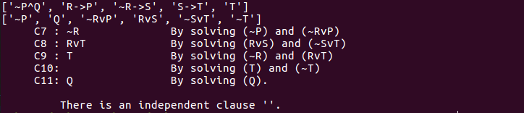

Example#7

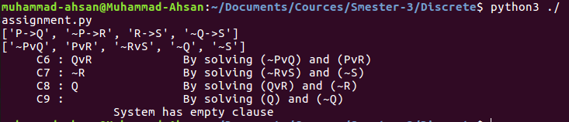

Example#8

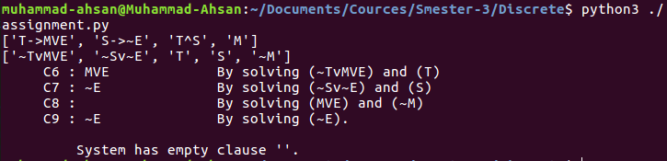

Example#9

