PRACTICAL EXAMINATION
Subject code: PRN232 – FA25
Duration: 85 minutes
FPTGear – Equipment Rental Management System
You are assigned to develop an ASP.NET Core Web API using .NET 8 or later for FPTGear, a system that manages rental equipment such as cameras, drones, and laptops.
The system must support user authentication (Login), role-based authorization (Admin / Customer), and allow data management through CRUD APIs and MVC/Razor Pages.
Database Schema
Users Table
Column | Data Type | Constraints
UserId | int | Primary Key, Identity
Email | nvarchar(100) | Unique
Password | varchar(100) | Encrypted (Hashed)
Role | nvarchar(20) | Values: 'admin', 'customer'
CreatedAt | datetime | Default: GETDATE()
Equipments Table
Column | Data Type | Constraints
EquipmentId | int | Primary Key, Identity
Name | nvarchar(100) | Required
Category | nvarchar(100) | Required
PricePerDay | decimal | Not null
DepositFee | decimal | Not null
StockQuantity | int | Default: 0
CreatedAt | datetime | Default: GETDATE()
UserId | int | Foreign Key to Users(UserId) (Uploader)

Rentals Table
Column | Data Type | Constraints
RentalId | int | Primary Key, Identity
EquipmentId | int | Foreign Key to Equipments(EquipmentId)
UserId | int | Foreign Key to Users(UserId)
Quantity | int | Must be > 0 and ≤ StockQuantity
StartDate | datetime | Required
EndDate | datetime | Required
Status | nvarchar(50) | Default: 'Active'
FineAmount | decimal | Default: 0
RentalDate | datetime | Default: GETDATE()
Database Design
The database includes three main entities:
Users, Equipments, and Rentals with one-to-many relationships between Users–Equipments and Users–Rentals.
Question 1: Build API with Authentication, Authorization, and CRUD (5 marks)
1.1 Create the database and EF Core models (1 mark)
- Use Code First or Database First approach.
- Define all relationships correctly among Users, Equipments, and Rentals.
1.2 Implement Authentication and Role-based Authorization (1 marks)
- POST /api/auth/login → return a JWT token containing role and user info.
Implement middleware to validate JWT and authorize routes:
- Admin → can access all CRUD endpoints.
- Customer → can only view available equipment and create their own rentals.
1.3 Create CRUD APIs for Equipment (1 mark)
Method | Endpoint | Description
POST | /api/equipments | Create new equipment (Admin only)
GET | /api/equipments | List all equipments (All users)
GET | /api/equipments/{id} | Get equipment details
PUT | /api/equipments/{id} | Update equipment info (Admin only)
DELETE | /api/equipments/{id} | Delete equipment (Admin only)
1.4 Create Rental API (1 mark)
- POST /api/rentals
- Input: EquipmentId, Quantity, StartDate, EndDate.
- Check stock availability.
- Deduct the rented quantity from StockQuantity.
- Save a new record with Status = 'Active' and RentalDate = GETDATE().
- PATCH /api/rentals/{id}/return
- When returned, update Status = 'Returned' and restore stock quantity.
- If returned after EndDate, calculate fine:
- FineAmount = 0.1 * PricePerDay * DaysLate * Quantity
1.5 OData Query Support (0.5 mark)
- Add OData for Equipments:
- Filter by PricePerDay greater than a value.
- Sort Equipments by Name descending.
1.6 Test with Postman (0.5 mark)
- Test all APIs (Auth, Equipment, Rental).
- Include screenshots of request and response in a Word file.
- Ensure JWT authentication headers are used for protected routes.
Question 2: Display API Data in ASP.NET MVC / Razor Pages (3 marks)
2.1 Display Equipments (1 mark)
- Implement /Equipments page listing all available equipment.
- Show columns: Name, Category, PricePerDay, StockQuantity, and Uploader Email.
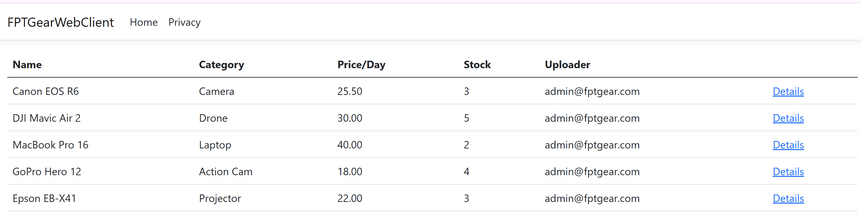
2.2 Equipment Details (1 mark)
- Implement /Equipments/Details/{id} to show full information.
- Include a “Rent Now” button for logged-in customers.
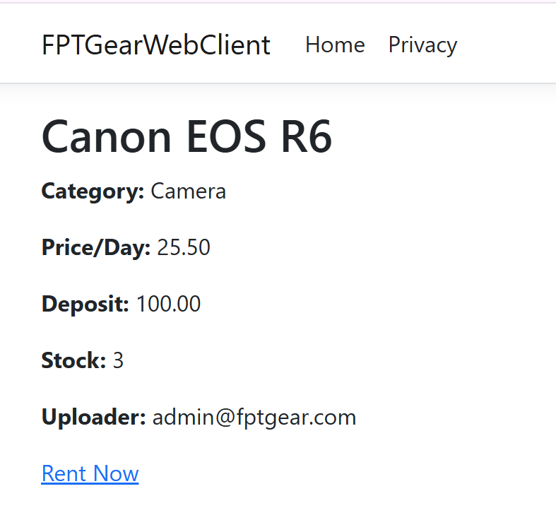
2.3 Create Rental from UI (1 mark)
- Implement a form allowing customers to create a rental order via API.
- Automatically calculate the total deposit (DepositFee * Quantity) before submitting.
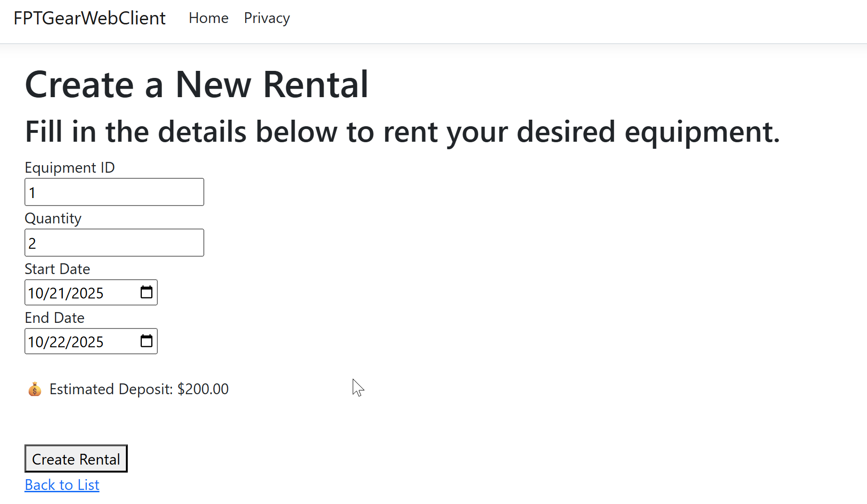
3. Architecture & Object Mapping Points
Criteria | Marks
Apply Repository Pattern and Separation of Concerns | 1 mark
Use AutoMapper for DTO conversion | 1 mark
Important Notes:
- Functionality Requirement: Your submission must be fully functional. Projects that fail to compile or run will receive a score of zero. Ensure all features are correctly implemented and thoroughly tested before submission.
- Without word file, question 1 will not be graded.
Submission Requirements:
- Submit all project files, Include a word file.
- Ensure that no personal identifiers (name or student ID) are included in the submission.
Additional Instructions:
- You may use local resources, but internet access is allowed to install packages via NuGet(in the first 5 minutes).
- Strict adherence to the project structure (Business, DataAccess, Repositories) is required to achieve full marks.

