PRN232 Assignment 01
Building ASP.NET Core Web API and Web Application
FUCourseManagementSystem
Course | PRN232 - ASP.NET Core Web API
Assignment | Assignment 01
Technology | .NET 8, ASP.NET Core Web API, OData, EF Core, MS SQL Server
Submission | Backend solution, Frontend solution, SQL script, report, screenshots

1. Introduction
A Course Management System (CMS) is a software application that helps universities manage academic courses, lecturers, students, class sections, and course enrollment activities. In a university environment such as FPT University, the system supports academic departments in organizing course information, assigning lecturers, managing class sections, tracking student enrollment, and generating academic reports.
Imagine you are a developer of a Course Management System named FUCourseManagementSystem. To implement a part of this system, your tasks include:
- Manage lecturer accounts.
- Manage student accounts.
- Manage course information.
- Manage class sections.
- Manage student course enrollments.
The application has a default admin account whose email is admin@FUCourseManagementSystem.org and password is @@abc123@@. This default account must be stored in the appsettings.json file.
The application must support adding, viewing, modifying, deleting, and searching information. These standardized operations are known as Create, Read, Update, Delete (CRUD) and Search.
This assignment explores creating an ASP.NET Core Web API with OData support using C# and Entity Framework Core. The client application can be developed as an ASP.NET Core Web MVC or Razor Pages application. An MS SQL Server database will be created to persist and manage data.

2. Assignment Objectives
- Use Visual Studio 2019 or above to create an ASP.NET Core Web API project and a Client Web Application project.
- Build an ASP.NET Core Web API with OData support.
- Perform CRUD actions using Entity Framework Core.
- Apply 3-layer architecture to develop the application.
- Apply Repository pattern and Singleton pattern.
- Implement CRUD and searching functions in the client application by calling Web API.
- Validate data types and business rules for all input fields.
- Implement role-based functions for Admin, Academic Staff, Lecturer, and Student.
- Run and test all actions of both Web API and Client Web Application.

3. Use Case Diagram
The following diagram gives students a high-level overview of the main actors and their responsibilities in FUCourseManagementSystem.
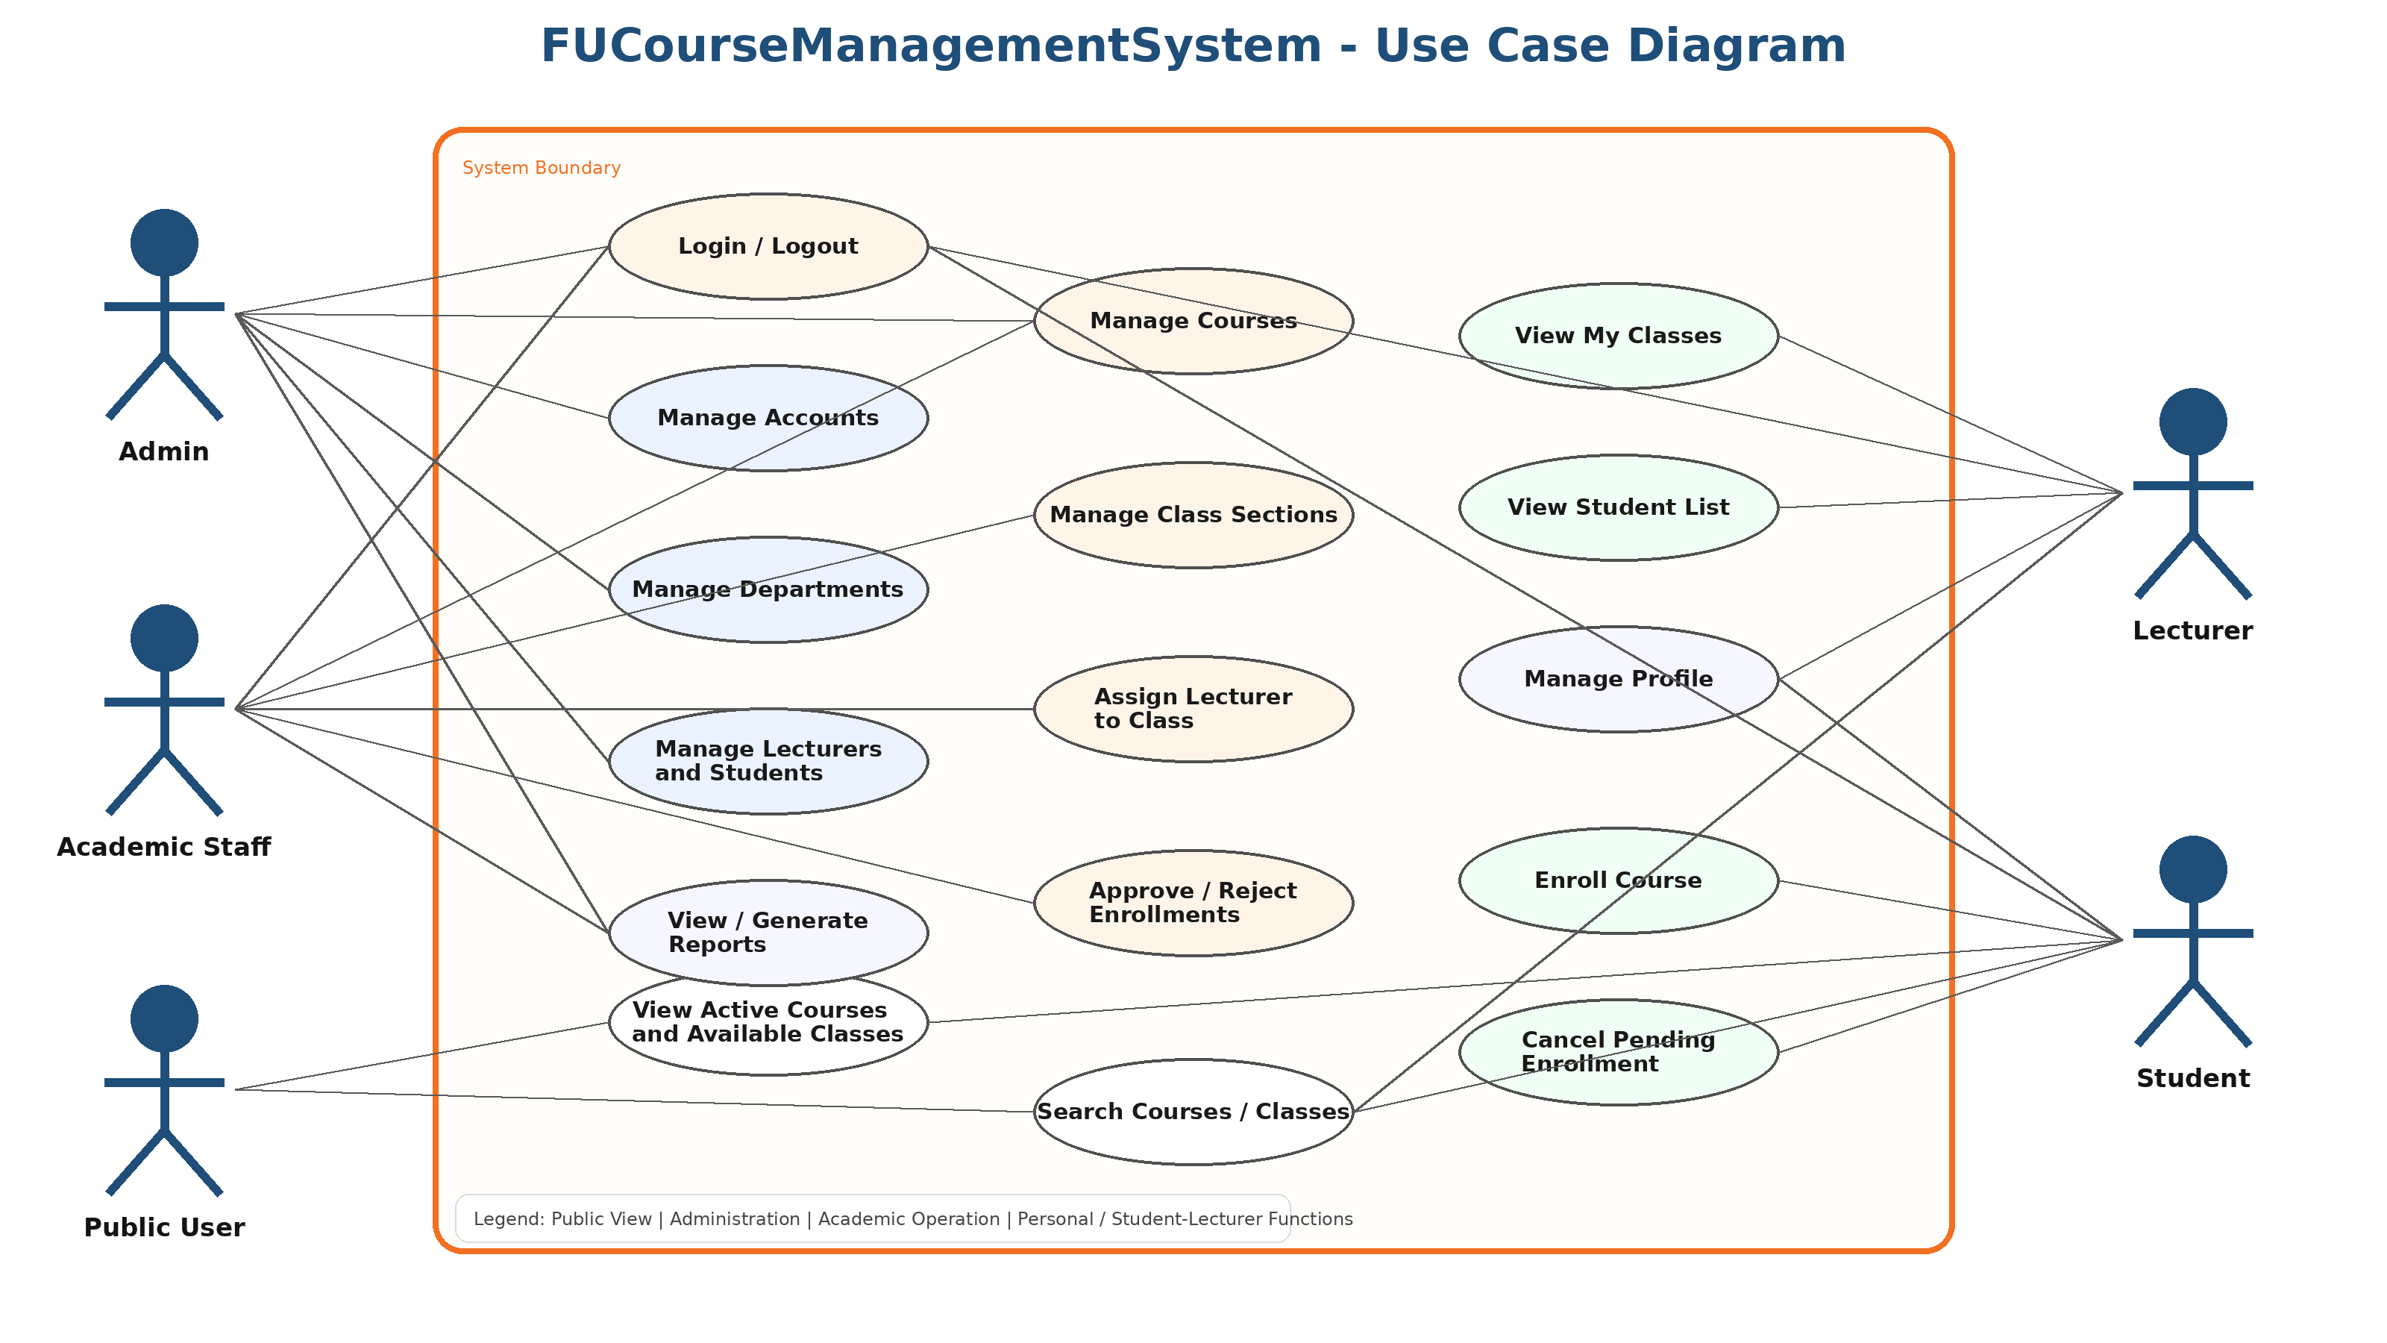
Figure 1. Use case overview of FUCourseManagementSystem

4. Database Relationship Diagram
The following ERD illustrates the core tables and relationships students should implement in the database.
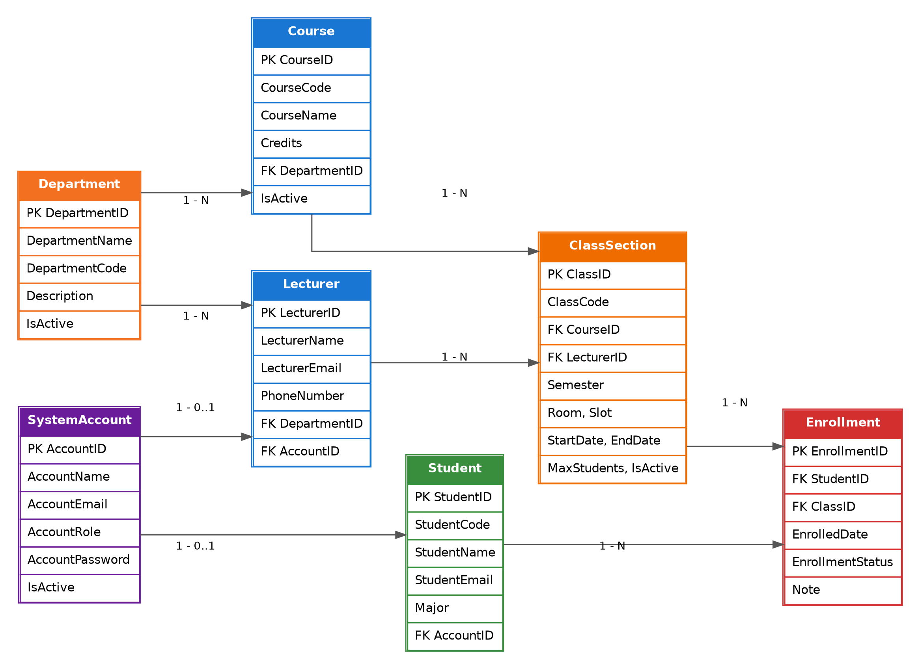
Figure 2. Entity relationship diagram for the Course Management System

5. Database Design
A part of the Course Management Database includes the following entities:

5.1. SystemAccount
Field | Description
AccountID | Primary key
AccountName | Full name of the user
AccountEmail | Login email
AccountRole | Role of account
AccountPassword | Password
IsActive | Account status

Roles: Admin is stored in appsettings.json; Lecturer = 1; Student = 2; Academic Staff = 3.

5.2. Department
Field | Description
DepartmentID | Primary key
DepartmentName | Name of department
DepartmentCode | Short code, for example SE, AI, CF
Description | Department description
IsActive | Active or inactive status

5.3. Course
Field | Description
CourseID | Primary key
CourseCode | Course code, for example PRN232, SWP391
CourseName | Course name
Credits | Number of credits
Description | Course description
DepartmentID | Foreign key to Department
IsActive | Course status

5.4. Lecturer
Field | Description
LecturerID | Primary key
LecturerName | Full name
LecturerEmail | Lecturer email
PhoneNumber | Contact number
DepartmentID | Foreign key to Department
AccountID | Foreign key to SystemAccount
IsActive | Lecturer status

5.5. Student
Field | Description
StudentID | Primary key
StudentCode | Student code
StudentName | Full name
StudentEmail | Student email
Major | Student major
AccountID | Foreign key to SystemAccount
IsActive | Student status

5.6. ClassSection
Field | Description
ClassID | Primary key
ClassCode | Class code, for example SE18A01
CourseID | Foreign key to Course
LecturerID | Foreign key to Lecturer
Semester | Semester code, for example SP26, SU26, FA26
Room | Classroom
Slot | Study slot
StartDate | Start date
EndDate | End date
MaxStudents | Maximum number of students
IsActive | Class status

5.7. Enrollment
Field | Description
EnrollmentID | Primary key
StudentID | Foreign key to Student
ClassID | Foreign key to ClassSection
EnrolledDate | Enrollment date
EnrollmentStatus | Pending, Approved, Rejected, Cancelled
Note | Optional note

6. Main Functions

6.1. Public Functions
- View the list of active courses.
- Search courses by course code, course name, department, or semester.
- View course details.
- View available class sections.
Only active courses and active class sections are shown to public users.

6.2. Authentication
Members must authenticate by Email and Password. The system supports Admin, Academic Staff, Lecturer, and Student roles. The default Admin account is read from appsettings.json.

7. Role-Based Requirements

Admin Role
- Manage system accounts.
- Manage departments.
- Manage lecturers.
- Manage students.
- View all courses and classes.
- View all enrollments.
- Generate academic reports.
- Delete an account only if the account is not linked to a lecturer or student.

Academic Staff Role
- Manage course information.
- Manage class sections.
- Assign lecturers to class sections.
- View enrollment lists.
- Approve or reject student enrollment requests.
- Generate course enrollment reports.
- Delete a course only if it has not been assigned to any class section.
- Delete a class section only if no student has enrolled in it.

Lecturer Role
- View assigned class sections.
- View the list of students enrolled in assigned classes.
- View course information related to assigned classes.
- Update own profile.
- Search students in assigned classes.
- View teaching history by semester.

Student Role
- View active courses.
- Search available courses and class sections.
- Enroll in an available class section.
- Cancel enrollment if the enrollment is still pending.
- View enrollment history.
- Update own profile.

8. Enrollment Business Rules
- A student cannot enroll in the same class section more than once.
- A student cannot enroll if the class section has reached the maximum number of students.
- A student cannot enroll in an inactive course or inactive class section.
- A student can only cancel enrollment when the status is Pending.
- Academic Staff must enter a rejection reason when rejecting an enrollment request.

9. Client Application Requirements
Students must create a Client Web Application using ASP.NET Core Web MVC or ASP.NET Core Razor Pages. The Client Application must interact with the Web API to perform all required functions.
Role | Required Screens
Admin | Login, Dashboard, Account Management, Department Management, Lecturer Management, Student Management, Academic Reports
Academic Staff | Course Management, Class Section Management, Lecturer Assignment, Enrollment Approval, Course Enrollment Report
Lecturer | My Classes, Class Details, Student List, Teaching History, My Profile
Student | Course List, Course Details, Available Classes, Enroll Course, My Enrollments, My Profile

10. CRUD and Search Requirements
The following modules must support Create, Read, Update, Delete, and Search:
- Account Management
- Department Management
- Course Management
- Lecturer Management
- Student Management
- Class Section Management
- Enrollment Management
Creating and updating actions must be performed using a popup dialog or modal form. Delete actions must always combine with confirmation.

11. Validation Requirements
Module | Validation Rules
Account | Email is required and must be valid; password is required; role and status are required.
Course | Course code and course name are required; credits must be greater than 0; department is required; course code must be unique.
Class Section | Class code, course, lecturer, and semester are required; MaxStudents must be greater than 0; StartDate must be earlier than EndDate.
Student | Student code, name, and valid email are required; student code must be unique.
Enrollment | Student and class section are required; status is required; duplicate enrollment is not allowed.

12. Technical Requirements
- Visual Studio 2019 or above
- .NET 8
- ASP.NET Core Web API
- ASP.NET Core MVC or Razor Pages
- Entity Framework Core
- MS SQL Server 2012 or above
The backend project must use ASP.NET Core Web API. Students are not allowed to connect directly to the database from API Controllers. Every database operation must be performed through Repository, Data Access Object, and Service Layer. The database connection string must be read from appsettings.json.

13. Architecture Requirements
Project / Layer | Responsibility
FUCourseManagementSystem.BusinessObjects | Entity classes
FUCourseManagementSystem.DataAccess | DAO classes and DbContext
FUCourseManagementSystem.Repositories | Repository interfaces and implementations
FUCourseManagementSystem.Services | Business logic
FUCourseManagementSystem.API | Web API controllers
FUCourseManagementSystem.WebClient | MVC or Razor Pages client

14. Naming Convention and Submission Requirements
Students must create two Visual Studio solutions:
- StudentName_ClassCode_A01_BE.sln
- StudentName_ClassCode_A01_FE.sln
Students must submit:
- Source code of Backend solution.
- Source code of Frontend solution.
- SQL script file.
- Short report document.
- Screenshots of main functions.

15. Important Notes
- The application must run successfully before submission.
- All CRUD functions must be tested.
- Search functions must be implemented in both API and Client Application.
- Delete actions must check business constraints before deleting data.
- Popup dialog or modal form must be used for Create and Update actions.
- Confirmation dialog must be used for Delete actions.
- Students must not hard-code the connection string in source code.
- Students must not access DbContext directly from Controllers.
- Admin account must be loaded from appsettings.json.

