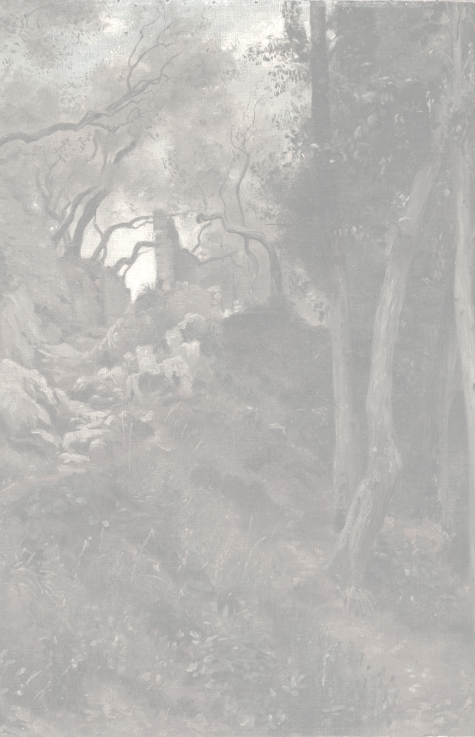

THE ANCIENT ROAD

You are a lone adventurer and have headed west.
At the edge of a wood lies an ancient road.
The road leads to magnificent ruins of a world lost to time.

HOW TO PLAY
- This is a journal writing game using blank hex grid to map out an ancient world.
- Each hex traveled will be filled with unique features and encounters.
- Keep track of each day, what you see, what you do, and what you encounter.
- You will find relics of the old world and with these you can perform rituals to gain insight into ancient mysteries, increase your power, defeat hideous monstrosities.

BEFORE YOU PLAY
Create a character using a system of your preference; if you need one, see the appendices.

TIME OF YEAR  Roll 1d4:  1 : Spring 2 : Summer  3 : Fall 4 : Winter | TIME UNTIL NEXT SEASON  Roll 1d4  1: One Month 2: Two Months  3: Three Months 4: One Week

THE FIRST HEX
What kind of hex is this? Roll 2d6
6, 7, 8 : Forest 5, 9 : Hills 4, 10 : Mountains 3, 11 : Plains 2, 12 : Swamps

1.0 – ORDER OF PLAY
For each day, do the following:
1. Note the days since start. Each month is 30 days, note any season changes.
2. Determine the day’s weather, section 1.2.
3. Expend 1 ration and 1 water-skin, if possible, else you must hunt and gather.
4. Select your two actions for the day, section 1.3
5. Resolve movement, if any.
6. If you move into a new hex, determine features, 2.1 to 2.8.
7. If you explore, resolve exploration
8. Resolve encounters 5.1
9. Resolve all other actions.

1.2 – WEATHER
What is today’s weather? Roll 1d6.
 | Spring | Summer | Fall | Winter
1 | Cold | Very Hot* | Cold | Very Cold*
2 - 4 | Clear and Warm | Clear and Hot | Clear and Chilly | Clear and Cold
5 | Rainy | Rainy | Rainy | Snowy
6 | Heavy Rain* | Heavy Rain* | Snowy | Heavy Snow*
*Difficult weather, slows travel.

1.3 – ACTIONS
Select two
1. Move one hex, in difficult weather you may only move once.
2. Explore one hex, reveals hidden features.
3. Explore one ruin, reveals mysteries.
4. Hunt and Gather, gain 1d6 rations and fill all water skins.
5. Study relics, gain deeper insight into mysteries.
6. Contemplate, realize ancient connections.
7. Perform rituals, sacrifice artifacts for power.

1.4 – TRAVEL & ENCOUNTERS
- Decide which hex side you wish to cross, travel there. If its a new hex, roll on 2.1 to 2.8.
- Roll 1d6 to see if and where you have an encounter. Note the result, resolve in section 5.1.
1 to 3 : Nothing 4 : Wilderness 5: Ruin 6: Dungeon

2.1 – ENTERING A NEW HEX
Per you current hex, roll 1d8 to determine the type for the next hex you enter
 | Forests | Hills | Mountains | Plains | Swamp
1 | Forests | Hills | Mountains | Plains | Swamp
2 | Forests | Hills | Mountains | Plains | Swamp
3 | Forests | Forests | Mountains | Forests | Swamp
4 | Hills | Forests | Hills | Forests | Forests
5 | Hills | Mountains | Hills | Hills | Forests
6 | Mountains | Mountains | Hills | Hills | Forests
7 | Plains | Plains | Forests | Mountains | Plains
8 | Swamp | Swamp | Plains | Swamp | Hills

2.2 – HEX TERRAIN
What is this hex like? Roll 1d8 per under this hex’s type.
Forests
1 | Clear of brush, ease of travel | 5 | Overgrown, difficult to travel
2 | Large old trees, thick canopy | 6 | Heavy canopy no light, rotting leaves
3 | Rolling Hills, thorny bushes | 7 | Long limbed oaks surrounding a cave
4 | Gnarled roots, small boulders | 8 | Dense with young and fallen pines
Plains
1 | Perfectly flat fields of grass | 5 | Cut through by shallow ravines
2 | Heavy shrubs filled with thorns | 6 | Dusty air swirls up dried grasses
3 | Farmland reclaimed by nature | 7 | Heavy oaks surrounded by scrub grass
4 | Spotted with large ancient trees | 8 | Sulfuric tar pits, scattered willow trees
Hills
1 | Gently rolling, clear sight | 5 | Rocky, with flowing creeks
2 | Sparse with trees and bush | 6 | Bluff overlook, exposed cave entry
3 | Large sections of dense brush | 7 | Moors covered in wildflowers
4 | Sharp rock outcroppings | 8 | Twisted trees atop sandy dunes
Mountains
1 | Airy and easy path, no rough terrain | 5 | Towering mountains, echoing caves
2 | Few trees, undulating, rocky | 6 | Fog covered pines and granite boulders
3 | Dense canopy with steep inclines | 7 | Deadly cliffs with scattered ferns
4 | Natural hot springs and geysers | 8 | Sharp ledges packed with old snow
Swamps
1 | Knobbed cypress trees, thick humidity | 5 | A rocky cave juts out of a clear pool
2 | Thick algae pools on stagnant water | 6 | Dense overgrowth and muddy ground
3 | Salty Marshlands with thin pines | 7 | Thick canopy, lily pad covered ponds
4 | Mangroves, brackish flowing water | 8 | Grey dead trees litter a dry swamp bed

2.3 – WATER FEATURES
- For a newly entered hex, roll 1d6 to see if you come across water, 1-3 no and 4-6 yes.
- If yes, you can freely refill any water-skins. Roll 1d12 to determine the type:
Water Features
1 | Pond | 5 | River, Gentle | 9 | Hot Spring
2 | Lake | 6 | River, Rapid | 10 | Geyser
3 | Creek | 7 | Waterfall | 11 | Ancient Well
4 | Stream | 8 | Spring | 12 | Oasis

2.4 – THE ROAD | 2.5 – CROSS ROADS
- Where does the road head? Roll 2d6. | - Roll 1d6, on a 1 there is a second road.
- The red side is where you entered this hex | - If there is a second road, roll 1d4:
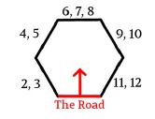 | 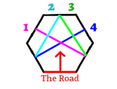
2.6.1 – HEX INHABITANTS
- Roll 1d6 for size to see if this hex is populated (on a 4 to 6). Then roll the d6 per the size.
- If it is, roll 1d6 for who, and again under the appropriate column.
 | Size | Who | Monstrous | Demi Human | Human
1 | No one | Monstrous | Goblins | Elf | Bandits
2 | No one | Monstrous | Hobgoblins | Dwarf | Tribal Warriors
3 | No one | Demi human | Orcs | Halfling | Cultists
4 | Scouts, 1d6 | Demi human | Kobolds | Gnome | Treasure Hunters
5 | Outpost, 2d6 | Human | Trolls | Centaur | Pioneers
6 | Settlement, 4d6 | Human | Bug bear | Giant | Wizard & hirelings

2.6.2 – INHABITANT ACTIVITIES
- If there are inhabitants, depending on their size, roll 1d6 to see what they are doing.
- If you need a who or what to further explain see section 5.
 | Scouts | Outpost | Settlement
1 | Searching for threats | Defending against threats | Building defenses
2 | Mapping new lands | Setting up a watch tower | Developing farmland
3 | Seeking Treasure | Erecting an excavation camp | Building a school
4 | Pursuing wild herds | Hunting wild game | Trading furs and pelts
5 | Hunting enemies | Raiding enemies | Training scouts
6 | Tracking lost allies | Consulting neighbors | Negotiating alliances

2.7 – OBVIOUS FEATURES
- For each hex, roll on the natural scenes and ancient ruins tables, 1d20 each.
- All ancient ruins are all accompanied by signs of former habitation, collapsed dwellings.
- Each ruin will have a state and a component that has its own description and application 2.8
Natural Scenes
1 | A flock of ravens | 6 | Narrow Gorge | 11 | Gigantic Waterfall | 16 | Dormant Lava Dome
2 | A large stalking cat | 7 | Animal Trail | 12 | Massive Redwoods | 17 | Natural Stone Arch
3 | A herd of deer | 8 | Massive Tree | 13 | Sandstone Mesa | 18 | Fields of lavender
4 | Hooting Owls | 9 | Littered Ravine | 14 | Limestone Grotto | 19 | Crater of devastation
5 | A family of bears | 10 | Deadly Canyon | 15 | Flowering Trees | 20 | Erupting Geyser

Ancient Ruins
1 | Castle | 6 | Bridge – Ravine | 11 | Colosseum | 16 | Temple
2 | Fortress | 7 | Bridge – River | 12 | Aqueduct | 17 | Basilica
3 | Barracks | 8 | Defensive Wall | 13 | Cistern | 18 | Monastery
4 | Fort | 9 | Bath house | 14 | Mill and Granary | 19 | Cloisters
5 | Keep | 10 | Chariot Racecourse | 15 | Farmhouses | 20 | Forum (4 Structures)

2.8 – Ancient Ruin Descriptions
- For each ancient ruin, roll 1d8 on each column.
- Ruin state cover the ruin as a whole. But the component is a piece of the ruin and has its own description and application.
 | Ruin State | Component | Description | Application
1 | Untouched | Statues | Devilish | Praise Deity
2 | Weathered | Frescoes | Vibrant | Preserve History
3 | Disheveled | Columns | Ornate | Mark Sacrifice
4 | Overgrown | Archway | Imposing | Describe Ritual
5 | Partially Collapsed | Stained Glass | Brilliant | Provide Warning
6 | Collapsed | Mosaic | Elaborate | Instruct Morals
7 | Partially Destroyed | Bas-Relief | Menacing | Reveal Knowledge
8 | Nearly Destroyed | Stone Door | Brutal | Persecute Evil

2.9 – HIDDEN FEATURES
If you decide to fully explore the hex, roll 1d20
Hidden Features
1 | Witch’s Hut | 6 | Mushroom Grove | 11 | Healing Fountain | 16 | Weird Ziggurat
2 | Standing Stone | 7 | Overgrown Cemetery | 12 | A Lone Crypt | 17 | Dragon’s Skeleton
3 | Stone Circle | 8 | Corrupted Shrine | 13 | Catacombs | 18 | Wizard’s Tower
4 | Mineshaft | 9 | Haunted Battlefield | 14 | Magical Pool | 19 | A field of corpses
5 | Monster’s lair | 10 | Pyramidal Mound | 15 | Burial Mound | 20 | Two Features

3.1 – DUNGEON ENTRANCES
For ruins and caves, you must roll to see if there is a dungeon present. Roll 1d6.
1: Forest 2: Hills 4 : Mountains 4: Plains 5 : Swamps 6:

4.0 – RELICS
Rituals – you make sacrifice a relic with a ritual that takes one hour
One relics of religion may be sacrificed to regain all hit points
Two relics of religion may be sacrificed to increase maximum hit points by 3
One relic of knowledge may be sacrificed to learn everything about a neighboring hex – perform all rolls for this hex now

Mysteries
Sculptures of deities
A cask of old wine
Scenes of a tragedy
Remains of a sacrifice
Bejeweled attire
Marble bust of a noble

Appendix 1 – Simple Characters
If you do not have a preferred system use this system as a simple alternative:

1. CHARACTERISTICS
- Roll 3d6 for each of the following characteristics:
- Physique: strength, dexterity, and violence
- Survival: wisdom, stealth, and constitution
- Investigation: intelligence, education, and perception.
- Roll 1d6 + 2 for your HP, if your survival is 13 or higher, add +1 to this result.

2. PROFESSION
Choose a profession from the below:

Archaeologist – Advantage on investigation | Priest – Heal 1d4 damage, once per day
Assassin – Advantage on damage | Warrior – Advantage on combat
Hunter – Advantage on survival | Wizard – Two additional spells in a spellbook

3. ARMAMENT
Select or roll for weaponry and armor.

 | Weaponry | Damage | Armor | Defense
1 | Spellbook and Dagger | 1d4 | None | 0
2 | Wand and Staff | 1d4+1 | Robes of hiding | 0
3 | Sword and Shield | 1d6 | Leather Armor | 1
4 | Mace and Shield | 1d6 (+1 vs undead) | Chain armor | 2
5 | Shortbow and Shortsword | 1d6 & 1d6 | Chest Plate | 3
6 | Two Handed Sword | 1d10 | Half Plate | 4

4. SPELLS
If you have a spellbook roll 1d12 three times below, for a wand roll 1d12 once.
Spells Table
1 | Animate Dead | 4 | Fireball | 7 | Lightning Bolt | 10 | Silence
2 | Charm Person | 5 | Invisibility | 8 | Read Magic | 11 | Sleep
3 | Entangle | 6 | Light / Darkness | 9 | Read Languages | 12 | Unlock

5. EQUIPMENT
Select equipment, up to 8 slots of items can be stored in a backpack. Each item uses 1 slot:
backpack
bedroll
chalk
crowbar
lantern
lock-picks (3)
flask of oil (3)
hammer
hunting bow
mirror, small
pen and parchment paper
rations (7)
rope 50ft
spikes (10)
tinderbox
tent, 2 person
torches (5)
twine, 100 ft
water-skin (2)
wax candles (10)
winter clothing
wire, 100 ft
wool blanket

Appendix 2 – Simple Gameplay Mechanics
1.1 Checks
- When you are uncertain if you can succeed in a task you wish to take, roll 1d20 against one of your three characteristics. If the result is equal to or lower you succeed.

1.2 Actions
Things you may want to make checks for, and what occurs on a success
Hunting | Gain 1d6 worth of rations from game

2. Oracle
- If you want to know something about the world, ask a yes or no question.
- If you the the answer is likely yes, add one to the oracle roll; if unlikely, subtract one.
- Once you have the question and the likelihood in mind, roll 1d6.
1 or 2 : No 3 : Somewhat no 4: Somewhat yes 5 or 6 : Yes

3.1 Combat
- Combat between you and you foe(s) is broken up over rounds.
- Regardless of enemy numbers, you roll only once for everyone’s attacks that round.
- For the combat round, roll 1d20 to determine the outcome using the table below.
- You may flee instead of attacking, but you still must roll an attack roll to see if you take any damage. If you survive any damage, you successfully escape.

3.2 Attack Rolls
- Roll 1d120 to resolve a round of combat. If your physique is 13 or higher, add +1 to this roll.
- Disarmed enemies do not deal damage on their next hit.

Attack Roll Table
1 | You are down, see the death table | 11 | No one hits
2, 3 | You are hit and stumble, -1 next round | 12 to 15 | You hit
4, 5 | Brutal hit, take +1 damage (min. 2 dmg) | 16, 17 | You hit and disarm 1 enemy
6 to 9 | Enemies Hit | 18, 19 | You hit twice
10 | No one hits | 12 | You immediately slay 1 enemy

3.3 Damage Rolls
- For the number of hits made, roll that many dice -- your weapon’s damage or enemy’s.
- Enemies always deal 1d6 damage. For multiple hits, only take the highest dice rolled.
- Subtract your armor’s defense from that roll & take that damage with a minimum of 1.

3.4 Death Roll Table
If you reach 0 HP or get a 1 on the attack roll you might die. Roll 1d6 for the result.

Death Roll Table
1, 2 | You have died, the game is over.
3 | You are unconscious and taken prisoner. You awake to armed guards prodding you.
4 | You awake with 1 HP, but a prisoner. No one is watching you.
5 | You are left for dead and wounded. Permanently reduce max HP by half, round up.
6 | You are left for dead, but awake hours later at 1 HP.

