Summary

In summary, I found zero errors with the way my program had run. However, one of the major issues I had involved testing my program. When I initially wrote the code for my program, even though my program was working completely fine and was done in an object-oriented style, I still found that it was hard to test huge methods. However, I was able to easily fix this problem by simply taking small blocks of code within each large method and making them into a method itself. As such, I was able to test large methods by individually testing the smaller methods that make up each large method.

Screenshot for DriverTest

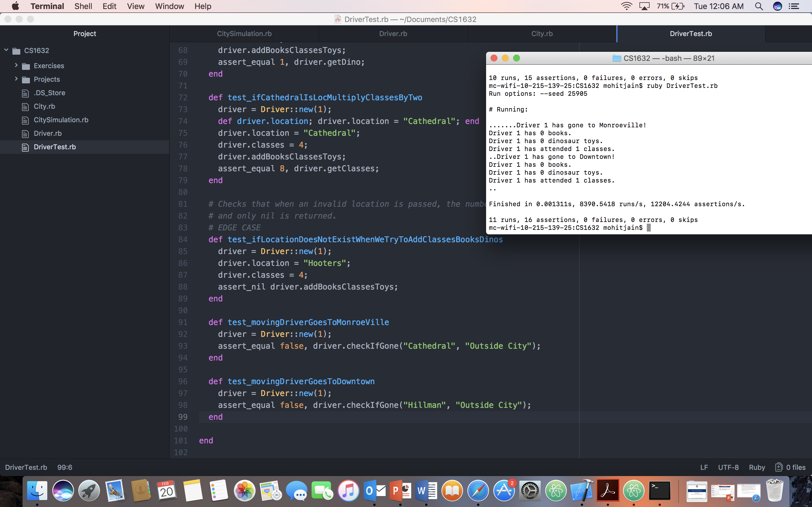

Screenshot for CityTest

