**Index.html (HOME PAGE)**

**TAKE PART IN HUMANITARIAN AIDS**

**TO IDPS AND WAR REFUGEES IN BURMA**

Myanmar has over 70-year of civil war that emerged after its independence from the British colony. The main reason for this huge civil war is the nationalism and religion of the Myanmar Military called Tatmadaw.

**IDPs and War Refugees**

**What?**

An internally displaced person (IDP) is someone who is forced to leave their home but who remains within their country's borders. They are often referred to as refugees, although they do not fall within the legal definitions of a refugee. IDPs in Burma are mostly ethnic minorities called, Kachin, Karen, Shan, Karenni, Chin.

**Why?**

In 1960, some ethnic minorities such as Kachin and Karen, started their armed revolution against Myanmar Military and formed their respective ethnic army to protect their race. After 1962-military-coup by Tatmadaw, the arm conflicts between Ethnic Armed Organization (EAO) and Tatmadaw grew up and as the Tatmadaw is being such a professional powerful army, Tatmadaw conducted many special military operations with sea land air against EAOs.

**How?**

During these operations, Tatmadaw targeted not only EAOs but all the people of that ethnic as well, in another way, it is called genocide against minorities. Therefore, the number of IDPs became increased decade by decade and in 2021, over 2 million people are internally displaced.

**Hands to Burma**

Hands to Burma is the Myanmar’s largest humanitarian organization, saving lives in emergencies and using food assistance to build a pathway to peace, stability and prosperity for people recovering from conflict, disasters, and the impact of climate change. We deliver lasting impact by providing health care, helping children learn, and empowering individuals and communities to become self-reliant, always seeking to address the inequalities facing women and girls.

Video - <https://www.youtube.com/watch?v=1MGRB5ZmKpU>

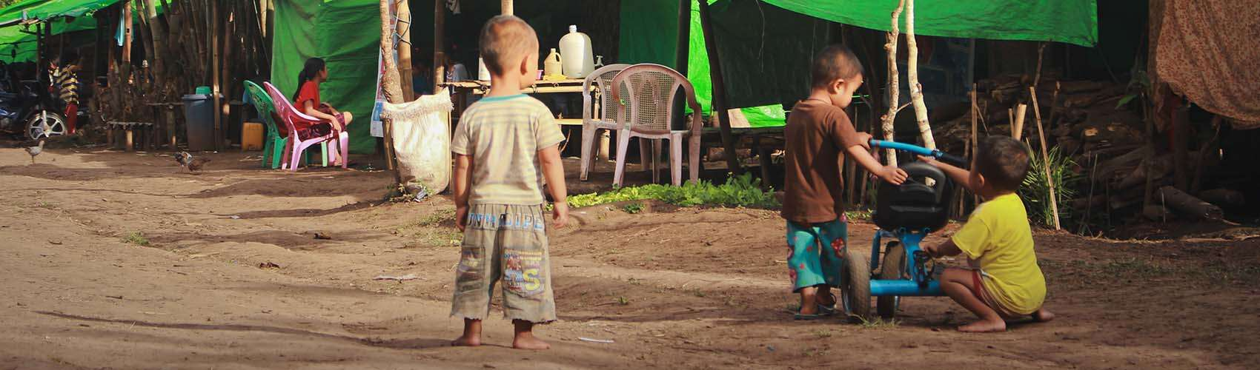

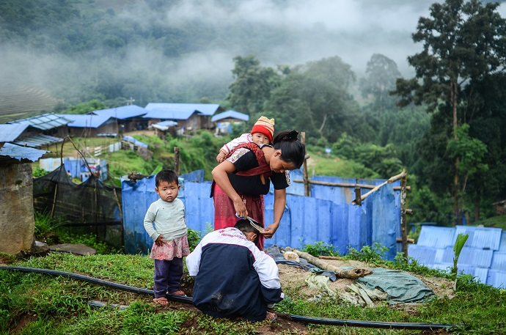

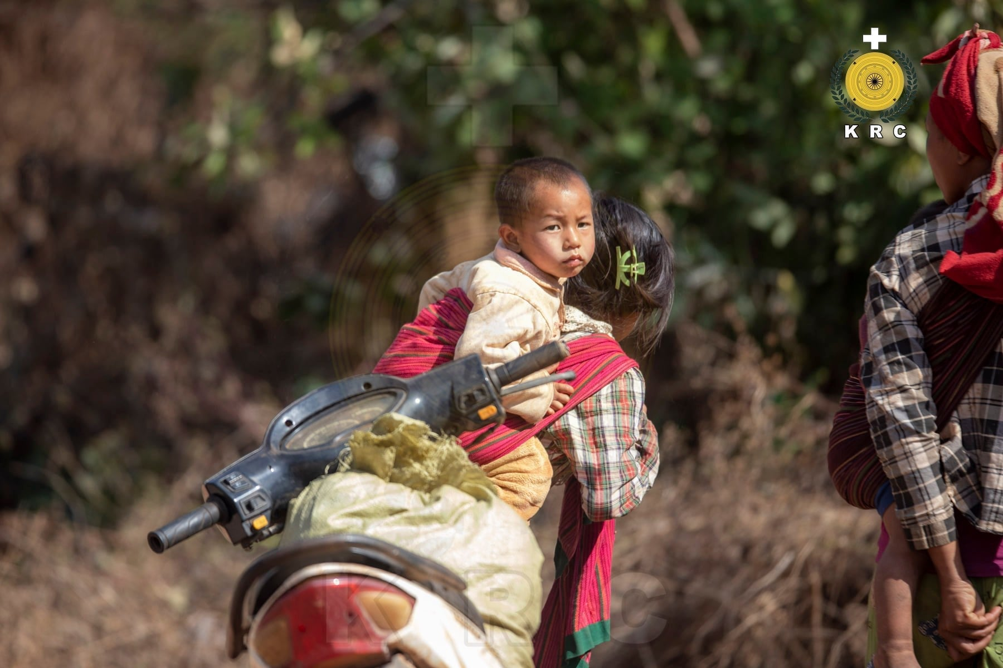

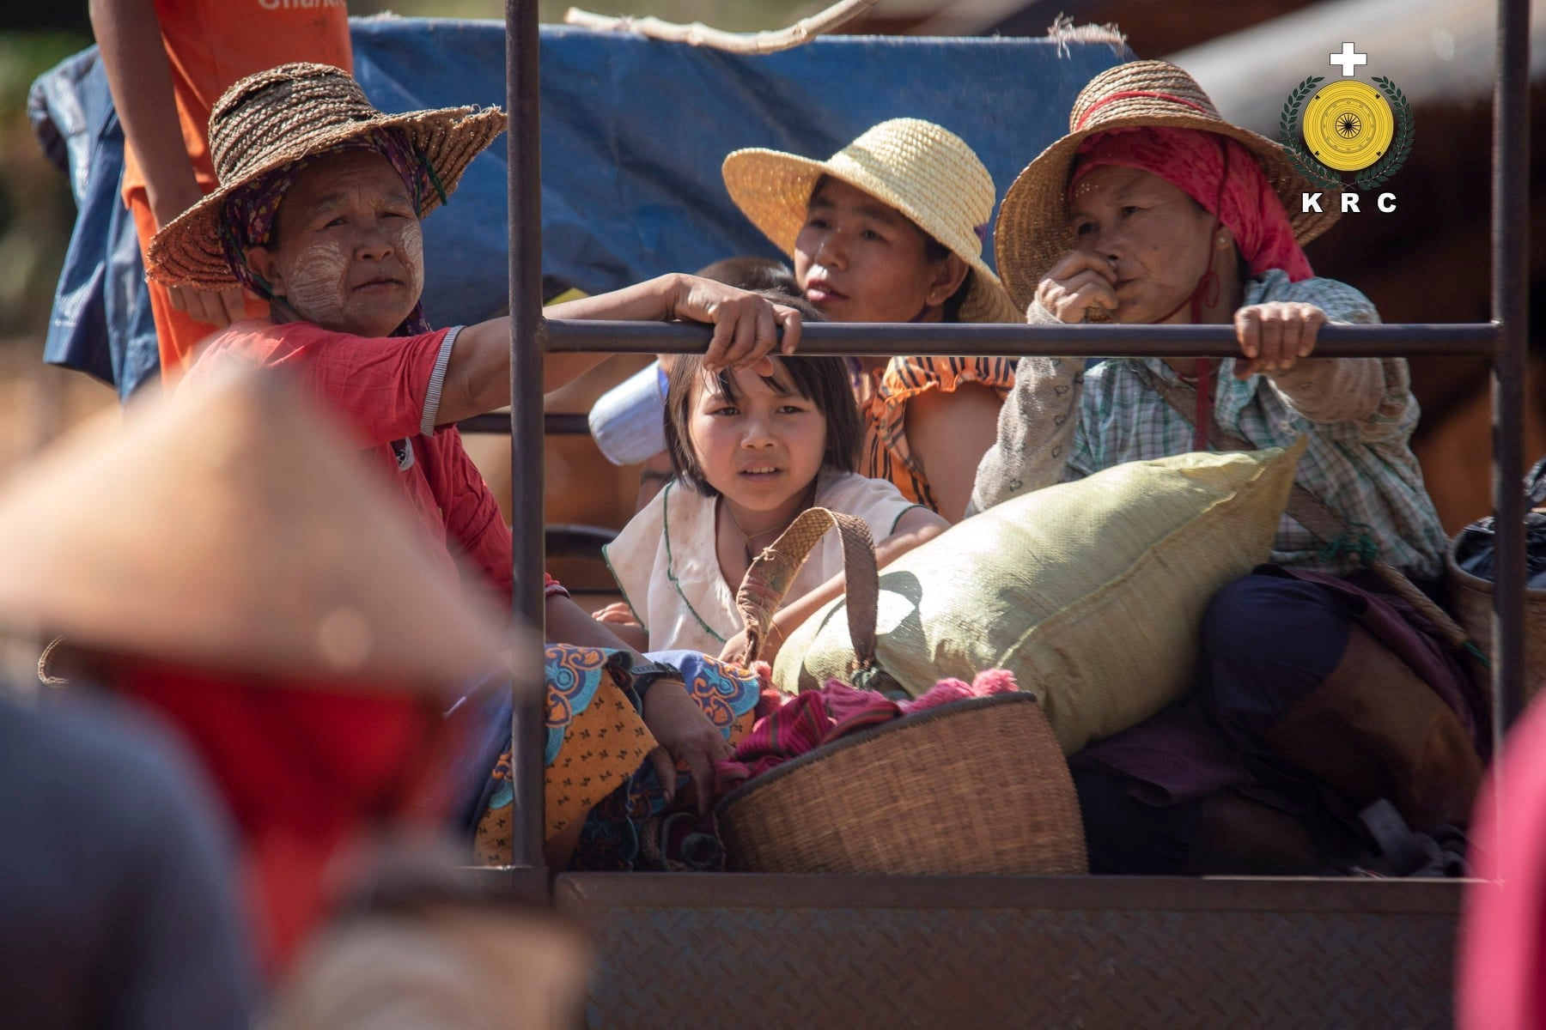

**INTERNALLY DISPLACED PERSON (IDPs)**

Myanmar (Burma) is a country formed with different diversity of people with different blood. The largest ethnic in Myanmar (Burma) is Bamar, and also 98% of Myanmar's military is composed of Bamar People. Therefore, Myanmar Military tried to overwhelm the other ethnic minorities. Myanmar has been under Military Regime since 1962 and its de facto institution, Tatmadaw, performed many special military operations to commit genocide against many minorities and Rohingya (in 2016-2018) within 70 years. Myanmar Military, Tatmadaw, conducted a 4-cut operation (The “four cuts” was a doctrine which was designed to sever insurgents from their key inputs like funding, food, intelligence, and recruits) for ethnic cleansing, in which, they used airstrikes on the innocent minorities, they burnt down many villages. Therefore, the only thing that minorities can do is just run. In the Rohingya Genocide, 116,000 Rohingya were beaten, and 36,000 were thrown into fires. The military operations displaced a large number of people, triggering a refugee crisis. The largest wave of Rohingya refugees fled Myanmar in 2017, resulting in the largest human exodus in Asia since the Vietnam War. During the 2021 Myanmar Spring Revolution, almost all the people in Myanmar, except mainland people, became IDPs and war refugees because of the fascist army, Tatmadaw.

**Rakhine State**: According to OCHA reports of January 2015, there are 146,524 IDPs still living in camps in Rakhine State, while the UNHCR reported in 2014 about 140,000 IDPs in this State. They are victims of the communal violence which broke out in 2012 and which resulted in the death of over 200 people amongst Rakhine and Rohingya communities. The UNHCR and other INGOs have provided shelters, food and medicine. However, the IDPs in the camps face hardships such as lack of health−care support and children’s education. Rakhine and Rohingya communities continue to fear each other and their mutual mistrust prevents harmony between the two communities. President Thein Sein has approved the expenditure of 2 billion Kyat for IDP resettlement projects. The first step will be to build houses for them.

**Meikhtila**: Over 3,000 IDPs are still living in five camps in Meikhtila township of Mandalay Division. There were about 8,000 IDPs in Meikhtila after communal violence broke out there in March 2013. A resettlement committee composed of the regional government, local authorities, private donors and IDP representatives was formed after the incident in 2013. The Chief Minister of Mandalay Division approved a resettlement plan proposed by the resettlement committee in 2014. Since then, the Mandalay Divisional Government and local authorities have built houses in the township for resettling the IDPs. Local authorities made available 220 houses in August 2014.42 A further 350 houses were occupied by 350 families on 19 August that year.

**Kachin State**: According to the OCHA, there were in excess of 90,000 IDPs in government− and KIO−controlled areas of Kachin State in 2014, the UNHCR reporting about 100,000 Kachin IDPs in the State itself and adjoining areas. Alhough there was a reduction of armed conflict in the State between the KIA and government forces, outbreaks of fighting nonetheless persisted. Therefore, most IDPs were afraid to return home, although a few did so. Clashes between KIA and government forces, in the Hpa−kant area in 2014 and Tanine township in early 2015, created a further 3,000 IDPs. These people have been living in conditions of great hardship from lack of food, medicine, shelter and absence of work to provide income. Their children are missing out on education because there are insuficient schools and educational materials. The UN and other INGOs attempted to send them humanitarian assistance but the government forces refused permission. The Kachin State Government built houses for IDPs in Ngwe San Pyaw village in Myitkyina. Over 100 new houses in Ngwe San Pyaw village were transferred to Kachin IDPs in May 2014. This was a result of the formation that month of the Joint Conflict Resolution Committee composed of 5 members each from the KIO and the Government. According to Kachin State Social Welfare Minister, Daw Bauk Ja, the Kachin State Government would return 33 families to their homes at the end of August that year. 192 IDP families from Sein Lon Kabar, Sein Lon Kagyi and Pan Mu villages in Moemauk township in Kachin State returned home on 11 October.44 An outcome achieved by the Joint Conflict Resolution Committee (JCRC) meeting held on 3 October. Both the Union Government and the Kachin State Government delivered assistance to the returning IDPs.

**Shan State**: IDPs are living in camps in areas controlled by the Government and in those under the control of the ethnic armed forces. In the course of the year, armed conflict created new IDPs in northern Shan State where a significant amount of fighting occurred. There is no ceasefire accord between the TNLA and the Government, which helps explain the frequent clashes in this sector. According to the Ta’ang Women’s Organization (TWO), there are at least 3,000 IDPs in the Ta’ang area of northern Shan State. Additionally, the SSPP and government forces in northern Shan State fought one another despite a ceasefire agreement. Government forces launched an offensive against SSPP camps near Tapha Soung bridge in Kehsi township in early October. The fighting lasted five days and resulted in the flight of at least 2,500 villagers. Government forces took control of the SSPP camps after heavy fighting. A series of ceasefire talks between the SSPP and government oficials resulted in the SSPP evacuating its camps and the cessation of hostilities in Kehsi township. Thereupon the Shan IDPs returned home. The MNDAA is a newly resurrected group. It was the first ethnic armed group to sign a ceasefire agreement with the previous military regime, in 1989. The Kokang region became known as Special Region One and was favored by the military regime during a long ceasefire period. However, when in 2009 the military regime ordered the MNDAA to transform its forces into a BGF, the MNDAA refused. Government forces then attacked and captured Laukkai, the capital of the Kokang region. Peng Jiasheng went underground and regrouped his troops. The MNDAA struck back at government forces based in Laukkai on 9 February 2015, and since then fighting has taken place almost every day. According to mainstream media reports, this has boosted the number of IDPs in the Sino−Myanmar border area to about 100,000. Some fled to Lashio, the capital of northern Shan State. Armed conflict is still occurring at the time of writing. IDPs in the border area face hardship from lack of shelter, food, medicine and schools for children.

**Karen and Mon States**: There was no heavy fighting between KNU and government forces in 2014, but in September and October DKBA columns led by Col. Saw San Aung fought government forces in both Karen and Mon States. This created an additional 2,000 IDPs in these States. Luckily, the fighting only lasted a few weeks, and then these IDPs could go home. According to a UNHCR report, there are 230,000 refugees living in Thai camps while some thousands of IDPs are living in the border area of Myanmar. After Karen armed groups and the Government signed ceasefire agreements, a few Karen refugees returned home. Some resettled in the Kyauk Kyi project area which was provided by INGOs. Also, the KNU has built houses in Karen State to resettle its members’ families plus some other refugees. However, most refugees living in the Thai camps do not want to go back home. One reason is that they are at risk from undiscovered landmines in their old village areas. Another reason is that Myanmar army, which experience has taught them to fear, is now deployed in their area. Oficially−recognized refugees as well as IDPs are afraid that government soldiers will continue to commit human rights abuses.

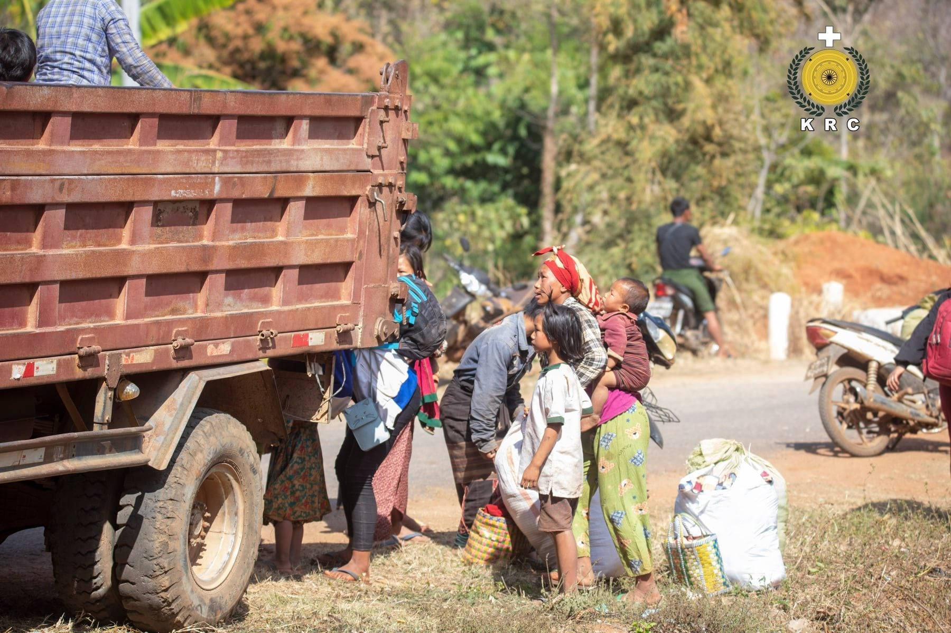

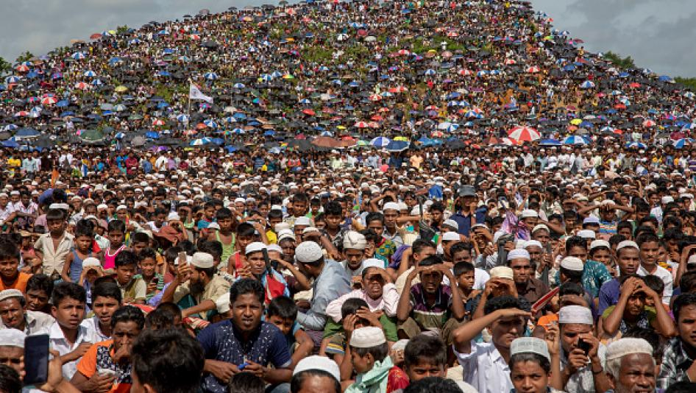

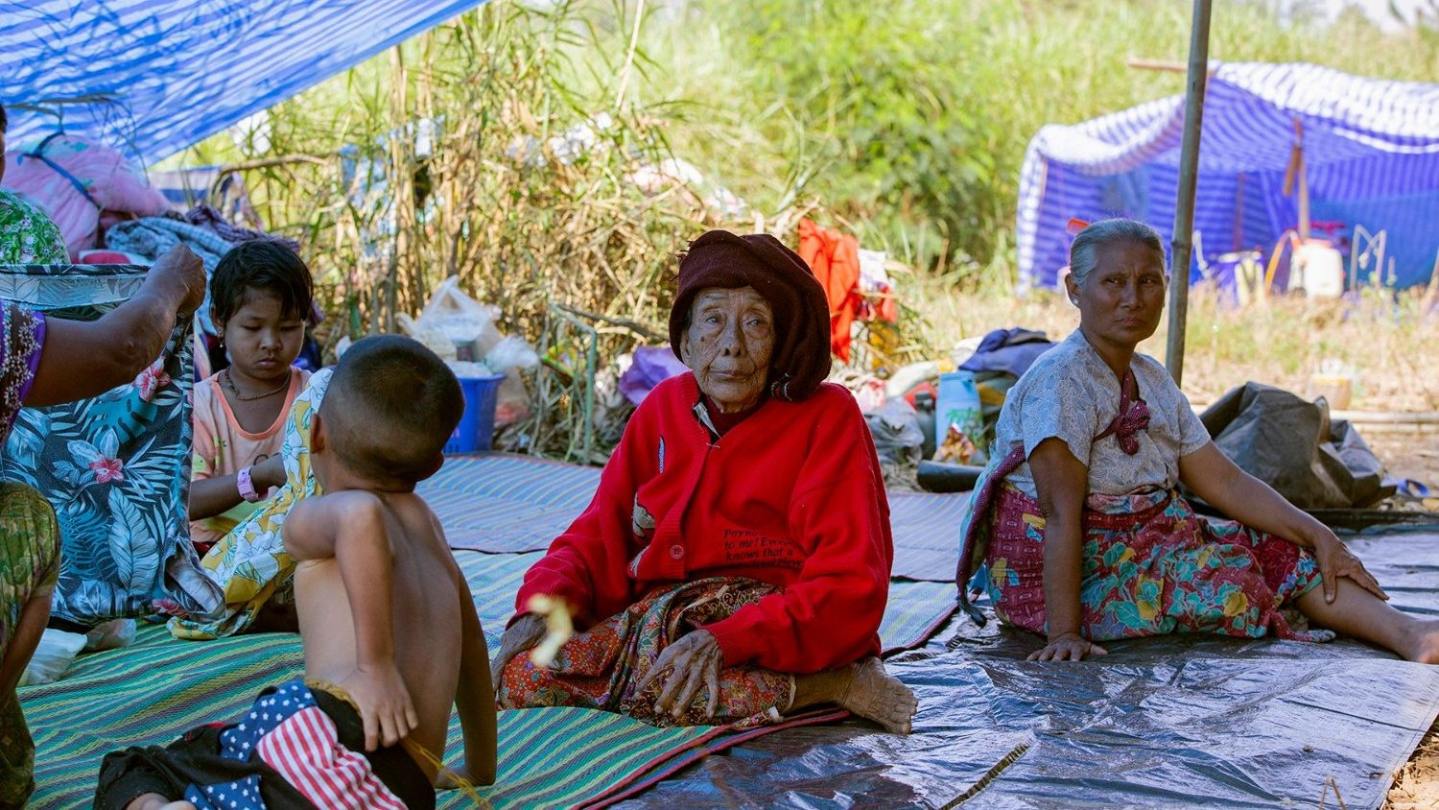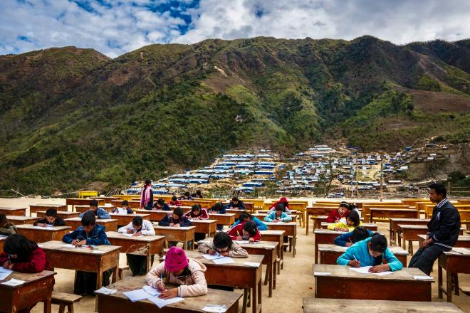

**STATEMENTS**

CURRENT NET FUNDS - 9045 USD

|  |  |  |  |
| --- | --- | --- | --- |
| **Name** | **Date** | **Country** | **Amount** |
| **Janice Monahan** | **12 January 2022** | **Singapore** | **150 USD** |
| **Rollin Fadel** | **12 January 2022** | **Japan** | **150 USD** |
| **Lera Stroman** | **12 January 2022** | **Finland** | **150 USD** |
| **Adan Schiller** | **12 January 2022** | **Norway** | **150 USD** |
| **Adan Schiller** | **12 January 2022** | **Germany** | **150 USD** |
| **Adan Schiller** | **12 January 2022** | **France** | **150 USD** |
| **Adan Schiller** | **12 January 2022** | **UK** | **150 USD** |
| **Adan Schiller** | **12 January 2022** | **BURMA** | **150 USD** |
| **Adan Schiller** | **12 January 2022** | **Thailand** | **150 USD** |
| **Adan Schiller** | **12 January 2022** | **Hungary** | **150 USD** |

**DONATE**

First name (text input)

Last name (text input)

Country (dropdown menu)

Postal code (text input)

Phone (dropdown menu and text input)

Address (text input)

Email (text input)

Amount (text input)

Cardholder’s Name (text input)

Card number (text input)

Expiry date (calendar)

CVC (password holder)

EU Citizen (YES and NO – radio button)

Accept to terms and conditions (checkbox)

Accept to data privacy protection (EU LAW) (Checkbox)

DONATE NOW (submit button)