МІНІСТЕРСТВО ОСВІТИ І НАУКИ УКРАЇНИ
ВСП «ФАХОВИЙ КОЛЕДЖ ІНФОРМАЦІЙНИХ ТЕХНОЛОГІЙ НАЦІОНАЛЬНОГО УНІВЕРСИТЕТУ «ЛЬВІВСЬКА ПОЛІТЕХНІКА»

Звіт
про виконання лабораторної роботи № 16
з дисципліни «Web дизайн та web технології»

Виконав
студент групи ТКБ-31
Заяць Богдан
Викладач: Кісіль М.М.

Львів 2022

Тема:
Обробка форм та подій

Мета:
Навчитися працювати з формами та обробником подій

Хід роботи

Скріншоти
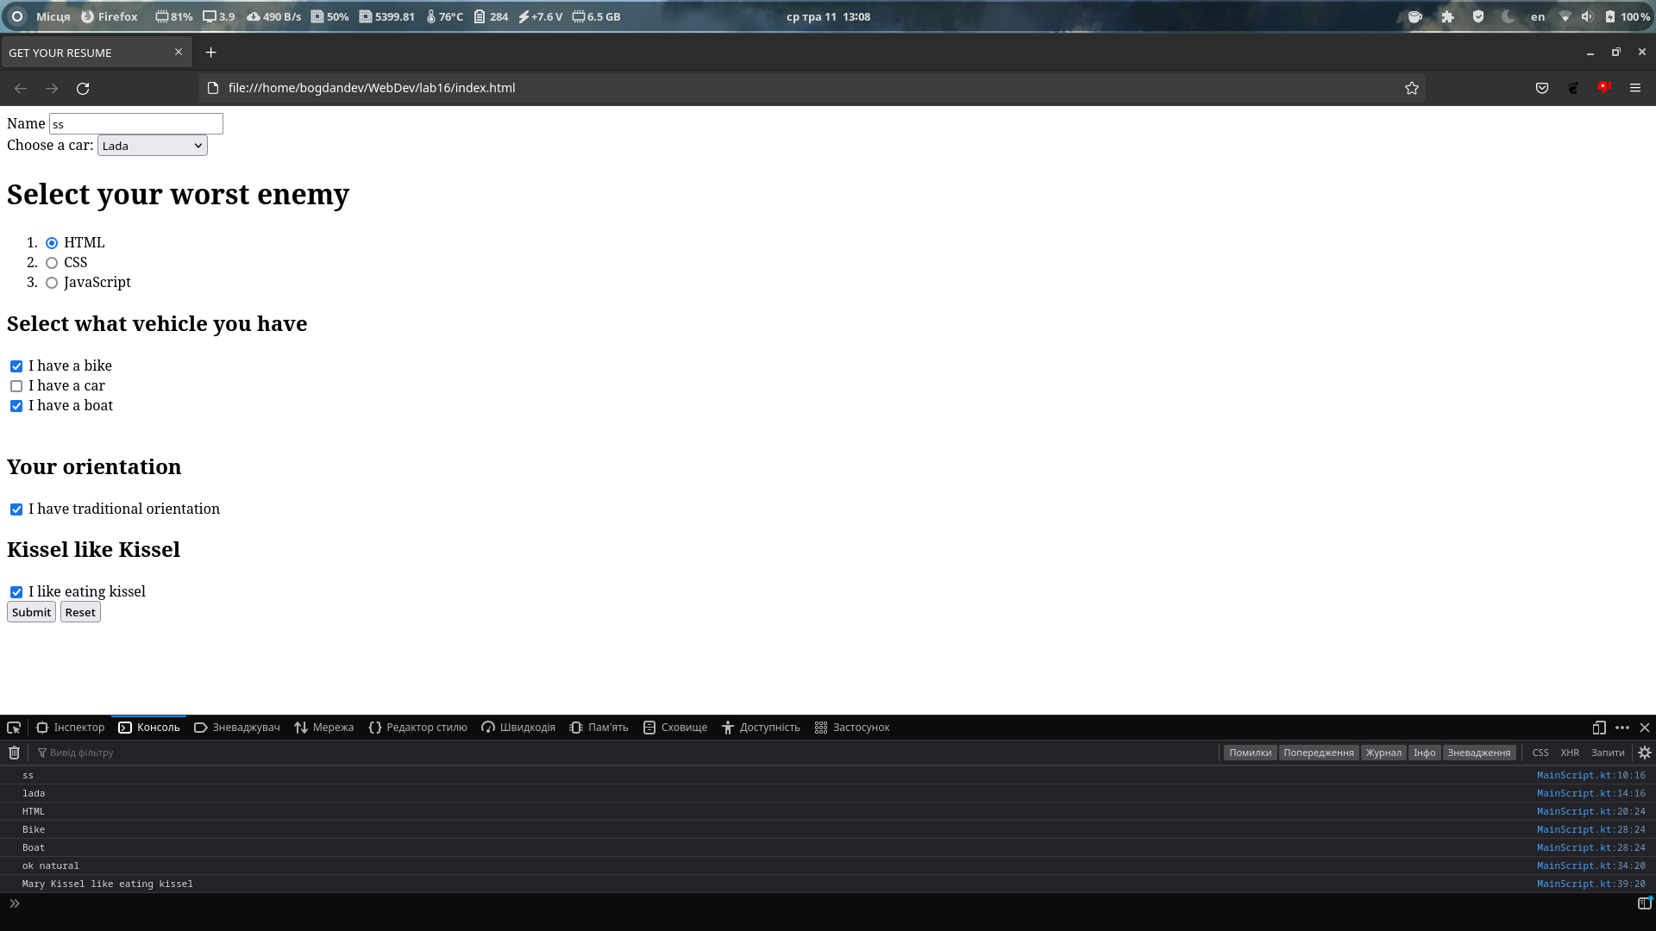

код :

Kotlin:
import kotlinx.browser.document
import org.w3c.dom.*

fun main() {
val myForm = document.getElementById("my-form") as HTMLFormElement
myForm.addEventListener("submit", {
it.preventDefault()
val name = document.getElementById("name") as HTMLInputElement
console.log(name.value)

val cars = document.getElementById("cars") as HTMLSelectElement
val car = cars.selectedOptions[0] as HTMLOptionElement
console.log(car.value)

val yourWorstEnemies = document.getElementsByName("worst-enemy")
for (i in 0 until yourWorstEnemies.length) {
val enemy = yourWorstEnemies[i] as HTMLInputElement
if (enemy.checked) {
console.log(enemy.value)
}
}

val yourVehicles = document.getElementsByName("vehicles")
for (i in 0 until yourVehicles.length) {
val yourVehicle = yourVehicles[i] as HTMLInputElement
if (yourVehicle.checked) {
console.log(yourVehicle.value)
}
}

val yourOrientation = document.getElementById("orientation") as HTMLInputElement
if (yourOrientation.checked) {
console.log(yourOrientation.value)
}

val yourKissel = document.getElementById("kissel") as HTMLInputElement
if (yourKissel.checked) {
console.log(yourKissel.value)
}
})
}

HTML:
<!DOCTYPE html>
<html lang = "en">

<head>
<meta charset = "UTF-8">
<meta http-equiv = "X-UA-Compatible" content = "IE=edge">
<meta name = "viewport" content = "width=device-width, initial-scale=1.0">
<title>GET YOUR RESUME</title>
</head>

<body>
<div>
<form id = "my-form" action = "test.html" method = "get">
<div>
<label for = "name"> Name </label>
<input type = "text" name = "name" id = "name" required>
</div>

<div>
<label for = "cars">Choose a car:</label>
<select id = "cars" name = "cars">
<option value = "lada">Lada</option>
<option value = "zhiguli">Zhiguli</option>
<option value = "fiat">Fiat</option>
<option value = "audi">Audi</option>
<option value = "tractor">FreakingTractor</option>
</select>
</div>

<div>
<h1>Select your worst enemy</h1>
<ol>
<li><input type = "radio" id = "html" name = "worst-enemy" value = "HTML">
<label for = "html">HTML</label><br></li>
<li><input type = "radio" id = "css" name = "worst-enemy" value = "CSS">
<label for = "css">CSS</label><br></li>
<li><input type = "radio" id = "javascript" name = "worst-enemy" value = "JavaScript">
<label for = "javascript">JavaScript</label></li>
</ol>
</div>

<div>
<h2>Select what vehicle you have</h2>
<input type = "checkbox" id = "vehicle1" name = "vehicles" value = "Bike">
<label for = "vehicle1"> I have a bike</label><br>
<input type = "checkbox" id = "vehicle2" name = "vehicles" value = "Car">
<label for = "vehicle2"> I have a car</label><br>
<input type = "checkbox" id = "vehicle3" name = "vehicles" value = "Boat">
<label for = "vehicle3"> I have a boat</label><br><br>
</div>

<div>
<h2>Your orientation</h2>
<input type = "checkbox" id = "orientation" name = "orientation" value = "ok natural" required>
<label for = "orientation"> I have traditional orientation </label><br>
</div>

<div>
<h2>Kissel like Kissel</h2>
<input type = "checkbox" id = "kissel" name = "kissel" value = "Mary Kissel like eating kissel"
required>
<label for = "kissel"> I like eating kissel</label><br>
</div>

<div>
<button type = "submit"> Submit</button>
<button type = "reset"> Reset</button>
</div>

</form>
</div>
<script src = "build/distributions/lab16.js"></script>
</body>

</html>

Висновок:
Навчився я працювати з формами та обробником подій...

