DOCUMENTATION TEST

1. REGISTER

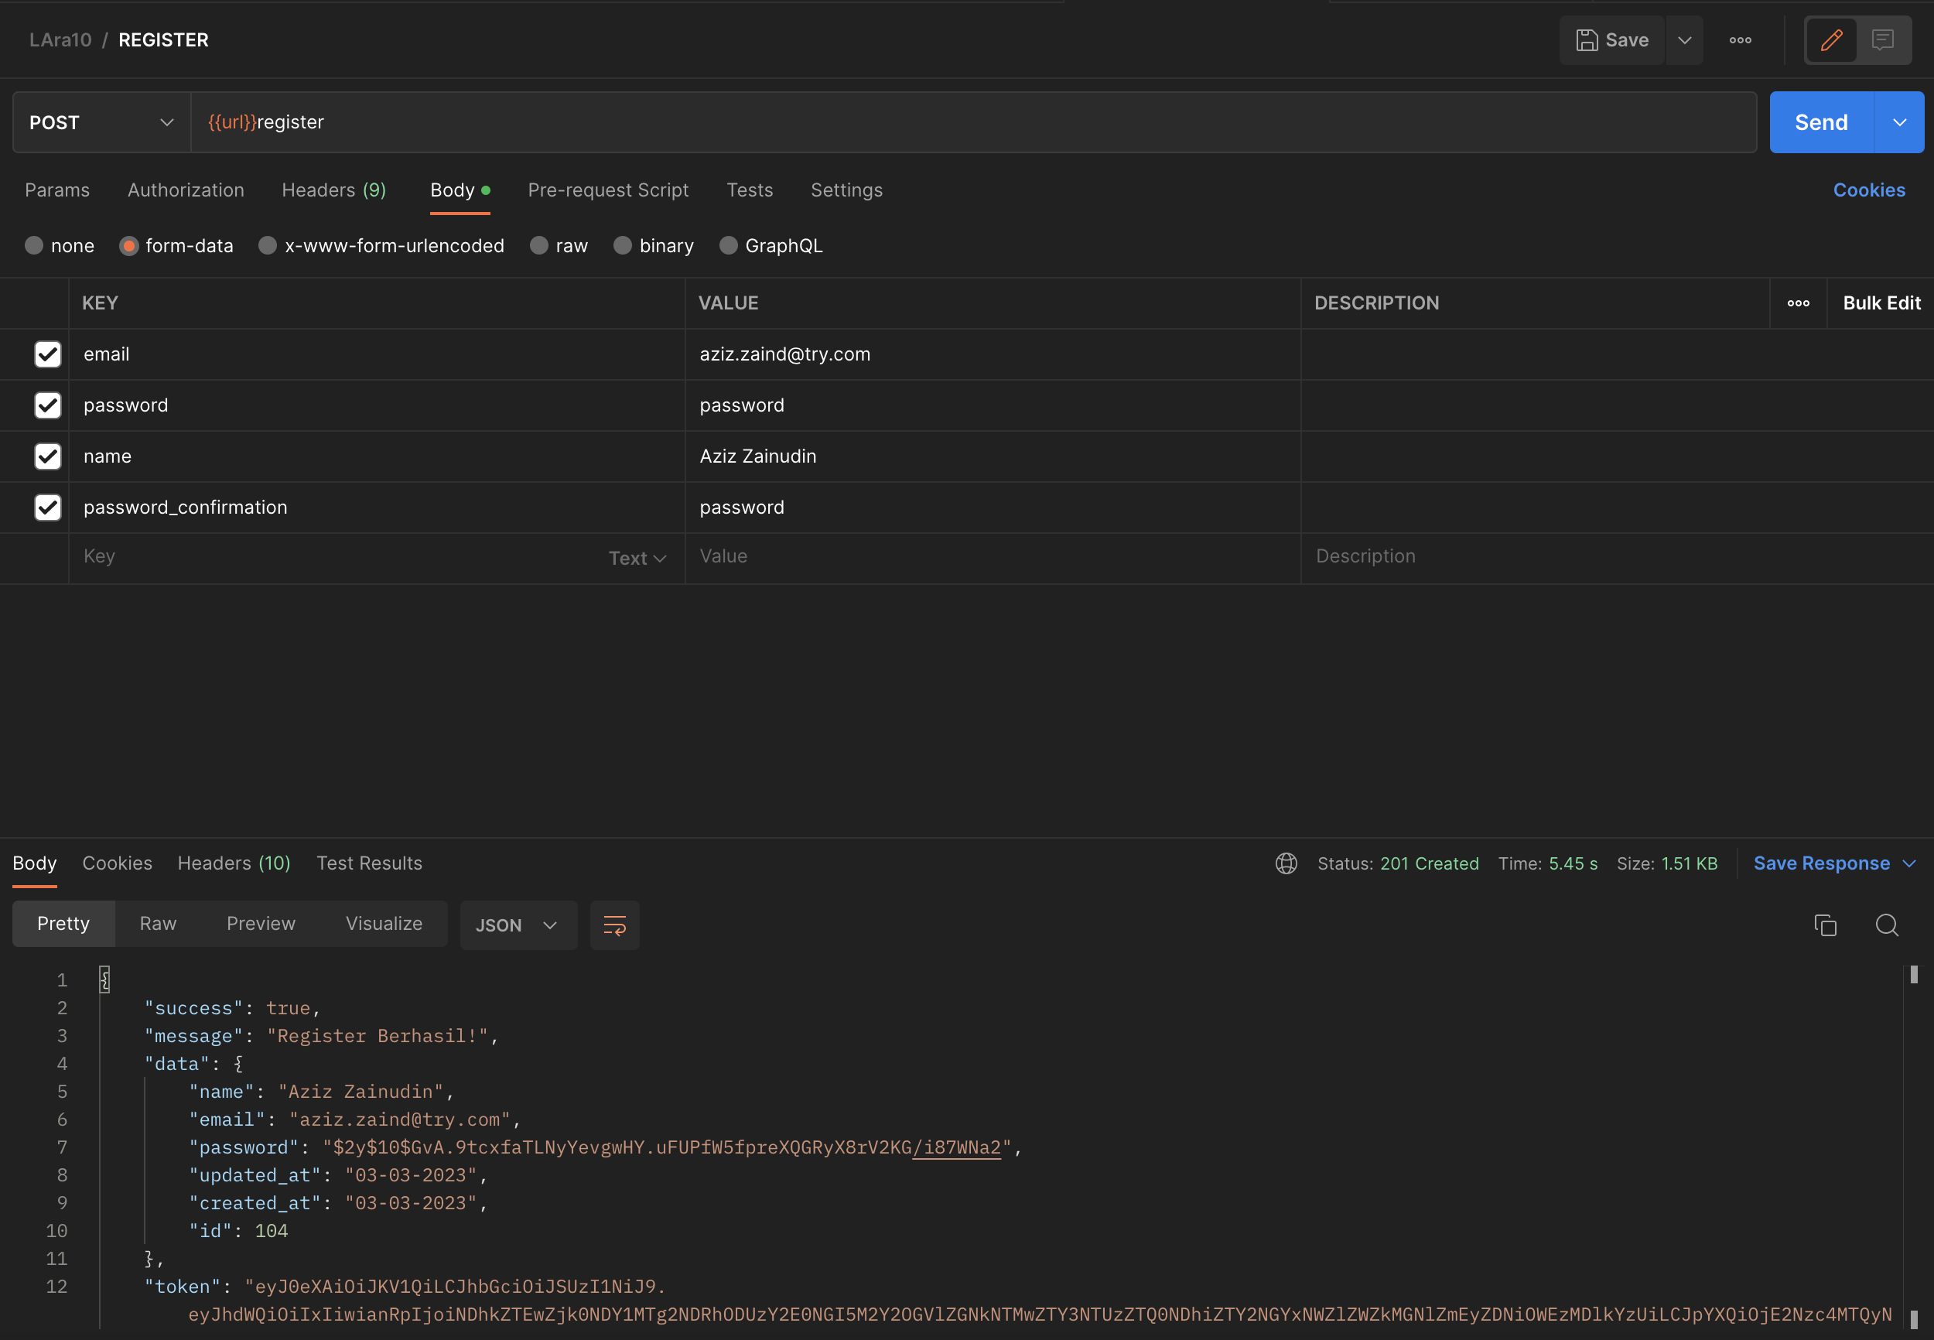

|  |  |
| --- | --- |
| KEY | REQUIRED |
| Email | Yes |
| Name | Yes |
| Password | Yes |
| Password_confirmation | Yes |

Result nya akan mengirimkan email seperti ini.

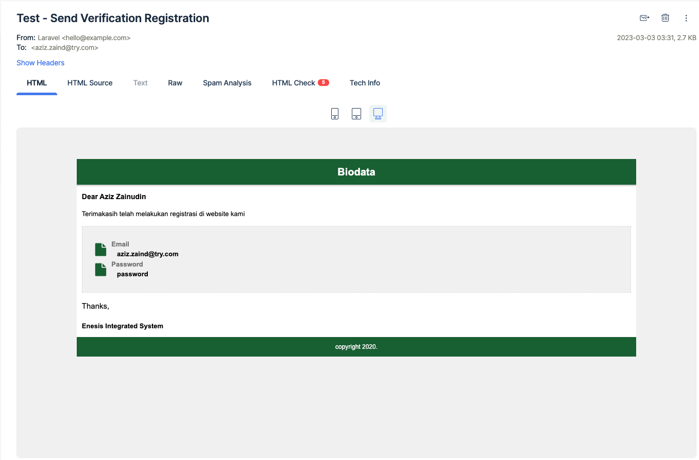

1. LOGIN

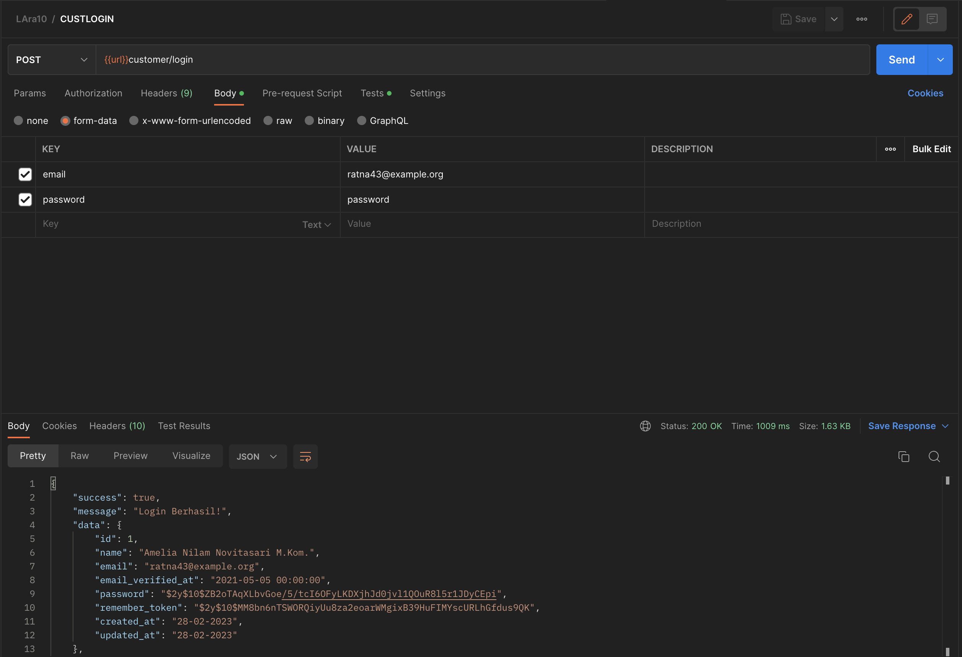

|  |  |
| --- | --- |
| KEY | REQUIRED |
| Email | Yes |
| Name | Yes |

1. PRODUCT
   1. List

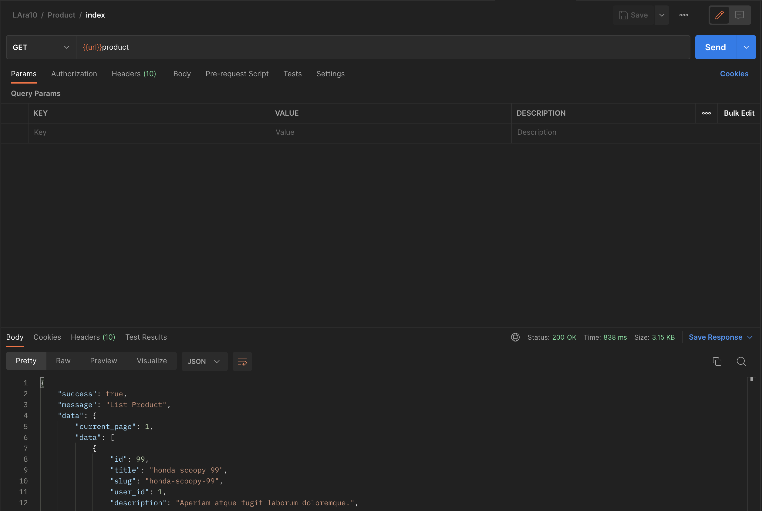

* 1. Detail

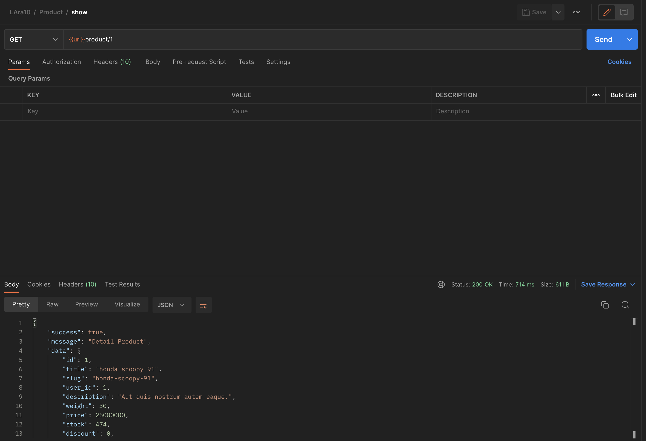

1. CART
   1. List

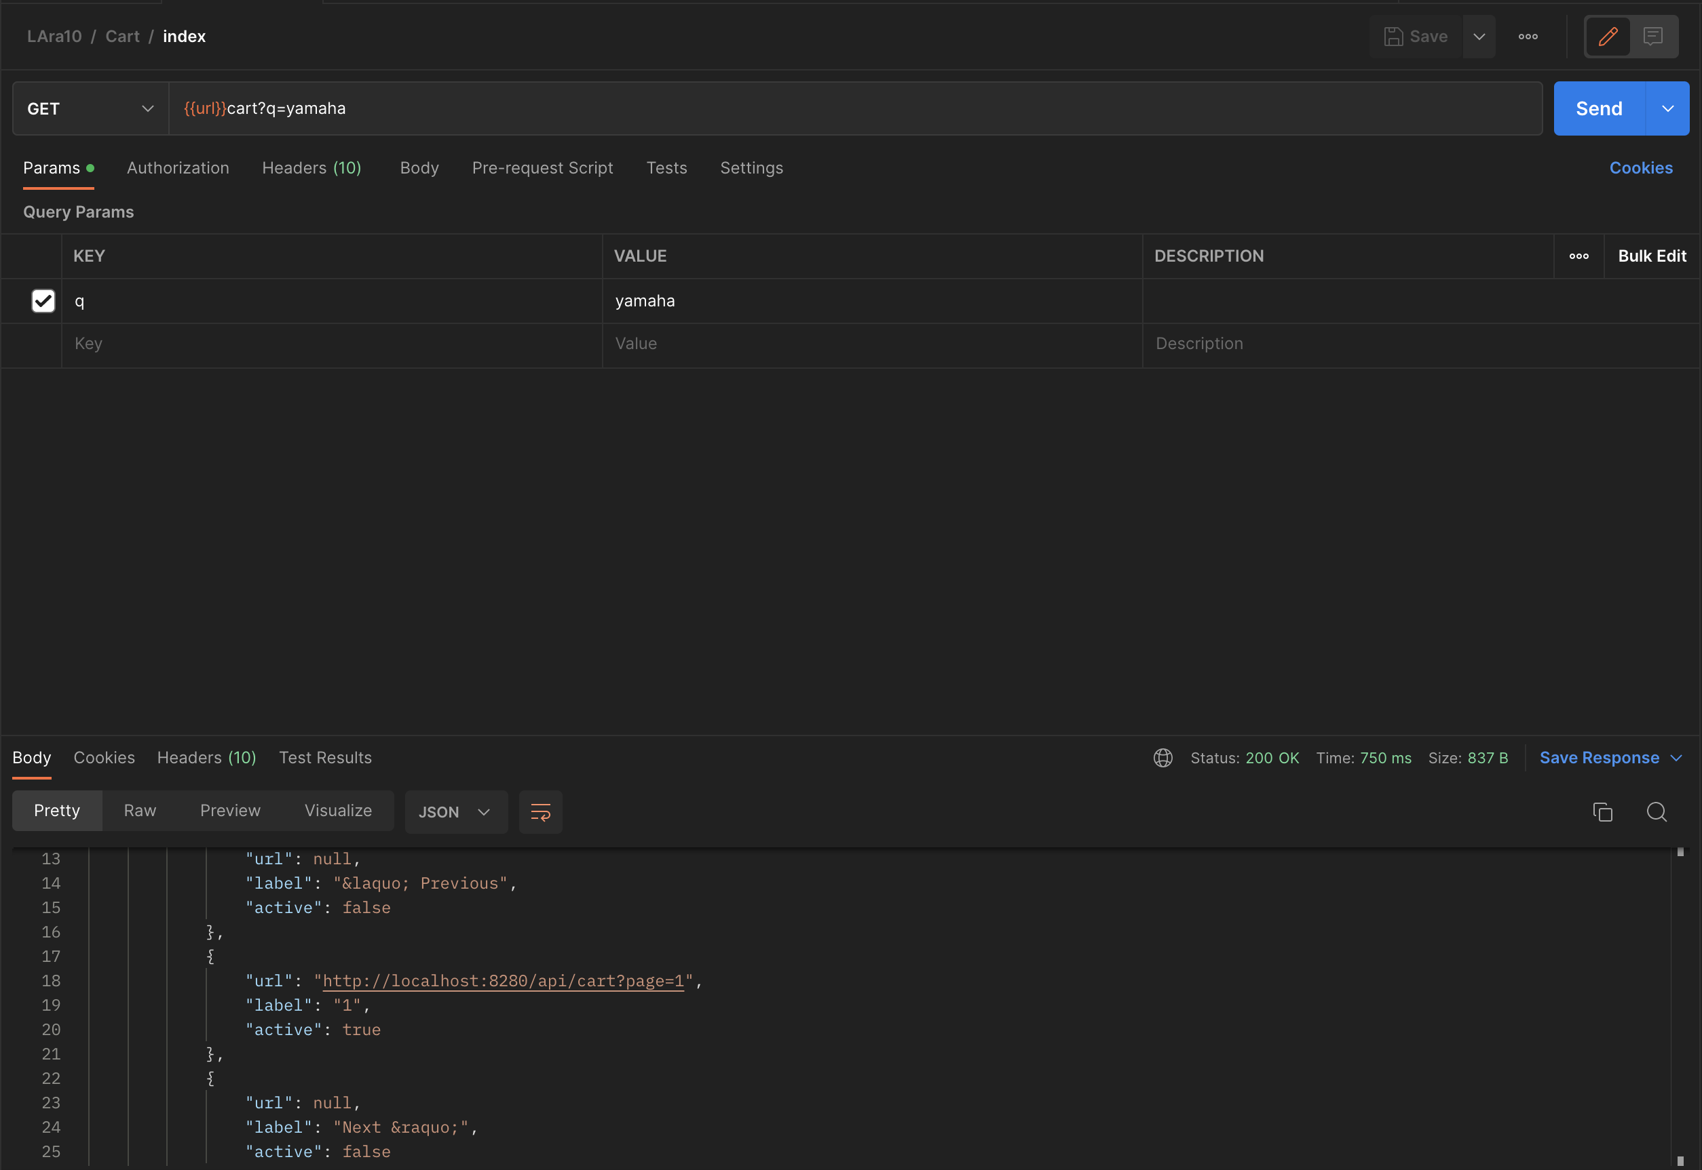

|  |  |  |
| --- | --- | --- |
| KEY | REQUIRED | DESC |
| Q | Optional | Pencarian berdasarkan nama produk |

* 1. Store

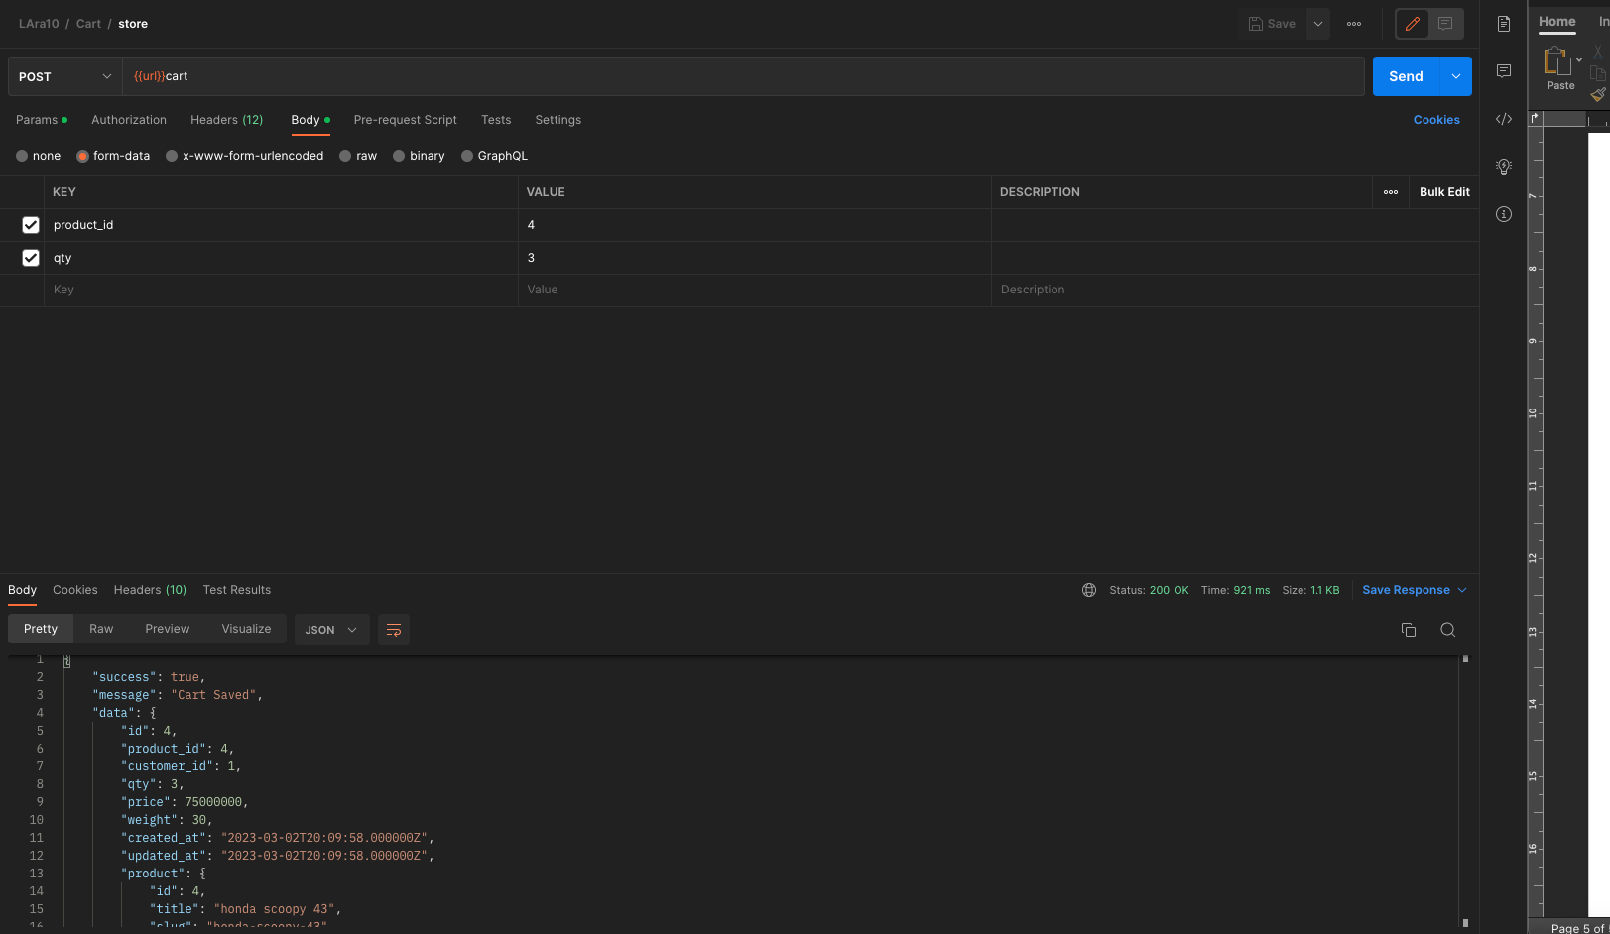

|  |  |  |
| --- | --- | --- |
| KEY | REQUIRED | DESC |
| Product_id | Yes | Produk yang ditambahkan ke keranjang |
| Qty | Yes|numeric | Jumlah kuantiti |

* 1. Update

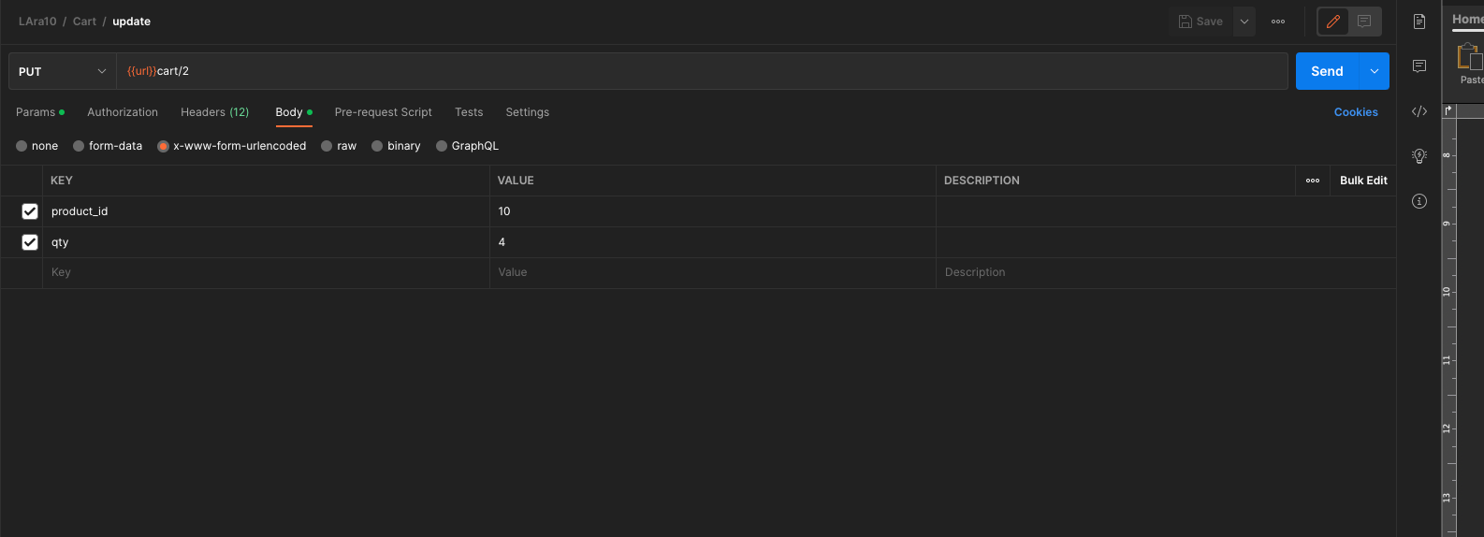

|  |  |  |
| --- | --- | --- |
| KEY | REQUIRED | DESC |
| Product_id | Yes | Produk yang ditambahkan ke keranjang |
| Qty | Yes|numeric | Jumlah kuantiti |

* 1. Delete

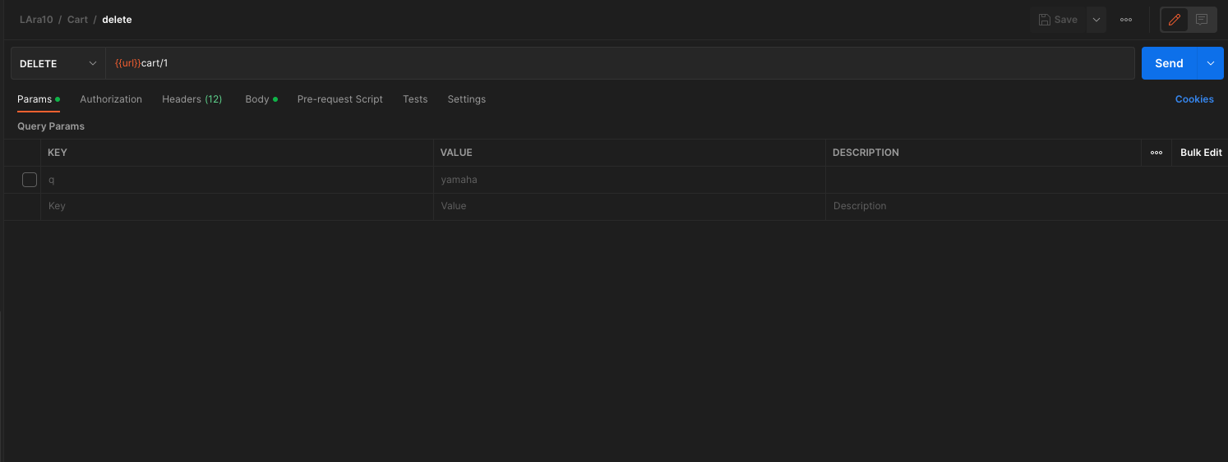

1. ORDER
   1. List

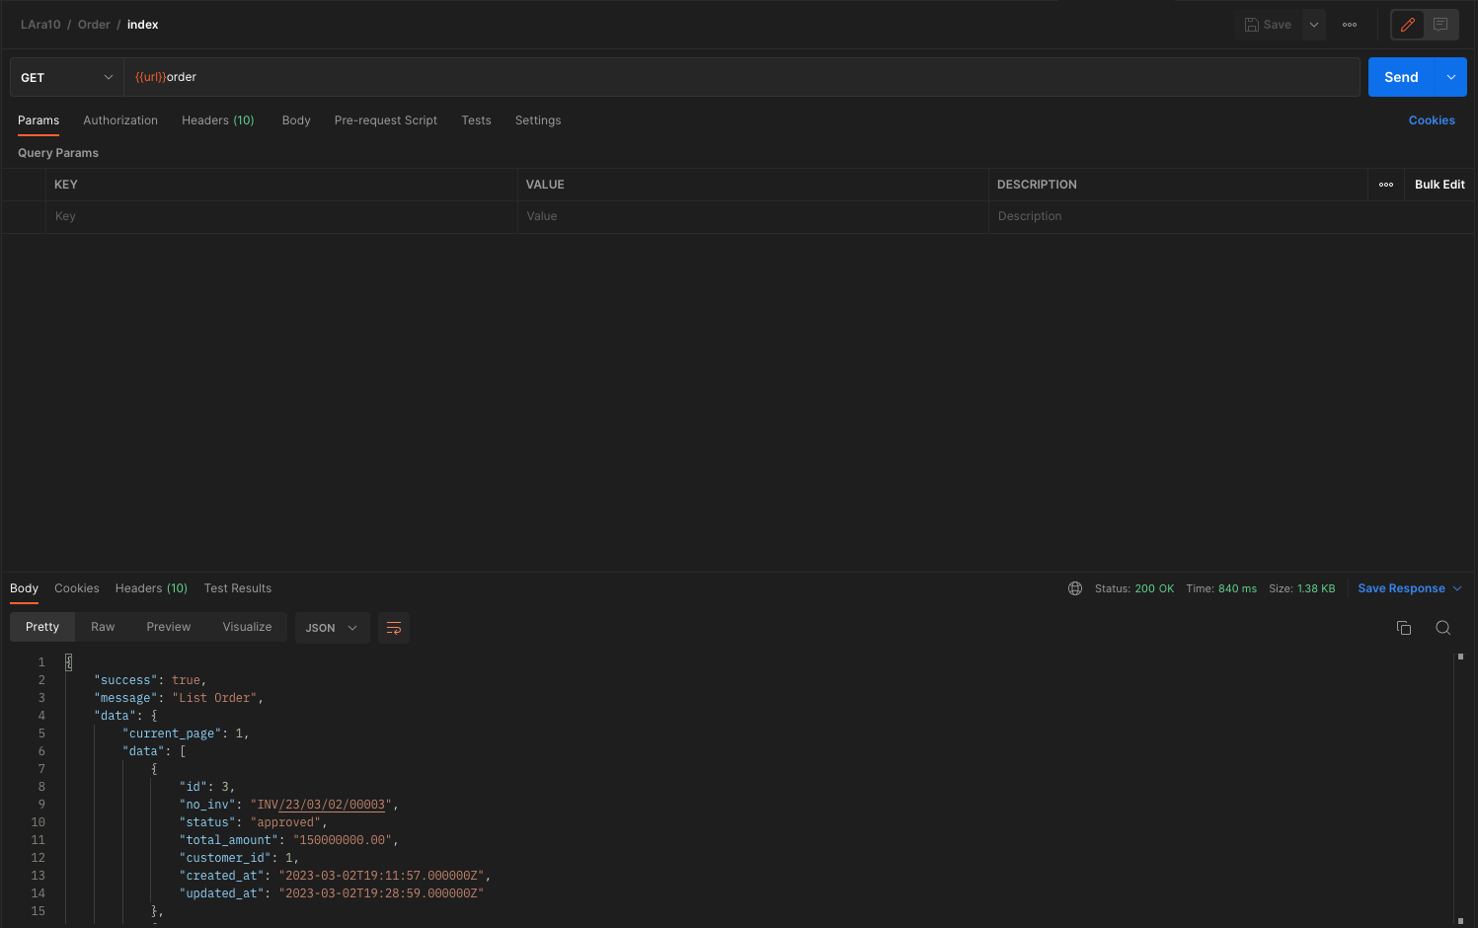

|  |  |  |
| --- | --- | --- |
| KEY | REQUIRED | DESC |
| Q | Optional | Pencarian berdasarkan nama nomor invoice |

* 1. Excel

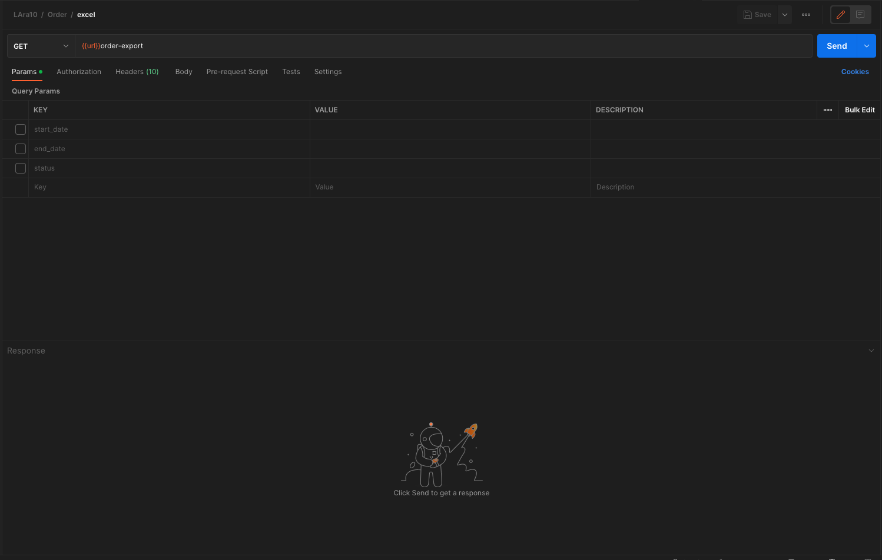

|  |  |  |
| --- | --- | --- |
| KEY | REQUIRED | DESC |
| Start_date | Optional | Range Tanggal mulai |
| End_date | Optional | Range Tanggal Selesai |
| Status | Optional | Ada pilihan status: process, approved, cancel |

* 1. Store by product

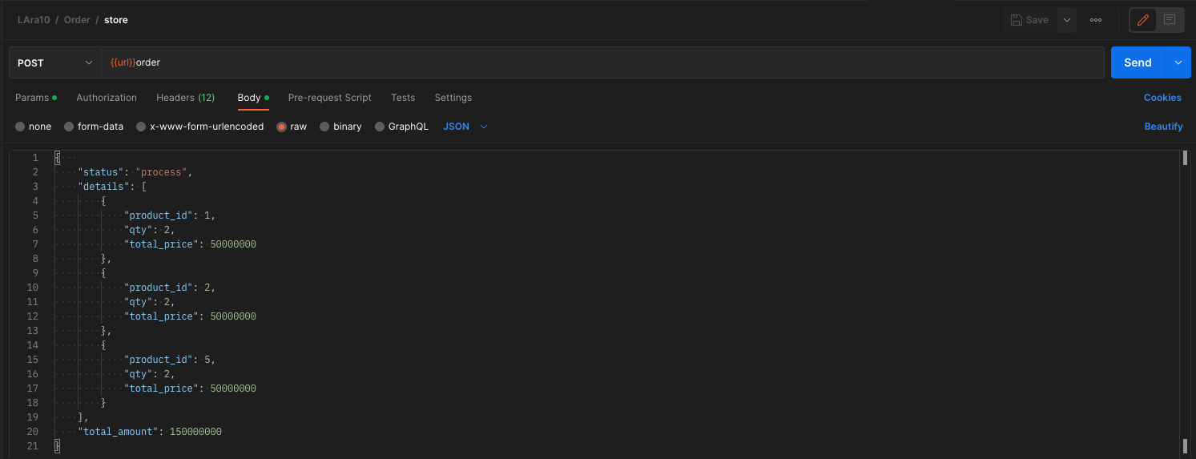

|  |  |  |
| --- | --- | --- |
| KEY | REQUIRED | DESC |
| Status | Optional | Ada pilihan status: process, approved, cancel  Jika kosong maka default process |
| Details | Required|array |  |
| Product_id | Required |  |
| Qty | Required |  |
| Total_price | Required | Penjumlahan harga dari table product di kali dengan kuantiti |
| Total amount | Required | Penjumlahan total price |

Submit pada order akan mengirimkan notif email

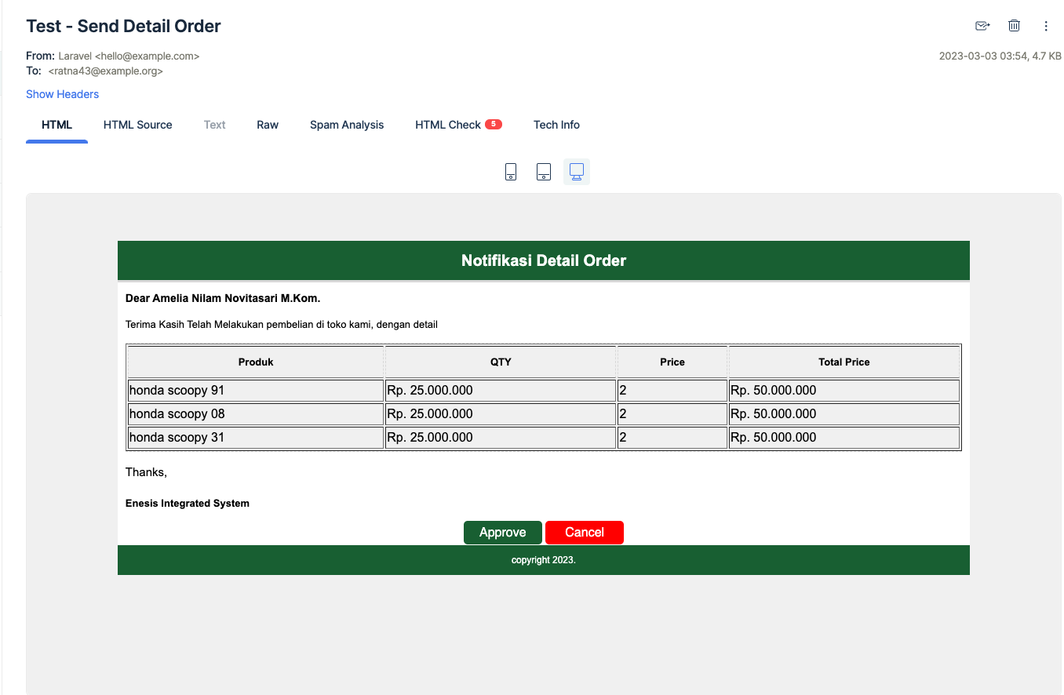

Tombol ini bisa di gunakan untuk approval dan cancel order. Tampilan Ketika sudah di klik

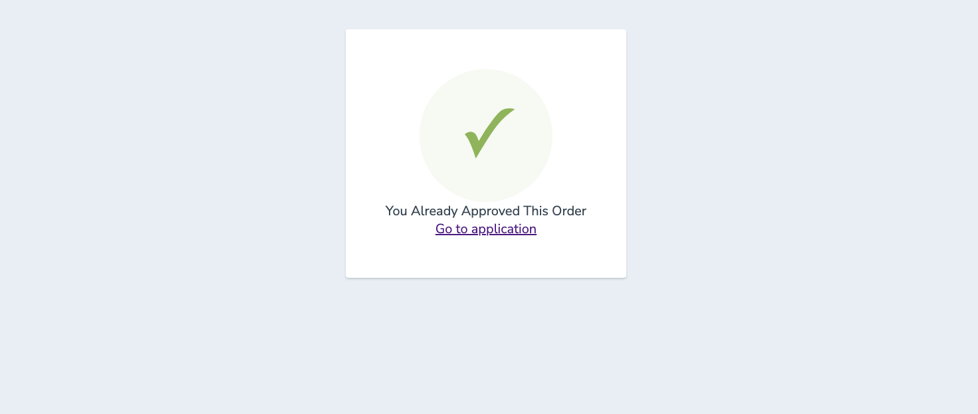

* 1. Update

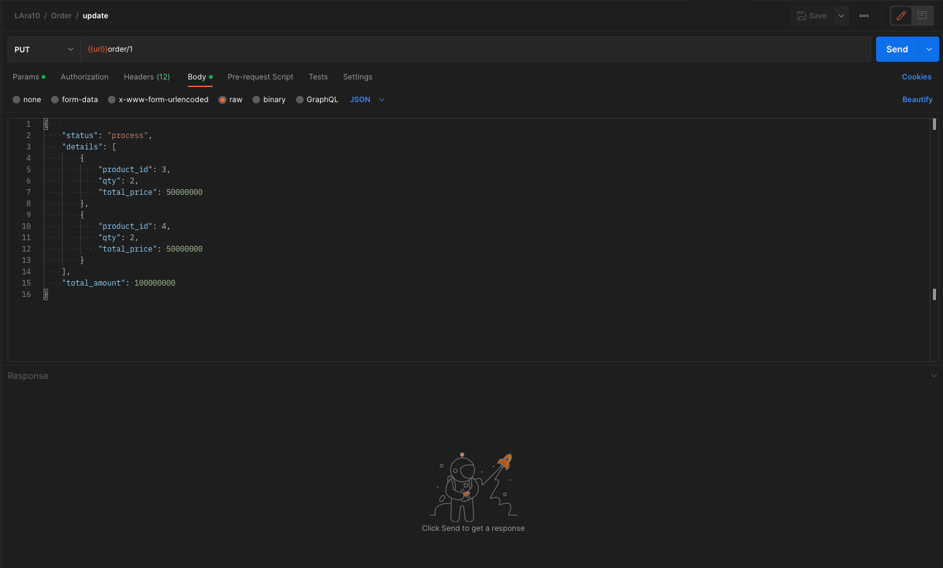

|  |  |  |
| --- | --- | --- |
| KEY | REQUIRED | DESC |
| Status | Optional | Ada pilihan status: process, approved, cancel  Jika kosong maka default process |
| Details | Required|array |  |
| Product_id | Required |  |
| Qty | Required |  |
| Total_price | Required | Penjumlahan harga dari table product di kali dengan kuantiti |
| Total amount | Required | Penjumlahan total price |

* 1. Delete

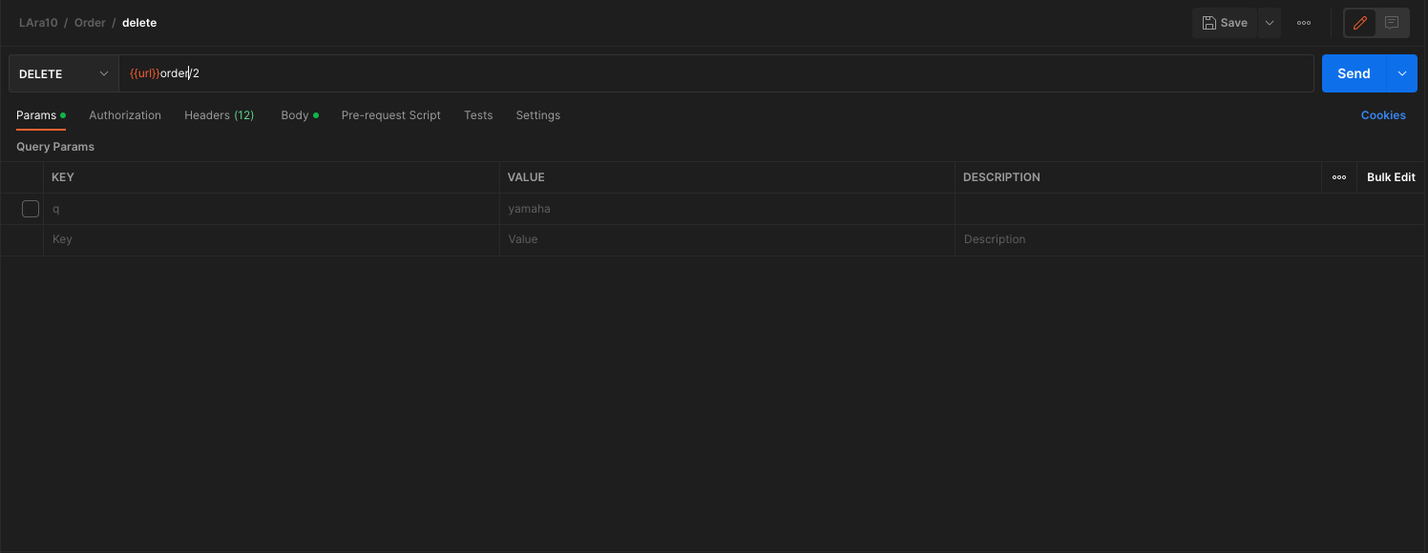

1. SOAL BAGIAN 2

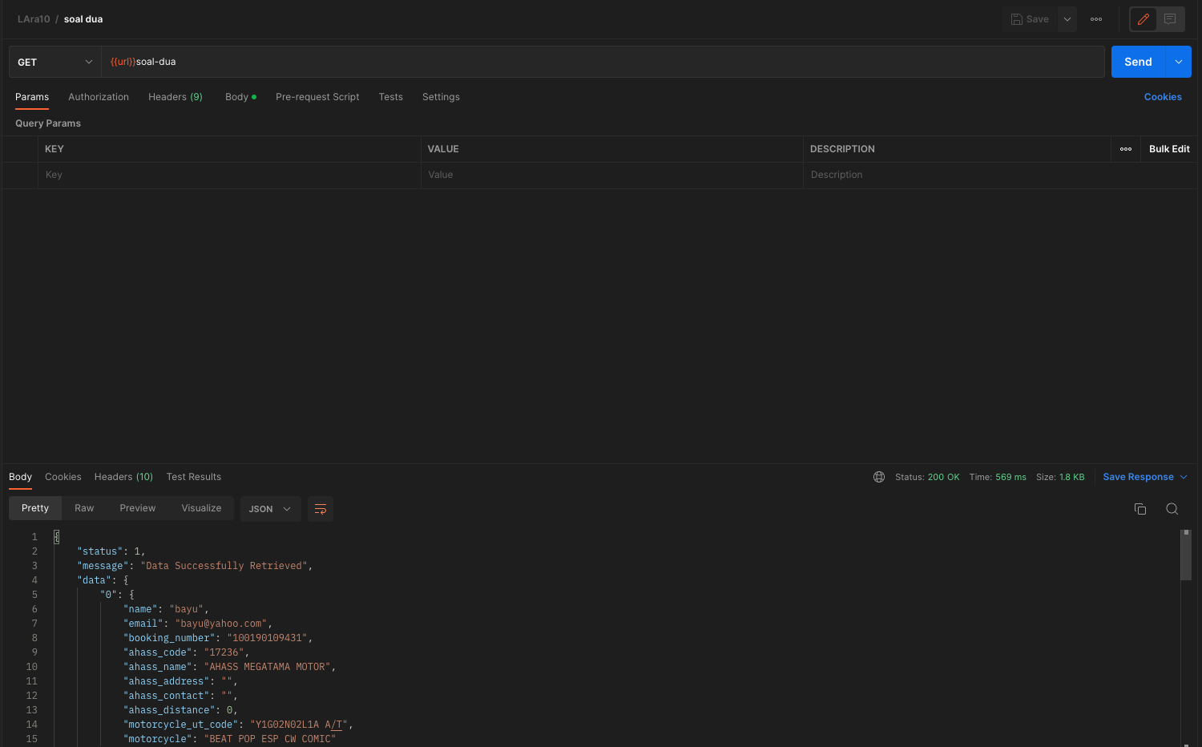

Result json :

