



# A MINI PROJECT REPORT ON HOME WIRELESS SYSTEM

Submitted in fulfilment of the requirement of

Computer Communication Lab By

RA2011003011177 SIDDHARTH PATEL RA2011003011175 AYUSH DOGRA RA2011003011176 YASH VEER SINGH RA2011003011178 ZAYD HASSAN RA2011003011150 SM FAHAD JAAN

Under the Guidance of

M. Rajalakshmi

Department of Computing Technologies

SRM Institute of Science and Technology, Kattankulathur





# **CERTIFICATE**

This is to certify that Computer Communication Lab Mini Project entitled “HOME WIRELESS SYSTEM” Submitted by “SIDDHARTH PATEL”( RA2011003011177), “AYUSH DOGRA ” (RA2011003011175), “YASH VEER SINGH” (RA2011003011176), “ZAYD HASSAN”(RA2011003011178), “SM FAHAD JAAN” (RA2011003011150) for the partial fulfilment of the requirement for Semester IV Subject of Computer Communication Lab to the SRM Institute of Science and Technology, is a bonafide work carried out during Semester IV in Academic Year 2021-2022.





# **Declaration**

We declare that this written submission represents our ideas in our own words and where others’ ideas or words have been included, we have adequately cited and referenced the original sources. We also declare that I have adhered to all principles of academic honesty and integrity and have not misrepresented or fabricated or falsified any idea/data/fact/source in my submission. We understand that any violation of the above will be cause for disciplinary action by the Institute and can also evoke penal action from the sources which have thus not been properly cited or from whom proper permission has not been taken when needed.





# **Table of content**

|  |  |  |
| --- | --- | --- |
| Sr. no | Chapter | Page No. |
| 1 | Abstract | 1 |
| 2 | Introduction | 2 |
| 3 | Addressing Table | 3 |
| 4 | Network Topology Diagram | 4 |
| 5 | Output Screenshot | 5 |
| 6 | Conclusion | 6 |





**Abstract**

A wireless network proposal has to be developed for a house. The house four rooms, with one kitchen. The house has a server, which is used by its house members across the house for wireless facilities. All the members have high speed internet connection. There are approximately 10 users in house.

The main objective of this project is to develop a home automation system using an Arduino board with Bluetooth being remotely controlled by any Android OS smart phone. As technology is advancing so houses are also getting smarter. Modern houses are gradually shifting from conventional switches to centralized control system, involving remote controlled switches. Presently, conventional wall switches located indifferent parts of the house make it difficult for the user to go near them to operate. Even more it becomes more difficult for the elderly or physically handicapped people to so. Remote controlled home automation system provides a most modern solution with smart phones. In order to achieve this, a Bluetooth module is interfaced to the Arduino board at the receiver end while on the transmitted end, A GUI application on the cell phone sends ON/OFF commands to the receiver where loads are connected. By touching the specified location on the GUI, the loads can be turned ON/OFF remotely through this technology.

In this project we have used Cisco Packet Tracer. After implementation of all pcs and servers, the system is tested in different stages and it was successful for its purpose.





# **Introduction**

Home automation is the process of [controlling home appliances automatically](https://www.elprocus.com/home-automation-projects-engineering-students/) using various control system techniques. The electrical and electronic appliances in the home such as fan, lights, outdoor lights, [fire alarm](https://www.elprocus.com/fire-alarm-circuit-using-thermistor/), kitchen timer, etc., can be controlled using various control techniques.

There are various techniques to control home appliances such as [IOT based home](https://www.elprocus.com/wireless-home-automation-using-internet-of-things/) [automation over the cloud](https://www.elprocus.com/wireless-home-automation-using-internet-of-things/), home automation under Wi-Fi through android apps from any smartphone, Arduino based home automation, home automation by android application based remote control, home automation using digital control, RF based home automation system and touch screen based home automation

This system is super-cost effective and can give the user, the ability to control any electronic device without even spending for a remote control. This project helps the user to control all the electronic devices using his/her smartphone. Time is a very valuable thing. Everybody wants to save time as much as they can. New technologies are being introduced to save our time. To save people’s time we are introducing Home Automation system using Bluetooth. With the help of this system, you can control your home appliances from your mobile phone. You can turn on/off your home appliances within the range of Bluetooth.

.





# **Addressing Table**

|  |  |
| --- | --- |
| APPLIANCES | IP ADDRESS |
| Router 0 | LAN Users – GE/0/0-192.168.2.1, GE/0/1- 192.168.1.1 |
| Wireless router 0(WRT300N) | LAN Users – 192.168.1.2 SUBNET MASK-255.255.255.0 |
| Laptop-PT(LAPTOP1) | Default Gateway – 192.168.1.2 IPV4 Address-192.168.1.103  Subnet Mask-255.255.255.0 |
| Laptop-PT(LAPTOP0) | Default Gateway – 192.168.1.2 IPV4 Address-192.168.102  Subnet Mask-255.255.255.0 |
| Smartphone-PT(Smartphone0) | Default Gateway – 192.168.1.2 IPV4 Address-192.168.1.101  Subnet Mask-255.255.255.0 |
| PC-PT(PC0) | IPV4 Address-192.168.1.2  Subnet Mask-255.255.255.0 Default Gateway-192.168.2.1 |

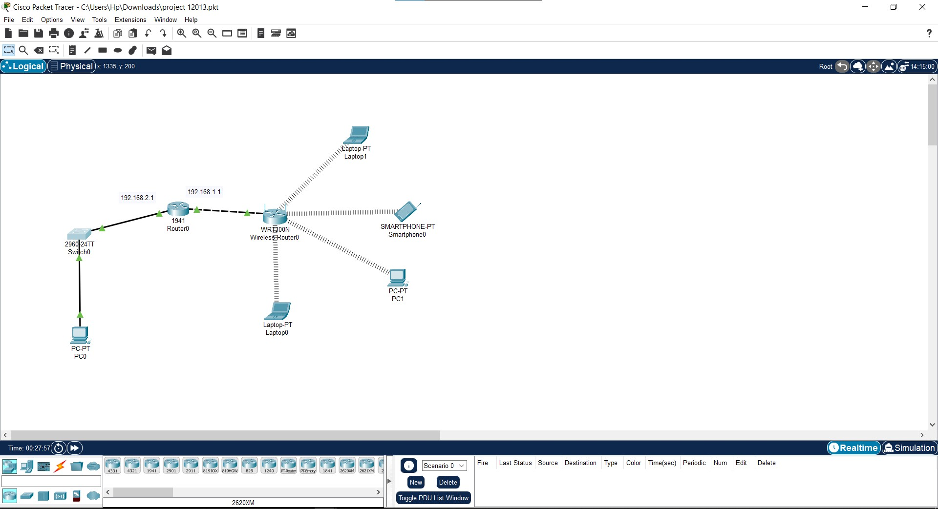



**Network Topology Diagram**



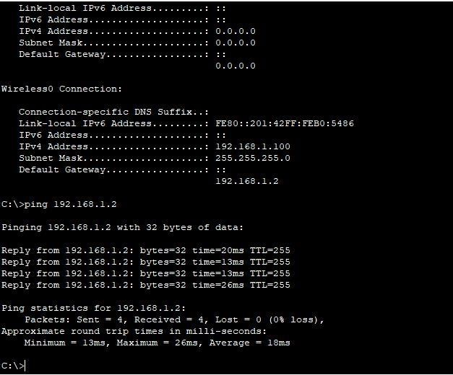

**OUTPUT SCREENSHOT**





**Conclusion**

Most homeowners in developing countries lack complete and total control over their homes. They are not able to access vital home automation features such as control and monitoring of home appliances, low-cost security, and efficient energy usage by implication.

The OpenHAB 2 protocol is relevant to automating the home while interconnecting appliances based on its flexibility and capability for full customization, to achieve the goals of

(1) providing a secure control mechanism for home appliances via a mobile or web application; (2)

improving the security of connected home appliances through the system’s inbuilt intrusion detection, alarm, and wireless communication data encryption standards; (3) meeting the essential energy management requirement of the household by providing a means to monitor and remotely turn off unnecessary active appliances to conserve energy and reduce electricity bills; (4) offering a wirelessly controlled switch for all home appliances; and (5) making a significant contribution to the existing body of knowledge on secured home automation.