󠄀

**Performance modeling view**

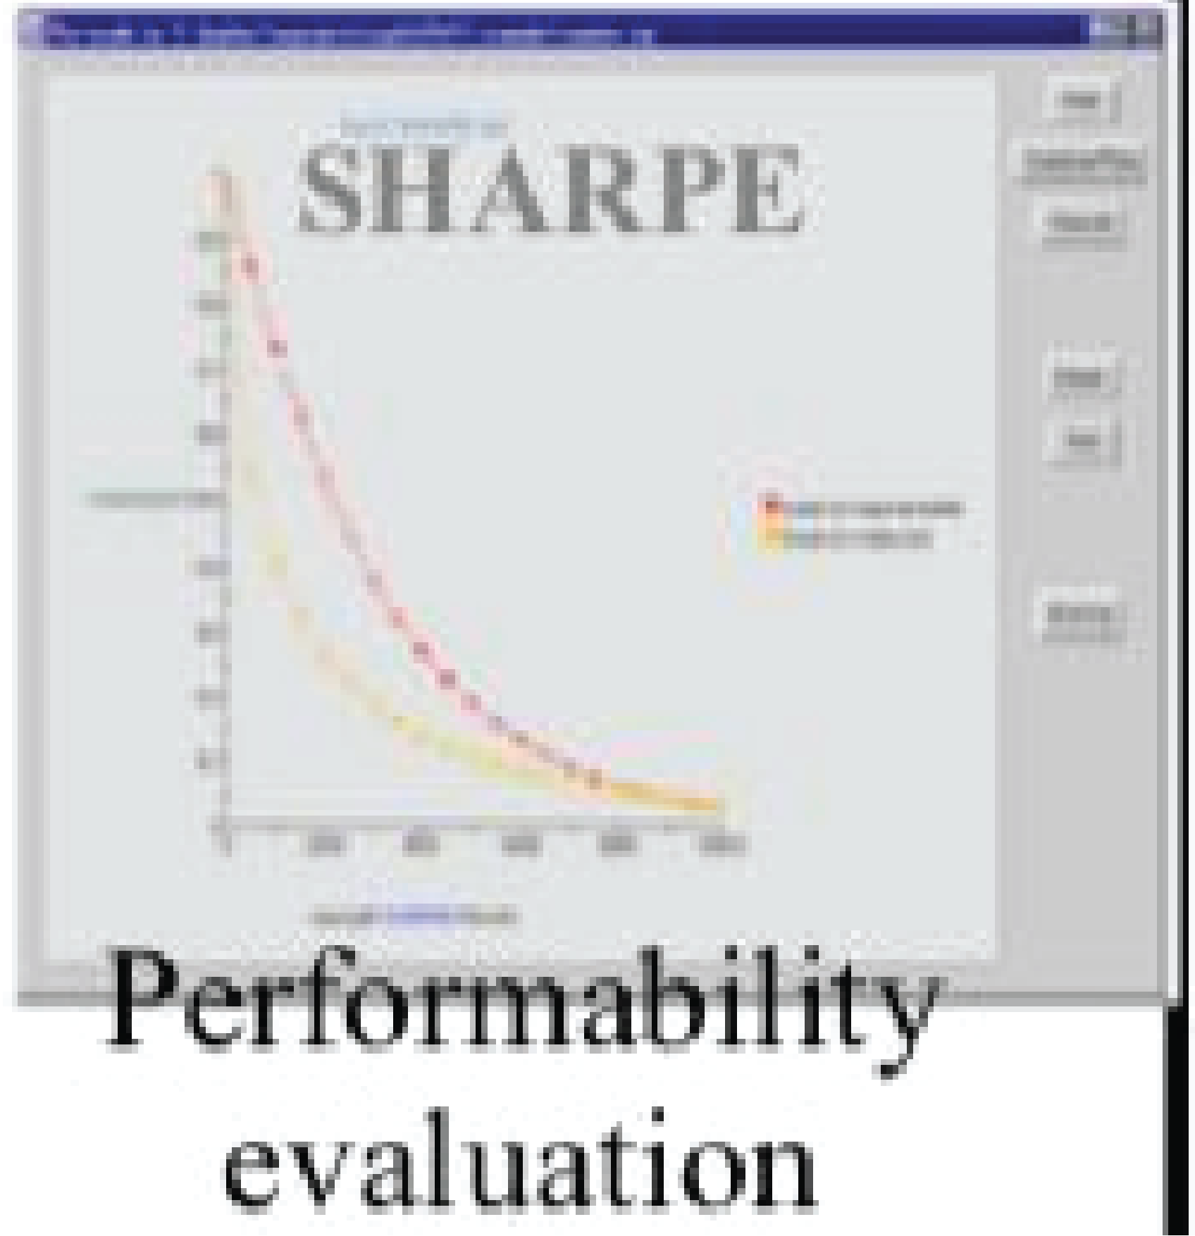

Performability SRN model

Model synchronization using Guard functions

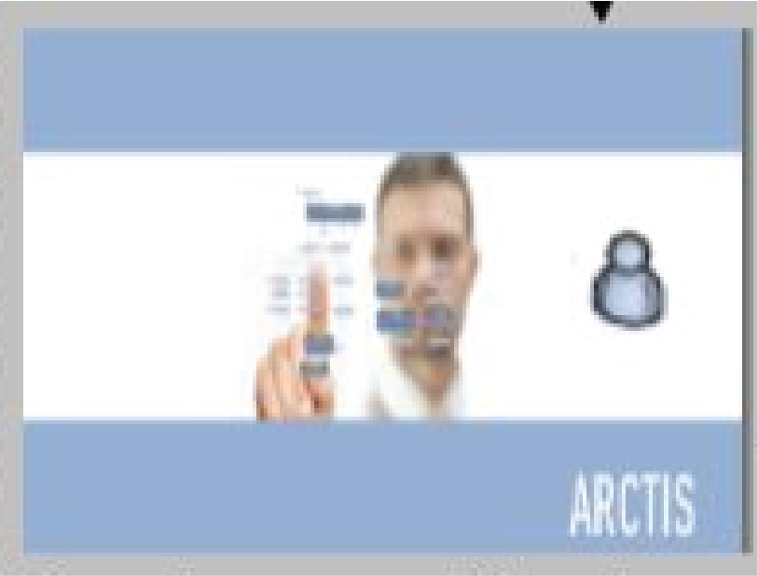

Model Validator

**Model transformation phase**

Dependability SRN model

Performance SRN model

UML

Collaboration & activity diagram

Model Validator

Phase for State machine generation

**Model Annotation Phase**

**Dependability Modeling view**

+

**Deployment Phase**