

**American International University- Bangladesh**

**CSC 3215: Web Technologies**

**CO2 and CO4 Evaluation**

**Finished Project Report**

**Spring/Summer/Fall 2020-2021**

**Project Title: Ecommerce Website (Food)**

**Section: H**

|  |  |
| --- | --- |
| Student Name | Student Id |
| MD Rifat Al JAYED UTSHO | 18-369790-1 |
| Sneha,Prantika Biswas | 18-37385-1 |
|  |

**Project Description:**

**Ecommerce Website (Food)**

**Registration & Validation:** In this site, 2 types of users can use it – General user & Admin. For general user, he or she just need to order their food. But for admin he or she needs to create account After signing up, user can log in to use the site. While providing log in information, data will be checked whether the user info is right or wrong then they can easily log into admin panel

**General User’s Functionalities**: This site offers a general user to Buy their foods. He/she can check which foods are available currently in this site. If user’s expected movie is absent, user can request the movie. Whenever they order something, it will automatically go to admin panel order section. While ordering He/she can also edit his/her profile information (mail, Address, and phone number).

**Admin’s Functionalities:** Admins will handle everything. He/she can add a new food, edit the Foods’s information and also can delete any specific foods. He/she will receive the foods requests that are being requested by the general users.

**Project Folder Structure:**

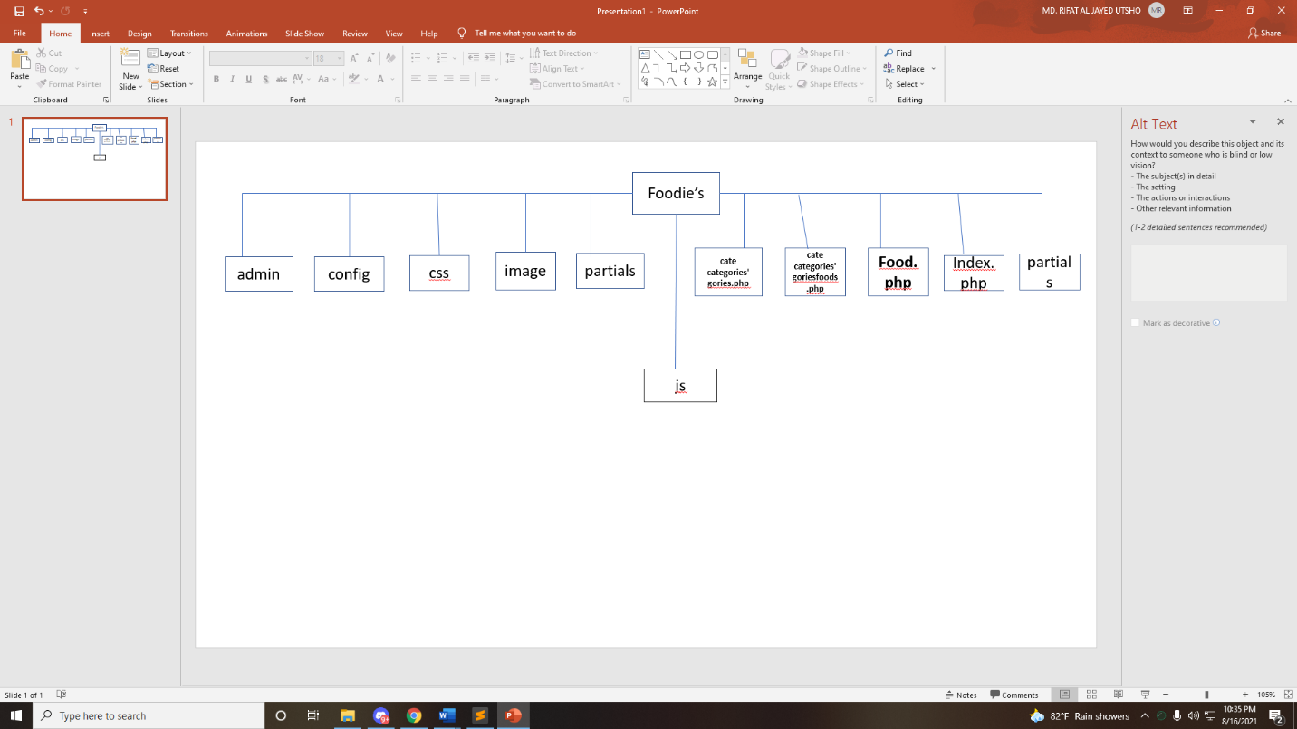

**Screenshot:**

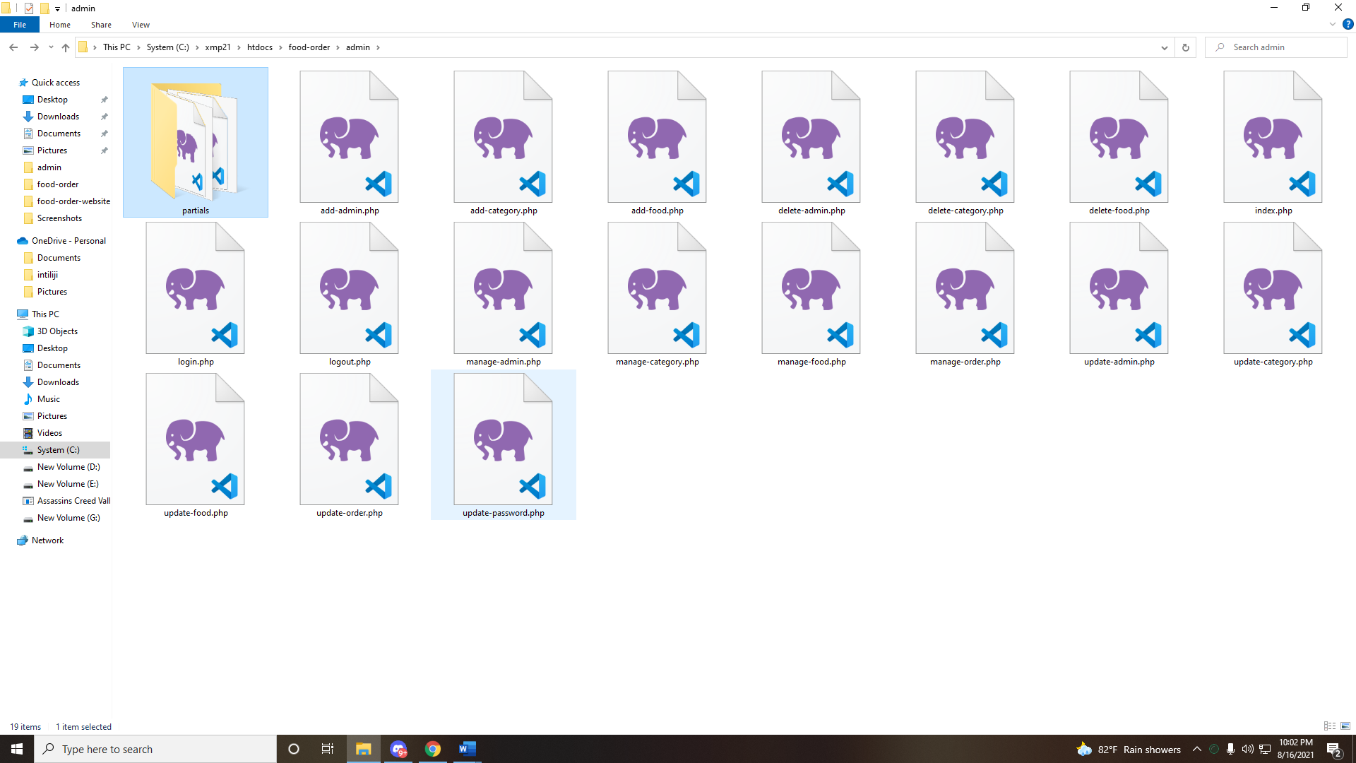

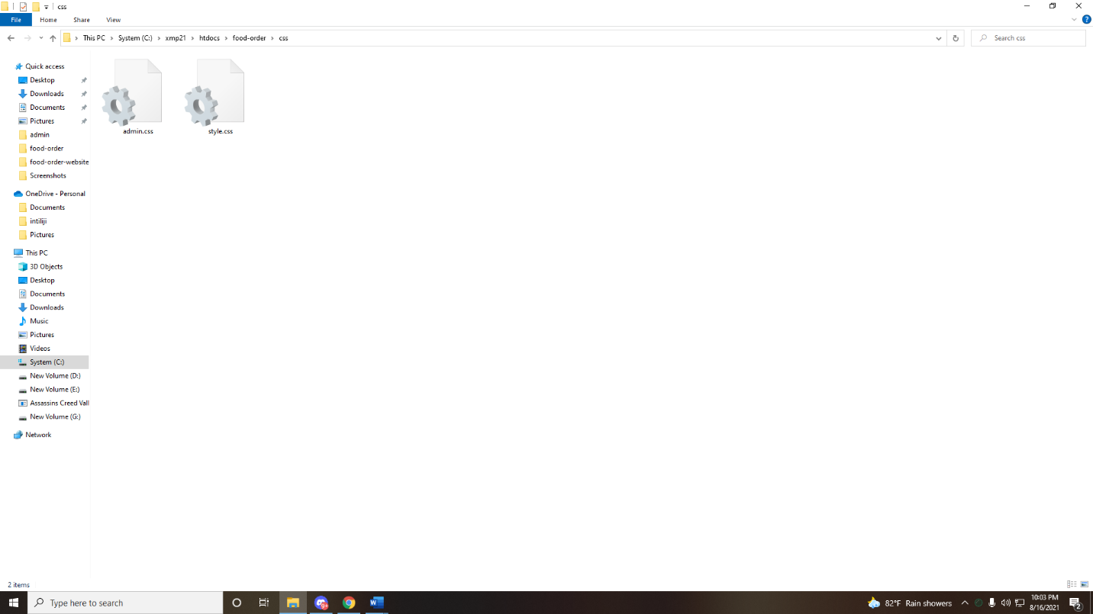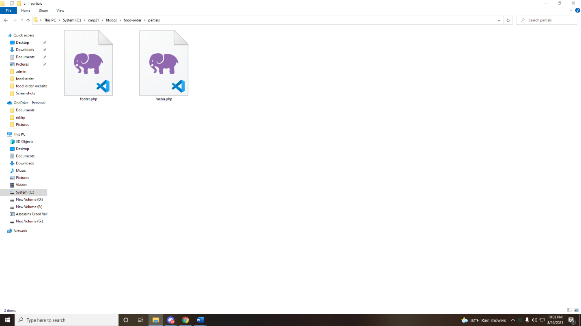

Index.php:

<?php include('partials/menu.php'); ?>

<!-- Main Content Section Starts -->

<div class="main-content">

<div class="wrapper">

<h1>Dashboard</h1>

<br><br>

<?php

if(isset($_SESSION['login']))

{

echo $_SESSION['login'];

unset($_SESSION['login']);

}

?>

<br><br>

<div class="col-4 text-center">

<?php

//Sql Query

$sql = "SELECT * FROM tbl_category";

//Execute Query

$res = mysqli_query($conn, $sql);

//Count Rows

$count = mysqli_num_rows($res);

?>

<h1><?php echo $count; ?></h1>

<br />

Categories

</div>

<div class="col-4 text-center">

<?php

//Sql Query

$sql2 = "SELECT * FROM tbl_food";

//Execute Query

$res2 = mysqli_query($conn, $sql2);

//Count Rows

$count2 = mysqli_num_rows($res2);

?>

<h1><?php echo $count2; ?></h1>

<br />

Foods

</div>

<div class="col-4 text-center">

<?php

//Sql Query

$sql3 = "SELECT * FROM tbl_order";

//Execute Query

$res3 = mysqli_query($conn, $sql3);

//Count Rows

$count3 = mysqli_num_rows($res3);

?>

<h1><?php echo $count3; ?></h1>

<br />

Total Orders

</div>

<div class="col-4 text-center">

<?php

//Creat SQL Query to Get Total Revenue Generated

//Aggregate Function in SQL

$sql4 = "SELECT SUM(total) AS Total FROM tbl_order WHERE status='Delivered'";

//Execute the Query

$res4 = mysqli_query($conn, $sql4);

//Get the VAlue

$row4 = mysqli_fetch_assoc($res4);

//GEt the Total REvenue

$total_revenue = $row4['Total'];

?>

<h1>$<?php echo $total_revenue; ?></h1>

<br />

Revenue Generated

</div>

<div class="clearfix"></div>

</div>

</div>

<!-- Main Content Setion Ends -->

**Categories.php:**

<?php include('partials/menu.php'); ?>

<!-- CAtegories Section Starts Here -->

<section class="categories">

<div class="container">

<h2 class="text-center">Explore Foods</h2>

<?php

//Display all the cateories that are active

//Sql Query

$sql = "SELECT * FROM tbl_category WHERE active='Yes'";

//Execute the Query

$res = mysqli_query($conn, $sql);

//Count Rows

$count = mysqli_num_rows($res);

//CHeck whether categories available or not

if($count>0)

{

//CAtegories Available

while($row=mysqli_fetch_assoc($res))

{

//Get the Values

$id = $row['id'];

$title = $row['title'];

$image_name = $row['image_name'];

?>

<a href="<?php echo SITEURL; ?>category-foods.php?category_id=<?php echo $id; ?>">

<div class="box-3 float-container">

<?php

if($image_name=="")

{

//Image not Available

echo "<div class='error'>Image not found.</div>";

}

else

{

//Image Available

?>

<img src="<?php echo SITEURL; ?>images/category/<?php echo $image_name; ?>" alt="Pizza" class="img-responsive img-curve">

<?php

}

?>

<h3 class="float-text text-white"><?php echo $title; ?></h3>

</div>

</a>

<?php

}

}

else

{

//CAtegories Not Available

echo "<div class='error'>Category not found.</div>";

}

?>

<div class="clearfix"></div>

</div>

</section>

<!-- Categories Section Ends Here -->

<?php include('partials/footer.php'); ?>

Categories-food.php:

<?php include('partials/menu.php'); ?>

<?php

//CHeck whether id is passed or not

if(isset($_GET['category_id']))

{

//Category id is set and get the id

$category_id = $_GET['category_id'];

// Get the CAtegory Title Based on Category ID

$sql = "SELECT title FROM tbl_category WHERE id=$category_id";

//Execute the Query

$res = mysqli_query($conn, $sql);

//Get the value from Database

$row = mysqli_fetch_assoc($res);

//Get the TItle

$category_title = $row['title'];

}

else

{

//CAtegory not passed

//Redirect to Home page

header('location:'.SITEURL);

}

?>

<!-- fOOD sEARCH Section Starts Here -->

<section class="food-search text-center">

<div class="container">

<h2>Foods on <a href="#" class="text-white">"<?php echo $category_title; ?>"</a></h2>

</div>

</section>

<!-- fOOD sEARCH Section Ends Here -->

<!-- fOOD MEnu Section Starts Here -->

<section class="food-menu">

<div class="container">

<h2 class="text-center">Food Menu</h2>

<?php

//Create SQL Query to Get foods based on Selected CAtegory

$sql2 = "SELECT * FROM tbl_food WHERE category_id=$category_id";

//Execute the Query

$res2 = mysqli_query($conn, $sql2);

//Count the Rows

$count2 = mysqli_num_rows($res2);

//CHeck whether food is available or not

if($count2>0)

{

//Food is Available

while($row2=mysqli_fetch_assoc($res2))

{

$id = $row2['id'];

$title = $row2['title'];

$price = $row2['price'];

$description = $row2['description'];

$image_name = $row2['image_name'];

?>

<div class="food-menu-box">

<div class="food-menu-img">

<?php

if($image_name=="")

{

//Image not Available

echo "<div class='error'>Image not Available.</div>";

}

else

{

//Image Available

?>

<img src="<?php echo SITEURL; ?>images/food/<?php echo $image_name; ?>" alt="Chicke Hawain Pizza" class="img-responsive img-curve">

<?php

}

?>

</div>

<div class="food-menu-desc">

<h4><?php echo $title; ?></h4>

<p class="food-price">$<?php echo $price; ?></p>

<p class="food-detail">

<?php echo $description; ?>

</p>

<br>

<a href="<?php echo SITEURL; ?>order.php?food_id=<?php echo $id; ?>" class="btn btn-primary">Order Now</a>

</div>

</div>

<?php

}

}

else

{

//Food not available

echo "<div class='error'>Food not Available.</div>";

}

?>

<div class="clearfix"></div>

</div>

</section>

<!-- fOOD Menu Section Ends Here -->

<?php include('partials/footer.php'); ?>

Order.php:

<?php include('partials/menu.php'); ?>

<?php

//CHeck whether food id is set or not

if(isset($_GET['food_id']))

{

//Get the Food id and details of the selected food

$food_id = $_GET['food_id'];

//Get the DEtails of the SElected Food

$sql = "SELECT * FROM tbl_food WHERE id=$food_id";

//Execute the Query

$res = mysqli_query($conn, $sql);

//Count the rows

$count = mysqli_num_rows($res);

//CHeck whether the data is available or not

if($count==1)

{

//WE Have DAta

//GEt the Data from Database

$row = mysqli_fetch_assoc($res);

$title = $row['title'];

$price = $row['price'];

$image_name = $row['image_name'];

}

else

{

//Food not Availabe

//REdirect to Home Page

header('location:'.SITEURL);

}

}

else

{

//Redirect to homepage

header('location:'.SITEURL);

}

?>

<!-- fOOD sEARCH Section Starts Here -->

<section class="food-search">

<div class="container">

<h2 class="text-center text-white">Fill this form to confirm your order.</h2>

<form action="" method="POST" class="order">

<fieldset>

<legend>Selected Food</legend>

<div class="food-menu-img">

<?php

//CHeck whether the image is available or not

if($image_name=="")

{

//Image not Availabe

echo "<div class='error'>Image not Available.</div>";

}

else

{

//Image is Available

?>

<img src="<?php echo SITEURL; ?>images/food/<?php echo $image_name; ?>" alt="Chicke Hawain Pizza" class="img-responsive img-curve">

<?php

}

?>

</div>

<div class="food-menu-desc">

<h3><?php echo $title; ?></h3>

<input type="hidden" name="food" value="<?php echo $title; ?>">

<p class="food-price">$<?php echo $price; ?></p>

<input type="hidden" name="price" value="<?php echo $price; ?>">

<div class="order-label">Quantity</div>

<input type="number" name="qty" class="input-responsive" value="1" required>

</div>

</fieldset>

<fieldset>

<legend>Delivery Details</legend>

<div class="order-label">Full Name</div>

<input type="text" name="full-name" placeholder="E.g. zayedutsho" class="input-responsive" required>

<div class="order-label">Phone Number</div>

<input type="tel" name="contact" placeholder="E.g. 9843xxxxxx" class="input-responsive" required>

<div class="order-label">Email</div>

<input type="email" name="email" placeholder="E.g. hi@zayedutsho.com" class="input-responsive" required>

<div class="order-label">Address</div>

<textarea name="address" rows="10" placeholder="E.g. Street, City, Country" class="input-responsive" required></textarea>

<input type="submit" name="submit" value="Confirm Order" class="btn btn-primary">

</fieldset>

</form>

<?php

//CHeck whether submit button is clicked or not

if(isset($_POST['submit']))

{

// Get all the details from the form

$food = $_POST['food'];

$price = $_POST['price'];

$qty = $_POST['qty'];

$total = $price * $qty; // total = price x qty

$order_date = date("Y-m-d h:i:sa"); //Order DAte

$status = "Ordered"; // Ordered, On Delivery, Delivered, Cancelled

$customer_name = $_POST['full-name'];

$customer_contact = $_POST['contact'];

$customer_email = $_POST['email'];

$customer_address = $_POST['address'];

//Save the Order in Databaase

//Create SQL to save the data

$sql2 = "INSERT INTO tbl_order SET

food = '$food',

price = $price,

qty = $qty,

total = $total,

order_date = '$order_date',

status = '$status',

customer_name = '$customer_name',

customer_contact = '$customer_contact',

customer_email = '$customer_email',

customer_address = '$customer_address'

";

//echo $sql2; die();

//Execute the Query

$res2 = mysqli_query($conn, $sql2);

//Check whether query executed successfully or not

if($res2==true)

{

//Query Executed and Order Saved

$_SESSION['order'] = "<div class='success text-center'>Food Ordered Successfully.</div>";

header('location:'.SITEURL);

}

else

{

//Failed to Save Order

$_SESSION['order'] = "<div class='error text-center'>Failed to Order Food.</div>";

header('location:'.SITEURL);

}

}

?>

</div>

</section>

<!-- fOOD sEARCH Section Ends Here -->

<?php include('partials/footer.php'); ?>