**Restaurant Automation Application**

Comp 3322 - Software Engineering

Final Project Report

**Submitted by**

Ferhat Alaydin

Zafer Yildiz

Computer Science Department

5/5/2015

**Table of Contents**

1. **Introduction**
2. **Project Organization**

2.1 Software Process Model

* 1. Roles and Responsibilities

**3. Project Management Plan**

3.1 Tasks

3.2 Timetable

* 1. Meetings

**4. Test**

4.1 Features Tested

**5. Additional Material**

5.1 Screenshots

5.2 Final Presentation

5.3 Code

**INTRODUCTION**

In this project, we create a common and useful application: Restaurant Automation Application. Through this project, we aim to create an application that can be used by small to mid-size restaurants.

Through this application, customers can pick their orders via the menu in application. Item number can be increased and the total amount of order is calculated by the application. All the shareholders are aware of what are ordered and what the total amount is.

From Subway to Whataburger, restaurants are seeing the benefits of IT automation on their operational, datacenter and business processes. Technology streamlines restaurant IT processes, as it does for every other industry.

This project’s aim is to help both restaurant owners and customers. This automation program may help to restaurants by means of three key ways:

1-) Provisioning virtual/cloud resources — As more and more retail and restaurants turn to virtual and cloud resources, the need for efficient resource usage is more important than ever. Automation can optimize your IT department's use of cloud and virtual resources, allocating additional resources when more computing power is needed and automatically spinning down resources during idle times. As a result, restaurants can eliminate IT resource waste from idle machines as well as improve IT spending on virtual/cloud resources.

2-) Onboarding and off boarding employees — Let’s face it: Restaurants are a revolving door for employment. As a result, IT and Human Resources are often tasked with constantly adding and removing users from the system. Restaurants can minimize the time it takes to manually add new employees to their human resources and accounting systems by creating an automated process that kicks in as soon as an employee is hired. Similarly, when an employee leaves, an automated process can be kicked off to remove the account and other permissions. As a result, you can avoid time-consuming and error-prone manual processes that require heavy management and maintenance.

3-) Streamlined reporting — IT manages all of the data pathways in and out of the business, facilitating the delivery of data to end users in a fast and reliable manner. In order to do this effectively, IT needs insight into workload performance statistics, including job successes and failures. Automation’s built-in reporting tool provides this insight and allows users to create custom reports in a matter of minutes. For example, using automation, your IT department can streamline and consolidate reporting processes by setting up parameters for reports instead of custom scripting each time. This way, reports only need to be run once rather than the same report being run hundreds of times.

Through this application, the customers of the restaurants can give their orders effectively. It means, since the application will decrease the wrong order possibilities. Besides, they can see their orders’ total immediately.

To use this application, no one will need to be a technical expert. It can be easily used by users including customers, waiters and cashiers.

**2 PROJECT ORGANIZATION**

**2.1 Software Process Model**

In our project, we selected The Waterfall Model for our application development process as is seen below picture.

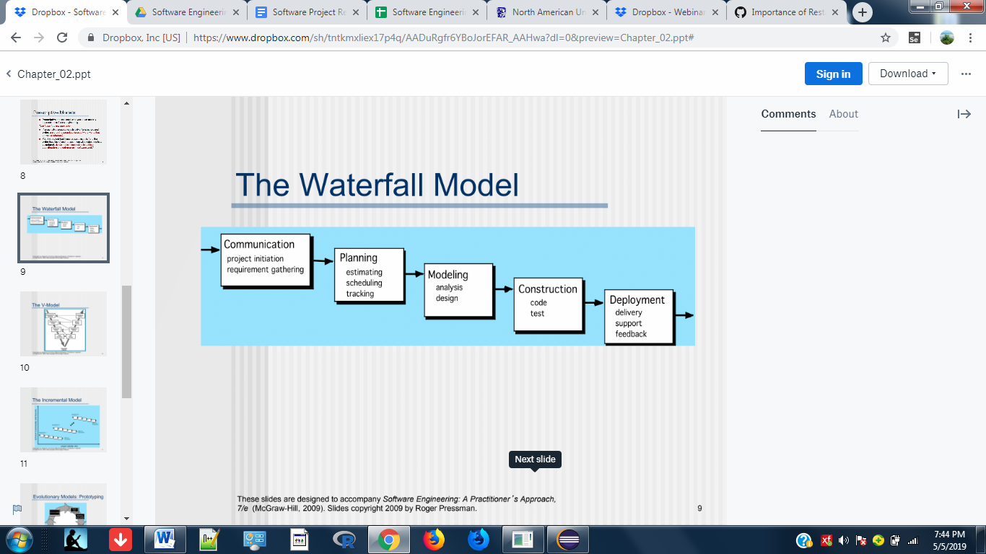

The reason why we pick this model can be itemized as below:

**1 .**  It is great guideline to create a great project from beginning to the end. It nicely summarizes all the necessary steps without any confusion.

**2.** With this method, generally you will be aware if you completed the previous step without problem. So, we can localize any problem that we met and then, we can continue to our way confidently.

**3.** We thought that the testing process will be easier for us if we use this model.

**2.2 Roles and Responsibilities**

In this project, group members’ contributions and roles can be expressed as below:

Ferhat Alaydin:

- Work heavily on coding process

- Based on comments, make necessary changes in program

-Use necessary tools like Java, Java Script etc.

Zafer Yildiz:

- Make researches on effective implementations of Restaurant Automation applications.

- Make comments of created codes.

- Verify the application’s workability and work on testing process

- Create the Final Project documents

**3 PROJECT MANAGEMENT PLAN**

**3.1 Tasks**

We managed our tasks based on below UML diagram

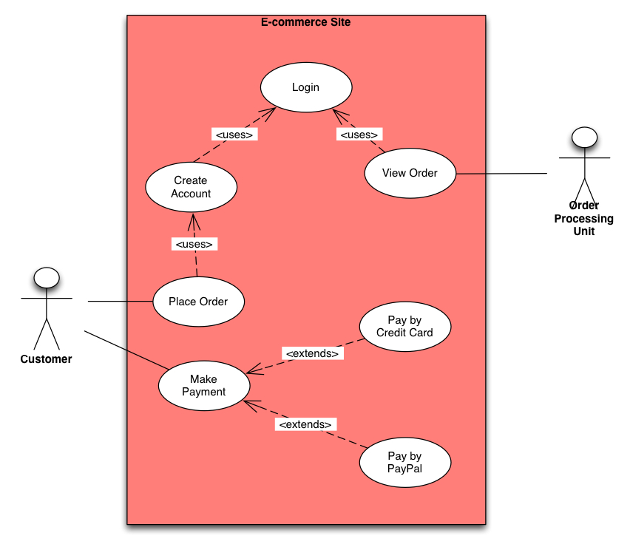

To complete the task, we followed below items and used mentioned tools:

- Make researches on effective implementations of Restaurant Automation applications

- Work heavily on coding process

- Based on comments, make necessary changes in program

- Work on necessary testing processes

- Use necessary tools like Java, Java Script etc.

**3.2 Timetable**

|  |  |  |
| --- | --- | --- |
| **Task** | **Start Date** | **End date** |
| 1.0 Planning |  |  |
| 1.1 Subtask 1 |  |  |
| Create the idea and give a name for the project. Create an outline | Feb 5 | Feb 15 |
| 1.2 Subtask 2 |  |  |
| The group decides on tasks and distributes them between members of the group according to their skills and knowledge. | Feb 15 | Mar 5 |
| 2.0 Analysis |  |  |
| 2.1 Subtask 1 |  |  |
| Make researches on similar projects from industry. | Mar 5 | Mar 15 |
| 2.2 Subtask 2 |  |  |
| The time for group members to review Java and other skills they needed to work on the project. Plus start coding process | Mar 15 | Apr 5 |
| 3.0 Design |  |  |
| 3.1 Subtask 1 |  |  |
| Icons, background pictures, general outline of menu is created. | Apr 5 | Apr 10 |
| 4.0 Implementation |  |  |
| 4.1 Subtask 1 |  |  |
| Mr. Ferhat writes the Java code. Mr. Zafer checks and give feedbacks | April 10 | April 25 |
| 5.0 Testing |  |  |
| Work on testing process and debugging | April 25 | April 30 |
| Final test of different functions of application. Final debugging. | April 30 | May 5 |
| 6.0 Deployment |  |  |
| 6.2 Final Presentation of Project | May 5 | - |

**3.3 Meeting Notes**

Some of the meeting minutes are given below:

Meeting 1

We need to created outline. Attached this issue, we list below items:

* We need to determine the needs like; how the order will be given how the order will be transferred to kitchen how the waiter will be informed how the customer request the orders and bills how the payment will be completed etc...

* All the needs are needed to attached the application

* The visuals of the application is also important

* As other step, we are looking for and researching similar projects form industry

* After that the detailed coding and testing process will start. This is our initial plan with Mr. Ferhat so far.

Meeting 2

To write our codes, we need to determine our needs. We start our design writing the main needs as below:

* List of beverages

* Price and name of beverages

* List of meals

* Price and name of meals

Meeting 3

We continued our determination of needs as is mentioned below:

1- Multiply the price of each beverage and meal by the quantity to get the cost of order.

2-How can we use object orientation in our project

Meeting 4

Determine the classes for coding process

1-) Beverages and meals will be used as class names

2-How can we call these classes?

3-How can we write main method for classes?

Meeting 5

Continual discussions about coding process based on below items:

1-) Which one is better if or case in our program

2-) Which java package we needs for our programs

Meeting 6

Continual discussions about coding process based on below items:

1-) How can we write methods

2-) How van we write login class

Meeting 7

1-Which type of variable we should use ( local, instance or class)

2-How can we use GUI component in our program

Meeting 8

1-How many methods we should use

2-How can we use constructor to initialize our GUI component

1. **TEST**

Screenshot 1 shows our coding and logging process to our application.

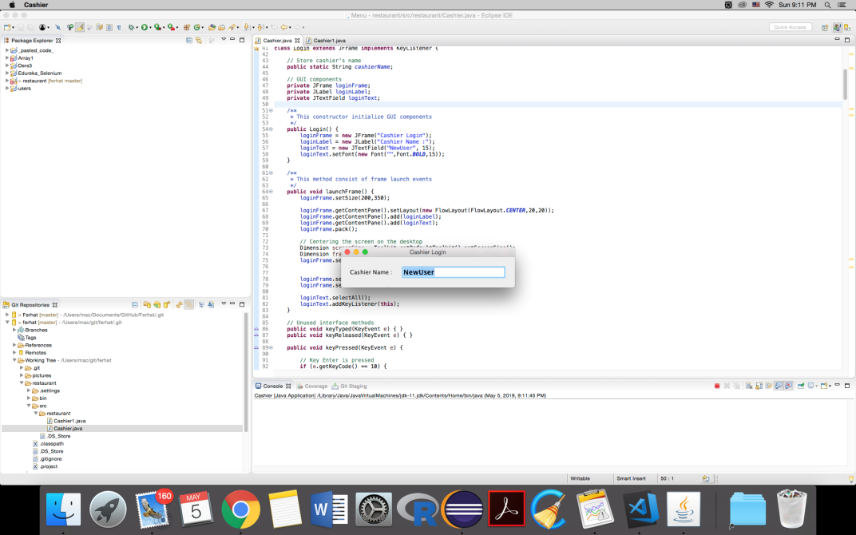

After we login to our application, we see below screenshot. When we click 1, it means we order Fried Chicken, when we click 2, it means we order Fried Noodles etc…

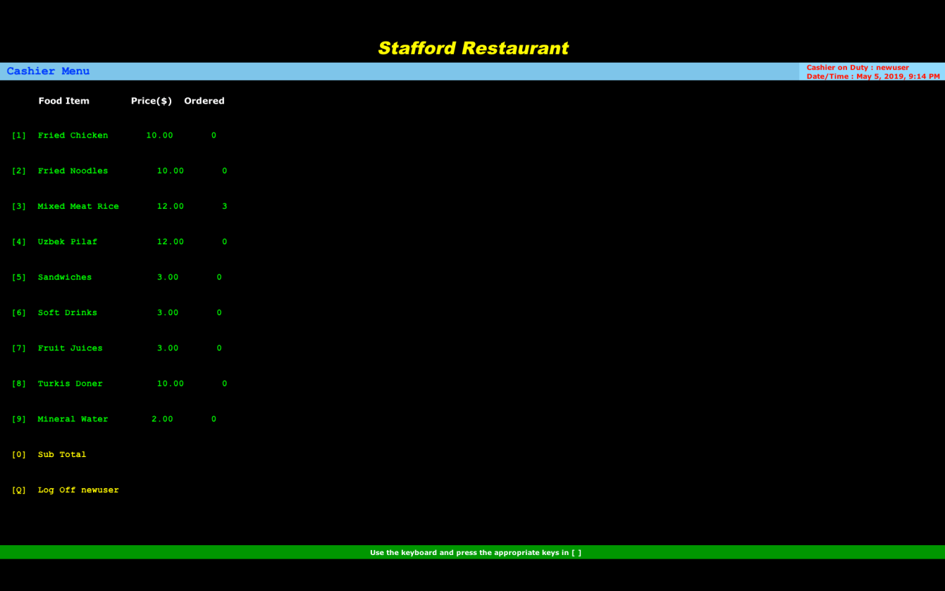

As is seen below screenshot, when we click the same item number again, it increases the order amount for this item. For example, when we click the number 1 two times, it means we give 2 Fried Chicken order.

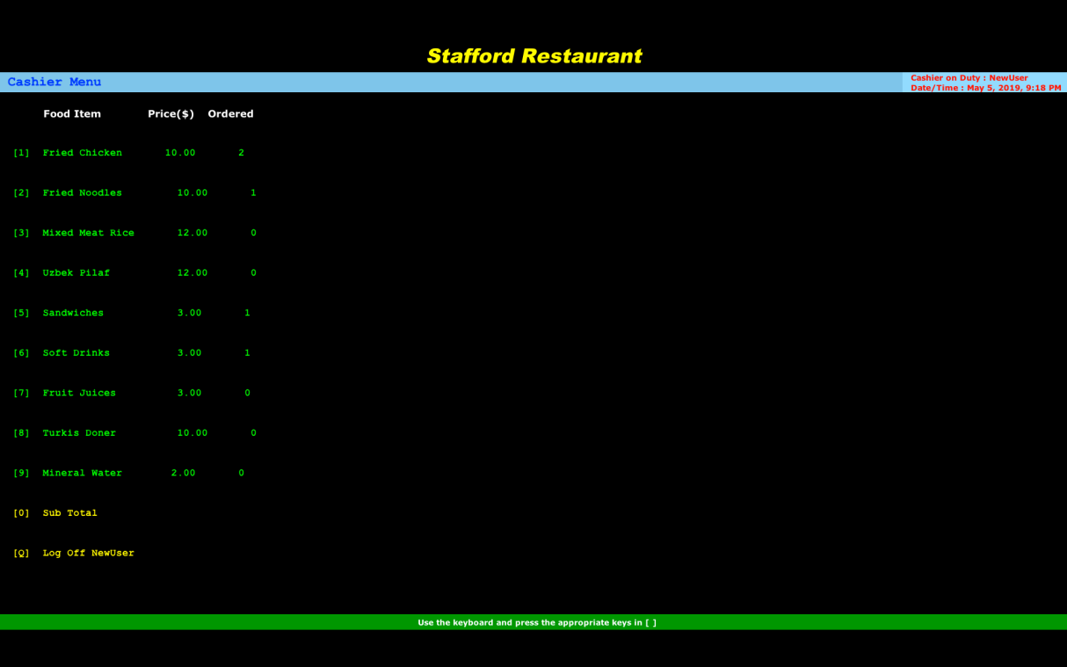

When we click 0 button, the total amount of the order is seen at the bottom part of the screen. As you will see also from that screenshot, the application shows the actual date and time also.

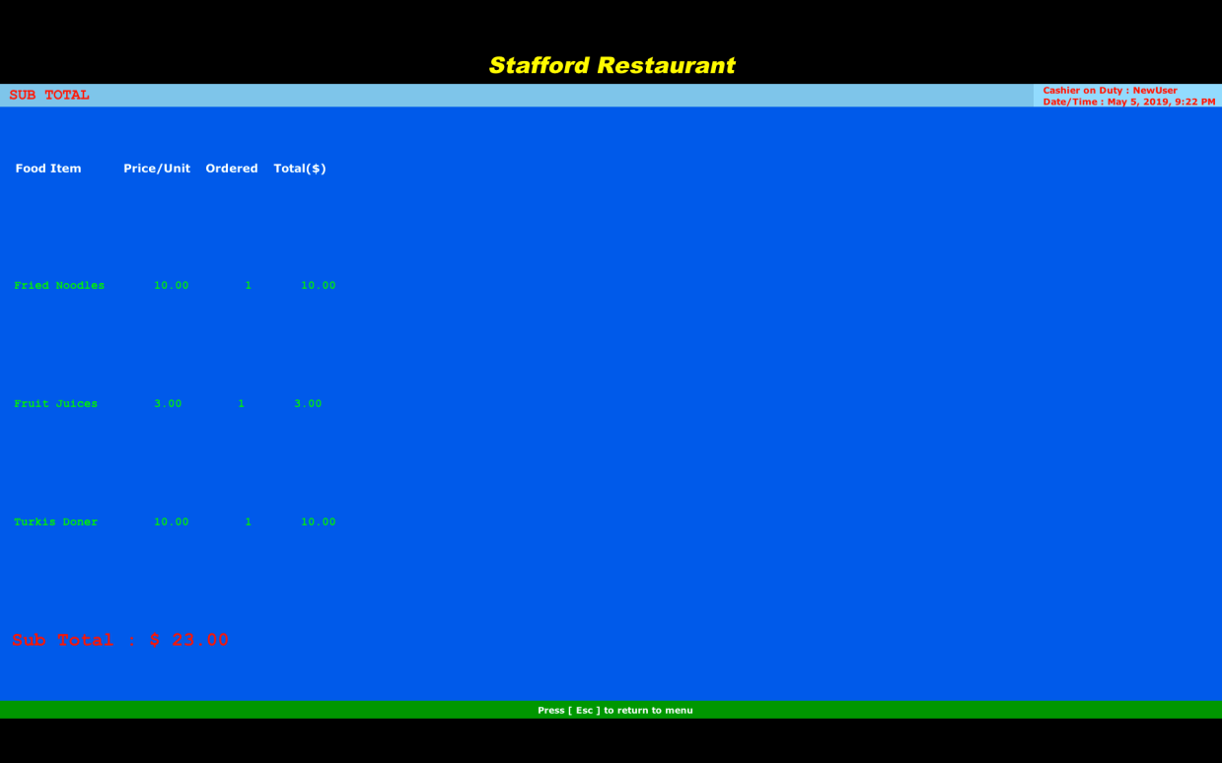

Below screen shows that; when we click the Q button in our application, a good by message appears.

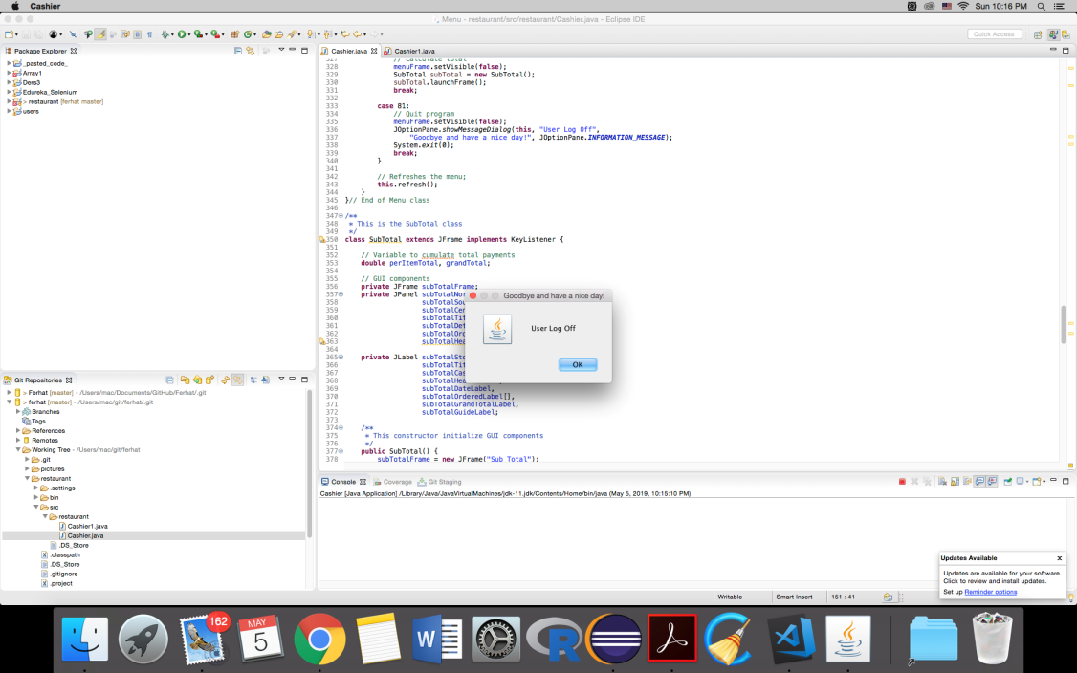

**5 ADDITIONAL MATERIAL**

**5.1 Screenshots**

<https://github.com/ferhatchem/ferhat/tree/master/screenshoots>

**5.2 Final Demo Link**

<https://drive.google.com/file/d/1hRlQTuC_1UVl6TxJQ2fDl5hc_fXAqe7P/view?usp=sharing>

**5.3 Code**

<https://github.com/ferhatchem/ferhat/blob/master/restaurant/Cashier.java>

**5.3.1 Repository**

<https://github.com/ferhatchem/ferhat/>

<https://github.com/ferhatchem/restaurant/>

<https://github.com/zayiltech/restaurant>

**Reference**

<https://www.fastcasual.com/blogs/3-ways-restaurants-can-use-automation-to-drive-business-value/>