**TESTING PART OF OUR PROJECT Zafer Yildiz & Ferhat Alaydin**

Screenshot 1 shows our coding and logging process to our application.

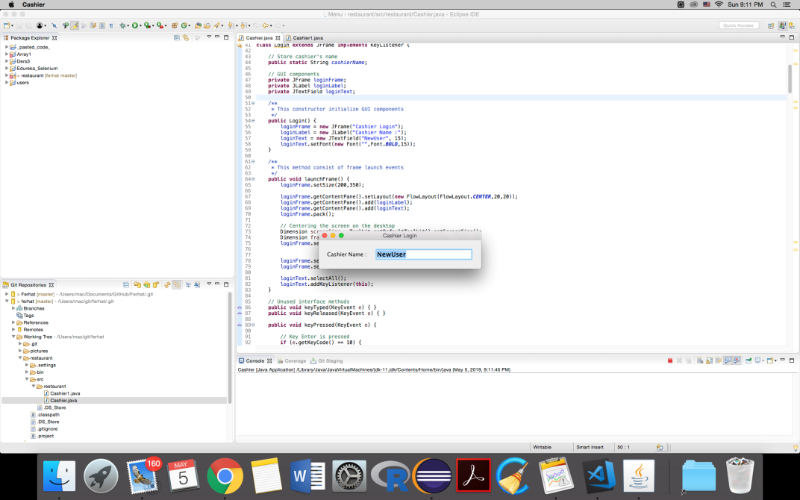

After we login to our application, we see below screenshot. When we click 1, it means we order Fried Chicken, when we click 2, it means we order Fried Noodles etc…

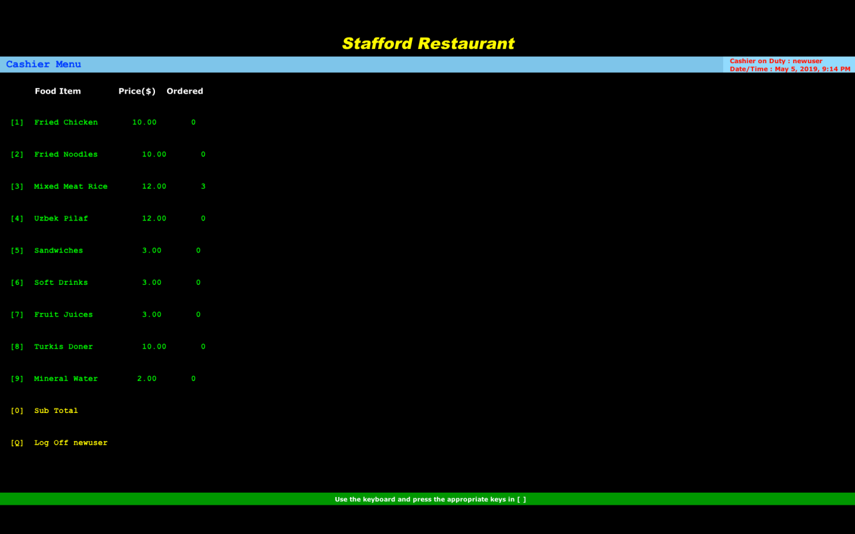

As is seen below screenshot, when we click the same item number again, it increases the order amount for this item. For example, when we click the number 1 two times, it means we give 2 Fried Chicken order.

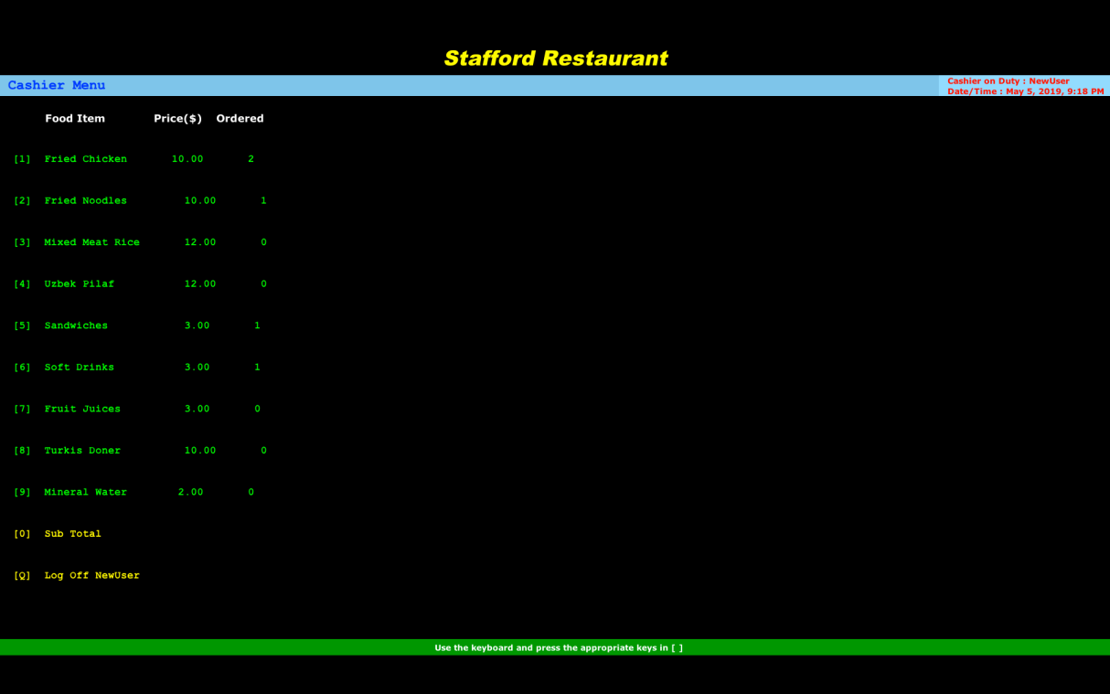

When we click 0 button, the total amount of the order is seen at the bottom part of the screen. As you will see also from that screenshot, the application shows the actual date and time also.

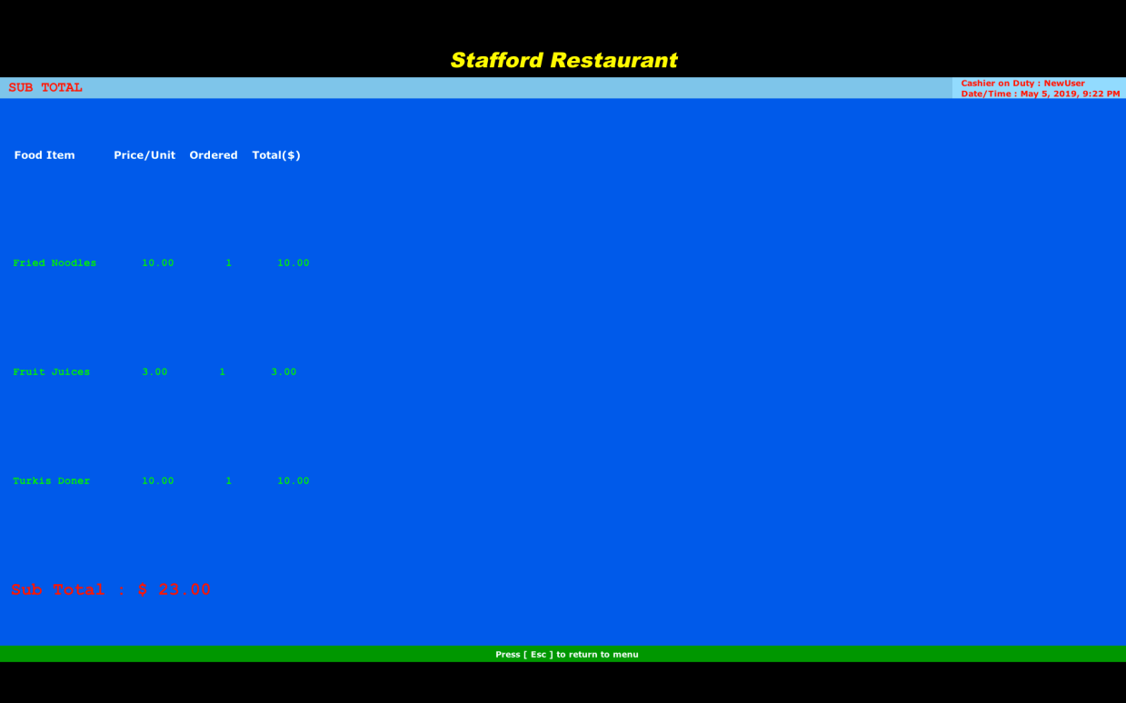

As is seen below screen, when we click the Q button in our application, a good by message appears.

