Cairo University  
Faculty of Computers and Artificial Intelligent

**CS251**

**Software Engineering I**

Project Name

Software Design

Team Names

Month & Year

Contents

Instructions [To be removed] 3

Team 3

Document Purpose and Audience 3

System Models 3

I. Class diagrams 3

Important Algorithm 4

II. Sequence diagrams 5

Class - Sequence Usage Table 6

Ownership Report 6

Policy Regarding Plagiarism: 7

# Team

|  |  |  |  |
| --- | --- | --- | --- |
| **ID** | **Name** | **Email** | **Mobile** |
| 20200651 | Youssef zayn-elabden okasha | Joozain309@gmail.com | 01118142769 |
| 20200545 | Mostafa Mohamed kamal | Mostafasheka11@gmail.com | 01024488979 |
| 20200300 | Abdallah farghal abdallah | Abdallakamal365@gmail.com | 01123936890 |
| 20200035 | Ahmed Mohamed ahmed | Ahammoudasalman@gmail.com | 01144199606 |

# Document Purpose and Audience

* The audience of this documentation is the developers who will write the implementation of the system and the purpose is to understand how the system should works in the given scenarios and the exceptions that might happen and how it should be handled.

| **Class ID** | **Class Name** | **Description & Responsibility** |
| --- | --- | --- |
| 1 | ***Vehicle*** | Class vehicle acts as an entity object and responsible for holding all the information about the parked vehicles |
| 2 | ***Garage*** | The class Garage represents the garage and holds an entity of slot and sensors and the class is responsible for managing the park-in, park-out, displaying the total income for the garage and displaying the empty slots in the garage  Processes |
| 3 | ***Config*** | Class config is an interface for the searching way that is used to find the available slot to park the vehicle and it includes one abstract method |
| 4 | ***Best fit*** | Class best fit include a function search only |
| 5 | ***First come first served*** | Class *First come first served* include a function search only |
| 6 | ***Authentication*** | Class authentication has two methods log-in and reset password  And it is responsible for verifying the admin who is authorized to access specific functionalities of the system |
| 7 | ***LocalTimeMethods*** | It’s only responsible for formatting and calculate durations of time and it includes two functions (formatting,calculateDuration) |
| 8 | ***ParkForIn*** | It’s an interface which the parkIn class inherit from just in order of adding any extensions by adding a class similar to parkIn |
| 9 | ***ParkForOut*** | It’s an interface which the parkOut class inherit from just in order of adding any extensions by adding a class similar to parkOut. |
| 10 | ***ParkIn*** | It contains the park-in function which is responsible about parking the vehicle in the slot according the chosen configuration of the admin. |
| 11 | ***ParkOut*** | It contains the park-out function which is responsible about getting the vehicle out of the slot and give the parking fees. |
| 12 | ***Slots*** | Class slots is acts as an entity that holds the information about each slot and holds the vehicle object which is parked at each reserved slot  and also responsible about finding a specific vehicle in the slots by it’s ID |
| 13 | ***Sensor*** | Class sensor acts as an indicator that the slot is empty or not. |
| 14 | ***CornerSituations*** | This class manage that unexpected situation like parking in while the garage is full or parking out while the garage is empty or not finding the id of the vehicle which is parking out right now. |
| 15 | ***ConsolUi*** | Contains two function one for entering the information of the configuration of the garage and one that displays a form of the functionalities of the system acter using any of them. |
| 16 | ***FeesCalculations*** | This class is responsible about calculating the parking fees for the vehicle. |

### Important Algorithm

* First come first served algorithm: iterating over the slots and chose the first slot with a sensor that indicates that the slot is empty.
* Best fit algorithm: iterating over the slots and find the most suitable slot for the vehicle by finding the slot with the minimum area between all the available slots that is it is length and width is greater than or equal to the length and width of the vehicle.

## II. Sequence diagrams

First sequence : (use case id =1)

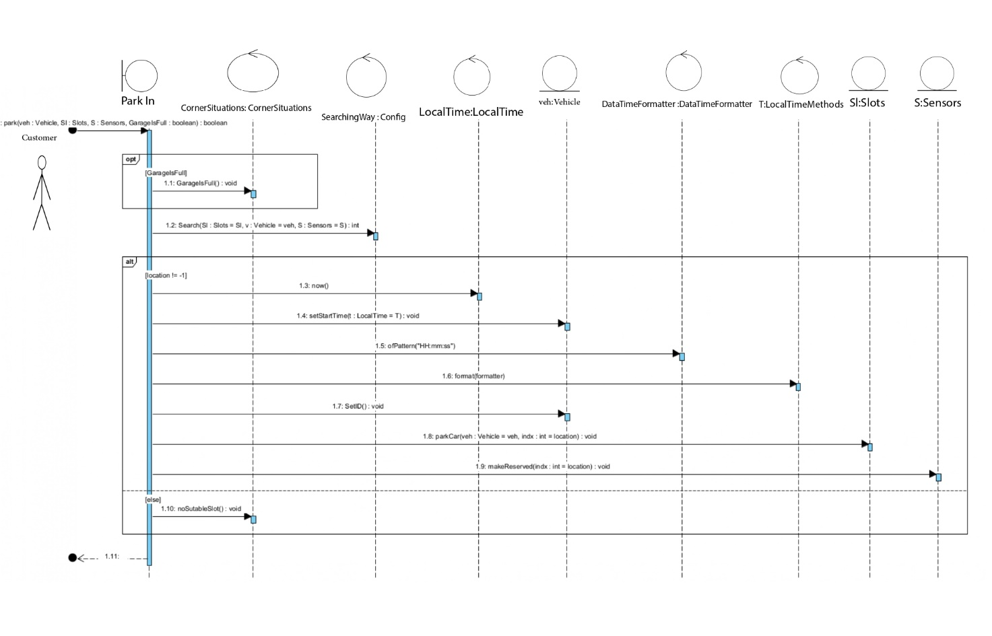

Second sequence (use case id =2)

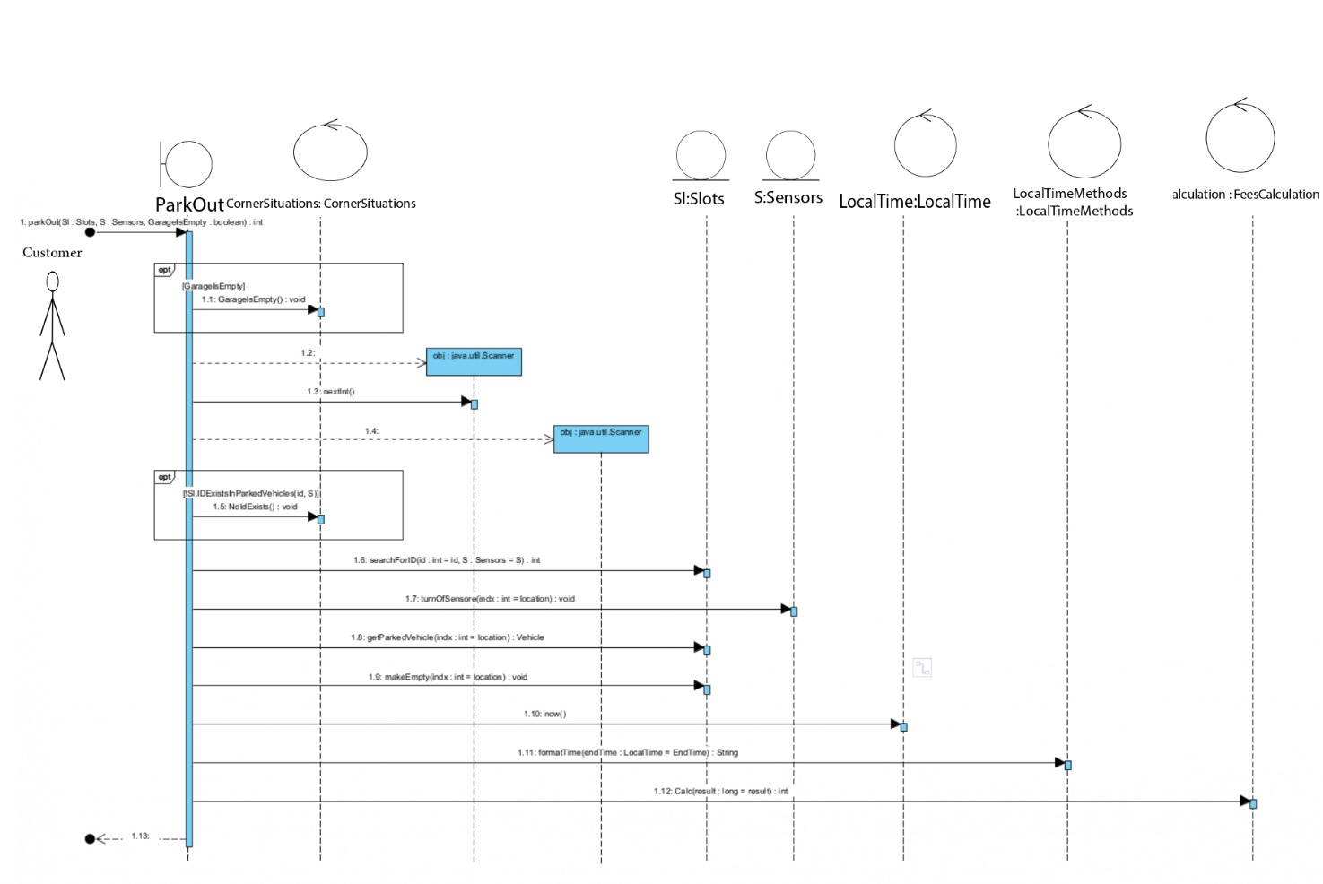

**Third sequence (**use case id = 3)

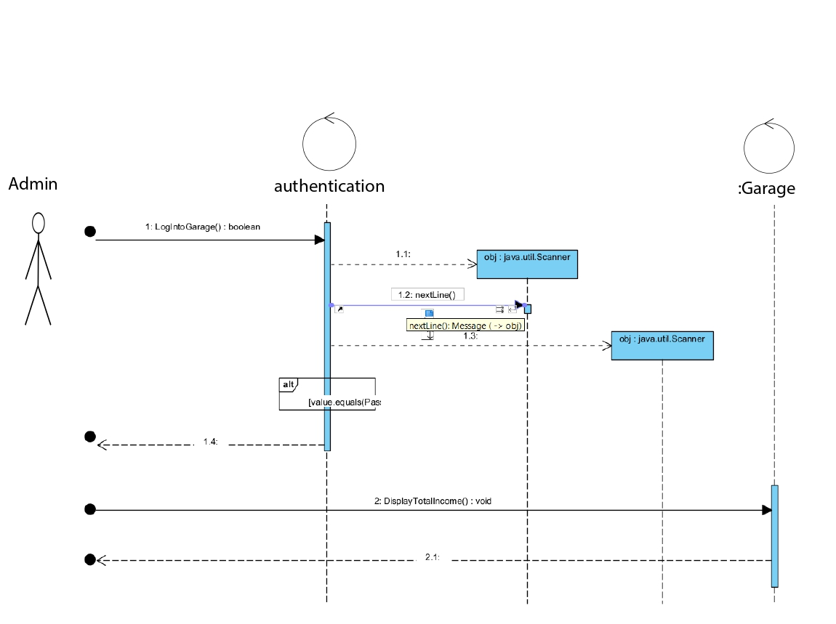

### Class - Sequence Usage Table

| **Class Name** | **Sequence Diagrams** | **Overall used methods** |
| --- | --- | --- |
| adminstor | 1, 3 | Get the garage data (slots,parking way) |
| Vehicle | 1,2 | Enter the car data,Park in , park out, pay the fees |
| garage | 1,2,3 | Search about free slot, display the free slot , display the enter & depature time , display the total income |
| BestFit | 1 | Search and get the suitable slot |
| FirstComFirstServed | 1 | Search and get the suitable slot |
| authentication | - | Authenticate password for admin log in |
| Config |  | Configuration for the vehicle to park in |
| ConsolUi |  | Giving configuration for the garage and make its form |
| CornerSituations |  | Showing the status of the garage empty or full and if there suitable slots for car |
| FeesCalculation |  | Calculating fees for each car |
| LocalTimeMethods |  | Calculating the duration for each car |
| Main |  |  |
| ParkForIn |  | Interface for park in function |
| ParkForOut |  | Interface for park out function |
| ParkIn |  | Park in for each car |
| ParkOut |  | Park out for each car |
| Sensors |  | Showing the status for each slot |
| Slots |  | Getting number of slots taken and empty and it’s dimensions to park car and give it id and search for it’s id |

Ownership Report

|  |  |
| --- | --- |
| **Item** | **Owners** |
| Sequence diagrams | *Abdalla farghl & ahmed mohamed* |
| Class diagam | Mostafa Mohamed & Youssef zayn-elabden |

# Policy Regarding Plagiarism:

**Students have collective ownership and responsibility of their project. Any violation of academic honesty will have severe consequences and punishment for ALL team members.**

1. تشجع الكلية على مناقشة الأفكار و تبادل المعلومات و مناقشات الطلاب حيث يعتبر هذا جوهريا لعملية تعليمية سليمة
2. ساعد زملاءك على قدر ما تستطيع و حل لهم مشاكلهم فى الكود و لكن تبادل الحلول غير مقبول و يعتبر غشا.
3. أى حل يتشابه مع أى حل آخر بدرجة تقطع بأنهما منقولان من نفس المصدر سيعتبر أن صاحبيهما قد قاما بالغش.
4. قد توجد على النت برامج مشابهة لما نكتبه هنا أى نسخ من على النت يعتبر غشا يحاسب عليه صاحبه.
5. إذا لم تكن متأكدا أن فعلا ما يعد غشا فلتسأل المعيد أو أستاذ المادة.
6. فى حالة ثبوت الغش سيأخذ الطالب سالب درجة المسألة ، و فى حالة تكرار الغش سيرسب الطالب فى المقرر.