**Prescribing decisions**

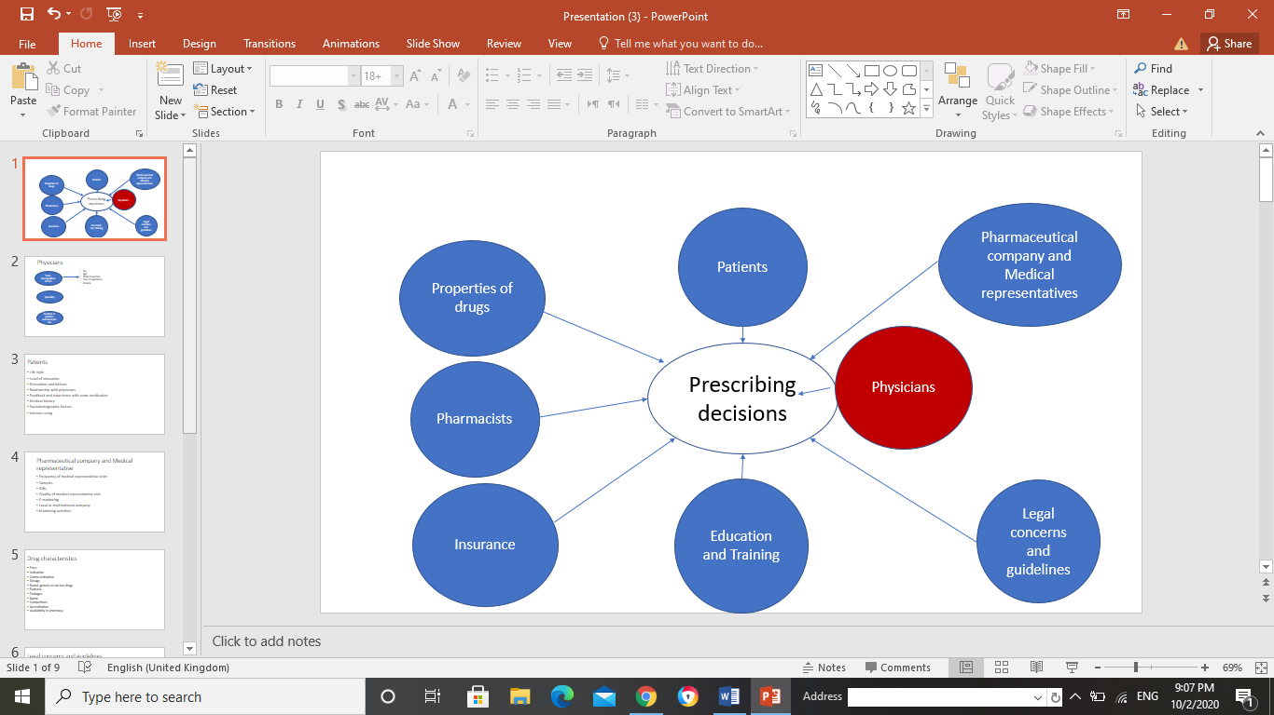









**Turkey**

152 GPs working in the primary health centers and hospitals in Erzurum province of Eastern Turkey participated in 2006 on study titled “Impact of pharmaceutical promotion on prescribing decisions of general practitioners” in order to determine the self-reported impact of pharmaceutical promotion on the decision-making process of prescription of GPs in Eastern Turkey. The questionnaire includes questions about socio-demographics, number of patients per day, time per patient, frequency of sales representative visits to GPs, participation of GPs in training courses on prescribing (in-service training, drug companies), factors affecting prescribing decision, reference sources concerning prescribing and self-reported and self-rated effect of the activities of sales representatives on GPs prescribing decisions. Divers factors have tested in this study such as work site, numbers of patients examined per day, year of practice, quality and content of formal pharmacology education during medical faculties and promotional activities. Concerning the visits of MRs, 72.3% of the physicians were visited by MRs more than once a month and 61.2% of physicians reported that their prescribing decisions were always affected by MRs activities. About training programs, 75.6% of the GPs participated in training programs of pharmaceutical companies and 28.2% had gone into in-service training provided by public sector on prescribing due the impact of promotional activities on physicians who participated in training courses of pharmaceutical companies was significantly higher on general practitioners who did not participate in any training of companies. About work site, year of practice, number of patients examined per day and frequency of medical representative visit the results of this study demonstrate that the impact of promotional activities is high on physicians working at primary health care centers, on physicians whose year of practice was 5 years and under, on physicians who examined 60 or more patients per day and on physicians who were visited by MRs more than once a month. Furthermore, the physicians who examined 60 and more patients a day participated in training courses of pharmaceutical companies more frequently than the physicians who examined fewer than 60 patients a day. In addition, the quality and content of formal pharmacology education during medical faculties affected directly the prescribing decision and the attitudes of GPs towards the relations between doctors and pharmaceutical companies. As reference resources in case of any problems in prescribing are drug guides of pharmaceutical companies (73,7%), medical books, and the documents of pharmaceutical companies. So all these results indicate a lack of formal continuing medical education and an adequate monitoring of prescribing behaviors provided by public sector.

**Egypt**

Egypt, as the largest Arab middle-income country, with a population of about 85 million people and central to modern Middle Eastern politics, plays an influential role for pharmaceutical companies’ promotional strategies. 47 pharmaceutical producers active in Egypt; 37 belonging to the public sector, 4 producers for the local private sector and 6 multinationals. Multinational and local private companies own more than half of the total market share. The Egyptian Medicines Authority (EDA) is the regulatory body for safety and quality of pharmaceutical products, conducting pharmaceutical practices and providing high-quality medicines at reasonable prices. In 2011, EDA established the Marketing and Media Control Department with the aim of reviewing and ensuring the safety of promotional materials and regulating the activities of the scientific offices of pharmaceutical companies. A qualitative study was conducted in 2014, to analyze the perceptions and attitudes of Egyptian physicians and pharmacists towards Pharmaceutical Marketing. The gifts offered by pharmaceutical company to physicians are drug samples, office supplies, cash and invitations to conferences or sponsored continuing medical education (CME) events. Some of doctors considered promotional gifts bearing the name of a drug useful as a reminder of that name, which actually seemed to match the intentions of the pharmaceutical industry. Doctors who admitted accepting gifts probably did this because receiving gifts from drug companies was considered a common and accepted practice in Egypt and elsewhere. About CME, The physicians considered the continued medical education (CME) events to be of high quality, but considered that juxtaposition of information and promotion was inconvenient. Sources of information used during prescribing decisions: medical studies, scientific conferences, textbooks, scientific journals, individual experiences with pharmacological treatment, university staff prescription habits and available information on the Internet. As results of this study, physicians did not feel influenced by pharmaceutical promotion in their prescription habits and it was mentioned that adjuvants and non-prescription medicines were more easily overprescribed than prescription medicines. Concerning samples, while the physicians give free medical samples to patients with poor social and economic conditions, it was demonstrating that availability of samples increases prescribing of the same brands, makes physicians adopt new drugs faster and shifts prescribing decisions towards less appropriate choices. Pharmacists had various attitudes towards pharmaceutical promotion. “In Egypt, promotion is about financial promotion, not ethical promotion. So it is about how much profit you make, not whether this is an effective medicine” says one pharmacist. In addition, pharmacists noted that they are aware of the incentives given to doctors to influence their prescribing pattern. This appears when doctors prescribe unnecessary medications.

**Nigeria**

In 2017, a cross sectional study was conducted in Abia State to describe the effect of medical representative on the prescribing behavior for physicians. 185 private and public medical practitioners participated in this study. The questionnaire includes questions about socio demographic data, practice and attitude to drug promotion, frequency of visits by medical representatives in the previous 12 months, types of incentives received, drug promotion methods, drug promotion information, sources of drug information, and awareness of code of regulation on drug promotion. All respondents were visited by medical representatives with 47, 6% of physicians are influenced by medical representatives and 66, 5% of respondents had positive attitude to drug promotion.

In addition, all respondents accepted the gifts and the most common incentive received by the medical practitioners was branded office stationeries (pens, jotters, diaries, calendars). The predominant drug information provided by MRs was both brand name of the drugs and drug indications. None of the respondents was informed on the boxed warnings for specific medications which are available in Nigeria. The most common source of drug information is to ask or contact a colleague or pharmacist especially when they have drug information problems. As noted, 84.9% of doctors were aware by the code of ethics and regulation of promotion so this awareness should be translated to appropriate prescribing practice and positive attitude towards drug promotion.

In the Chi-square bivariate analyzes, work in public health facilities was significantly related to the position and prescribing practices of study participants. This may be a reflection of the accessibility and frequency of visits by medical practitioners working in public health facilities among other epidemiological variables.

This study showed the high level of drug promotion induced prescription practice could be reflection of the frequency of visits and enthusiastic gifts by the medical representatives to medical practitioners in Nigeria.

**Ethiopia**

To assess the influence of MRs on prescribing practice, a study titled “Influence of Medical Representatives on Prescribing Practices in Mekelle, Northern Ethiopia” was conducted enrolling all physicians working in public and private health facilities from February to March 2015. A questionnaire was prepared in this cross sectional study comprising two types of questions; Questions on the socio-demographic characteristics of the physician: age, gender, religion, average monthly income, year of experience, qualification and practice site and Questions about drug promotion and prescribing practice. Out of 90 questionnaires distributed to respondents, 83 were filled completely with response rate of 92%.

The results of this study showed that 97, 6% of physicians were visited by medical representatives (MRs) and 48.2% of physicians believed that MRs influenced their prescribing pattern. The information provided by MRs concerns the brand name of a product (84,3%) and drug indication (30,1%) while 63,9% of physicians declared that MRs never had informed the made-quietly and accurately.

The medical representatives use a variety of promotional methods including face to face (54,2%), using medical samples (25,2%), using brochures and stickers (3,6%), using other electronic materials (3,6%), referring to articles (9,6%), participating during new product launching (3,6%) and participating during company cycle meeting (4,8%).

Half of the respondents accept gifts from pharmaceutical company and most of the accepted gifts are drug samples and stationery.

Two important factors influence prescribing decisions; acceptance of gifts and the practice site. The acceptance of gifts by physicians has 6 times more influence on their prescribing pattern than physicians who do not accept gifts provided by medical representative. In addition, doctors working in private health facilities were almost 13 times more likely to be influenced to change their prescribing practices by MRs than those in public facilities.

**Peru**

In 2014, one study has conducted in a general hospital in Lima, Peru to explore the interaction and attitudes of physicians with pharmaceutical company. It is clear the active relationship between physicians and Pharmaceutical company. 95% of attending and 85,7% of residents have at least one monthly interaction with medical representatives. And when we asking about reasons to accept medical representative 81,8% of physicians accepted them for respecting the another’s job and 55,2% of physicians to receive drug samples.

About gifts offered by Pharmaceutical company, most of the physicians received samples and promotional materials and they accepted invitations to dinners with frequency of at least once every four months. 31,8% of physicians received materials or equipment for professional use ,27,8% of physicians received personal gifts, 15,5% of physicians received travel expenses to Congress. 88,5% of physicians believe that acceptance of gifts and dinner has no impact on prescribing decisions and 35,2% of physicians believe that those gifts affect their colleagues’ prescriptions.

Concerning gifts offered by Pharmaceutical company; 31,8% of physicians received materials or equipment for professional use, 7,8% of physicians received personal gifts and 15,5% of physicians received travel expenses to Congress. Concerning detailing activities: 75% of physicians considered that the information brought up by pharmaceutical representatives is ‘‘not trustworthy’’ and 80.3% of physicians stated that reps ‘‘prioritize the promotion of their products over patients’ benefit’’. But, 47.6% of participants stated that the information provided by pharmaceutical representatives helps them ‘‘learn about new products’’ and ‘‘stay up to date’’.

Taking into consideration the specialty of physicians, Anesthesiologists reported few numbers of encounters with medical representatives and more than half of them believe that most promotional activities and gifts affected the prescribing behavior. In contrast, pediatricians reported large number of encounters with medical representatives and likewise more than half of them didn’t believe that promotional activities influence prescribing behavior.

As conclusion, this study shows a close and active relationship between physicians and medical representatives.