Data and Preprocessing
Methodology and Implementation, Phase 1
2.2 Dataset
2.2.1 Source and Collection
The corpus used for this project is the public Suicide and Depression Detection dataset, collected from Reddit through the Pushshift archive and released on Kaggle. The posts are drawn from the SuicideWatch community and from a set of control communities, and each post carries a single label marking it as suicide or non suicide. This gives a binary classification task with naturally written, long form text, which suits the language modelling at the heart of the project. Reddit was chosen over a source such as Twitter because its posts are longer and more discursive, so they carry more of the linguistic signal that the project sets out to study.
2.2.2 Pre-processing and Filtering
The raw file holds 232,074 posts. Three filtering rules were applied before any modelling. Posts with empty or whitespace only text were removed, of which there were none, which confirms the integrity of the export. Posts shorter than five words were removed because they carry too little signal to be useful, which excluded 961 posts, around 0.4 percent of the data. Exact duplicate posts were removed, of which there were none. After filtering, 231,113 posts remain, split as 115,669 suicide and 115,444 non suicide. The two classes are therefore almost perfectly balanced, with a difference below one tenth of one percent, so no resampling or class weighting was needed.
2.2.3 Dataset Statistics
Table 1 summarises the corpus. The clearest pattern is the difference in length between the two classes. Suicide posts have a median of 128 words against 31 for non suicide posts, a little over four times longer, and the gap is just as wide at the mean and the ninety fifth percentile. This length difference is a genuine property of the data rather than a modelling choice, and it means a model can use length as a partial proxy for the label. The point is noted here so that later results are read with it in mind. Figure 1 shows the full word count distribution for each class, with both clipped at the ninety ninth percentile for display.
Table 1. Summary statistics of the corpus after filtering.
 | All posts | Suicide | Non-suicide
Count | 231,113 | 115,669 | 115,444
Median word count | 61 | 128 | 31
Mean word count | 132.9 | 203.3 | 62.4
95th percentile word count | 473 | 631 | 205

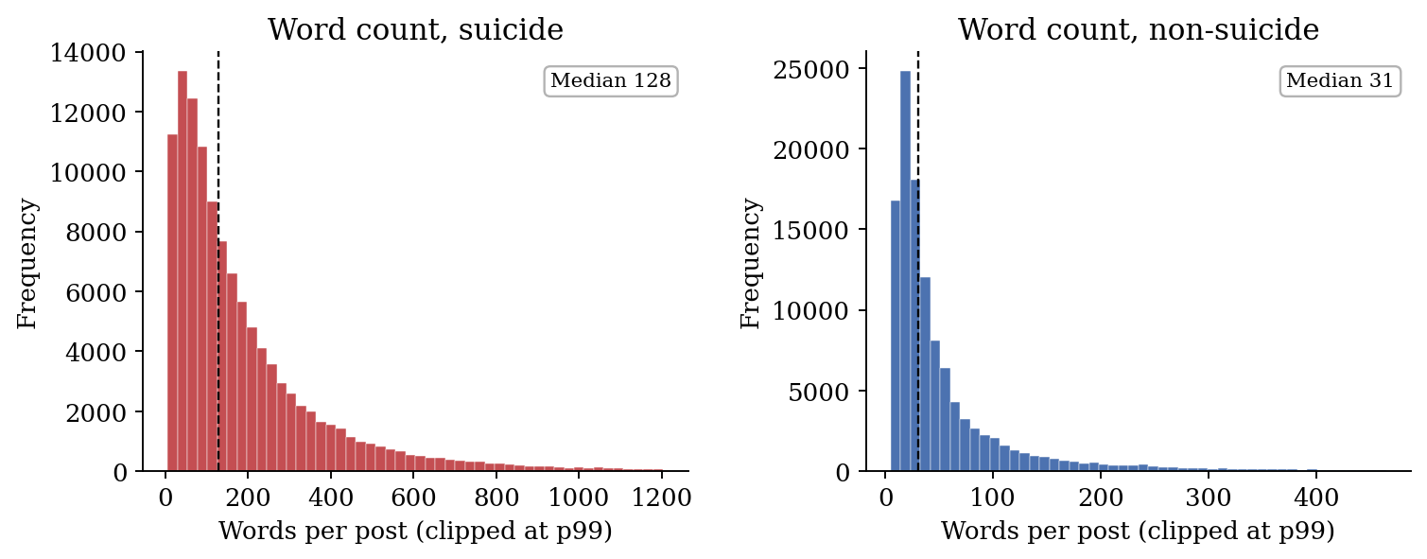
Figure 1. Word count distribution by class, clipped at the ninety ninth percentile. The dashed line marks the median. Suicide posts are markedly longer than non suicide posts.
2.2.4 Data Splits
The data is divided into four parts rather than the usual three, and the design is driven by the conformal prediction stage that comes later in the project. That stage only gives its guarantee if its calibration data has never been used for training, tuning or selection, so a dedicated calibration set is carved out and protected. The test set is removed first so that nothing downstream can touch it, the calibration set is removed next, and the remaining pool is divided into training and validation. Every split is stratified so that all four hold the same class balance, and the partition is driven by a fixed seed so it is identical on every run. Table 2 reports the resulting sizes and Figure 2 shows the balance of the filtered corpus.
Table 2. Four way stratified split. The calibration set is reserved only for conformal prediction.
Split | N | % total | Suicide | Purpose
Train | 129,422 | 56.0 | 64,774 | Model training
Validation | 32,356 | 14.0 | 16,194 | Selection and threshold tuning
Calibration | 23,112 | 10.0 | 11,567 | Conformal prediction only
Test | 46,223 | 20.0 | 23,134 | Final evaluation, touched once
Total | 231,113 | 100 | 115,669

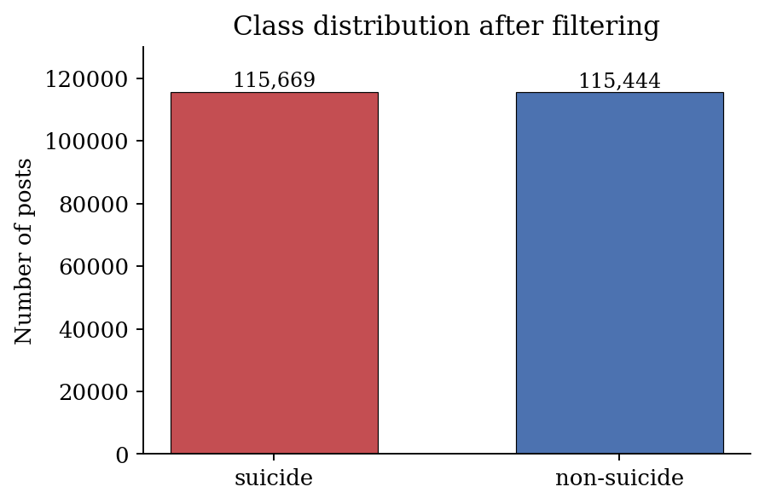
Figure 2. Class distribution of the filtered corpus. The near perfect balance removes the usual motivation for resampling.
2.3 Preprocessing Pipeline
All classical models share a single cleaning pipeline that raises the ratio of signal to noise before the text is turned into numbers. Figure 3 shows the flow from a raw post to the final feature matrix. The steps are listed below in the order they run.
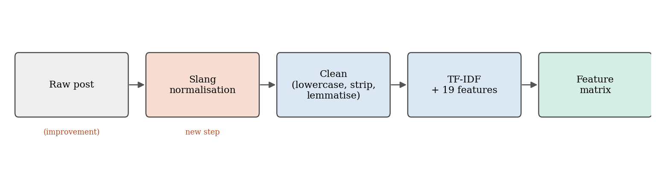
Figure 3. The preprocessing pipeline from a raw post to the feature matrix. The slang normalisation step is the improvement added in this work.
- Lowercasing.
- Removal of HTML tags.
- Replacement of web links with a placeholder token.
- Removal of user mentions.
- Removal of characters that are not letters.
- Tokenisation with the NLTK tokeniser.
- Stopword removal using the NLTK English list.
- Lemmatisation with the WordNet lemmatiser.
The cleaned text is then turned into a TF-IDF representation, which scores each term by how often it appears in a post against how common it is across the corpus. The vocabulary is capped at fifty thousand terms, includes both single words and adjacent pairs so that patterns such as a negation followed by a feeling are captured, and ignores terms that appear in fewer than three posts. The vectoriser learns its vocabulary from the training set only and then applies that fixed vocabulary to the other splits, since fitting it on validation or test data would leak information into the model.
2.3.1 Handcrafted Features
Alongside TF-IDF, a set of nineteen features drawn from the clinical and psycholinguistic literature is computed and joined to the matrix. These are taken from the raw text rather than the cleaned text, because punctuation and capitalisation carry emotional signal that cleaning would remove. They fall into four groups, summarised in Table 3. Post length is included directly because of the four to one length difference noted earlier. First person singular density follows earlier work linking self focused language to people at risk. The negation and hopelessness counts capture denial and the cognitive markers of hopelessness, and the VADER scores capture emotional tone. Three of the VADER scores can be negative, so they are dropped for the Multinomial Naive Bayes model, which needs non negative inputs, leaving sixteen features for that model and nineteen for the others.
Table 3. The four groups of handcrafted features.
Group | Count | Features
Surface statistics | 9 | word and character counts, average word length, exclamation and question count and density, ellipsis count, uppercase ratio
First person singular | 2 | count and density of I, me, my, myself and related forms
Negation and hopelessness | 4 | negation count and density, hopelessness lexicon count and density
VADER sentiment | 4 | negative, neutral, positive and compound scores
Total | 19

2.3.2 Improvement: Slang and Algospeak Normalisation
The original pipeline noted a weakness that it did not address during training. People writing about suicide on social media often replace direct words with coded substitutes, partly out of habit and partly to avoid automated moderation. This practice is known as algospeak, and the clearest case is the word unalive used in place of suicide or kill, alongside a wider family of forms such as kms, kys, sewer slide and end it all. This is documented in peer reviewed work on moderation avoidance on TikTok by Steen, Yurechko and Klug (2023). A plain bag of words model is blind to these terms, because the exact tokens never enter its vocabulary, so a post whose only marker is a phrase such as wanna kms produces almost no useful features and can slip through.
To close this gap a normalisation step was added at the very start of the pipeline, before any other cleaning. It rewrites a conservative list of well established coded and informal terms into plain wording, so unalive becomes suicide and wanna kms becomes want to kill myself. The list only covers terms whose meaning is established, so it does not invent signal that was not there. The step is controlled by a single switch in the configuration, which means the pipeline can be run with and without it and the effect measured as a clean comparison rather than asserted.
The reach of the change was measured directly on the filtered corpus. A total of 2,976 posts contain at least one coded term that the plain vocabulary would not have captured in full. Of these, 2,836 belong to the suicide class and only 140 to the non suicide class, so more than ninety five percent of the affected posts are genuine crisis posts. Figure 4 shows this split. This confirms that the recovered terms are a real signal rather than noise, and that the change is targeted at exactly the posts where missing a marker matters most. Table 4 lists the most frequent coded terms found.
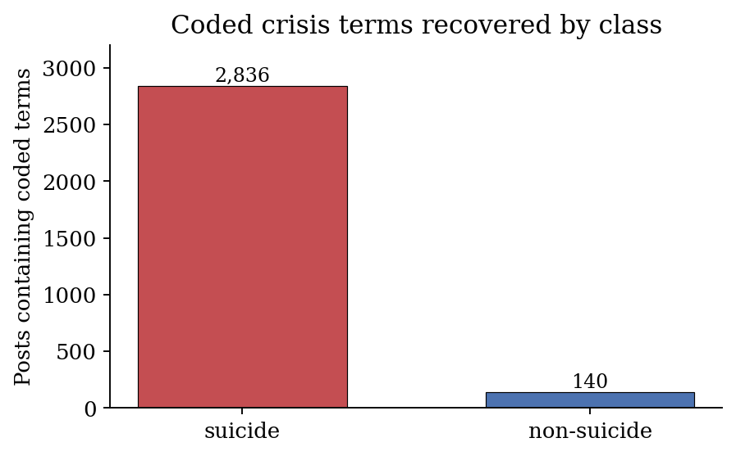
Figure 4. Posts containing coded crisis terms, split by class. The recovered terms fall overwhelmingly in the suicide class.
Table 4. Most frequent coded terms recovered by the normalisation step.
Coded term | Posts
end it all | 2,565
kms | 393
kys | 10
unalive and variants | 17
sewer slide and variants | 11

3.4 Data Pipeline (Implementation)
3.4.1 Tools and Version Control
The pipeline is written in Python and organised as a small package with separate modules for configuration, data loading, preprocessing and feature engineering. A single configuration file holds every path and constant, so no other module hardcodes a location and the whole pipeline can be moved or rerun by changing one file. The work is tracked with Git, with each stage committed as it is completed, so the history is auditable and any change can be traced. Scikit-learn provides the TF-IDF vectoriser, NLTK provides the tokeniser, stopwords and lemmatiser, and VADER provides the sentiment features.
3.4.2 Loading and Splitting
The loader reads the raw CSV with latin-1 encoding, which the export requires, drops the index column and maps the class column to a binary label. It then applies the three filtering rules and builds the four way split in the order described earlier, with stratification at every step and a fixed seed. Two automatic checks confirm that the test set does not overlap the development pool and that the calibration set does not overlap the validation set, since any such overlap would undermine the later conformal guarantee.
3.4.3 Preprocessing Execution
The full preprocessing runs from a single script. It cleans every split, fits the vectoriser on the training set, transforms the other splits, builds the handcrafted features in both the full and the Naive Bayes safe versions, and saves the cleaned text, the vectoriser, the feature matrices and a summary file. On the development machine the complete run took around thirty five minutes, with most of that spent computing the sentiment features across 231,113 posts. As a check on faithfulness, the filtered corpus and the four split sizes reproduce the original figures exactly, which gives confidence that later results are compared on the same footing.
Reference
Steen, E., Yurechko, K. and Klug, D. (2023). You Can (Not) Say What You Want: Using Algospeak to Contest and Evade Algorithmic Content Moderation on TikTok. Social Media + Society, 9(3).

