**PAGE 1**

DUMMY LOG IN

SIMPLE CSS

NO DATABASE

GAMIL ID TO CONNECT TO NEWLETTERS

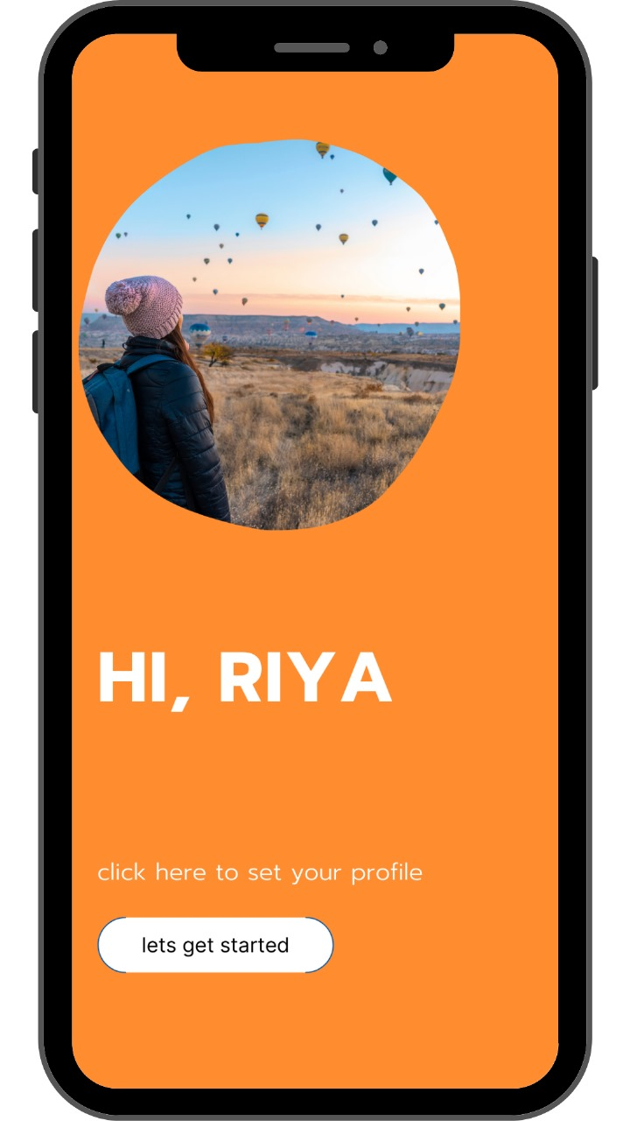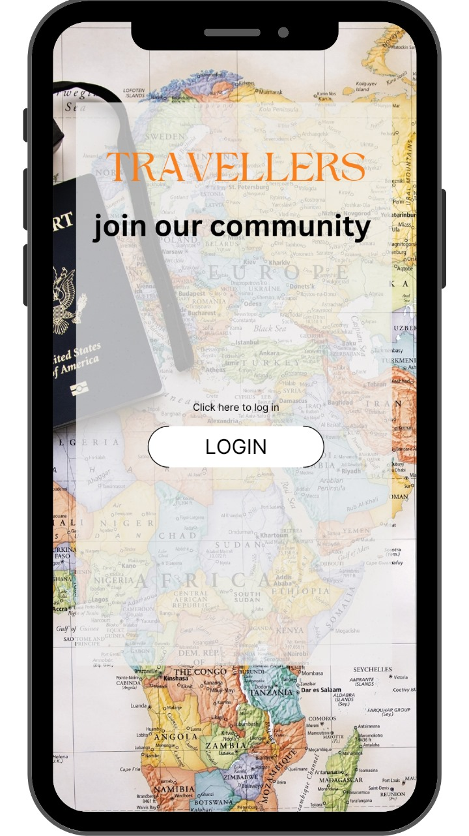

**PAGE 2**

FAMILY COUPLE SOLO OR FRIENDS ( THIS PAGE HAS , 4 OPTIONS TO CHOOSE FROM THEN A NEW PAGE WILL OPEN AS PER THE OPTION CHOSEN , ON TOP THERE WILL BE HOME PAGE ICON TO GO BACK TO “HI RIYA PAGE “ THATS IT

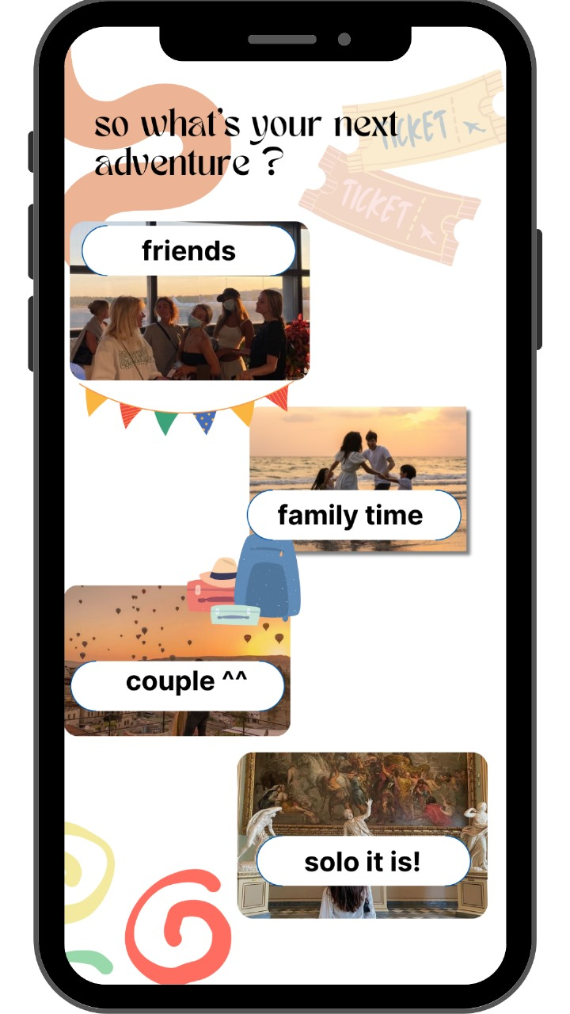

**PAGE 3**

MOST IMPORTANT PAGE EVER

FEATURES :

* THE MATCHES PAGE IS THE CURRENT PAGE WHICH WILL SHOW THE RESULT OF TRAVEL DESTINATION

SLIDE SHOW FULL SCREEN OF OPTIONS ACCORDING TO THE TYPE OF TRIP SELECTED ON THE PICHLE PAGE

IT WILL HAVE A FILTER OPTION WITH ALL THE THEMES LIKE LANGUAGE , CAMPING , BEACH AND ALL

YOU CAN WISHLIST THE DESTINATION ASWELL

EACH DESTINATION WILL HAVE SOCIAL MEDIA ICONS , WHICH WILL TAKE U TO THE TOKYO RELATED REELS POSTS AND VLOGS IN INSTA YOUTUBE ETC

EACH DESTINATION WILL HAVE A COMMENT BOX TOO

* 4 TOP BAR MENU OPTION , MATCHES , BLOG , FESTIVALS AND COMMUNITY
* BLOG LINK WILL TAKE US TO A PAGE FULL OF BLOGS ON “ FAMILY TRIP” AND IT WILL HAVE AN OPTION OF WRITE YOUR OWN BLOG
* FESTIVAL WILL HAVE ALL FESTIVALS NO FILTER AS FESTIVALS ME KYA HI FILTER HOGA SOLO COUPLE AND All ka
* COMMUNITY , IS A DISCUSSION FORM WHERE PEOPLE CAN SHARE THEIR MEMORIES OF GOING ON ANY FAMILY TRIP , LIKE AN OPEN COMMENT BOX
* ON TOP BAR IS A MESSAGE BOX FOR MESSAGES (LINK IT TO CONTACTS)
* A HOME PAGE ICON ASWELL AVAILABLE

