Newcastle United
Performance & Tactical Analytics Portfolio
Combined analytical report | 2025/26 Premier League

From shot-on-target control to event-level, tactical and player analysis

Scope: 43-match initial pattern study; 38-match 2025/26 event study; 962 shots; 108 goals

Executive summary
- The project begins with a simple empirical result: Newcastle’s shot-on-target (SOT) differential is much more closely associated with match points than raw shot differential. The first study therefore decomposes SOT control into shot volume and shot accuracy rather than treating total shots as sufficient.
- Event-level analysis then shows that Newcastle generally retain better chance quality after scoring than after conceding. Over complete 15-minute post-score windows, Newcastle recorded a positive xG differential; the corresponding post-concede figure was negative.
- The clearest tactical mechanism in the available data is territorial pressure. Post-score windows with positive Newcastle pressure produced substantially stronger PGCI, xG and SOT control than windows in which Newcastle were pushed into negative territory. This gap was especially relevant away from home.
- Player-level analysis identifies combinations worth video review rather than claiming causal player effects. Fabian Schär and Lewis Miley repeatedly appear in high-control windows, while the Miley-Tonali combination produced the strongest repeated pair signal in the sample.
- The practical conclusion is a focused tactical question: after Newcastle score, what behaviours allow them to keep the game in positive territory - particularly away from home - and can those behaviours be linked to repeatable personnel, pressing, spacing and progression patterns?

How the project developed
1. Match-level pattern discovery: 43 supplied Premier League matches were used to identify the relationship between shots, SOT, venue, opponent strength, game state and points.
2. SOT-control decomposition: SOT differential was separated into shot-volume and shot-accuracy mechanisms to create tactical hypotheses.
3. Event-level upgrade: The 2025/26 season was reconstructed at shot/goal level to measure the 5, 10 and 15 minutes after Newcastle score or concede.
4. Tactical mechanism: Minute-level pressure/territory data was used to test why control is retained in some post-score periods and lost in others.
5. Player-level layer: Line-ups and substitutions were used to identify players and combinations repeatedly present in high-control post-score windows.

Part I - Match-Level SOT Control
Dataset: 43 Premier League matches across 2025/26 and the first five matches in the supplied 2026/27 data.

Executive finding
Newcastle's SOT differential is best understood as the combination of two mechanisms: total-shot volume and shot accuracy. Together they explain 86.9% of the observed match-to-match variation in SOT differential in this sample. That makes 'create more shots' too simple a diagnosis: extra attempts only translate into SOT control if their accuracy is maintained.

Home vs away
Newcastle averaged +0.55 SOT differential at home compared with -0.67 away. Points per game were 1.68 at home and 0.95 away. The away environment is therefore a clear area for deeper tactical investigation.

Opponent strength
Lower (<1.30 PPG): Newcastle averaged +1.56 total shots, -7.78 percentage points in shot accuracy and -0.06 SOT differential (16 matches).
Mid (1.30–1.50 PPG): Newcastle averaged +0.83 total shots, +0.47 percentage points in shot accuracy and +0.92 SOT differential (12 matches).
Higher (>1.50 PPG): Newcastle averaged -4.00 total shots, +4.27 percentage points in shot accuracy and -0.80 SOT differential (15 matches).
The analytical value here is separating volume from accuracy. A negative SOT differential against a particular opponent class can arise because Newcastle cannot generate enough attempts, because too few attempts hit the target, or both.

Game state
When leading at half-time: +0.50 average SOT differential, -2.06 shot differential, +8.15pp accuracy differential and 2.00 PPG.
When drawing at half-time: +1.17 average SOT differential, +1.58 shot differential, -0.72pp accuracy differential and 1.75 PPG.
When trailing at half-time: -1.60 average SOT differential, -0.73 shot differential, -11.77pp accuracy differential and 0.27 PPG.
These splits describe how matches look under different game states; they do not establish that the half-time score causes the shooting pattern.

After Newcastle score first
The supplied match-level data does not contain goal timestamps, so a true post-first-goal analysis cannot yet be calculated. A conservative proxy — Newcastle ahead at half-time with the opponent on zero — occurs in 15 matches. Newcastle went 9W-2D-4L and averaged 1.93 PPG. The next dataset upgrade should add event timestamps, allowing SOT/xG to be measured in the 5, 10 and 15 minutes after the opening goal.

Repeated opponent exposure
Lowest average SOT differentials among opponents faced at least twice: Brentford (-3.50, n=2), West Ham (-3.00, n=2), Liverpool (-3.00, n=3), Arsenal (-2.50, n=2), Aston Villa (-2.00, n=2).
These opponent figures are signals for video/event-data follow-up, not stable opponent effects, because the samples are only two or three matches each.

Questions worth taking to event-level data
- Against which defensive structures does Newcastle's total-shot volume collapse?
- When Newcastle have a shot-volume advantage but not a SOT advantage, where are those extra attempts coming from?
- Does away SOT underperformance come from fewer penalty-area entries, lower-quality attempts, or stronger opponent transition threat?
- What changes in Newcastle's shot production in the 15 minutes immediately after scoring or conceding?
- Do specific opponents repeatedly force Newcastle into low-accuracy shooting zones?
- Can a leakage-free pre-match SOT-control model be built from rolling five-match SOT, xG, venue, rest and opponent-strength variables?

Portfolio conclusion
The presentation-worthy claim is not simply that Newcastle perform better when they win the SOT battle. It is that SOT control has separable volume and accuracy components, and their balance changes with venue, opponent strength and game state. That creates specific tactical hypotheses that can be tested with richer event data.

Part II - Event-Level Post-Goal Control
Premier League | 38 matches | 962 shots | 108 goals

Executive findings
- After Newcastle scored, their average xG differential remained positive over complete 5-, 10- and 15-minute windows: +0.075, +0.155 and +0.160 respectively.
- After conceding, the equivalent xG differentials were -0.042, -0.003 and -0.062. The strongest contrast therefore appears in chance quality rather than raw shot volume.
- At 15 minutes after Newcastle scored, Newcastle generated 1.95 shots and 0.88 shots on target per goal event versus 1.90 shots and 0.69 SOT for opponents, while the xG split was 0.331 vs 0.171.
- Newcastle's 15-minute Post-Goal Control Index (PGCI) averaged 51.9 after scoring and 44.8 after conceding. A score of 50 represents an even share of shots, SOT and xG.
- The home/away split is important: after scoring at home, 15-minute PGCI was 55.6 with +0.217 xG differential; away it was 45.8 with only +0.067 xG differential.
- Shot quality helps explain the SOT pattern. In complete 15-minute windows after Newcastle scored, Newcastle's shots averaged 0.170 xG, 74.4% were inside the box and average estimated distance was 13.8m. Opponent shots averaged 0.090 xG, 66.2% inside the box and 15.8m.
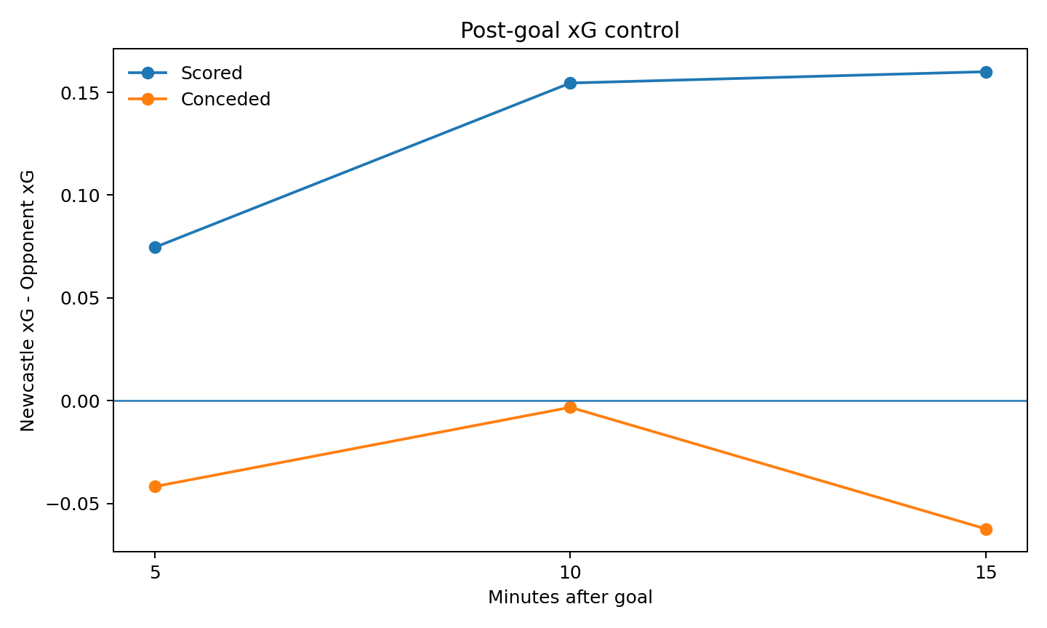

5 / 10 / 15-minute response
Event | Window | N | Shot diff | SOT diff | xG diff | xGOT diff | PGCI
Conceded | 5m | 49 | +0.00 | -0.06 | -0.042 | -0.051 | 43.7
Conceded | 10m | 43 | +0.30 | -0.02 | -0.003 | -0.034 | 50.9
Conceded | 15m | 40 | -0.12 | -0.12 | -0.062 | -0.094 | 44.8
Scored | 5m | 51 | +0.16 | +0.18 | +0.075 | +0.064 | 56.0
Scored | 10m | 48 | +0.17 | +0.12 | +0.155 | +0.108 | 53.3
Scored | 15m | 42 | +0.05 | +0.19 | +0.160 | +0.116 | 51.9
Windows are included only when the full requested amount of playing time remained in the match, so late goals do not artificially depress the post-goal event counts.
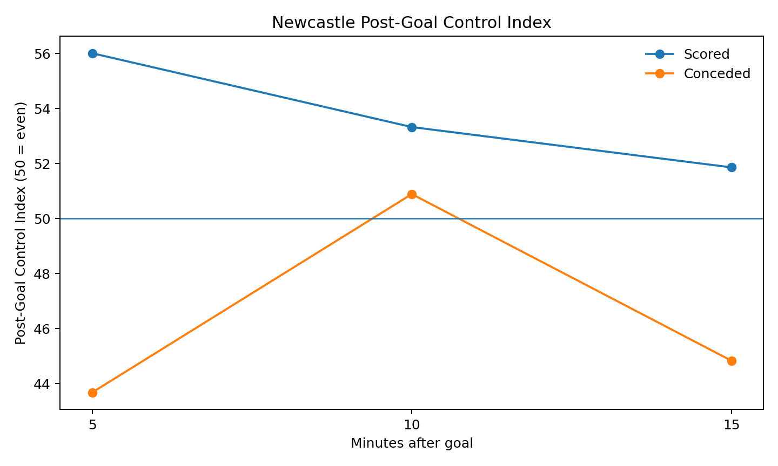

Why the SOT differential changes
The event data suggests the post-score advantage is not simply Newcastle taking more shots. The more distinctive change is shot quality. After scoring, Newcastle's 15-minute shots were closer, more frequently inside the box and carried substantially higher xG per attempt than the opponent's shots. After conceding, Newcastle's own 15-minute attempts were lower quality than the opponent's.
Prior goal | Team | Shots | xG/shot | Inside box | Avg distance | SOT%
Conceded | Opponent | 79 | 0.138 | 72.2% | 15.5m | 44.3%
Conceded | Newcastle | 74 | 0.114 | 66.2% | 16.0m | 40.5%
Scored | Opponent | 80 | 0.090 | 66.2% | 15.8m | 36.2%
Scored | Newcastle | 82 | 0.170 | 74.4% | 13.8m | 45.1%
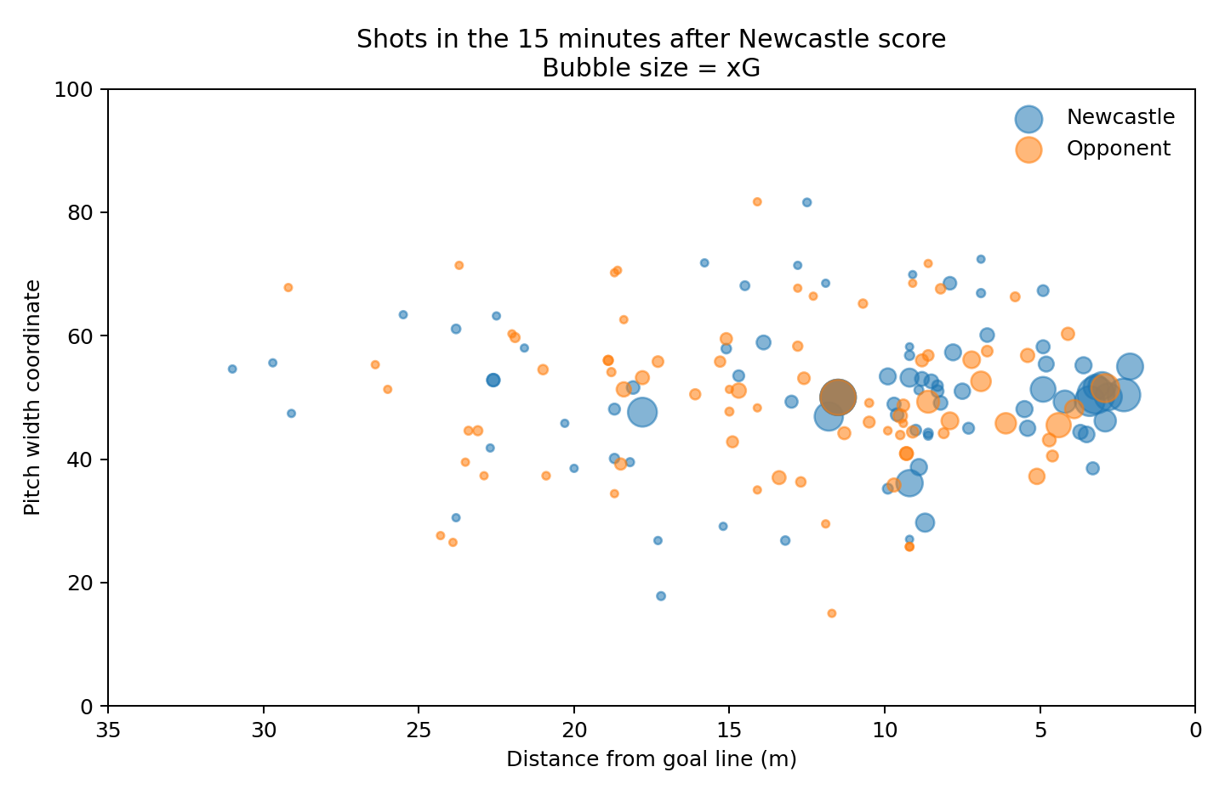

Context: venue and score state
The strongest repeatable contextual split is venue. Newcastle retained much more control after scoring at home than away. Score-state samples become small quickly, so those splits should be treated as descriptive rather than causal.
Prior goal | Venue | N | Shot diff | SOT diff | xG diff
Conceded | Away | 19 | -0.11 | -0.11 | -0.101
Conceded | Home | 21 | -0.14 | -0.14 | -0.028
Scored | Away | 16 | -0.12 | +0.31 | +0.067
Scored | Home | 26 | +0.15 | +0.12 | +0.217

Opening-goal behaviour
- When Newcastle conceded the opening goal and a complete 15-minute window remained (n=12), the subsequent average SOT differential was +0.00, xG differential -0.019, and PGCI 46.0.
- When Newcastle scored the opening goal and a complete 15-minute window remained (n=22), the subsequent average SOT differential was +0.45, xG differential +0.199, and PGCI 54.0.

Opponent signals
For opponents faced in at least two complete 15-minute post-score windows, the table below highlights where Newcastle most often lost or retained control. These are small repeated samples and should be used to generate tactical questions, not as opponent rankings.
Opponent | N | PGCI | xG diff | SOT diff
Nottingham Forest | 2 | 23.4 | -0.19 | -1.00
West Ham United | 4 | 32.3 | -0.03 | -1.00
Brentford | 3 | 39.2 | +0.06 | -0.67
Everton | 5 | 39.8 | -0.16 | -0.20
Manchester City | 3 | 47.1 | +0.32 | +0.33
Liverpool | 2 | 50.9 | -0.21 | -0.50
Leeds United | 2 | 52.7 | -0.08 | +0.00
Tottenham Hotspur | 3 | 59.9 | +0.28 | +1.00
Burnley | 4 | 68.4 | +0.67 | +1.50
Chelsea | 3 | 75.5 | +0.16 | +0.67
Brighton & Hove Albion | 3 | 80.8 | +0.67 | +1.00
Crystal Palace | 2 | 85.5 | +0.33 | +2.00

Methodology and limitations
- Source: the uploaded FPL-Core-Insights 2025/26 Premier League event dataset. Newcastle's 38 league matches contain 962 shot records and 108 goal incidents.
- Playing-time alignment accounts for first-half and second-half added time. Events at the same effective timestamp as the goal are excluded from the post-goal window.
- SOT is defined as shot outcomes recorded as 'save' or 'goal'. xGOT is summed where supplied; non-on-target shots have no xGOT and contribute zero.
- PGCI = 100 × mean(Newcastle shot share, Newcastle SOT share, Newcastle xG share) within a window. If neither team records an event for a component, that component is assigned 50%. Thus 50 is neutral control.
- Shot distance is an estimate from the supplied coordinates: horizontal distance from goal plus pitch-width displacement converted using a 68m pitch width. It is useful comparatively, not as tracking-grade geometry.
- Bootstrap intervals in the workbook are event-level resamples and do not fully model within-match dependence. Results are descriptive and the samples become smaller for late goals and contextual splits.
- This study identifies associations in observed match states; it does not establish that scoring itself causes the subsequent pattern.

Analyst takeaway
The actionable question is not simply whether Newcastle shoot more after a goal. The 2025/26 event data indicates that after scoring, Newcastle generally protect their SOT position through better chance quality, particularly at home; after conceding, that quality advantage disappears. A useful next tactical layer would link these windows to possession sequences, field tilt, substitutions and pressing actions to identify the mechanisms that create or erode that control.

Part III - Tactical Explanation
2025/26 Premier League | Tactical event-level extension

Core finding
Territorial pressure is the clearest mechanism in the available event data. In complete 15-minute windows after Newcastle scored, 27 goal events had a positive average Newcastle momentum signal and 15 had a negative signal. Positive-pressure windows produced a mean Post-Goal Control Index (PGCI) of 62.4, +0.314 xG differential and +0.519 SOT differential. Negative-pressure windows produced a PGCI of 32.9, -0.118 xG differential and -0.400 SOT differential.

Why the home/away gap appears
After scoring at home, Newcastle's average post-goal momentum signal was +9.16 and the team held positive pressure for 63.5% of the observed minutes. The corresponding PGCI was 55.6 and xG differential +0.217. Away from home, average momentum fell to +2.79, positive-pressure share to 50.1%, PGCI to 45.8 and xG differential to +0.067. This supports a specific tactical interpretation: the away drop in post-score control is associated with Newcastle spending less of the following period on the front foot, rather than simply a universal reduction in shooting.
After scoring | N | Momentum | Positive pressure | PGCI | SOT diff | xG diff
Home | 26 | +9.16 | 63.5% | 55.6 | +0.35 | +0.217
Away | 16 | +2.79 | 50.1% | 45.8 | -0.06 | +0.067

What happens when territory is lost?
The separation is large. When the 15-minute post-score momentum signal was positive, Newcastle averaged +0.85 shots, +0.52 SOT and +0.314 xG relative to the opponent. When it was negative, Newcastle averaged -1.40 shots, -0.40 SOT and -0.118 xG. The earlier SOT-control finding therefore has a plausible event-level mechanism: maintaining territorial pressure after scoring is associated with Newcastle continuing to create the better chances and preventing the opponent from accumulating attempts.

Substitutions: useful context, not a causal answer
Newcastle made a substitution within 15 minutes of scoring in 14 complete windows. Those windows had a lower average PGCI (45.8) than the 28 windows without a Newcastle substitution (54.9). This should not be read as substitutions causing control to fall. Managers are more likely to change personnel when the game state, fatigue or opponent pressure already demands it, creating strong selection bias. The result is better treated as a flag for future player-level work.

What the data does and does not let us say
- The source provides minute-level momentum/pressure, shots, goal incidents, line-ups, substitutions and whole-match team statistics.
- Whole-match possession and average positions were not used as if they were 15-minute post-goal measures; doing so would mix pre-goal and post-goal behaviour.
- The momentum signal is used as a territory/pressure proxy. It is not possession percentage and should not be presented as one.
- These are descriptive associations from one league season. Multiple goal events can occur in the same match, so observations are not fully independent.
- The evidence supports 'loss of territorial pressure is associated with loss of SOT/xG control'; it does not establish a causal tactical mechanism such as deliberately defending deeper.

Analyst interpretation
The strongest presentation-ready conclusion is: Newcastle's ability to protect a lead is linked to whether they can keep the game in positive territory after scoring. At home they do this considerably more often; away, the pressure signal becomes much closer to neutral and their SOT control disappears. This turns the project from a generic 'more shots are good' result into a tactical question for analysts: what personnel, pressing structure or ball-progression behaviour allows Newcastle to keep territory after going ahead, especially away from St James' Park?

Next test
The next player-level stage should isolate the personnel and substitutions present in positive- versus negative-pressure post-score windows. That is the right place to test whether particular midfield combinations, wide players or substitutions repeatedly coincide with Newcastle retaining territory.

Part IV - Player-Level Control
Who is on the pitch when Newcastle retain control after scoring?

Executive finding
The player-level layer strengthens the previous territorial-pressure finding, but it should be treated as association rather than player causation. Among players with repeated complete 15-minute post-score windows, Fabian Schär and Lewis Miley appear most consistently in high-control periods. Schär's 13 complete windows averaged a PGCI of 66.8, +0.332 xG differential and +0.85 SOT differential; Miley's 17 averaged PGCI 64.7, +0.277 xG and +0.88 SOT.

Repeated player signals
Player | Windows | PGCI | Momentum | xG diff | SOT diff
F. Schär | 13 | 66.8 | +15.64 | +0.332 | +0.85
L. Miley | 17 | 64.7 | +10.48 | +0.277 | +0.88
J. Murphy | 16 | 61.7 | +7.50 | +0.258 | +0.69
V. Livramento | 16 | 60.5 | +8.70 | +0.211 | +0.63
B. Guimarães | 33 | 53.4 | +7.29 | +0.184 | +0.33
S. Tonali | 23 | 51.3 | +8.65 | +0.182 | +0.22
Bruno Guimarães is especially useful as a reference because he appears in 33 of the 40 complete windows, giving a much broader sample than most players. His windows remain positive on PGCI, momentum, xG and SOT differential, but the smaller-sample peaks above should not automatically be interpreted as stronger individual effects.

Unit combinations
The most striking repeated combination was Lewis Miley + Sandro Tonali: 8 complete windows together produced PGCI 80.3, +0.524 xG differential and +1.50 SOT differential. Miley + Jacob Murphy (8 windows) also produced PGCI 77.2 and +1.13 SOT differential. Schär appears in several of the highest-control defensive/midfield pairings.
Pair | N | PGCI | Momentum | xG diff | SOT diff
Miley + Tonali | 8 | 80.3 | +15.28 | +0.524 | +1.50
Miley + J. Murphy | 8 | 77.2 | +10.93 | +0.353 | +1.13
Schär + J. Murphy | 6 | 70.6 | +17.88 | +0.331 | +1.00
Schär + Gordon | 9 | 68.4 | +16.62 | +0.304 | +0.78
Schär + Livramento | 8 | 68.3 | +10.20 | +0.331 | +0.75

What not to conclude
These results do not prove that selecting a named player will raise Newcastle's post-goal control. Player availability, opponent strength, venue, score state, substitutions and the period of the season all affect who is on the pitch. Goal windows within the same match are also not independent. For that reason, the analysis is best used to identify combinations worth video review rather than to rank players.

Substitution signal
The substitution samples are too small for a reliable player-on ranking. For example, Willock entered during four qualifying post-score windows and Murphy during three. These changes often occur precisely because the match context is already changing, so attributing the subsequent control level to the substitute would be misleading. The workbook retains the numbers for auditability, but they should stay out of any strong presentation claim.

Analyst takeaway
The most useful football question produced by this stage is now narrower: video-review the high-control Miley-Tonali and Schär-led post-score windows against the low-control windows and identify the repeatable behaviours - spacing in midfield, counter-press positioning, full-back height, ability to win second balls and progression after regains. That would convert the statistical association into a tactical explanation Newcastle's analysts could evaluate.

Method
- 40 Newcastle goals had a complete 15 minutes of playing time remaining and were used for this player-level study.
- A player counts as present only if he remained on the pitch for the entire 15-minute window after the goal.
- PGCI is the mean of Newcastle's shot share, SOT share and xG share, scaled 0-100; 50 represents even control.
- Pair combinations shown require at least six shared complete windows. Individual player tables include players with at least five.
- Momentum is the source dataset's minute-level pressure/territory signal re-signed so positive values favour Newcastle.

Integrated conclusions
- SOT control is more informative than raw shot volume because it combines the ability to generate attempts with the ability to turn those attempts into credible goalmouth threat.
- After Newcastle score, the strongest signal is not simply “more shots”. The event study points to better chance quality and, in successful windows, sustained territorial pressure.
- The home/away difference matters: Newcastle’s post-score control is materially stronger at home, while away matches more often move toward neutral or negative pressure.
- Personnel results are best used as video-review prompts. High-control windows involving Schär, Miley, Murphy, Livramento and the Miley-Tonali pairing warrant tactical inspection, but the statistical samples do not isolate individual causal effects.
- The next analytical step should therefore be targeted video and richer possession/pressing event data, not another broad correlation model.

Key limitations
- The initial match-level study includes 43 matches spanning 2025/26 and the first five supplied 2026/27 matches, whereas the event-level tactical/player work focuses on the complete 2025/26 Premier League season.
- Post-goal windows are descriptive associations. Scoring changes match incentives and opponent behaviour, so the analysis does not establish a causal effect of the goal itself.
- Player and pair samples are modest and heavily confounded by opponent, venue, availability, score state and selection. They should not be interpreted as player rankings.
- The pressure/momentum field is a territory proxy from the source dataset, not possession percentage or tracking data.
- Multiple goal events can occur in one match, so event observations are not fully independent.

Portfolio takeaway
The project progresses from a broad statistical observation to a narrower football question. Newcastle’s strongest post-score periods are characterised by sustained territorial pressure and better chance quality; the main weakness appears when that territorial control disappears, particularly away from home. The most valuable follow-up is therefore to identify the repeatable tactical behaviours and personnel structures that allow Newcastle to keep opponents pinned back after taking the lead.

