


INDIVIDUAL ASSIGNMENT

LANKA

COMP40004

WEB DEVELOPMENT AND OPERATING SYSTEMS-1
COMK2461

HAND OUT DATE: 15th July 2024

HAND IN DATE: ASSIGNMENT2: 13th September 2024

WEIGHTAGE: ASSIGNMENT 2: 30%

INSTRUCTION TO CANDIDATES:

- Students are advised to underpin their answers with the use of references (cited using the Harvard Name System of Referencing).

- Late submission will be awarded zero (0) unless Extenuating Circumstances (EC) are upheld.

- Cases of plagiarism will be penalized

- Assignment presentation should be submitted in the form of softcopy and hardcopy both; modeling work should be submitted in softcopy form

Contents

- Introduction
- Achknowledgement
- Wireframes
3.1 Mobile wireframes
3.2 Desktop wireframes
- Challenges faced

1.Title Page

Report Name: Hospital website and wireframe

Name: Ahmed Zayn Mohamed Zareer

CB Number: CB016024

Date: 8/16/2024

Acknowledgement

I would like to express my gratitude to our lecturer Mr. pradeep pallegama who helped us get a good understanding of the module and guided us through the WDOS 1 assignment.

Furthermore, I would like to thank my fellow colleagues who helped me out throughout this assignment.

Introduction

The main objective of the WDOS 1 assignment is to create a functional website for a Hospital. This report contains the wireframes for the webpage design, the challenges faced and how I over came them during the process of creating webpages for the ‘Care Corner’ Hospital

Desktop wireframe

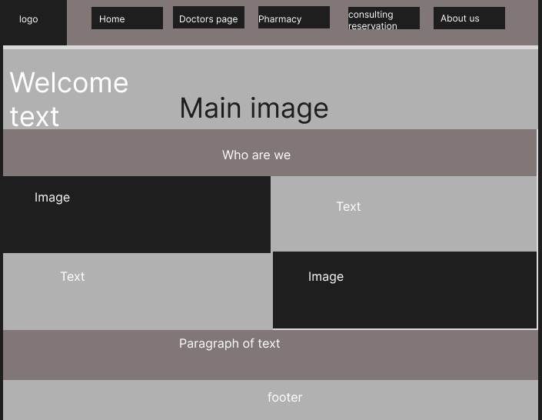

Challenges faced

I faced multiple challenges throughout my webpage designing. Here are a few of them :

- I had issues with placing my welcome text on top of the main image in the home pages. The text was appearing outside the image. Using div elements did not solve the issue either.

- One of the problems I had with the css styling of the webpage was with animations and transitions. I had limited knowledge of the properties, and therefore struggled to create the animations that I wanted and did not know how to style some of the animation ideas that I had.

How I overcame the challenges faced.

- The text over image issue was solved after learning the ‘position: relative’ and the ‘position: absolute;’ properties in CSS. I was able to set the main image to ‘position:relative’ and the text div to ‘position: absolute’. Thereafter I was able to style the text div element relative to the image and place it where I wanted using the ‘top’, ‘left’, ‘rights’ css properties.

- The animation challenges was dealt with by browsing YouTube and the internet for guides on animations and transformations in CSS. After building a basic idea on those, I was able to apply animations with ease. Though I did not come a pro at it, the basic knowledge cleared a lot of doubts I had and now I have the basic idea on adding animations and transitions. So learning the advanced methods will be much easies.

References

