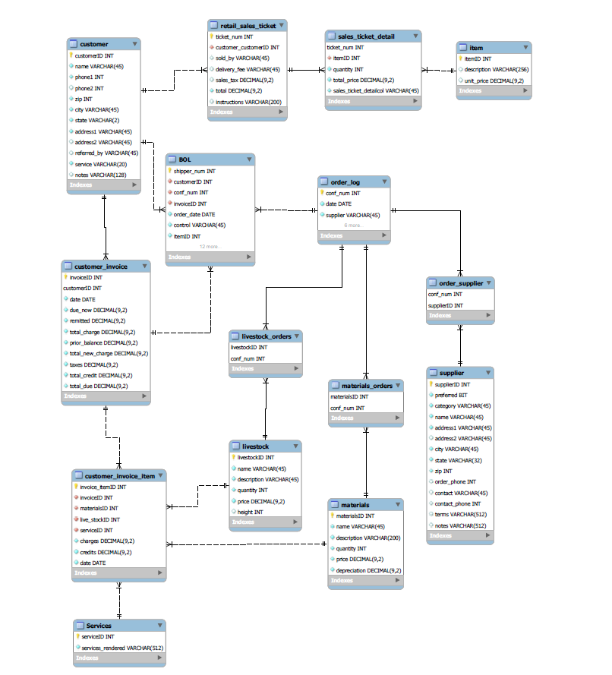

-- MySQL Script generated by MySQL Workbench

-- Mon Mar 15 14:46:11 2021

-- Model: New Model Version: 1.0

-- MySQL Workbench Forward Engineering

SET @OLD_UNIQUE_CHECKS=@@UNIQUE_CHECKS, UNIQUE_CHECKS=0;

SET @OLD_FOREIGN_KEY_CHECKS=@@FOREIGN_KEY_CHECKS, FOREIGN_KEY_CHECKS=0;

SET @OLD_SQL_MODE=@@SQL_MODE, SQL_MODE='ONLY_FULL_GROUP_BY,STRICT_TRANS_TABLES,NO_ZERO_IN_DATE,NO_ZERO_DATE,ERROR_FOR_DIVISION_BY_ZERO,NO_ENGINE_SUBSTITUTION';

-- -----------------------------------------------------

-- Schema mydb

-- -----------------------------------------------------

-- -----------------------------------------------------

-- Schema mydb

-- -----------------------------------------------------

CREATE SCHEMA IF NOT EXISTS `mydb` DEFAULT CHARACTER SET utf8 ;

USE `mydb` ;

-- -----------------------------------------------------

-- Table `mydb`.`customer`

-- -----------------------------------------------------

CREATE TABLE IF NOT EXISTS `mydb`.`customer` (

`customerID` INT NOT NULL AUTO_INCREMENT,

`name` VARCHAR(45) NOT NULL,

`phone1` INT NOT NULL,

`phone2` INT NULL DEFAULT NULL,

`zip` INT NOT NULL,

`city` VARCHAR(45) NOT NULL,

`state` VARCHAR(2) NOT NULL,

`address1` VARCHAR(45) NOT NULL,

`address2` VARCHAR(45) NULL DEFAULT NULL,

`referred_by` VARCHAR(45) NULL DEFAULT NULL,

`service` VARCHAR(20) NOT NULL,

`notes` VARCHAR(128) NULL DEFAULT NULL,

PRIMARY KEY (`customerID`))

ENGINE = InnoDB;

-- -----------------------------------------------------

-- Table `mydb`.`customer_invoice`

-- -----------------------------------------------------

CREATE TABLE IF NOT EXISTS `mydb`.`customer_invoice` (

`invoiceID` INT NOT NULL AUTO_INCREMENT,

`customerID` INT NOT NULL,

`date` DATE NOT NULL,

`due_now` DECIMAL(9,2) NOT NULL,

`remitted` DECIMAL(9,2) NOT NULL,

`total_charge` DECIMAL(9,2) NOT NULL,

`prior_balance` DECIMAL(9,2) NOT NULL,

`total_new_charge` DECIMAL(9,2) NOT NULL,

`taxes` DECIMAL(9,2) NOT NULL,

`total_credit` DECIMAL(9,2) NOT NULL,

`total_due` DECIMAL(9,2) NOT NULL,

PRIMARY KEY (`invoiceID`, `customerID`),

INDEX `fk_customer_invoice_customer1_idx` (`customerID` ASC) VISIBLE,

CONSTRAINT `fk_customer_invoice_customer1`

FOREIGN KEY (`customerID`)

REFERENCES `mydb`.`customer` (`customerID`)

ON DELETE NO ACTION

ON UPDATE NO ACTION)

ENGINE = InnoDB;

-- -----------------------------------------------------

-- Table `mydb`.`Services`

-- -----------------------------------------------------

CREATE TABLE IF NOT EXISTS `mydb`.`Services` (

`serviceID` INT NOT NULL AUTO_INCREMENT,

`services_rendered` VARCHAR(512) NOT NULL,

PRIMARY KEY (`serviceID`))

ENGINE = InnoDB;

-- -----------------------------------------------------

-- Table `mydb`.`materials`

-- -----------------------------------------------------

CREATE TABLE IF NOT EXISTS `mydb`.`materials` (

`materialsID` INT NOT NULL AUTO_INCREMENT,

`name` VARCHAR(45) NOT NULL,

`description` VARCHAR(200) NOT NULL,

`quantity` INT NOT NULL,

`price` DECIMAL(9,2) NOT NULL,

`depreciation` DECIMAL(9,2) NOT NULL,

PRIMARY KEY (`materialsID`))

ENGINE = InnoDB;

-- -----------------------------------------------------

-- Table `mydb`.`livestock`

-- -----------------------------------------------------

CREATE TABLE IF NOT EXISTS `mydb`.`livestock` (

`livestockID` INT NOT NULL AUTO_INCREMENT,

`name` VARCHAR(45) NOT NULL,

`description` VARCHAR(45) NOT NULL,

`quantity` INT NOT NULL,

`price` DECIMAL(9,2) NOT NULL,

`height` INT NULL,

PRIMARY KEY (`livestockID`))

ENGINE = InnoDB;

-- -----------------------------------------------------

-- Table `mydb`.`customer_invoice_item`

-- -----------------------------------------------------

CREATE TABLE IF NOT EXISTS `mydb`.`customer_invoice_item` (

`invoice_itemID` INT NOT NULL AUTO_INCREMENT,

`invoiceID` INT NOT NULL,

`materialsID` INT NOT NULL,

`live_stockID` INT NOT NULL,

`serviceID` INT NOT NULL,

`charges` DECIMAL(9,2) NOT NULL,

`credits` DECIMAL(9,2) NOT NULL,

`date` DATE NOT NULL,

PRIMARY KEY (`invoice_itemID`),

INDEX `fk_InvoiceDetails_CustomerInvoice1_idx` (`invoiceID` ASC) VISIBLE,

INDEX `fk_InvoiceDetails_LS_Materials1_idx` (`materialsID` ASC) VISIBLE,

INDEX `fk_InvoiceDetails_LiveStock1_idx` (`live_stockID` ASC) VISIBLE,

INDEX `serviceID_idx` (`serviceID` ASC) VISIBLE,

CONSTRAINT `fk_InvoiceDetails_CustomerInvoice1`

FOREIGN KEY (`invoiceID`)

REFERENCES `mydb`.`customer_invoice` (`invoiceID`)

ON DELETE NO ACTION

ON UPDATE NO ACTION,

CONSTRAINT `fk_InvoiceDetails_LS_Materials1`

FOREIGN KEY (`materialsID`)

REFERENCES `mydb`.`materials` (`materialsID`)

ON DELETE NO ACTION

ON UPDATE NO ACTION,

CONSTRAINT `fk_InvoiceDetails_LiveStock1`

FOREIGN KEY (`live_stockID`)

REFERENCES `mydb`.`livestock` (`livestockID`)

ON DELETE NO ACTION

ON UPDATE NO ACTION,

CONSTRAINT `serviceID`

FOREIGN KEY (`serviceID`)

REFERENCES `mydb`.`Services` (`serviceID`)

ON DELETE NO ACTION

ON UPDATE NO ACTION)

ENGINE = InnoDB;

-- -----------------------------------------------------

-- Table `mydb`.`order_log`

-- -----------------------------------------------------

CREATE TABLE IF NOT EXISTS `mydb`.`order_log` (

`conf_num` INT NOT NULL,

`date` DATE NOT NULL,

`supplier` VARCHAR(45) NOT NULL,

`item` VARCHAR(45) NOT NULL,

`quantity` INT NOT NULL,

`ext_price` DECIMAL(9,2) NOT NULL,

`taxrs` DECIMAL(9,2) NOT NULL,

`shipping` DECIMAL(9,2) NOT NULL,

`total` DECIMAL(9,2) NOT NULL,

PRIMARY KEY (`conf_num`))

ENGINE = InnoDB;

-- -----------------------------------------------------

-- Table `mydb`.`livestock_orders`

-- -----------------------------------------------------

CREATE TABLE IF NOT EXISTS `mydb`.`livestock_orders` (

`livestockID` INT NOT NULL,

`conf_num` INT NOT NULL,

INDEX `fk_LiveStockOrders_LiveStock1_idx` (`livestockID` ASC) VISIBLE,

PRIMARY KEY (`conf_num`, `livestockID`),

CONSTRAINT `fk_LiveStockOrders_LiveStock1`

FOREIGN KEY (`livestockID`)

REFERENCES `mydb`.`livestock` (`livestockID`)

ON DELETE NO ACTION

ON UPDATE NO ACTION,

CONSTRAINT `fk_LiveStockOrders_OrderLog1`

FOREIGN KEY (`conf_num`)

REFERENCES `mydb`.`order_log` (`conf_num`)

ON DELETE NO ACTION

ON UPDATE NO ACTION)

ENGINE = InnoDB;

-- -----------------------------------------------------

-- Table `mydb`.`supplier`

-- -----------------------------------------------------

CREATE TABLE IF NOT EXISTS `mydb`.`supplier` (

`supplierID` INT NOT NULL,

`preferred` BIT NOT NULL,

`category` VARCHAR(45) NOT NULL,

`name` VARCHAR(45) NOT NULL,

`address1` VARCHAR(45) NOT NULL,

`address2` VARCHAR(45) NULL DEFAULT NULL,

`city` VARCHAR(45) NOT NULL,

`state` VARCHAR(32) NOT NULL,

`zip` INT NOT NULL,

`order_phone` INT NULL DEFAULT NULL,

`contact` VARCHAR(45) NULL DEFAULT NULL,

`contact_phone` INT NULL DEFAULT NULL,

`terms` VARCHAR(512) NULL DEFAULT NULL,

`notes` VARCHAR(512) NULL DEFAULT NULL,

PRIMARY KEY (`supplierID`))

ENGINE = InnoDB;

-- -----------------------------------------------------

-- Table `mydb`.`BOL`

-- -----------------------------------------------------

CREATE TABLE IF NOT EXISTS `mydb`.`BOL` (

`shipper_num` INT NOT NULL,

`customerID` INT NOT NULL,

`conf_num` INT NOT NULL,

`invoiceID` INT NOT NULL,

`order_date` DATE NOT NULL,

`control` VARCHAR(45) NOT NULL,

`itemID` INT NOT NULL,

`quantity_ordered` INT NOT NULL,

`quantity_shipped` INT NOT NULL,

`quantity_back_ord` INT NOT NULL,

`eta` DATE NULL DEFAULT NULL,

`description` VARCHAR(128) NOT NULL,

`uom` VARCHAR(45) NOT NULL,

`unit_price` DECIMAL(9,2) NOT NULL,

`extended_amount` DECIMAL(9,2) NOT NULL,

`instructions` VARCHAR(1024) NOT NULL,

`num_items` INT NOT NULL,

`num_pieces` INT NOT NULL,

`phone` INT NOT NULL,

PRIMARY KEY (`shipper_num`),

INDEX `fk_BOL_OrderLog1_idx` (`conf_num` ASC) VISIBLE,

INDEX `customerID_idx` (`customerID` ASC) VISIBLE,

INDEX `invoiceID_idx` (`invoiceID` ASC) VISIBLE,

CONSTRAINT `fk_BOL_OrderLog1`

FOREIGN KEY (`conf_num`)

REFERENCES `mydb`.`order_log` (`conf_num`)

ON DELETE NO ACTION

ON UPDATE NO ACTION,

CONSTRAINT `fk_customerID_bol`

FOREIGN KEY (`customerID`)

REFERENCES `mydb`.`customer` (`customerID`)

ON DELETE NO ACTION

ON UPDATE NO ACTION,

CONSTRAINT `invoiceID`

FOREIGN KEY (`invoiceID`)

REFERENCES `mydb`.`customer_invoice` (`invoiceID`)

ON DELETE NO ACTION

ON UPDATE NO ACTION)

ENGINE = InnoDB;

-- -----------------------------------------------------

-- Table `mydb`.`order_supplier`

-- -----------------------------------------------------

CREATE TABLE IF NOT EXISTS `mydb`.`order_supplier` (

`conf_num` INT NOT NULL,

`supplierID` INT NOT NULL,

INDEX `fk_OrderSupplier_SupplierInfo1_idx` (`supplierID` ASC) VISIBLE,

PRIMARY KEY (`conf_num`, `supplierID`),

CONSTRAINT `fk_OrderSupplier_OrderLog1`

FOREIGN KEY (`conf_num`)

REFERENCES `mydb`.`order_log` (`conf_num`)

ON DELETE NO ACTION

ON UPDATE NO ACTION,

CONSTRAINT `fk_OrderSupplier_SupplierInfo1`

FOREIGN KEY (`supplierID`)

REFERENCES `mydb`.`supplier` (`supplierID`)

ON DELETE NO ACTION

ON UPDATE NO ACTION)

ENGINE = InnoDB;

-- -----------------------------------------------------

-- Table `mydb`.`materials_orders`

-- -----------------------------------------------------

CREATE TABLE IF NOT EXISTS `mydb`.`materials_orders` (

`materialsID` INT NOT NULL,

`conf_num` INT NOT NULL,

PRIMARY KEY (`materialsID`, `conf_num`),

INDEX `fk_materials_has_order_log_order_log1_idx` (`conf_num` ASC) VISIBLE,

INDEX `fk_materials_has_order_log_materials1_idx` (`materialsID` ASC) VISIBLE,

CONSTRAINT `fk_materials_has_order_log_materials1`

FOREIGN KEY (`materialsID`)

REFERENCES `mydb`.`materials` (`materialsID`)

ON DELETE NO ACTION

ON UPDATE NO ACTION,

CONSTRAINT `fk_materials_has_order_log_order_log1`

FOREIGN KEY (`conf_num`)

REFERENCES `mydb`.`order_log` (`conf_num`)

ON DELETE NO ACTION

ON UPDATE NO ACTION)

ENGINE = InnoDB;

-- -----------------------------------------------------

-- Table `mydb`.`retail_sales_ticket`

-- -----------------------------------------------------

CREATE TABLE IF NOT EXISTS `mydb`.`retail_sales_ticket` (

`ticket_num` INT NOT NULL,

`customer_customerID` INT NOT NULL,

`sold_by` VARCHAR(45) NULL,

`delivery_fee` VARCHAR(45) NULL,

`sales_tax` DECIMAL(9,2) NULL,

`total` DECIMAL(9,2) NOT NULL,

`instructions` VARCHAR(200) NULL,

PRIMARY KEY (`ticket_num`),

INDEX `customerID_idx` (`customer_customerID` ASC) VISIBLE,

CONSTRAINT `fk_customerID_rst`

FOREIGN KEY (`customer_customerID`)

REFERENCES `mydb`.`customer` (`customerID`)

ON DELETE NO ACTION

ON UPDATE NO ACTION)

ENGINE = InnoDB;

-- -----------------------------------------------------

-- Table `mydb`.`item`

-- -----------------------------------------------------

CREATE TABLE IF NOT EXISTS `mydb`.`item` (

`itemID` INT NOT NULL,

`description` VARCHAR(256) NULL,

`unit_price` DECIMAL(9,2) NULL,

PRIMARY KEY (`itemID`))

ENGINE = InnoDB;

-- -----------------------------------------------------

-- Table `mydb`.`sales_ticket_detail`

-- -----------------------------------------------------

CREATE TABLE IF NOT EXISTS `mydb`.`sales_ticket_detail` (

`ticket_num` INT NOT NULL,

`itemID` INT NOT NULL,

`quantity` INT NOT NULL,

`total_price` DECIMAL(9,2) NOT NULL,

`sales_ticket_detailcol` VARCHAR(45) NOT NULL,

PRIMARY KEY (`ticket_num`),

INDEX `itemID_idx` (`itemID` ASC) VISIBLE,

CONSTRAINT `itemID`

FOREIGN KEY (`itemID`)

REFERENCES `mydb`.`item` (`itemID`)

ON DELETE NO ACTION

ON UPDATE NO ACTION,

CONSTRAINT `ticket_num`

FOREIGN KEY (`ticket_num`)

REFERENCES `mydb`.`retail_sales_ticket` (`ticket_num`)

ON DELETE NO ACTION

ON UPDATE NO ACTION)

ENGINE = InnoDB;

SET SQL_MODE=@OLD_SQL_MODE;

SET FOREIGN_KEY_CHECKS=@OLD_FOREIGN_KEY_CHECKS;

SET UNIQUE_CHECKS=@OLD_UNIQUE_CHECKS;

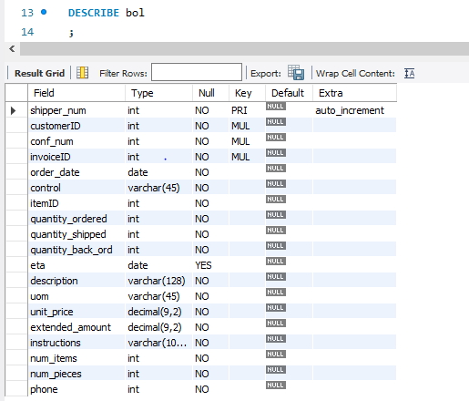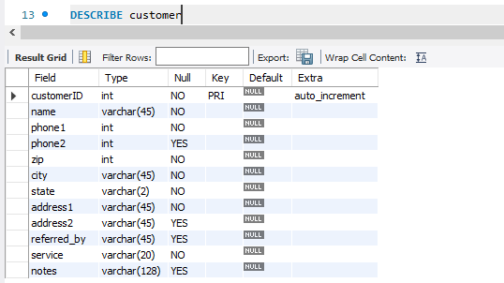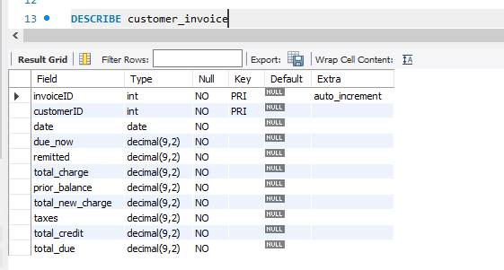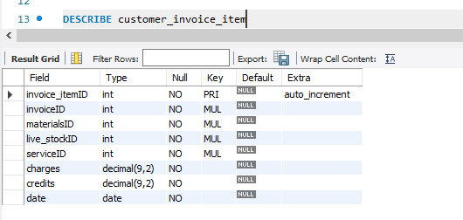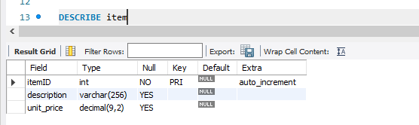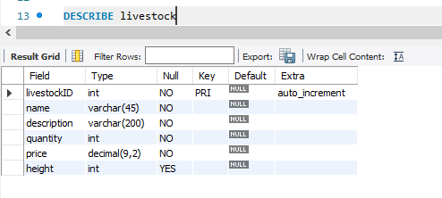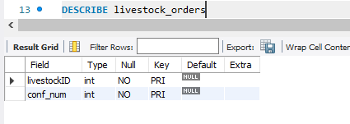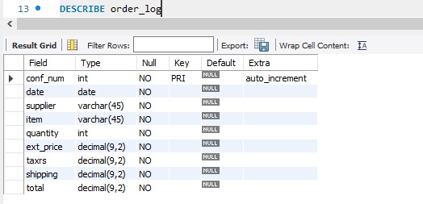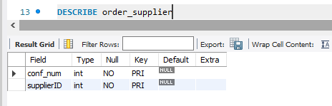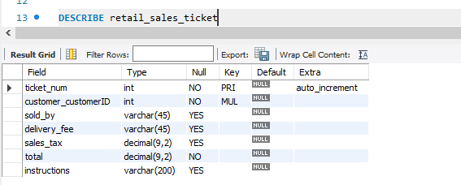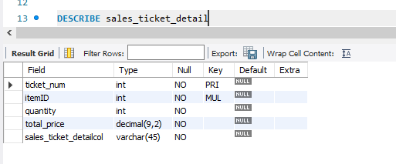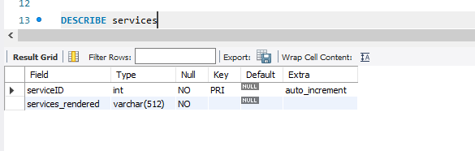

/* INSERT INTO livestock(name, description, quantity, price, height, category)

VALUES('Camellia Barbara Clark', 'Something you can replace your ex-wife with', 1, 20.00, 6, shrub),

('Mimosa Pink', 'mmmmmmm mimosas', 3, 25.00, 4, tree),

('Honey Locust', 'I thought locusts had another name', 7, 30.00, 6, tree),

('Black Gum', 'A very beatiful piece of life, no doubt', 43, 15.00, 8, tree),

('Azalea Red Bells', 'Go the bell plants if you wanna keep acting like a ding dong', 25, 18.00, 4, shrub),

('Corylopsis Winterthur', 'cory... winter...', 10, 10.00, 8, shrub),

('Mock Orange', 'Very very close to the real orange', 14, 20.00, 4, shrub),

('Mugo Pine', 'one of the classics', 17, 35.00, 2, shrub); */

/* INSERT INTO materials(name, description, quantity, price)

VALUES('Barn Red', 'red gravel is pretty neat', 1, 20.00),

('Quaker Blend', 'not the kind of oatmeal you want', 3, 25.00),

('Keystone', 'I thought locusts had another name', 7, 30.00),

('Boulders', 'large boulder about the size of a small boulder ', 43, 15.00),

('Diamondstone', 'GME', 25, 18.00),

('Used Railroad Ties', 'ya like railroad ties?', 10, 10.00); */

/* INSERT INTO customer(name, phone1, zip, city, state, address1, service)

VALUES ('Bobby Shmurda', 0000001919, 01920, 'Los Angeles', 'CA', '1800 bababoeey st', 'mowing'),

('Kanye West', 0400201919, 01220, 'Jacksonhole', 'WY', '420 nut st', 'other'),

('Dr. J', 0096001919, 11920, 'Boulder', 'CO', '6900 funnynumber st', 'landscaping'),

('Koolaid Man', 0050401939, 22920, 'San Diego', 'CA', '0001 st st', 'mowing'); */

/* INSERT INTO supplier(category, name, address1, contact_phone, city, state, zip)

VALUES ('livestock', 'McGinnis Farms Inc.', '', '7209638227', 'Grayson', 'GA', 34217),

('sod', 'Earth and Turf Company', '', '7173552446', 'New Holland', 'PA', 36548); */

/* INSERT INTO retail_sales_ticket(customer_customerID,delivery_fee, sales_tax, total)

SELECT c.customerID, 3.50, 1.20, 20.00

FROM customer c */

/* INSERT INTO retail_sales_ticket(customer_customerID,delivery_fee, sales_tax, total)

SELECT c.customerID, 3.50, 1.20, 20.00

FROM customer c */

/* INSERT INTO item (description, unit_price)

VALUES ('a pack of pepsis', 5.00),

('garden staples', 2.00),

('sunflower seeds', 1.00),

('genuine leather gloves', 4.00),

('propane tank 1 gallon', 2.00),

('that sloppey', 5.00),

('irrigation pipage 6 feet', 3.00),

('three pairs of socks', 1.00),

('candy', 7.00),

('soil, the good kind', 9.00); */

/* INSERT INTO sales_ticket_detail(fk_ticket_num, fk_itemID, quantity, total_price)

SELECT r.ticket_num, i.itemID, 5, 5 * i.unit_price

FROM retail_sales_ticket r, item i */

