**create** **table** college

(

id **bigint** **primary** **key** ,

**name** **varchar** **not** **null** ,

**size** **integer** **not** **null** **default** 100

);

**insert** **into** college(id, **name**, **size**) **values** (10, 'КФУ',50000);

**insert** **into** college(id, **name**, **size**) **values** (20, 'МГУ',38000);

**insert** **into** college(id, **name**, **size**) **values** (30, 'МФТИ',7000);

**insert** **into** college(id, **name**, **size**) **values** (40, 'Иннополис',1077);

**insert** **into** college(id, **name**, **size**) **values** (50, 'Сколково',1070);

**create** **table** student

(

id **bigint** **primary** **key** ,

city **varchar** **not** **null** ,

**name** **varchar** **not** **null** ,

telegram_contact **varchar** **not** **null**,

college_id **bigint** **not** **null**,

**constraint** fk_college_id **foreign** **key** (college_id) **references** college(id)

);

**insert** **into** student(id, city, **name**, telegram_contact, college_id) **values** (10, 'Казань','Иван Иванов','@ivanov1991',10);

**insert** **into** student(id, city, **name**, telegram_contact, college_id) **values** (20, 'Москва','Екатерина Андреева','@kate_',20);

**insert** **into** student(id, city, **name**, telegram_contact, college_id) **values** (30, 'Новосибирск','Анна Потапова','@apotap',30);

**insert** **into** student(id, city, **name**, telegram_contact, college_id) **values** (40, 'Казань','Ильяс Мухаметшин','@ilyas',40);

**insert** **into** student(id, city, **name**, telegram_contact, college_id) **values** (50, 'Москва','Сергей Петров','@spetrov',50);

**create** **table** course

(

id **bigint** **primary** **key** ,

**name** **varchar** **not** **null**,

is_online **boolean** **not** **null** **DEFAULT** **false**,

amount_of_students **integer** **check** ( amount_of_students >= 1 ),

college_id **bigint** **NOT** **NULL**,

**constraint** fk_course_college_id **foreign** **key** (college_id) **references** college(id)

);

**insert** **into** course(id, **name**, is_online, amount_of_students, college_id) **values** (10,'Введение в РСУБД', **true**, 300 , 10);

**insert** **into** course(id, **name**, is_online, amount_of_students, college_id) **values** (20,'Data Mining', **true**, 10 , 20);

**insert** **into** course(id, **name**, is_online, amount_of_students, college_id) **values** (30,'Нейронные сети', **true**, 25 , 30);

**insert** **into** course(id, **name**, is_online, amount_of_students, college_id) **values** (40,'Цифровая трансформация', **true**, 50 , 40);

**insert** **into** course(id, **name**, is_online, amount_of_students, college_id) **values** (50,'Актерское мастерство', **false**, 15 , 50);

**create** **table** student_on_course

(

id **bigint** **primary** **key** ,

student_id **bigint** **not** **null** ,

course_id **bigint** **not** **null** ,

student_rating **integer** **not** **null** **DEFAULT** 50 **check** ( student_rating **BETWEEN** 0 **and** 100 ),

finished_date **date**,

**constraint** fk_student_id **foreign** **key** (student_id) **references** student(id),

**constraint** fk_course_id **foreign** **key** (course_id) **references** course(id)

);

**insert** **into** student_on_course(id, student_id, course_id, student_rating, finished_date) **VALUES** (10,10,10,75, **null**);

**insert** **into** student_on_course(id, student_id, course_id, student_rating, finished_date) **VALUES** (20,10,20,83, **null**);

**insert** **into** student_on_course(id, student_id, course_id, student_rating, finished_date) **VALUES** (30,10,40,40, **null**);

**insert** **into** student_on_course(id, student_id, course_id, student_rating, finished_date) **VALUES** (40,20,50,95, '2022-12-12');

**insert** **into** student_on_course(id, student_id, course_id, student_rating, finished_date) **VALUES** (50,30,30,76, '2022-12-12');

**insert** **into** student_on_course(id, student_id, course_id, student_rating, finished_date) **VALUES** (60,30,40,42, **null**);

**insert** **into** student_on_course(id, student_id, course_id, student_rating, finished_date) **VALUES** (70,40,10,76, **null**);

**insert** **into** student_on_course(id, student_id, course_id, student_rating, finished_date) **VALUES** (80,40,20,83, **null**);

**insert** **into** student_on_course(id, student_id, course_id, student_rating, finished_date) **VALUES** (90,40,50,96, **null**);

**insert** **into** student_on_course(id, student_id, course_id, student_rating, finished_date) **VALUES** (100,50,10,12, **null**);

**insert** **into** student_on_course(id, student_id, course_id, student_rating, finished_date) **VALUES** (110,50,20,21, **null**);

**insert** **into** student_on_course(id, student_id, course_id, student_rating, finished_date) **VALUES** (120,50,30,56, **null**);

**insert** **into** student_on_course(id, student_id, course_id, student_rating, finished_date) **VALUES** (130,50,40,92, **null**);

**A**

**select** **name**, telegram_contact **from** student

**where** city = 'Казань'

**order** **by** **name** **desc**

**B**

**select** 'университет: ' || **name** || '; количество студентов: ' || **size** **as** "полная информация" **from** college

**order** **by** "полная информация"

**C**

**select** **name**, **size** **from** college

**where** id **in**(10, 30, 50)

**order** **by** **size**, **name**

**D**

**select** **name**, **size** **from** college

**where** id **not** **in**(10, 30, 50)

**order** **by** **size**, **name**

**E**

**select** **name**, amount_of_students **from** course

**where** is_online = **true** **and** amount_of_students >= 27 **and** amount_of_students <= 310

**order** **by** **name** **desc**, amount_of_students **desc**

**F**

**select** **name** **from** student

**union**

**select** **name** **from** course

**order** **by** 1 **desc**

**G**

**select** **name**, 'университет' **as** object_type **from** college

**union**

**select** **name**, 'курс' **as** object_type **from** course

**order** **by** object_type, **name**

**H**

**select** **name**, amount_of_students **from** course

**order** **by** **case** **when** amount_of_students = 300 **then** 1 **else** amount_of_students **end**

**limit** 3

**I**

**insert** **into** course(id, **name**, is_online, amount_of_students, college_id) **values** (60,'Machine Learning', **false**, 17 , 20);

**select** * **from** course

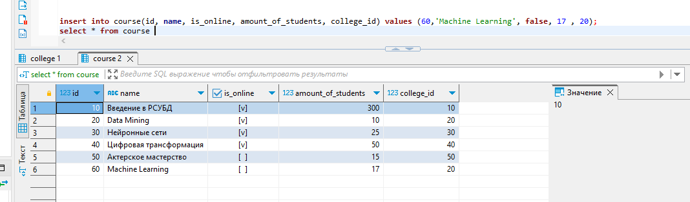

**J**

**with** _inner_1 **as**

(**select** id **from** course

**except**

**select** id **from** student_on_course),

_inner_2 **as**

(**select** id **from** student_on_course

**except**

**select** id **from** course)

**select** id **from** _inner_2

**union**

**select** id **from** _inner_2

**order** **by** 1

**K**

**select** foo.student_name, course.**name** course_name, foo.collage_name student_college, student_on_course.student_rating student_rating **from** student_on_course

**inner** **join**

(**select** student.id id, student.**name** student_name, college.**name** collage_name **from** student

**inner** **join** college **on** student.college_id = college.id

**where** college.**size** > 5000) **as** foo

**on** student_on_course.student_id = foo.id

**inner** **join** course **on** student_on_course.course_id = course.id

**where** student_on_course.student_rating > 50

**order** **by** 1,2

**L**

**select** **distinct** S1.**name** student_1, S2.**name** student_2, S1.city city

**from** student S1

**inner** **join** student S2 **ON** S1.city = S2.city **AND** S1.id > S2.id

**order** **by** 1

**M**

**select** "Оценка", **count**(*) **as** "Количество студентов" **from**

(

**select** **case**

**when** student_rating < 30 **then** 'неуд'

**when** student_rating >= 30 **and** student_rating < 60 **then** 'удвл'

**when** student_rating >= 60 **and** student_rating < 85 **then** 'хор'

**else** 'отл'

**end** **as** "Оценка"

**from** student_on_course

) **as** foo

**group** **by** "Оценка"

**order** **by** 2

**N**

**select** course.**name** **as** "Курс", **case**

**when** student_rating < 30 **then** 'неуд'

**when** student_rating >= 30 **and** student_rating < 60 **then** 'удвл'

**when** student_rating >= 60 **and** student_rating < 85 **then** 'хор'

**else** 'отл'

**end** **as** "Оценка", **count**(*) **as** "Количество студентов"

**from** student_on_course

**inner** **join** course **on** student_on_course.course_id = course.id

**group** **by** "Курс", "Оценка"

**order** **by** "Курс", "Количество студентов"