Deit recepie

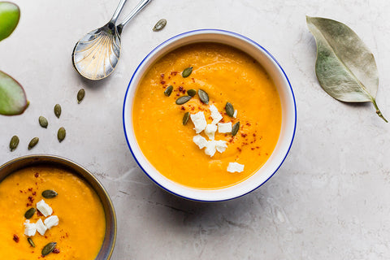
Dhadood's Carrot Ginger Soup
Makes 4 servings
By Katie O'Connell, Ayurvedic Health Practitioner, Yoga Instructor and Founder of Dragonfly Yoga Barn
Ingredients:
- 3 Tbsp olive oil
- 1 medium onion, chopped
- 4 cloves garlic, chopped
- 1 Tbsp ginger, chopped
- 1 lb carrots, shredded
- 1 orange, peeled and chopped
- 1 tsp "Better than Bouillon" vegetable base
- 2 cups water
- Salt and pepper to taste
Instructions:
- Sauté onion, garlic and ginger in olive oil (5-10 minutes).
- Add carrots, orange, vegetable base, water, salt and pepper.
- Let simmer for 40 minutes, stirring occasionally.
- Let stand for several hours (suggestion to deepen flavors).
- Blend in small batches.
- After reheating, add more water slowly to bring to desired consistency.
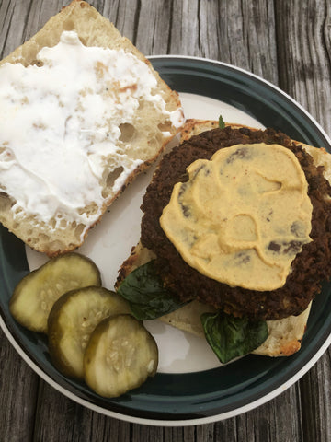
Adzuki Bean Burgers (V, GF)
Makes 6 large patties
By Pooja, Ayurvedic Counselor and Founder of Honey, Ghee and Tea
Ingredients:
- 2 1/2 cups adzuki beans, soaked for at least 3 hours
- 3/4 cup oat flour
- 1/4 cup fresh parsley, chopped
- 1/4 cup onion, diced
- 1 tsp fresh garlic, minced
- 1/2 cup carrot, peeled and shredded
- 1 tsp ground white pepper (can substitute black pepper)
- 1 tsp cumin powder
- 1 tsp dry thyme
- 1/2 tsp coriander powder
- 1/4 tsp cinnamon powder
- 1/4 tsp clove powder
- 1/4 tsp turmeric powder
- 1 tsp salt or per taste
- Oil to brush before baking
Instructions:
- Rinse Adzuki beans. Place in the Instant Pot with 2 1/2 cups of water and cook on high pressure x 16 mins, natural pressure release.**
- Preheat oven to 350F.
- In a large bowl, add drained cooked adzuki beans and roughly mash with hands.
- Then add in remaining ingredients except oil and combine well.
- Equally divide mixture into 6 parts and form patties with hands. May need to lightly oil hands.
- Place on greased baking tray and brush the top of each patty with more oil.
- Place in oven to bake for 28-30 minutes.
- Remove from oven and then sauté in 1/2 tsp oil on the stovetop to make crispier or eat as is with your favorite bread, toppings, and condiments!
**Stove Top Adzuki Bean cooking instructions: Rinse Adzuki beans and place in a large pot with 8 cups of water. Bring to a boil. Once boiling, lower heat to bring to a simmer, cover pot, and allow to cook for 45-50 minutes stirring occasionally.
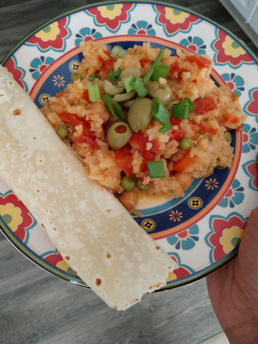
Arroz sin Pollo
By Kimberly Washington M.S., RYT, Certified Yoga Teacher, Ayurvedic Lifestyle Consultant and Founder of Yoga by Kimberly
Ingredients:
- 2 Tbs. Olive oil
- 1/2 Onion (small)
- 4-5 Garlic cloves, chopped
- Salt and pepper
- 1.5 tsp Sazon seasoning (we love Spice Tree Organics brand)
- 1 (15oz.) can diced tomatoes with juice
- ½ Red bell pepper seeded and chopped
- 2 large carrots peeled and cut 1/ inch thick
- ½ pounds fresh green beans trimmed and cut in half
- 1 (15oz.) can of chickpeas drained and rinsed
- ½ cup frozen peas (un-thawed)
- 1 cup white long-grain rice
- Salt and pepper to taste
- *Sliced Scallions, fresh cilantro, and halved green olives as an optional garnish
Instructions:
- Heat the olive oil in a skillet over medium-high heat until shimmering. Brown the onion and carrots for about 5 minutes, then add garlic and seasonings and continue to cook until fragrant about 1 minute.
- Transfer onion mixture to a slow cooker and add all remaining ingredients except rice and peas.
- Set crock pot to high 4 hours.
- At the last hour, working quickly, stir the rice and peas into the pot and continue cooking until rice is done, about 30-40 minutes.
- Season with salt and pepper to taste.
*Top with optional garnish and served with warmed tortillas*
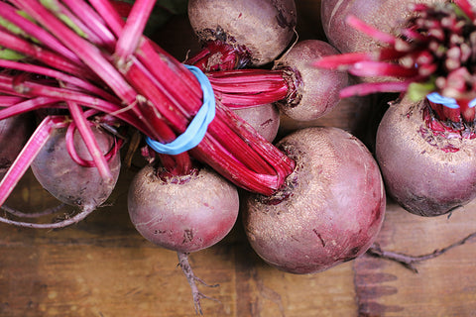
Baked Beet Root
Serves 2
By Dr. Michael Bittner E-RYT700, Ayurvedic Practitioner, Yoga/Feng Shui/Qigong Teacher and Co-Founder of The ZenSpot Institute
Check out the instructional video on how to make this dish here.
Ingredients:
- 1 large red beet
- Fresh thyme (6 -10 individual sprigs)
- Coconut or olive oil (1/8 cup max)
- Himalayan Salt
- Pepper
Instructions:
- Preheat oven to 400 degrees
- Place baking sheet in pan and coat with coconut or olive oil
- Wash the beet
- Trim away leaves and slice off top and bottom to create flat surface.
- Peel the beet.
- Square the beet by slicing off edges.
- Begin to cut ¼” sections, and then again, eventually cubing all pieces.
- Place cubes in bowl and drizzle with coconut or olive oil
- Strip thyme from stem, chop coarsely, and sprinkle over the beet cubes.
- Add salt and pepper to taste (not too much)
- Mix all together.
- Empty the beet onto the baking sheet, spreading out the cubes.
- Cook for 10 – 12 minutes
- Remove from oven and serve with basmati rice.
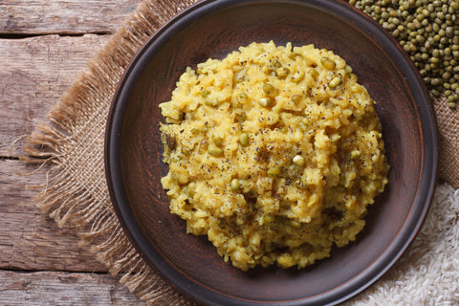
Kitchiri/Kichidi (spiced rice and lentil porridge)
Makes 4 servings
By the Lotus Blooming Herbs Kitchen
Ingredients:
- 1 cup split moong dal
- 1 cup white basmati rice
- 6 cups water
- 1 Tbsp ghee or coconut oil
- 1 inch fresh ginger, chopped or grated
- 1/4-1/2 tsp Himalayan sea salt
- 1/2 tsp coriander powder
- 1/2 tsp cumin powder
- 1/2 tsp cumin seeds
- 1/2 tsp black cumin seeds
- 1/2 tsp mustard seeds
- 1/2 tsp turmeric powder
- Pinch hing (asafoetida)
- 2 cups assorted vegetables (ie. carrots, zucchini, mustard greens, dandelion greens, asparagus, sweet potato, kale, spinach)
- Chopped cilantro to garnish (optional)
- Yogurt to garnish (optional)
Instructions:
- Rinse moong dal under cool water. Set aside.
- Rinse rice 4-5 times under cool water. Set aside.
- Heat up ghee in a pot on medium-low heat. Add all spices, but not salt. Sauté on medium-low until seeds start popping.
- Add dal and rice and stir to coat in spices.
- Add water, bring to a boil, lower heat and simmer for about 20 minutes.
- Add vegetables and cook for 10 minutes longer.
- Add salt to taste.
- Serve with chopped cilantro and yogurt if desired.

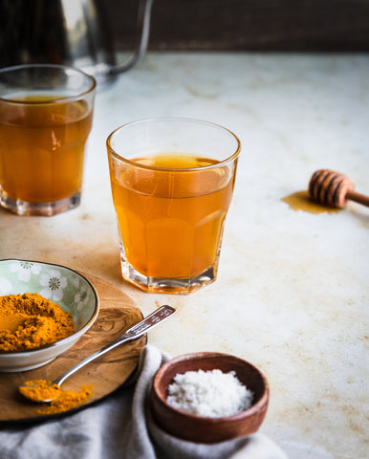

Turmeric Tea Recipe
- 8oz hot water
- 1/8 tsp organic ground turmeric
- 1/4-1/2 tsp sea salt
- Spoonful of honey (optional, but recommended for dry coughs)
Add ingredients to a glass. Stir until all ingredients are dissolved. You may need to stir the tea from time to time as the turmeric may settle. Take this tea 1-3 times a day as needed.

Immune boosting tonics

GENERAL IMMUNE SUPPORT
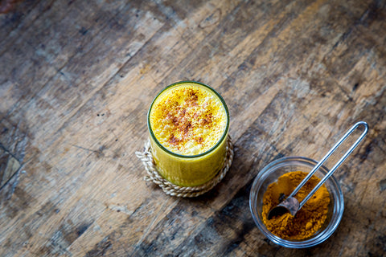
Turmeric Milk
In Ayurveda, spices are never taken alone. They are always first cooked in some type of oil or fat and then consumed. This helps to release the beneficial oils in the spices so the body can absorb them better. In addition, spices are often consumed with other spices, which help to balance any qualities that could be overly heating, cooling or drying.
Turmeric milk, (haldi doodh), or “golden milk,” is a popular tonic today among the health conscious community. However, it has been a staple in Indian households for thousands of years. It is important to note that milk is also never taken cold or alone in Ayurveda. To support the digestibility of the dairy, it is always heated with spices.
Curcumin, the active compound in turmeric has immense anti-inflammatory properties and is loaded with antioxidants that help to fight against free radical damage. This is why it is so popular with people suffering from joint pain. Ginger and cinnamon, two other spices common in turmeric milk, have also been shown to have strong anti-inflammatory properties.
Curcumin, ginger and cinnamon have also been shown to have some anti-bacterial, antiviral and antifungal activity.
Spices are often prescribed in Ayurvedic medicine to support digestion as well. As we have discussed, digestion impacts immune health, so this can be extremely helpful in supporting overall health and well being.
Here is a basic recipe for 1 serving of Turmeric Milk:
Ingredients:
- 1 cup of milk (dairy or unsweetened non-dairy milk)
- 1/2 tsp of turmeric
- ¼ tsp cardamom or 2 green cardamom pods, crushed
- 1/2 tsp of ginger powder or 1 tsp freshly grated ginger
- 1/4 tsp of cinnamon powder or ½ inch cinnamon stick
- 1 pinch of ground black pepper or 3-4 whole black peppercorns
- 1 tsp of honey or maple syrup (optional)
Instructions:
- Heat milk to a saucepan for a minute or two over medium heat.
- Add in turmeric and give it a good stir with a whisk.
- Add in remaining spices and bring to a low simmer for minutes, stirring every so often.
- Turn off heat and stir in sweetener if using.
- Strain mixture into a cup and enjoy!
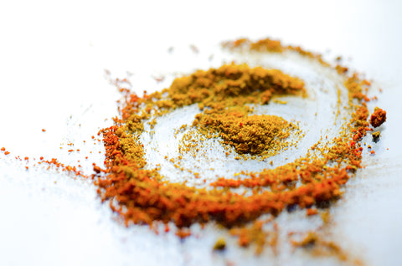
Detox Tea
This wonderful immune boosting detox tea was contributed by Resident Ayurveda Expert at Atmananda Yoga in New York City, Amita Banerjee. She has a wealth of knowledge when it comes to Ayurveda, so make sure to check out her site here.
Ingredients:
- 3 cups of water.
- ½ teaspoon of turmeric
- 3 crushed cardamom
- 3 cloves
- ½ teaspoon of crushed black pepper
- 1 teaspoon of grated fresh ginger
Instructions:
- Bring all ingredients to a boil and simmer for 10 minutes.
- Pour this over two slices of lemon and a bag of green tea and store in a flask.
- Drink half a cup every hour. Make a second batch in the evening to last until after dinner.

IMMUNE BOOSTERS WHEN SYMPTOMS PRESENT
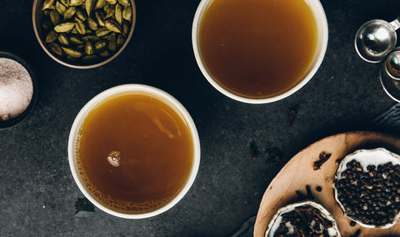
Lotus Blooming Herbs Kashayam
This is one of our favorite recipes for building immune strength. Kashayam refers to a water decoction of herbs that is used for a variety of different ailments. This recipe is a bit more time intensive but well worth it. It is especially good for when you are feeling something coming on or just want to keep your immune system strong.
Ingredients:
- 12 oz filtered water
- 1 tsp jaggery* (unrefined cane sugar)
- ½ tsp fresh lime juice
- ¼ tsp Himalayan pink salt
- 1 tsp whole black peppercorns
- ¼ tsp whole cloves
- 5 whole cardamom pods
Instructions:
- Bring water to a boil.
- Add jaggery and simmer for 2 minutes.
- Add lime juice and simmer for 2 minutes.
- Add Himalayan pink salt and simmer for 2 minutes.
- Add peppercorns and simmer for 2 minutes.
- Add ¼ teaspoon of cloves and simmer for 2 minutes.
- Crush and add cardamom and simmer for 2 minutes.
- Stir the mixture and simmer for 3 minutes.
- Strain it into a cup and drink hot. Make this fresh every time! Drink 2-3 times a day.
*You can find jaggery in most Indian grocery stores or online.

Throat Soothing Tea
This mixture was recommended by one of our Ayurvedic teachers, Dr. Paul Dugliss M.D., founder of New World Ayurveda. This is ideal to take if you you feel a sore throat coming on. We also highly recommend this course for anyone that is interested in learning more about Ayurveda.
Ingredients:
- 1/2 tsp turmeric powder
- 1/2 tsp licorice root powder
- 1/2 tsp ginger powder
Instructions:
Dissolve all powders in a cup of boiled water. Drink.

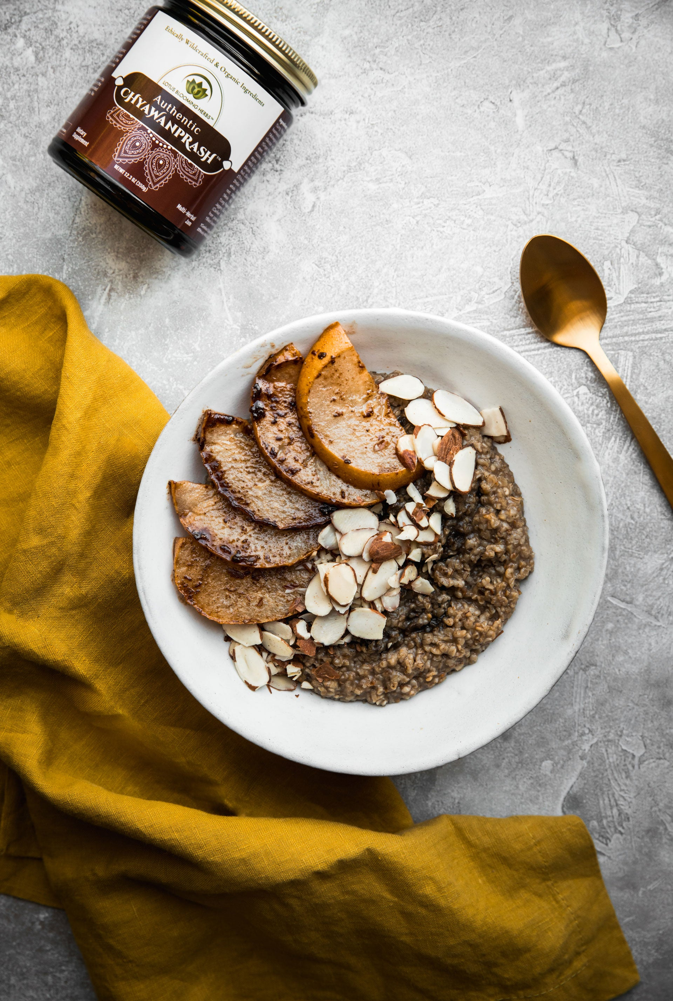
CHYAWANPRASH OATMEAL WITH SPICED PEARS
1 serving of Ayurveda oatmeal
Ingredients:
- 1/3-1/2 cup oats (sprouted organic oats preferable)
- Water
- 1-2 tsp Authentic Chyawanprash™
- 1 chai tea bag (optional)
- 1/2 pear, cored and cut into 1/4 inch slices
- 1/2 tsp coconut sugar
- 1/4 tsp cinnamon
- 1/4 tsp cardamom
- 1/2 Tbsp ghee, butter or vegan butter
- Honey or maple syrup (optional)
- Toasted sliced almonds or walnuts (optional)
Instructions:
- Cook oats according to package directions, using recommended amount of water. If using chai tea bag, first bring water to a boil, then add tea bag to water, simmer for 3 minutes. Discard tea bag and then add oats.
- While oats are cooking, heat butter in a pan over medium-high heat. Be careful not to burn it. Once butter is hot, add slices of pear. Sprinkle with coconut sugar, cinnamon and cardamom. Cook for a few minutes and then flip and cook for a few more minutes until slightly soft and golden.
- Once oats are done cooking, let cool for a few minutes, stir in Authentic Chyawanprash. Drizzle honey or maple syrup if desired. Top with spice pears and toasted nuts. Enjoy!

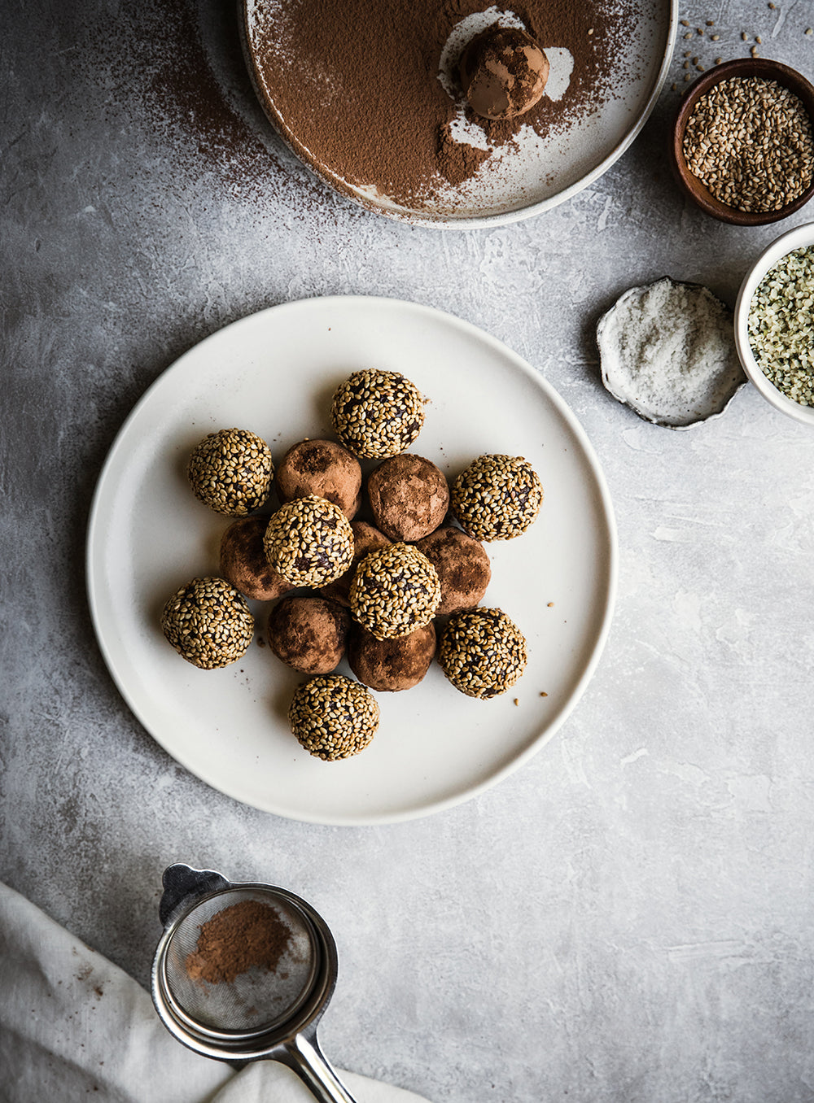COCOA SHILAJIT ENERGY BALLS
Makes 16 energy snack balls
Ingredients:
- 2-3 pea sized portions Authentic Shilajit⁣™
- 1 Tbsp hot water⁣
- 8-10 dates, pitted⁣
- 1.5 cups raw cashews⁣
- 2 Tbsp hemp seeds⁣
- 1/4 tsp sea salt⁣
- 3 Tbsp unsweetened cocoa powder⁣
- 2 tsp vanilla extract⁣
- 1 Tbsp ghee or coconut oil⁣ ⁣
To roll:⁣
- 3 Tbsp toasted sesame seeds⁣
- 3 Tbsp cocoa powder⁣
Instructions:
- Put Shilajit in a small dish. Add 1 Tbsp hot water and stir until dissolved. Set aside.⁣
- In the bowl of a food processor, put pitted dates and pulse until crumbly.⁣
- Add in cashews, hemp seeds, cocoa powder and salt. Pulse until starting to incorporate. It should be a bit crumbly still.⁣
- Next add in vanilla extract, Shilajit mixture and ghee or coconut oil. Process until all ingredients combine and a ball forms. ⁣
- Take a spoonful at a time and roll into a ball. Place on a parchment lined dish.⁣
- Put in the fridge for 30 minutes. ⁣
- To roll in toppings, remove from fridge. Place sesame seeds and cocoa powder in two shallow dishes. Carefully roll half the balls in the sesame seeds and half in the cocoa powder (or use whichever you prefer.)⁣
- Place back on dish and put in the fridge for 2 hours. Store in an airtight container in the fridge.

Carrot Beet Juice Recipe

Carrot beet juice is a heavenly combination of healthy and juicy beet, carrot and ginger. This recipe also uses refreshingly aromatic fresh lime juice, which makes it one of the best vegetable juices. Whether you are planning to make carrot and beet juice for its health benefits or just for thirst quencher nutrient rich drink, its surely going delight your taste buds.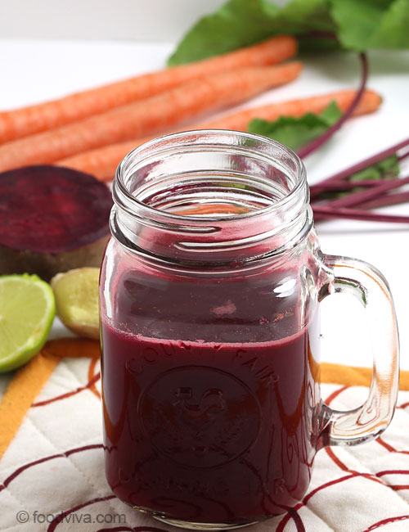

Ingredients:
1/2 medium Beet, peeled and chopped
4 Carrots, peeled and chopped
1/4 inch piece of Ginger
1/2 Lemon or Lime
1/2 cup Water
Directions For Making Juice Without Juicer :
- Wash carrot and beetroot in running water and pat dry them.
- Peel and cut beetroot and carrot into small pieces. if you are using organic carrots, no need to peel them.
- Pour 1/2 cup water in the jar of a blender. Add carrot, beetroot and ginger. Squeeze lemon over it

Celery Juice Recipe
Celery can provide dietary fiber bulk required for low calorie weight loss diets. Add refreshingly tasty and rejuvenating celery juice to your daily diet to get full benefits of its fibers and minerals. Since potassium and vitamins rich celery is taste neutral and does not have any palatable appeal, this juice recipe uses apple that gives sweeter touch to increase its palatability.
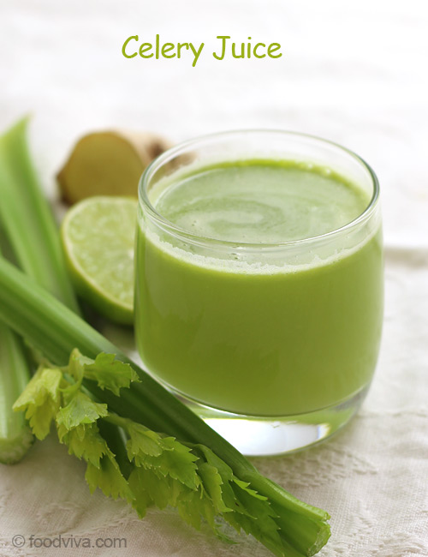

Ingredients:
2 Celery Sticks
1 Apple or Pear
1/4 inch Ginger, optional
1/4 Lime or Lemon
Directions:
- Wash celery sticks and apple in running water to remove any dirt and impurities.
- Cut celery into long pieces. Peel, core and cut apple into slices.
- Process all ingredients alternatively (except lemon) through juicer.
- Collect the juice in its container.

Fresh Tomato Juice Recipe
Fresh tomato juice is a well acclaimed vegetable juice which not just tastes best but easy to make as well because it does not require any cooking. This universal juice can be drunk alone or with ice or used as an ingredient to make cocktails.
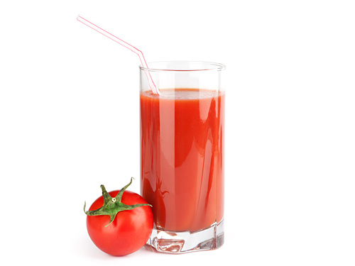
Ingredients:
6 Ripe Tomatoes, cored and chopped
2 Carrots, peeled and chopped
1 Celery stick, chopped
1/4 teaspoon Ground Black Pepper
Salt
2 Ice Cubes
Directions:
- Place an empty container beneath the nozzle of juice extractor and process tomatoes, carrots and celery.
- When juicing process is complete, add salt and black pepper in extracted juice and mix well.
- Add ice cubes in chilled serving glasses and pour juice over it.
- Serve it for immediate consumption.

