Yellow Mung Dal Soup

Serves 6 Yellow mung is sweet and cooling, and mainly calms vata and pitta. It is very easy to digest and promotes strength.The seasonings here help to balance the drying, light and astringent qualities of this soup that could aggravate vata. Doshic Notes Vata = Pitta = Kapha =

Ingredients
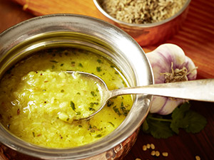
1 cup yellow mung dal 6 cups water 4 Tbs safflower oil 1 tsp black mustard seeds 1 tsp cumin seeds 1 pinch hing (asafetida) 2 large cloves garlic, chopped 1 small handful cilantro leaves, chopped 5 curry leaves, fresh or dried 1/2 tsp turmeric 1 tsp masala powder 3/4 salt

Preparation
Wash the mung dal twice. Put the mung dal and 3 cups of the water into a soup pot and bring to a boil. Cook on medium heat for 25 minutes, uncovered, stirring occasionally to prevent sticking. Add the last 3 cups of the water and boil for another 20 minutes. Remove from the heat and beat with an eggbeater until smooth. Set aside. Heat the oil in a small saucepan until medium hot. Add the cumin seeds, mustard seeds and hing. Stir until the seeds pop. Turn down the heat, add the garlic and brown lightly. Then put in the curry leaves, cilantro, turmeric and masala powder. Stir well and then add this mixture to the soup. Add salt. Simmer for 2 minutes and serve.

Ayurvedic Carrot Soup Recipe

The cooling qualites of the coconut milk mitigate the heating qualities of the carrots and ginger. The sweet flavors of the sugar and crystalized ginger also help reduce the heat. Doshic Notes Vata – Pitta – Kapha –

Ingredients
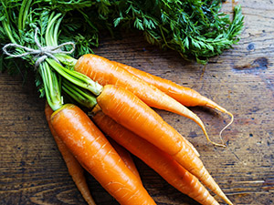2 Tbs butter 2 lbs carrots, peeled and chopped 2 onions, chopped small 1 Tbs ginger, grated fine 2 tsp salt 1/4 cup ginger, crystallized 1 tsp sugar 4 cups water 1/2 tsp baking soda 3/4 cup coconut milk, reduced fat 1 bunch cilantro, chopped Salt and pepper to taste

Preparation
Heat the butter in a large soup pot, preferably a heavy one, over medium heat until melted. Add the onions, salt, grated ginger, sugar, and crystallized ginger. Cook until the vegetables are softened, about 5-10 minutes. Add chopped carrots, water, and baking soda. Bring this to a simmer. Cover and reduce the heat to medium low, and cook until the carrots are very tender, about 20 minutes. Puree the soup in a blender, in batches, until smooth. Return the soup to the pot, stir in the coconut milk and cook gently over medium low heat until the soup is hot. Season with salt and pepper to taste. Sprinkle individual servings with cilantro before serving. Serve with chapatis for a light lunch.

