Lab Experiment 3
AIM: Database Schema for a customer-sale scenario:
Customer(Cust id : integer, cust_name: string)
Item(item_id: integer, item_name: string, price: integer)
Sale(bill_no:integer,bill_data:date,cust_id: integer, item_id: integer, qty_sold: integer)

For the above schema, perform the following:

SOLUTION CODE: (By MAHIN-2401010123)

- Create tables with the appropriate integrity constant.
CREATE DATABASE IF NOT EXISTS CustomerSaleDB;
USE CustomerSaleDB;
DROP TABLE IF EXISTS Sale;
DROP TABLE IF EXISTS Item;
DROP TABLE IF EXISTS Customers;
CREATE TABLE Customers (
cust_id INT PRIMARY KEY,
cust_name VARCHAR(50) NOT NULL
);
CREATE TABLE Item (
item_id INT PRIMARY KEY,
item_name VARCHAR(50) NOT NULL,
price INT CHECK (price > 0)
);
CREATE TABLE Sale (
bill_no INT PRIMARY KEY,
bill_date DATE NOT NULL,
cust_id INT,
item_id INT,
qty_sold INT CHECK (qty_sold > 0),
FOREIGN KEY (cust_id) REFERENCES Customers(cust_id),
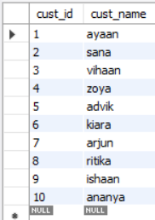
FOREIGN KEY (item_id) REFERENCES Item(item_id)
);

- Insert 10 records in each table.
INSERT INTO Customers (cust_id, cust_name) VALUES
(1, 'ayaan'), (2, 'sana'), (3, 'vihaan'), (4, 'zoya'), (5, 'advik'),
(6, 'kiara'), (7, 'arjun'), (8, 'ritika'), (9, 'ishaan'), (10, 'ananya');
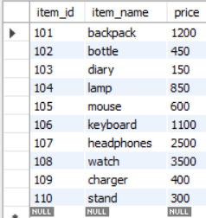

INSERT INTO Item (item_id, item_name, price) VALUES
(101, 'backpack', 1200), (102, 'bottle', 450), (103, 'diary', 150),
(104, 'lamp', 850), (105, 'mouse', 600), (106, 'keyboard', 1100),
(107, 'headphones', 2500), (108, 'watch', 3500), (109, 'charger', 400),
(110, 'stand', 300);

INSERT INTO Sale (bill_no, bill_date, cust_id, item_id, qty_sold) VALUES
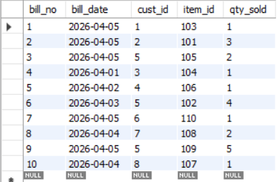
(1, CURDATE(), 1, 103, 1),
(2, CURDATE(), 2, 101, 3),
(3, CURDATE(), 5, 105, 2),
(4, '2026-04-01', 3, 104, 1),
(5, '2026-04-02', 4, 106, 1),
(6, '2026-04-03', 5, 102, 4),
(7, CURDATE(), 6, 110, 1),
(8, '2026-04-04', 7, 108, 2),
(9, CURDATE(), 5, 109, 5),
(10, '2026-04-04', 8, 107, 1);

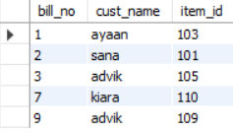
- List bills for current date with customer names and item numbers.
SELECT S.bill_no, C.cust_name, S.item_id
FROM Sale S
JOIN Customers C ON S.cust_id = C.cust_id
WHERE S.bill_date = CURDATE();

- List total Bill details with qty, price, and final amount.
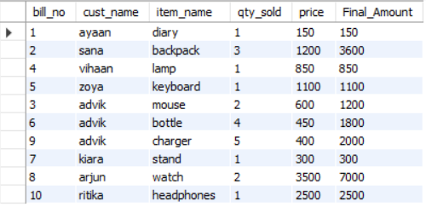
SELECT S.bill_no, C.cust_name, I.item_name,
S.qty_sold, I.price, (S.qty_sold * I.price)
AS Final_Amount
FROM Sale S
JOIN Customers C ON S.cust_id = C.cust_id
JOIN Item I ON S.item_id = I.item_id;

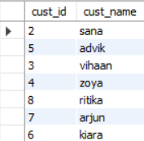
- List details of customers who bought products with price > 200.
SELECT DISTINCT C.* FROM Customers C
JOIN Sale S ON C.cust_id = S.cust_id
JOIN Item I ON S.item_id = I.item_id
WHERE I.price > 200;

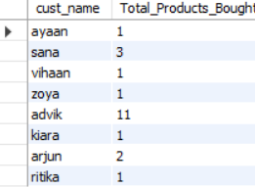
- Count of products bought by each customer.
SELECT C.cust_name, SUM(S.qty_sold)
AS Total_Products_Bought
FROM Customers C
JOIN Sale S ON C.cust_id = S.cust_id
GROUP BY C.cust_name;

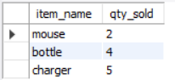
- Products bought by customer with cust_id 5.
SELECT I.item_name, S.qty_sold
FROM Sale S
JOIN Item I ON S.item_id = I.item_id
WHERE S.cust_id = 5;

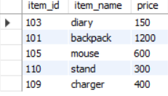
- List item details sold as of today.
SELECT I.* FROM Sale S
JOIN Item I ON S.item_id = I.item_id
WHERE S.bill_date = CURDATE();

- Create view for bill details.
CREATE OR REPLACE VIEW Bill_Details AS
SELECT S.bill_no, S.bill_date, S.cust_id, S.item_id, I.price, S.qty_sold,
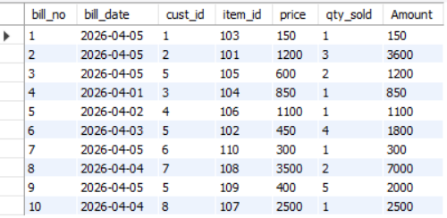
(S.qty_sold * I.price) AS Amount
FROM Sale S
JOIN Item I ON S.item_id = I.item_id;

- Create view for weekly daily sales.
SELECT bill_date, SUM(S.qty_sold * I.price) AS Total_Daily_Sales
FROM Sale S
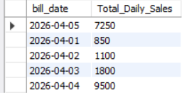
JOIN Item I ON S.item_id = I.item_id
WHERE bill_date >= CURDATE() - INTERVAL 7 DAY
GROUP BY bill_date;

