Lab Experiment 7
Objective: Rollback and Commit commands Create Teacher table with the following fields (Name, DeptNo, Date of joining, DeptName, Location, Salary)
- Insert five records.
- Give Increment of 25% salary for Mathematics Department.
- Perform Rollback command.
- Give increment of 15% salary for Commerce Department.
- Perform Commit command.

SOLUTION CODE: (By MAHIN-2401010123)
CREATE DATABASE IF NOT EXISTS school_management;
USE school_management;
SET SQL_SAFE_UPDATES = 0;

DROP TABLE IF EXISTS Teacher;
CREATE TABLE Teacher (
TeacherName VARCHAR(50),
DeptNo INT,
DateOfJoining DATE,
DeptName VARCHAR(50),
LocationName VARCHAR(50),
SalaryAmt INT
);

(a) Insert five records.
INSERT INTO Teacher (TeacherName, DeptNo, DateOfJoining, DeptName, LocationName, SalaryAmt) VALUES
('amit kumar', 10, '2021-01-10', 'mathematics', 'delhi', 40000),
('sunita devi', 20, '2020-03-15', 'commerce', 'mumbai', 35000),
('rahul sharma', 10, '2022-05-22', 'mathematics', 'delhi', 42000),
('priya nair', 30, '2019-11-01', 'science', 'kochi', 50000),
('aniket das', 20, '2023-02-14', 'commerce', 'kolkata', 32000);

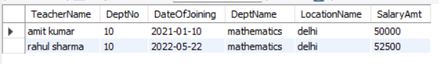
(b) Give Increment of 25% salary for Mathematics Department.
START TRANSACTION;
UPDATE Teacher
SET SalaryAmt = SalaryAmt * 1.25
WHERE DeptName = 'mathematics';
SELECT * FROM Teacher WHERE DeptName = 'mathematics';

(c) Perform Rollback command.
ROLLBACK;
SELECT * FROM Teacher WHERE DeptName = 'mathematics';
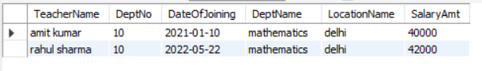

(d) Give increment of 15% salary for Commerce Department.
START TRANSACTION;
UPDATE Teacher
SET SalaryAmt = SalaryAmt * 1.15
WHERE DeptName = 'commerce';

(e) Perform Commit command.
COMMIT;
SELECT * FROM Teacher;
SET SQL_SAFE_UPDATES = 1;

