Lab Experiment 8
AIM: Create Sales table with the following fields (Sales No, Salesname, Branch, Salesamount, DOB)
- Insert five records.
- Calculate total salesamount in each branch.
- Calculate average salesamount in each branch.
- Display all the salesmen, DOB who are born in the month of December as day in character format i.e. 21-Dec-09.
- Display the name and DOB of salesman in alphabetical order of the month.

SOLUTION CODE: (By MAHIN-2401010123)
CREATE DATABASE IF NOT EXISTS sales_db;
USE sales_db;

DROP TABLE IF EXISTS Sales;
CREATE TABLE Sales (
SalesNo INT PRIMARY KEY,
SalesName VARCHAR(50),
BranchName VARCHAR(50),
SalesAmount INT,
DateOfBirth DATE
);

(a) Insert five records.
INSERT INTO Sales (SalesNo, SalesName, BranchName, SalesAmount, DateOfBirth) VALUES
(101, 'arnav gupta', 'north', 45000, '1995-12-21'),
(102, 'sana sheikh', 'south', 32000, '1998-05-15'),
(103, 'kabir malhotra', 'north', 55000, '1996-12-09'),
(104, 'isha patel', 'east', 40000, '1997-12-05'),
(105, 'vihaan nair', 'south', 28000, '1999-08-22');

(b) Calculate total salesamount in each branch.
SELECT BranchName, SUM(SalesAmount) AS TotalSales
FROM Sales
GROUP BY BranchName;

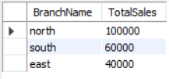

(c) Calculate average salesamount in each branch.
SELECT BranchName, AVG(SalesAmount) AS AverageSales
FROM Sales
GROUP BY BranchName;

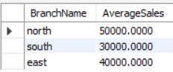

(d) Display all the salesmen, DOB who are born in the month of December as day in character format i.e. 21-Dec-09.
SELECT SalesName, DATE_FORMAT(DateOfBirth, '%d-%b-%y')
AS FormattedDOB
FROM Sales
WHERE MONTH(DateOfBirth) = 12;

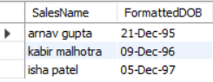

(e) Display the name and DOB of salesman in alphabetical order of the month.
SELECT SalesName, DateOfBirth
FROM Sales
ORDER BY MONTHNAME(DateOfBirth) ASC;

