Lab Experiment 4.1
AIM: Consider the following table: Table: CLASS (ID,Name)
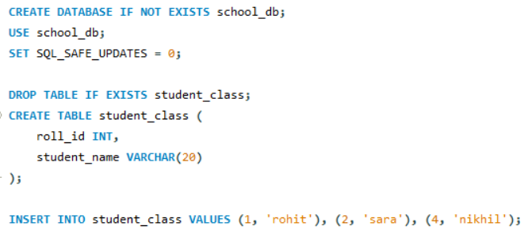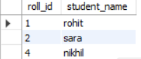
SOLUTION CODE: (By MAHIN-2401010123)

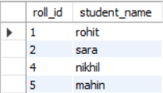
- INSERT INTO class VALUES (5,mahin’);.
SET autocommit = 0;
START TRANSACTION;
INSERT INTO student_class VALUES (5, 'mahin');
COMMIT;

(b) Update student_name with Savepoints A,B, and C
START TRANSACTION;
UPDATE student_class SET student_name = 'abhishek' WHERE roll_id = 5;
SAVEPOINT pt_a;

INSERT INTO student_class VALUES (6, 'tanya');
SAVEPOINT pt_b;

INSERT INTO student_class VALUES (7, 'rohit');
SAVEPOINT pt_c;

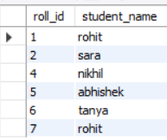
- Select 1: Shows all 5 records
SELECT * FROM student_class;
ROLLBACK TO pt_b;

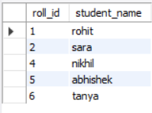
- Select 2: id 7 is gone; id 6 remains
SELECT * FROM student_class;
ROLLBACK TO pt_a;

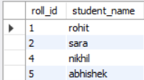
- Select 3: id 6 is gone; id 5 remains as 'abhishek'
SELECT * FROM student_class;
COMMIT;

Lab Experiment 4.2
AIM: Consider the following table and perform the following TCL-based SQL script: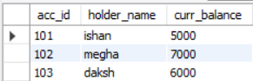

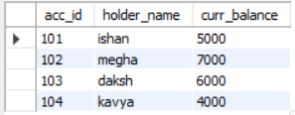
- Insert data into the table: (104, ‘kavya’, 4000)

START TRANSACTION;
INSERT INTO bank_ledger VALUES (104, 'kavya', 4000);
SET autocommit = 0;
SAVEPOINT s1;

- Update table, set balance where acc_id = 101 and acc_id = 102

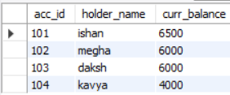
UPDATE bank_ledger
SET curr_balance = curr_balance + 1500 WHERE acc_id = 101;
UPDATE bank_ledger
SET curr_balance = curr_balance - 1000 WHERE acc_id = 102;
SAVEPOINT s2;

- Delete from table, where acc_id = 103 and insert ‘rehan’ at acc_id = 105
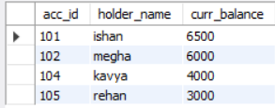
DELETE FROM bank_ledger WHERE acc_id = 103;
INSERT INTO bank_ledger VALUES (105, 'rehan', 3000);
SAVEPOINT s3;

- Undoes the delete of daksh, the insert of rehan, and name change of megha.
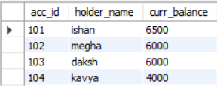
ROLLBACK TO s2;
SELECT * FROM bank_ledger;
COMMIT;

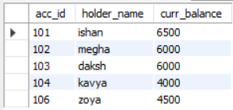
- Insert VALUES(106, ‘zoya’, 4500) and SAVEPOINT s4.

INSERT INTO bank_ledger VALUES (106, 'zoya', 4500);
SAVEPOINT s4;

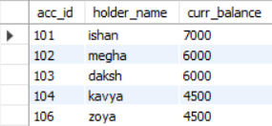
- Update table, set balance where acc_id = 101 and 104.

UPDATE bank_ledger SET curr_balance = curr_balance + 500
WHERE acc_id IN (101, 104);
SELECT * FROM bank_ledger;

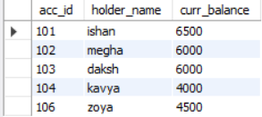
- ROLLBACK to s4 and commit.

ROLLBACK TO s4;
SELECT * FROM bank_ledger;
COMMIT;

