p-ArTéMiS data reduction pipeline
detailed design document.

 | Fonction | Nom | Date | Visa
Préparé par | Rédacteur | G. Willmann | 31/03/09
Vérifié par
Approuvé par

Date | Version | Pages
31/03/09 | 0.1 | Création

1) List of procedures

2) List of structures

3) Procedures description

4) Structures description

5) Short architectural design of procedures

You will find in this document descriptions of IDL procedures and structures that are part of the p-ArTéMiS data reduction pipeline. A short architectural design is described at the end of the document but you can also take a look at the user guide.

In order to use the pipeline, you will need to call the procedure traite_otf_map_main.pro. The pipeline is interfacing raw Multi-Beam FITS Raw Data Format files with IDL, by reading, copying and saving data into an IDL structure. Data are converted from V to pW (readfits_apex.pro) , the baselines and the correlated noise are subtracted, images are grouped and filtered if the wobbler id used (traite_otf_scan.pro) for each subscan (a subscan is made of a datacube and associated parameters from a part of an acquisition, not from a whole acquisition, typically a scan leg in scanning mode). We build elementary maps with do_map_scan.pro. Reduced data and elementary maps are saved and the final map is build in RA/DEC or in an azimuth/elevation projection (map_make.pro). Maps can also be build from multiple observations for a single object with combine_otf_map.pro provided the data are already reduced and data redundancy can be used to remove uncorrelated 1/f noise. (remove_uncordrifts.pro).

- List of procedures.

File name | Page
ASSO_IMAGES_2007.PRO | 10 / 68
BASELINE_SCAN.PRO | 11 / 69
CLEAN_CHAINE | 12 / 70
COMBINE_OTF_MAP.PRO | 13
CONV_EKH1DIM_KOSMA.PRO | 15
CREATE_CHAMP.PRO | 16 / 69
DECORREL_SCAN.PRO | 18 / 69
DLST2DTLOC.PRO | 19
DO_MAP_SCAN.PRO | 20 / 71
EKH_RESTORE.PRO | 21 / 72
EXTRACT_IMA_MOY.PRO | 22
FILTER_EKH_KOSMA.PRO | 24
HEADER2STRING | 25
INIT_OBS.PRO | 26
KILL_50HZ.PRO | 27
LOCATE_DUAL_BEAM.PRO | 28 / 73
LOCATE_SIGNAL.PRO | 29 / 73
MAKE_MODEL_DATA.PRO | 30 / 74
MAP_MAKE_CH.PRO | 31
MAP_MAKE.PRO | 32
MED_BASELINE_SCAN.PRO | 34 / 74
MEDIAN_DECORREL_SCAN.PRO | 35
PARALLACTIC_ANGLE.PRO | 36
POWER_MAP.PRO | 37
PW2JY.PRO | 38
RAW2CHOPBEAM_APEX.PRO | 39
READ_APEX.PRO | 40
READ_APEXOBSLOG.PRO | 41
READ_FITS_APEX.PRO | 42 / 74
REDUCE_DONNEESTRUCT.PRO | 43
REMOVE_UNCORDRIFTS.PRO | 44
RFILTER_EKH_KOSMA.PRO | 45
ROT_DAZDEL2DXDY.PRO | 46
ROT_DRADDEC2DXDY.PRO | 47
ROT_DXDY2DAZDEL.PRO | 48
ROT_DXDY2DRADDEC.PRO | 49
SET_POS_.PRO | 50 / 75
SHIFT_AND_ADD.PRO | 51 / 75
SIGMA_CLIP.PRO | 52 / 73
STRUCT_EXPAND.PRO | 53
TRAITE_OTF_MAP_MAIN.PRO | 54 / 76
TRAITE_OTF_SCAN.PRO | 58 / 77-78

Entry | Page | Description | Called by | Calling
asso_images_2007.pro | 10 / 68 | Return data cube and noise rms after averaging and subtracting signal for each period (when the wobbler is used) | traite_otf_scan | extract_ima_moy reduce_donneestruct  struct_expand
baseline_scan.pro | 11 / 69 | Subtract the order 1 polynomial fitted signal to the signal and give rms noise | traite_otf_scan
clean_chaine.pro | 12 / 70 | Modify String array | header2string
combine_otf_map.pro | 13 | Combine a list of reduced data from different observations (SCANS) for a single object on a map.  Uncorrelated 1/f noise can be removed as an option |  | init_obs  remove_uncordrifts  create_champ  do_map_scan  rot_dxdy2draddec  map_make
conv_ekh1dim_kosma.pro | 15 | Function convolving signal with input filter | shift_and_add ekh_restore
create_champ.pro | 16 / 69 | Calculate and fill a structure for a given subscan containing the dimensions of the field of view in RA/DEC | traite_otf_map_main combine_otf_map | rot_dxdy2dazdel  rot_dxdy2draddec
decorrel_scan.pro | 18 / 69 | Subtract correlated noise to signal | traite_otf_scan
dlst2dtloc.pro | 19 | Convert local time to local sideral time | do_map_scan
do_map_scan.pro | 20 / 71 | Create a map for a given subscan | traite_otf_map_main | set_pos_  parallactic_angle  dlst2dtloc
ekh_restore.pro | 21 / 72 | Filter bolometer signal | traite_otf_scan | filter_ekh_kosma rfilter_ekh_kosma  conv_ekh1dim_kosma
extract_ima_moy.pro | 22 | Return average image and noise from a data cube | asso_images_2007 | sigma_clip
filter_ekh_kosma.pro | 24 | Calculates a convolution function which will filter out spatial frequencies of  wavelength equal to the spacing of the original two-beam system, and its harmonics | shift_and_add  ekh_restore
header2string.pro | 25 | Extract header information and put it into IDL structure file | read_fits_apex | clean_chaine
init_obs.pro | 26 | Read and fill a structure containing directory path, calibration file and subscan list for a given scan number (observation) | traite_otf_map_main combine_otf_map
kill_50Hz.pro | 27 | Elimate 50 Hz noise in Fourier space | traite_otf_scan | rot_dxdy2draddec
locate_dual_beam.pro | 28 / 73 | Build a cube of mask, put the value 1 on the restaured (SAA mode) source : both negative and positive parts, put 0 elsewhere, modify goodpix_ima so that array pixels that see the source only in negative or positive before restauration are equal to 0 | traite_otf_scan | rot_dxdy2dazdel  rot_dxdy2draddec
locate_signal.pro | 29 / 73 | Build a mask | traite_otf_scan | rot_dxdy2draddec  rot_dxdy2dazdel
make_model_data.pro | 30 / 74 | Build a data cube for a given observation from a 2D source model | traite_otf_scan
map_make_ch | 31 | Build a channel map | traite_otf_map_main
map_make.pro | 32 | Build a map from combining a list of subscan map | traite_otf_map_main combine_otf_map
med_baseline_scan.pro | 34 / 74 | Subtract the median value to the signal and give rms noise | traite_otf_scan | rot_dxdy2draddec  rot_dxdy2dazdel
median_decorrel_scan.pro | 35 | Subtract median of correlated noise to signal | traite_otf_scan
parallactic_angle.pro | 36 | Calculate parallactic angle | set_pos_
power_map.pro | 37 | Convert bolometer signal from V to pW | read_fits_apex
pW2Jy | 38 | Convert subscan data cube in pW to Jansky (atmospheric extinction corrected) | traite_otf_map_main
raw2chopbeam_apex.pro | 39 | Convert wobbler displacement along wobbler coordinate system longitude axis to a signal with 1 value for ON position, -1 value for OFF position and 10 value for transitions | read_fits_apex
read_apex.pro | 40 | Restore or read MBfits data from APEX for a given subscan | traite_otf_map_main | read_fits_apex
read_apexobslog.pro | 41 | Read additional informations about an observation (stored in an HTML file). | read_fits_apex
read_fits_apex.pro | 42 / 74 | Put MBfits format into IDL structure file | read_apex | mrdfits get_calibration_camera  header2string  clean_chaine  read_apexobslog  readfits  power_map  altaz2hadec raw2chopbeam_apex  include :  header2string  clean_chaine
reduce_donneestruct.pro | 43 | Reduce temporal dimensions for vectors and cube in a given structure | asso_images_2007
remove_uncordrifts.pro | 44 | Remove uncorrelated 1/f noise from data | combine_otf_map
rfilter_ekh_kosma.pro | 45 | Works out a convolution function for the 2-beam restoration program, where the 2-beam separation need not be an integral number of map sampling intervals | ekh_restore
rot_dazdel2dxdy.pro | 46 | Convert set of coordinates in azimuth and elevation to detector coordinates | set_pos_
rot_draddec2dxdy.pro | 47 | Convert set of coordinates in right ascension and declination to detector coordinates | set_pos_
rot_dxdy2dazdel.pro | 48 | Convert set of coordinates in detector coordinates to azimuth and elevation | make_model_data locate_signal  med_baseline_scan locate_dual_beam cr50eate_champ
rot_dxdy2draddec.pro | 49 | Convert set of coordinates in detector coordinates to right ascension and declination | Make_model_data  locate_signal med_baseline_scan locate_dual_beam create_champ  combine_otf_map
set_pos_.pro | 50 / 75 | Set coordinates in units of pixels in the "final" rebinned image | do_map_scan | parallactic_angle  rot_dazdel2dxdy rot_draddec2dxdy
shift_and_add.pro | 51 / 75 | Filter bolometer signal | traite_otf_scan | filter_ekh_kosma  conv_ekh1dim_kosma
sigma_clip.pro | 52 / 73 | Flag data that are not within average +- threshold*rms | extract_ima_moy
struct_expand.pro | 53 | Add a new field in a given structure at a given position | asso_images_2007
traite_otf_map_main.pro | 54 / 76 | Reduces data for a given scan then build a map | user | read_apex  pW2Jy  traite_otf_scan  do_map_scan  create_champ  map_make  map_make_ch
traite_otf_scan.pro | 58 / 77-78 | Eliminate noise from subscan data and build a subscan map | traite_otf_map_main | kill_50Hz  med_baseline_scan  locate_signal  baseline_scan  make_model_data  decorrel_scan  shift_and_add  ekh_restore  locate_dual_beam  asso_images_2007

File name | Contents | Page
datastr (donnees) | datastr.datapar | 60
datastr.datapar |  | 64
champ |  | 65
carte_scan |  | 66
mapradecstr |  | 67
2) List of structures.

3) Procedures description.

asso_images_2007
___________________________________________________________________________

Filename : asso_images_2007

Purpose :
Return data cube and noise rms after averaging and subtracting signal for each period (when
the wobbler is used).

Calling sequence : asso_images_2007, donnees, diff_asso, error

Arguments :
donnees | input | structure | data
diff_asso | output | structure | data
error | output | integer | error

Called by :
traite_otf_scan

Calling :
extract_ima_moy
reduce_donneestruct
struct_expand

Pseudo code :

DIFF_ASSO is equal to DONNEES
IF the wobbler is used
locate when we are in ON position
find array index for ON, OFF and transition position
ELSE
find number of images for a 0.5 pixel displacement
END
calculate median value for the data cube, coordinates and time for ON and OFF position
IF the wobbler is used
subtract averaged cube for OFF and ON position
reduce the structure array and cube size before returning it

baseline_scan
___________________________________________________________________________

Filename : baseline_scan.pro

Purpose :
Subtract the order 1 polynomial fitted signal to the signal and give rms noise. It subtracts median baseline if there are less than 10 data points available.

Calling sequence : BASELINE_SCAN, cube, cube_mask_init, cube_corrige, rms_noise

Arguments :
cube | input | double array | initial data
cube_mask_init | input | double array | mask
cube_corrige | output | double array | baseline subtracted data
rms_noise | output | double array | calculated noise

Called by :
traite_otf_scan

Call :
None

Pseudo-code :

FOR each bolometer fit the signal(off source) with a first order polynom or take the median
IF there are less than 10 data points baseline is the median of the signal
END
subtract the baseline to the signal
calculate rms noise
END

clean_chaine
___________________________________________________________________________

Filename : readfits_apex.pro

Purpose :
Modify a given string array.

Calling sequence : chaine_c=CLEAN_CHAINE(chaine, car1, car2)

Arguments :
chaine | input | string array
car1 | input | string
car2 | input | string

Called by :
header2string

Calling :
none

Pseudo-code :

IF string CAR1 is in CHAINE string array
substitute CAR1 by string CAR2 in CHAINE
END

combine_otf_map
___________________________________________________________________________

Purpose :
Combine a list of reduced data from different observations (SCANS) for a single object on a
map. Uncorrelated 1/f noise can be removed as an option.

Calling sequence : COMBINE_OTF_MAP, scan_list, mapradecstr, removedrift=removedrift, do_rcp=do_rcp, project_list=project_list

Arguments :
scan_list | input | string array | list of observations
mapradecstr | output | structure | map
removedrift | input | keyword | parameter value
do_rcp | input | keyword | correct optical distorsion
project_list | input | string array | list of projects

Called by :
user

Calling :
init_obs
remove_uncordrifts
create_champ
do_map_scan
rot_dxdy2draddec
map_make

Pseudo-code :

load COMMON variables
execute INIT_OBS for the first scan number

IF the keyword REMOVEDRIFT is set THEN BEGIN

execute REMOVE_UNCORDRIFTS for the SCAN_LIST
set the rebin factor for map construction
FOR all the scan number named in the SCAN_LIST
execute INIT_OBS
FOR all the subscans
restore, /home/map_otf_xdr/project/otf_subscan_xxxx_x.xdr
restore, /home/map_otf_xdr/project/otf_subscan_nodrifts_xxxx_x.xdr (replace DONNEES_RED)
IF the keyword DO_RCP is set THEN BEGIN
produce CARTE_SCAN by executing DO_MAP_SCAN with RCP methods
ELSE BEGIN
produce CARTE_SCAN by executing DO_MAP_SCAN without distorsion files
END
save SUBSCANNAME, CARTE_SCAN, DONNEES_UNCAL, DONNEES, DONNEES_RED under
/home/map_otf_xdr/project/otf_subscan_nodrifts_xxxx_x.xdr
END
END
END

FOR all the scan number named in the SCAN_LIST
execute INIT_OBS
FOR all the subscans
IF the keyword REMOVEDRIFT is set THEN BEGIN
restore, /home/map_otf_xdr/project/otf_subscan_nodrifts_xxxx_x.xdr
ELSE BEGIN
restore, /home/map_otf_xdr/project/otf_subscan_xxxx_x.xdr
END
execute CREATE_CHAMP
END
END

build a map by executing MAP_MAKE

conv_ekh1dim_kosma
___________________________________________________________________________

Filename : conv_ekh1dim_kosma.pro

Purpose :
Function convolving signal with defined filter.

Calling sequence : CSignal1=CONV_EKH1DIM_KOSMA(Signal_1dim, CFUN, DNORM, naz)

Arguments :
Signal_1dim | input | double | signal
CFUN | input | double | filter
DNORM | input | double | normalization
naz | input | double | number of data

Called by :
shift_and_add
ekh_restore

Calling :
none

Pseudo-code :

FORTRAN code adapted to IDL

create_champ
___________________________________________________________________________

Filename : create_champ.pro

Purpose :
Calculate and fill a structure for a given subscan containing the dimensions of the field of
view in RA/DEC.

Calling sequence : CREATE_CHAMP, donnees=donnees, carte_scan=carte_scan, error_scan=error_scan, subscan_liste=subscan_liste, subscan_name=subscan_name, i=i, type=type, parang0, champ

Arguments :
donnees | input | structure | data
carte_scan | input | structure | subscan map
error_scan | input | integer | error value
subscan_liste | input | string array | list of subscans
subscan_name | input | string | subscan name
i | input | integer | index
type | input | string | MAP, CHMAP, or DECORREL
parang0 | output | double | parallactic angle
champ | output | structure | contains the dimensions of the field of view in RA/DEC

Called by :
traite_otf_map_main
combine_otf_map

Calling :
rot_dxdy2dazdel
rot_dxdy2draddec

Pseudo-code :

IF TYPE is equal to MAP or DECORREL
IF we scan in azimuth
we calculate offsets in azimuth or elevation by calling ROT_DXDY2DAZDEL
IF we are at the middle of the subscan we calculate PARANG0, the parallactic angle
END
we fill the structure CHAMP
ELSE BEGIN (we scan in right ascension)
we calculate offsets in right ascension or declination by calling ROT_DXDY2DRADDEC
we fill the structure CHAMP
END
END

IF TYPE is equal to CHMAP
IF we scan in azimuth
IF we are at the middle of the subscan we calculate PARANG0, the parallactic angle
END
we fill the structure CHAMP
END
END

decorrel_scan
___________________________________________________________________________

Filename : decorrel_scan.pro

Purpose :
Subtract correlated noise to signal.

Calling sequence : DECORREL_SCAN, donnees, cube_mask_init, donnees_corrigees, correl_matrice

Arguments :
donnees | input | structure | initial data
cube_mask_init | input | structure | mask
donnees_corrigees | output | structure | data after decorrelation
correl_matrice | output | double array | correl_matrice

Called by :
traite_otf_scan

Calling :
none

Pseudo-code :

select noise using the mask
correct data and build correl_matrice

dlst2dtloc
___________________________________________________________________________

Filename : dlst2dtloc.pro

Purpose :
Convert local sideral time to local time.

Calling sequence : dtloc=DLST2DTLOC(dlst)

Arguments :
dlst | input | double | local sideral time

Called by :
do_map_scan

Calling :
none

Pseudo-code :

do time conversion

do_map_scan
___________________________________________________________________________

Filename : do_map_scan.pro

Purpose :
Create a map for a given subscan.

Calling sequence : DO_MAP_SCAN, datastr, positions, map_out_dim, echant=echant, dx_rcp=dx_rcp, dy_rcp=dy_rcp, do_rcp=do_rcp, carte_scan

Arguments :
datastr | input | structure | data
echant | input | double | rebin factor
positions | input | double array | coordinates in pixel image
dx_rcp | input | float array | pixels offsets in x direction
dy_rcp | input | float array | pixels offsets in y direction
positions | input | string/keyword | use distorsion file
map_out_dim | output | double array | rebined map dimensions
carte_scan | output | structure | subscan map

Called by :
traite_otf_map_main

Calling :
set_pos_
parallactic_angle
dlst2dtloc

Pseudo-code :

calculate pixel coordinates in rebined output image by calling SET_POS_
find the index at the middle of the scan
find array coordinates at the middle of the scan ALPHA_MID, DELTA_MID
calculate horar angle PARANGLE
calculate rotation angle
create weight map
create map
fill CARTE_SCAN structure

ekh_restore
___________________________________________________________________________

Filename : ekh_restore.pro

Purpose :
Filter bolometer signal.

Calling sequence : resstruct=EKH_RESTORE(diff)

Arguments :
diff | input | structure | data structure

Called by :
traite_otf_scan

Calling :
filter_ekh_kosma
rfilter_ekh_kosma
conv_ekh1dim_kosma

Pseudo-code :

calculates filter with filter_ekh_kosma, filter with conv_ekh1dim_kosma
calculates rfilter with filter_ekh_kosma, filter again with conv_ekh1dim_kosma for all the pixels

extract_ima_moy
___________________________________________________________________________

Filename : extract_ima_moy.pro

Purpose :
Return average image and noise from a data cube.

Calling sequence : image=EXTRACT_IMA_MOY(cube, ima_rms, cube_rms = cube_rms, clip = threshold, rms_weight = rms_weight)

Arguments :
cube | input | double array | data
ima_rms | output | double array | averaged noise
cube_rms | input | keyword | averaged data
clip | input | keyword | flag data upon a given threshold
rms_weight | input | keyword | noise calculation method

Called by : asso_images_2007

Calling : sigma_clip

Pseudo-code :

IF the keyword "THRESHOLD" is used then for all the pixels
IF the keyword "CUBE_RMS" is used
IF the standard deviation of the pixel is greater than zero
flag data that are not within average +- THRESHOLD*rms
calculate WEIGHT=sum(1/CUBE_RMS(pixel)^2)
IMAGE(pixel)=sum(CUBE(pixel)/CUBE_RMS(pixel)^2)/WEIGHT
IF the keyword "RMS_WEIGHT" is set
IMA_RMS(pixel)=1/(WEIGHT)^0.5
ELSE BEGIN
IMA_RMS is the standard deviation of the mean
END
END
ELSE BEGIN
flag data that are not within average +- THRESHOLD*rms
IMAGE(pixel)=mean(CUBE(pixel))
IMA_RMS is the standard deviation of the mean

END

ELSE BEGIN

for all the pixels
IF the standard deviation of the pixel is greater than zero
calculate WEIGHT=sum(1/CUBE_RMS(pixel)^2)
IMAGE(pixel)=sum(CUBE(pixel)/CUBE_RMS(pixel)^2)/WEIGHT
IF the keyword "RMS_WEIGHT" is set
IMA_RMS(pixel)=1/(WEIGHT)^0.5
ELSE BEGIN
IMA_RMS is the standard deviation of the mean
END
END
ENDELSE

filter_ekh_kosma
___________________________________________________________________________

Filename : filter_ekh_kosma.pro

Purpose :
Calculates a convolution function which will filter out spatial frequencies of wavelength
equal to the spacing of the original two-beam system, and harmonics of this frequency.

Calling sequence : ffun=FILTER_EKH (BMSEP, naz, pas_az)

Arguments :
BMSEP | input | double | chopper amplitude
naz | input | double | number of data
pas_az | input | double | scan step

Called by :
shift_and_add
ekh_restore

Calling :
none

Pseudo-code :

FORTRAN code adapted to IDL

header2string
___________________________________________________________________________

Filename : readfits_apex.pro

Purpose :
Extract header information and put it into IDL structure file.

Calling sequence : chaine=header2string(commande, param_liste, header)

Arguments :
commande | input | string
param_liste | input | string array | list of parameters
header | input | header | header

Called by :
read_fits_apex

Calling :
clean_chaine

Pseudo-code :

FOR all the elements of the PARAM_LISTE
find the PARAM_LISTE values in the HEADER
call CLEAN_CHAINE to clean string values
END

init_obs
___________________________________________________________________________

Filename : init_obs.pro

Purpose :
Read and fill a structure containing directory path, calibration file and subscan list for a
given scan number (observation).

Calling sequence : INIT_OBS, scan_number=scan_number, type=type, init_obs_str

Arguments :
scan_number | input | string or integer | data
type | input | string | MAP, CHMAP, or DECORREL
init_obs_str | output | structure | parallactic angle

Called by :
traite_otf_map_main
combine_otf_map

Calling :
none

Pseudo-code :

load COMMON variables

extract SUBSCAN_LIST by finding basic_xdr file names or rawdata

open CALIBRATION_TABLE and find for the given SCAN_NUMBER the FLAT_FIELD, GOODPIX_IMA, CONV, DX_RCP, DY_RCP and PFOV.

store all in INIT_OBS_STR and return it

kill_50Hz
___________________________________________________________________________

Filename : kill_50Hz.pro

Purpose :
Elimate 50 Hz noise in Fourier space.

Calling sequence : KILL_50HZ, donnees, donnees_50Hz, rms_noise, rms_noise_50Hz

Arguments :
donnees | input | structure | initial data
donnees_50Hz | output | structure | data after frequency cut off
rms_noise | output | double array | initial noise
rms_noise_50Hz | output | double array | noise after frequency cut off

Called by :
traite_otf_scan

Calling :
none

Pseudo-code :

calculate rms_noise of the signal
subtract the mean of the signal to the signal
extract 50Hz noise in Fourier Space, calculate its rms noise

locate_dual_beam
___________________________________________________________________________

Filename : locate_dual_beam.pro

Purpose :
Build a cube of mask, put the value 1 on the restaured (SAA mode) source : both negative
and positive parts, put 0 elsewhere, modify goodpix_ima so that array pixels that see the
source only in negative or positive before restauration be set to 0.

Calling sequence : LOCATE_DUAL_BEAM, scan_str, masque_base_str

Arguments :
scan_str | input | structure | data
masque_base_str | input | structure | mask

Called by :
traite_otf_scan

Calling :
rot_dxdy2dazdel
rot_dxdy2draddec

Pseudo-code :

initialize source radius and pointing offsets
if we scan in azimuth we use rot_dxdy2dazdel to project source offsets on (x,y)
create 3 masks : cube_mask for both ON and OFF positions cube_mask_pos and cube_mask_neg for separate ON and OFF positions
if masque_base is defined, we use rot_dxdy2draddec to project source offsets on (x,y), do pointing corrections
for all the pixels
if the maximum of the pixel of cube_pos is equal to 1(resp. 0) and the maximum of the pixel of cube_neg is equal to 0(resp. 1) then good_pix_ima
is equal to 0 for this pixel
if one pixel of cube_pos is equal to 1 and is equal to 0 for cube_neg then good_pix_ima is equal to 0 for this pixel
return cube_mask

locate_signal
___________________________________________________________________________

Filename : locate_signal.pro

Purpose :
Build a mask.

Calling sequence : LOCATE_SIGNAL, scan_str, masque_base_str

Arguments :
scan_str | input | structure | data
masque_base_str | output | structure | mask

Called by : traite_otf_scan

Calling :
rot_dxdy2draddec
rot_dxdy2dazdel

Pseudo-code :

change pixels coordinates from detector coordinates dx, dy data to right ascension, declination
calculate angle on sphere in deg
calculate true angle in units of pixels masque

IF scan direction is along RA
calculate DELTA_AZ0, DELTA_EL0 offset in azimuth/elevation from the matrix center
change pixels coordinates from detector coordinates dx, dy data to right azimth, elevation
ELSE
calculate DELTA_AZ0, DELTA_EL0 offset in right ascension/declination from the matrix center
change pixels coordinates from detector coordinates dx, dy data to right ascension, declination
END

calculate DELTA_AZ, DELTA_EL, arrays giving offset in arcsec between pointed source and pixels array
mask is equal to 1 if pixels match with source

return mask

make_model_data
___________________________________________________________________________

Filename : make_model_data.pro

Purpose :
Build a data cube for a given observation from a 2D source model.

Calling sequence : donnees_mod=MAKE_MODEL_DATA(scan_str, model_str)

Arguments :
scan_str | input | structure | data
model_str | output | structure | 2D model

Called by :
traite_otf_scan

Calling :
rot_dxdy2draddec

Pseudo-code :

Change pixels coordinates from detector coordinates dx, dy data to right ascension, declination.

Build data cube.

map_make_ch
___________________________________________________________________________

Filename : map_make_ch.pro

Purpose :
Build a channel map.

Calling sequence : MAP_MAKE_CH, champ1=champ1, donnees2=donnees2, donnees_red=donnees_red, carte_scan=carte_scan, parang0=parang0,
init_obs_str=init_obs_str, project=project, cube_ch_map_str

Arguments :
champ1 | input | structure | contains the dimensions of the field of view in RA/DEC
donnees2 | input | structure | data
donnees_red | input | structure | data
carte_scan | input | structure | subscan map
init_obs_str | input | structure | contains calibration files for the observation
parang0 | input | double | parallactic angle
project | input | string | optional project directory
cube_ch_map_str | output | structure | map

Called by :
traite_otf_map_main

Calling :
none

Pseudo-code :

generate grids CH_MAP_CUBE and WEIGHT_CH_MAP in pixels array. The size is set by the min and max values of the coordinates for all
the CHAMP structure (all the subscans)
calculate CRPIX1 and CRPIX2

FOR all the subscans
restore, /home/map_otf_xdr/project/otf_subscan_xxxx_x.xdr
END

FOR all the bolometers(or pixels)

calculate bolometer positions on the final grid
put DONNEES_RED.CUBE*WEIGHT on CH_MAP_CUBE (one map per bolometer)

END
map_make
___________________________________________________________________________

Filename : map_make.pro

Purpose :
Build a map from combining a list of subscan map.

Calling sequence : MAP_MAKE, scan_list=scan_list, offset_str=offset_str, donnees=donnees, carte_scan=carte_scan, champ1=champ1,
error_otf_scan=error_otf_scan, parang0=parang0, project_=project_, mapradecstr, removedrift=removedrift

Arguments :
scan_list | input | string array | list of scans
offset_str | input | structure
donnees | input | structure | data
carte_scan | input | structure | subscan map
error_otf_scan | input | integer | error value
parang0 | input | double | parallactic angle
project_ | input | string | Optional project directory
mapradecstr | output | structure | map
removedrift | input | keyword | to use 1/f uncorrelated noise subtracted data
champ1 | input | structure | contains the dimensions of the field of view in RA/DEC

Called by :
traite_otf_map_main
combine_otf_map

Calling :
none

Pseudo-code :

load COMMON variables

generate grids MAP_RADEC and WEIGHT in pixels array. The size is set by the min and max values of the coordinates for all
the CHAMP structure (all the subscans)
calculate CRPIX1 and CRPIX2

FOR all the scan number stored in SCAN_LIST
FOR all the subscans
IF the keyword REMOVEDRIFT is set THEN BEGIN
restore, /home/map_otf_xdr/project/otf_subscan_nodrifts_xxxx_x.xdr
ELSE BEGIN
restore, /home/map_otf_xdr/project/otf_subscan_xxxx_x.xdr
END
calculate ROT_ANGLE
rotate CARTE_SCAN.IMAGE and CARTE_SCAN.WEIGHT by ROT_ANGLE centered on CRPIX1, CRPIX2
calculate positions on the final grid
put CARTE_ROT*WEIGHT_ROT on the final grid
END
END

return MAPRADECSTR

med_baseline_scan
___________________________________________________________________________

Filename : med_baseline_scan.pro

Purpose :
Subtract the median value to the signal and give rms noise.

Calling sequence : MED_BASELINE_SCAN, cube, cube_corrige, rms_noise

Arguments :
cube | input | double array | initial data
cube_corrige | output | double array | data after noise removal
rms_noise | output | double array | calculated noise

Called by :
traite_otf_scan

Call :
rot_dxdy2draddec
rot_dxdy2dazdel

Pseudo-code :

FOR all the bolometer signal
subtract the median of the signal to the signal
END

median_decorrel_scan
___________________________________________________________________________

Filename : median_decorrel_scan.pro

Purpose :
Subtract median of correlated noise to signal.

Calling sequence : MEDIAN_DECORREL_SCAN, donnees, donnees_corrigees, correl_matrice

Arguments :
donnees | input | structure | initial data
donnees_corrigees | output | structure | data after decorrelation
correl_matrice | output | double array | correl_matrice

Called by :
traite_otf_scan

Calling :
none

Pseudo-code :

correct data and build correl_matrice

parallactic_angle
___________________________________________________________________________

Filename : parallactic_angle.pro

Purpose :
Calculate parallactic angle.

Calling sequence : parang=PARALLACTIC_ANGLE(ha, delta, site_lat=site_lat)

Arguments :
ha | input | double | horar angle
delta | input | double | declination
site_lat | input | double | latitude

Called by :
set_pos_

Calling :
none

Pseudo-code :

use pallactic angle definition

power_map
___________________________________________________________________________

Filename : power_map.pro

Purpose :
Convert bolometer signal from V to pW.

Calling sequence : POWER_MAP, offset, bias, vl, cubein, cubeout

Arguments :
offset | input | float
bias | input | float
vl | input | float
cubein | input | float array
cubeout | output | float array

Called by :
read_fits_apex

Calling :
none

Pseudo-code :

FOR all the bolometer

convert signal from V(Keithley) to V("points milieux") using calibration_vrl_offset_450microns.xdr and interpol function

convert signal from V("points milieux") to incident power (pW) using calibration_450microns_keithley.xdr and interpol function

END

pW2Jy
___________________________________________________________________________

Filename : pW2Jy.pro

Purpose :
Convert subscan data cube in pW to Jansky with atmospheric extinction corrected.

Calling sequence : PW2JY, donnees, donnees_Jy, tau=tau, Conv=Conv

Arguments :
donnees | input | structure
donnees_Jy | output | structure
tau | input | double | optical opacity
Conv | input | double | conversion factor pW/Jy

Called by :
traite_otf_map_main

Calling : none

Pseudo-code :

print TAU and CONV values
calculate airmass and convert data

raw2chopbeam_apex
___________________________________________________________________________

Filename : raw2chopbeam_apex.pro

Purpose :
Convert wobbler displacement along wobbler coordinate system longitude axis to a signal
with 1 value for ON position, -1 value for OFF position and 10 value for transitions.

Calling sequence : chopbeam=RAW2CHOPBEAM_APEX(value, chopamp)

Arguments :
value | input | double array | chopper displacement along wobbler coordinate system longitude aexis
chopamp | input | float | chopper amplitude

Called by :
read_fits_apex

Calling :
none

Pseudo-code :

find where the value is comprised around 5 % of chopamp (ON : 1 value)
find where the value is comprised around 5 % of -chopamp (OFF : -1 value)
else put the value 10

read_apex
___________________________________________________________________________

Filename : read_apex.pro

Purpose :
Restore or read MBfits data from APEX for a given subscan.

Calling sequence : datastr=READ_APEX(scan_number, subscan, filetype, calibration_camera=calibration_camera, goodpix_ima=goodpix_ima, nopowermap=nopowermap)

Arguments :
scan_number | input | integer | scan number
subscan | input | integer | subscan number
filetype | input | string | MAP, CHMAP or DECORELL
goodpix_ima | input | integer array | 1 for good pixel, 0 for bad ones
calibration_camera | input | fits file | calibration file
nopowermap | input | keyword | do not calibrate V to pW

Called by : traite_otf_map_main

Calling : read_fits_apex

Pseudo-code :

execute OBS1_CONFIG
define DIRDEF
print SCAN_NUMBER, SUBSCAN, FILETYPE, PATH, DIR_ORIG, NOPOWERMAP

IF keyword PATH is set
DIRDEF is equal to PATH
END

IF keyword DIR_ORIG is set
DIRORIG is equal to DIR_ORIG
END

set FILENAME

IF FILENAME exists
restore FILENAME
ELSE call READFITS_APEX and store result in DATASTR
END

read_apexobslog
___________________________________________________________________________

Filename : read_apexobslog.pro

Purpose :
Read additional informations about an observation (stored in an HTML file).

Calling sequence : obslog=READ_APEXOBSLOG(scannumber, /ALL)

Arguments :
scannumber | input | integer | scan number
all | input | keyword | read all the obslog

Called by : readfits_apex

Calling : none

Pseudo-code :

retrieve APEXDATA directory

restore APEX_OBSLOG.XDR -> APEX_STRUCT

return APEX_STRUCT for given scannumber or all APEX_STRUCT if keyword /ALL is ON.

readfits_apex

Filename : readfits_apex.pro

Purpose :
Put MBfits format into IDL structure file.

Calling sequence : datastr = READFITS_APEX(scan_number, subscan, calibration_camera=calibration_camera, nopowermap=nopowermap)

Arguments :
scan_number | input | integer | scan number
subscan | input | integer | subscan number
goodpix_ima | input | integer array | 1 for good pixel, 0 for bad ones
calibration_camera | input | fits file | calibration file
nopowermap | input | keyword | do not calibrate V to pW

Include files :
header2string
clean_chaine

Called by :
read_apex

Calling :
mrdfits
GET_CALIBRATION_CAMERA
header2string
clean_chaine

Pseudo-code :
function CLEAN_CHAINE is defined
function HEADER2STRING is defined
execute OBS1_CONFIG
set APEXDATA directory
set CALIB_PARTEMIS directory
IF the keyword PATH is not set PATH is equal to APEXDATA/RAWDATA
set OBSNAME string
set SUBSCAN_NUM string
set LISTE_ARRAYDATA
set LISTE_DATAPAR
set LISTE_HEADERTEL
call READ_APEX_OBSLOG
call MRDFITS
call FXADDPAR
call GET_CALIBRATION_CAMERA
call READFITS
build structure

reduce_donneestruct
___________________________________________________________________________

Filename : reduce_donneestruct.pro

Purpose :
Reduce temporal dimensions for vectors and cube in a given structure.

Calling sequence : reduce_donneestruct, structin, npoints, structout

Arguments :
structin | input | structure
npoints | input | integer | dimension
structout | output | structure

Called by :
asso_images_2007

Calling :
none

Pseudo-code :

reduce temporal dimensions for vectors and cubes included of an empty structure
replicate

remove_uncordrifts
___________________________________________________________________________

Filename : remove_uncordrifts.pro

Purpose :
Remove uncorrelated 1/f noise from data.

Calling sequence : REMOVE_UNCORDRIFTS, visu=visu, dir_in=dir_in, num_scans=num_scans, nsubscans=nsubscans, pfov=pfov, dir_rcp=dir_rcp

Arguments :
visu | input | integer | visualization mode
dir_in | input | string | data path
nsubscans | input | integer | list of scans
num_scans | input | integer | maximum number of subscans
pfov | input | float | pixel field of view
dir_rcp | input | string | distorsion files path

Called by :
combine_otf_map

rfilter_ekh_kosma
___________________________________________________________________________

Filename : rfilter_ekh.pro

Purpose :
Works out a convolution function for the 2-beam restoration program, where the 2-beam
separation need not be an integral number of map sampling intervals.

Calling sequence : rfun=RFILTER_EKH_kosma(BMSEP, naz, pas_az)

Arguments :
BMSEP | input | double | chopper amplitude
naz | input | double | number of data
pas_az | input | double | scan step in azimuth

Called by :
ekh_restore

Calling :
none

Pseudo-code :

FORTRAN adapted to IDL

rot_dazdel2dxdy
___________________________________________________________________________

Filename : rot_dazdel2dxdy.pro

Purpose :
Convert set of coordinates in azimuth and elevation to detector coordinates.

Calling sequence : ROT_DAZDEL2DXDY, delta_az, delta_el, elev, delta_x, delta_y

Arguments :
delta_x | output | double
delta_y | output | double
elev | input | double | elevation
delta_az | input | double
delta_elev | input | double

Called by :
set_pos_

Calling :
none

Pseudo-code :

use adequate projection

rot_draddec2dxdy
___________________________________________________________________________

Filename : rot_draddec2dxdy.pro

Purpose :
Convert set of coordinates in right ascension and declination to detector coordinates.

Calling sequence : ROT_DRADDEC2DXDY, delta_alpha, delta_delta, rot_angle, delta_x, delta_y

Arguments :
delta_x | input | double
delta_y | input | double
rot_angle | input | double
delta_alpha | output | double
delta_delta | output | double

Called by : set_pos_dec_cte, set_pos_

Calling : none

Pseudo-code :

use adequate projection

rot_dxdy2dazdel
___________________________________________________________________________

Filename : rot_dxdy2dazdel.pro

Purpose :
Convert set of coordinates in detector coordinates to azimuth and elevation.

Calling sequence : ROT_DXDY2DAZDEL, delta_x, delta_y, elev, delta_az, delta_el

Arguments :
delta_x | input | double
delta_y | input | double
elev | input | double | elevation
delta_az | output | double
delta_elev | output | double

Called by :
make_model_data,
locate_signal,
med_baseline_scan,
locate_dual_beam

Calling :
none

Pseudo-code :

use adequate projection

rot_dxdy2draddec
___________________________________________________________________________

Filename : rot_dxdy2draddec.pro

Purpose :
Convert set of coordinates in detector coordinates to right ascension and declination.

Calling sequence : ROT_DXDY2DRADDEC, delta_x, delta_y, rot_angle, delta_alpha, delta_delta

Arguments :
delta_x | input | double
delta_y | input | double
rot_angle | input | double
delta_alpha | output | double
delta_delta | output | double

Called by :
locate_signal
med_baseline_scan
locate_dual_beam

Calling :
none

Pseudo-code :

use adequate projection

set_pos_
___________________________________________________________________________

Filename : set_pos_.pro

Purpose :
Set coordinates in units of pixels in the "final" rebinned image.

Calling sequence : SET_POS_, datastr, echant=echant, positions, out_ima_dim

Arguments :
datastr | input | structure | data
echant | input | double | rebin factor
positions | output | double array | coordinates in pixel image
out_ima_dim | output | double array | rebined map dimensions

Called by :
do_map_scan

Calling :
parallactic_angle
rot_dazdel2dxdy
rot_draddec2dxdy

Pseudo-code :

calculate pixel size in arcsec in rebin image
calculate rebined image size
calculate pixel (0,0) coordinates in final image
IF SCANDIR is equal to ALON and SCANTYPE equal to POINT
calculate roll angle on the image
convert set of coordinates in right ascension and declination to detector coordinates
END
IF SCANDIR is equal to RA
convert set of coordinates in azimuth and elevation to detector coordinates
END
convert set of coordinates in right ascension and declination to detector coordinates
calculate offsets from initial position in array coordinates and arcsec
calculate offsets in units of pixels in the "final" rebinned image
calculate positions

shift_and_add
___________________________________________________________________________

Filename : shift_and_add.pro

Purpose :
Filter bolometer signal.

Calling sequence : reestruct = SHIFT_AND_ADD(donnees)

Arguments :
donnees | input | structure | initial data

Called by :
traite_otf_scan

Calling :
Filter_ekh_kosma
Conv_ekh1dim_kosma

Pseudo-code :

calculates filter with filter_ekh_kosma, filter with conv_ekh1dim_kosma for all the pixels

sigma_clip
___________________________________________________________________________

Filename : sigma_clip.pro

Purpose :
Flag data that are not within average +- threshold*rms.

Calling sequence : indices=SIGMA_CLIP(data, threshold)

Arguments :
data | input | double array | data
threshold | input | double | threshold

Called by :
extract_ima_moy

Calling :
none

Pseudo-code :

flag values of DATA that are not within average +- THRESHOLD*rms

struct_expand
___________________________________________________________________________

Filename : struct_expand.pro

Purpose :
Add a new field in a given structure at a given position.

Calling sequence : STRUCT_EXPAND, struct_name, param_name, param_val, structout, pos=pos

Arguments :
struct_name | input | structure
param_name | iput | string | parameter name
param_val | input | any | parameter value
structout | output | structure
pos | input | integer | position

Called by :
asso_images_2007

Call :
none

Pseudo code :

create new structure STRUCTOUT, replicate old structure STRUCT_NAME and put PARAM_VAL at the position POS
with the name PARAM_NAME

traite_otf_map_main
___________________________________________________________________________

Filename : traite_otf_map_main.pro

Purpose :
Reduces data for a given scan then build a map.

Calling sequence : TRAITE_OTF_MAP_MAIN, scan_number=scan_number, type=type champ_masque=champ_masque,champ_base=champ_base, model=model, med_noise_rem = med_noise_rem, med_base = med_base, dir_dat=dir_dat, tau=tau, flat=flat, newreduc=newreduc, nopowermap=nopowermap, rmode=rmode, project=project, do_rcp=do_rcp, mapradecstr

Arguments :
scan_number | input | string/integer | scan/observation number
type | input | string | (‘MAP’, ‘CHMAP’ or ‘DECORREL’)
champ_masque | input | structure | existing mask
champ_base | input | structure | existing mask
model | input | structure | existing model
med_noise_rem | input | keyword | remove median noise
med_base | input | keyword | remove baseline
dir_dat | input | string | data path
tau | input | float | sky opacity
flat | input | string | flat field file name
newreduc | input | keyword | do new data reduction
nopowermap | input | keyword | do not interpolate from V to pW
rmode | input | string | wobbler reduction mode(‘SAA’, ‘EKH’ or ‘TP’)
project | input | string | alternative reduced data path
do_rcp | input | keyword | use optical distorsion files
mapradecstr | output | structure | map

Called by :
user

Calling :
read_apex
pW2Jy
traite_otf_scan
do_map_scan
create_champ
map_make
map_make_ch

Pseudo-code :

IF keyword CHAMP_MASQUE is set
then restore CHAMP_MASQUE from /apexdata/map_otf_fits/
IF type is equal to MAP
MASQUE_BASE_STR is CHAMP_MASQUE
END
IF type is equal to CHMAP
IMAGE_MODEL is CHAMP_MASQUE
END
IF type is equal to DECORREL
MASQUE_MODEL_STR is CHAMP_MASQUE
END
END

IF type is equal to DECORREL or to MAP
create structure CHAMP
create SCAN_MIN_LONGOFF array
create SCAN_MAX_LONGOFF array
create ERROR_OTF_SCAN array
IF MODE is not specified, MODE is TP
END

IF type is equal to DECORREL
IF keyword CHAMP_BASE is set
then restore CHAMP_BASE from /apexdata/map_otf_fits/
END
IF keyword MODEL is set
then restore MODEL from /apexdata/map_otf_fits/
END
END
END

IF type is equal to CHMAP
create structure CHAMP
create structure CHAMP1
create double PARANG0
END

FOR all the subscan do
IF the keyword NOPOWERMAP is set
call READ_APEX with the keyword /NOPOWERMAP, store result in DONNEES structure
END
IF the keyword NOPOWERMAP is set
call READ_APEX, store result in DONNEES structure
END
IF the source is BHR71-MM, MOVEFRAM is set to 0
END
save structure DONNEES
IF type is equal to DECORREL or to MAP
fill CDELT1 and CDELT2 array with pixels size in arcsec
END
DONNES_UNCAL is equal to DONNEES
IF the keyword TAU is set and the UNIT is in pW
call PW2JY to convert DONNEES in Jy
IF type is equal to DECORREL or to MAP
do flat field correction on DONNEES with FLAT_MARS
END
END
store GOODPIX_IMA in DONNEES

IF type is equal to DECORREL or to MAP
extract rotation angle(deg) of scanning direction relative to Az axis from OBSLOG
fill SCAN_MIN_LONGOFF and SCAN_MAX_LONGOFF
END
FILENAME is OTF_SUBSCAN_scannumber_subscannumber.xdr
FICHIER_OTF_SCAN checks existence of FILENAME with boulean value

IF type is equal to DECORREL
call TRAITE_OTF_SCAN with the appropriate keywords and arguments
END

IF type is equal to CHMAP
call TRAITE_OTF_SCAN if the keyword /NEWREDUC is set or FICHIER_OTF_SCAN is equal to zero
else restore data
END

IF type is equal to MAP
call TRAITE_OTF_SCAN with the appropriate keywords and arguments
else restore data
END

IF type is equal to DECORREL or MAP/CHMAP is used for the first time (FICHIER_OTF_SCAN equal to 0)
set ECHANT rebin factor to 3
create a subscanmap by calling DO_MAP_SCAN
save POSITIONS

IF type is not equal to DECORREL and ERROR_SCAN is equal to zero
save FILENAME as OTF_SUBSCAN_scannumber_subscannumber.xdr
END
call CREATE_CHAMP to fill CHAMP structure
CHAMP1, structure array is filled of CHAMP
IF type is equal to CHMAP
CHAMP1, structure array is filled of CHAMP
END
END

END

IF type is equal to DECORREL or to MAP

fill structure MED_SCAN_MIN
fill structure MED_SCAN_MAX
fill structure OFFSET_STR
call function MAP_MAKE direct map making

END

IF type is equal to CHMAP

call function MAP_MAKE_CH channel map making
calculate conversion factor

END

traite_otf_scan
___________________________________________________________________________

Filename : traite_otf_scan.pro

Purpose :
Eliminate noise from subscan data and build a subscan map.

Calling sequence : TRAITE_OTF_SCAN, donnees, masque_base_str, med_base=med_base,
med_noise_rem=med_noise_rem, model=model_str, masque_model=masque_model_str,
carte_scan,donnees_red,rms_noise,error, rest=rest, conv=conv

Arguments :
donnees | input | structure | data before reduction
masque_base_str | input | structure | mask model
med_base | input | keyword | remove median baseline
med_noise_rem | input | keyword | remove median correlated noise
model | input | structure | model
masque_model | input | structure | mask model
rest | input | keyword | wobbler restauration mode
conv | input | float | conversion factor Jy/beam/pW
donnees_red | output | structure | reduced data
rms_noise | output | double | calculated noise
error | output | integer | error=0,1,-1

Called by :
traite_otf_map_main

Call :
kill_50Hz
med_baseline_scan
locate_signal
baseline_scan
make_model_data
decorrel_scan
shift_and_add
ekh_restore
locate_dual_beam

Pseudo-code :

IF the keyword REST is not set REST is equal to TP
END

set rebin factor for scan construction

extract coordinates in degrees for the pointed source : ALPHA_SOURCE, DELTA_SOURCE

get the index at the center of the scan
get the coordinates at the center of the scan ALPHA_MID, DELTA_MID
calculate parallactic angle and rotation angle
eliminate 50 Hz noise by calling kill_50Hz

IF the keyword MED_BASE is set
subtract the median of the signal to the signal by calling MED_BASELINE_SCAN
ELSE create a mask by calling LOCATE_SIGNAL and store it into CUBE_MASQUE
subtract degree one polynomial fitted baselines to the signal by calling BASELINE_SCAN
END

IF the keyword MODEL_STR is set
build a model of the source by calling MAKE_MODEL_DATA
IF the keyword MASQUE_MODEL_STR is set
create a mask by calling LOCATE_SIGNAL and store it into CUBE_MASQUE_MODEL
subtract correlated noise by calling DECORREL_SCAN
END
END

IF the keyword MED_NOISE_REM is set
IF the keyword MED_NOISE_REM is equal to 10
subtract correlated noise by calling DECORREL_SCAN
ELSE
subtract the median of correlaed noise to the signal by calling MEDIAN_DECORREL_SCAN
END
END

IF the keyword MODEL_STR is set
subtract degree one polynomial fitted baselines to the signal by calling BASELINE_SCAN
END

IF we are using the wobbler is used and REST is equal to TP
call asso_images_2007
do ekh restauration by calling SHIFT_AND_ADD and EKH_RESTORE
call LOCATE_DUAL_BEAM
subtract degree one polynomial fitted baselines to the signal by calling BASELINE_SCAN
END

calculate POSITIONS array which is pixel coordinates array in the rebined image map

build a subscan map by calling DO_MAP_SCAN

4) Structures description.

datastr IDL structure
___________________________________________________________________________

Generic name : datastr (or donnees)

Purpose :
Store data and associated parameter from a subscan into a single structure. This is more or
less the exact contents of a MBFITS.

Variables :
.filename string subscan name (telescope,scan,subscan, and
project)
.cube float array data cube
.azim double array azimuth
.elev double array elevation
.rota double array rotation angle
.poschop integer array
.chopbeam integer array wobbler position :-1,10,1
.lst double array local sideral time in sec
.lst_mid double local sideral time in sec at the middle of the
subscan
.alpha_mid double coordinate reference
.delta_mid double coordinate reference
.cdelt1 float pixel size in arcsec
.cdelt2 float pixel size in arcsec
.crota1 float roll angle
.pas_az float scanning step in degree
.unit string flux units of the data
.datapar structure data-associated parameters
.subscan_number double subscan number
.obslog structure additional observation parameters
.extname string DATAPAR-MBFITS
.telescop string telescope name
.sitelong float site longitude in degree
.sitelat float site latitude in degree
.siteelev float site altitude in m
.diameter float telescope diameter in m
.projid string project name
.scannum long scan (or observation) number
.subscan string subscan number
.timesys string time system
.date_obs string observation date
.mjd float modified julian day
.lst_ini float local sideral time in sec at the beginning of the
subscan
.nobs integer total number of subscans in this scan
.nsubs integer total number of subscans in this scan
.utc2ut1 float UTC1-UTC time translation
.tai2ut float UTC-TAI time translation
.etutc float Ephemeris Time - UTC time translation
.gpstai float GPS time - TAI time translation
.ctype1 string native system type
.ctype2 string native system type
.wcsname string description of frame
.radesys string additional system definition for
ecliptic/equatorial coordinates
.equinox float equinox
.crval1 float native frame zero in basis system
.crval2 float native frame zero in basis system
.lonpole float native longitude of celestial pole
.latpole float native latitude of celestial pole
.object string source name
.blongobj float source longitude in basis frame
.blatobj float source latitude in basis frame
.longobj float source longitude in user native frame
.latgobj float source latitude in user native frame
.calcode string calibrator code
.movefram string true if tracking in a moving frame
.peridate float full julian date of perihelion passage
.peridist float perihelion distance
.longasc float longitude of ascending mode
.omega float angle from ascending node to perihelion
.inclinat float inclination
.eccentr float eccentricity
.orbepoch float epoch of orbital elements
.orbeqnox float elements equinox
.distance float geocentric distance
.scantype string scan astronomical type
.scanmode string mapping mode
.scangeom string scan geometry
.scandir string scan direction
.scanline integer number of lines in a scan
.scanrpts integer number of repeats of each scan line
.scanlen float line length
.scanxvel float tracking rate along line
.scantime float time for one line
.scanxspc float step along line between samples
.scanyspc float step between scan lines
.scanskew float offset in scan direction between lines
.scanpar1 float spare scan parameter
.scanpar2 float another pare scan parameter
.crocycle string cal/ref/on loop string
.zigzag integer zigzag scan
.trandist float holography transmitter distance
.tranfreq float holography transmitter frequency
.tranfocu float transmitter offset from prime focus
.wobused integer wobbler used or not
.wobthrow float wobbler throw
.wobdir string wobbler throw direction
.wobcycle float wobbler period
.wobmode string wobbler mode
.wobpatt string wobbler pattern
.phase1 string phase description
.nfebe integer number of FEBE
.pdeltaca float accumulted user pointing correction CA
.pdeltaie float accumulted user pointing correction IE
.fdeltaca float accumulted pointing correction to CA due to
focus
.fdeltaie float accumulted pointing correction to IE due to focus
.ia float pointing coefficient
.ie float pointing coefficient
.hasa float pointing coefficient
.haca float pointing coefficient
.hese float pointing coefficient
.hece float pointing coefficient
.hesa float pointing coefficient
.hasa2 float pointing coefficient
.haca2 float pointing coefficient
.hesa2 float pointing coefficient
.heca2 float pointing coefficient
.haca3 float pointing coefficient
.heca3 float pointing coefficient
.hesa3 float pointing coefficient
.npae float pointing coefficient
.ca float pointing coefficient
.an float pointing coefficient
.aw float pointing coefficient
.ttype1 string
.tform1 string
.checksum string
.datasum string
.chopamp float chopper amplitude in degree
.lambda float
.beta float
.source string source name
.otfvlam float
.spectime float
.otfsbet integer
.nimgchop float
.obsmode string
.offset float offet in V
.vl float VL in V
.vh float VH in V
.nchannels integer number of pixels
.freq float frequency in Hz
.rmsmoy float array noise value pixels by pixels
.goodpix_ima byte array array that contains good and bad pixels
.cube_orig float array raw data cube

datastr.datapar IDL structure
___________________________________________________________________________

Generic name : datapar (datastr.datapar)

Purpose :
Store data-associated parameters from MBFITS file.

Variables :
.filename string subscan name (telescope,scan,subscan, and
.mjd double array modified julian day
.lst double array local sideral time
.integtim double array integration time in sec
.phase long array 1-based phase number
.longoff double array longitude offset from souce in user native frame
.latoff double array latitude offset from souce in user native frame
.azimuth double array azimuth
.elevation double array elevation
.ra double array mean right ascencion
.dec double array mean declnation
.parangle double array parallactic angle
.cbaslong double array commanded longitude in basis frame
.cbaslat double array commanded latitude in basis frame
.baslong double array actual longitude in basis frame
.baslat double array actual latitude in basis frame
.rotangle double array angle of array in user native frame
.mcrval1 double array native frame zero system in basis system
.mcrval2 double array native frame zero system in basis system
.mlonpole double array basis longitude of body frame pole
.mlatpole double array basis latitude of body frame pole
.dfocus_x double array commanded X focus offset
.dfocus_y double array commanded Y focus offset
.dfocus_z double array commanded Z focus offset
.dphi_x double array commanded Phi-X offset
.dphi_y double array commanded Phi-Y offset
.dphi_z double array commanded Phi-Z offset
.wobdisln double array wobbler displacement along wobbler coordinate
system longitude axis
.wobdislt double array wobbler displacement along wobbler coordinate
system latitude axis

champ IDL structure
___________________________________________________________________________

Generic name : champ

Purpose :
Store subscan map dimensions in RA/DEC or azimuth/elevation for a given subscan.

Variables :
.subscan_name string subscan name (telescope,scan,subscan, and
project)
.alpha_min double min of the FOV in right ascencion (or azimuth)
.alpha_max double max of the FOV in right ascencion
.delta_min double min of the FOV in declination (or elevation)
.delta_max double max of the FOV in declination
.cdelt1 float pixel size in degree
.cdelt2 float pixel size in degree

carte_scan IDL structure
___________________________________________________________________________

Generic name : carte_scan

Purpose :
Store constructed subscan map and related information into a single structure. The map is
projected in pixel image.

Variables :
.filename string subscan name (telescope,scan,subscan, and project)
.image float array constructed map
.weight float array weight map
.crpix1 double pixel coordinate reference
.crpix2 double pixel coordinate reference
.alpha_ref double coordinate reference
.delta_ref double coordinate reference
.elevatio double elevation
.cdelt1 float pixel size in degree
.cdelt2 float pixel size in degree
.crota1 float roll angle
.scandir string scan direction
.dra_scan integer delta in right ascencion in arcsec on the map
.ddec_scan integer delta in declination in arcsec on the map
.daz_scan double delta in azimuth in arcsec on the map
.del_scan double delta in elevation in arcsec on the map
.source string source name

mapradecstr IDL structure
___________________________________________________________________________

Generic name : mapradecstr

Purpose :
Store constructed map and related information into a single structure. The map is projected
in RA/DEC or azimuth/elevation.

Variables :
.name string scan name
.image float array constructed map
.weight float array weight map
.crpix1 double pixel coordinate reference
.crpix2 double pixel coordinate reference
.alpha_ref double coordinate reference
.delta_ref double coordinate reference
.cdelt1 float pixel size in degree
.cdelt2 float pixel size in degree
.subscan_list string array list of subscan
.source string name of the observed
.unit string flux units of the map

5) Short architectural design of procedures.

asso_images_2007

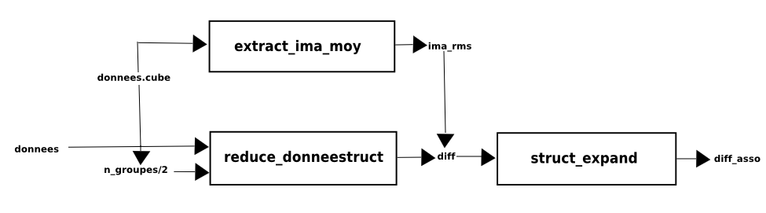

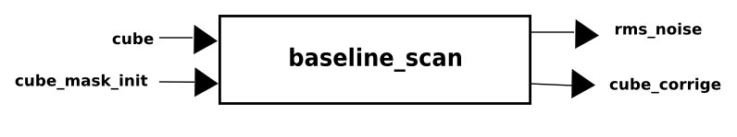

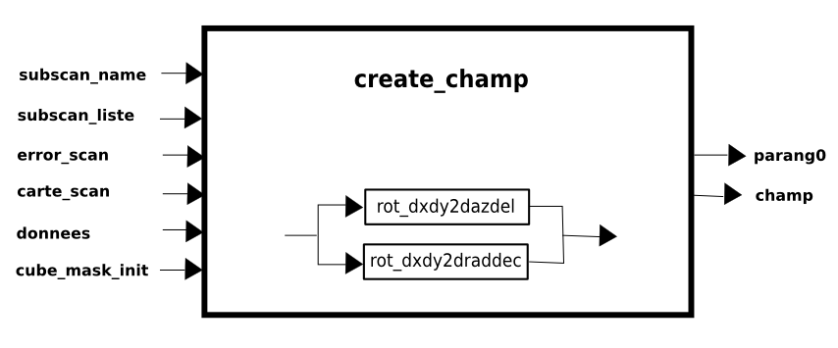

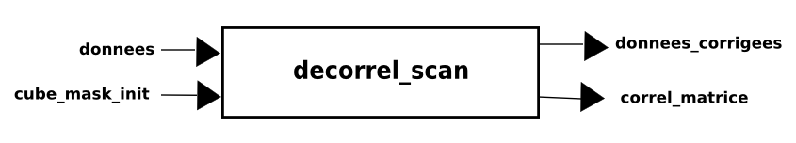

combine_otf_map

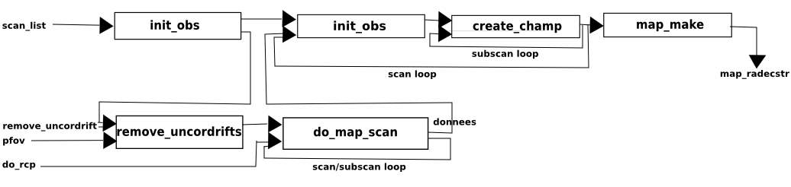

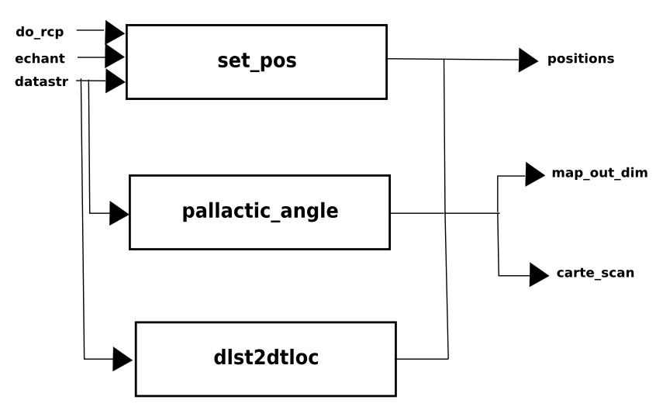
do_map_scan

ekh_restore

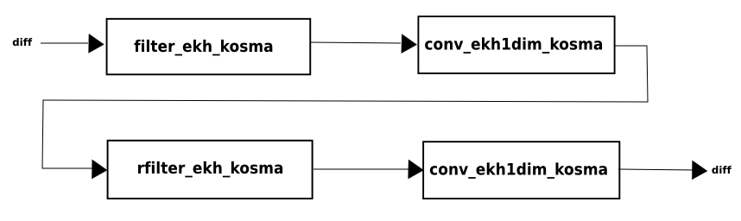

extract_ima_moy

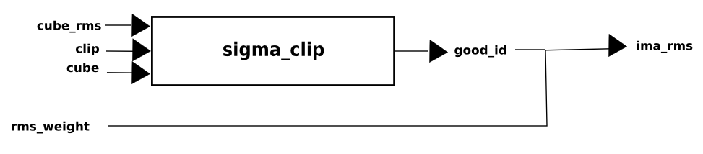

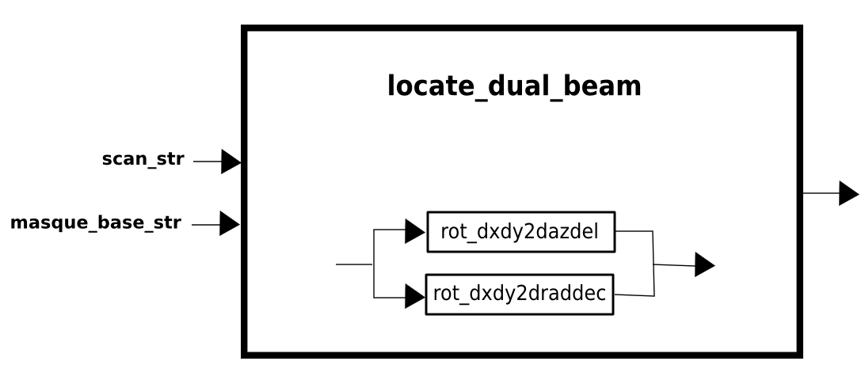

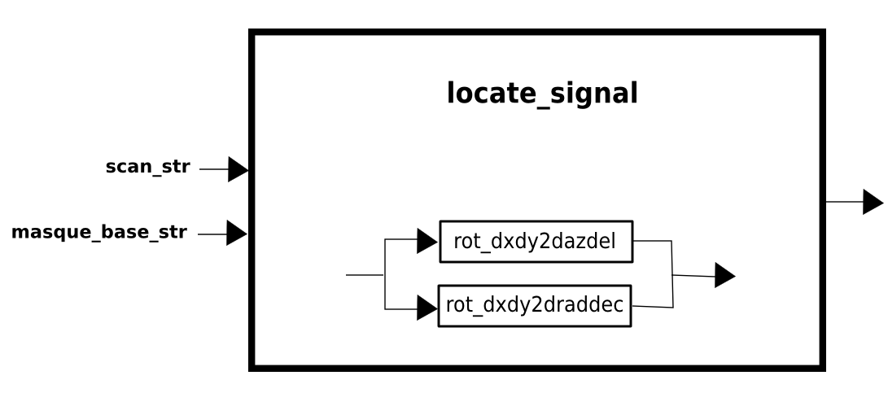

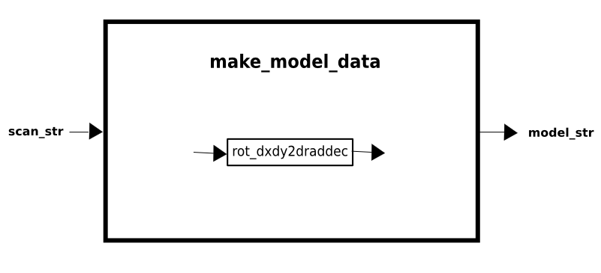

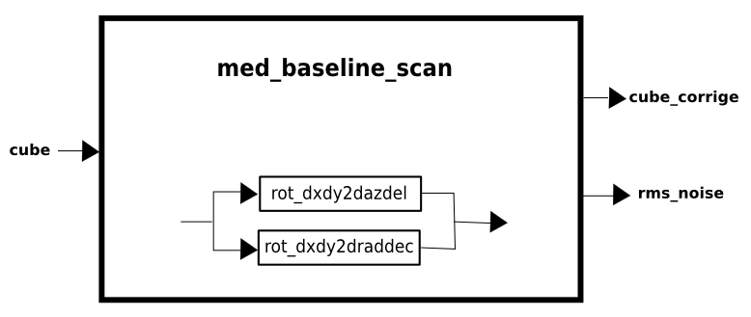

read_apex

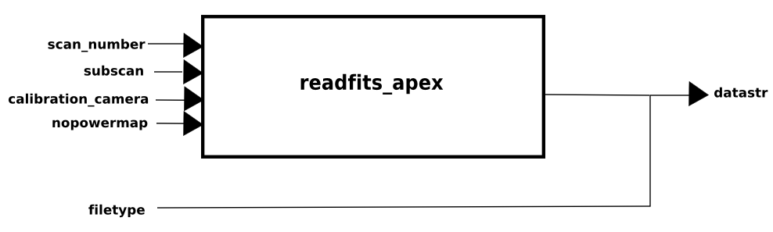

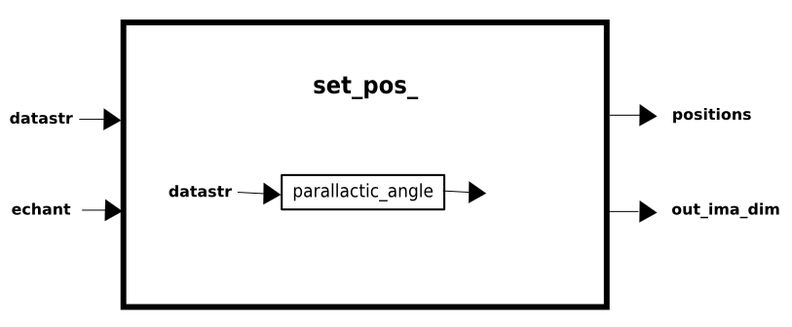

shift_and_add

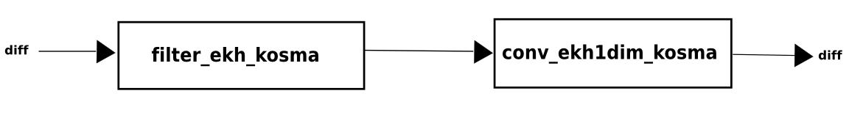

traite_otf_map_main

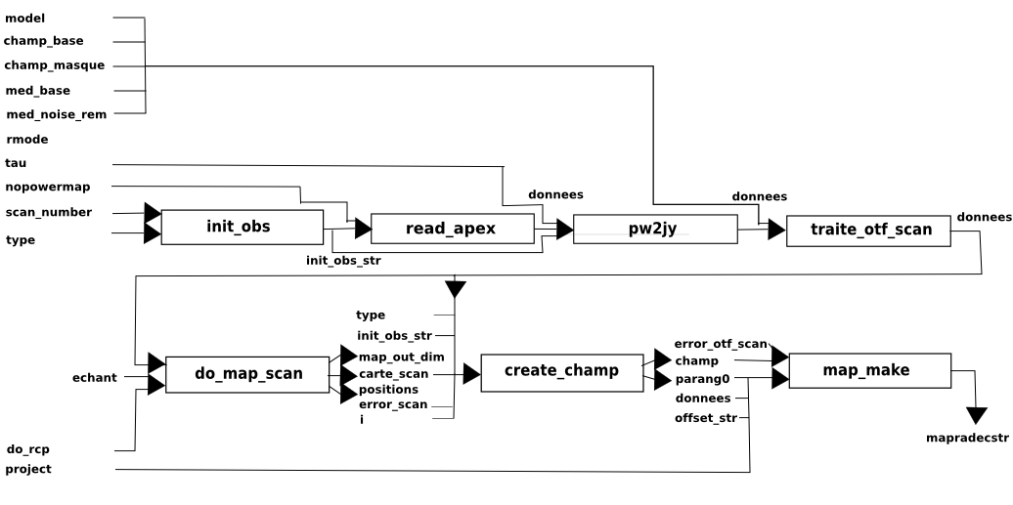

traite_otf_scan

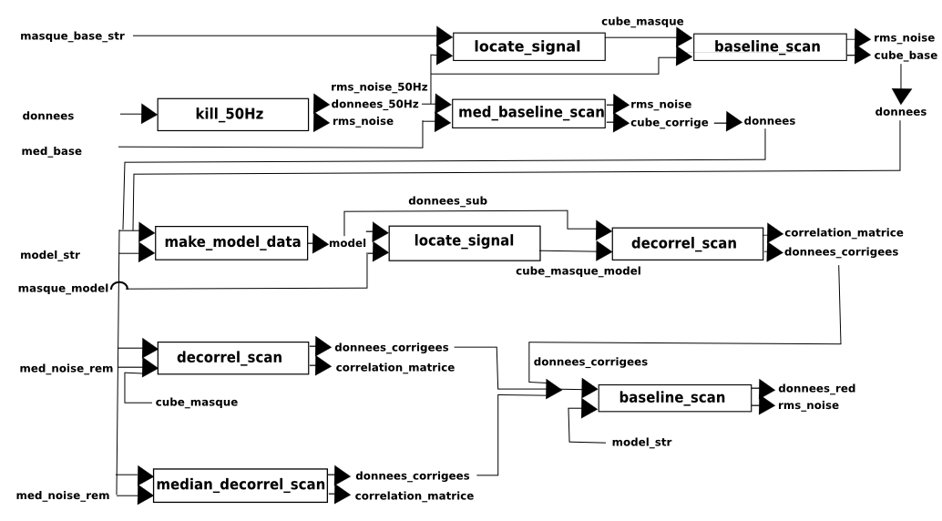

traite_otf_scan (next step if wobbler is ON)

Documents APPLICABLES

 | Titre | Référence
AD1 | Installation et utilisation du pipeline de réduction de données p-ArTéMiS.
AD2
AD3
AD4

