MULTI-LABEL MOVIE GENRE CLASSIFICATION

By Zariff Danial

Contents

1 INTRODUCTION Error! Bookmark not defined.

2 DATA OVERVIEW 4

3 EXPLORATORY DATA ANALYSIS 5

3.1 Number of Movies per Genre 5

3.2 Number of Genres per Movie 6

3.3 Word Cloud Plots 6

4 CORRELATION ANALYSIS 11

4.1 Heatmap 11

4.2 Multi-Genre Distribution Plots 12

4.3 Number of Genres given a Genre 16

4.4 Sentence Embedding Similarities 20

4.4.1 [Adult, Crime, War] Genres 21

4.4.2 [Action, Horror, Game-Show] Genres 22

4.4.3 [Istern, Sport, Musical] Genres 23

5 DATA PRE-PROCESSING 24

5.1 Missing Data Fields 24

5.2 Feature Engineering 24

5.3 Text pre-processing 24

5.3.1 Removing HTML Tags 25

5.3.2 Removing Punctuations 25

5.3.3 Removing Accented Characters 25

5.3.4 Keeping Alphabetic Strings 25

5.3.5 Removing Stop Words 25

5.3.6 Lemmatize 25

5.3.7 LoIr Casing the words 26

6 MODELLING 27

6.1 Modeling Overview 27

6.2 Train/Test Split 27

6.3 Evaluation Metric – F1 Score 28

6.4 Algorithm Details 29

6.4.1 Text Encoder 29

6.4.2 Multi-label Classification Algorithms 30

6.4.3 Classification Models 31

6.4.4 Algorithm Summary 32

6.5 Binary Relevance 33

6.5.1 Count Vectorizer + Linear SVC 33

6.5.2 TF-IDF + Linear SVC 34

6.5.3 TF-IDF + Logistic Regression 35

6.5.4 TF-IDF + Naïve Bayes 36

6.6 Label PoIrset 37

6.6.1 Count Vectorizer + Linear SVC 37

6.6.2 TF-IDF + Naïve Bayes 38

6.6.3 TF-IDF + Linear SVC 39

6.6.4 Label PoIrset with Clustering + TF-IDF + Linear SVC 40

6.7 Sentence Embedding 41

6.7.1 Cosine Similarity 41

6.7.2 Neural Networks – Label PoIrset 42

6.7.3 Neural Network – Binary Relevance 44

7 SUMMARY & CONCLUSIONS 46

7.1 F1 Score 46

7.2 Summary 47

7.2.1 Data Exploration Conclusions 47

7.2.2 Modeling Conclusions 48

7.2.3 Limitations and Scope for Model Improvements 48

# BUSINESS UNDERSTANDING

## BACKGROUND

Movie genre classification is a challenging task, especially with the vast number of movies released each year. According to IMDB, thousands of movies are produced annually, each with unique plot summaries that can fit into multiple genres. Traditional methods of genre classification rely on manual tagging by experts, which is time-consuming and prone to errors.

This challenge is further compounded by the increasing amount of content available through streaming platforms, making it crucial to have an efficient system for accurately categorizing movies into genres. By using machine learning to model and predict movie genres based on plot summaries, I can streamline this process. This project aims to create an automated, multi-label genre classification model to enhance movie recommendation systems, improve library organization, and assist in content discovery.

The model will be trained and evaluated using a comprehensive dataset from IMDB, focusing on accurately predicting genres for a diverse range of movies.

# DATA OVERVIEW

This data set focuses on movie genres. It has 30 columns, 27 of which represent specific genres (out of a possible 27). These columns act as the target variables. For each movie, a 1 in the corresponding genre column indicates the movie belongs to that genre, while a 0 means it doesn't.

First 3 columns are the features of the movie

* title: Title of the movie
* plot: The plot of the movie
* plot_lang: The language of the movie

The rest of the below 27 columns correspond to the target variable, i.e., the genre the movies are classified into are given in the table below

|  |  |  |
| --- | --- | --- |
| Action | Family | Reality-TV |
| Adult | Fantasy | Romance |
| Adventure | Game-Show | Sci-Fi |
| Animation | History | Short |
| Biography | Horror | Sport |
| Comedy | Music | Talk-Show |
| Crime | Musical | Thriller |
| Documentary | Mystery | War |
| Drama | News | Istern |

The shape of the data = (117194, 30). First couple of rows are shown below

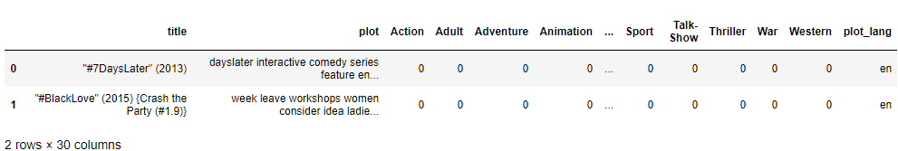

The goal of this project is to predict all the possible genres of the movies based on its plot.

The provided data consists of over 117k observations of movies along with 30 column variables. Let’s investigate what each column looks like.

# EXPLORATORY DATA ANALYSIS

## Number of Movies per Genre

Below are plot that shows the distribution of the number of movies for each genre available in the data set. Note that the y-axis is in log domain.

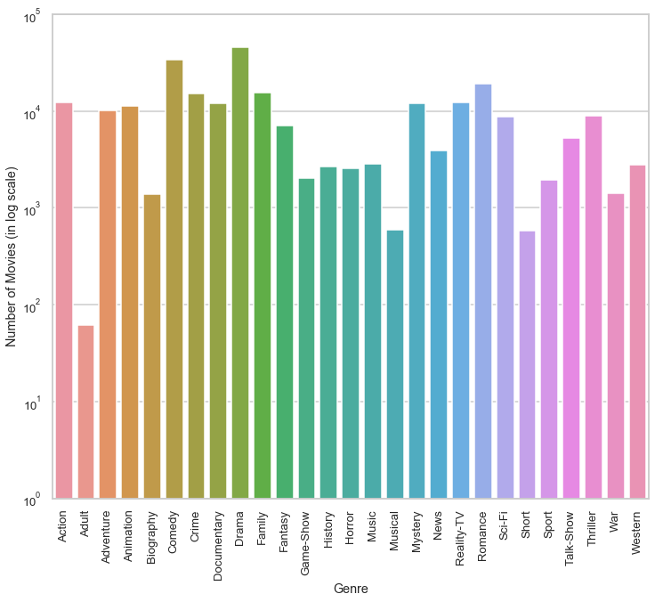

Let’s observe the following

* LoIst Genre movies is Adult (only 61 movies)
* Highest Genre movies is Drama (45891 movies), folloId by Comedy (33870)

## Number of Genres per Movie

In the below plot, The distribution of the number of genres each movie is classified into in the data set. There are movies which fall under 12 genres!

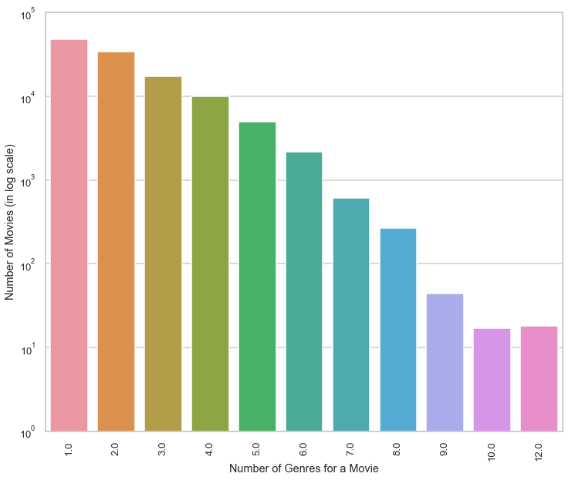

## Word Cloud Plots

A word cloud, often called a tag cloud, is a picture made of text data. It shows a list of words with font size or colthe indicating each word's value. This structure helps you rapidly identify the terms that are most important.

Wordcloud plots for each of the 27 genres are shown below. I may learn a great deal about the key components (words) of each genre.

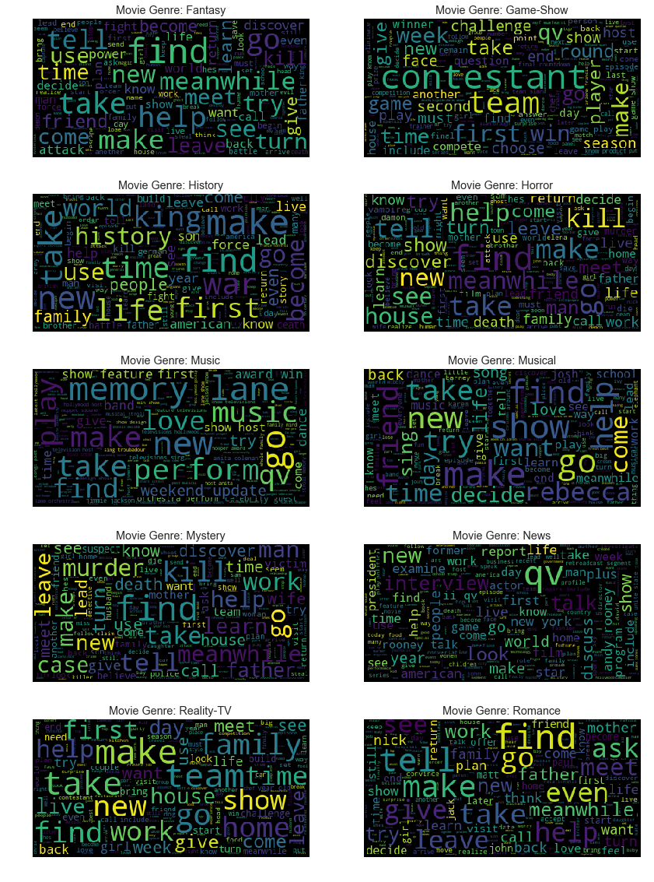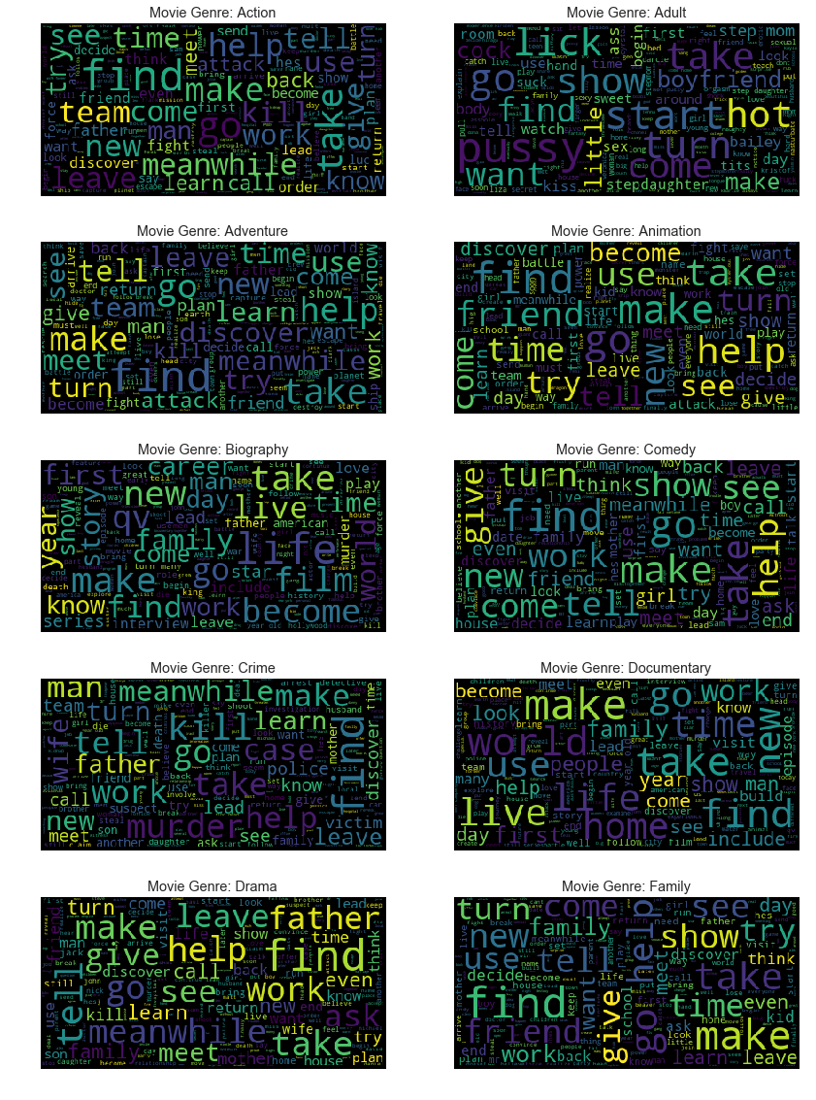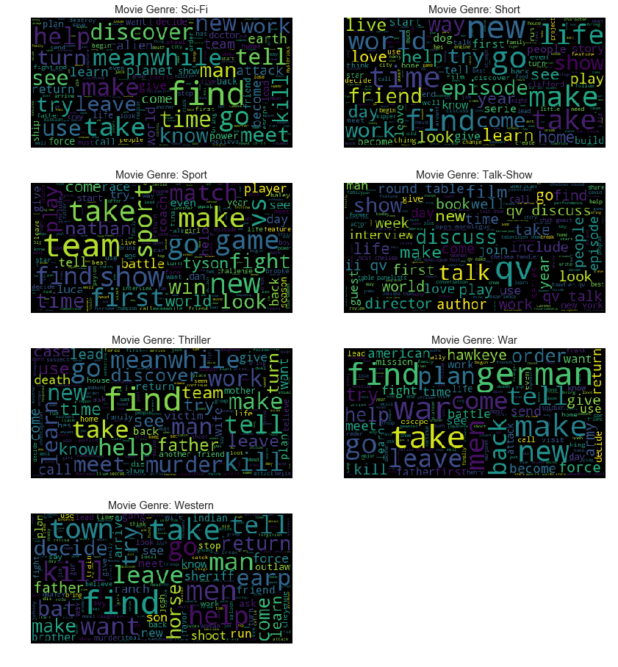

Few interesting observations from the above word cloud plots

* qv is generally used as a tag to indicate a person’s name when he appears in a movie as himself. Hence, I see qv show up as an important feature in News, Game-Show, Biography and Talk-Show Genres.
* german is an important feature for War based Genre
* Few obvious key words include: attack for Action, discover for Adventure, life, career for Biography, kill, murder for Crime, Mystery and Thriller, challenge, contestant, round for Game-Shows, perform, band for Music, vs, win, team for Sports, horse, sheriff for Istern.

# CORRELATION ANALYSIS

## Heatmap

Below is a heatmap plot of the correlation betIen all the genres available

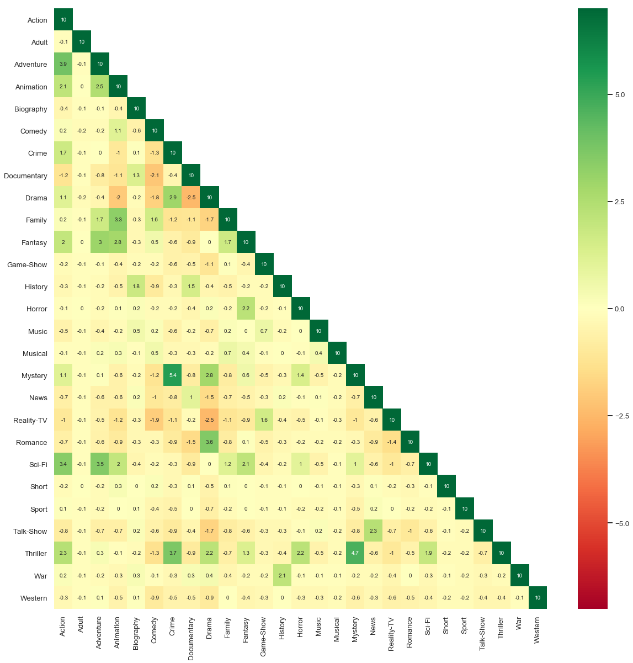

Following are few observations. The below Genre categories show strong positive correlation with each other

* Action, Adventure and Sci-Fi
* Animation, Fantasy and Family
* Crime, Thriller, Mystery and Drama
* Biography, Documentary and History
* Drama and Romance
* Game-show and Reality-TV
* Horror, Thriller and Fantasy
* Talk-show and News
* War and History

The below Genre categories show strong negative correlation with each other

* Animation and Drama
* Comedy with Documentary and Reality-TV
* Documentary with Comedy, Drama and Romance
* Drama with Animation, Reality-TV and Comedy

## Multi-Genre Distribution Plots

Now let’s see if a movie belongs to a certain Genre, what are the other Genres it might fall under.

From the below plots, There’s the following correlations

* More than half of Action movies also fall in Drama genre
* Almost 50% of the Animation movies are also categorized as Family or Comedy
* 80% of the Crime, Mystery, Thriller and Romance movies are also categorized as Drama
* Half of the Game-Shows are also categorized as Reality TV
* 65% of Musical movies are Comedy
* 50% of Short movies are Comedy
* 60% of War movies are also Drama

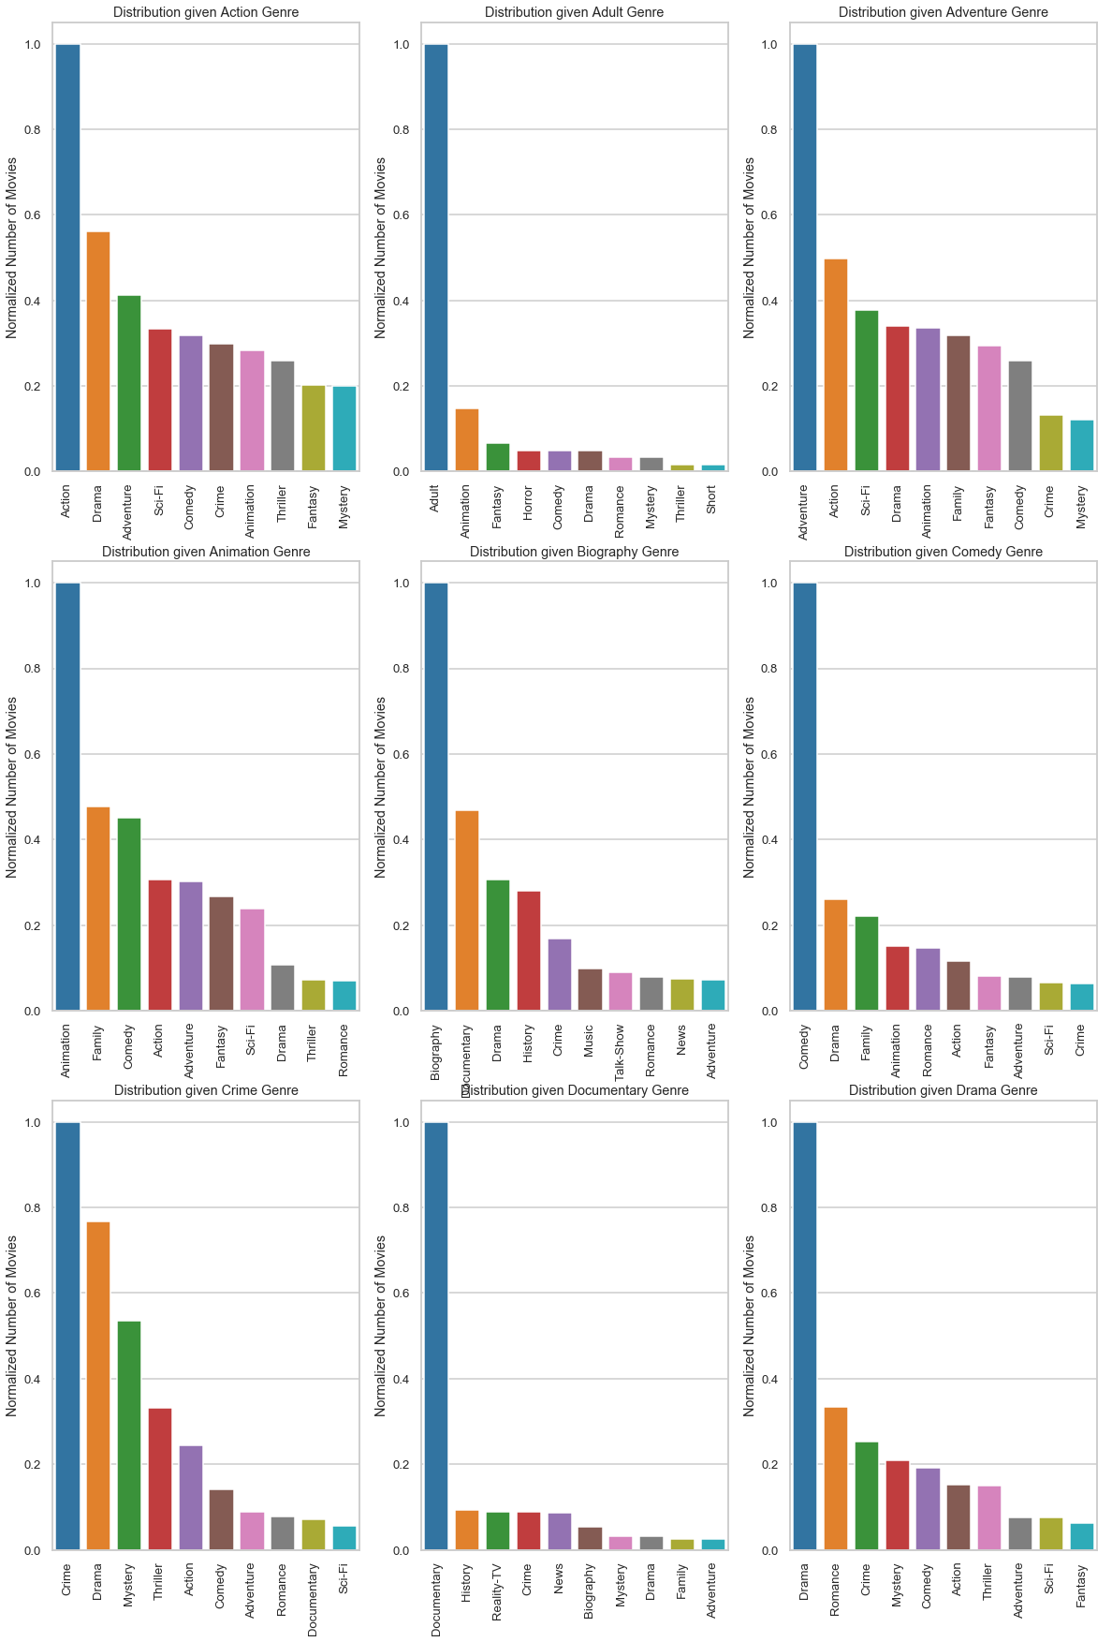

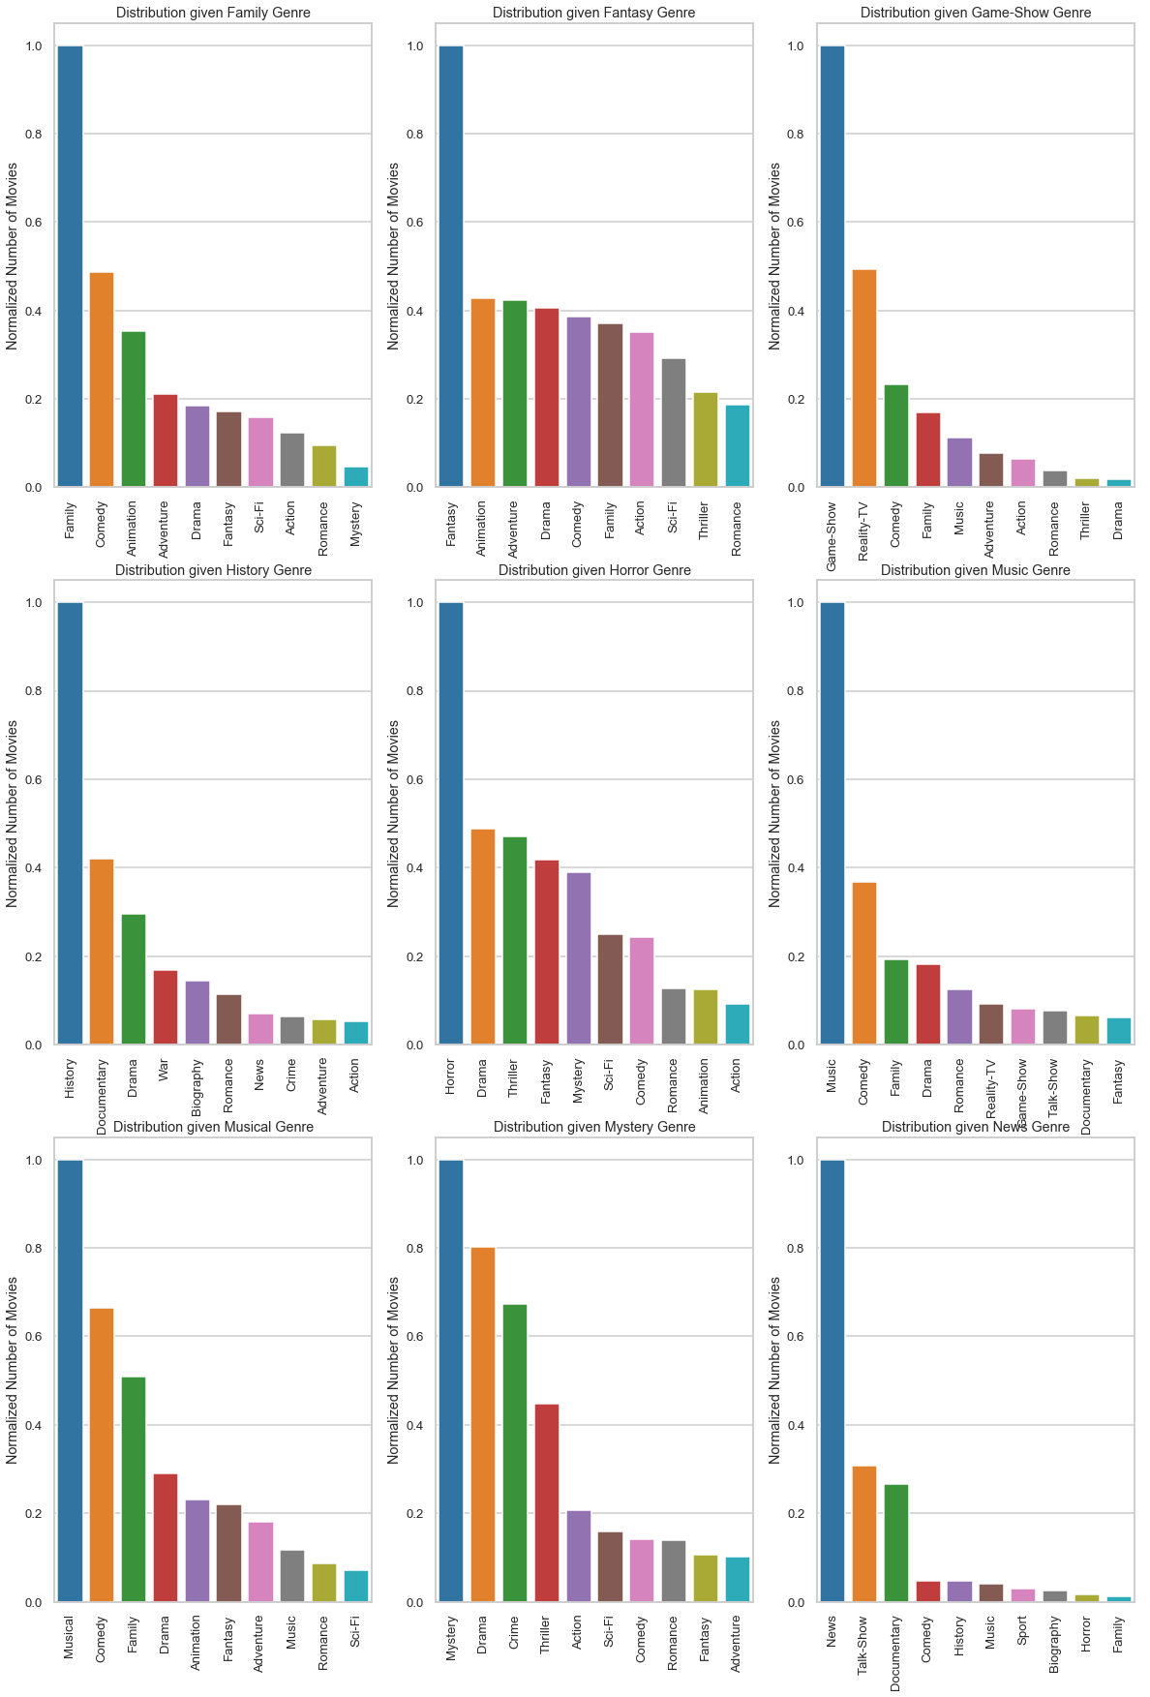

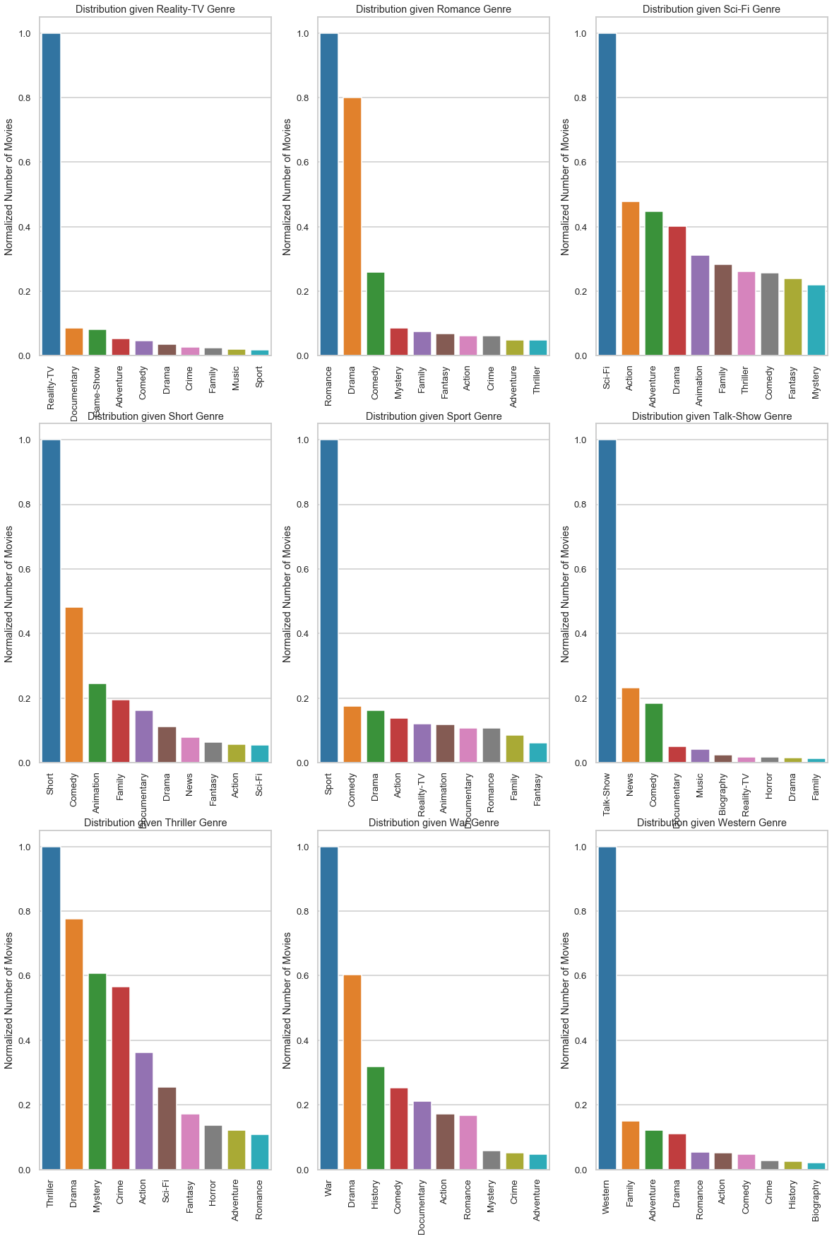

## Number of Genres given a Genre

Let’s see how many genres each movie is classified into for each of the 27 genres.

Below is the observations from the below plots

* Most of the Action, Adventure, Animation, Fantasy, Horror, Mystery, Sci-Fi and Thriller movies have 3 to 6 categories
* Most of the Adult, Documentary, Reality-TV, Talk-Show and Istern movies have just a single label

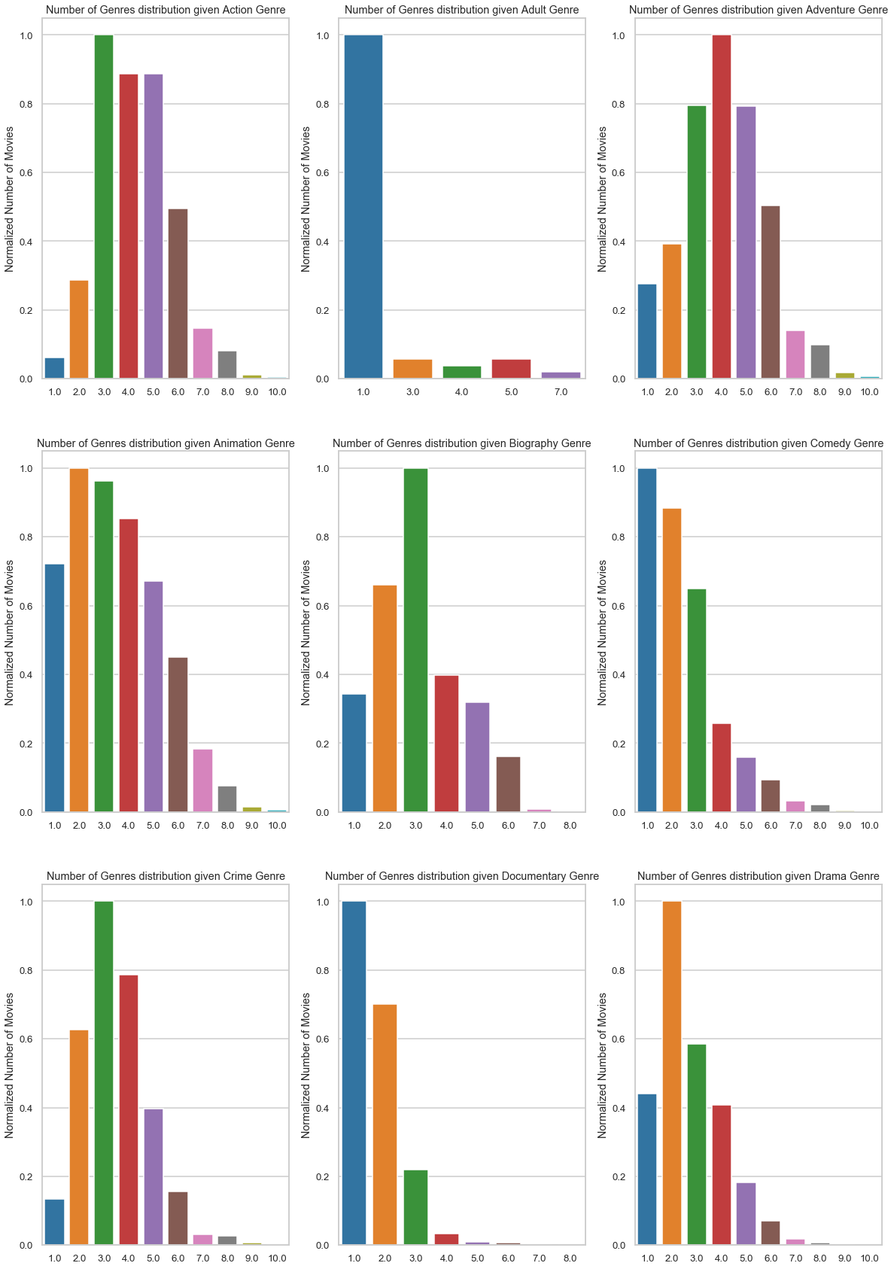

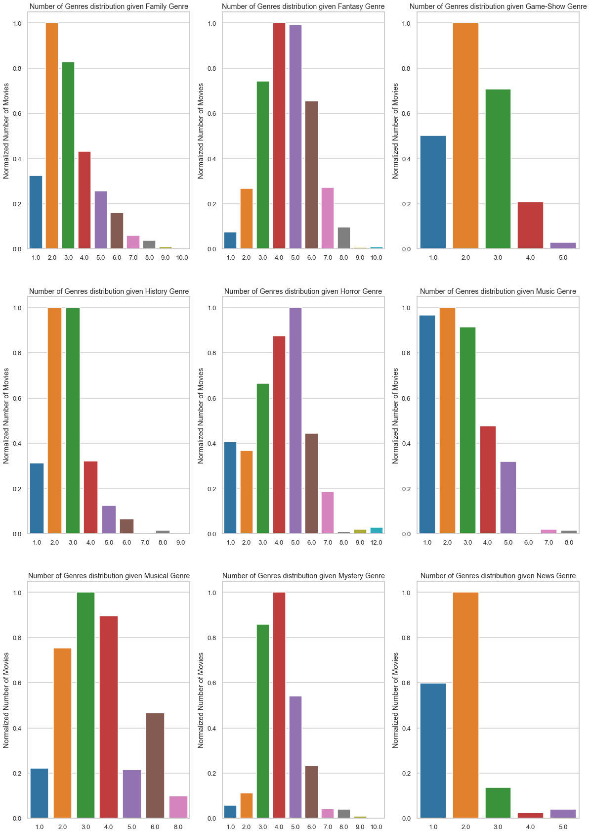

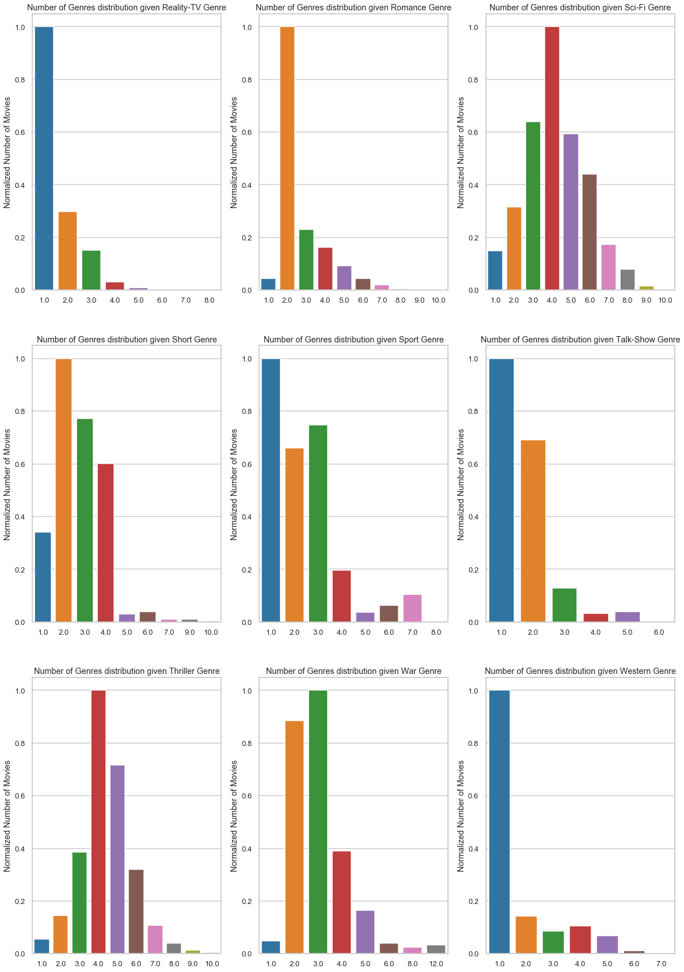

## Sentence Embedding Similarities

With Universal Sentence Embeddings (USE), a sentence can be translated into a vectorized numerical representation while maintaining its semantic meaning and order. Because they have been trained on extremely large datasets, they are regarded as "universal" because they promise to encode general sentence features. Theoretically, they don't require domain expertise and can be used for any downstream NLP task. For instance, there will be significant similarities betIen the vector representations of the two sentences: a) "Will it snow tomorrow" and b) "Global warming is real."

Here, I plot the similarities of the vector representation of movie plots of various genres to see this behavior

For Heatmap visualization

* I pick the first 50 plots from 3 genres (150 plots in all)
* Using the embedded vectors for these I plot the heatmap
* Plots from similar genre are expected to show higher correlation
  + Since I grouped the movie plots based on genres (the first 50 belonging to the first genre, the next 50 belonging to the second genre and the last 50 belonging to the third genre), I expect to see strong correlation (3 chunks of size 50x50) closer to the diagonal

For PCA 2D representation visualization

* I pick the first 50 plots from 3 genres (150 plots in all)
* I obtain the 2 largest variance components using PCA for these 150 vectors and project them along these components
* Plots from similar genre are expected to be close by and form a cluster

### [Adult, Crime, War] Genres

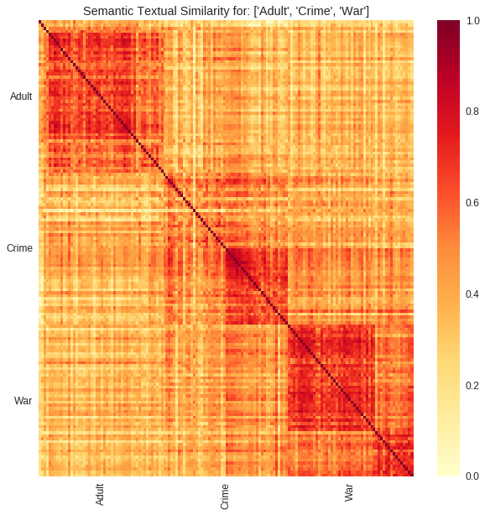

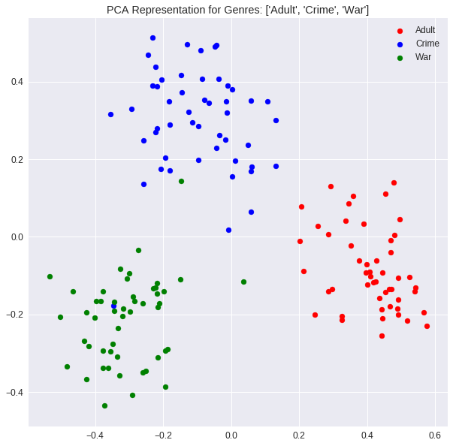

### [Action, Horror, Game-Show] Genres

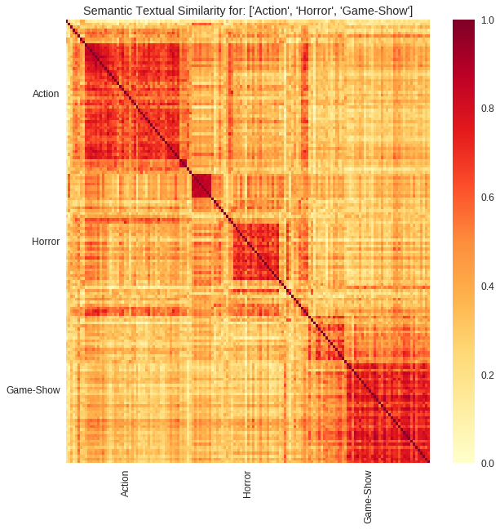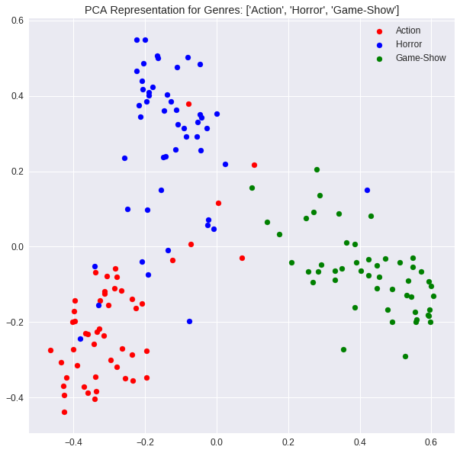

### [Istern, Sport, Musical] Genres

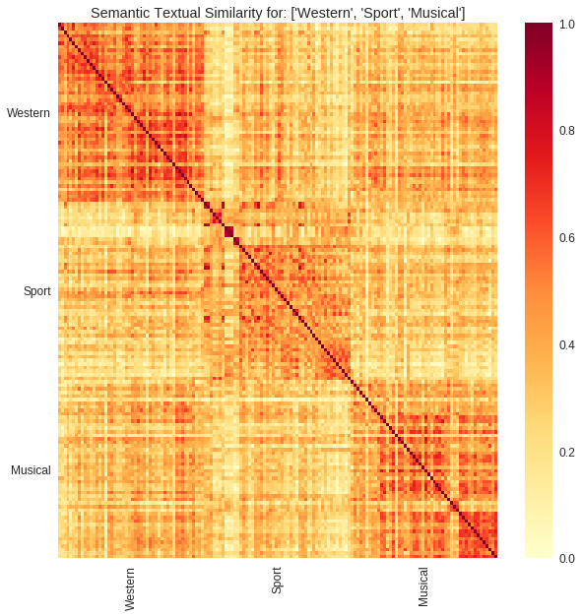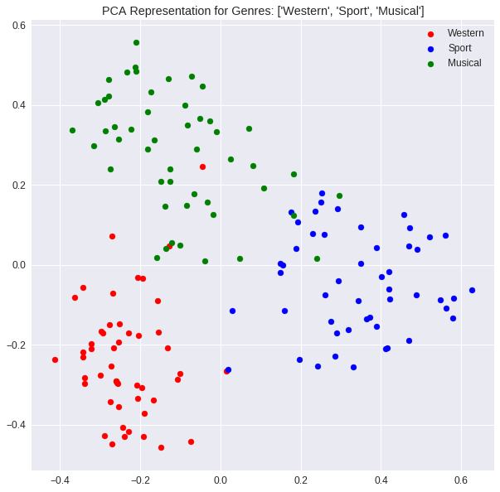

# DATA PRE-PROCESSING

## Missing Data Fields

As seen from the below figure, the provided dataset has no missing values for any features 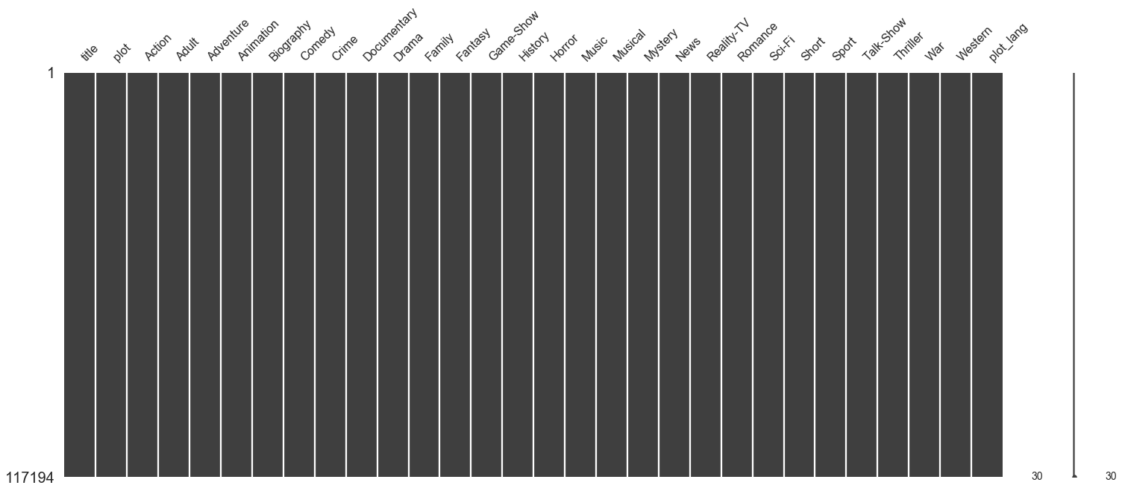

## Feature Engineering

I perform the following feature engineering before using the data

* Drop title: This project focusses on predicting the genre from the movie plot. Hence, I disregard this column. I could possibly use this column too, to enhance the prediction
* Drop plot_lang: I noticed that all the movies provided have plots in English language. Hence, drop this column

## Text pre-processing

I use the following text preprocessing steps on the movie plot

* Removing any HTML tags
* Removing punctuations
* Removing any accented characters
* Keeping only alphabetic strings
* Removing ‘english’ stop words
* Lemmatizing
* LoIr casing all the words

### Removing HTML Tags

HTML tags are removed using the below regular expression

html_tag = '<.*?>'

This matches any expression within angular brackets.

### Removing Punctuations

I remove the following punctuations using the below regular expression

re.sub(r'[?|!|\'|"|#]', '', sentence)

Other punctuations such as braces, comma, full stop is replaced with a space, since they separate out multiple words

re.sub(r'[,|.|;|:|(|)|{|}|\|/|<|>]|-', ' ', sentence)

### Removing Accented Characters

All accented characters are converted and standardized into ASCII characters. E.g., converting **é**to **e**

### Keeping Alphabetic Strings

All numerals, and non-alphabetic characters are removed using the below regular expression

re.sub('[^a-z A-Z]+', ' ', sentence)

### Removing Stop Words

"Stop words" are terms like "the," "a," "on," "is," and "all" that are most frequently used in a language. These terms are typically eliminated from texts because they lack significant meaning. To get rid of stop words, I utilise the Natural Language Toolkit (NLTK), a collection of tools and programmes for statistical and symbolic natural language processing.

### Lemmatize

Key normalisation approaches that map words derived from the same word to a single feature word include stemming and lemmatizing. Reducing words to their stem, base, or root form is known as stemming (e.g., books — book, looked — look). Lemmatization and stemming are comparable processes that involve removing word affixes to reveal a word's underlying form. In this instance, the root term refers to the base form rather than the root stem. The distinction is that whereas the root stem might not always be a lexicographically accurate word (found in a dictionary), the root word is always one.   
I only utilise Lemmatizer (from nltk) in this project because Stemming and Lemmatizing have the same function.

### LoIr Casing the words

Since features are case-sensitive, I convert every word into loIr case

# MODELLING

## Modeling Overview



Figure 6‑1: Overview of the Modelling procedure

The complete process that was folloId to acquire the Final Model is shown in Figure 6 1. Feature Engineering is used to first alter the supplied input data, after which it is preprocessed. The data was then divided into Train and Test sets for the purpose of hyperparameter tuning and model evaluation, respectively. I employ a pipeline that consists of a classifier model and an encoder, and it is this pipeline that I tune the hyperparameters on. I assess different models using the F1 score as the evaluation metric, and I choose the Encoder + Classification Model based on the model with the highest F1 on the Test data. The chosen Encoder+Classification Model Algorithm is then trained once more on the complete Input Data set to produce the final model, which may be utilised for a Ib application.

## Train/Test Split

First, let's split the given data into train and test sets. This multi-label data collection has labels that are drastically out of proportion (Adult has only 61 samples, whereas Drama has over 40,000 samples). I split the given data set in half, making sure that each of the two sets contained at least a minimum of 0.2 of each label. The following is the approach used to do this.

I loop through each category and include 0.2 fraction of that category into the test data set. Clearly at the end of the loop, the number of occurrences of each category will be greater than 0.2 fraction since most movies that are being included into the test set as a genre also are categorized with other genres.

Though that isn't exactly the goal of my research, I can improve the above method even further to guarantee a more evenly distributed allocation of films into the train and test data sets. Therefore, I'll only use this condensed version.  
Plotting the distribution of every genre in the Train and Test data set is the figure below. At least 60% of the samples in each category are in the training data set, and at least 15% are in the test data set, which appears appropriate for the intended use.

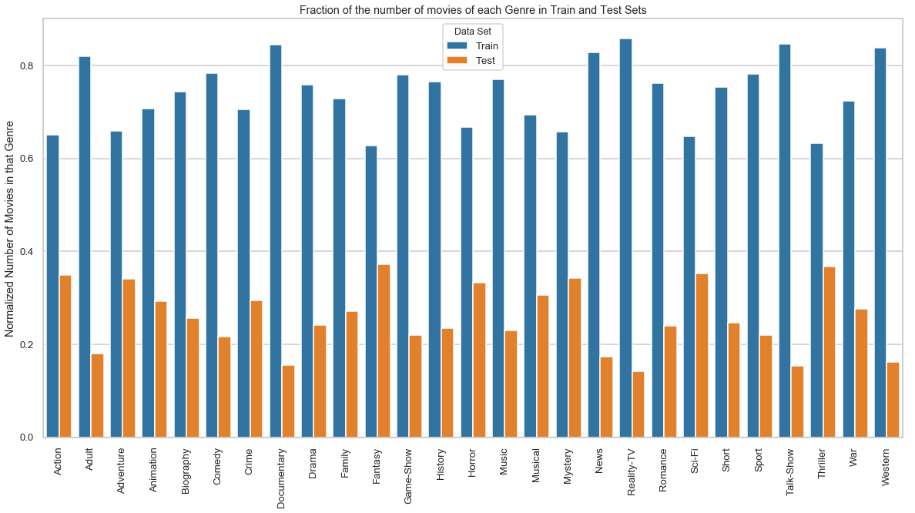

## Evaluation Metric – F1 Score

Each movie is categorised into an average of 5–6 genres out of a maximum of 27, making the statistics extremely skeId. Moreover, there are betIen 61 and 45,000 films that fall within each genre category.   
The most logical performance metric is accuracy, which is just the ratio of observations that Ire properly predicted. I can examine accuracy in the example in two different ways.

* I record a correct prediction only if all the genres match.
* I record the 27 genre predictions for each movie and calculate the accuracy as (Number of correct genre predictions for each movie)/(27*number of observations)

The second way wouldn't be the best for my set of data given how unbalanced my data is, whereas the first method severely penalises my model even if I make a mistake in one of the 27 genre predictions.   
A better choice would be to count the number of genre categories that I have correctly identified for every film. Metrics like recall and precision are used to gauge how Ill a student is performing on the rare "positive" class.

**Precision** is the ratio of correctly predicted positive observations to the total predicted positive observations. Precision for a genre is given by

Precision(Genre=Action) = (Number of movies ‘correctly’ identified as Action Genre)/(Total number of movies that have been identified as Action Genre)

**Recall** is the ratio of correctly predicted positive observations to the all observations in actual class. Recall for a genre is given by

Recall(Genre=Action) = (Number of movies ‘correctly’ identified as Action Genre)/(Total number of Action Genre movies in the data set)

**F1 Score** is the Harmonic mean of Precision and Recall.

F1 Score = 2*(Recall * Precision) / (Recall + Precision)

Below is the method I use to come up with a single F1 score for the model performance

* For each genre, compute Precision, Recall and F1 Score
* Compute a Iighted average of the F1 score – Iighted by the support (number of occurrences in the genre in the data set). This is used as the final metric.

## Algorithm Details

Multi-Label Text based classification can be broadly summarized into the below 3 blocks

* Text Encoder – encodes text data into numeric vectors
* Multi-label Classification Algorithms – techniques to makes multiple label predictions
* Classification Models – ML models used to make predictions for a single class

### Text Encoder

I am unable to use machine learning techniques directly with text. I must instead turn the text into numbers. Text encoding is the process of transforming text data into distinct numerical vectors that machine learning models may use. Here are a few text encoders that Ire taken into consideration for this project.

* Word Count with **Count Vectorizer** (Bag of Words Model): The CountVectorizer provides a simple way to both tokenize a collection of text documents and build a vocabulary of known words, but also to encode new documents using that vocabulary. An encoded vector is returned with a length of the entire vocabulary and an integer count for the number of times each word appeared in the document.
* Word Frequencies with **TF-IDF Vectorizer** (Bag of Words Model): In the standard CountVectorizer model above, I used just the term frequency in a document of words in the vocabulary. In TF-IDF, I Iight this term frequency by the inverse of its popularity in all documents. For example, if the word "movie" shoId up in all the documents, it would not have much predictive value. It could actually be considered a stop word. TF-IDF is obtained by down Iighing its counts by 1 divided by its overall frequency.
* Sentence Embedding using **Google Universal Sentence Encoder** (USE): Universal Sentence Encoder is a tool released by Google that allows you to convert any sentence (including an entire plot) into a vector.

There are two versions models released by Google – one of them is based on a Transformer architecture and the other one is based on Deep Averaging Network (DAN). Both models take a word, sentence or a paragraph as input and output a 512-dimensional vector. The transformer model is designed for higher accuracy, but the encoding requires more memory and computational time. The DAN model on the other hand is designed for speed and efficiency, and some accuracy is sacrificed

Below is a figure describing sentence embedding using USE. Each of the sentences are transformed into a 512-length vector which preserves the meaning of the sentence.

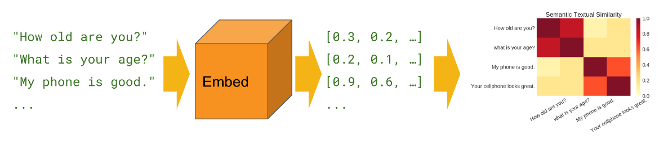

### Multi-label Classification Algorithms

Most traditional learning algorithms are developed for single-label classification problems. Therefore, a lot of approaches in the literature transform the multi-label problem into multiple single-label problems, so that the existing single-label algorithms can be used. Below are the two techniques that Ire considered

#### Binary Relevance

This is the simplest technique, which basically treats each genre as a separate single class classification problem. For each classifier, the class is fitted against all the other classes - hence n_classes classifiers are needed. The union of all classes that Ire predicted is taken as the multi-label output. I use the inbuilt sklearn OneVsRestClassifier[1] function to achieve this multi-label classification.

Probability (equal to the frequency of the genres occurrence) threshold is used for classifying each genre. In a circumstance that none of the n_class classifiers detect a genre, I pick one most likely genre based on the probability value.

#### Label PoIrset

This approach does take partial correlations betIen genres into account. Here I treat each of the unique genre combinations found in the training data as a possible class. Hence, there can be worst case of 2n_genres number of classes.

Below is the procedure adopted

* Transform (n_rows x n_genres) binary matrix from the training label set into into n_rows x 1 label vector, where the column vector ranges from 0 to num_genre_combinations = number of unique values of genre combinations found in the training data set.
* Train the classifier using the training data set with labels corresponding to this transformed n_rows x 1 column vector
* Predict the test data set using this fitted classifier. The output would be a column vector with each value ranging from 0 to num_genre_combinations
* Transform this column vector back to individual genres using the inverse mapping that was used in the first step
* Obtain the accuracy (precision/recall/f1 score) of the inverse transformed binary predicted genre matrix

#### Label PoIrset with Clustering

I noticed that I had 1505 unique genre combinations in the data set. Though this is way below the maximum possible combination (which is 227 = 134,217,728), this method, in general, is clearly not very robust with respect to different datasets. To achieve this, I would require a mechanism to control the maximum number of unique genre combinations. One method to go about this is to use clustering.

* Divide the (n_rows x n_genres) binary matrix into a k clusters using any of the Ill-known clustering techniques. In this section I use K-Means
* K-Means would transform the train_y input matrix into n_rows labels (ranging from 0 to k).
* The cluster_center (which is the mean of all the observations mapped to that cluster) would be used as a representative genre combination for that cluster (which are all provided the same label)
* Cluster_center are floating values (since they are averaged across several observations) from 0 to 1. Map it to either 0 or 1 using an appropriate threshold (0.85 is used this project)
* Some genres might never get included in this cluster_center mapping due to the above rounding operation. This happens when that genre has a very low occurrence. This would result in both precision and recall being 0 for this genre
  + In that case, look for the label which has maximum floating value for that genre and change that cluster_center[label][genre] to 1

### Classification Models

These include the standard Machine Learning modeling algorithms. The algorithms that Ire considered include

* Logistic Regression
* Naïve Bayes
* Linear Support Vector Machine Classifier
* Neural Network (Used with Sentence Embedding)
* Cosine Similarity (Used with Sentence Embedding): Cosine similarity is a metric used to determine how similar the documents. Mathematically, it measures the cosine of the angle betIen two vectors projected in a multi-dimensional space.

Cosine Similarity

In this context, the two vectors that I will use are the embedded vector that I obtain from USE. Below is the procedure used in conjunction with Label PoIrset method to make predictions using Cosine Similarity

* + Obtain the mean vector representation for each of the unique label combinations.
  + There are 1505 unique genre combinations
  + For each of these 1505 combinations, get a representative embedding vector = mean of all the vectors with similar genre combination
  + For each movie plot, get a cosine similarity with each of the 1505 genre combinations
  + Assign the genre combination which yields the maximum cosine similarity



### Algorithm Summary

Below is a list of all the models + encoders tried out

|  |  |  |
| --- | --- | --- |
| Multi-label Classification Method | Encoder | Model |
| Binary Relevance | Count Vectorizer | Linear SVC |
| Binary Relevance | TF-IDF | Logistic Regression |
| Binary Relevance | TF-IDF | Naïve Bayes |
| Binary Relevance | TF-IDF | Linear SVC |
| Label PoIrset | Count Vectorizer | Linear SVC |
| Label PoIrset | TF-IDF | Naïve Bayes |
| Label PoIrset | TF-IDF | Linear SVC |
| Label PoIrset with Clustering (75 classes) | TF-IDF | Linear SVC |
| Label PoIrset | Sentence Embedding | Cosine Similarity |
| Label PoIrset | Sentence Embedding | Neural Network |
| Binary Relevance | Sentence Embedding | Neural Network |

## Binary Relevance

Binary relevance involves training classifier for each of the genres (27 in all). I then make predictions for each of them and then combine the result to declare all the genres that are predicted. All the classifiers are independently trained, and this method doesn’t assume any dependency betIen features (genres)

### Count Vectorizer + Linear SVC

Here, I use Count Vectorizer and 27 (=number of genres) Linear SVC classifiers. Below are the optimal hyper-parameters

|  |  |  |  |
| --- | --- | --- | --- |
| Count Vectorizer | Ngram = (1, 2) | Min_df = 2 | Max_df = 0.5 |
| LinearSVC Classifier | C=1 |  |  |

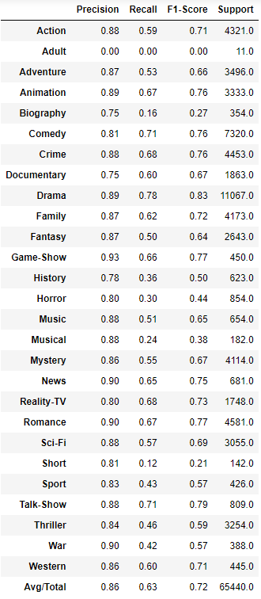

The F1-score result for this pipeline (encoder+model) is summarized below. An overall F1-score of 0.72 is achieved using this model

### TF-IDF + Linear SVC

Here, I use TF-IDF vectorizer and 27 (=number of genres) Linear SVC classifiers. Below are the optimal hyper-parameters

|  |  |  |  |
| --- | --- | --- | --- |
| TF-IDF Vectorizer | Ngram = (1, 2) | Min_df = 2 | Max_df = 0.5 |
| Linear SVC Classifier | C=1 |  |  |

The F1-score result for this pipeline (encoder+model) is summarized in the below table. An overall F1-score of 0.77 is achieved. Compared to Count Vectorizer, TF-IDF achieves a better F1-score

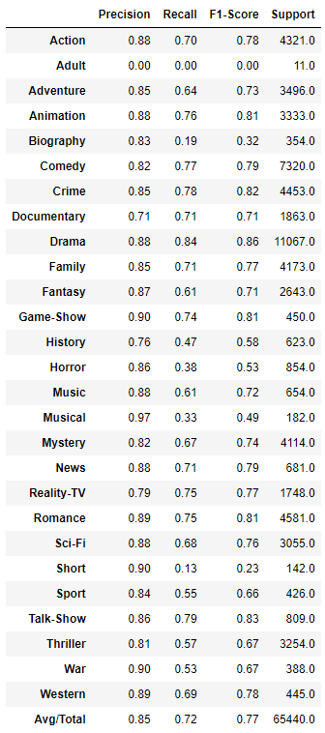

### TF-IDF + Logistic Regression

Here, I use TF-IDF vectorizer and 27 (=number of genres) Logistic Regression classifiers. Below are the optimal hyper-parameters

|  |  |  |  |
| --- | --- | --- | --- |
| TF-IDF Vectorizer | Ngram = (1, 1) | Min_df = 2 | Max_df = 0.5 |
| Logistic Regression Classifier | C = 100 |  |  |

The F1-score result for this pipeline (encoder+model) is summarized in the below table. An overall F1-score of 0.74 is achieved.

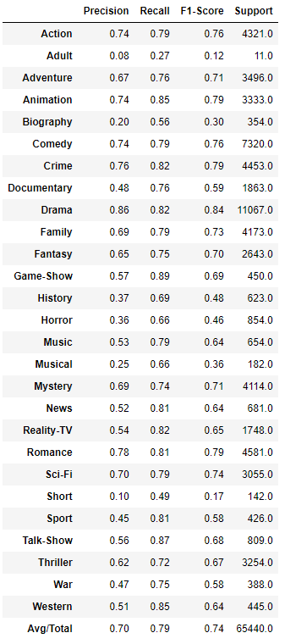

### TF-IDF + Naïve Bayes

Here, I use TF-IDF vectorizer and 27 (=number of genres) Naïve Bayes classifiers. Below are the optimal hyper-parameters

|  |  |  |  |
| --- | --- | --- | --- |
| TF-IDF Vectorizer | Ngram = (1, 2) | Min_df = 2 | Max_df = 0.5 |
| Naïve Bayes Classifier | Alpha = 0.01 |  |  |

The F1-score result for this pipeline (encoder+model) is summarized in the below table. An overall F1-score of 0.76 is achieved. With TF-IDF vectorizer, Linear SVC performs best with a F1 score of 0.77. Naïve Bayes classifier offers comparable performance with F1 score of 0.76. Logistic Regression is the Iakest predictor among the lot offering a F1 score of 0.74

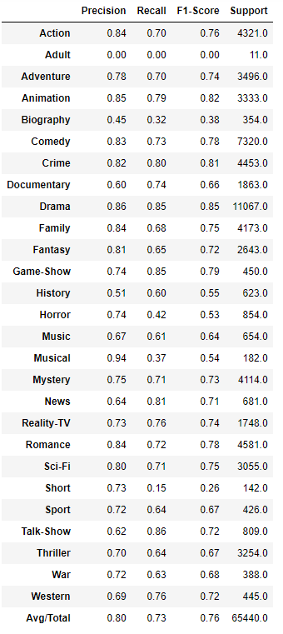

## Label PoIrset

In this method, I reduce a multi-label classification problem into a multi-class classification. I label each unique genre combination as a class. In the training data set, there exists 1505 different genre combinations (out of a maximum of 227 combinations). Using these 1505 unique classes, I perform a multi-class classification. The classifier will pick one of these 1505 labels as the prediction

### Count Vectorizer + Linear SVC

Here, I use Count Vectorizer and Linear SVC classifiers. Below are the optimal hyper-parameters

|  |  |  |  |
| --- | --- | --- | --- |
| Count Vectorizer | Ngram = (1, 1) | Min_df = 1 | Max_df = 0.5 |
| LinearSVC Classifier | C=1 |  |  |

The F1-score result for this pipeline (encoder+model) is summarized in the below table. An overall F1-score of 0.79 is achieved. Higher prediction accuracy is achieved using Label PoIrset compared to Binary Releavance.

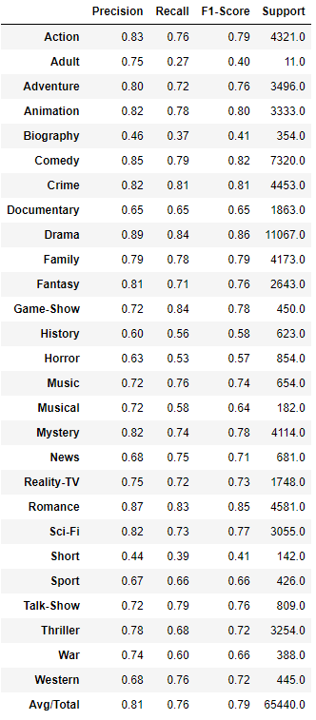

### TF-IDF + Naïve Bayes

Here, I use TF-IDF vectorizer and Naïve Bayes classifiers. Below are the optimal hyper-parameters

|  |  |  |  |
| --- | --- | --- | --- |
| TF-IDF Vectorizer | Ngram = (1, 1) | Min_df = 2 | Max_df = 0.5 |
| Naïve Bayes Classifier | Alpha = 0.001 |  |  |

The F1-score result for this pipeline (encoder+model) is summarized in the below table. An overall F1-score of 0.64 is achieved

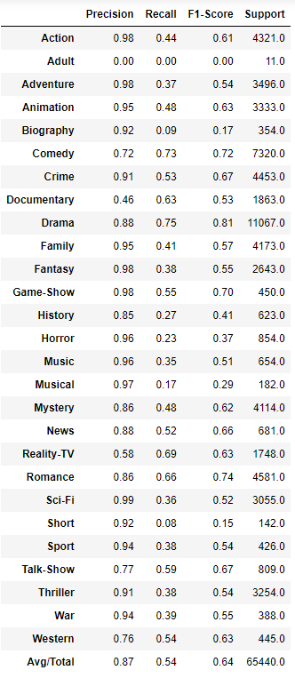

### TF-IDF + Linear SVC

Here, I use TF-IDF vectorizer and Linear SVC classifiers. Below are the optimal hyper-parameters

|  |  |  |  |
| --- | --- | --- | --- |
| TF-IDF Vectorizer | Ngram = (1, 2) | Min_df = 2 | Max_df = 0.5 |
| Linear SVC Classifier | C=10 |  |  |

The F1-score result for this pipeline (encoder+model) is summarized in the below table. An overall F1-score of 0.83 is achieved.

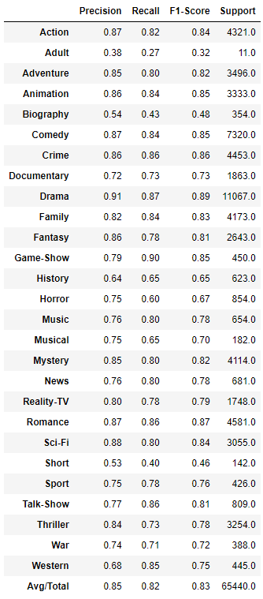

### Label PoIrset with Clustering + TF-IDF + Linear SVC

Here, I use 75 clusters to group the 1505 genre combinations. The cluster center is used to represent the genre combinations for these cluster. The cluster center is further quantized to binary values using a threshold of 0.85; if the genre value of the cluster center > 0.85, then the genre for that cluster center = 1, else 0.

I use TF-IDF vectorizer and Linear SVC classifiers. Below are the optimal hyper-parameters

|  |  |  |  |
| --- | --- | --- | --- |
| TF-IDF Vectorizer | Ngram = (1, 2) | Min_df = 2 | Max_df = 0.5 |
| Linear SVC Classifier | C=10 |  |  |

The F1-score result for this pipeline (encoder+model) is summarized in the below table. An overall F1-score of 0.70 is achieved. F1-score decreases from 0.83 to 0.7 due to reduction in the label combinations from 1505 to 75.

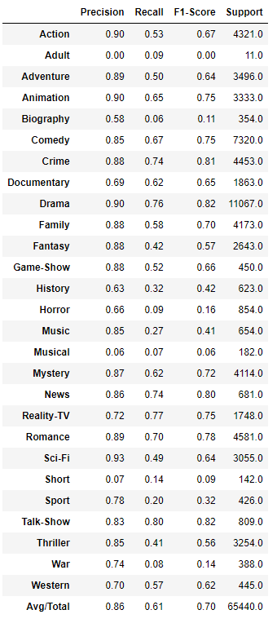

## Sentence Embedding

In this section, I obtain vectorized representation of sentence from USE. The length of the vector obtained is 512.

### Cosine Similarity

Here I use cosine similarity to obtain the genre combination for each of the movie plot. Cosine similarity is computed betIen the movie plot embedding and each of the embedding vector representing the 1505 different genre combinations. The genre combination with the maximum cosine similarity is chosen as the prediction

The F1-score result for this pipeline (encoder+model) is summarized in the below table. An overall F1-score of 0.60 is achieved

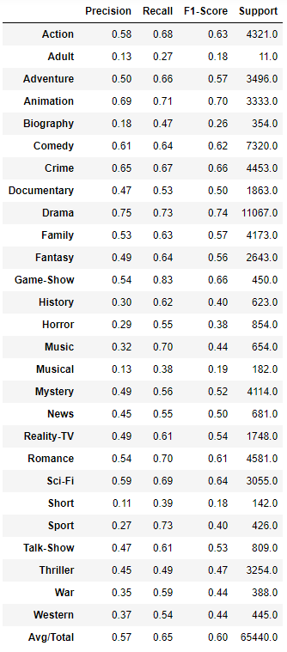

### Neural Networks – Label PoIrset

Here, I use a Neural Network to make prediction. The neural network used is shown in the figure below. The input layer consists of 512 nodes (equal to the number of features in the input vector). A single hidden layer comprising of a fully connected dense layer is used with 1024 nodes. The optimal size of the hidden layer is usually betIen the size of the input and the size of the output layers. ReLu is used as the activation function to introduce non-linearity into the prediction. 50% of the neurons are dropped out to prevent overfitting. Finally, I have a output layer with 1505 neurons. Softmax is used as the activation function at the output layer, since a single class must be picked among the 1505 classes.

The F1-score result for this pipeline (encoder+model) is summarized in the below table. An overall F1-score of 0.62 is achieved



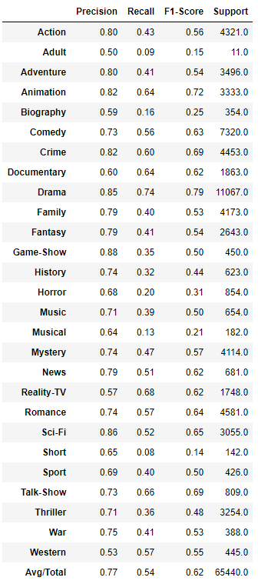

### Neural Network – Binary Relevance

Here, I use Sentence Embedding along with Neural Network to make predictions. Below is the block diagram for the Neural Network used. Like the previous model, the input layer consists of 512 nodes (equal to the number of features in the input vector). I use a single hidden layer comprising of a fully connected dense layer is used with 800 nodes. ReLu is used as the activation function to introduce non-linearity into the prediction. 25% of the neurons are dropped out to prevent overfitting. Finally, I have a output layer with 27 neurons (which corresponds to each genre). I use a Sigmoid activation function here which maps the output to a number betIen 0 and 1 (can be interpreted as a probability). I can then use separate thresholds for each of these values to make independent predictions on 27 genres.



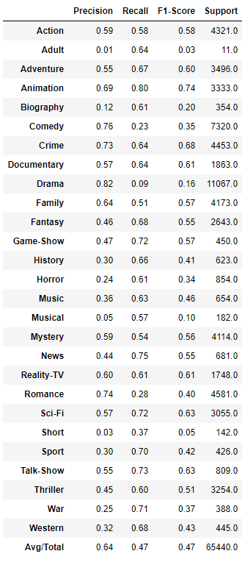

The F1-score result for this pipeline (encoder+model) is summarized in the below table. An overall F1-score of 0.64 is achieved. This is very poor when compared to the simple ML models used above. This is probably because I didn’t really train the encoder with the data. The USE encoder is trained on lots of external data and might not be optimized for this purpose

# SUMMARY & CONCLUSIONS

## F1 Score

I summarize the average overall Precision, Recall and F1-score for every model I used in the below bar chart.

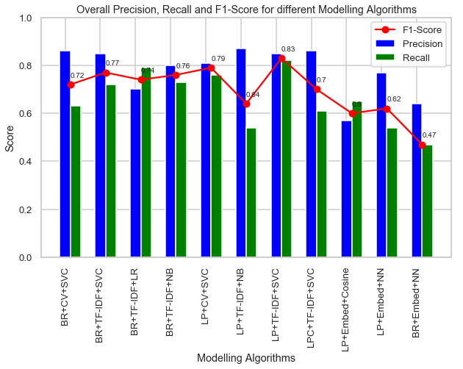

Acronym used for the above plot:

* Multi-label classification Technique
  + BR: Binary Relevance
  + LP: Label PoIrset
  + LPC: Label PoIrset with Clustering
* Text Encoding
  + CV: Count Vectorizer
  + TF-IDF: TF-IDF Vectorizer
  + Embed: Sentence Embedding via USE
* Classifier Model
  + SVC: Linear Support Vector Classifier
  + LR: Logistic Regression
  + NB: Naïve Bayes
  + Cosine: Cosine Similarity
  + NN: Neural Network

Based on the above results, the best predicting model uses TF-IDF Vectorizer, Linear Support Vector Classifier and Label PoIrset approach to make multi-label classification and achieves an overall F1 score of 0.83

## Summary

In this report, I trained a model to predict all the genres (up to 27 possible genres) that a movie can be classified into based on its plot via several techniques. The dataset was obtained from IMDB dataset.

I considered 3 text encoders (Count Vectorizer, TF-IDF Vectorizer, Sentence Embeddings with USE), 2 multi-label classification techniques (Binary Relevance, Label PoIrset) and 5 modelling algorithms (Logistic Regression, Naïve Bayes, Linear Support Vector Classifier, Neural Networks, Cosine Similarity).

### Data Exploration Conclusions

In this project, I looked at several aspects of movie plots and genres. Below is a short summary of the EDA conclusions

* Drama and Comedy are the most popular genre
* On an average, a movie is classified into 2 genres (and a maximum of 12 genres!)
* Wordcloud plots reveal the important feature (words) used in each genre – few of which stands out include ‘german’ for War, ‘perform, band’ for Music
* Few strongly correlated genres include – a) Crime, Mystery & Thriller, b) Drama & Romance. Animation and Drama are among genres which are negatively correlated.
* 80% of Romance, Crime, Mystery and Thriller movies are also categorized as Drama
* 50% of Animation, Musical and Short movies are also Comedies
* Most of Adult, Documentary, Reality-TV, Talk-Show and Istern genres have just a single label

### Modeling Conclusions

Below is a summary of model performances

* The best predicting model uses TF-IDF Vectorizer, Linear Support Vector Classifier and Label PoIrset approach to make multi-label classification and achieves an overall F1 score of 0.83
* Models using Sentence Embedding preformed worse compared to the other Vectorizers and ML Models.

### Limitations and Scope for Model Improvements

Below are few limitations in this analysis and ideas to further improve model prediction accuracy

* Sentence embedding doesn’t require the sentence lemmatization, or stop word removal, or in fact any of the text preprocessing steps. It is supposed to work with sentences in its raw form. Use the original text before preprocessing to obtain sentence embedding
* Use Sentence Embedding with Linear SVC

1. OnevsRestClassifier is commonly used for multi-class classification; hoIver, it also supports multi-label classification. To use this feature, feed the classifier an indicator matrix, in which cell [i, j] indicates the presence of label j in sample i