HW 1 Write-up – Isaiah King

Alpha = 1

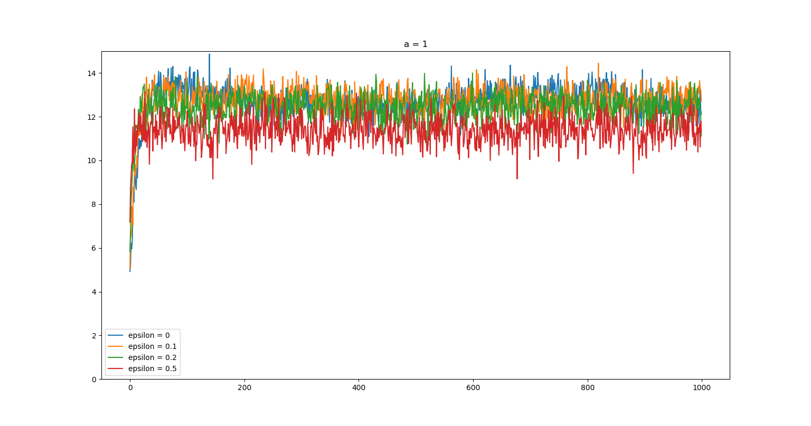

When alpha is set to 1 the model is able to get decent results with reasonable epsilon values (0.1, and 0.2) however, this was not the most optimal configuration. When compared with other values of alpha, it is clear that the model continually gives the intermediate, new gradient for Q too much weight in later stages. As such, it has a harder time selecting the most optimal option at a point where it should have learned it.

Alpha = 0.9^k

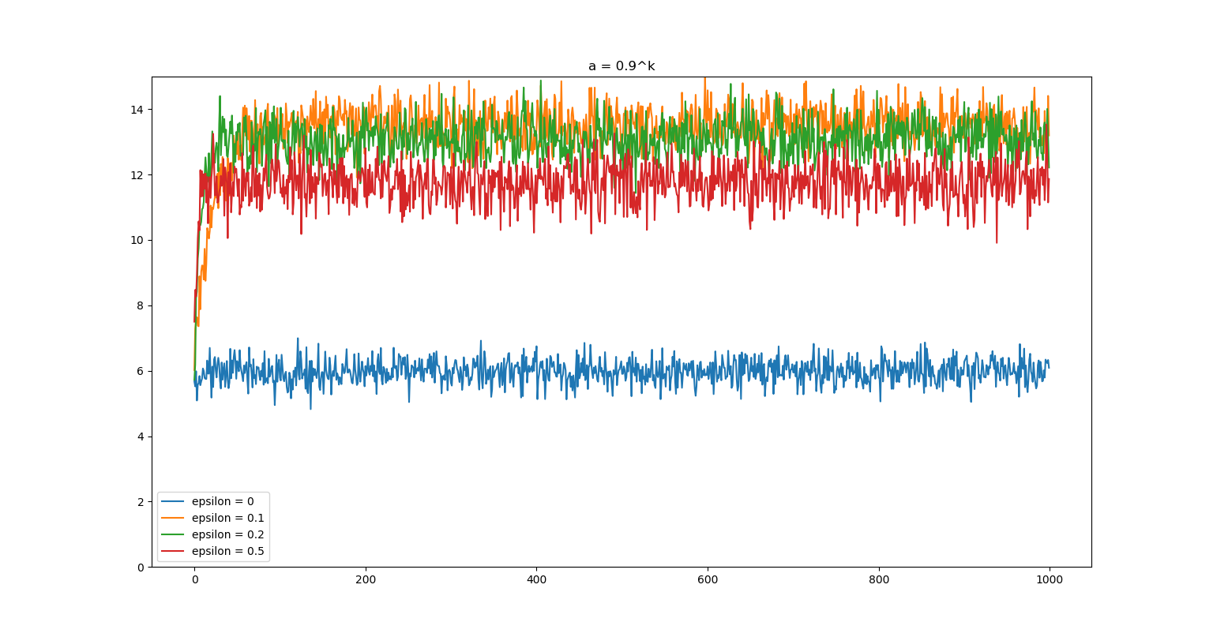

This was one of the highest performing alpha-values for the model. Though, we observe that its optimization depends heavily on the value selected for epsilon. This is abundantly clear when we observe the performance of the greedy action, which performed about half as well as the others. We also observe that with a higher performing alpha value, we trade off efficiency, as the best performing epsilon (e=0.1) takes significantly longer to achieve peak performance. This situation is prevalent in all subsequent models.

Alpha = 1/(1+ln(1+k))

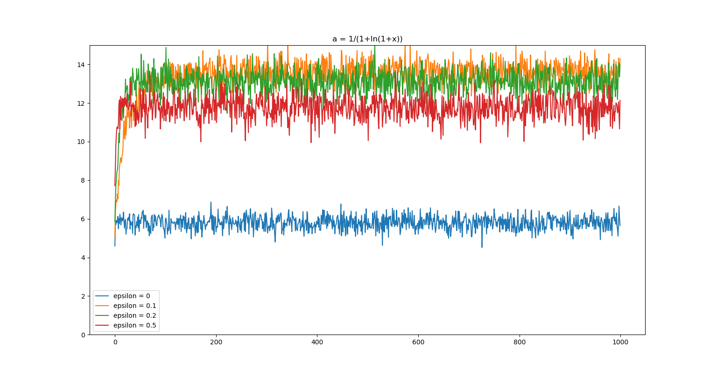

This model performed in a very similar manner to the a=0.9^k model. However, we note that the descending weight placed on delta-Q in this model produced the second highest results of any non-optimistic initial valued model (where epsilon=0.1). We observe that this model learned the optimal parameters faster than any, other than the greedy and optimistic initial valued models, as is evident from the graph, and attribute its success to this.
Alpha = 1/k

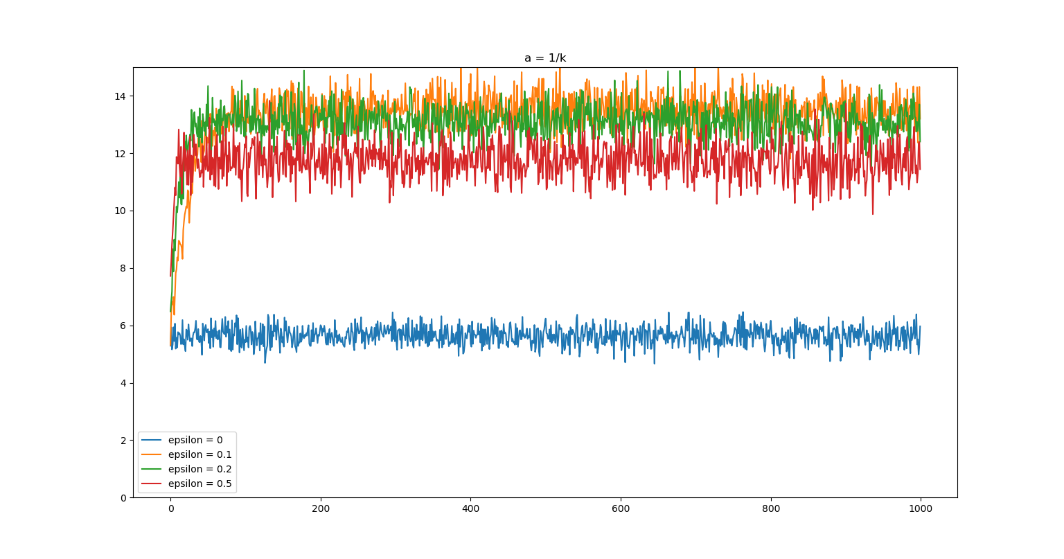
This was the highest performing model that did not have optimistic initial values. Again, we see the relationship between the length of time the model has been training, and how much weight it puts in the adjustment to the expected Q value should go down over time, and this model does this the fastest. It is likely that this is the reason this model is the highest performer.
Optimistic Initial Values

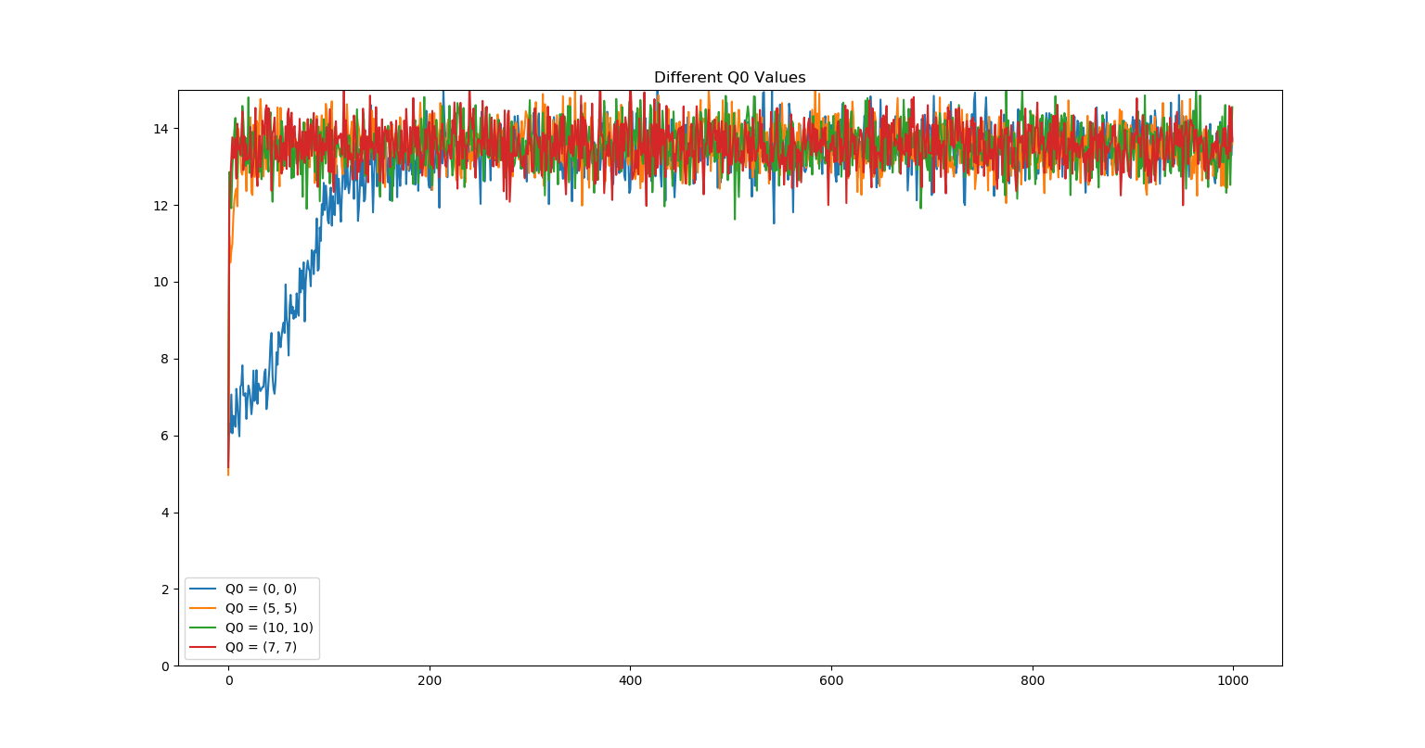
By using optimistic initial values, the time it took for the model to find the best Q values was drastically reduced. The blue line for optimizing at 0,0 (which is what previous models did) is a clear indicator of this. Predictably, 10,10 was the highest performing model. This is likely because it was the closest to the average optimal value of Q2, which is consistently 14.

