Q2.1 (a)

# 95th percentile  
qnorm(0.95, mean=10, sd=3)

## [1] 14.93456

# 99th percentile  
qnorm(0.99, mean=10, sd=3)

## [1] 16.97904

Q2.1 (b)

# 95th percentile of the t-distribution with 10 degrees of freedom  
qt(0.95, df=10)

## [1] 1.812461

# 99th percentile of the t-distribution with 10 degrees of freedom  
qt(0.99, df=10)

## [1] 2.763769

# 95th percentile of the t-distribution with 25 degrees of freedom  
qt(0.95, df=25)

## [1] 1.708141

# 99th percentile of the t-distribution with 25 degrees of freedom  
qt(0.99, df=25)

## [1] 2.485107

Q2.1 (c)

# 95th percentile of the chi-squared distribution with 1 degrees of freedom  
qchisq(0.95, df=1)

## [1] 3.841459

# 99th percentile of the chi-squared distribution with 1 degrees of freedom  
qchisq(0.99, df=1)

## [1] 6.634897

# 95th percentile of the chi-squared distribution with 4 degrees of freedom  
qchisq(0.95, df=4)

## [1] 9.487729

# 99th percentile of the chi-squared distribution with 4 degrees of freedom  
qchisq(0.99, df=4)

## [1] 13.2767

# 95th percentile of the chi-squared distribution with 10 degrees of freedom  
qchisq(0.95, df=10)

## [1] 18.30704

# 99th percentile of the chi-squared distribution with 10 degrees of freedom  
qchisq(0.99, df=10)

## [1] 23.20925

Q2.1 (d)

# 95th percentile of the F-distribution with 2 and 10 degrees of freedom  
qf(0.95, df1=2, df2=10)

## [1] 4.102821

# 99th percentile of the F-distribution with 2 and 10 degrees of freedom  
qf(0.99, df1=2, df2=10)

## [1] 7.559432

# 95th percentile of the F-distribution with 4 and 10 degrees of freedom  
qf(0.95, df1=4, df2=10)

## [1] 3.47805

# 99th percentile of the F-distribution with 4 and 10 degrees of freedom  
qf(0.99, df1=4, df2=10)

## [1] 5.994339

Q2.2 (a)

# 95th percentile of square of standard normal distribution  
qnorm(0.95, mean = 0, sd=1)^2

## [1] 2.705543

# 90th percentile of chi-squared distribution with 1 degree of freedom  
qchisq(0.90, df=1)

## [1] 2.705543

# 97.5th percentile of square of standard normal distribution  
qnorm(0.975, mean = 0, sd=1)^2

## [1] 3.841459

# 95th percentile of chi-squared distribution with 1 degree of freedom  
qchisq(0.95, df=1)

## [1] 3.841459

# 98.75th percentile of square of standard normal distribution  
qnorm(0.9875, mean = 0, sd=1)^2

## [1] 5.023886

# 97.5th percentile of chi-squared distribution with 1 degree of freedom  
qchisq(0.975, df=1)

## [1] 5.023886

We can see from the following results that:

1. the 90th percentile of the chi-squared distribution is equal to the 95th percentile of the square of the standard normal distribution.
2. the 95th percentile of the chi-squared distribution is equal to the 97.5th percentile of the square of the standard normal distribution.
3. the 97.5th percentile of the chi-squared distribution is equal to the 98.75th percentile of the square of the standard normal distribution.

Q2.2 (b)

v1 <- 1  
v2 <- 20  
  
# 95th percentile of square of t distribution  
qt(0.95, df=v2)^2

## [1] 2.974653

# 90th percentile of f distribution (1, v2)  
qf(0.90, df1=v1, df2=v2)

## [1] 2.974653

# 97.5th percentile of square of t distribution  
qt(0.975, df=v2)^2

## [1] 4.351244

# 95th percentile of f distribution (1, v2)  
qf(0.95, df1=v1, df2=v2)

## [1] 4.351244

# 98.75th percentile of square of t distribution  
qt(0.9875, df=v2)^2

## [1] 5.871494

# 97.5th percentile of f distribution (1, v2)  
qf(0.975, df1=v1, df2=v2)

## [1] 5.871494

We can see from the following results that:

1. the 90th percentile of the F distribution (1, v2) is equal to the 95th percentile of the square of the t distribution (v2).
2. the 95th percentile of the F distribution (1, v2) is equal to the 97.5th percentile of the square of the t distribution (v2).
3. the 97.5th percentile of the F distribution (1, v2) is equal to the 98.75th percentile of the square of the t distribution (v2).

Q2.4 (a)

weekof <- c("January 30", "June 39", "March 2", "October 26", "February 7")  
no_of_cars_sold_y <- c(20, 18, 10, 6, 11)  
ave_no_of_salesppl_x <- c(6, 6, 4, 2, 3)  
  
# create matrix with the data  
data <- cbind(weekof, no_of_cars_sold_y, ave_no_of_salesppl_x)  
  
# create data frame  
df <- as.data.frame(data)  
transform(df, no_of_cars_sold_y = as.numeric(no_of_cars_sold_y), ave_no_of_salesppl_x = as.numeric(ave_no_of_salesppl_x))

## weekof no_of_cars_sold_y ave_no_of_salesppl_x  
## 1 January 30 20 6  
## 2 June 39 18 6  
## 3 March 2 10 4  
## 4 October 26 6 2  
## 5 February 7 11 3

# construct scatterplot of y against x, where y is the number of cars sold and x is the average number of salespeople  
plot(ave_no_of_salesppl_x, no_of_cars_sold_y, xlab="Ave # of salespeople", ylab="# of cars sold", main="Scatterplot of # of cars sold against ave # of salespeople")

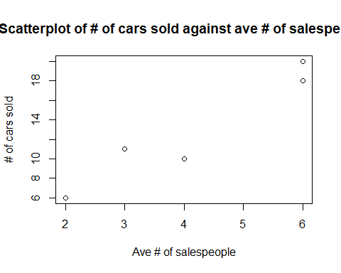 Q2.4 (b)

# estimate intercept using Method of least squares  
xbar = mean(ave_no_of_salesppl_x)  
ybar = mean(no_of_cars_sold_y)  
b1 = sum((ave_no_of_salesppl_x - xbar) * (no_of_cars_sold_y - ybar)) / sum((ave_no_of_salesppl_x - xbar)^2)  
b0 = ybar - b1 * xbar  
cat("The estimated intercept:", b0, "\n")

## The estimated intercept: -0.125

cat("The estimated slope of the least squares line:", b1, "\n")

## The estimated slope of the least squares line: 3.125

# check using built in function 'lm'  
model <- lm(no_of_cars_sold_y ~ ave_no_of_salesppl_x)  
  
# print the summary of the model  
summary(model)

##   
## Call:  
## lm(formula = no_of_cars_sold_y ~ ave_no_of_salesppl_x)  
##   
## Residuals:  
## 1 2 3 4 5   
## 1.375 -0.625 -2.375 -0.125 1.750   
##   
## Coefficients:  
## Estimate Std. Error t value Pr(>|t|)   
## (Intercept) -0.1250 2.4055 -0.052 0.962   
## ave_no_of_salesppl_x 3.1250 0.5352 5.839 0.010 *  
## ---  
## Signif. codes: 0 '***' 0.001 '**' 0.01 '*' 0.05 '.' 0.1 ' ' 1  
##   
## Residual standard error: 1.915 on 3 degrees of freedom  
## Multiple R-squared: 0.9191, Adjusted R-squared: 0.8922   
## F-statistic: 34.09 on 1 and 3 DF, p-value: 0.01001

Q2.4 (c)

# plot the least squares line  
plot(ave_no_of_salesppl_x, no_of_cars_sold_y, xlab="Ave # of salespeople", ylab="# of cars sold", main="Scatterplot of # of cars sold against ave # of salespeople")  
abline(model, col="red")

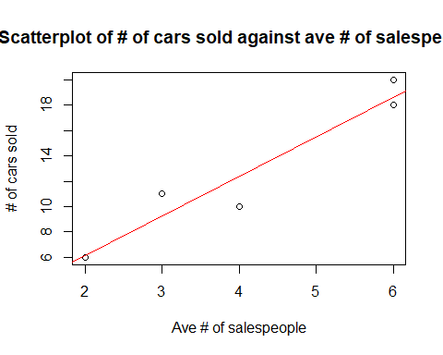 Q2.4 (d)

# estimate the number of cars sold when the average number of salespeople is 5  
x = 5  
y = b0 + b1 * x  
cat("The estimated number of cars sold when the average number of salespeople is 5:", y, "\n")

## The estimated number of cars sold when the average number of salespeople is 5: 15.5

Q2.4 (e)

# Calculate the fitted values mu_hat for each observed value of x  
mu_hat = b0 + b1 * ave_no_of_salesppl_x  
  
# Calculate the residuals e_i for each observed value of x  
e_i = no_of_cars_sold_y - mu_hat  
  
# Plot the residuals against the fitted values  
plot(mu_hat, e_i, xlab="Fitted values", ylab="Residuals", main="Residuals against Fitted values")

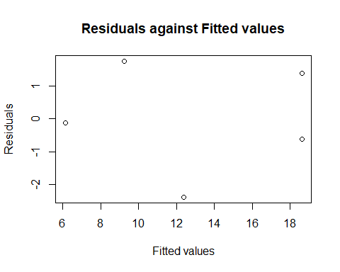 Q2.4 (f)

# estimate of the variance  
n = length(no_of_cars_sold_y)  
rss = sum(e_i^2)  
estimate_variance = rss / (n - 2)  
cat("The estimated variance:", estimate_variance, "\n")

## The estimated variance: 3.666667

Q2.6 (a)

# import data  
q6data = read.table(file='hooker.txt', header = T)  
q6data

## BT AP  
## 1 210.8 29.211  
## 2 210.2 28.559  
## 3 208.4 27.972  
## 4 202.5 24.697  
## 5 200.6 23.726  
## 6 200.1 23.369  
## 7 199.5 23.030  
## 8 197.0 21.892  
## 9 196.4 21.928  
## 10 196.3 21.654  
## 11 195.6 21.605  
## 12 193.4 20.480  
## 13 193.6 20.212  
## 14 191.4 19.758  
## 15 191.1 19.490  
## 16 190.6 19.386  
## 17 189.5 18.869  
## 18 188.8 18.356  
## 19 188.5 18.507  
## 20 185.7 17.267  
## 21 186.0 17.221  
## 22 185.6 17.062  
## 23 184.1 16.959  
## 24 184.6 16.881  
## 25 184.1 16.817  
## 26 183.2 16.385  
## 27 182.4 16.235  
## 28 181.9 16.106  
## 29 181.9 15.928  
## 30 181.0 15.919  
## 31 180.6 15.376

# Plot TEMP against AP, where BT is the temperature and AP is the air pressure  
plot(q6data$AP, q6data$BT, xlab="AP", ylab="TEMP", main="Scatterplot of TEMP against AP")

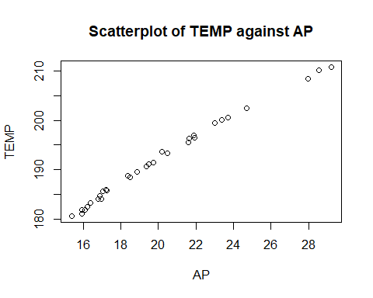

A Linear model seems appropriate as the relationship between TEMP and AP (as seen by the plots) seems to be linear.

Q2.6 (b)

x = 100 * log(q6data$AP, base = exp(1))  
  
# plot the scatterplot of TEMP against x  
plot(x, q6data$BT, xlab="100 * ln(AP)", ylab="TEMP", main="Scatterplot of TEMP against 100 * ln(AP)")

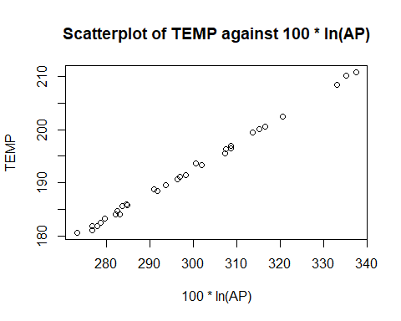

From the plot, it seems that a Linear model seems appropriate as the relationship between TEMP and 100*ln(AP) (as seen by the plots) seems to be linear as well.

Q2.6 (c)

xbar = mean(q6data$AP)  
ybar = mean(q6data$BT)  
b1 = sum((q6data$AP - xbar) * (q6data$BT - ybar)) / sum((q6data$AP - xbar)^2)  
b0 = ybar - b1 * xbar  
cat("The estimated intercept:", b0, "\n")

## The estimated intercept: 146.6729

cat("The estimated slope:", b1, "\n")

## The estimated slope: 2.252596

# check using built in function 'lm'  
q6model <- lm(q6data$BT ~ q6data$AP)  
  
# print the summary of the model  
summary(q6model)

##   
## Call:  
## lm(formula = q6data$BT ~ q6data$AP)  
##   
## Residuals:  
## Min 1Q Median 3Q Max   
## -1.6735 -0.6805 0.2203 0.5296 1.3976   
##   
## Coefficients:  
## Estimate Std. Error t value Pr(>|t|)   
## (Intercept) 146.67290 0.77641 188.91 <2e-16 ***  
## q6data$AP 2.25260 0.03809 59.14 <2e-16 ***  
## ---  
## Signif. codes: 0 '***' 0.001 '**' 0.01 '*' 0.05 '.' 0.1 ' ' 1  
##   
## Residual standard error: 0.806 on 29 degrees of freedom  
## Multiple R-squared: 0.9918, Adjusted R-squared: 0.9915   
## F-statistic: 3498 on 1 and 29 DF, p-value: < 2.2e-16

# estimate of the variance  
n = length(q6data$BT)  
  
# Calculate the fitted values mu_hat for each observed value of x  
mu_hat = b0 + b1 * q6data$AP  
  
# Calculate the residuals e_i for each observed value of x  
e_i = q6data$BT - mu_hat  
  
# Plot the residuals against the fitted values  
plot(mu_hat, e_i, xlab="Fitted values", ylab="Residuals", main="Residuals against Fitted values")

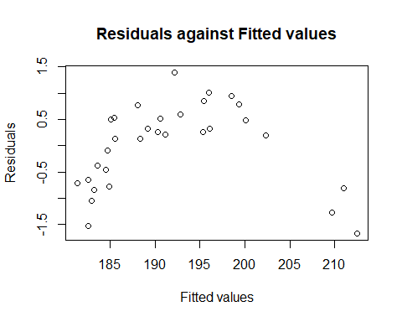

rss = sum(e_i^2)  
estimate_variance = rss / (n - 2)  
cat("The estimated variance:", estimate_variance, "\n")

## The estimated variance: 0.6496679

# plot the least squares line  
plot(x, q6data$BT, xlab="100*ln(AP)", ylab="TEMP", main="Scatterplot of TEMP against 100*ln(AP)")  
abline(q6model, col="red")

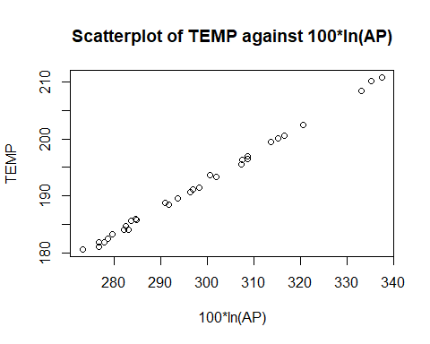

# plot the least squares line  
plot(q6data$AP, q6data$BT, xlab="AP", ylab="TEMP", main="Scatterplot of TEMP against AP")  
abline(q6model, col="red")

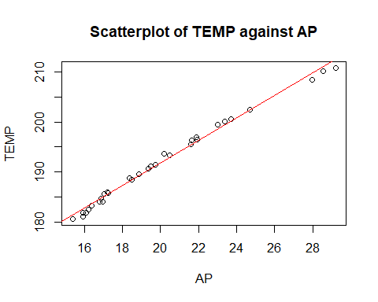

We can see that from both scatterplots, the fitted line can only be seen on TEMP against AP, and not TEMP against 100*ln(AP). This is likely due to the fitted line being based on the original data, and not the transformed data.

Regardless, the fitted line seems to be a good fit for the data, as the residuals seem to be randomly scattered around 0, and there is no clear pattern in the residuals.